**TMS Feedback – 22.07.2021**

**Project**

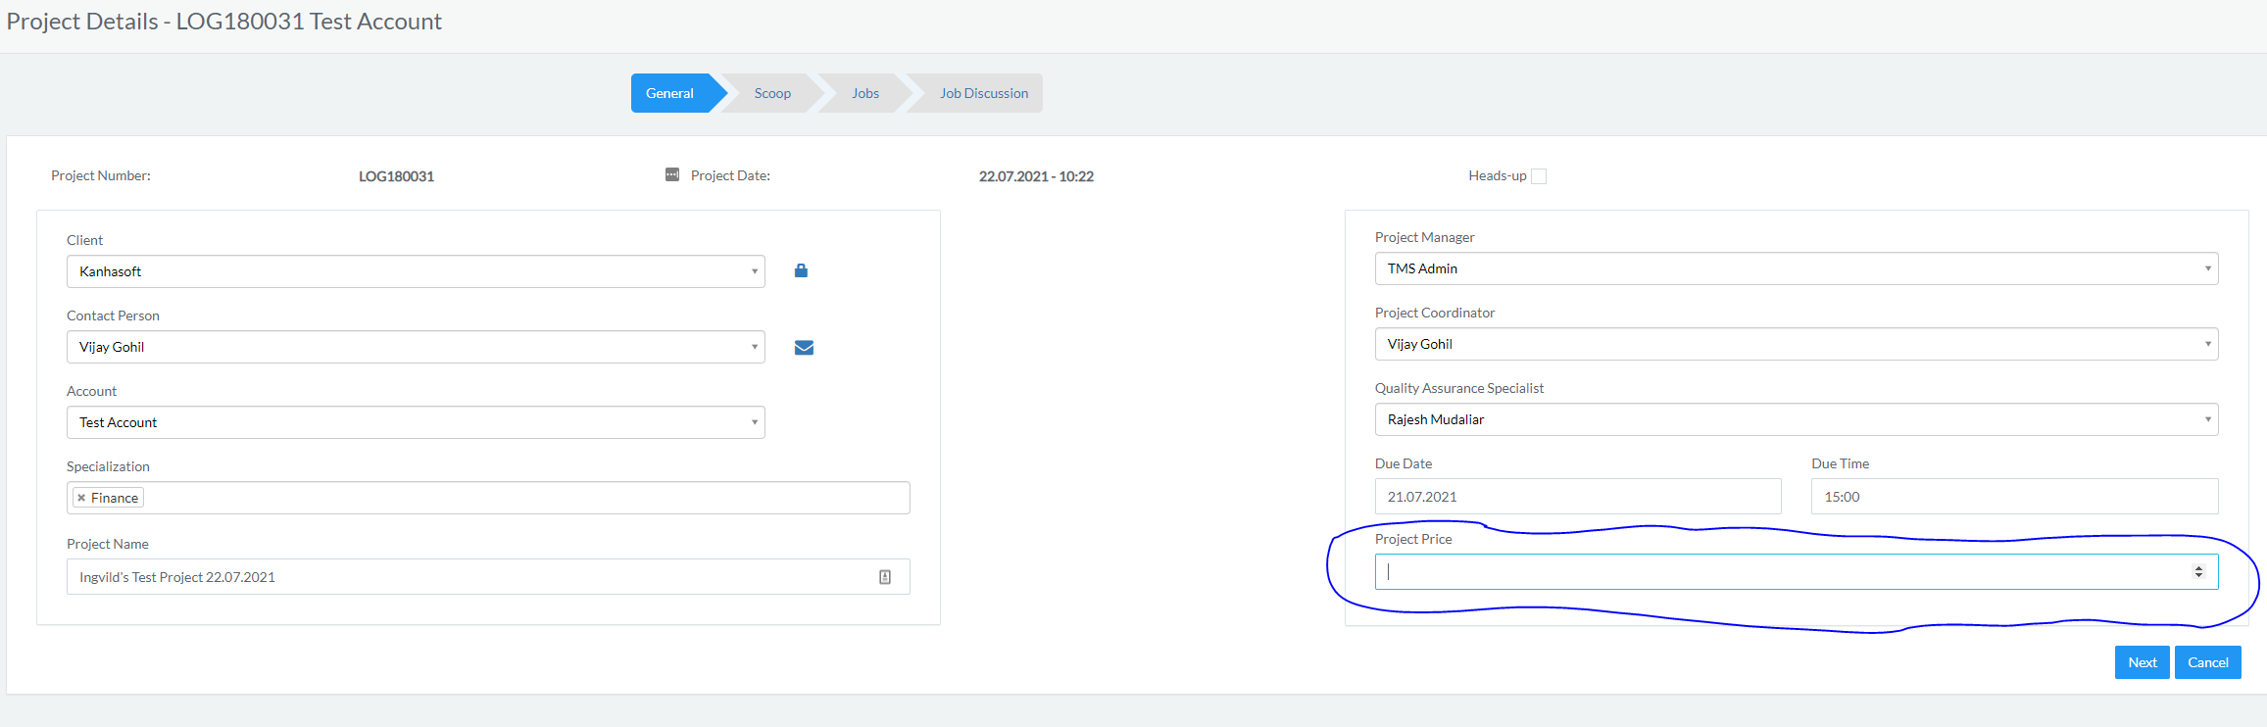

Let’s remove the Project Price field, as it doesn’t belong there.

**Scoop**

**1.**

Great, the favorites now shows, thank you 😊

Last thing, could we show the languages with their Title name (English name of language) and not the Name (where the language has the language written in the original languages, and not English).

**File Manager:**

**2.**

Great that it now downloads the folder, could the folders downloaded be named:

Scoop Number_Client_Folder Name

Example: LOG180031-01_Test Account_Original files.zip

**Create Jobs phase**

**3.**

When the Scoop is created, could we add a button to jump to the Jobs window?

Example: Go to Jobs

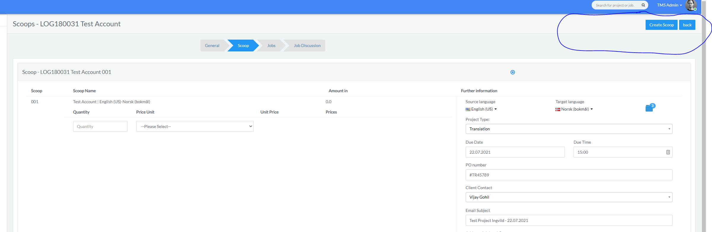

**4.**

When clicking the Source folder (and Target folder), we should be able to upload files that linguists can download. Could you make that option possible?

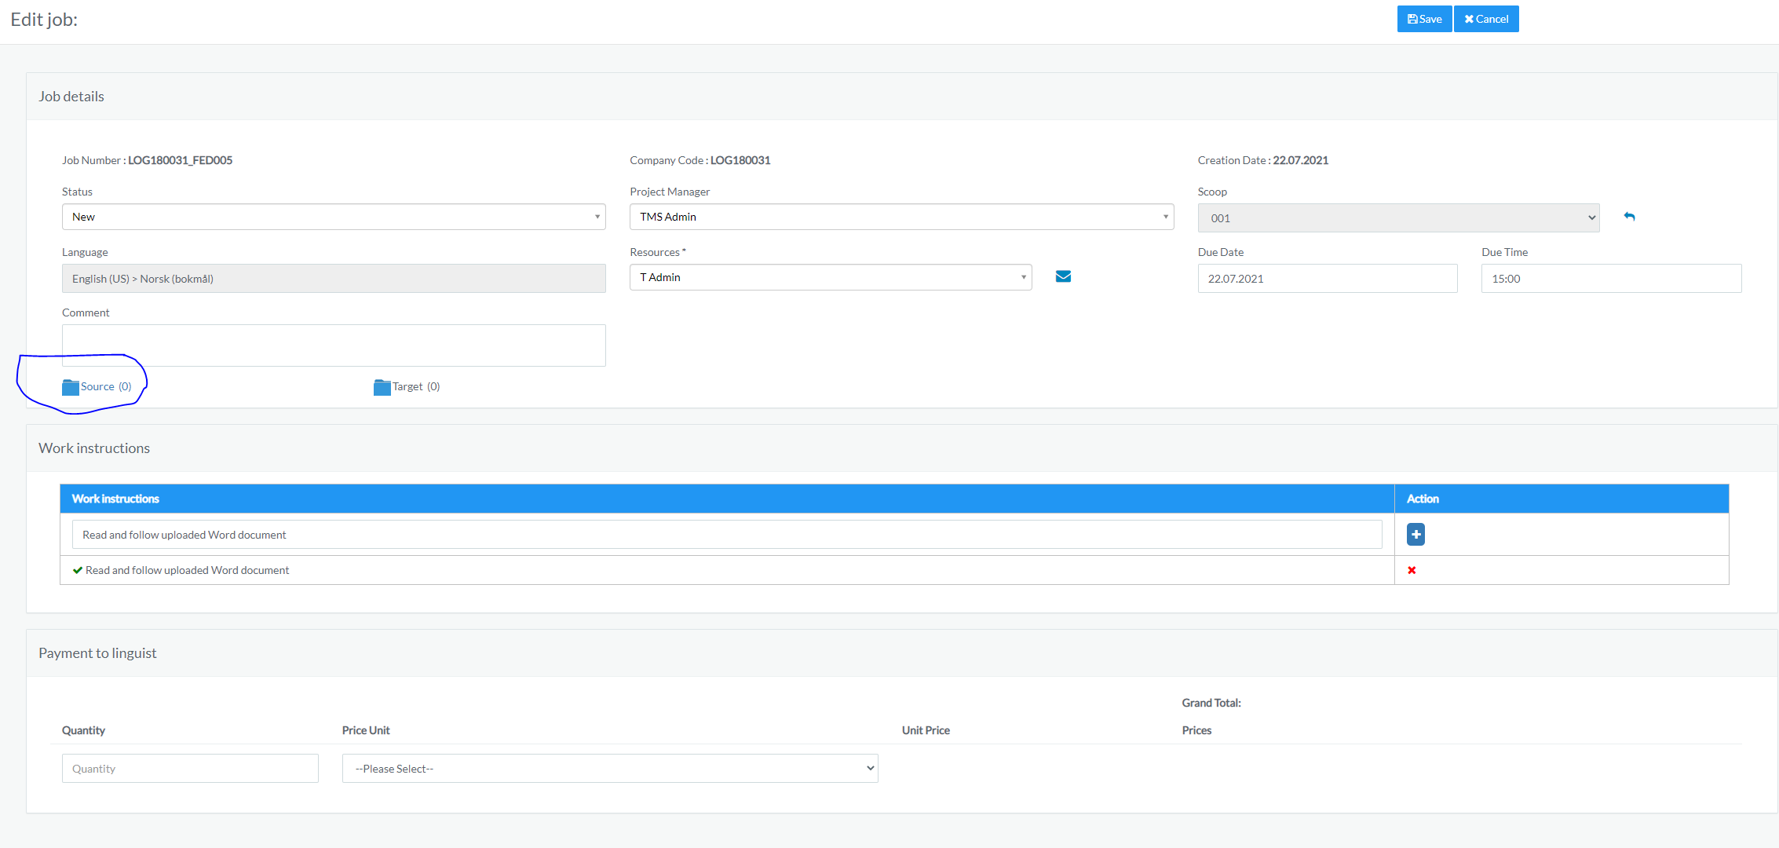

We also need that option from here:

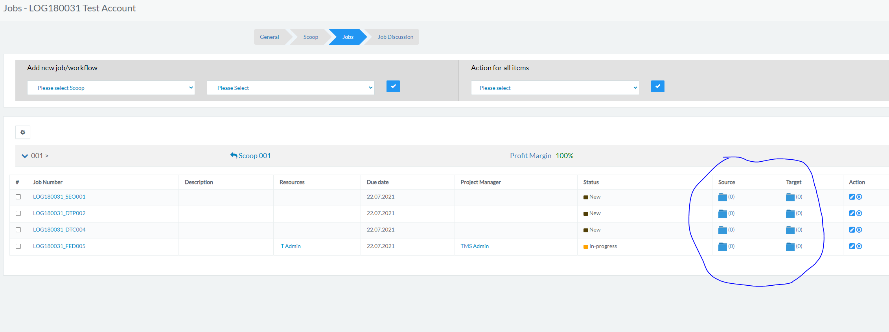

**5.**

**Margin for Jobs:**

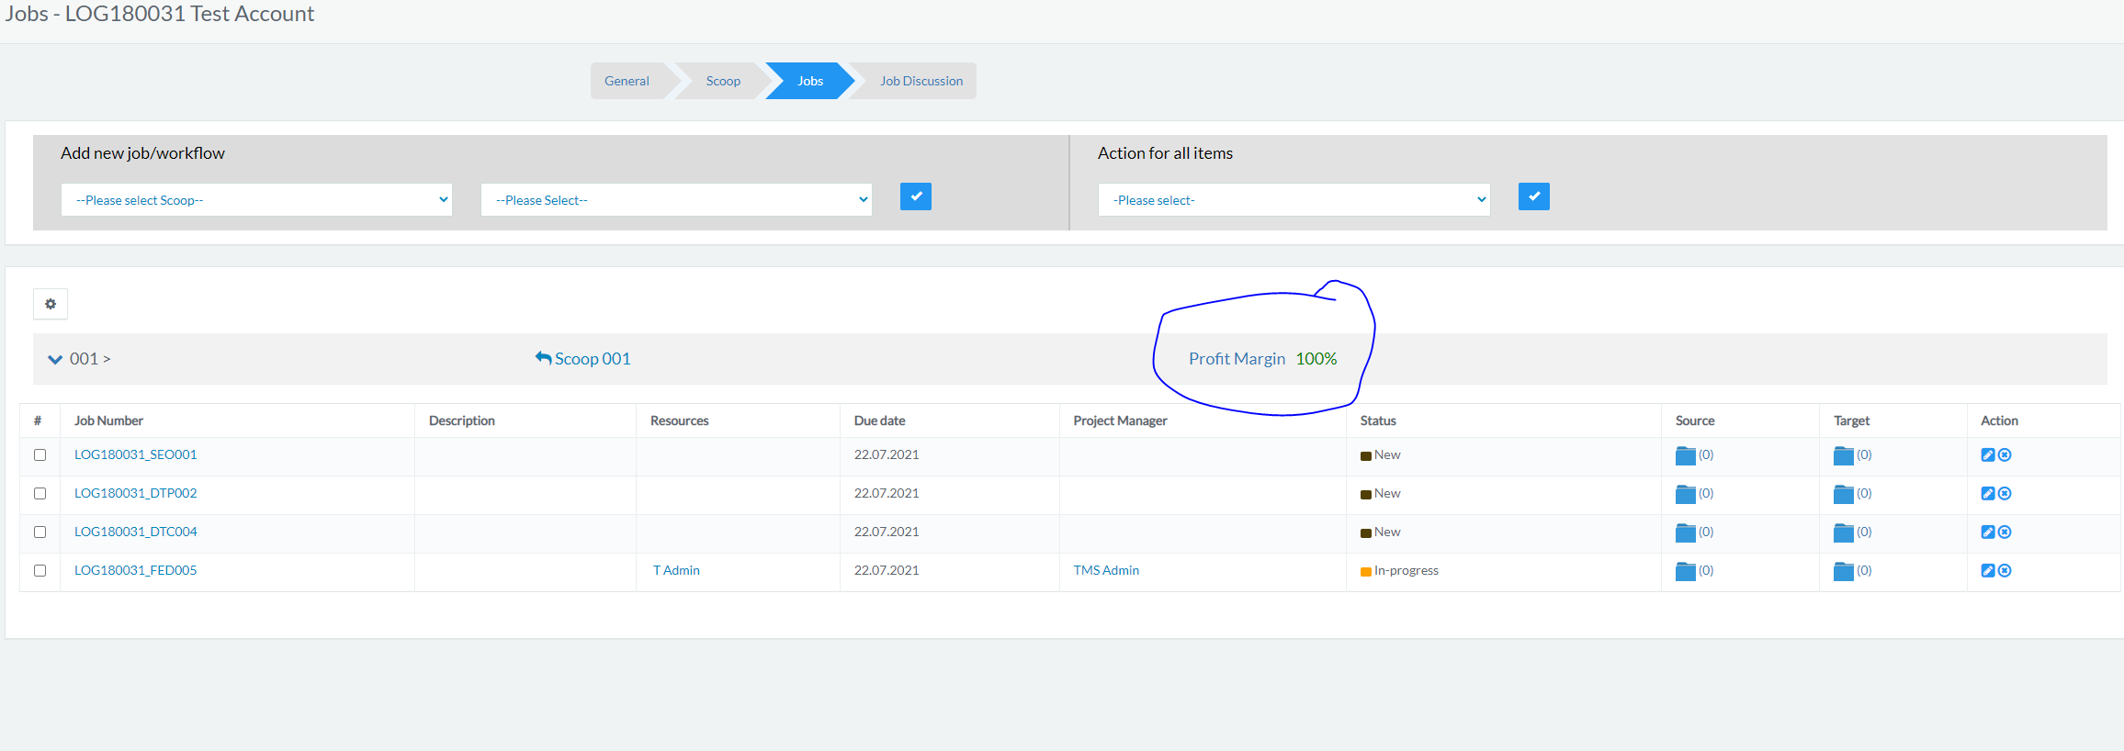

This needs to calculate the cost of the job, compared with the payment received from the client in the Scoop. So, if we receive 50 EUR and pay 25 EUR, the margin should show 50 %.