# Documentation

* In this Assignment we are creating a RMI calculator using java RMI
* It supports stack operations and arithmetic operations also, and Multiple clients can connect to the same server also.
* I had written my code in Eclipse Ide compiled and I had also compiled it using the windows Power shell.

**Steps to compile:**

* Since it is a Maven Project we need java 17 or later

**Step 1**: Copy the root directory and change the command to our root in power shell.

cd E:\distributed_Assignment1

**mvn clean compile**

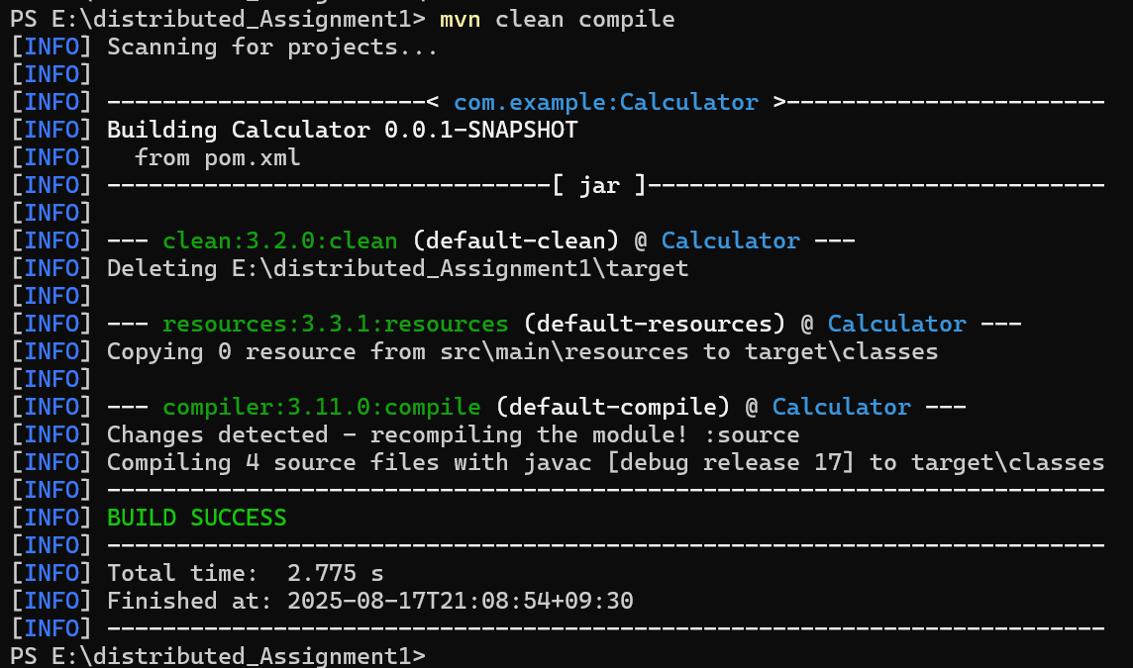

When we hit enter we get output like this

**Step 2**: Now copy the directory path where our class flies are saved and we will start the RMI Registry.

cd E:\distributed_Assignment1\src\main\java

**javac (Get-ChildItem -Path calculator -Filter *.java | ForEach-Object { $_.FullName })**

**java -cp . calculator.CalculatorServer**



**Step 3**: Now The server is ready Open new Window and run the client.

**java -cp . calculator.CalculatorClient**

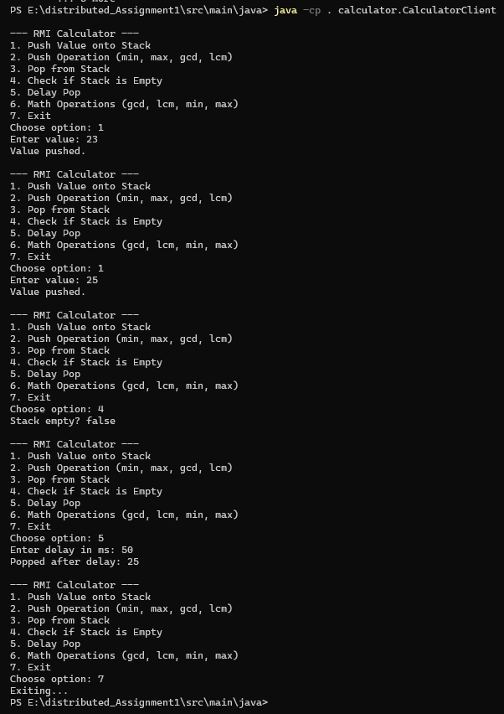

Here client can perform the actions also

Step 4: now we need to test the code we have writen whether it is working as intended or not.

* Before that we need to come to our root directory because maven needs to read POM.XML file.

E:\distributed_Assignment1

**mvn test**

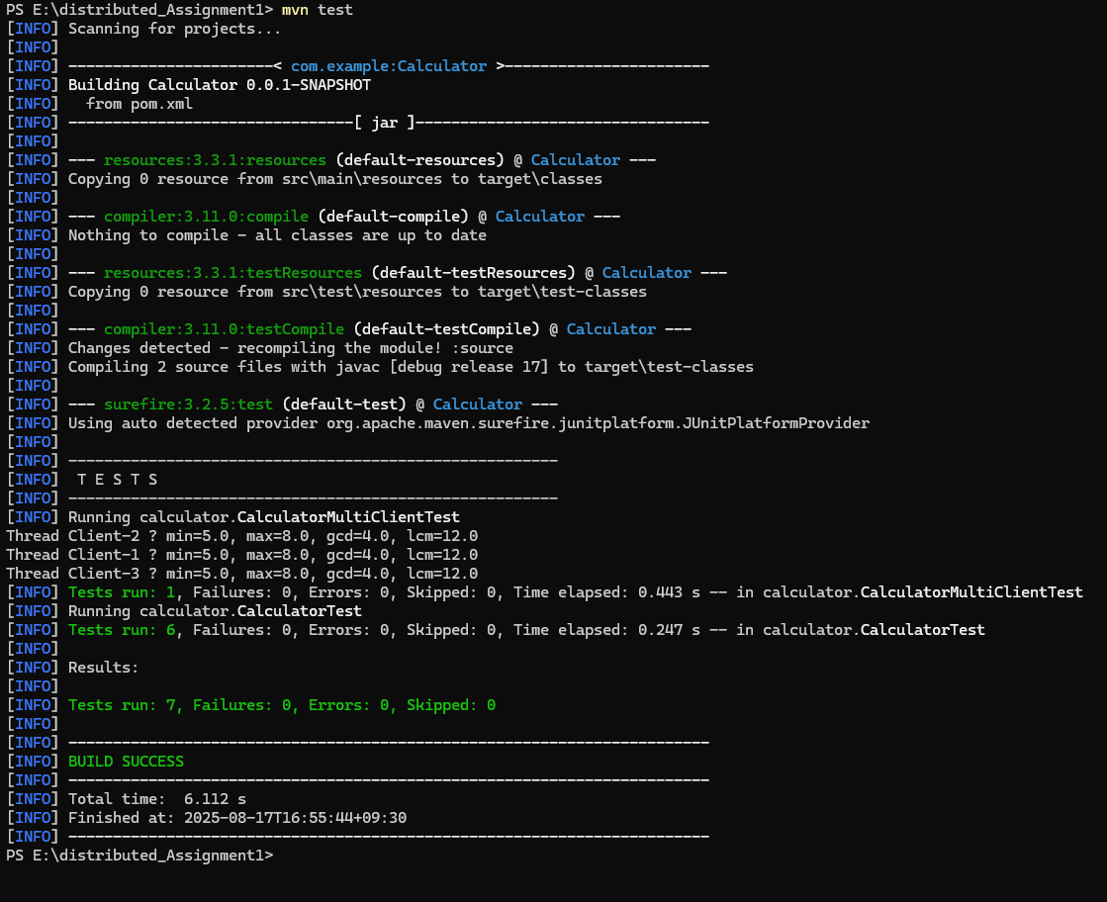

We can see the Test cases have passed for our Test Programs.