**Practical No - 9**

**Aim**: Data Pre-Processing

**Solution:** Only the first tab, ‘Pre-process’, is active at the moment because there is no dataset open.

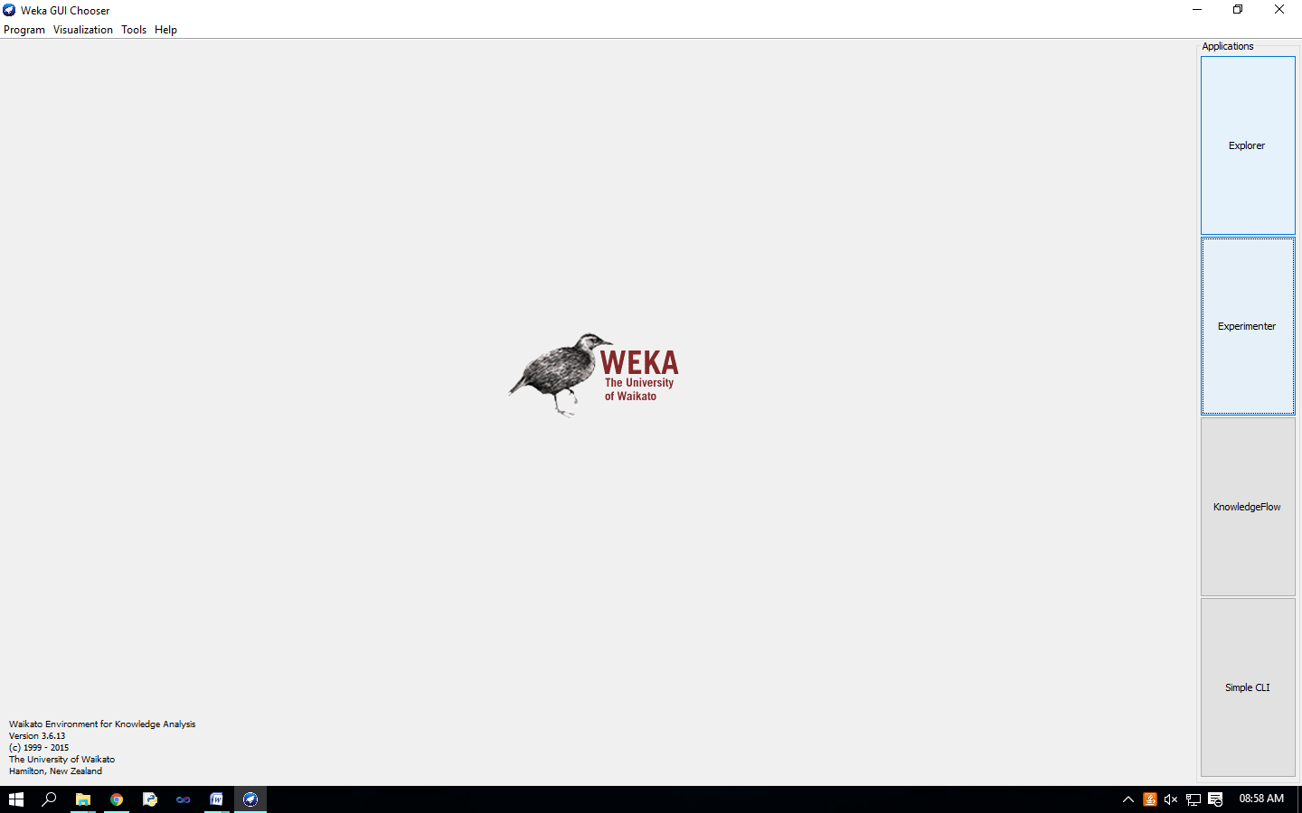

Opening file from a local file system Click on ‘Open file…’ button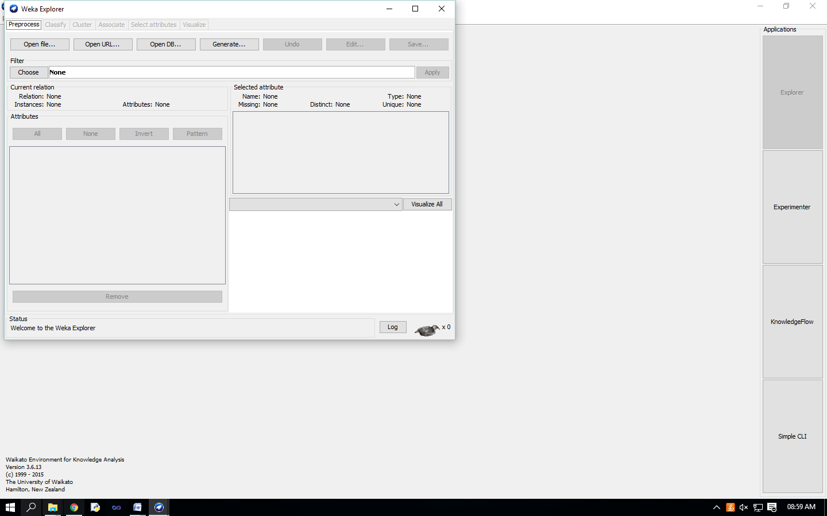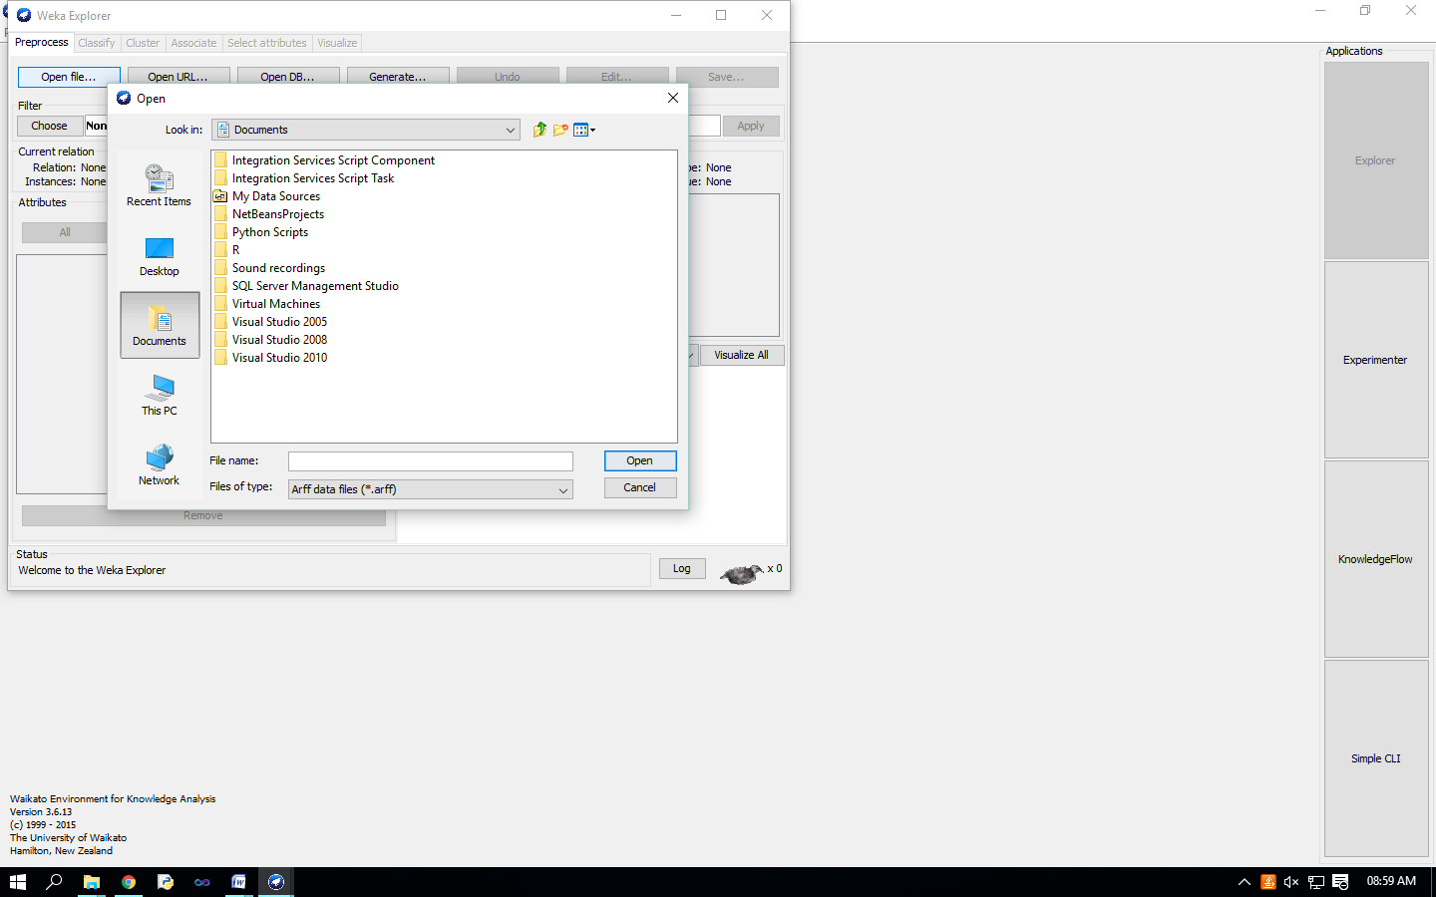

It brings up a dialog box allowing you to browse for the data file on the local file system, choose “weather.arff” file.

C:\Program Files (x86)\Weka-3-6\data

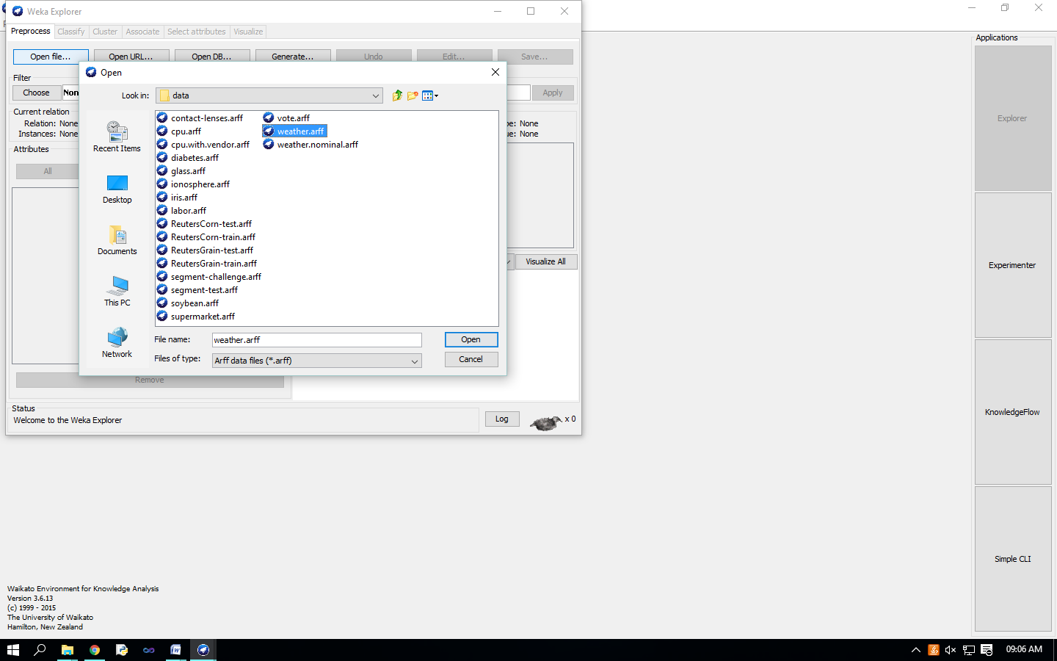

Loading data The most common and easiest way of loading data into WEKA is from ARFF file, using Open File button. 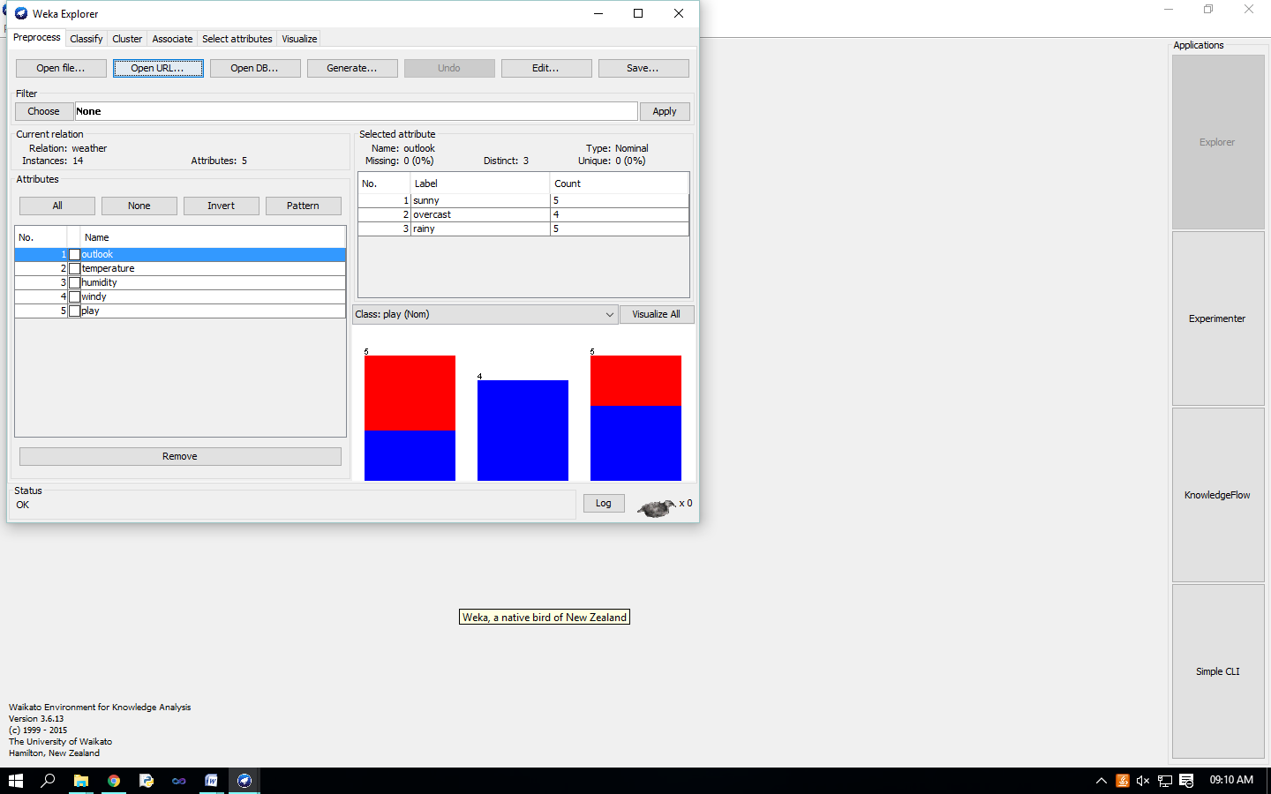 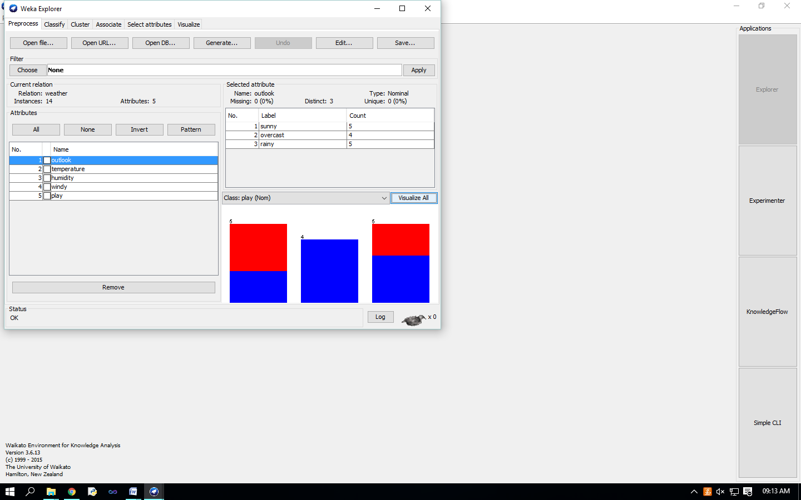

Visualize Attributes: 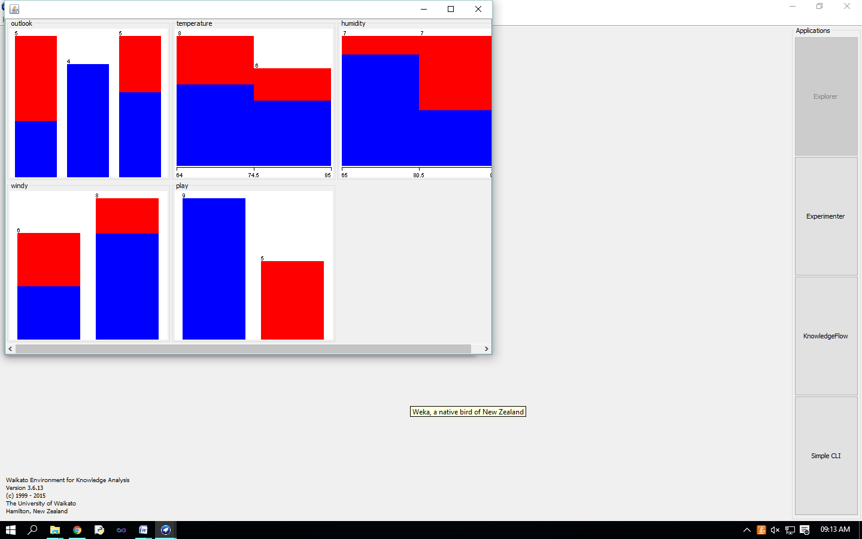

visualize all attributes by clicking on ‘Visualize All’ button.,

**Practical No – 10**

**Aim :** Data discretization.

**Solution :**

In ‘Filters’ window, click on the ‘Choose’ button.

This will show pull-down menu with a list of available filters. Select Supervised 🡪Attribute 🡪

Discretize and click on ‘Apply’ button.

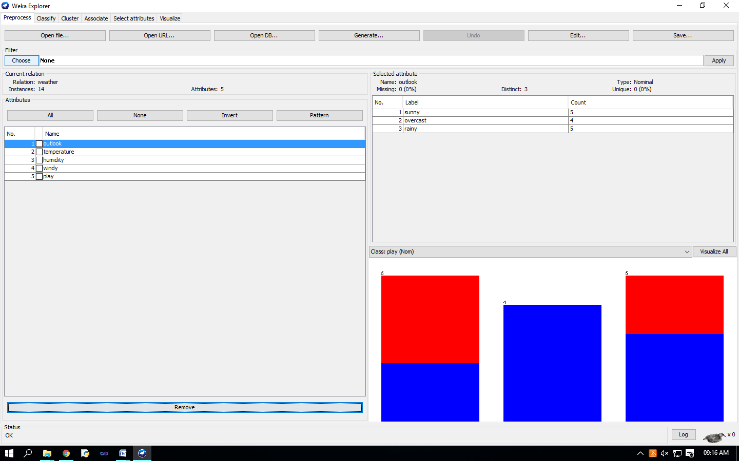 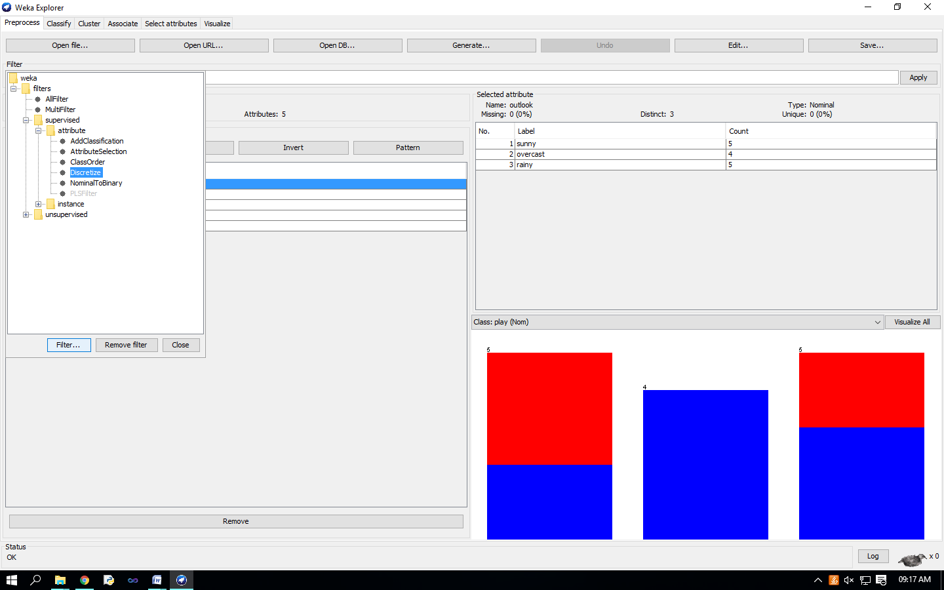 The filter will convert Numeric values into Nominal.

the fields in the window changes to reflect available options.

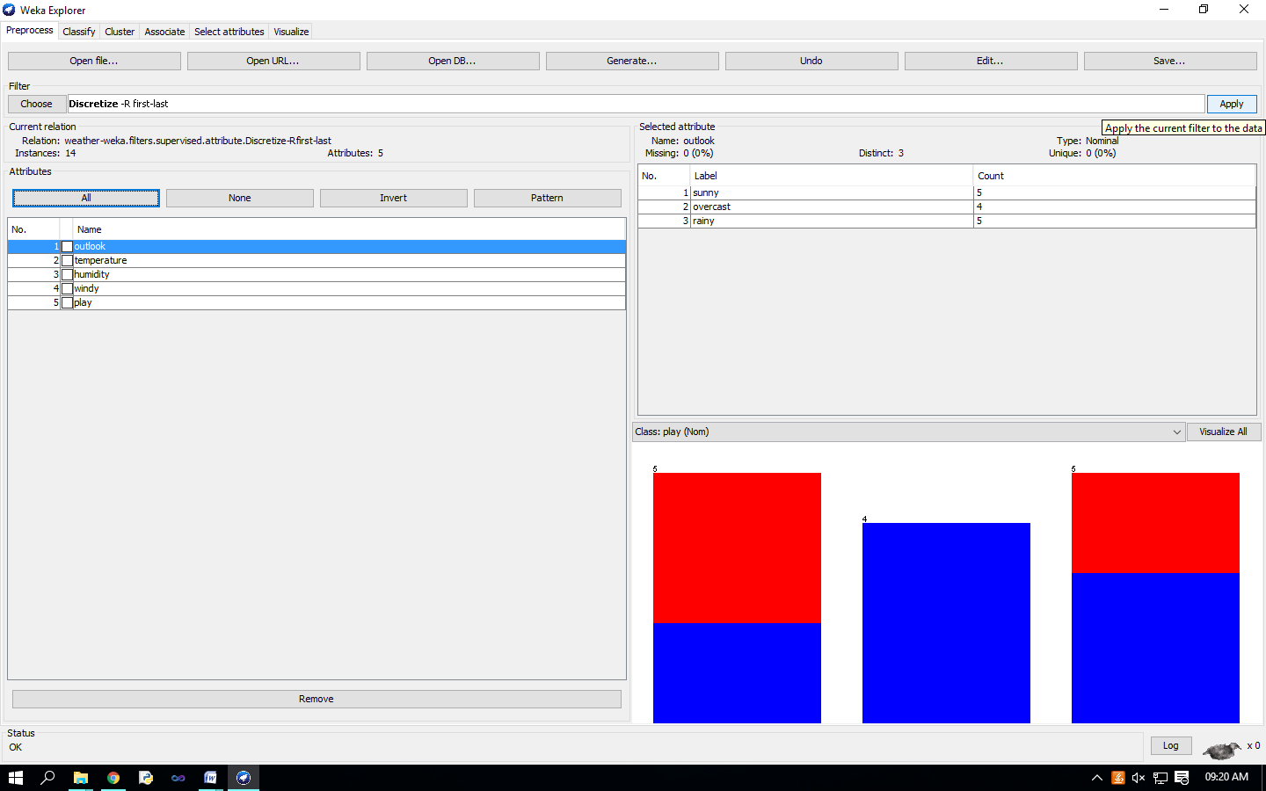 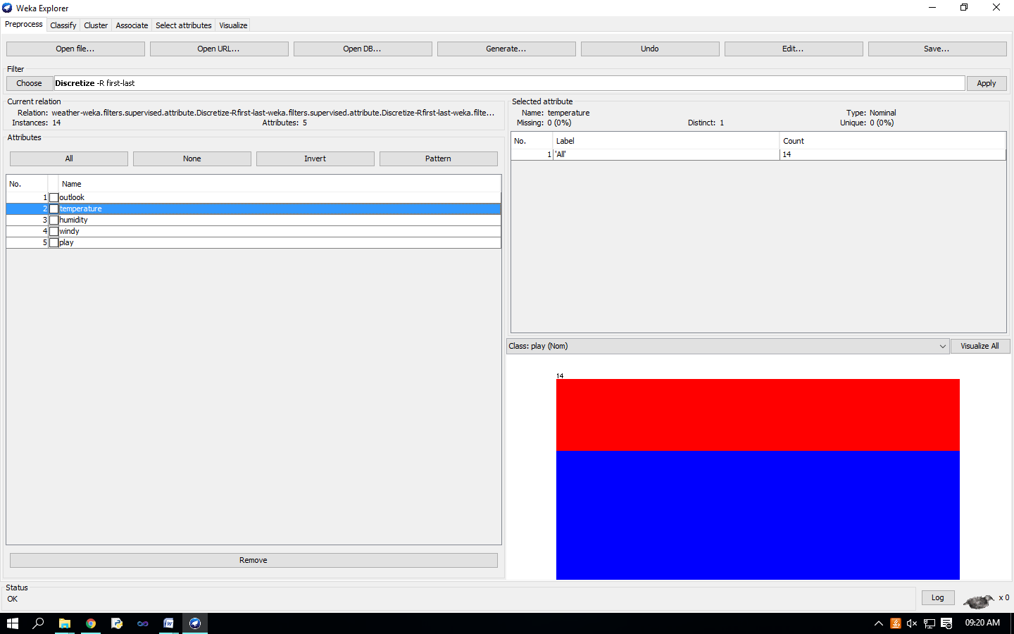 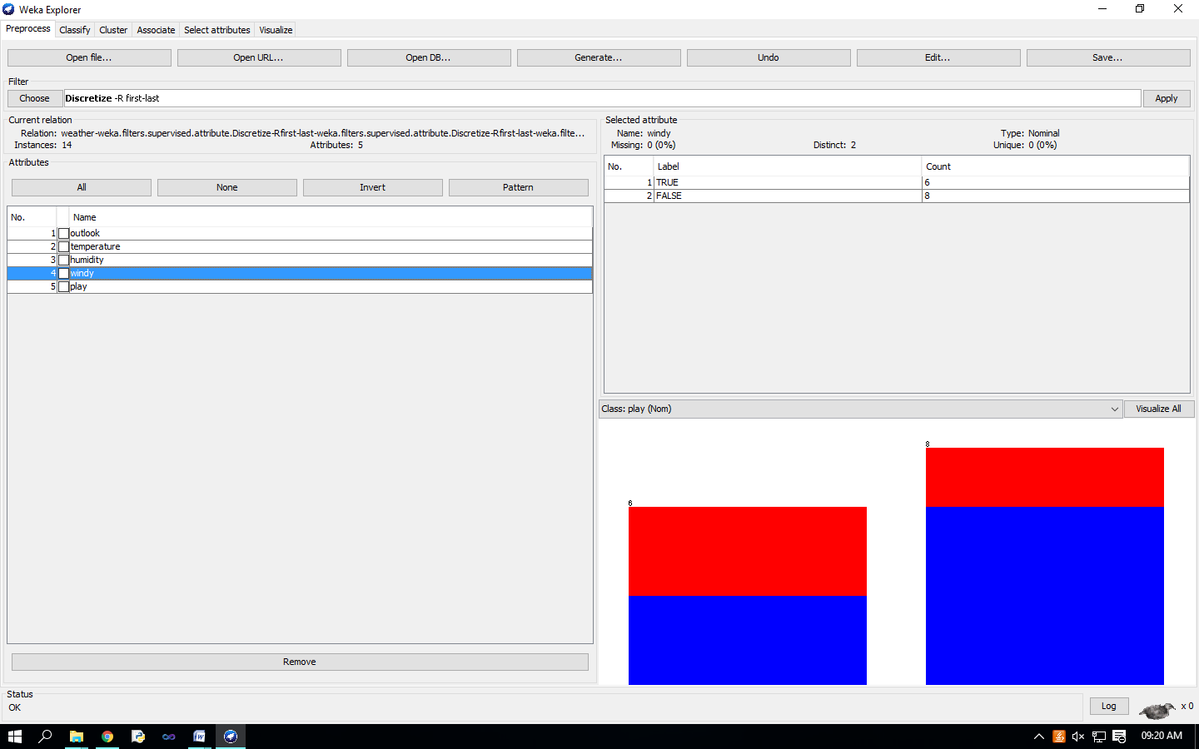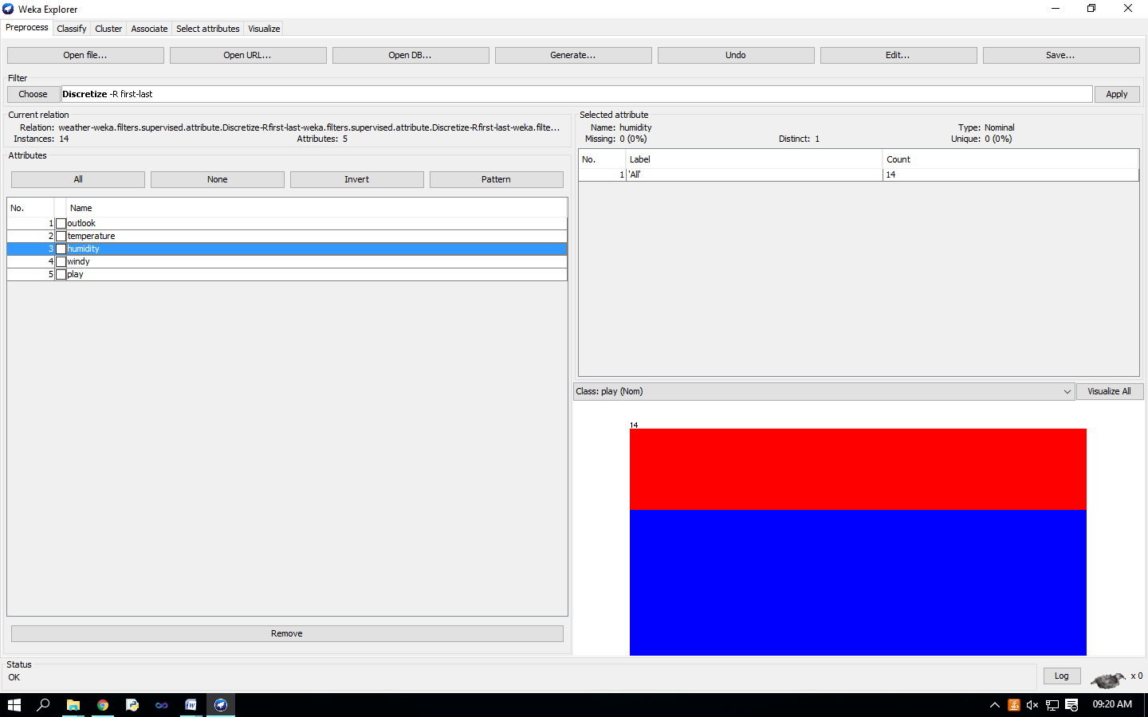 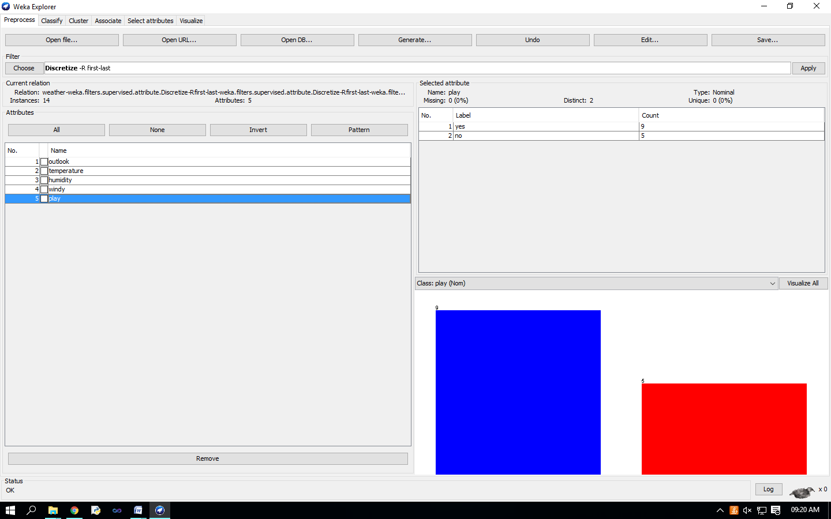

**Practical No - 11**

**Aim** : Classification problems.

**Solution** : Once you have your data set loaded, all the tabs are available to you. Click on the ‘Classify’ tab.

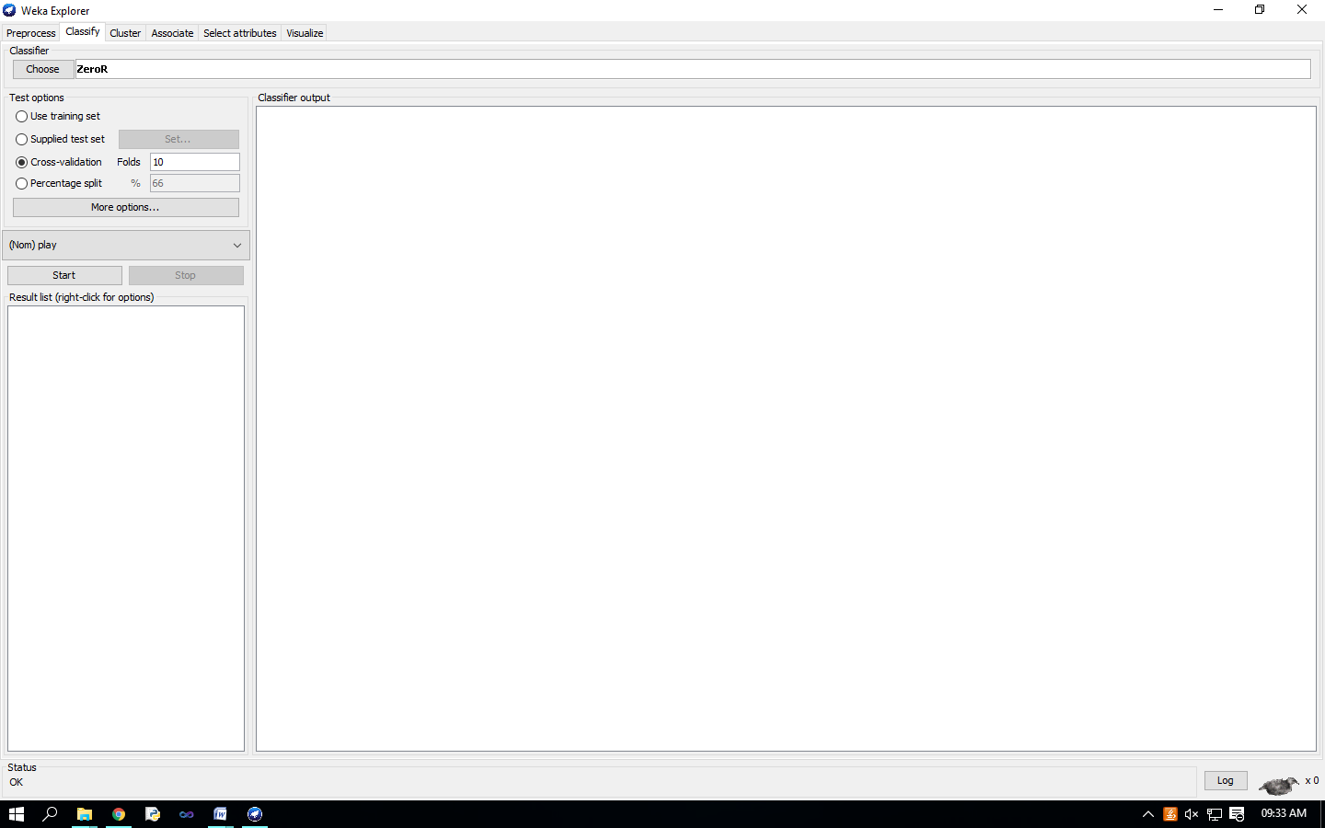 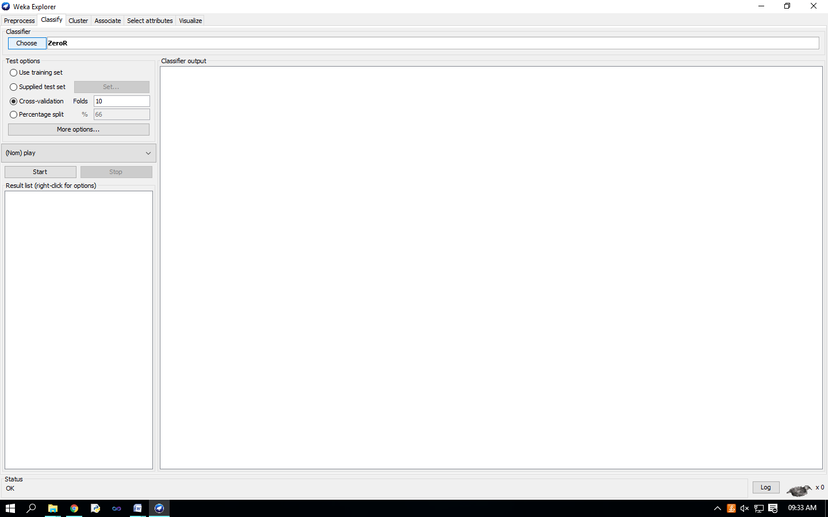

Click on ‘Choose’ button in the ‘Classifier’ box just below the tabs and select C4.5 classifier WEKA   Classifiers   Trees   J48. 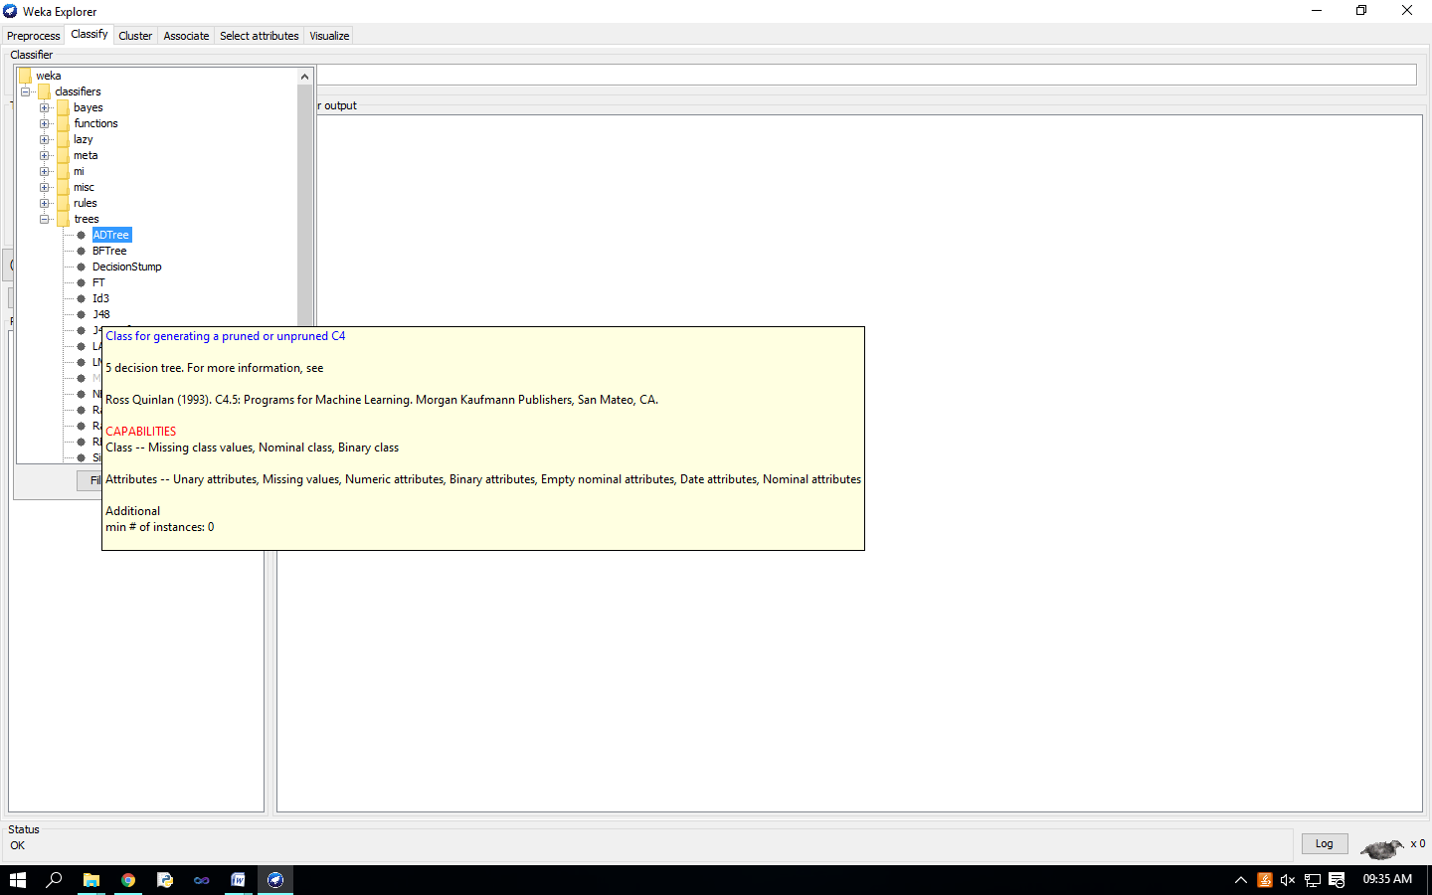 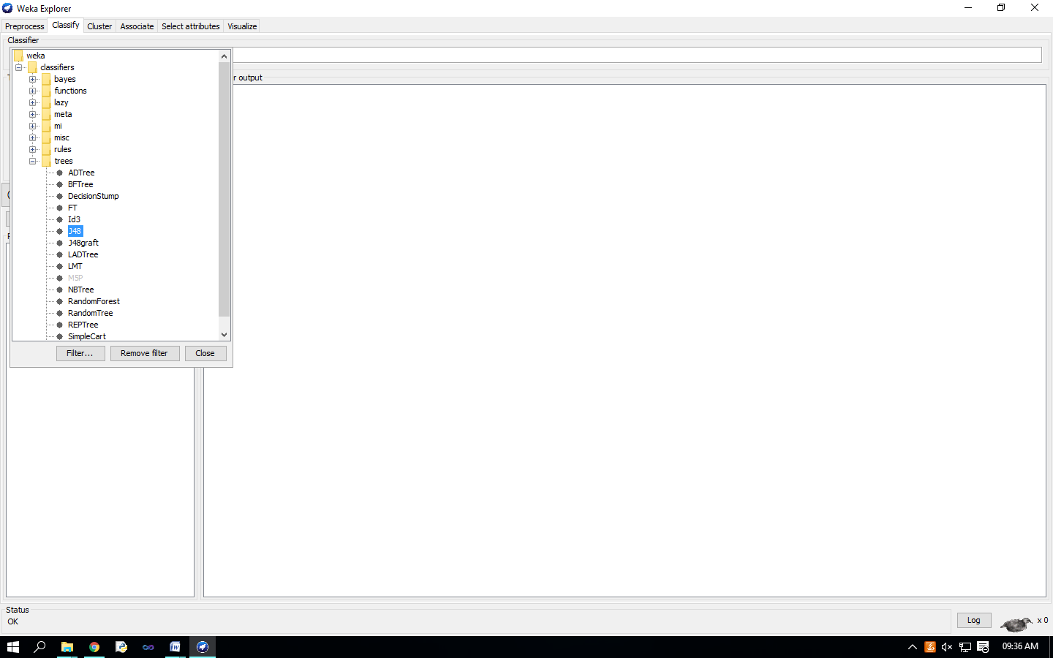 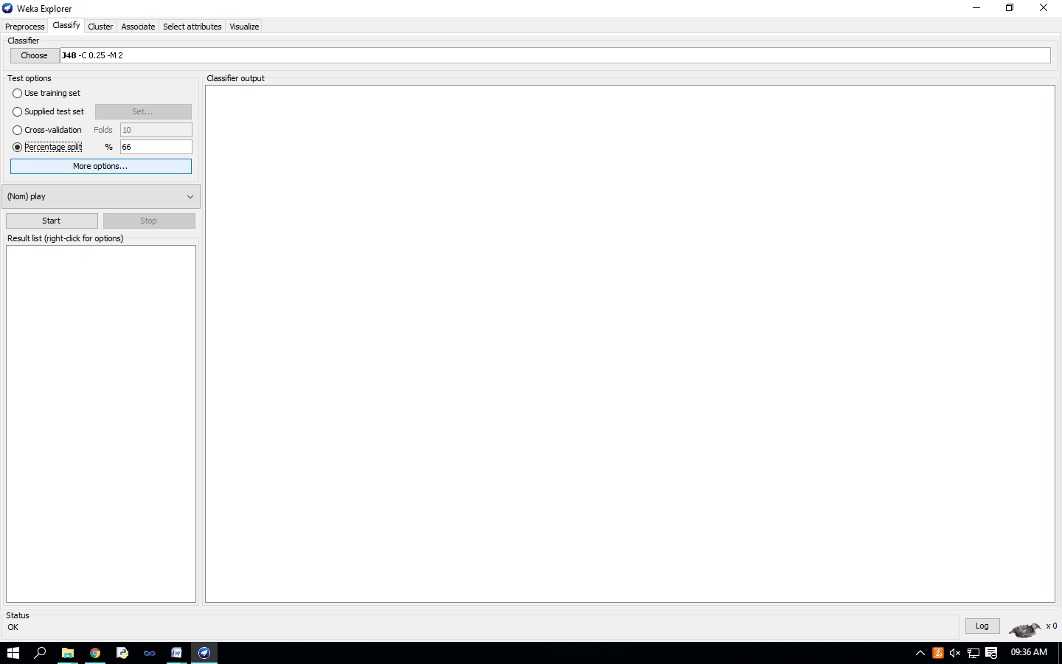

Check ‘Percentage split’ radio-button and keep it as default 66%. Click on ‘More options…’ button. make sure that the Following options are checked : 1. Output model. 2. Output per-class stats. 3. Output confusion matrix 4. Store predictions for visualization. 5. Set ‘Random seed for Xval / % Split’ to 1.

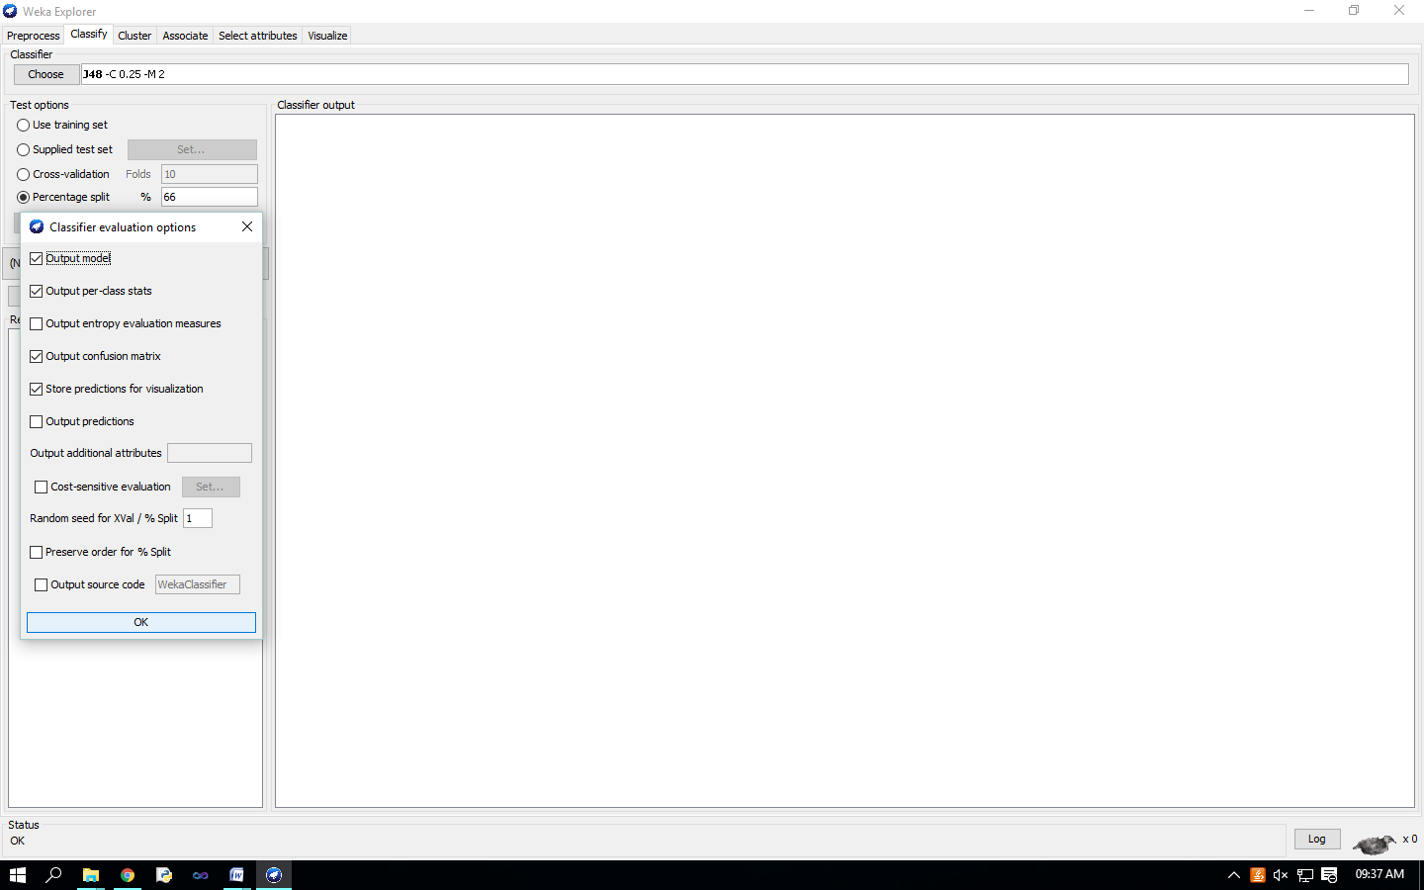 Once the options have been specified, you can run the classification algorithm. Click on ‘Start’ button 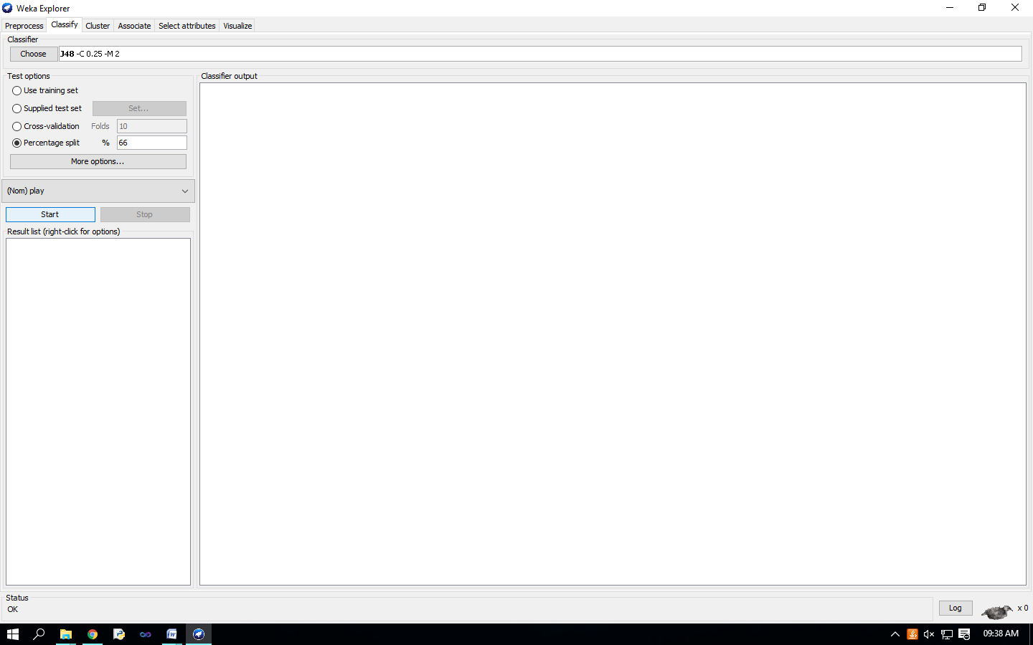 To see a graphical representation of the classification tree. Right-click on the entry in ‘Result list’ for which you would like to visualize a tree. 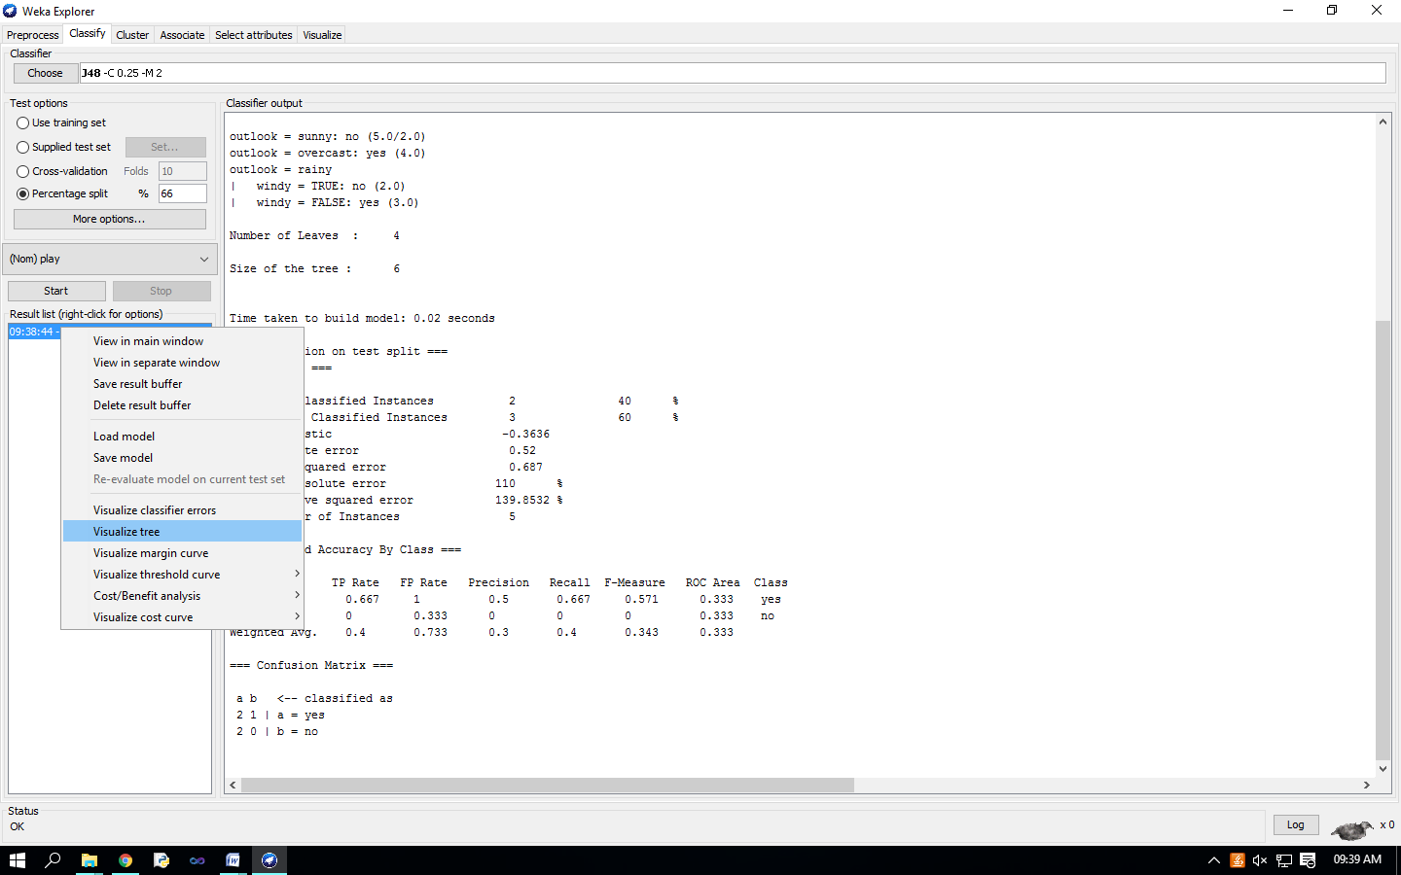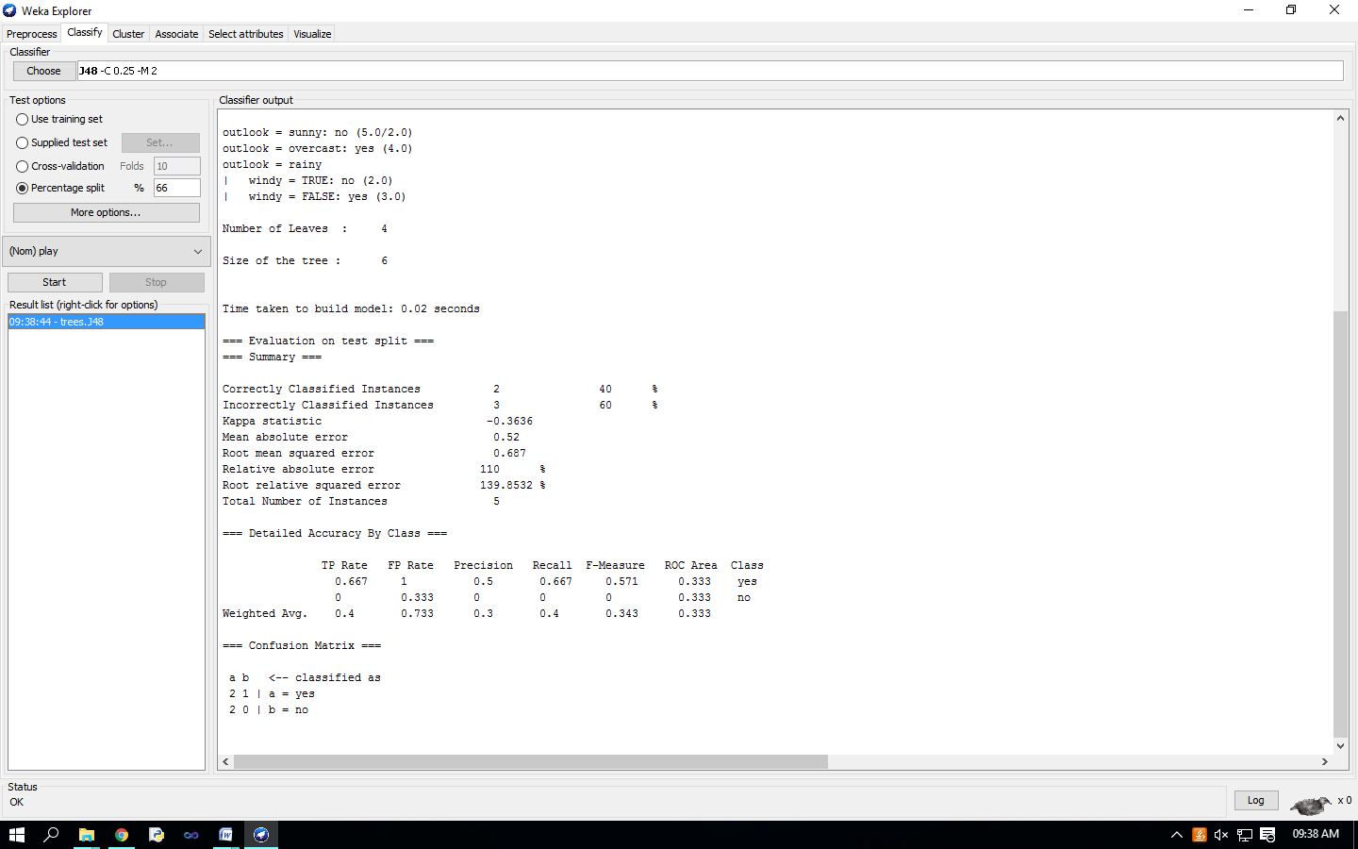 Select the item ‘Visualize tree’; a new window comes up to the screen displaying the tree.

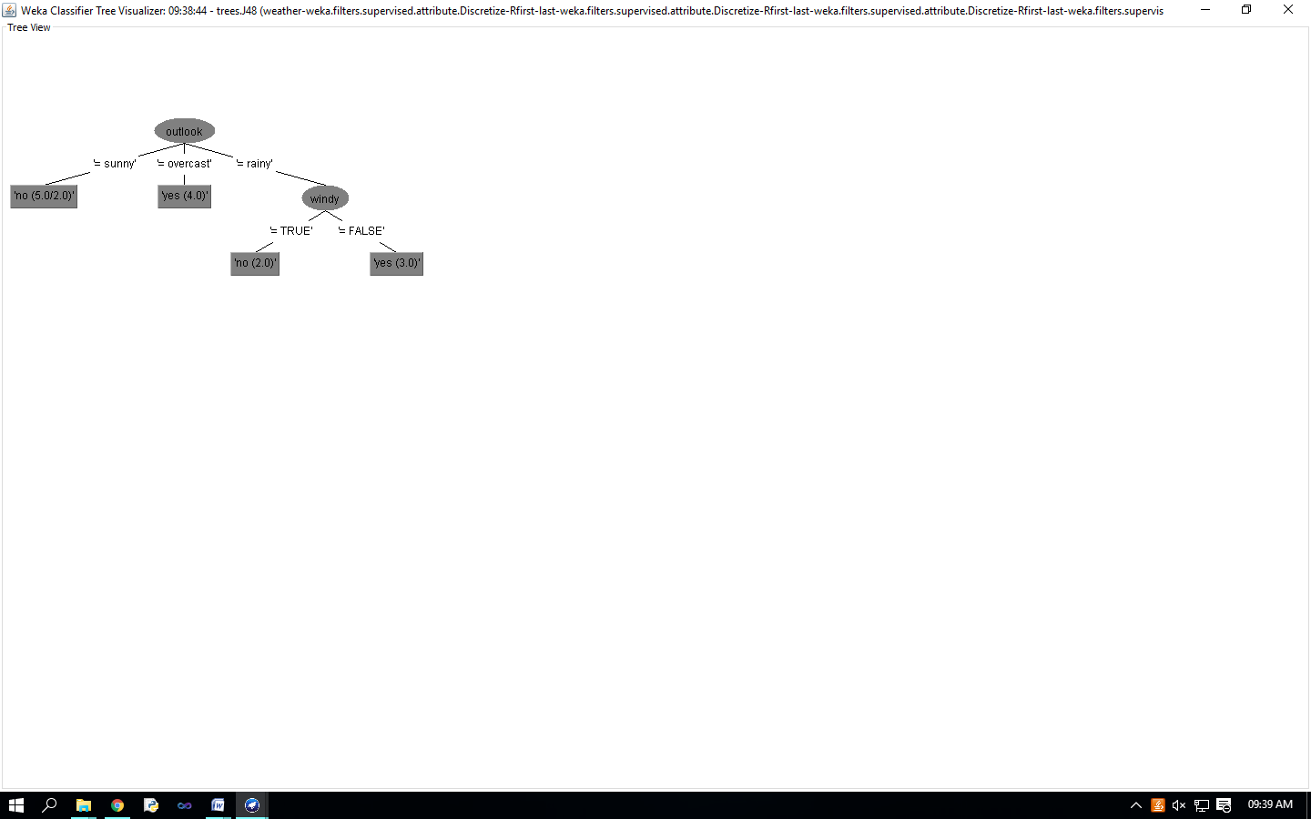 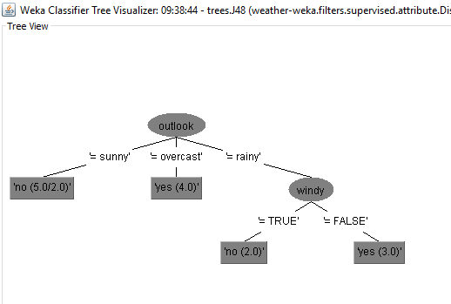

To visualize classification errors. Right-click on the entry in ‘Result list’ again and select ‘Visualize classifier errors’ from the menu: 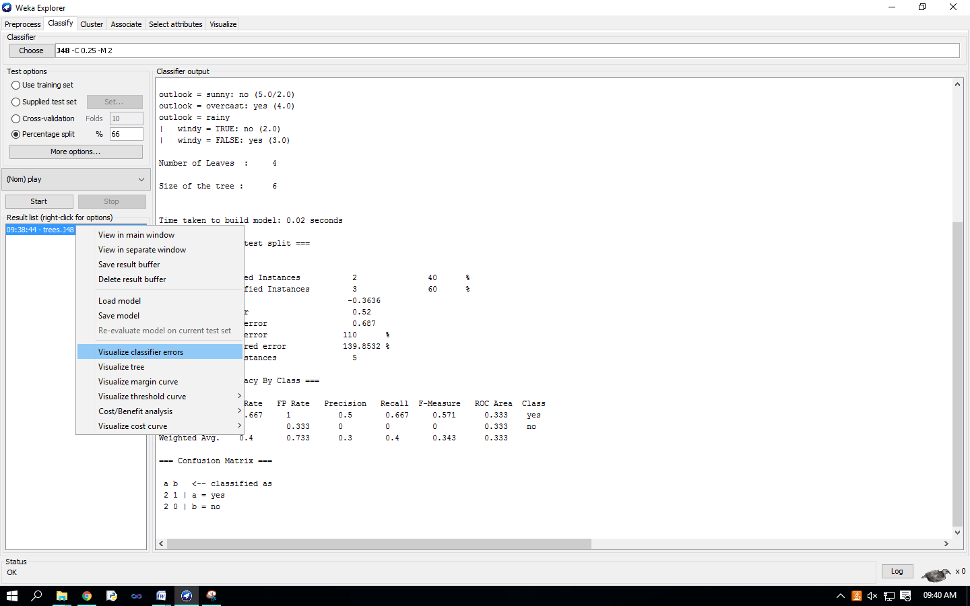 Visualize’ window displaying graph appears on the screen. 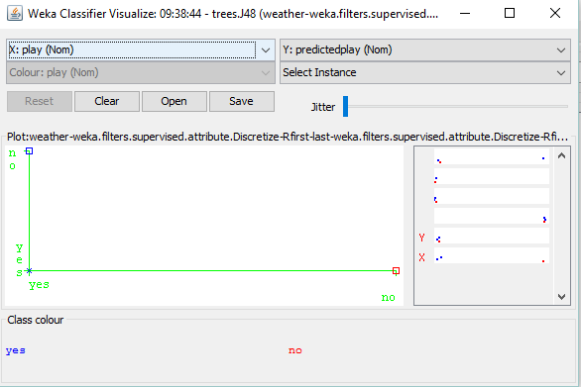 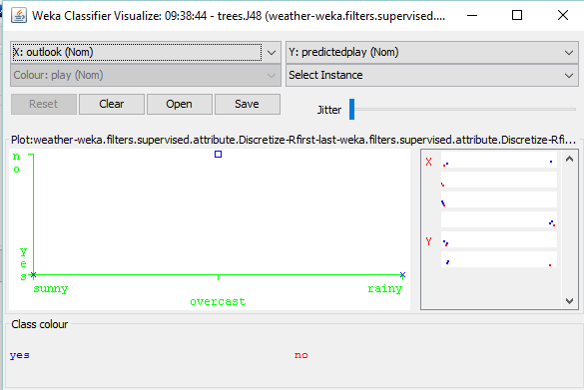

**Practical No - 12**

**Aim** : Clustering Analysis.

**Solution** : we will use customer data [6] that is contained in “customers.arff” file and analyze it with k-means clustering scheme.

We have to create excel file

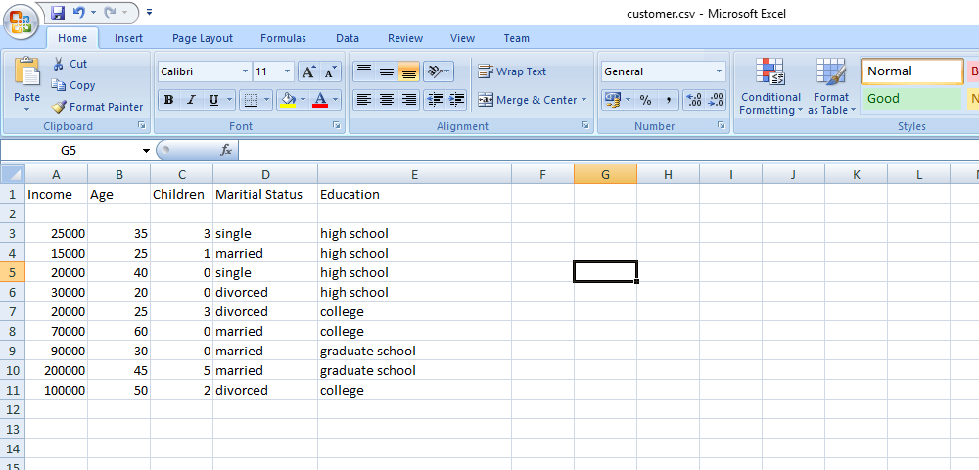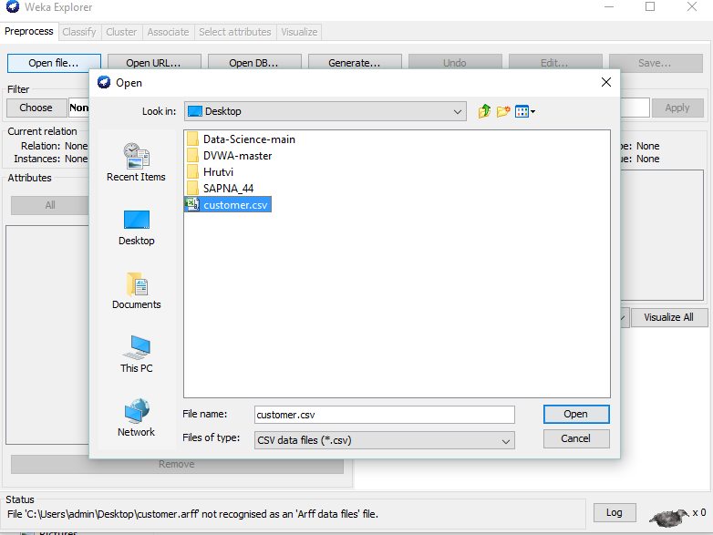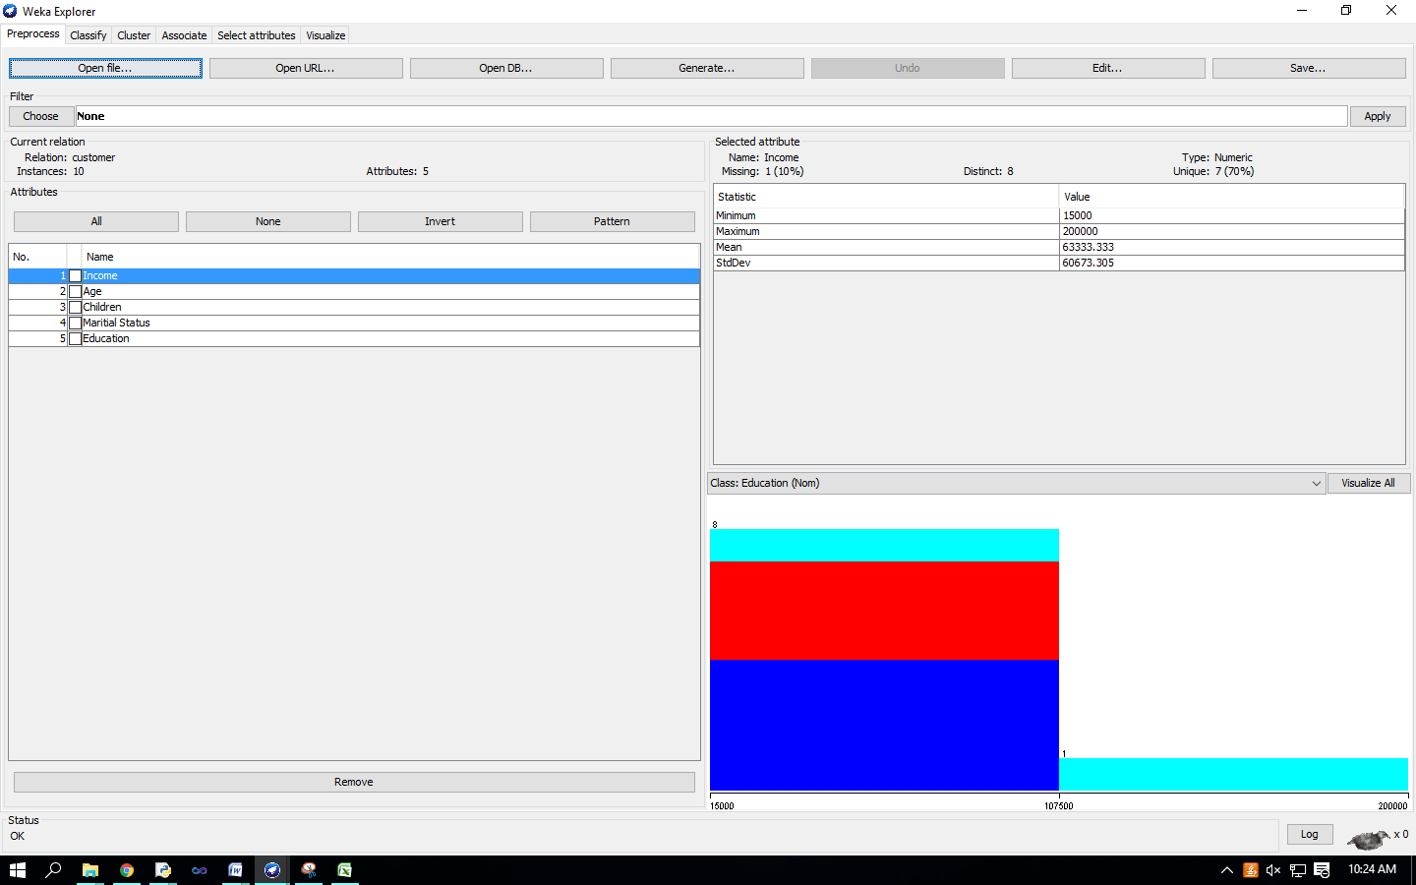 In ‘Preprocess’ window click on ‘Open file…’ button and select “customers.arff” file. Click ‘Cluster’ tab at the top of WEKA Explorer window.

In the ‘Clusterer’ box click on ‘Choose’ button. In pull-down menu select WEKA   Clusterers, and select the cluster scheme ‘SimpleKMeans’. Some implementations of K-means only allow numerical values for attributes. 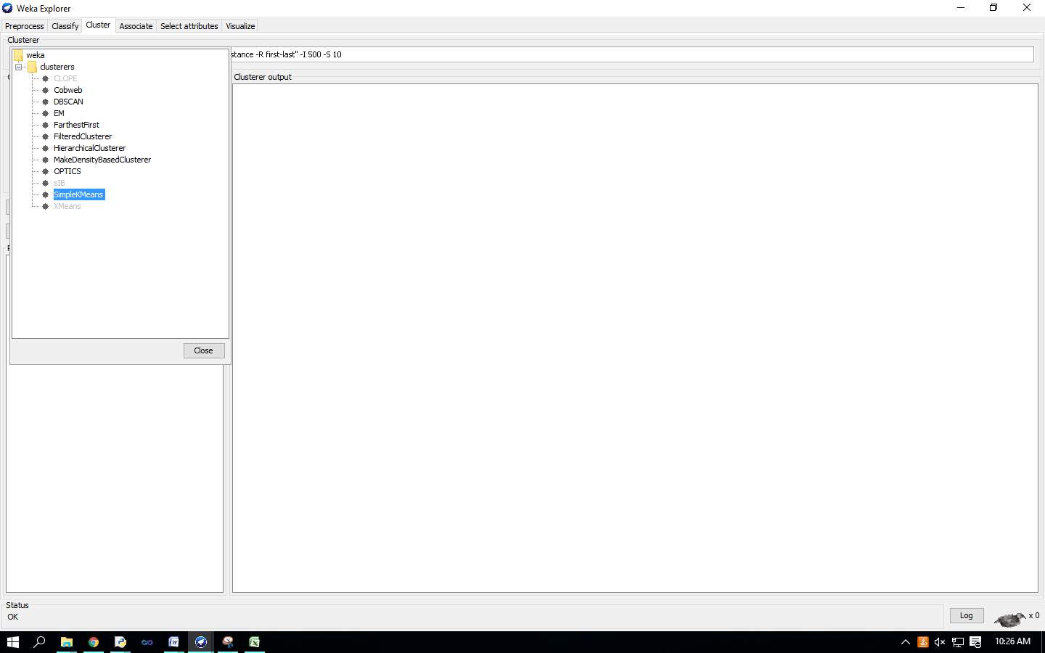 right-click on the algorithm “weak.gui.GenericObjectEditor” comes up to the screen. Set the value in “numClusters” box to 5(instead of default 2) because you have five clusters in your .arff file.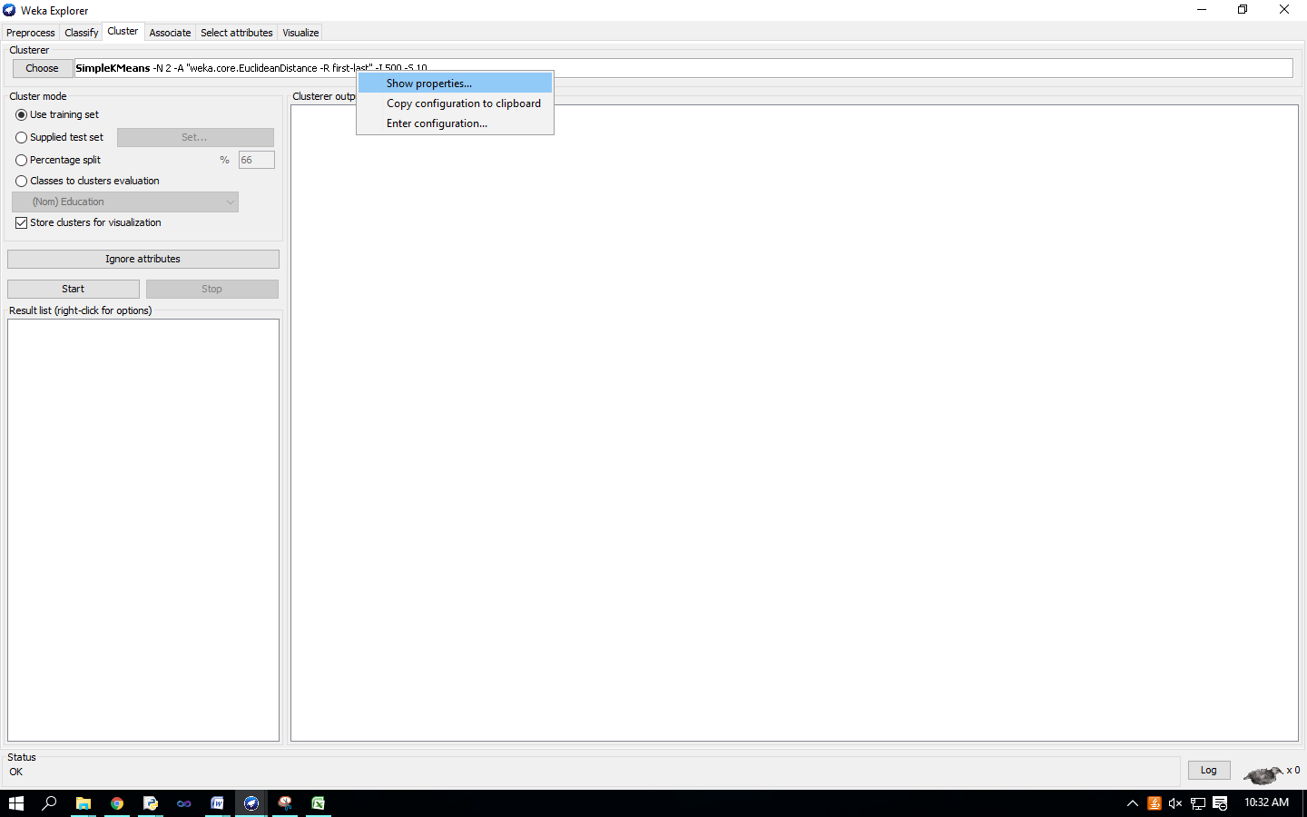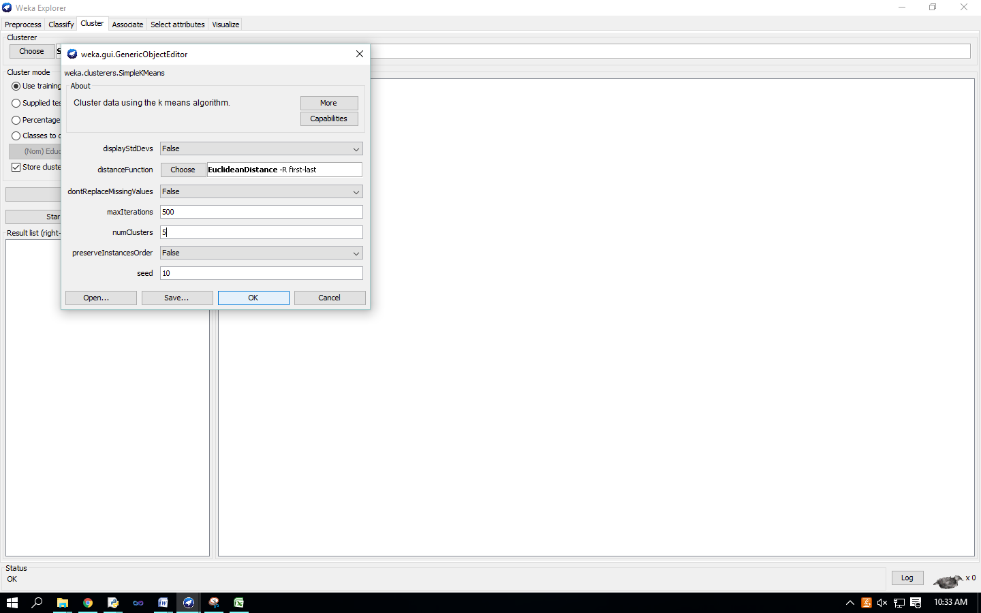 Click on ‘Classes to cluster evaluation’ radio-button in ‘Cluster mode’ box and select ‘marital_status’ in the pull-down box below. 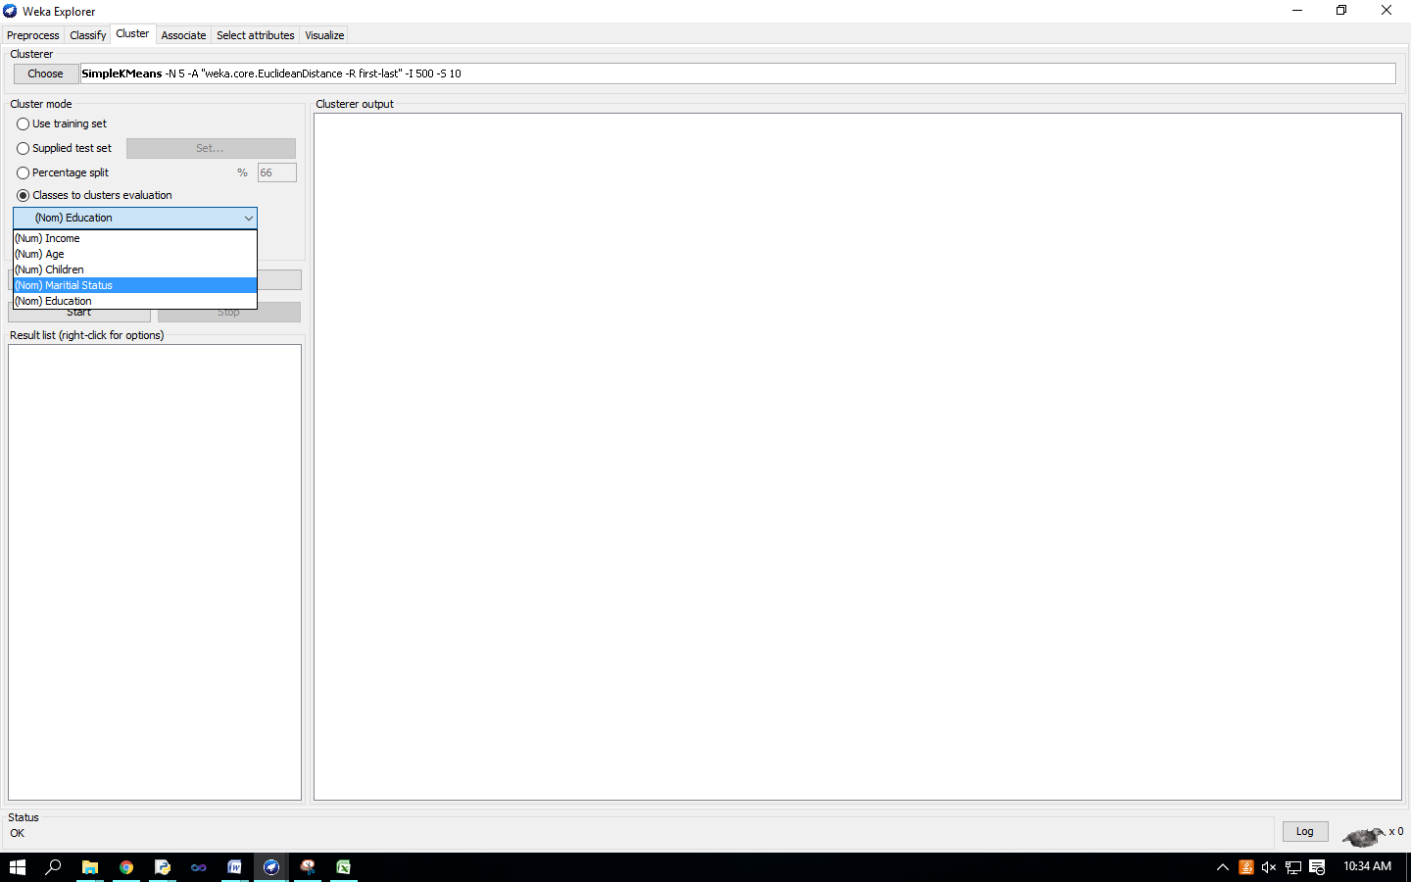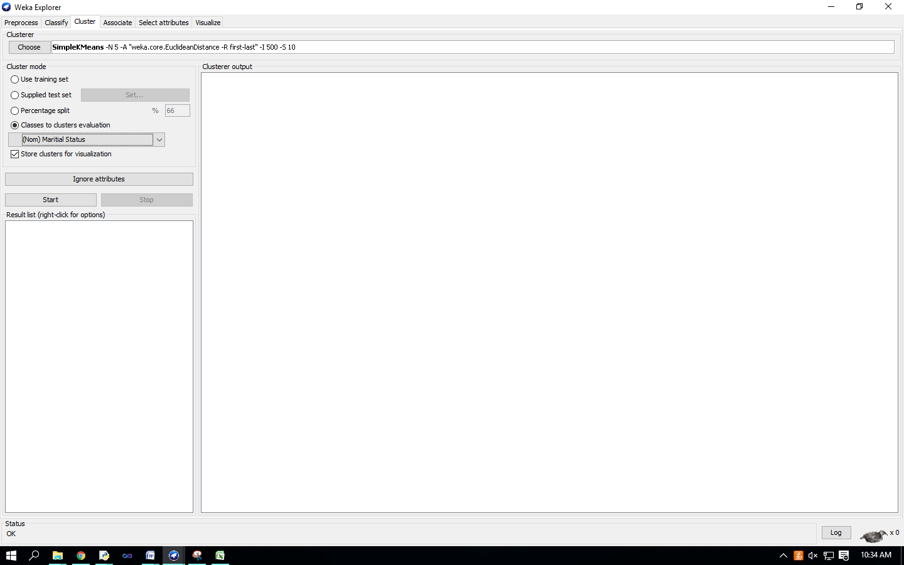 Click on the ‘Start’ button to execute the algorithm. 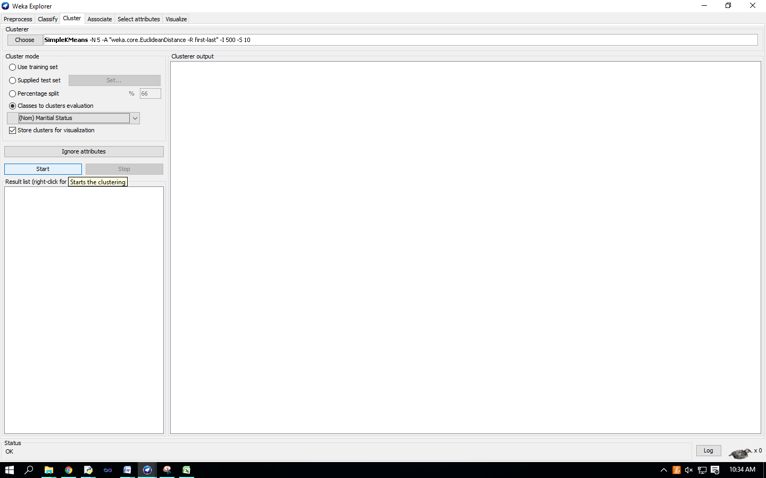

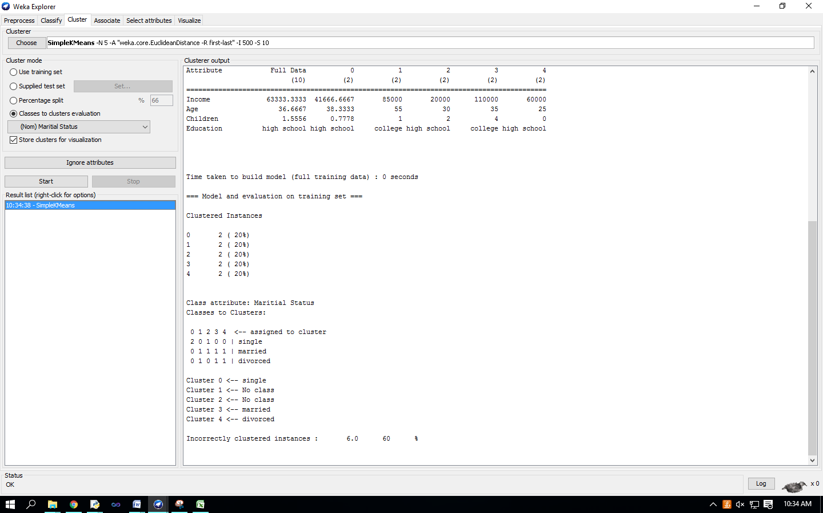

Right-click on the entry in the ‘Result list’ and select ‘Visualize cluster assignments’ in the pull-down window. 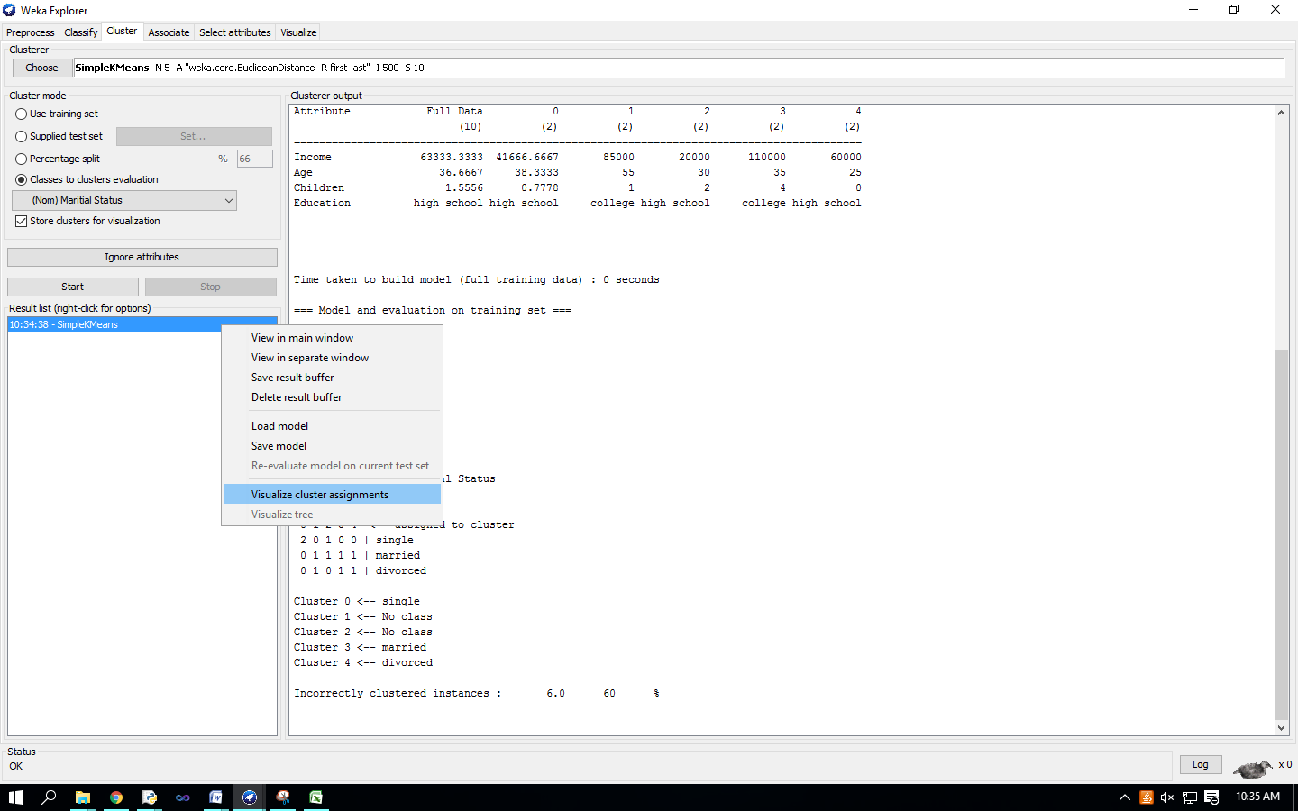 ‘Weka Clusterer Visualize’ window.

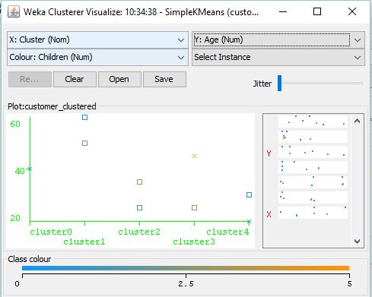

**Practical No-13**

**Aim** : Association Rule Mining.

**Solution** : Choosing Association Scheme Click ‘Associate’ tab at the top of ‘WEKA Explorer’ window. It brings up interface for the Apriori algorithm. 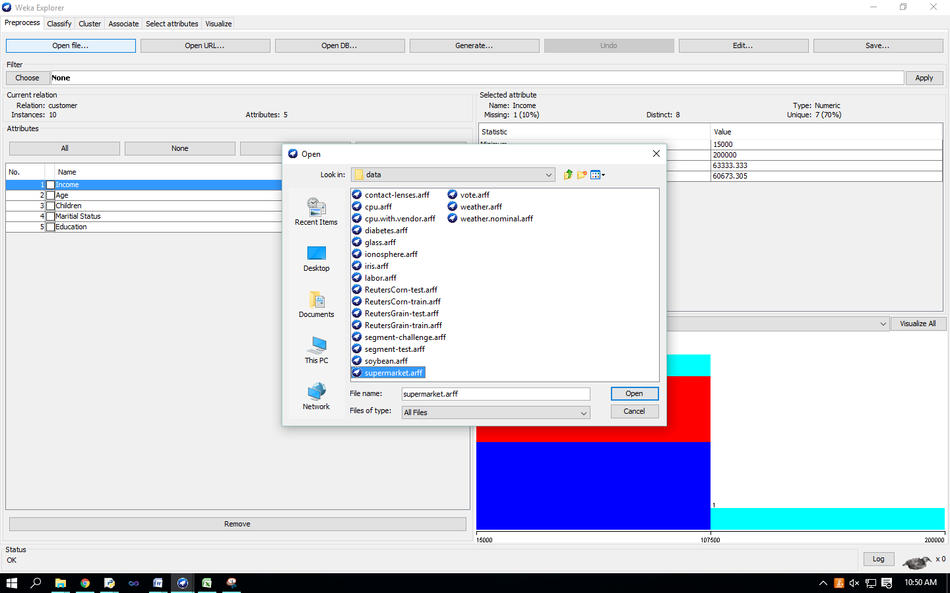

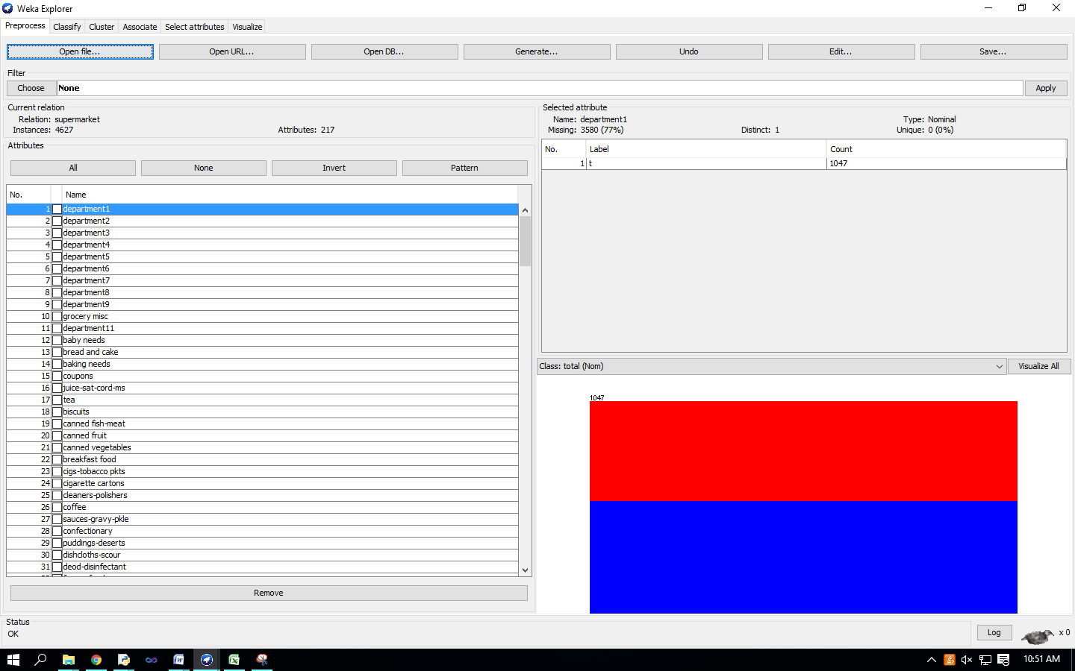 Setting Test Options

Check the text field in the ‘Associator’ box at the top of the window

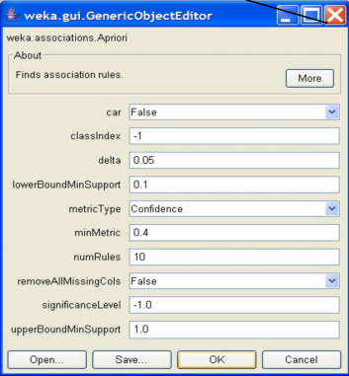

Right-click on the ‘Associator’ box, ‘GenericObjectEditor’ appears on your screen Click on the ‘Start’ button to execute the algorithm