Assignment – Day2

# Git

### Configured vimdiff as merge tool

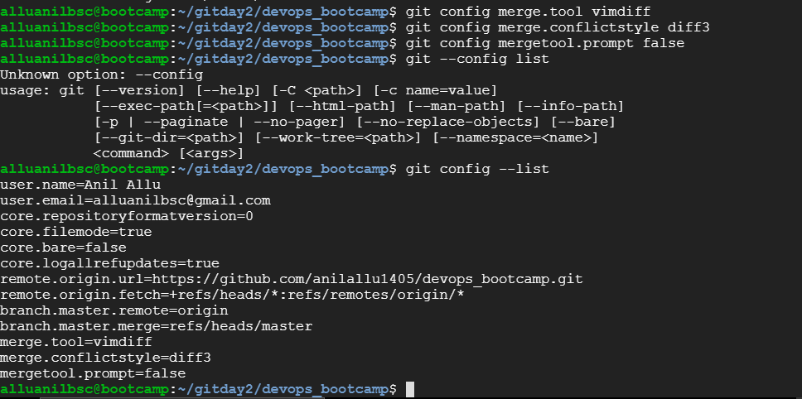

### Created 2 separate branches from master

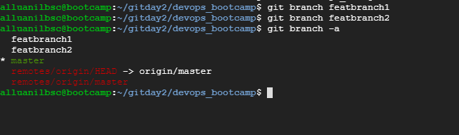

### Merged branch1 into master & tried merging branch 2 into master(merge conflict arised)

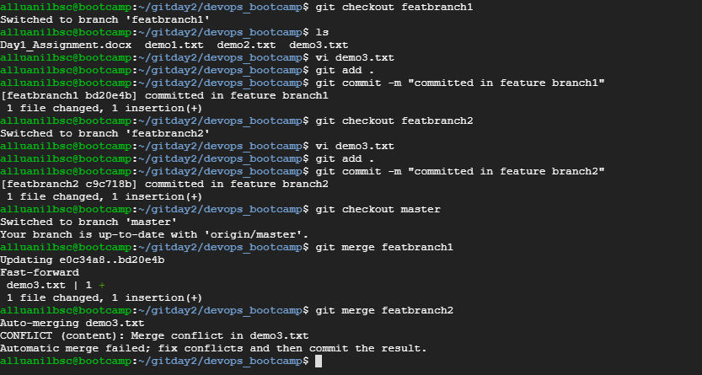

### Merging using vimdiff merge tool

Vimdiff gui after executing “git mergetool” command

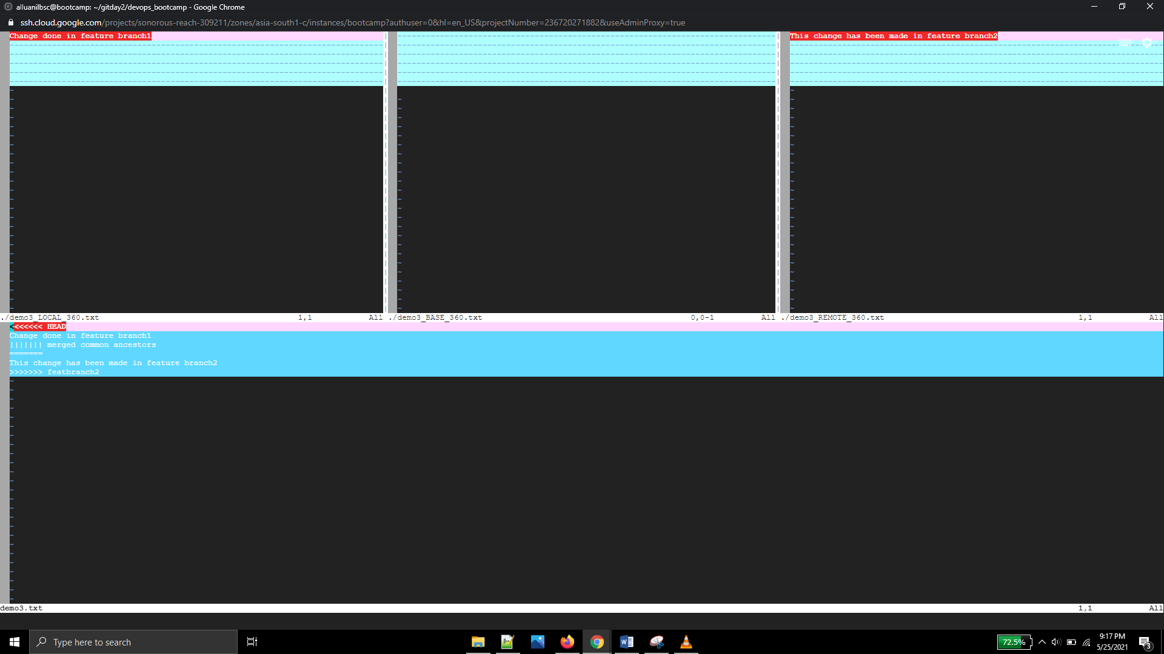

### Resolving merge conflict

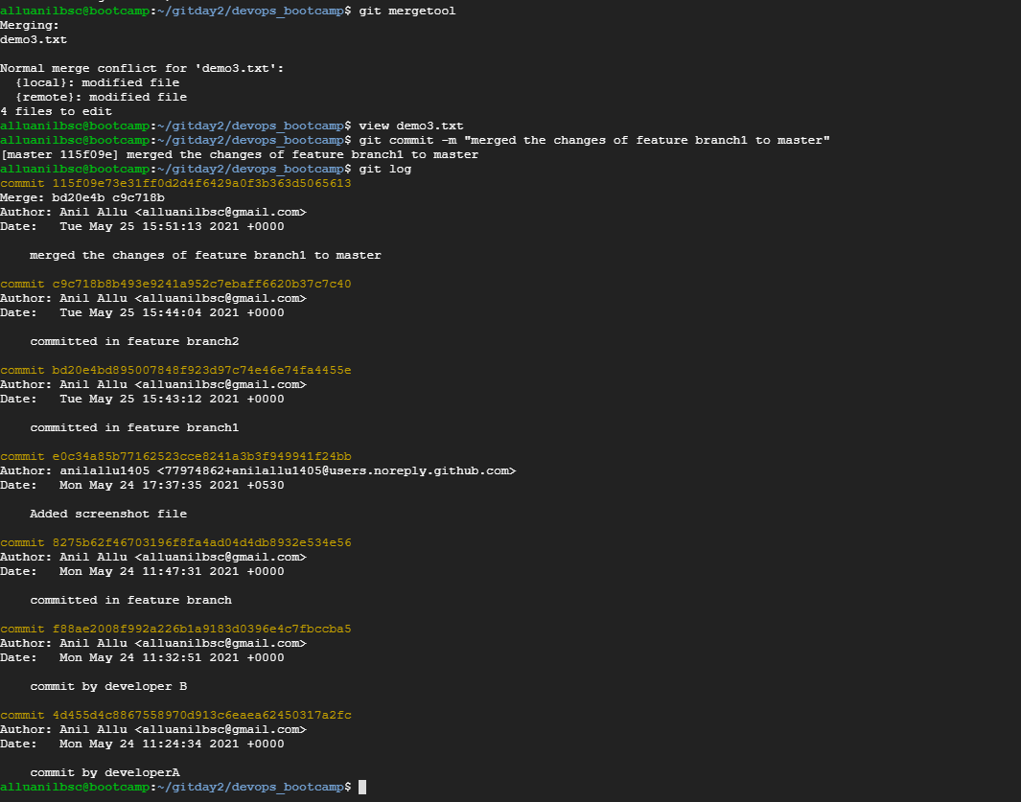

# Jenkins

### Jenkins, Maven and tomcat installation

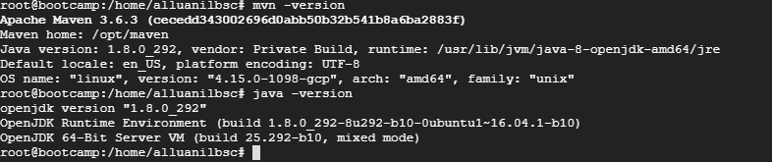

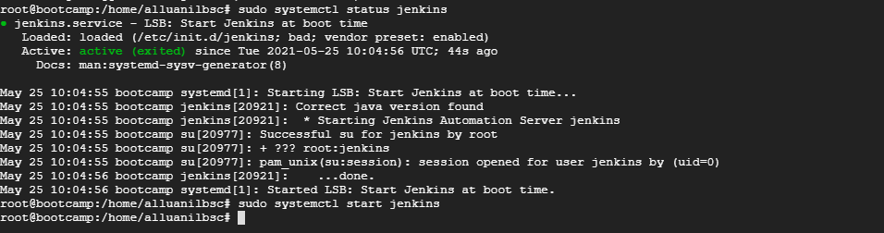

After setting up Jenkins, installed deploy to container plugin

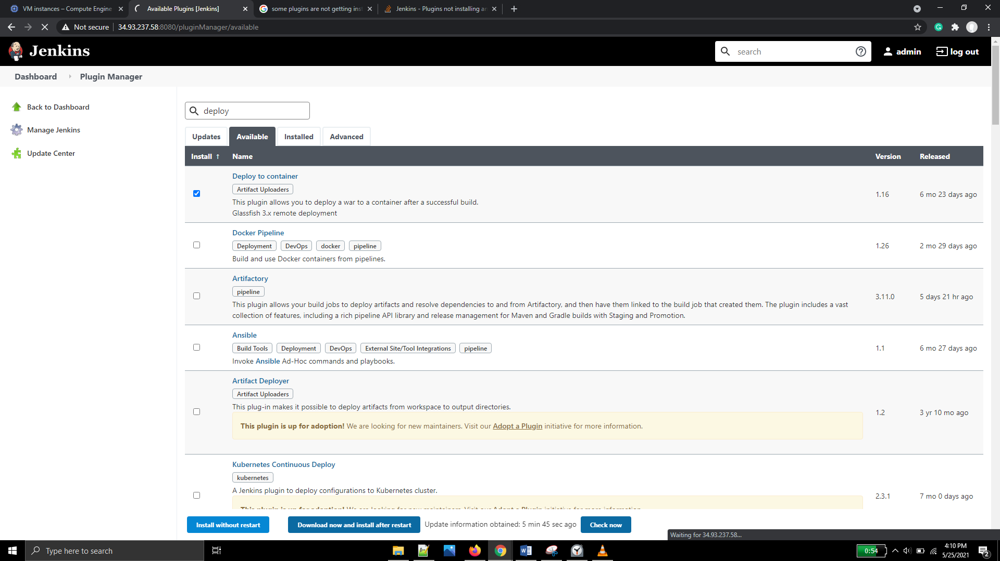

Installed tomcat8 (as few issues were faced during installation in GCP Ubuntu 18.04 instance)

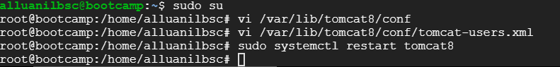

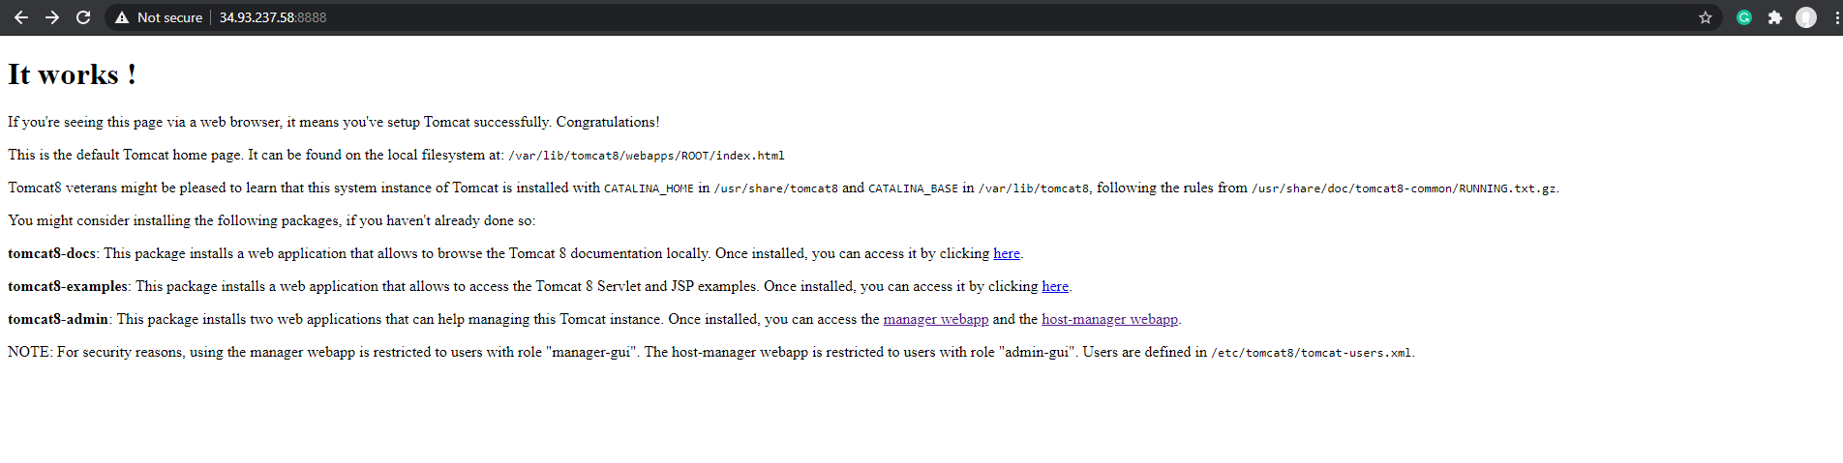

### Created 3 projects – Code checkout, compile and test, deploy

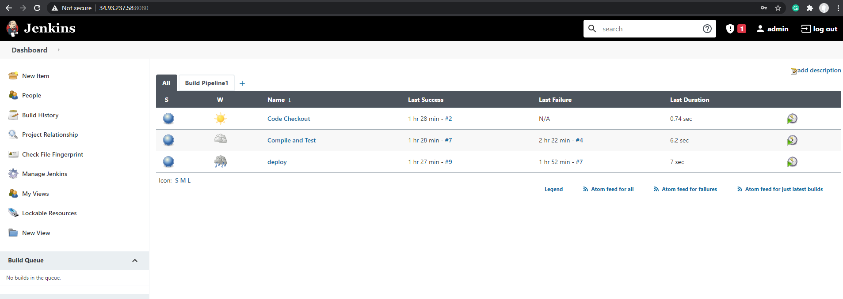

Output of Code checkout

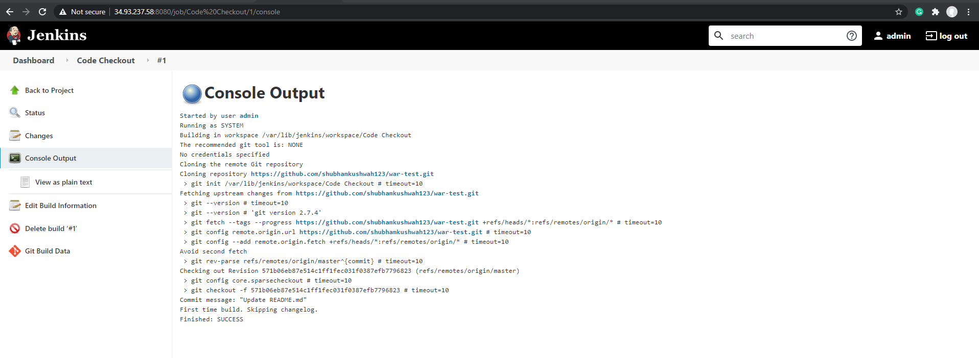

Output of Compile and test

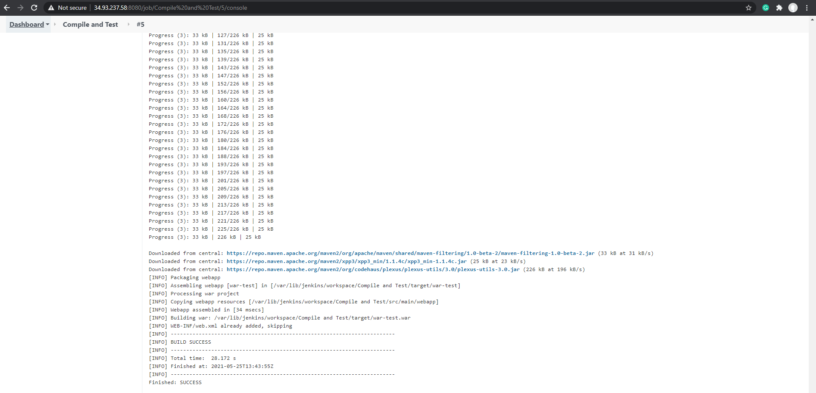

Output of deploy project

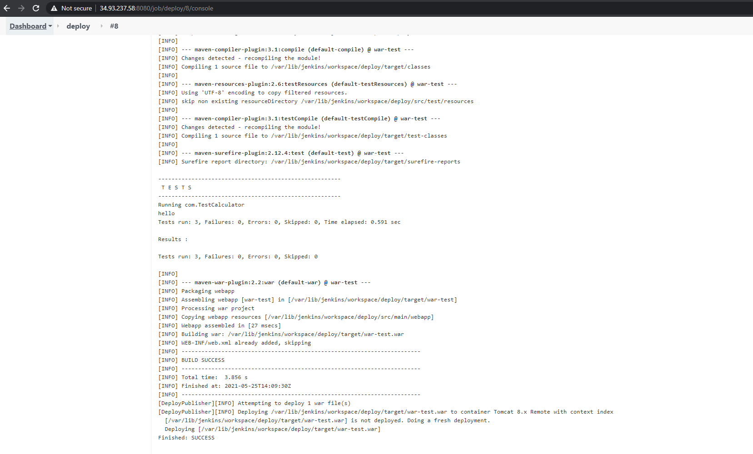

Tomcat page after completion of deploy job

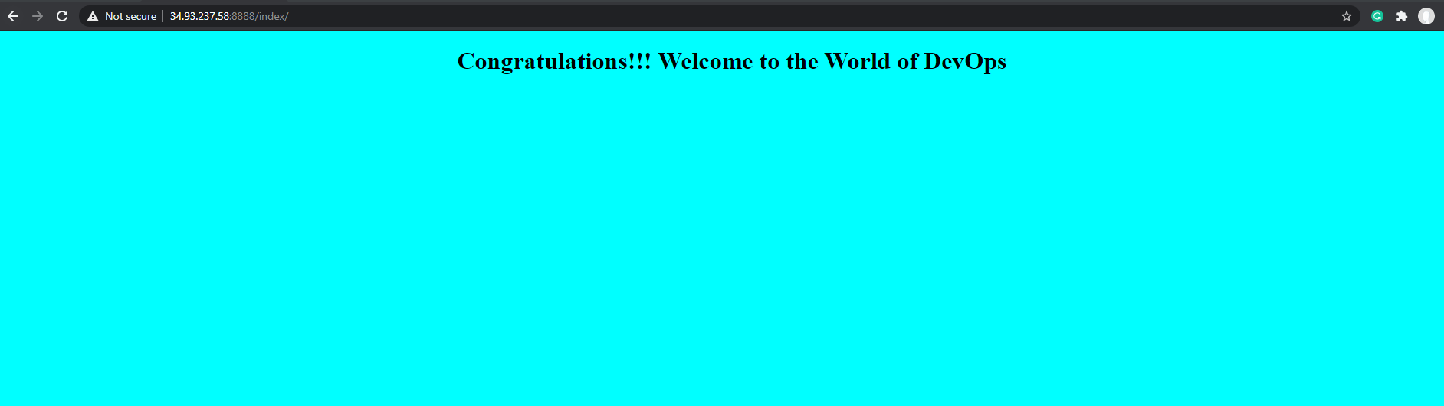

### Creating a pipeline view

Installing the Build pipeline plugin

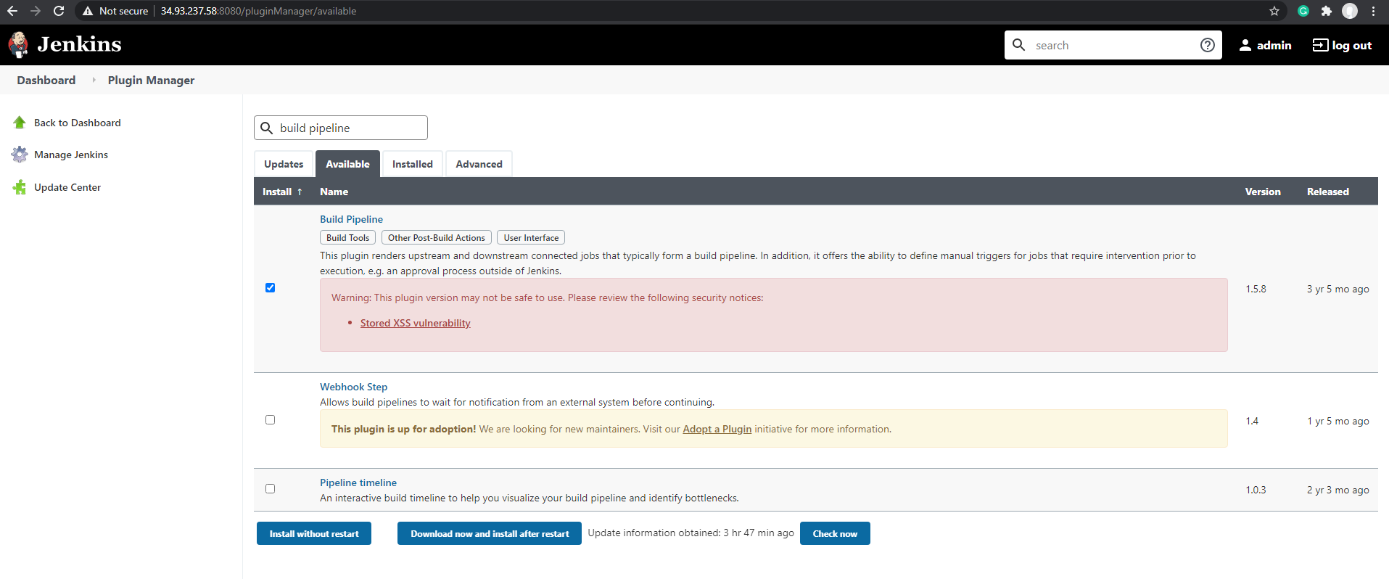

Modify the 2nd and 3rd job for pipeline creation

Added “Code checkout” project as Projects to Watch in Build Triggers for `Compile and test` project

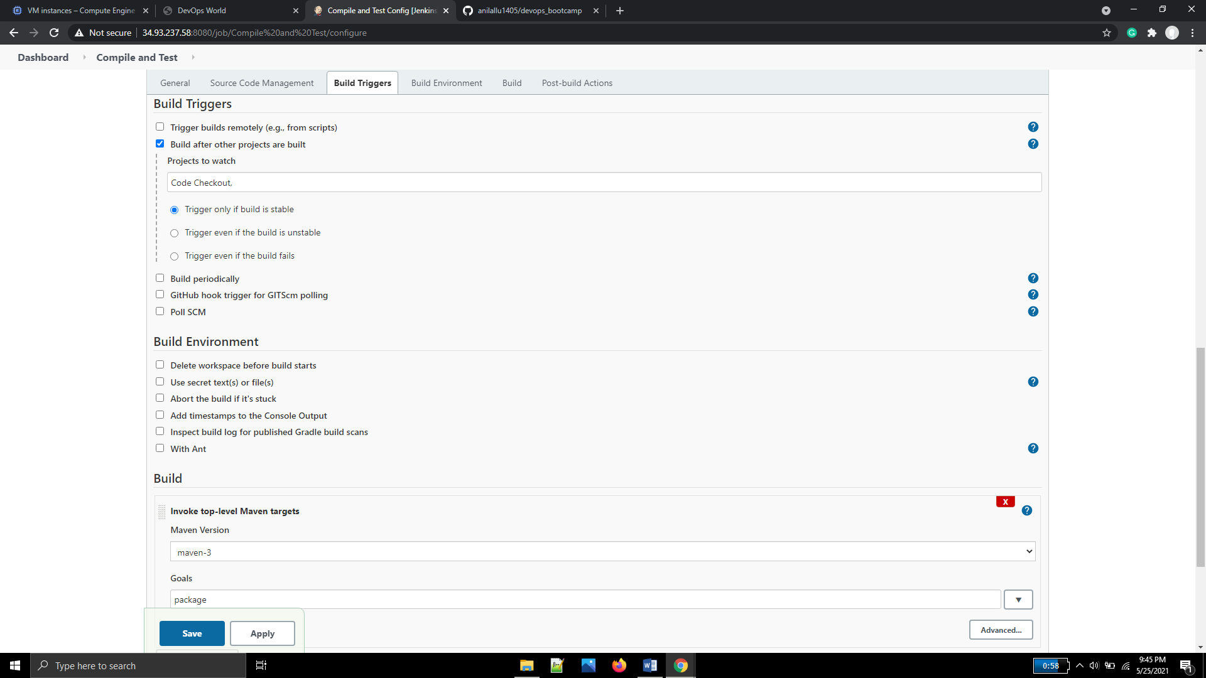

Added “Compile and test” project as Projects to Watch in Build Triggers for ` Deploy Project` project

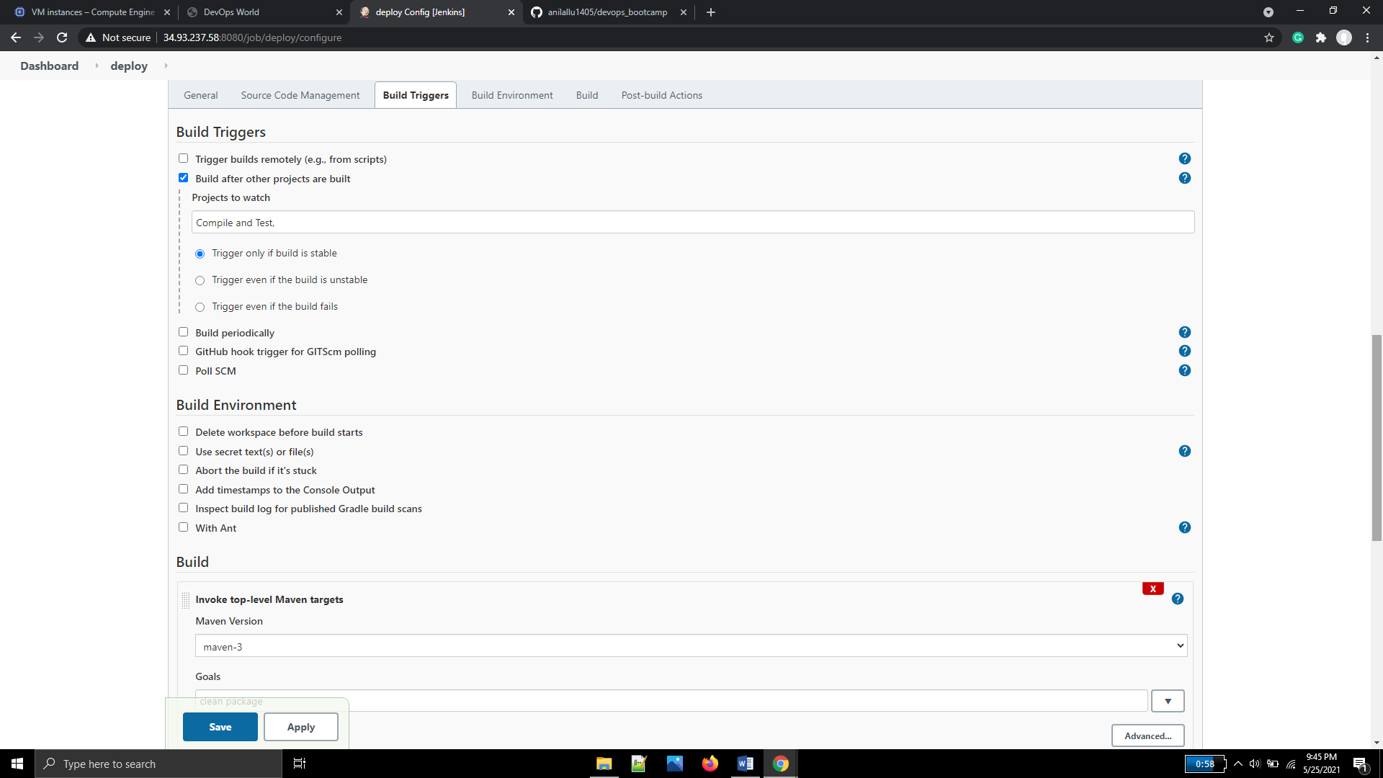

Changed the context path to index1

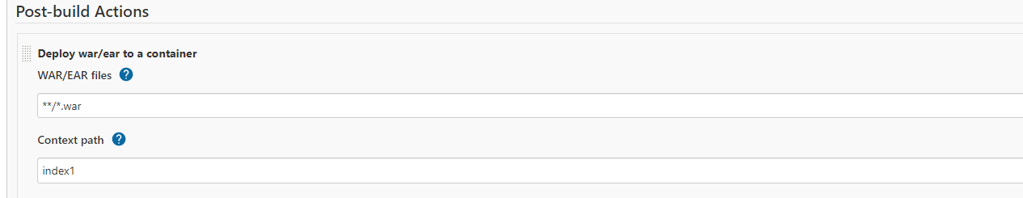

Running the pipeline

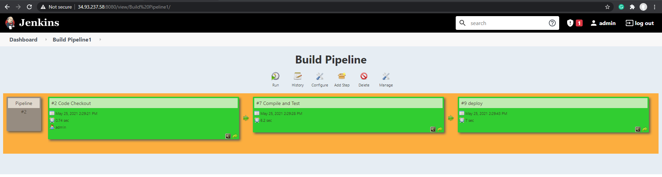

### Console output of each execution of job after pipeline

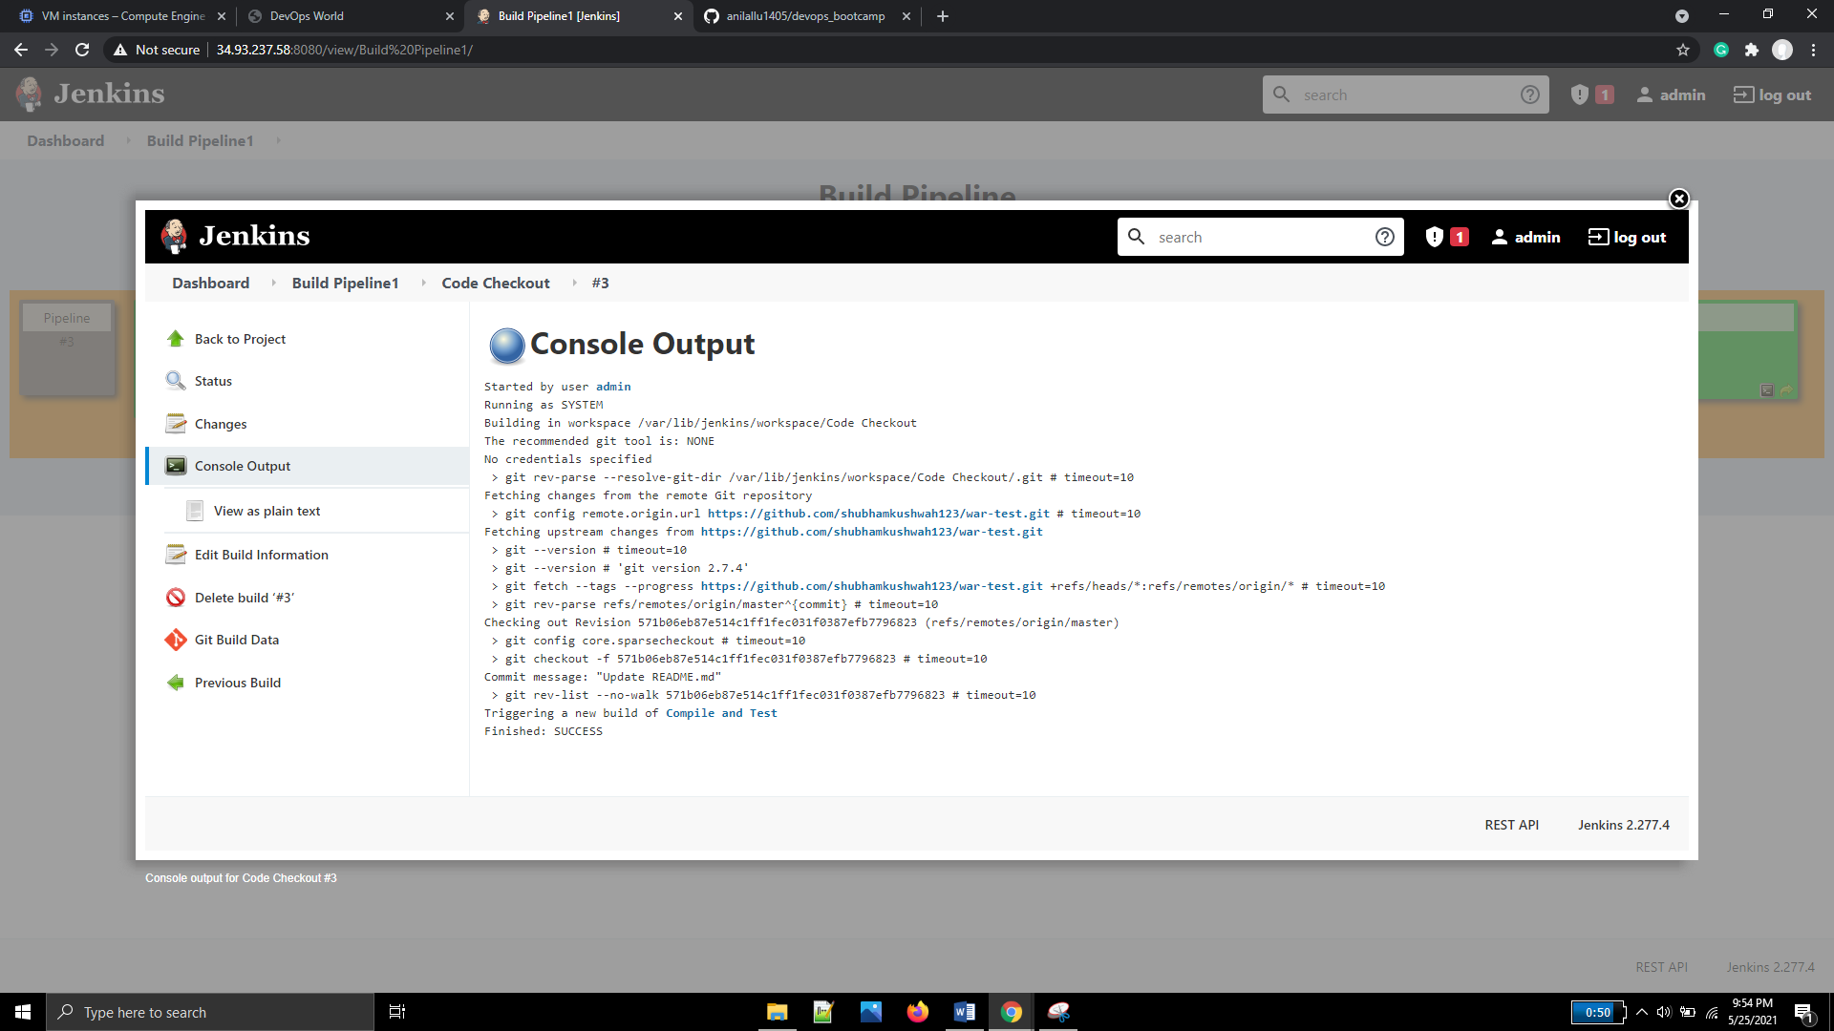

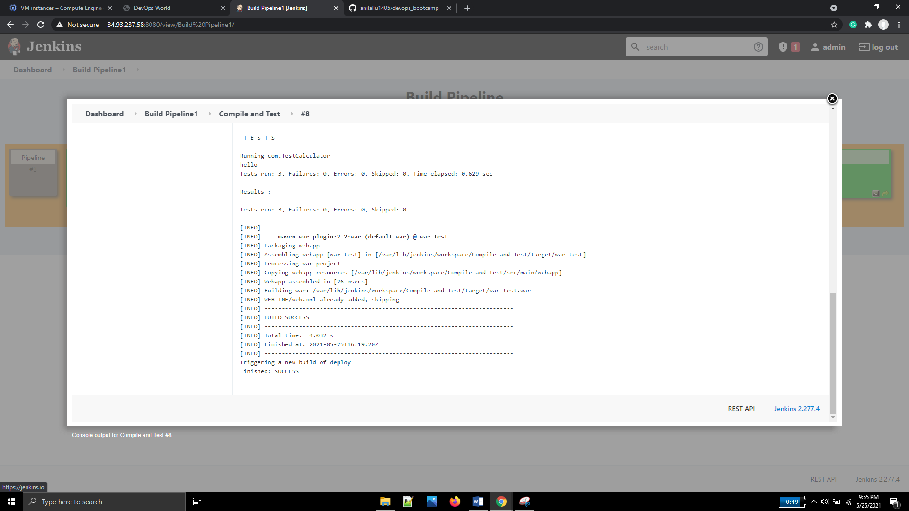

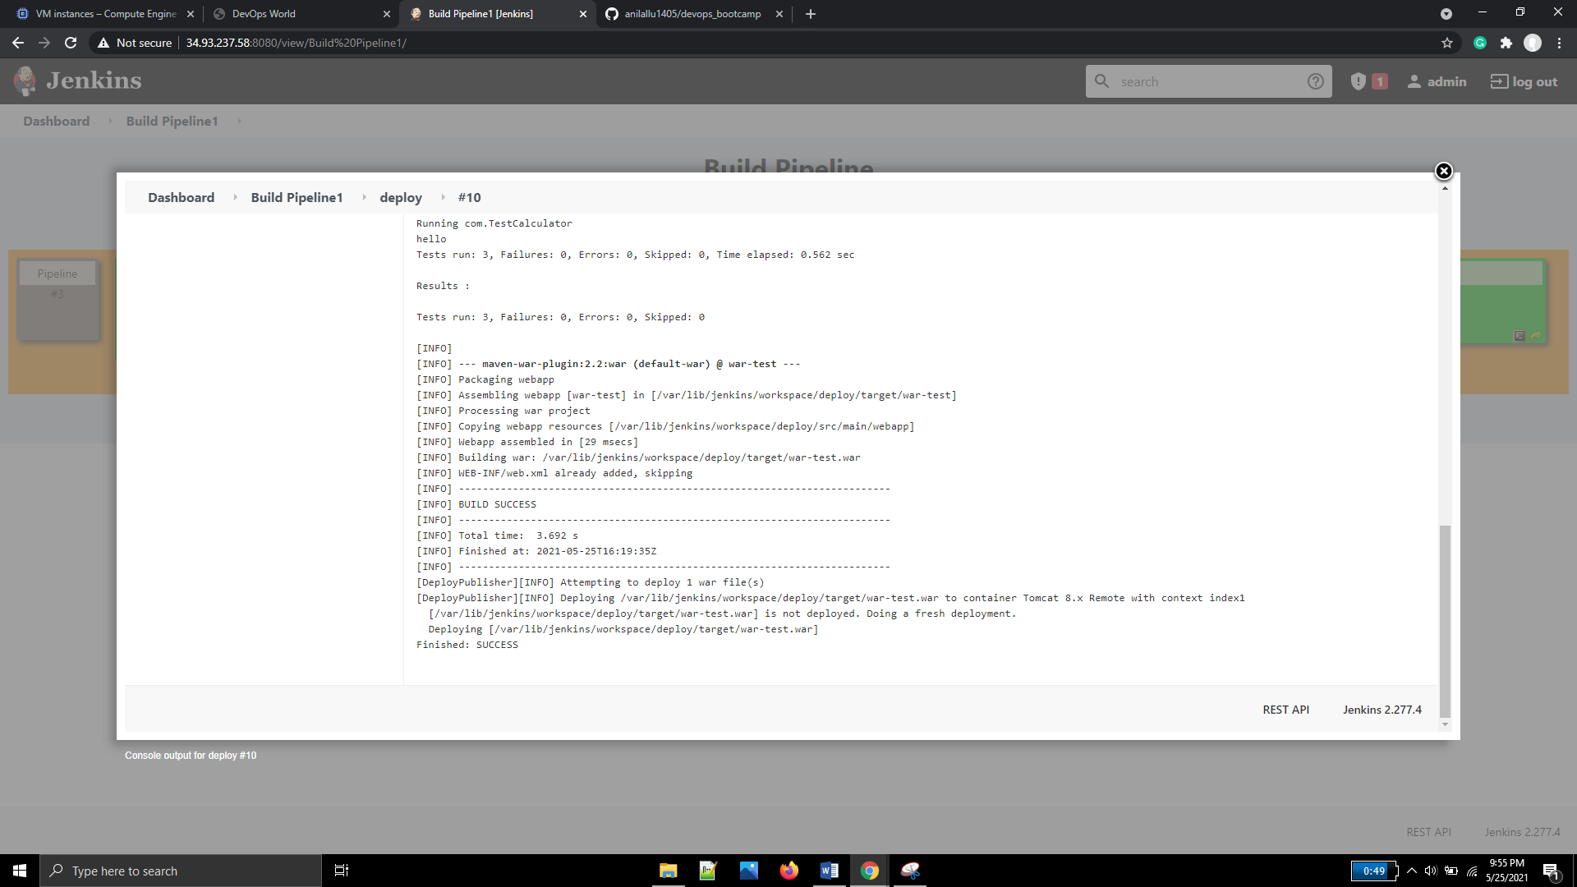

After building the pipeline (tomcat index1 context page)

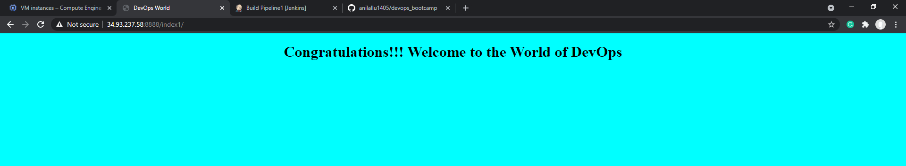

### Configured maven in Global tool configuration

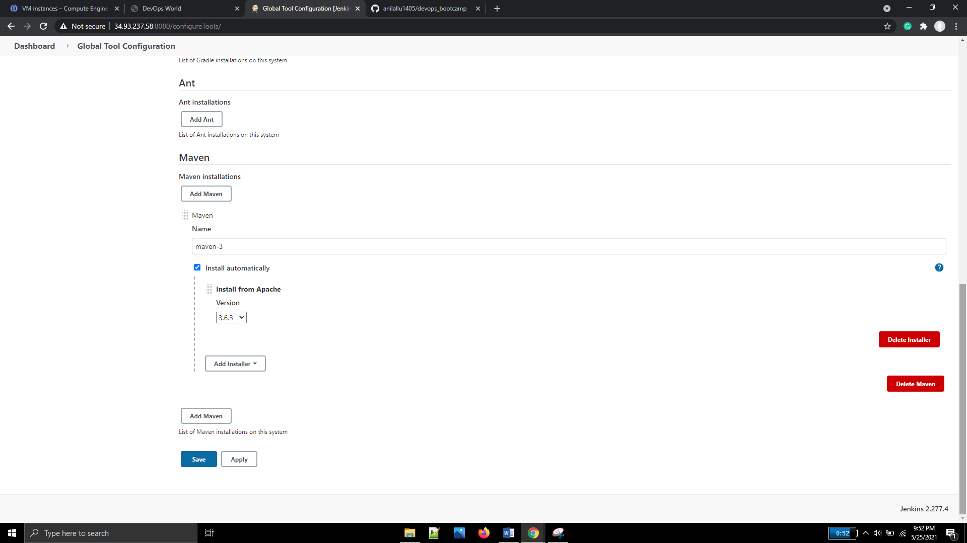

### Pipeline job with scripts & GitHub webhook

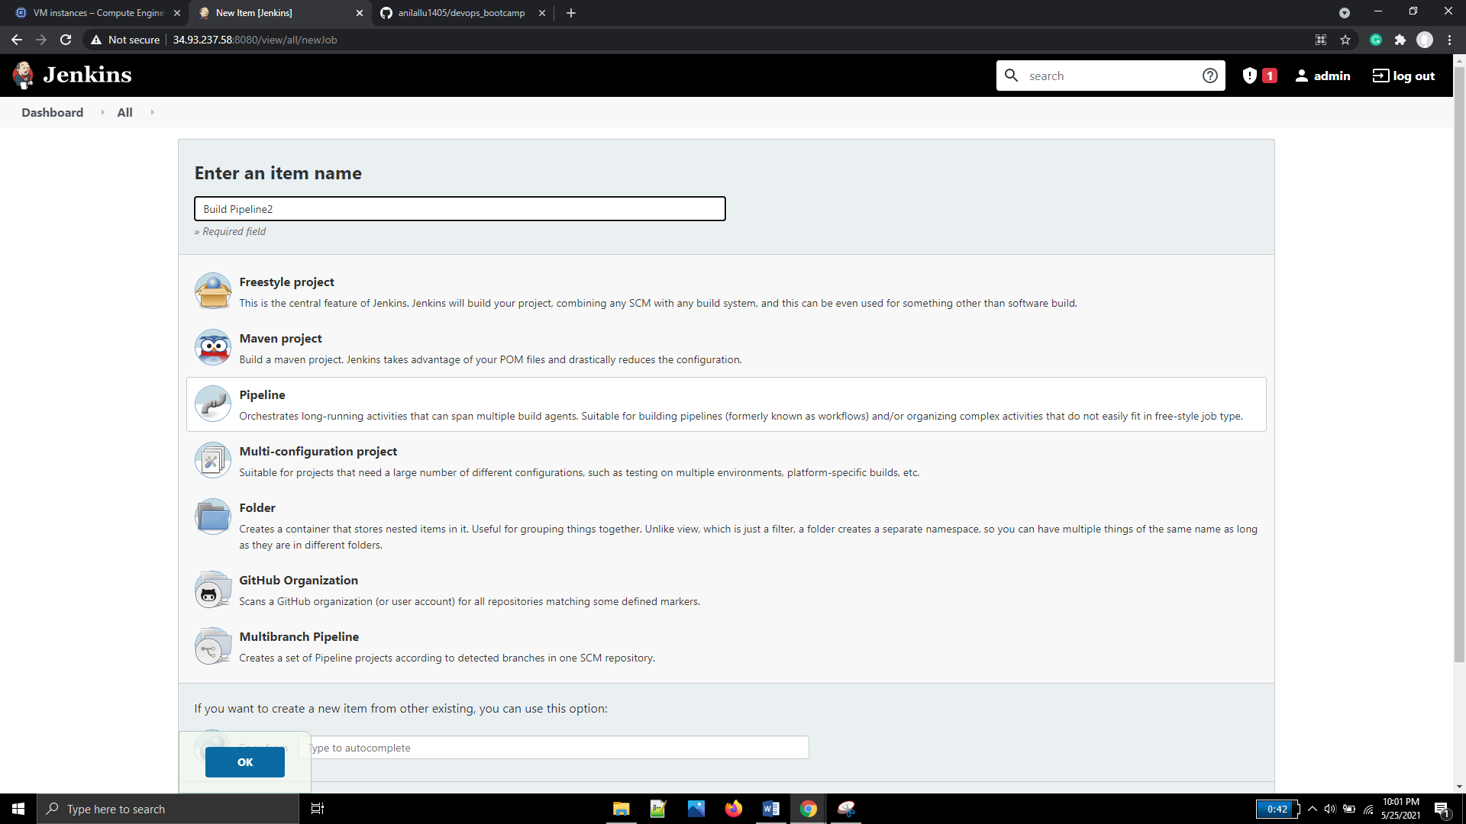

Generated pipeline script for deploy step(with tomcat8)

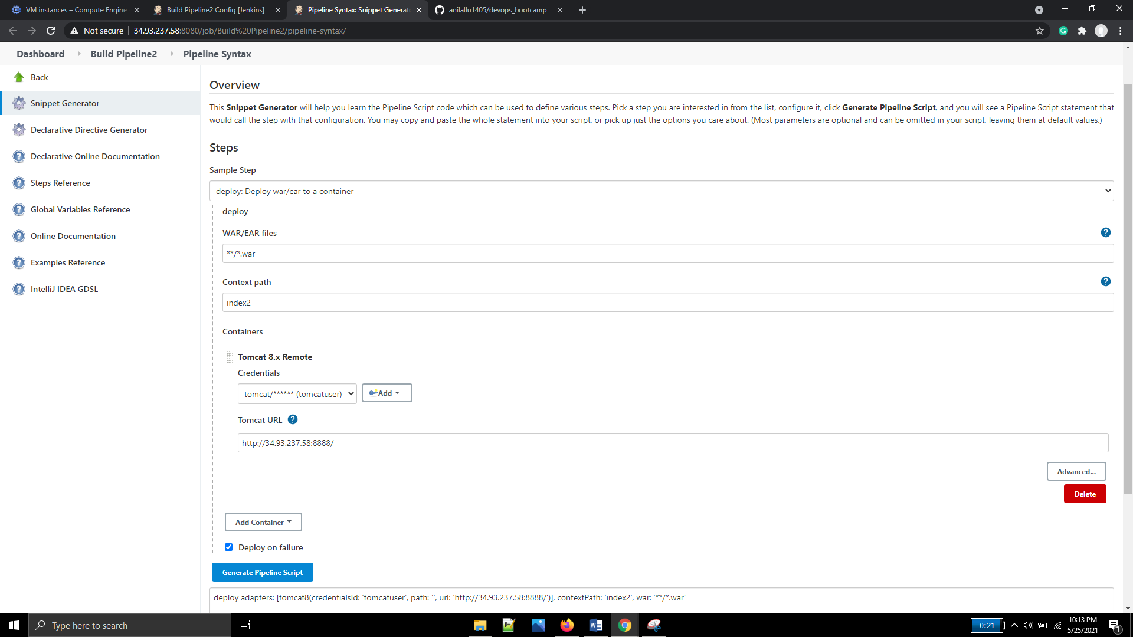

Updated the script in pipeline2 job

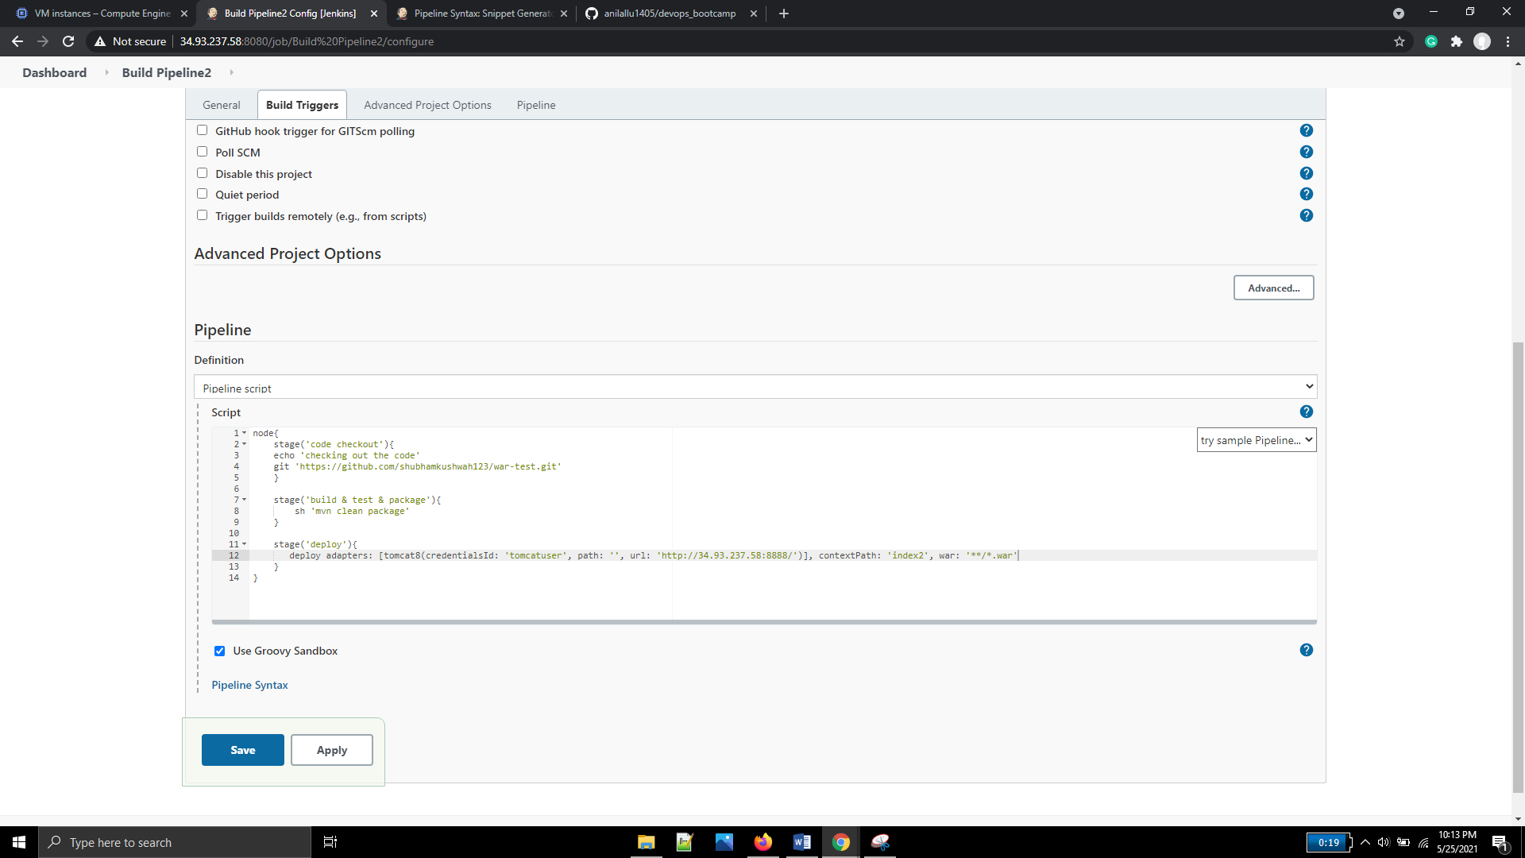

Output of pipeline2 job (with groovy script)

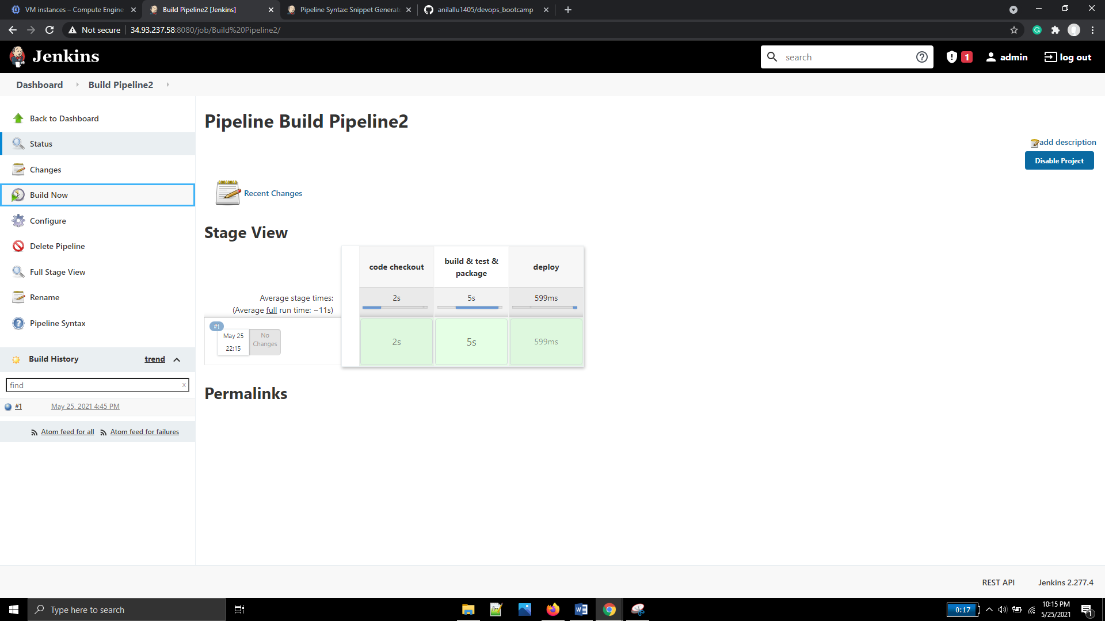

Tomcat page(context: index2)

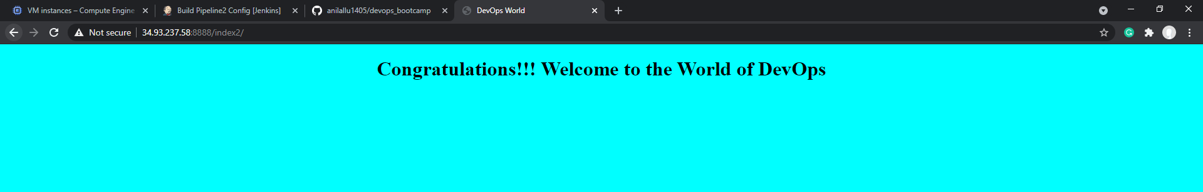

### Github webhook configuration

Created a new job to test pipeline using git webhook and configured the build triggers

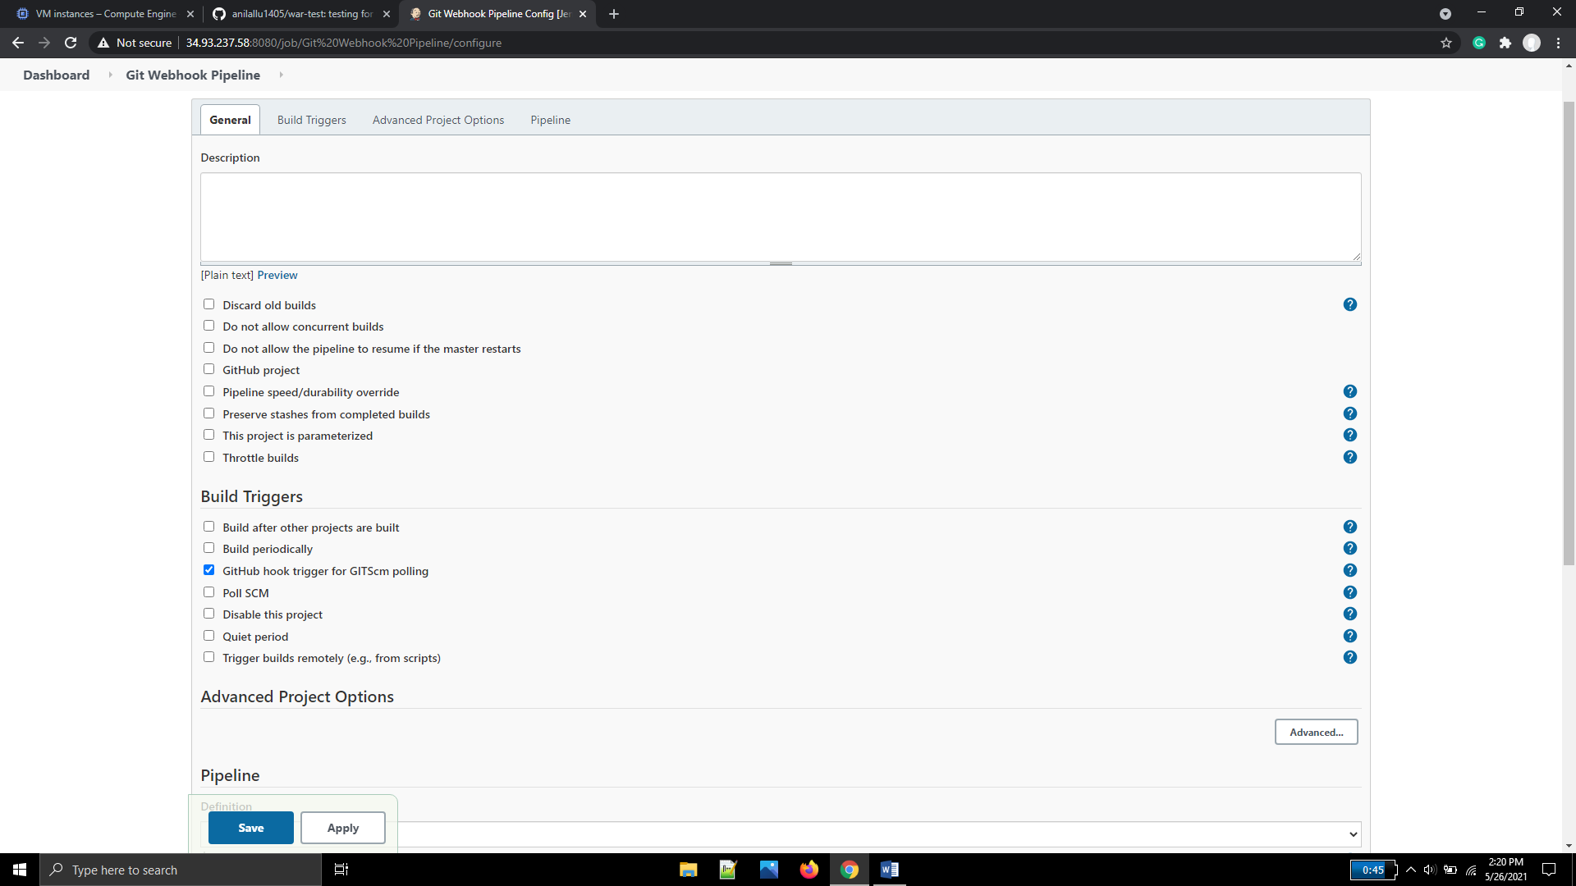

Forked the war-test project to github

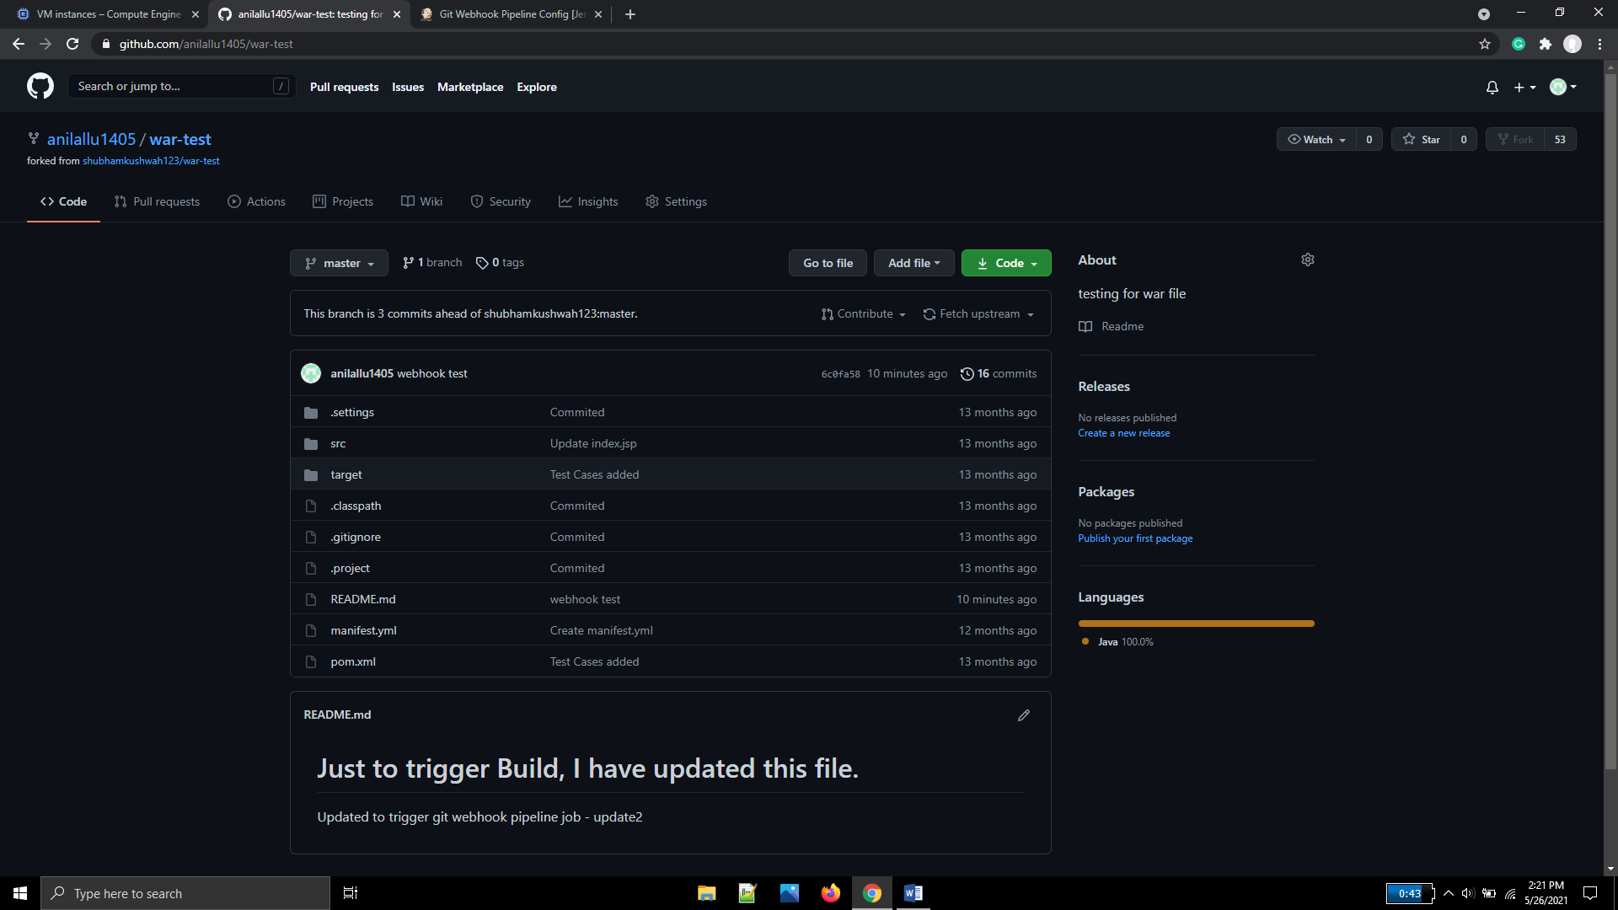

Configured git webhook with Jenkins url suffixing /github-webhook/

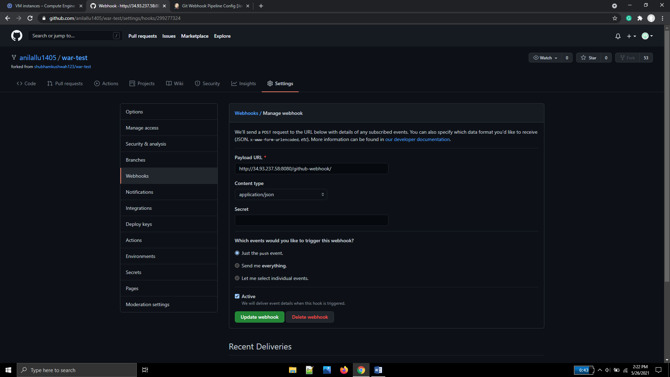

Edited Readme file and commited changes in the forked code. The pipleline job(with buildid #2) got triggered

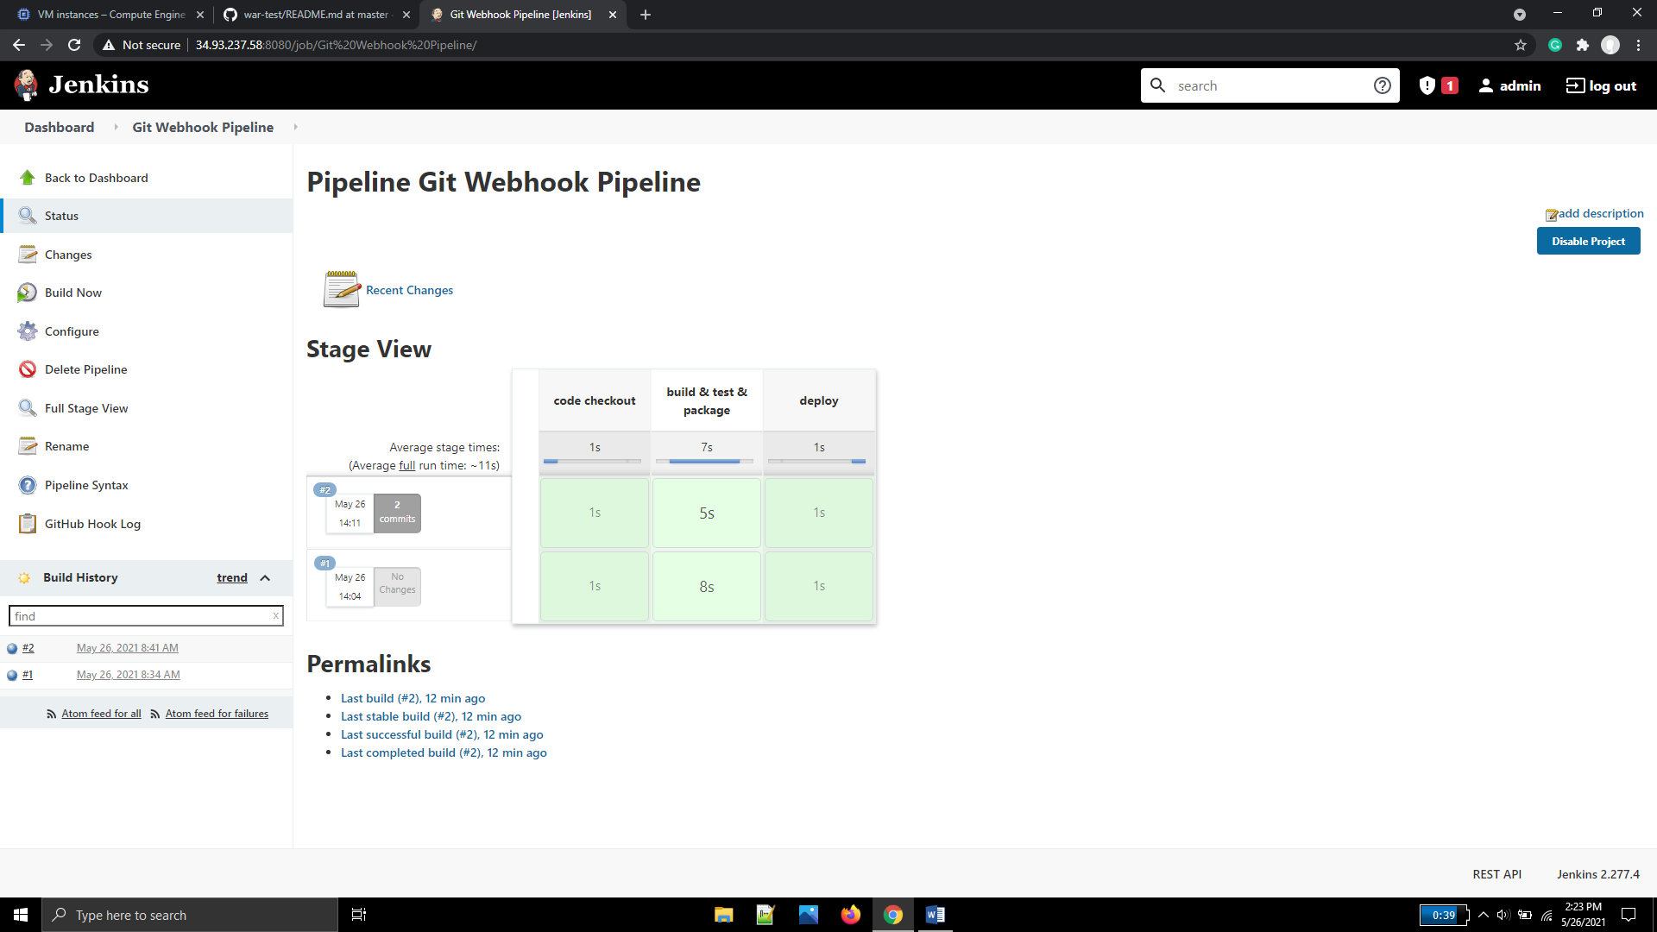

Tomcat index page (with context = index3) got loaded successfully

