## Docker image creation, push and pull to docker hub

Installed Docker and cloned the github project

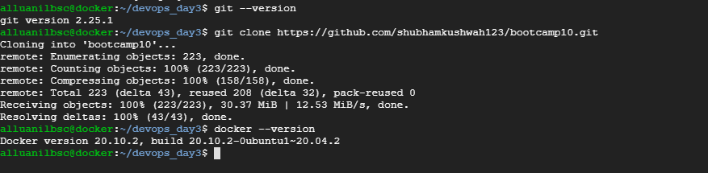

Copied the index.html file to another location and edited Dockerfile

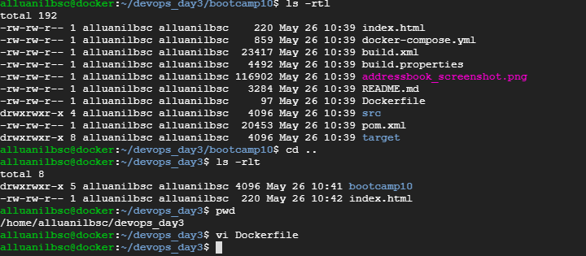

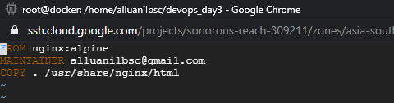

Building the docker image:

docker build -t alluanilbsc/my-docker-image:1.0 .

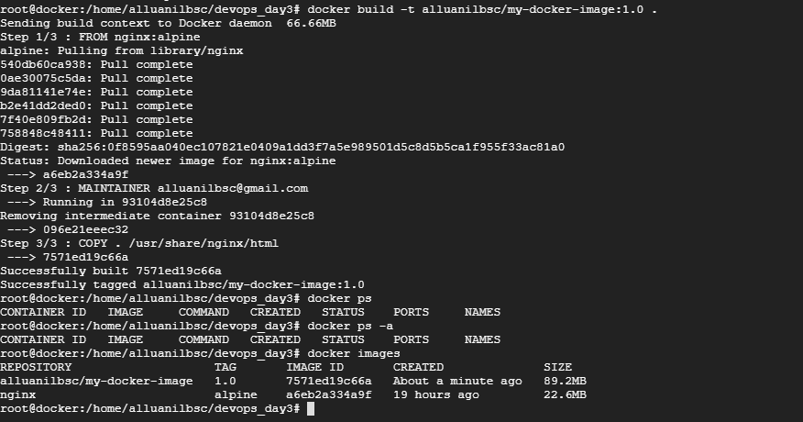

Running the docker image:

docker run -d -p 80:80 alluanilbsc/my-docker-image:1.0

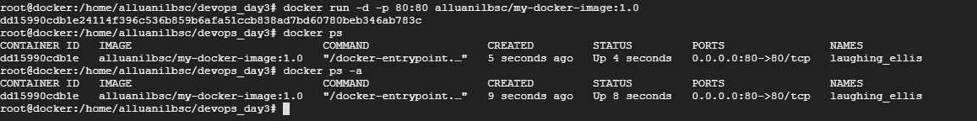

Static page opened after running nginx in browser with port 80

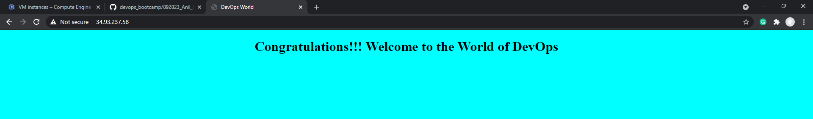

Pushing the image to docker hub

docker push alluanilbsc/my-docker-image:1.0

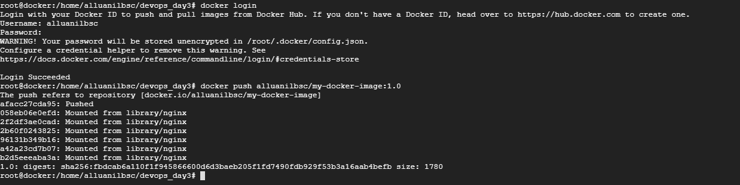

Image reflected in dockerhub

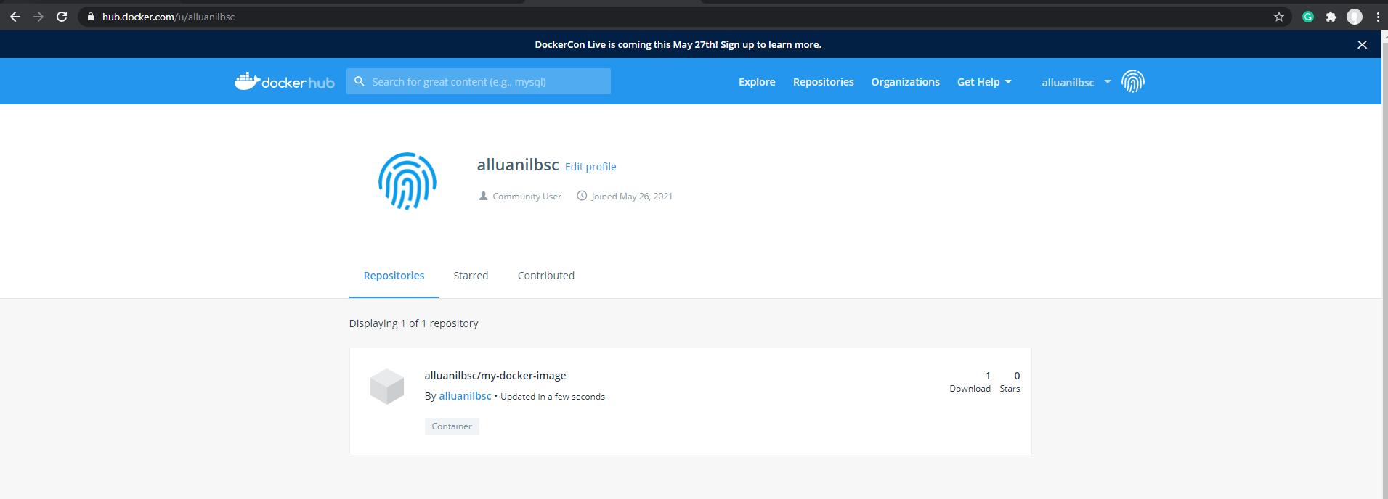

Opened another VM in gcp and excuted below commands

apt update

apt install docker.io

sudo service docker start

docker pull alluanilbsc/my-docker-image:1.0

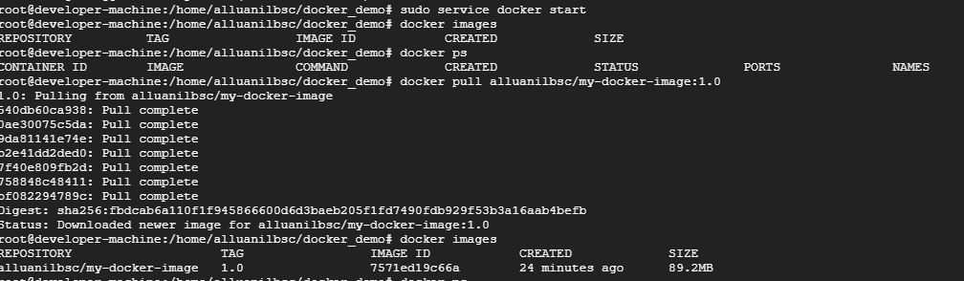

Run the instance using below command

docker run -d -p 80:80 alluanilbsc/my-docker-image:1.0





Static page opened after running nginx in browser with port 80 (in the new VM)

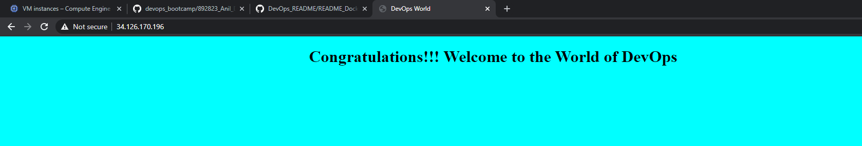

## Docker – Compose

Executed below commands to install docker-compose and run the yml file in the cloned project folder

sudo apt install docker-compose

docker-compose up

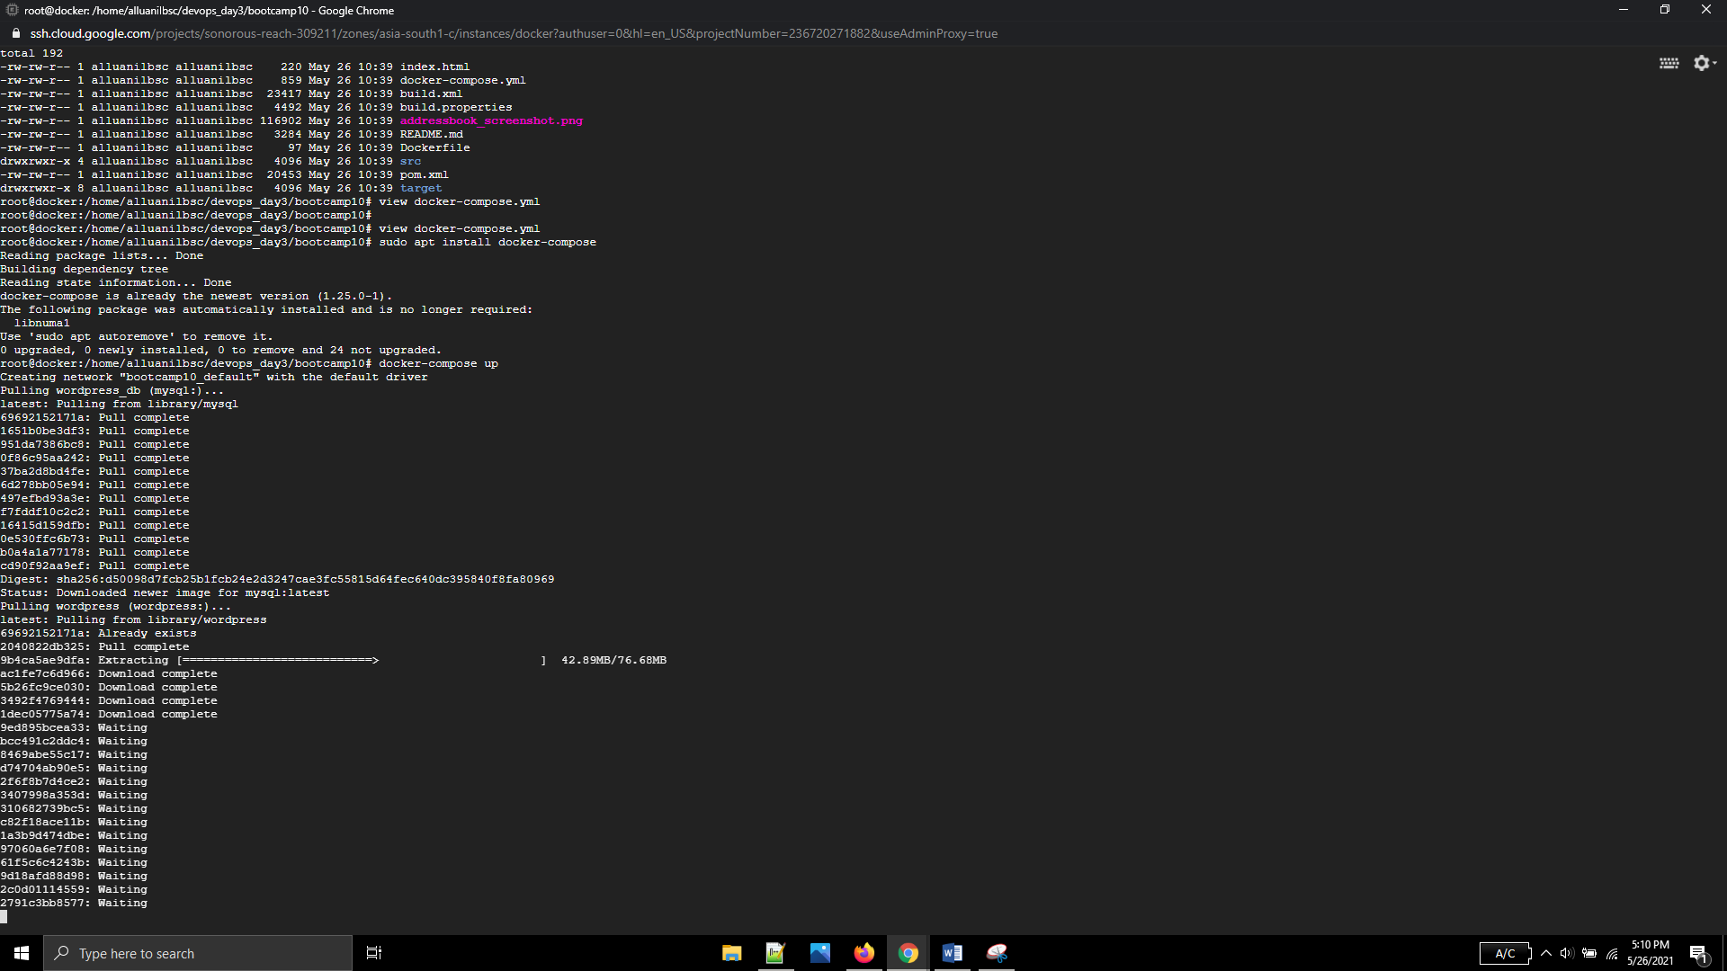

Changed ports in yml file due to errors, stopped running container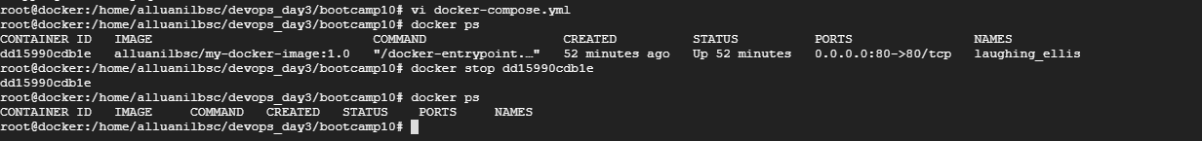

Re-ran docker compose up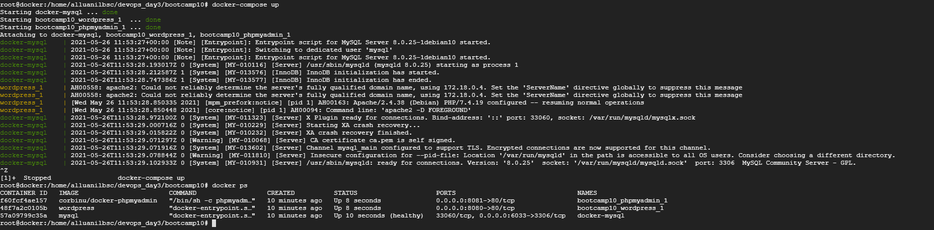

Php admin running status

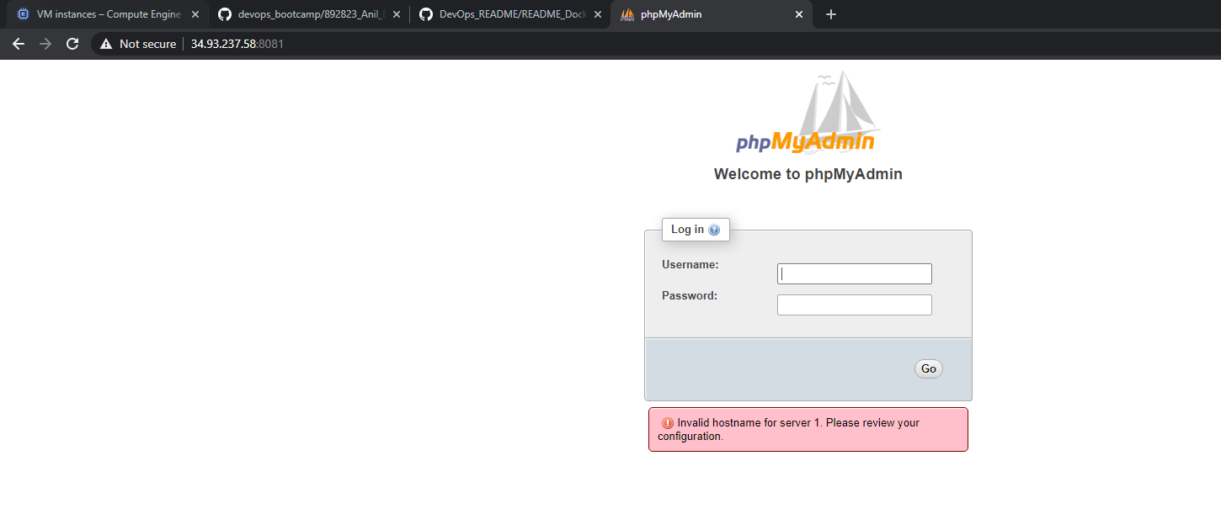

Wordpress running status

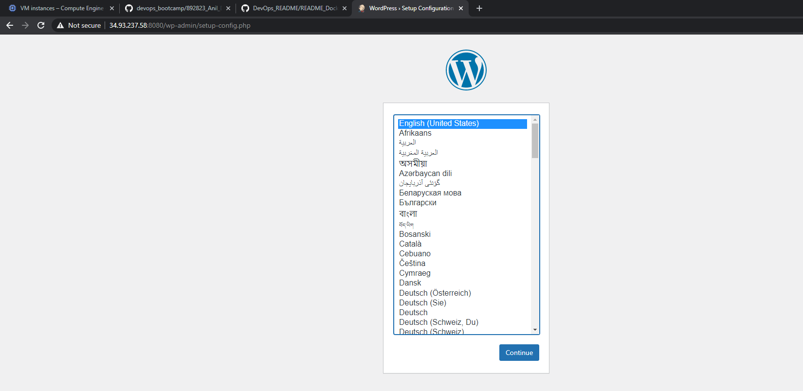

Connecting to mysql database in -it mode

Before connecting to mysql, installed mysql-client : apt-get install mysql-client

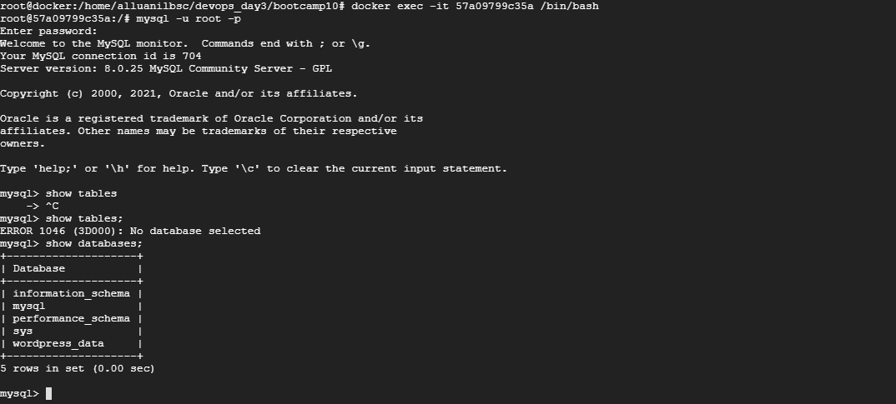

Selected the database mysql and listed tables

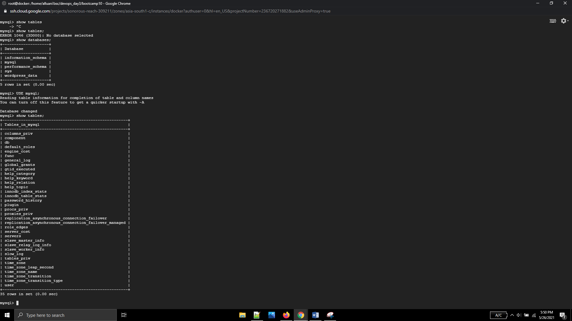

Created a table named test with id, name and age.

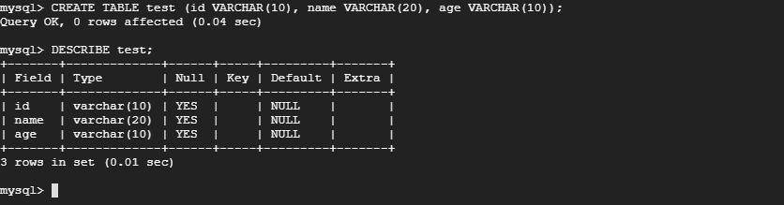

Table created successfully

