**Created 2 instances for ansible(master and slave)**

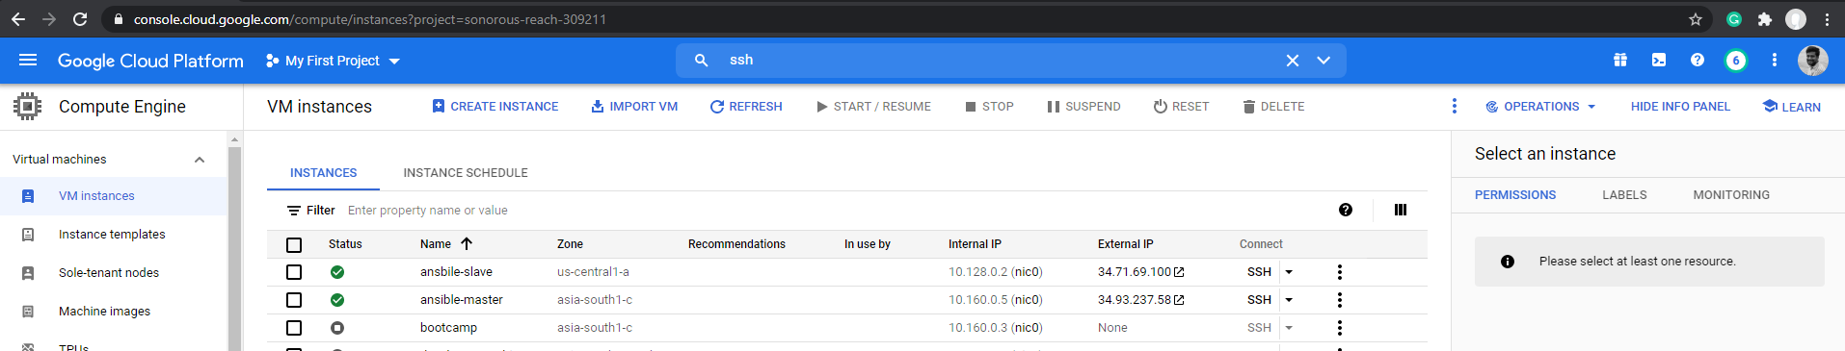

**Created a password less connection between master and slave node**

Generated a private key in master node, configured it in GCP

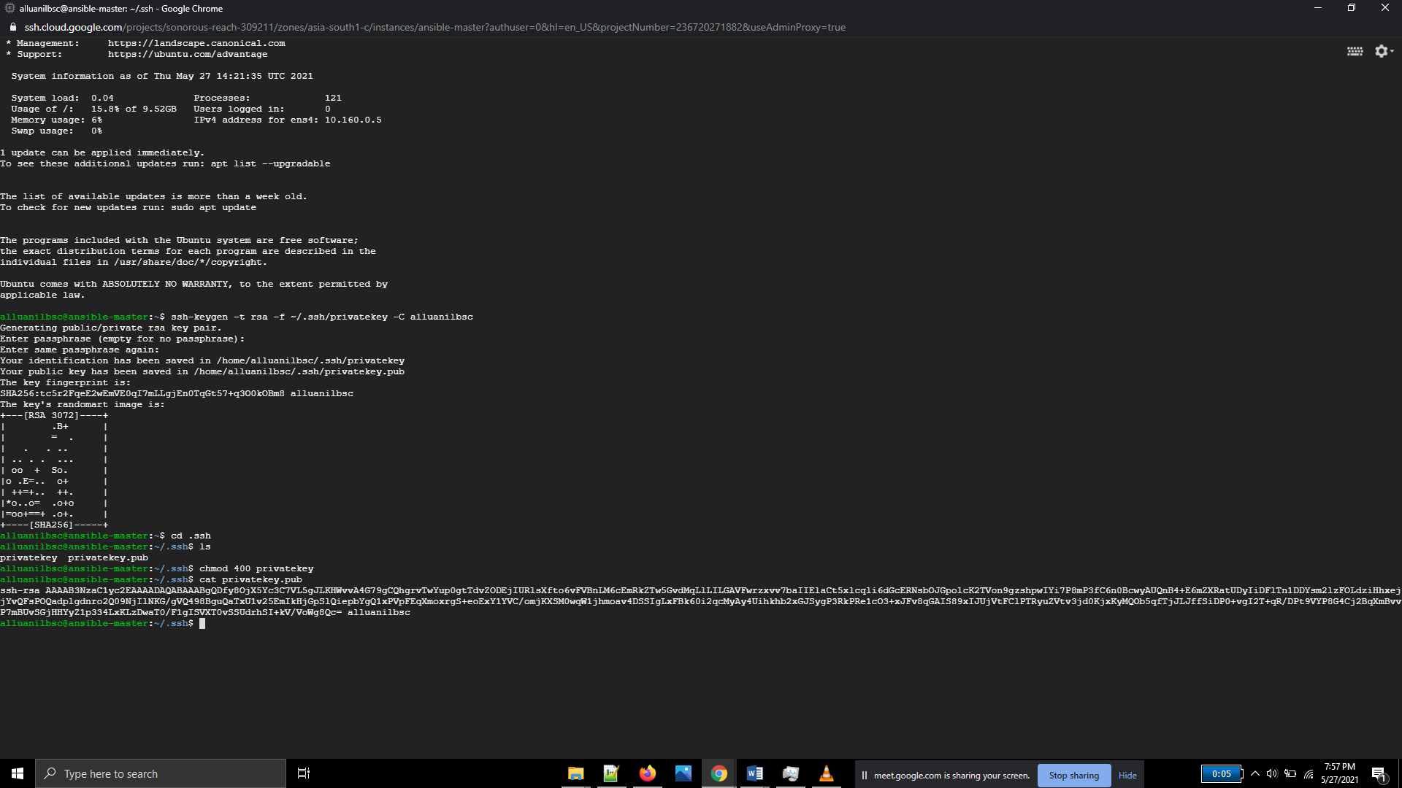

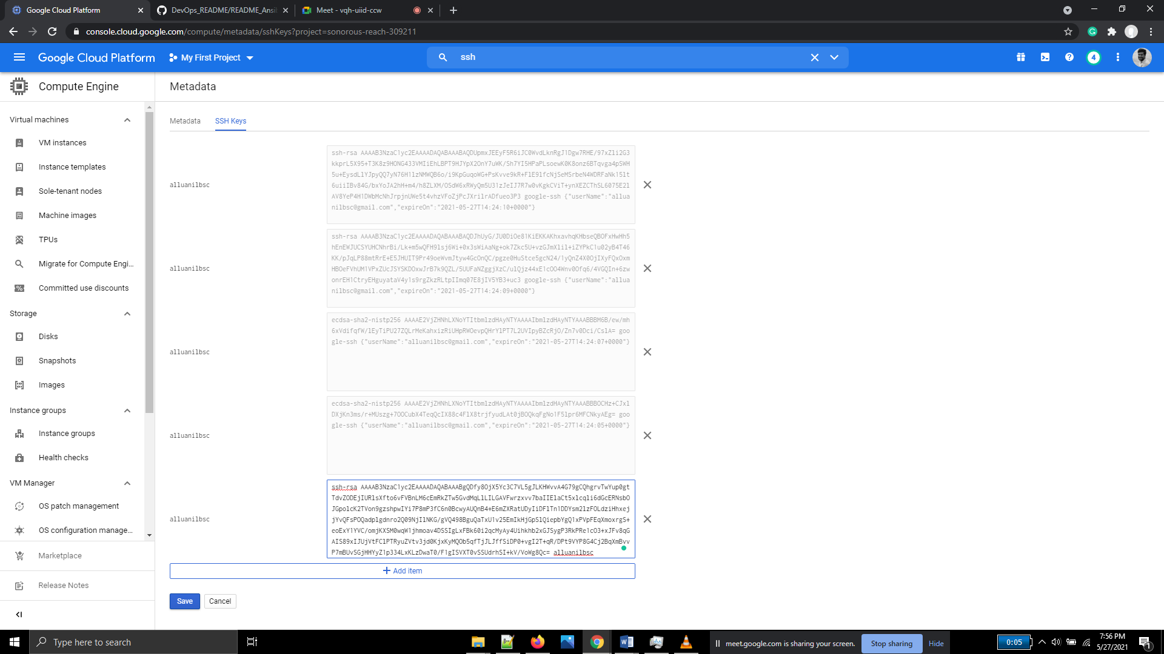

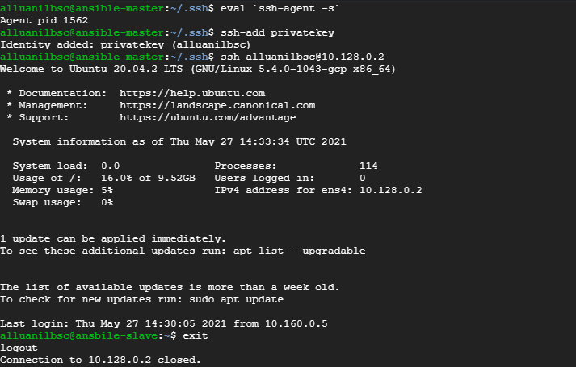

**Ansible installation**

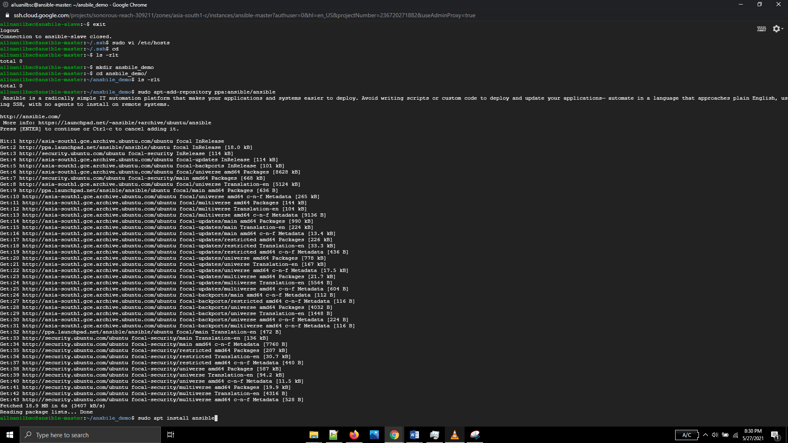

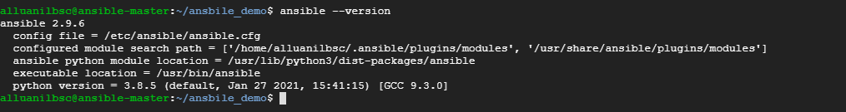

Added private ip of slave node in /etc/ansible/hosts

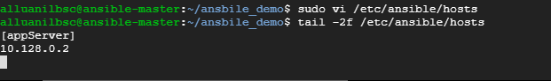

**Cloned the github project, built and pushed the docker image with address-book war to docker hub**

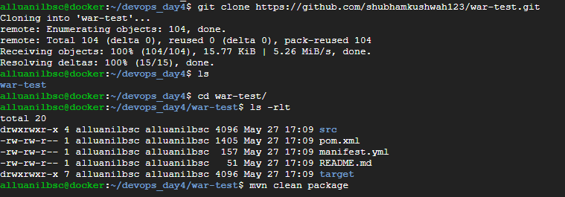

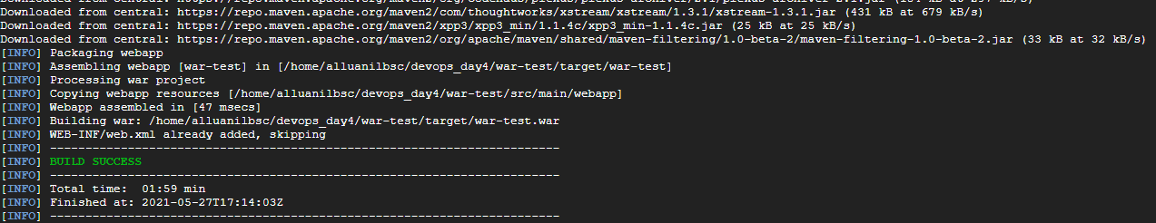



Pushed the image to docker hub

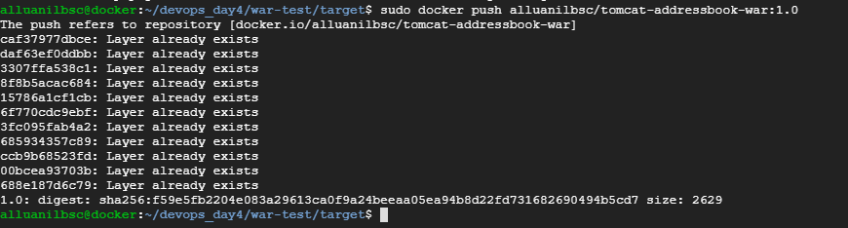

Image reflected in docker hub

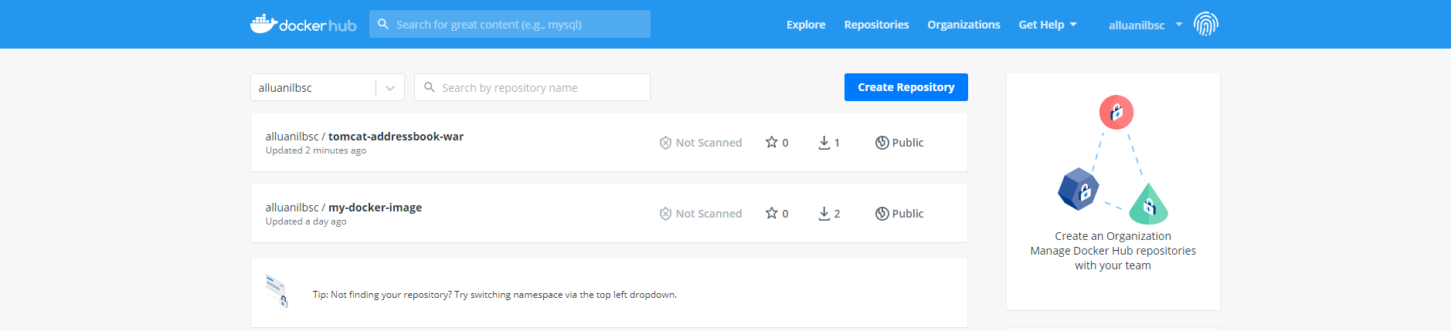

**Ansible-Playbook execution**

Edited yaml file to install the applications. Mentioned the docker image which contains war-test.war (the image is incorrectly named and saved as addressbook)

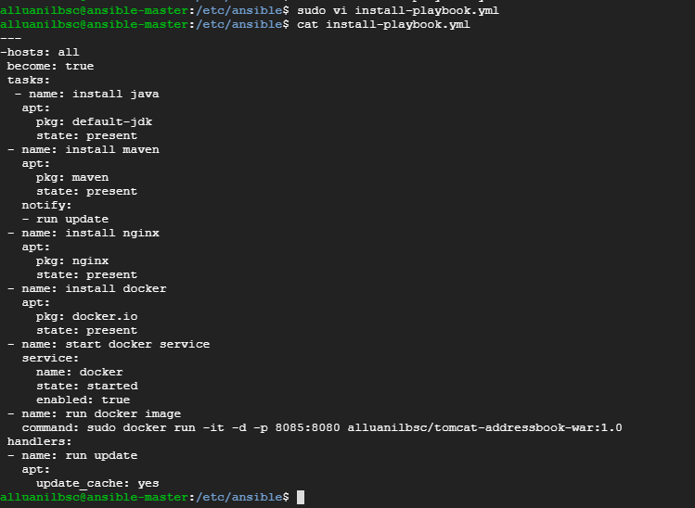

Corrected indentation errors. Resolved them

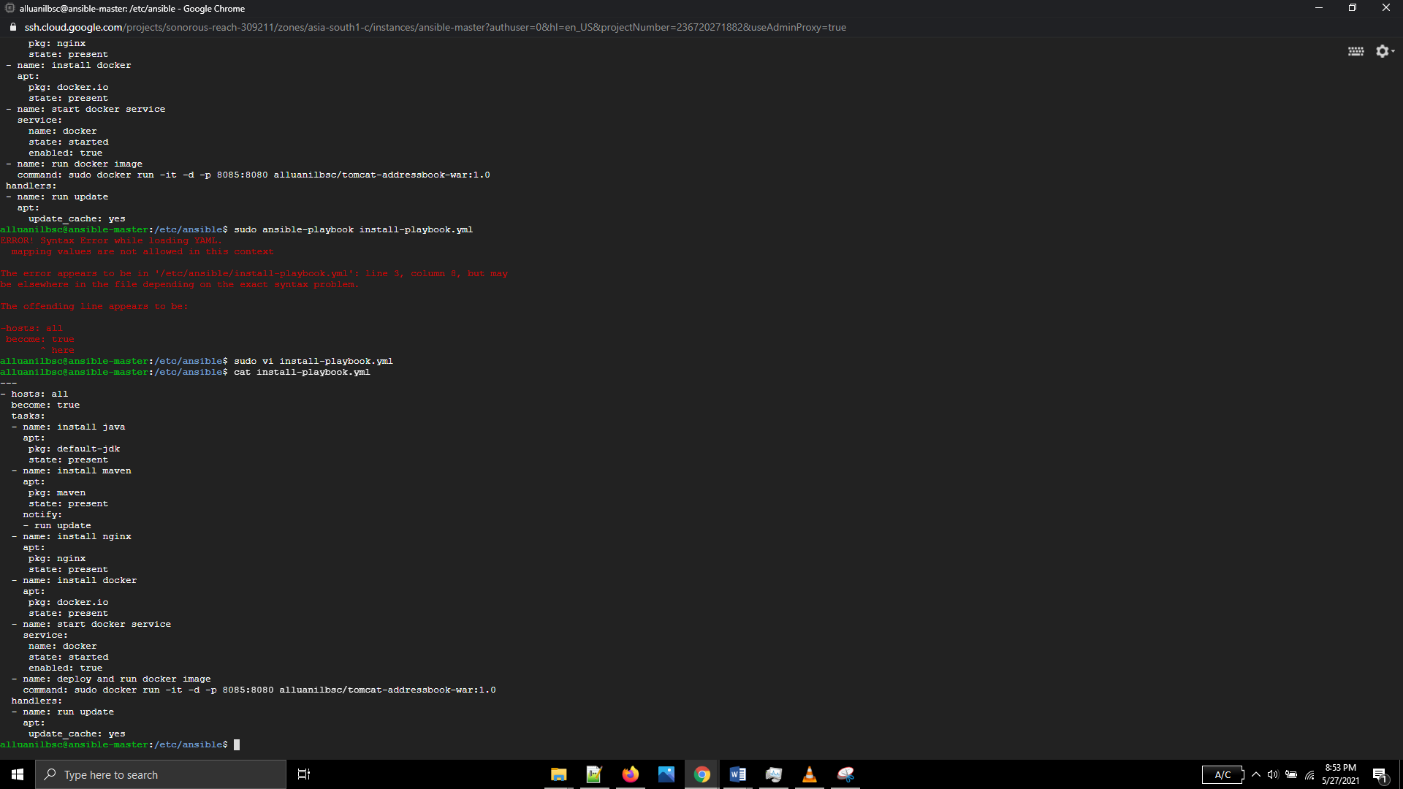

Got below error during java installation due to root permission issue

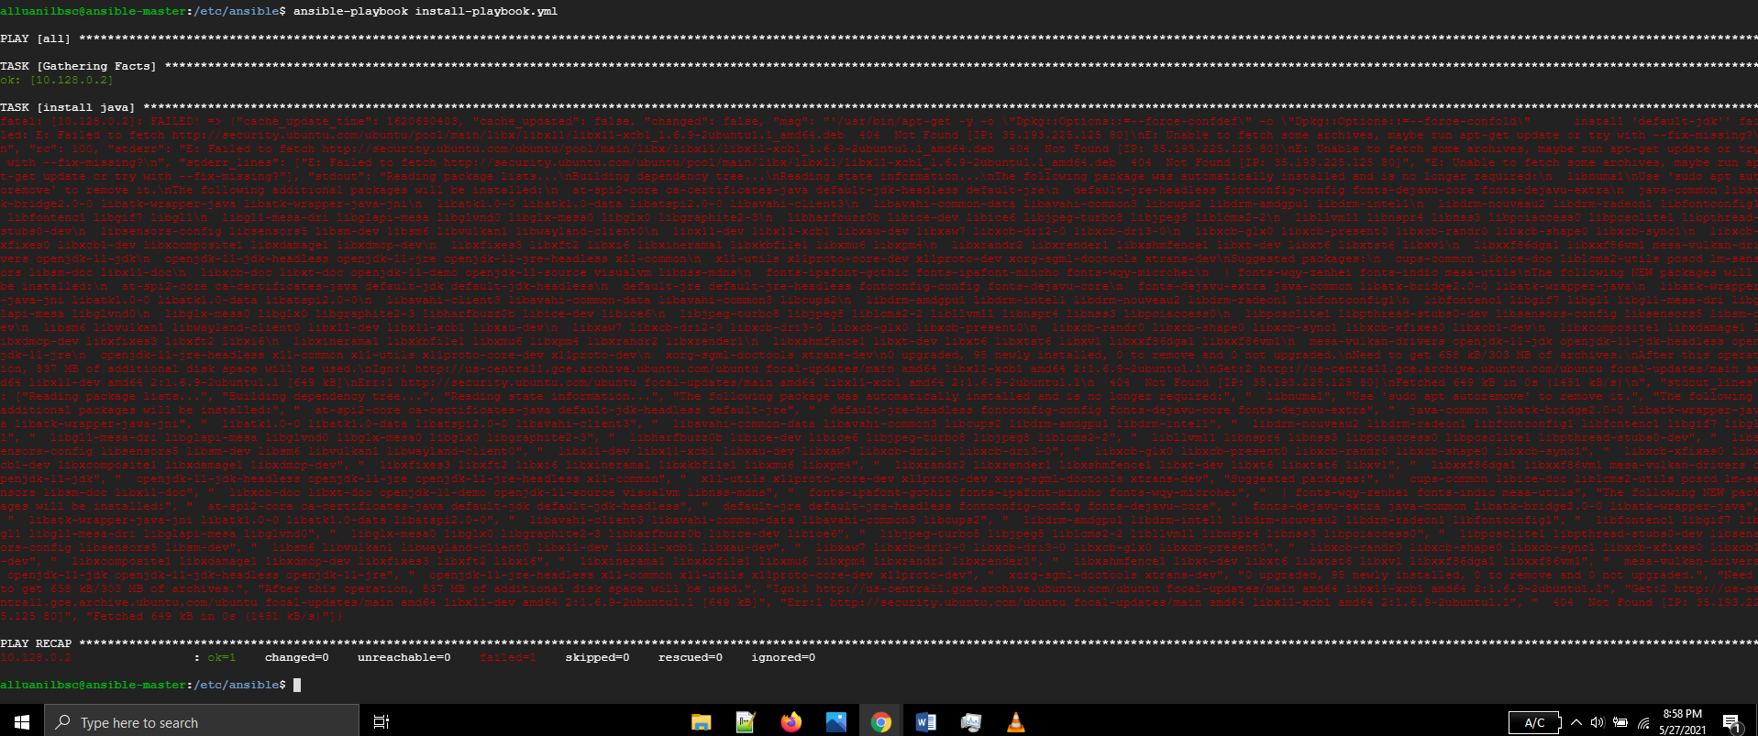

Configured password less authentication with root user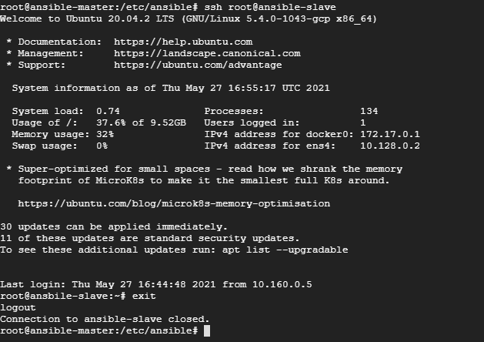

Then re-ran ansible playbook as root user. The playbook ran successfully.

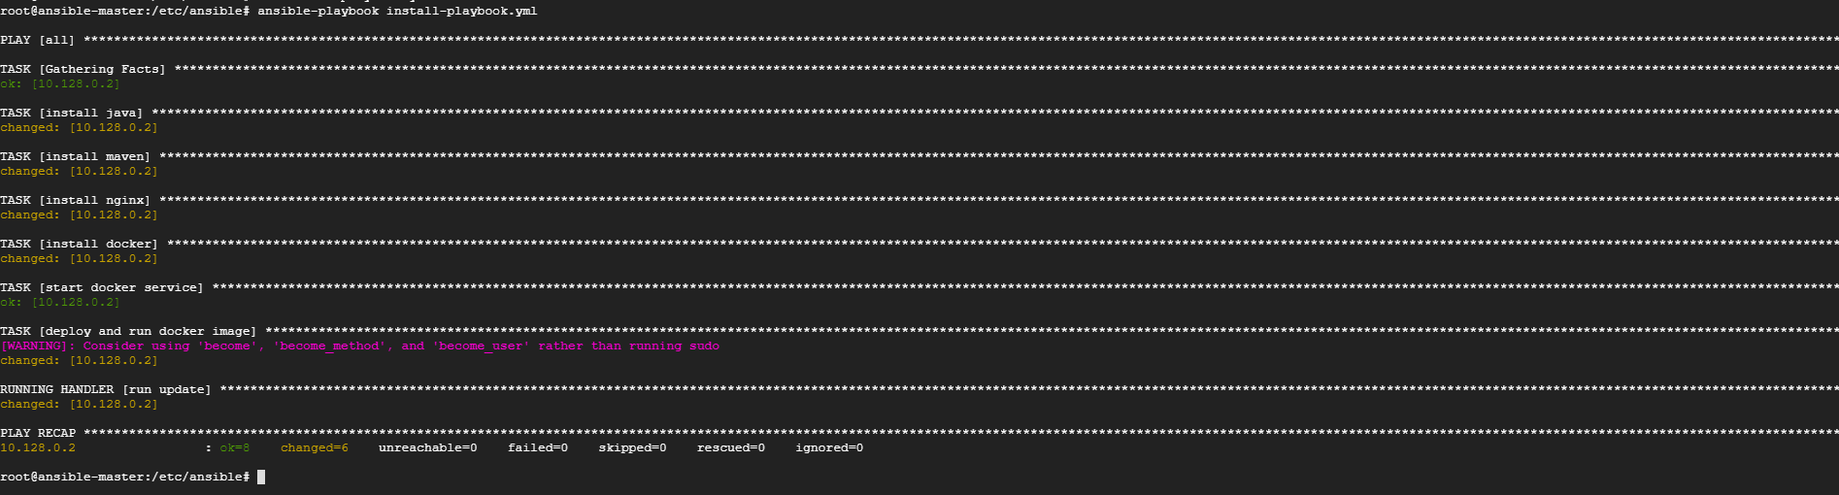

**Verification of deployed applications in Slave node:**

In slave node, before running ansible playbook

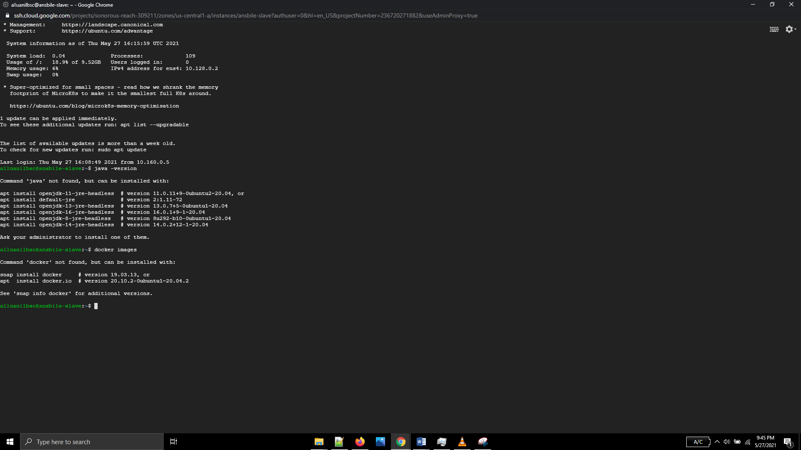

In slave node, after running ansible playbook

nginx, maven, java and docker are installed. The docker image of war-test war file is running

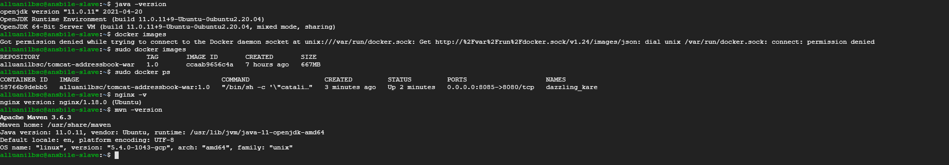

The application is running in slave node with 8085 port

