## Git Assignment – Day1

1. Create a local git repository devloperA and create 3 files(demo1, 2 and 3)

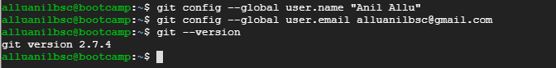

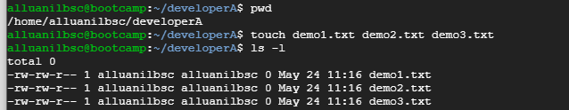

1. Add all the 3 files into staging area and commit it in the local repository

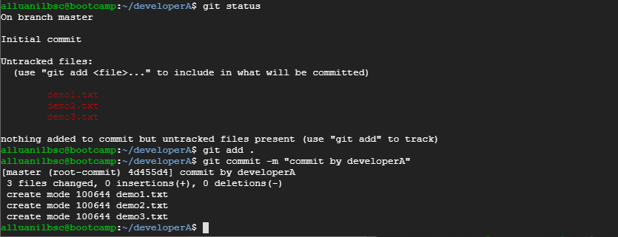

1. Create a remote repository

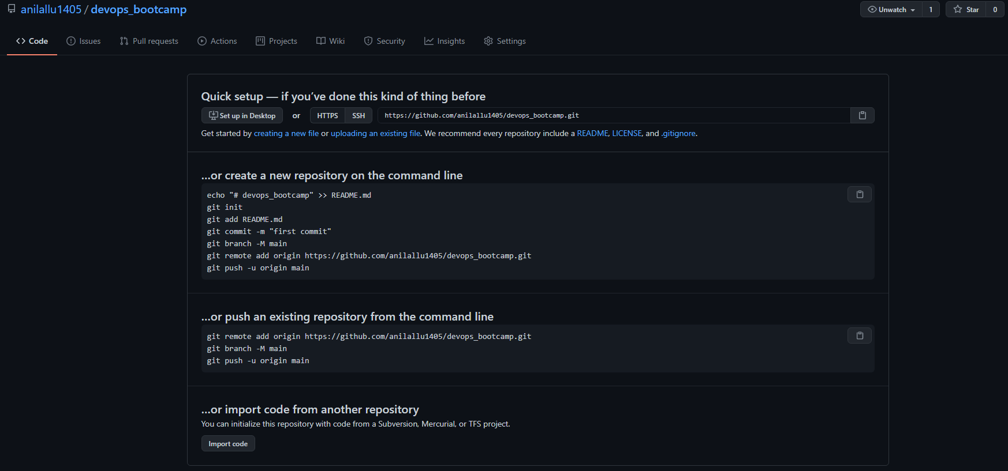

1. Add remote repository to the local repository and push the changes to remote repo from local repo

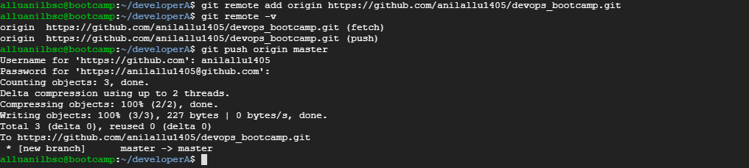

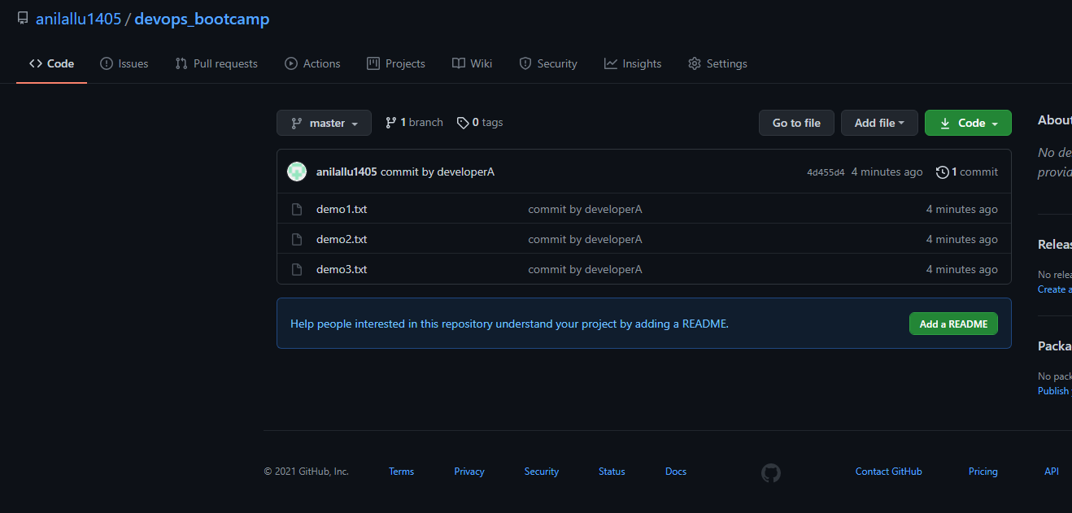

1. Clone the remote repository to another folder developerB

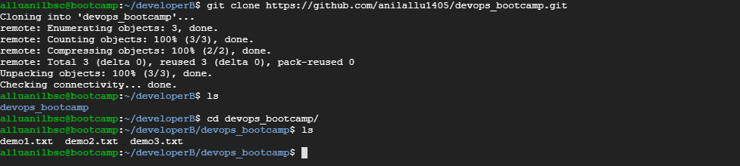

1. Make and commit changes via developer and synchronize changes in developerA repository

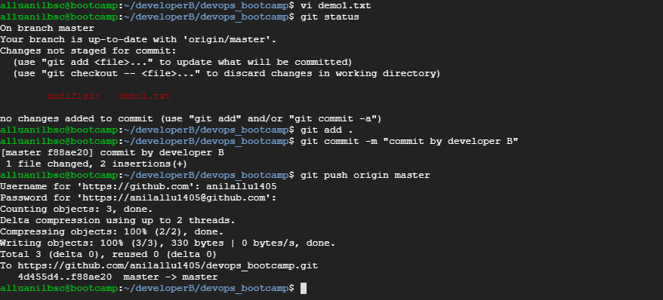

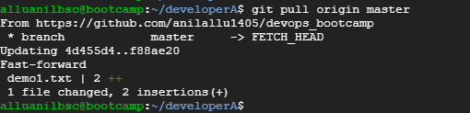





1. Create a feature branch and change the files

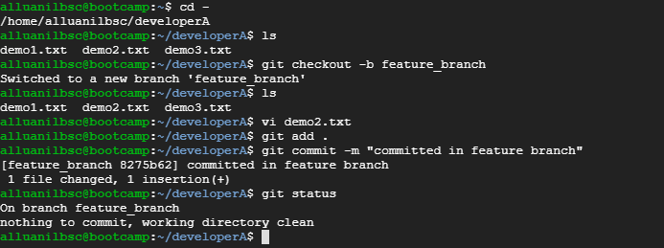

1. Merge back the created branch with master branch

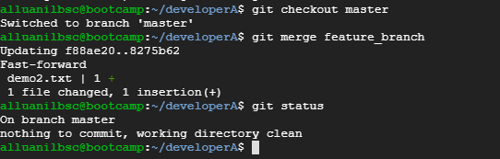

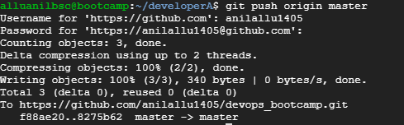

1. Delete the feature1 branch after merging

