Bug Report

**BUG #1 (JIRA ID- LYNX-XXXX)**

**Summary**: Persönliche Angaben screen is not validating duplicate Nationality

**Description**:

On the “Persönliche Angaben” screen when a customer selects to declare a second different nationality then the screen is allowing the customer to select the name nationality which was already selected as first nationality and the customer is able to proceed to next screen with this duplicate input selection.

**Steps to Reproduce:**

1. Navigate to the below website and check that “Persönliche Angaben” screen is displayed: <https://www.lynxbroker.de/wertpapierdepot/depoteroeffnung/antrag/wizard/start>.
2. Enter valid inputs in all the mandatory fields on the page till “Staatsangehörigkeit” field
3. Select “Niederlande” as option from dropdown for Staatsangehörigkeit field
4. Select Ja button for “Weitere Staatsangehörigkeit” field which will display second Staatsangehörigkeit field
5. Again select “Niederlande” as option from dropdown for second Staatsangehörigkeit field
6. Enter valid inputs in all remaining mandatory fields on the page till “Staatsangehörigkeit” field and click Weiter button at the end of page
7. Check that customer is able to navigate to next screen even with duplicate country as Nationality

**Expected Result:**

The system should not allow the customer to select same nationality twice for Nationalities field and throw error before proceeding to next screen

**Actual Result:**

Customer is able to select same nationality twice for Nationalities field and able to proceed to next screen without errors

**Environment:**

Deployed on : Development

Browser: Google Chrome version 114.0.5735.198 (64-bit)

Operating System: mac Os 13.4.1 (22F82)

**Additional Notes:**

The issue is consistent across different browsers (e.g., Firefox, Safari).Clearing browser cache and cookies did not resolve the problem.

**Screenshots:**

Attached is a screenshot of Persönliche Angaben screen showing same nationality selection in both Nationalities field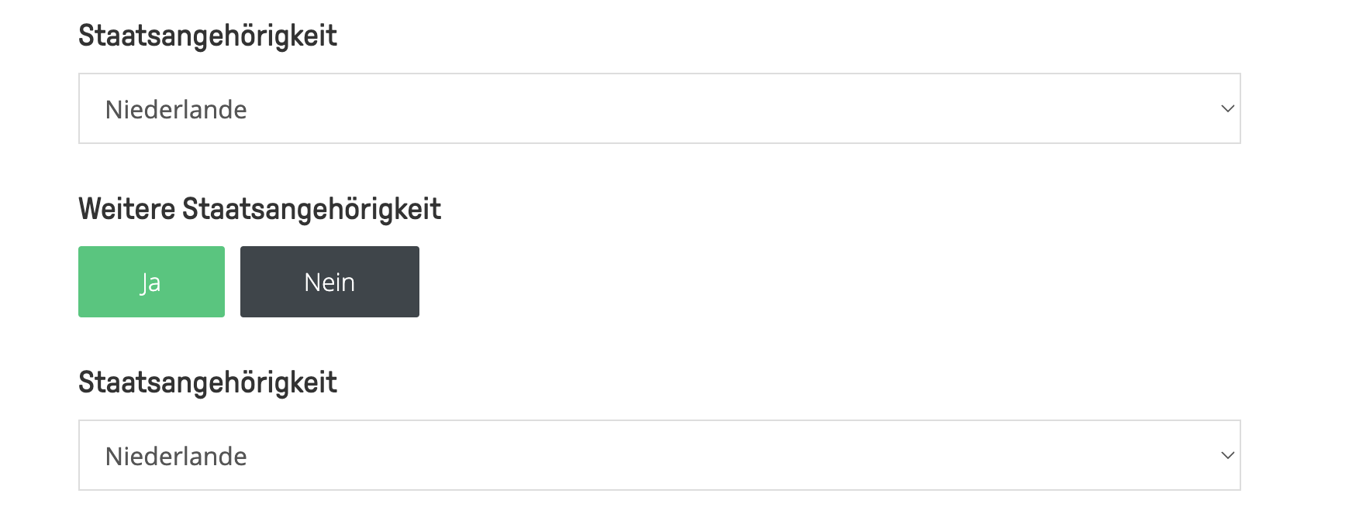

**Severity**: High

**Priority**: Medium