**Objective: Create a ASP.NET Core MVC Web application**

**Theory:**

**MVC Framework:**

The Model-View-Controller (MVC) architectural pattern separates an application into three main groups of components: Models, Views, and Controllers. This pattern helps to achieve separation of concerns. Using this pattern, user requests are routed to a Controller which is responsible for working with the Model to perform user actions and/or retrieve results of queries. The Controller chooses the View to display to the user, and provides it with any Model data it requires.

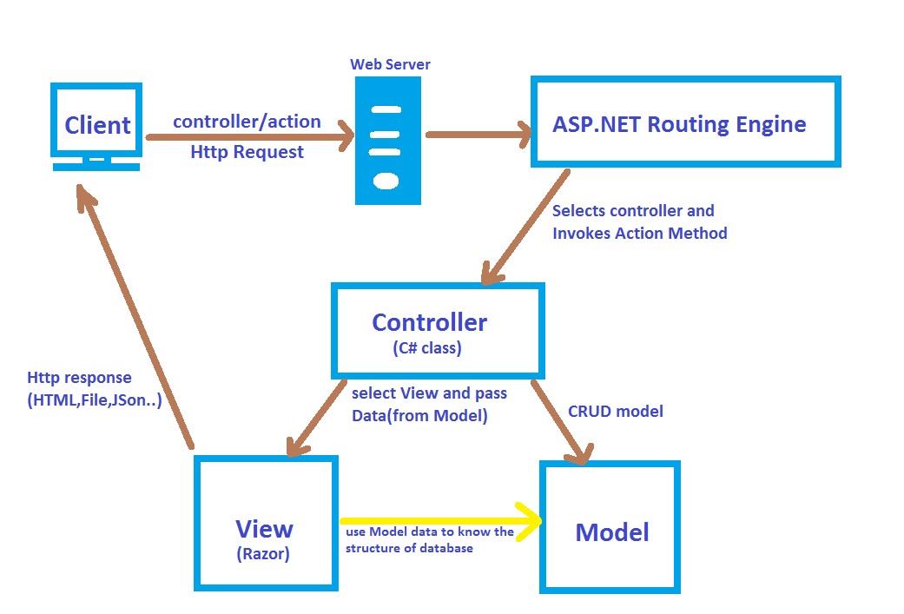

The ASP.NET Core MVC framework is a lightweight, open source, highly testable presentation framework optimized for use with ASP.NET Core.

ASP.NET Core MVC provides a patterns-based way to build dynamic websites that enables a clean separation of concerns. It gives you full control over markup, supports TDD-friendly development and uses the latest web standards.

## Features

ASP.NET Core MVC includes the following:

* Routing
* Model binding
* Model validation
* Dependency injection
* Filters
* Web APIs and etc.

**Implementation using Visual Studio 2019 IDE:**

* **Creating a Web App & Run**

1. From the Visual Studio, select Create a new project.
2. Select ASP.NET Core Web Application and then select Next.
3. Name the project as you like or Assignment1 as below:
4. Choose the location path to save your project.

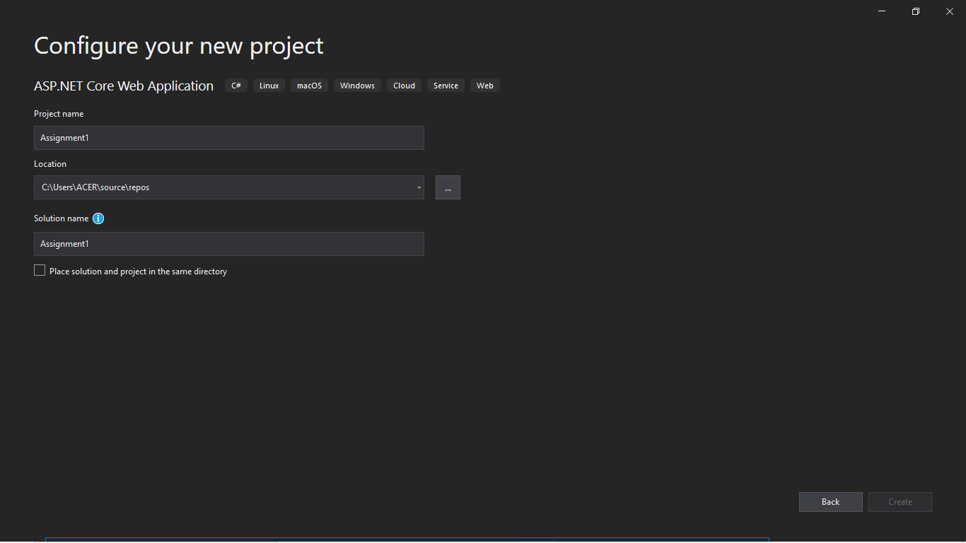

5. Then, Click Create

* Select Web Application (Model-View-Controller),

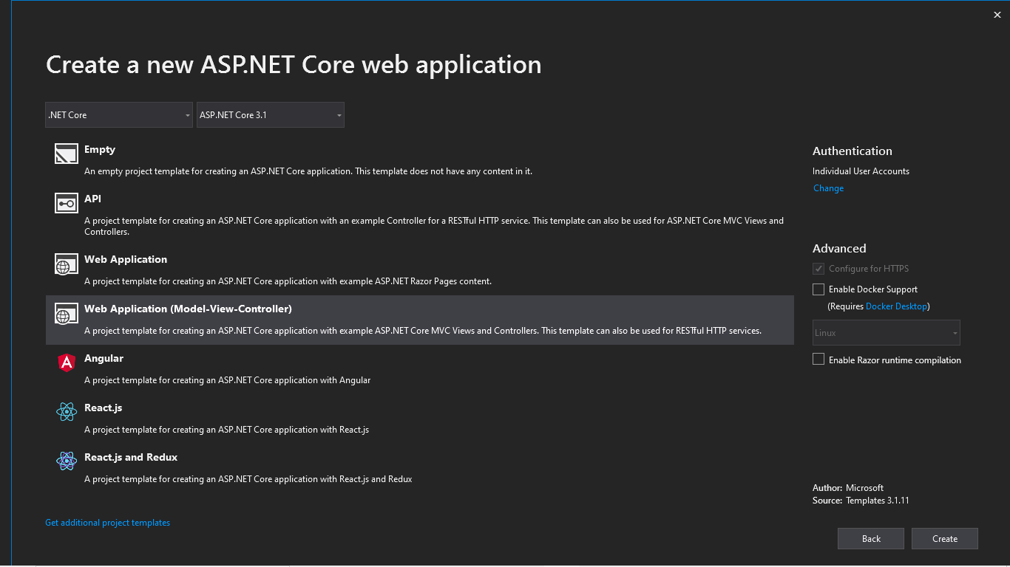

and then select Create.

* Add a data model class
* Right-click the Models folder > Add > Class. Name the file StudentsModel.cs.
* Update the StudentsModel.cs file with the following code:

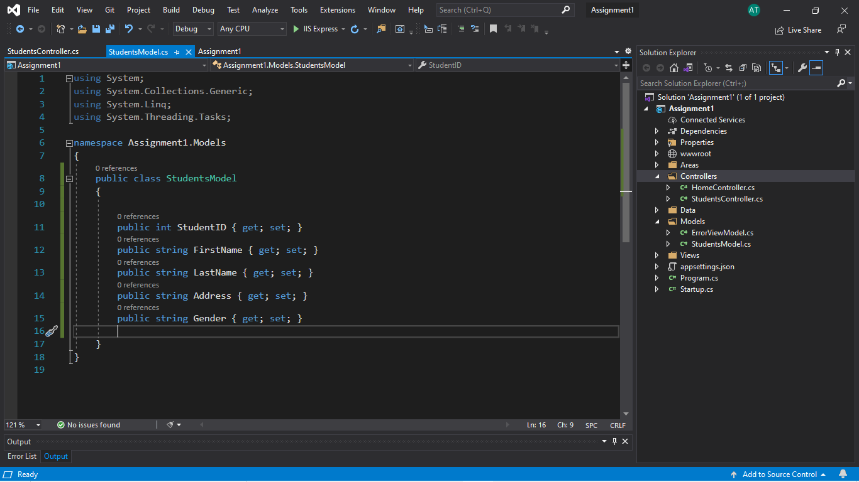

## **Add a controller**

1. In Solution Explorer, right-click Controllers > Add > Controller
2. In the Add Scaffold dialog box, select Controller Class – Empty
3. In the Add Empty MVC Controller dialog, enter Controller name and select Add.

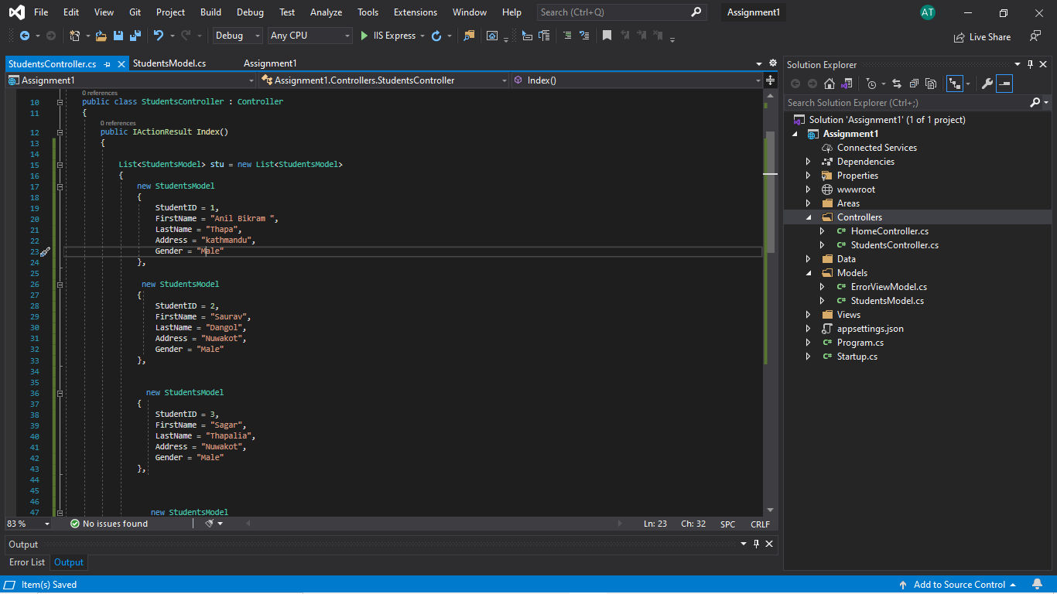

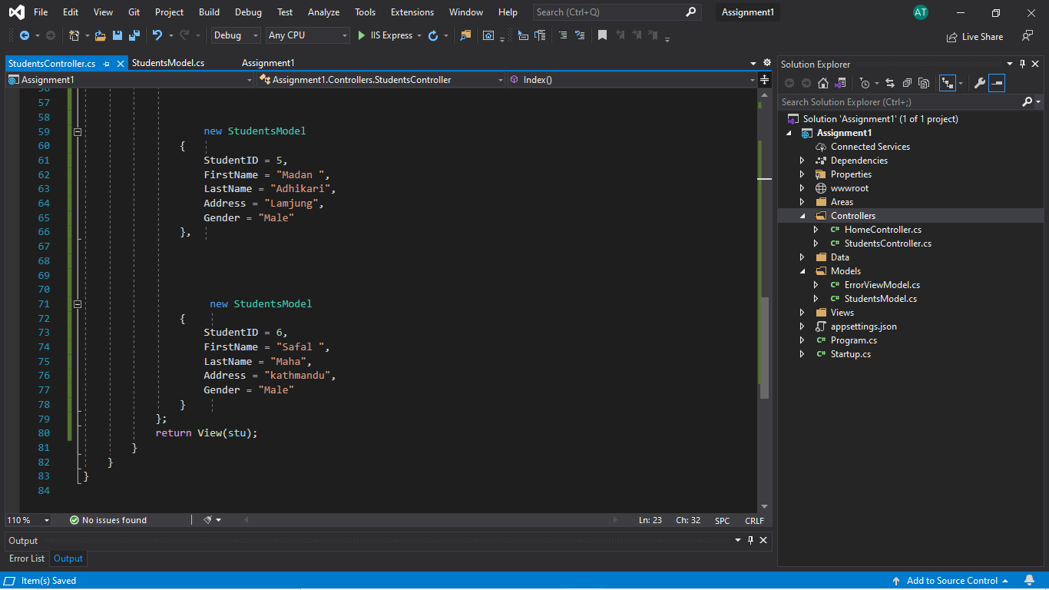

* **Add a view**
* Right-click on the action of the function of controller and add view.
* enter view Select Razor View Keep the Name box value, Index.cshtml and Select Add

Replace the contents of the Views/Home/Index.cshtml Razor view file with the following:

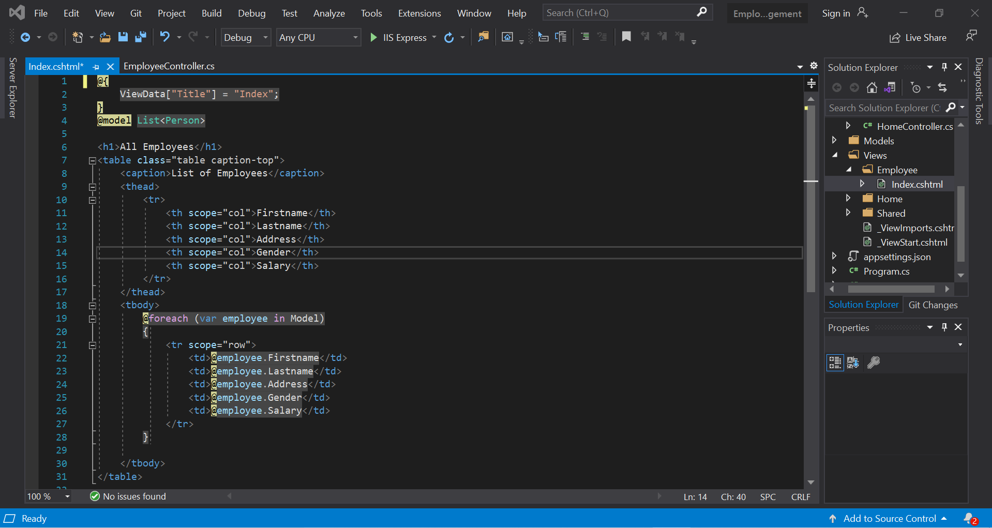

**Result on Chrome Browser:**

Now, to see the result the App,

◦ Select Ctrl-F5 to run the app in non-debug mode, Or

◦ Select IIS Express Button

Then the app is run on web browser and we gave the URL as: /Home/Index to see the result.

We can also click show table option on nav bar to view data exactly as the above url.

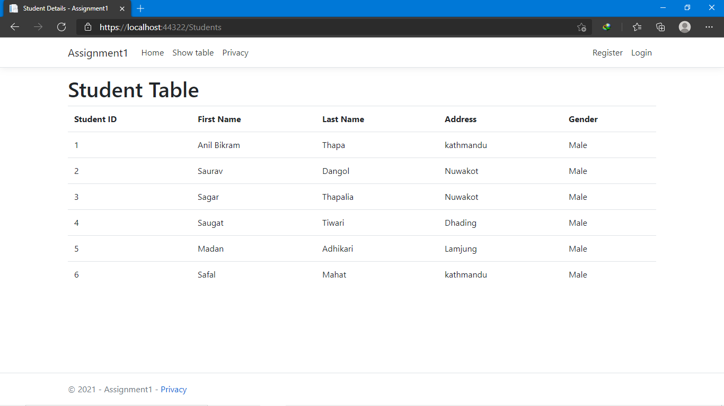

**Conclusion:**

In this lab of Net Centric Computing, we learned about the MVC framework on ASP.NET core. We successfully created a project called “Assignment1” and we add a controller named 'StudentsController.cs' which contains a public class Index in which we initialize the List as List<StudentsModel> stu = new List<StudentsModel> using object initializer syntax and returns as an object. And then we create a view of the above Index class as 'Index.cshtml' which shows the students details as a table. Also, we created a model named ‘StudentsModel.cs' which manages the data come from the controllers.

Thus, we successfully created a simple ASP.NET app which show the list of students details on the web page using the concept of MVC framework.