|  |  |  |
| --- | --- | --- |
| E-PostMan | December 18  2014 | |
| E-PostMan is the WAA final project based in Spring MVC Framework | |  |

**E-PostMan**

Version: 0.0.1 SNAPSHOT

E-PostMan is an Electronic version of MUM Mail Box System. It is based on Spring MVC Framework. It's main purpose is to minimized paper work and stored all the mail box related data in database to manage Mail Box user,History and all its transaction data.

[Source Code](<https://bitbucket.org/syraz37/epostman>)

**Why E-PostMan?**

Simplify your life:

* Stay in touch with your postal mail service and get email notification for every new item you received.

Take control:

* Receive notification, view transaction history of your delivered items,and other documents in just a few clicks

**Spring Along With Other Technologies Used and Covered**

* Spring MVC based on Annotation(CoC)
* GIT(Distributed Code Repository)
* Dependency Injection or IoC
* Spring Security
* JPA/Hibernate
* Internationalization
* Validation
* REST/Ajax
* JSTL/Spring Tag Lib/JSP
* Exception Handling
* File Upload
* Java Mail

**Features:**

* User Registration
* Mail Box Management
* User Management
* Mail Item Management
* Email Notification
* Status Tracking

**Block Diagram:**

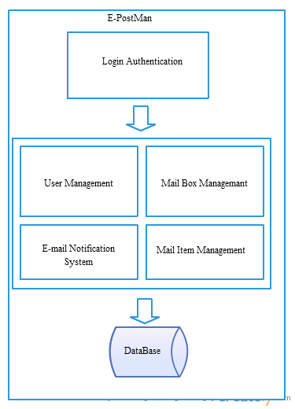

Figure: Block Diagram

**Use Case Diagram:**

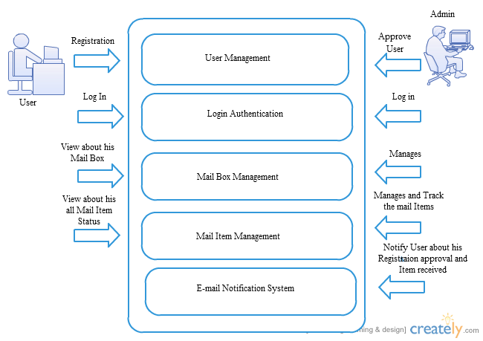

Figure: User Case Diagram

**Schema Diagram:**

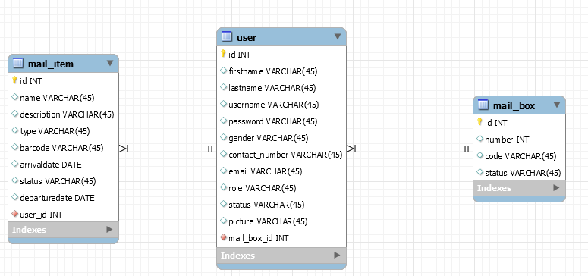

**UML-Class Diagram:**

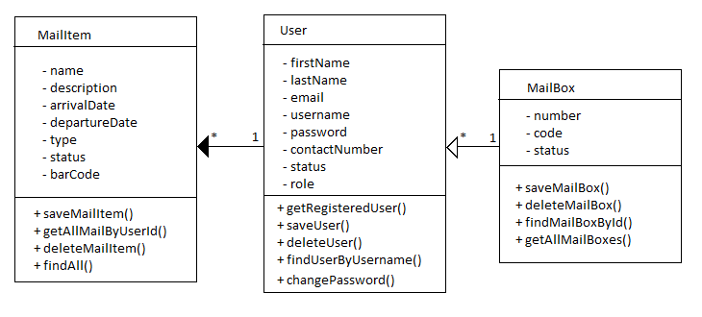

**Sequence Diagram:**

**For Admin:**

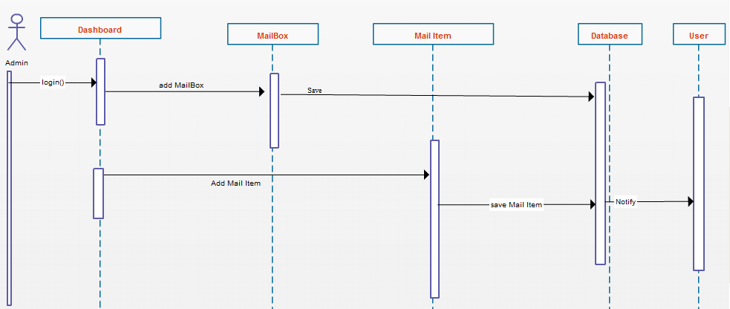

**For User:**

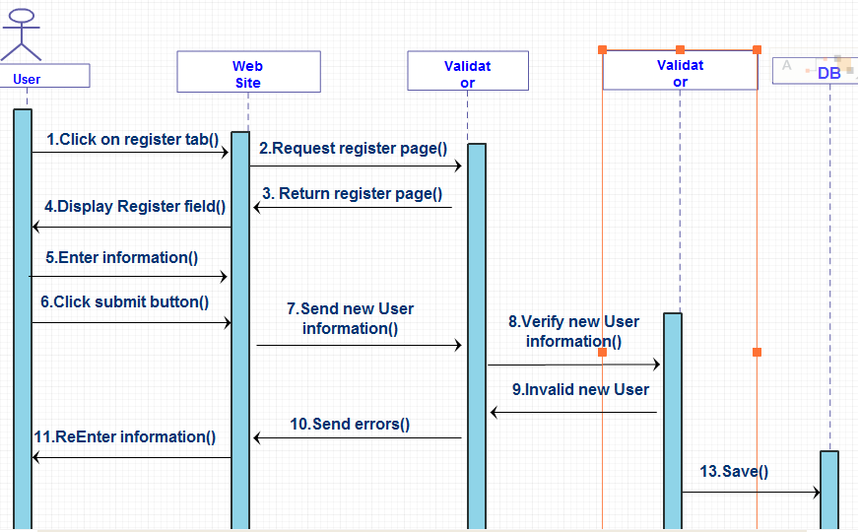

**Future Enhancement:**

* Bar code scanning
* Out going mail tracking
* Multiple admin role
* System Notification
* Moblie Application