UNIT 1- FUNDAMENTALS OF DEEP LEARNING

Fundamentals of deep learning refer to the basic concepts and principles that underlie the field of deep learning. These include:
- Neural Networks: Deep Learning is a type of Machine Learning that involves training artificial neural networks to perform tasks such as image classification, natural language processing, and speech recognition.
- Training: Deep Learning models are trained by feeding large amounts of data into a neural network, and adjusting the weights of the network through a process known as backpropagation.
- Layers: Deep neural networks are composed of multiple layers of interconnected nodes, each performing a specific function. The input layer receives the raw data, and the output layer produces the final prediction.
- Activation Functions: Each node in a neural network applies an activation function to its inputs, transforming the output to a desired range. Common activation functions include sigmoid, ReLU and softmax.
- Convolutional Neural Networks (CNNs): CNNs are a type of neural network specifically designed for image processing tasks. They use convolutional layers to extract features from the input image, and pooling layers to down sample the features.
- Recurrent Neural Networks (RNNs): RNNs are a type of neural network designed for processing sequences of data, such as time-series data or natural language text. They use feedback connections to store information about previous inputs and use this to make predictions.
- Backpropagation: Backpropagation is the process of adjusting the weights of a neural network in order to minimize the error between the predicted output and the actual output.
- Overfitting: Overfitting occurs when a model is trained too well on the training data and begins to perform poorly on new, unseen data. Regularization techniques such as dropout and early stopping can help prevent overfitting.
- Transfer Learning: Transfer learning is a technique where a pre-trained model is used as a starting point for a new task, rather than training a new model from scratch. This can greatly reduce the amount of data and computing resources required for training.
- GPU Acceleration: Deep Learning models require a lot of computational power, and Graphics Processing Units (GPUs) are well-suited for this type of work. GPUs can accelerate the training process by several orders of magnitude compared to CPUs.

ARTIFICIAL INTELLIGENCE
Artificial Intelligence is composed of two words Artificial and Intelligence, where Artificial defines "man-made," and intelligence defines "thinking power", hence AI means "a man-made thinking power." So, we can define AI as, "It is a branch of computer science by which we can create intelligent machines which can behave like a human, think like humans, and able to make decisions."

Why Artificial Intelligence?
- With the help of AI, we can create such software or devices which can solve real- world problems very easily and with accuracy such as health issues, marketing, traffic issues, etc.
- With the help of AI, we can create your personal virtual Assistant, such as Cortana, Google Assistant etc.
- With the help of AI, we can build such Robots which can work in an environment where survival of humans can be at risk.
- AI opens a path for other new technologies, new devices, and new Opportunities.

Goals of Artificial Intelligence:
- Replicate human intelligence
- Solve Knowledge-intensive tasks
- An intelligent connection of perception and action
- Building a machine which can perform tasks that requires human intelligence such as:
  - Proving a theorem
  - Playing chess
  - Plan some surgical operation
- Driving a car in traffic Creating some system which can exhibit intelligent behavior, learn new things by itself, demonstrate, explain, and can advise to its user.
Definition: “AI is the study of how to make computers do things at which, at the moment, people are better”.

Applications:
- Gaming
- Natural Language Processing (NLP)
- Expert Systems
- Vision Systems
- Speech Recognition
- Handwriting Recognition
- Intelligent Robots

Advantages:
- High Accuracy with fewer errors
- High-Speed
- High reliability
- Useful for risky areas
- Digital Assistant
- Useful as a public utility

Disadvantages:
- High Cost
- Can't think out of the box
- No feelings and emotions
- Increase dependency on machines
- No Original Creativity

HISTORY OF MACHINE LEARNING
The early history of Machine Learning (Pre-1940):
1834: In 1834, Charles Babbage, the father of the computer, conceived a device that could be programmed with punch cards. However, the machine was never built, but all modern computers rely on its logical structure.
1936: In 1936, Alan Turing gave a theory that how a machine can determine and execute a set of instructions.

The era of stored program computers:
1940:
In 1940, the first manually operated computer, "ENIAC" was invented, which was the first electronic general-purpose computer. After that stored program computer such as EDSAC in 1949 and EDVAC in 1951 were invented.
1943:
In 1943, a human neural network was modeled with an electrical circuit. In 1950, the scientists started applying their idea to work and analysed how human neurons might work.
Computer machinery and intelligence:
1950:
In 1950, Alan Turing published a seminal paper, "Computer Machinery and Intelligence," on the topic of artificial intelligence. In his paper, he asked, "Can machines think?"
Machine intelligence in Games:
1952:
Arthur Samuel, who was the pioneer of machine learning, created a program that helped an IBM computer to play a checkers game. It performed better more it played.
1959:
In 1959, the term "Machine Learning" was first coined by Arthur Samuel.
The first "AI" winter:
- The duration of 1974 to 1980 was the tough time for AI and ML researchers, and this duration was called as AI winter.
- In this duration, failure of machine translation occurred, and people had reduced their interest from AI, which led to reduced funding by the government to the researches.
Machine Learning from theory to reality:
1959: In 1959, the first neural network was applied to a real-world problem to remove echoes over phone lines using an adaptive filter.
1985: In 1985, Terry Sejnowski and Charles Rosenberg invented a neural network NETtalk, which was able to teach itself how to correctly pronounce 20,000 words in one week.
1997: The IBM's Deep blue intelligent computer won the chess game against the chess expert Garry Kasparov, and it became the first computer which had beaten a human chess expert.
Machine Learning at 21st century:
2006: In the year 2006, computer scientist Geoffrey Hinton has given a new name to neural net research as "deep learning," and nowadays, it has become one of the most trending technologies.
2012: In 2012, Google created a deep neural network which learned to recognize the image of humans and cats in YouTube videos.
2014: In 2014, the Chabot "EugenGoostman" cleared the Turing Test. It was the first Chabot who convinced the 33% of human judges that it was not a machine.
2014:DeepFace was a deep neural network created by Facebook, and they claimed that it could recognize a person with the same precision as a human can do.
2016:AlphaGo beat the world's number second player Lee sedol at Go game. In 2017 it beat the number one player of this game KeJie.

2017: In 2017, the Alphabet's Jigsaw team built an intelligent system that was able to learn the online trolling. It used to read millions of comments of different websites to learn to stop online trolling.
Machine Learning at present:
Now machine learning has got a great advancement in its research, and it is present everywhere around us, such as self-driving cars, Amazon Alexa, Catboats, recommender system, and many more. It includes Supervised, unsupervised, and reinforcement learning with clustering, classification, decision tree, SVM algorithms, etc.
Modern machine learning models can be used for making various predictions, including weather prediction, disease prediction, stock market analysis, etc.

PROBABILISTIC MODELING
Probabilistic modeling is a powerful approach in machine learning that involves representing uncertainty and variability in data using probability distributions. It allows us to express not only the most likely outcomes but also the range of possible outcomes and their associated likelihoods. This is particularly useful in situations where data is noisy, incomplete, or ambiguous.
Naive Bayes
Naïve Bayes algorithm is a supervised learning algorithm, which is based on Bayes theorem and used for solving classification problems.
- It is mainly used in text classification that includes a high-dimensional training dataset.
- Naïve Bayes Classifier is one of the simple and most effective Classification algorithms which help in building the fast machine learning models that can make quick predictions.
- It is a probabilistic classifier, which means it predicts on the basis of the probability of an object.
- Some popular examples of Naïve Bayes Algorithm are spam filtration, Sentimental analysis, and classifying articles.
The Naïve Bayes algorithm is comprised of two words Naïve and Bayes:
- Naïve: It is called Naïve because it assumes that the occurrence of a certain feature is independent of the occurrence of other features. Such as if the fruit is identified on the bases of color, shape, and taste, then red, spherical, and sweet fruit is recognized as an apple. Hence each feature individually contributes to identify that it is an apple without depending on each other.
- Bayes: It is called Bayes because it depends on the principle of Bayes' Theorem.

Bayes' Theorem:
Bayes' theorem is also known as Bayes' Rule or Bayes' law, which is used to

determine the probability of a hypothesis with prior knowledge. It depends on the conditional probability. The formula for Bayes' theorem is given as:
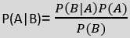
where
- P(A|B) is Posterior probability: Probability of hypothesis A on the observed event B
- P(B|A) is Likelihood probability: Probability of the evidence given that the probability of a hypothesis is true
- P(A) is Prior Probability: Probability of hypothesis before observing the evidence
- P(B) is Marginal Probability: Probability of Evidence

Working of Naïve Bayes' Classifier: Consider a dataset of weather conditions and corresponding target variable "Play". So using this dataset we need to decide that whether we should play or not on a particular day according to the weather conditions. So, to solve this, we need to follow the below steps:
- Convert the given dataset into frequency tables
- Generate Likelihood table by finding the probabilities of given features
- Now, use Bayes theorem to calculate the posterior probability
Example: If the weather is sunny, then the Player should play or not?

S.No | Outlook | Play
0 | Rainy | Yes
1 | Sunny | Yes
2 | Overcast | Yes
3 | Overcast | Yes
4 | Sunny | No
5 | Rainy | Yes
6 | Sunny | Yes
7 | Overcast | Yes
8 | Rainy | No
9 | Sunny | No
10 | Sunny | Yes
11 | Rainy | No
12 | Overcast | Yes
13 | Overcast | Yes
Frequency table for the Weather Conditions:

Weather | Yes | No
Overcast | 5 | 0
Rainy | 2 | 2
Sunny | 3 | 2
Total | 10 | 4
Likelihood table weather condition:
Weather | No | Yes
Overcast | 0 | 5 | 5/14=0.35
Rainy | 2 | 2 | 4/14=0.29
Sunny | 2 | 3 | 5/14=0.35
All | 4/14=0.29 | 10/14=0.71

Applying Bayes' Theorem:

P(Yes|Sunny)= P(Sunny|Yes)*P(Yes)/P(Sunny) P(Sunny|Yes)= 3/10= 0.3
P(Sunny)= 0.35 P(Yes)=0.71
So P(Yes|Sunny) = 0.3*0.71/0.35= 0.60

P(No|Sunny)= P(Sunny|No)*P(No)/P(Sunny)
P(Sunny|NO)= 2/4=0.5 P(No)= 0.29
P(Sunny)= 0.35
So P(No|Sunny)= 0.5*0.29/0.35 = 0.41

So as we can see from the above calculation that P(Yes|Sunny)>P(No|Sunny). Hence on a Sunny day, Player can play the game.
Here are some key concepts and aspects of probabilistic modeling in machine learning:
- Probability Distributions: These distributions describe how likely different values or events are to occur. Common types of distributions used in machine learning include the Gaussian (normal) distribution, Bernoulli distribution, multinomial distribution, and more.
- Bayesian Inference: Bayesian inference is a probabilistic approach that updates our beliefs about a model's parameters based on new evidence or data. It uses Bayes' theorem to calculate the posterior probability distribution over the model parameters given the observed data.
- Bayesian Networks: Bayesian networks, also known as probabilistic graphical models, are a way to represent complex probabilistic relationships between variables using a graph structure.
- Hidden Markov Models (HMMs): HMMs are a type of probabilistic model used for modeling sequential data where the underlying states are hidden. They are commonly used in speech recognition, natural language processing, and other time-series analysis tasks.
- Gaussian Processes: Gaussian processes are a non-parametric probabilistic model used for regression and classification tasks. They define a distribution over functions and are particularly useful when dealing with small datasets or when the underlying relationships are complex and difficult to model parametrically.
- Probabilistic Programming: Probabilistic programming languages (PPLs) are programming languages specifically designed for probabilistic modeling. They allow developers to express probabilistic models and perform inference over them in a more intuitive and flexible manner.
- Variational Inference: Variational inference is a technique used to approximate complex posterior distributions that arise in Bayesian inference. It frames the
inference problem as an optimization problem and aims to find an approximation that is close to the true posterior distribution.
- Monte Carlo Methods: Monte Carlo methods, such as Markov Chain Monte Carlo (MCMC), are used to estimate complex integrals and perform numerical simulations in probabilistic models. MCMC methods are often used to sample from the posterior distribution when exact solutions are difficult to obtain.
- Applications: Probabilistic modeling has a wide range of applications, including but not limited to:
  - Anomaly detection
  - Image and speech recognition
  - Natural language processing
  - Recommender systems
  - Medical diagnosis
  - Robotics and autonomous systems
  - Financial modeling and risk assessment

Finally, probabilistic modeling provides a robust framework for handling uncertainty and making informed decisions in various machine learning tasks. It's a key tool in modern AI and is widely used across different domains.

EARLY NEURAL NETWORKS
Early neural networks in machine learning refer to the early stages of development and research into artificial neural networks (ANNs). ANNs are computational models inspired by the structure and function of biological neural networks in the human brain. They are composed of interconnected nodes, also known as neurons, that process and transmit information.
- McCulloch-Pitts Neuron (1943): The earliest concept of a neural network was introduced by Warren McCulloch and Walter Pitts in their paper "A Logical Calculus of Ideas Immanent in Nervous Activity." They proposed a simple model of a neuron that takes binary inputs and produces binary outputs based on weighted connections.
- Perceptron (1957): The perceptron was developed by Frank Rosenblatt as a binary classification algorithm. It was designed to mimic the behavior of a single neuron and was used to solve linearly separable classification problems. The perceptron learning
algorithm updates the weights based on misclassified examples. However, its limitations became apparent when it was unable to handle non-linearly separable data.
- Neural Network Winter (1969-1980s): Neural networks faced a period of reduced popularity known as the "neural network winter." Researchers encountered difficulties in training deep networks, and alternative machine learning methods gained more attention.
- Backpropagation Algorithm (1986): The backpropagation algorithm, a method for training multilayer neural networks, was reintroduced by Geoffrey Hinton and David Rumelhart. Backpropagation uses gradient descent to adjust the weights of the network based on the error between predicted and actual outputs. This discovery rekindled interest in neural networks.
- Hinton's Boltzmann Machines (1980s-1990s): Geoffrey Hinton extended the concept of neural networks by introducing Boltzmann machines, which are a form of stochastic, generative neural networks. These machines were challenging to train effectively and were also part of the neural network winter.
- Convolutional Neural Networks (1980s-1990s): YannLeCun's work on convolutional neural networks (CNNs) paved the way for image processing tasks. CNNs use convolutional layers to automatically learn hierarchical features from images, allowing them to excel at tasks like image recognition.
- Recurrent Neural Networks (1980s-1990s): Recurrent neural networks (RNNs), designed to handle sequential data, were developed around the same time. They contain cycles in their connections, allowing them to maintain internal states and process sequences.
- Long Short-Term Memory (LSTM) Networks (1997): SeppHochreiter and Jürgen Schmidhuber introduced LSTM networks, addressing the vanishing gradient problem in RNNs. LSTMs use memory cells and gating mechanisms to capture and propagate information over long sequences, making them highly effective for tasks involving sequential data.

KERNEL METHODS
Kernel methods are a class of techniques in machine learning that operate
in the context of feature spaces, allowing nonlinear relationships between data points to be
captured within linear algorithms. These methods are particularly useful when dealing with complex, high-dimensional data that might not be easily separable using traditional linear techniques. Kernel methods find applications in various tasks, including classification, regression, clustering, and dimensionality reduction. Some key concepts and aspects of kernel methods in machine learning are:
- Kernel Function: At the heart of kernel methods is the kernel function, which measures the similarity between pairs of data points in the original input space or feature space. The kernel function implicitly maps the data into a higher-dimensional space, where the data might be more linearly separable.
- Kernel Trick: The "kernel trick" is a crucial idea in kernel methods. It enables the use of kernel functions to compute inner products between data points in the high- dimensional space without explicitly mapping them into that space. This allows for more efficient calculations and avoids the computational burden of working with high-dimensional data explicitly.
- Support Vector Machines (SVMs): SVMs are a popular class of algorithms that utilize kernel methods. They aim to find a hyperplane that best separates data into different classes while maximizing the margin between them. SVMs with kernels can effectively handle complex decision boundaries by implicitly transforming the data into a higher-dimensional space.
- Kernel PCA (Principal Component Analysis): Kernel PCA extends the traditional PCA method to capture nonlinear relationships among data points. By applying the kernel trick to PCA, it allows for nonlinear dimensionality reduction, which is useful for data visualization and feature extraction.
- Kernel Ridge Regression: Kernel ridge regression is an extension of linear ridge regression that employs kernel functions. It's useful for regression tasks, particularly when the relationship between input features and the target variable is nonlinear.
- Gaussian Processes: Gaussian processes (GPs) are probabilistic models that can be thought of as an infinite-dimensional generalization of multivariate Gaussian distributions. Kernels are used in GPs to define the covariance between different
points in the input space. GPs are used for regression, classification, and uncertainty estimation.
- Kernel Clustering: Kernel methods can also be used in clustering algorithms to capture nonlinear patterns in data. Methods like kernel k-means use kernels to measure the similarity between data points in feature space, enabling better clustering of non-convex clusters.
- Choosing Kernel Functions: The choice of kernel function depends on the characteristics of the data and the underlying relationships you want to capture. Common kernel functions include the linear kernel, polynomial kernel, Gaussian (RBF) kernel, sigmoid kernel, and more.
- Hyperparameters: Kernel methods often involve hyperparameters, such as the regularization parameter in SVMs or the kernel bandwidth in Gaussian kernels. These hyperparameters influence the performance of the model and may require tuning.

DECISION TREES
- Decision Tree is a supervised learning technique that can be used for both classification and Regression problems, but mostly it is preferred for solving Classification problems.
- It is a tree-structured classifier, where internal nodes represent the features of a dataset, branches represent the decision rules and each leaf node represents the outcome.
- In a Decision tree, there are two nodes, which are the Decision Node and Leaf Node. Decision nodes are used to make any decision and have multiple branches, whereas Leaf nodes are the output of those decisions and do not contain any further branches.
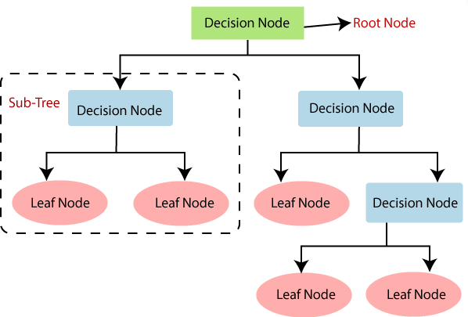
- It is a graphical representation for getting all the possible solutions to a problem/decision based on given conditions.

Why use Decision Trees?
- Decision Trees usually mimic human thinking ability while making a decision, so it is easy to understand.
- The logic behind the decision tree can be easily understood because it shows a tree- like structure.

Decision Tree Terminologies:
- Root Node: Root node is from where the decision tree starts. It represents the entiredataset, which further gets divided into two or more homogeneous sets.
- Leaf Node: Leaf nodes are the final output node, and the tree cannot be segregatedfurther after getting a leaf node.
- Splitting: Splitting is the process of dividing the decision node/root node into sub- nodes according to the given conditions.
- Branch/Sub Tree: A tree formed by splitting the tree.
- Pruning: Pruning is the process of removing the unwanted branches from the tree.
- Parent/Child node: The root node of the tree is called the parent node, and other nodesare called the child nodes.
How does the Decision Tree algorithm Work?
- Step-1: Begin the tree with the root node, says S, which contains the complete dataset.
- Step-2: Find the best attribute in the dataset using Attribute Selection Measure (ASM).
- Step-3: Divide the S into subsets that contains possible values for the best attributes.
- Step-4: Generate the decision tree node, which contains the best attribute.
- Step-5: Recursively make new decision trees using the subsets of the dataset created in step -3. Continue this process until a stage is reached where you cannot further classify the nodes and called the final node as a leaf node.
Attribute Selection Measure (ASM) Techniques:There are 2 popular techniques for Attribute Selection Measure (ASM). They are
- Entropy: Entropy measures the impurity of a collection of examples.

Where, p+ is the proportion of positive examples in S p– is the proportion of negative examples in S
- Information Gain: Information Gain is the expected reduction in entropy caused by partitioning the examples according to this attribute. The information gain, Gain(S, A) of an attribute A, relative to a collection of examples S, is defined as

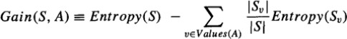
Where, Values (A) is the set of all possible values for attribute A SV is the subset of S for which attribute A has value v

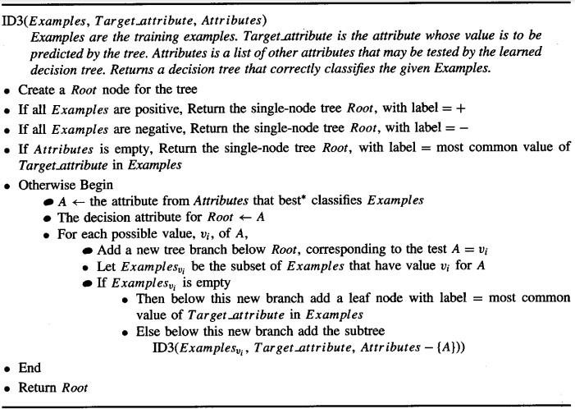
Decision tree based ID3 Algorithm:

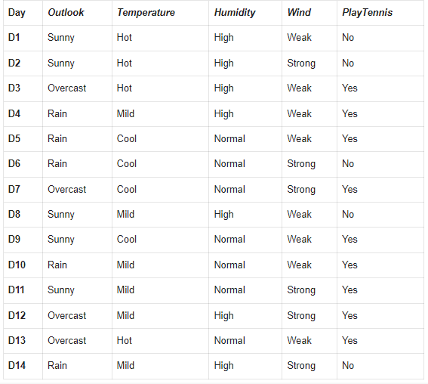
Example:

The above dataset consists of 14 examples& 4 attributes (Outlook, Temperature, Humidity, Wind).If we want to draw a decision tree using ID3 algorithm, first we need to understand which attribute is giving maximum information out of available attributes.
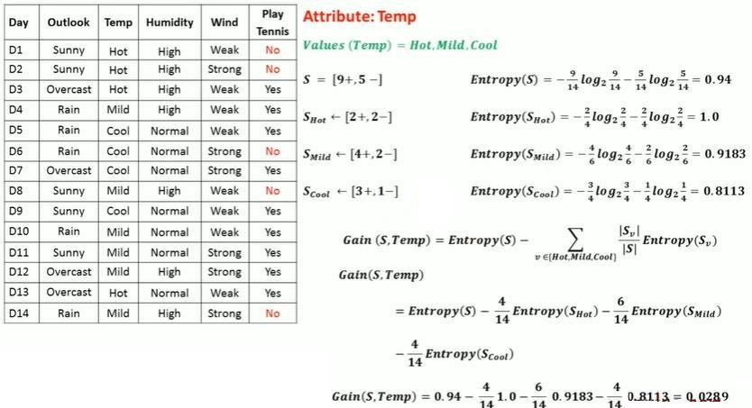
So, First we need to calculate the information gain of every attribute. The attribute which is having maximum information gain is considered as the root node. 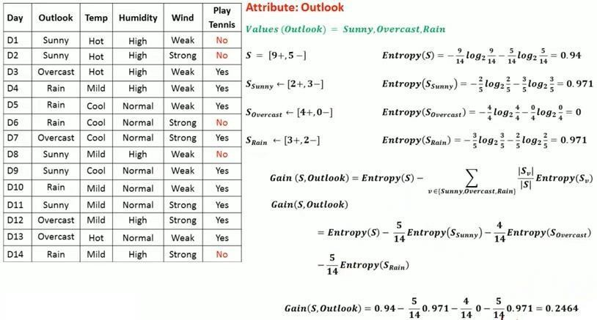
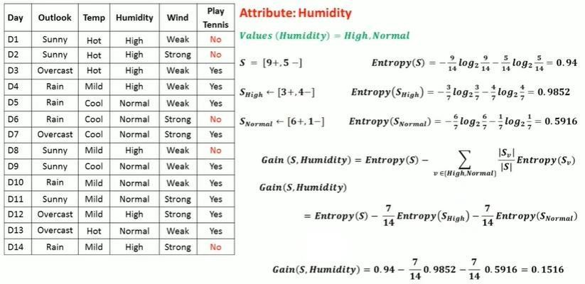
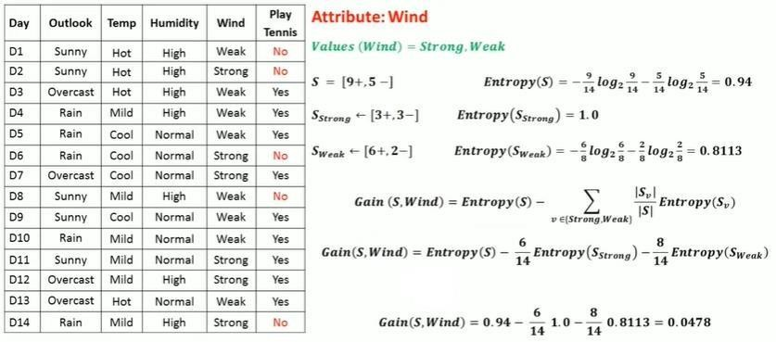

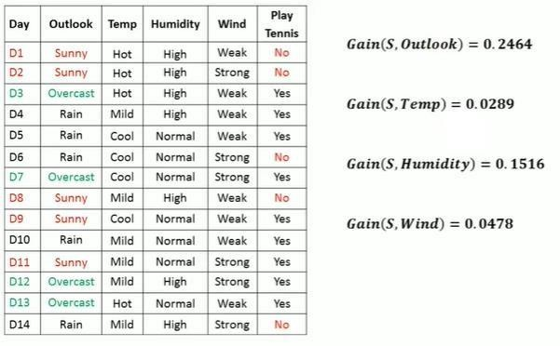

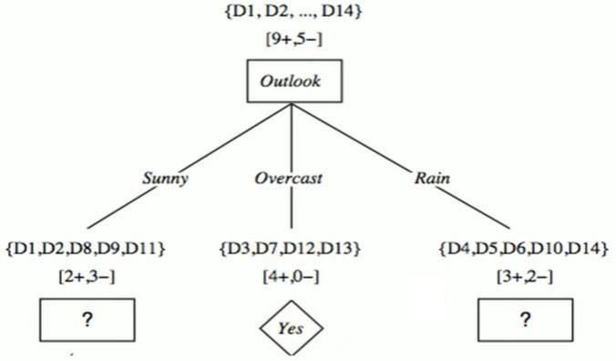
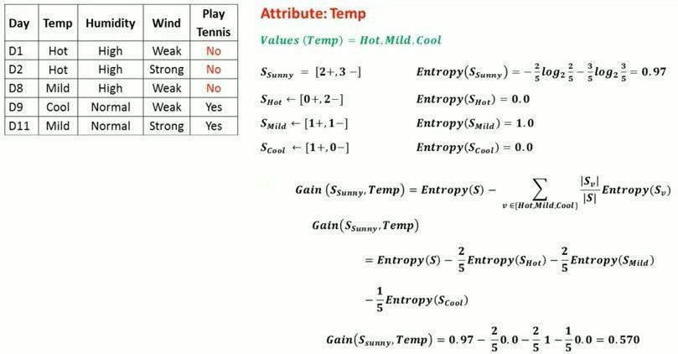
From the above, Outlook attribute has the maximum information gain. So, Outlook is the rootnode.

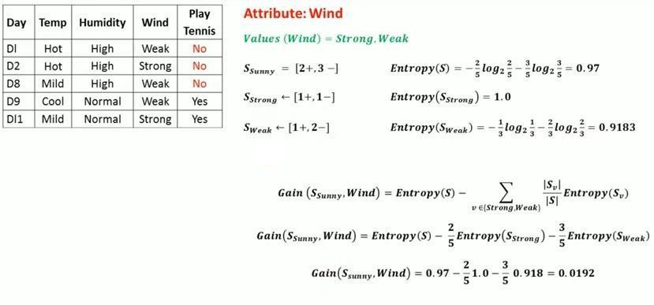
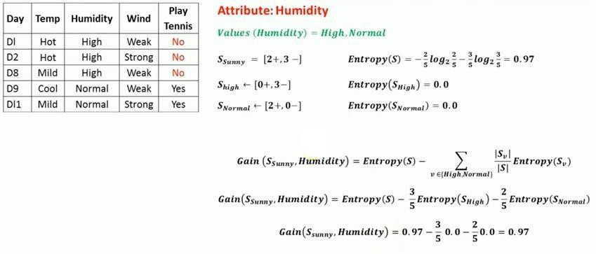
From the above, Humidity attribute has the maximum information gain. So, the tree is as follows
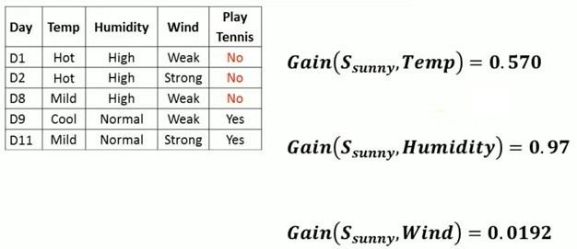
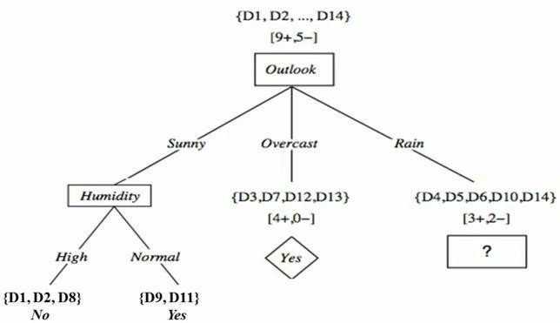
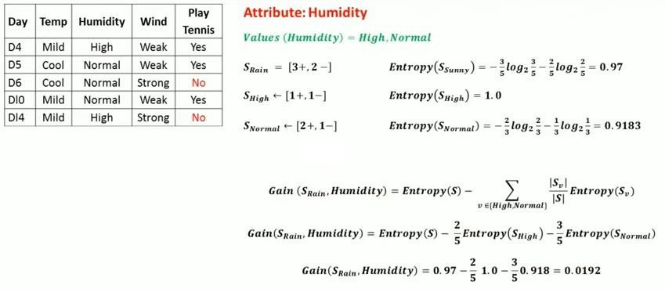

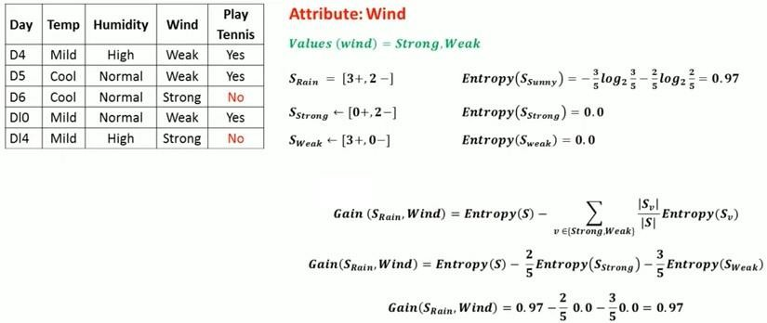
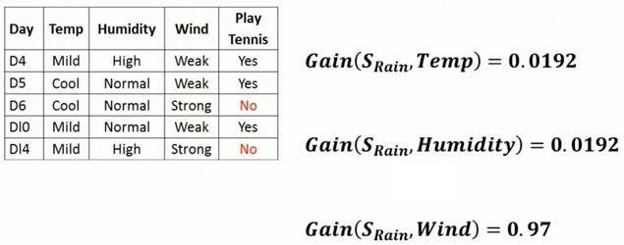
From the above, Wind attribute has the maximum information gain. Finally, the tree is asfollows
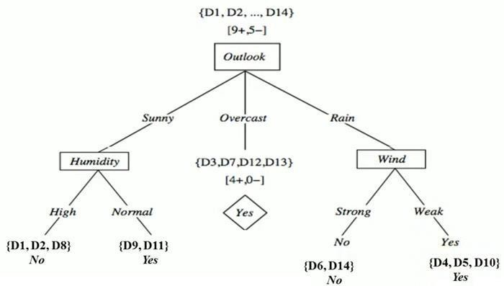

RANDOM FORESTS
Random Forest is a popular machine learning algorithm that belongs to the supervised learning technique. It can be used for both Classification and Regression problems in ML. It is based on the concept of ensemble learning, which is a process of combining multiple classifiers to solve a complex problem and to improve the performance of the model.
As the name suggests, "Random Forest is a classifier that contains a number of decision trees on various subsets of the given dataset and takes the average to improve the predictive accuracy of that dataset." Instead of relying on one decision tree, the random forest takes the prediction from each tree and based on the majority votes of predictions, and it predicts the final output.
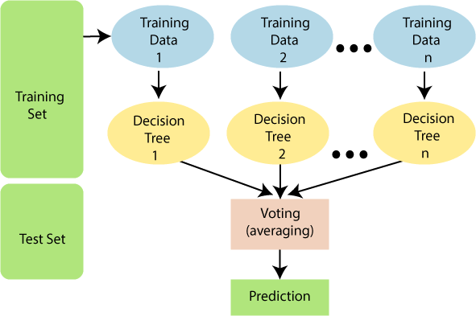
The greater number of trees in the forest leads to higher accuracy and prevents the problem of overfitting.

Working of Random Forest Algorithm:
Random Forest works in two-phase first is to create the random forest by combining N decision tree, and second is to make predictions for each tree created in the first phase. The Working process isas follows:
Step-1: Select random K data points from the training set.
Step-2: Build the decision trees associated with the selected data points (Subsets). Step-Step-3: Choose the number N for decision trees that you want to build.
Step-4: Repeat Step 1 & 2.
Step-5: For new data points, find the predictions of each decision tree, and assign the newdata points to the category that wins the majority votes.

Applications of Random Forest:
- Banking: Banking sector mostly uses this algorithm for the identification of loan risk.
- Medicine: With the help of this algorithm, disease trends and risks of the disease canbe identified.
- Land Use: We can identify the areas of similar land use by this algorithm.
- Marketing: Marketing trends can be identified using this algorithm.

Advantages of Random Forest:
- Random Forest is capable of performing both Classification and Regression tasks.
- It is capable of handling large datasets with high dimensionality.
- It enhances the accuracy of the model and prevents the overfitting issue.

Disadvantages of Random Forest:
- Although random forest can be used for both classification and regression tasks, it isnot more suitable for Regression tasks.

GRADIENT BOOSTING MACHINES
Machine learning is one of the most popular technologies to build predictive models for various complex regression and classification tasks. Gradient Boosting Machine (GBM) is considered one of the most powerful boosting algorithms. GBM is an ensemble method in machine learning which converts the weak learners into strong learners.
- Gradient Boosting Machine (GBM) is one of the most popular forward learning ensemble methods in machine learning. It is a powerful technique for building predictive models for regression and classification tasks.
- GBM helps us to get a predictive model in form of an ensemble of weak prediction models such as decision trees. Whenever a decision tree performs as a weak learner then the resulting algorithm is called gradient-boosted trees.
- It enables us to combine the predictions from various learner models and build a final predictive model having the correct prediction.

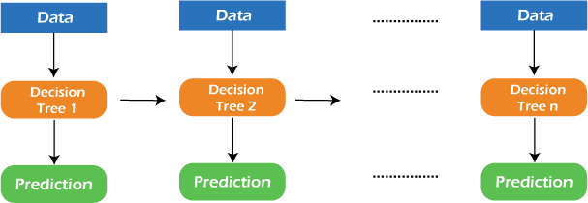

Working of Gradient Boosting Machine (GBM):
Generally, most supervised learning algorithms are based on a single predictive model such as linear regression, penalized regression model, decision trees, etc. But there are some supervised algorithms in ML that depend on a combination of various models together through the ensemble. In other words, when multiple base models contribute their predictions, an average of all predictions is adapted by boosting algorithms.Gradient boosting machines consists of 3 elements as follows:
- Loss function
- Weak learners
- Additive model
- Loss Function: The loss function in GBM plays a crucial role in guiding the learning process by quantifying the errors and providing a measure of how well the model is performing. The loss function used in GBM defines the discrepancy between the predicted values and the actual target values.
The goal of the GBM algorithm is to minimize this loss function iteratively by adding weak learners to the ensemble. The Classification of loss function is as follows:
  - Continuous response, y ∈ R:
    - Gaussian L2 loss function
    - Laplace L1 loss function
    - Huber loss function, δ specified
    - Quantile loss function, α specified
  - Categorical response, y ∈ {0, 1}:
    - Binomial loss function
    - Adaboost loss function
  - Other families of response variables:
    - Loss functions for survival models
    - Loss functions count data
    - Custom loss functions

- Weak Learners: Weak learners are the base learner models that learn from past errors and help in building a strong predictive model design for boosting algorithms in machine learning. Generally, decision trees work as a weak learners in boosting algorithms.
Boosting is defined as the framework that continuously works to improve the output from base models. Below is a sequence of training the weak learner to improve their performance where each tree is in the sequence with the previous tree's residuals.
  - Consider a data set and fit a decision tree into it.
F1(x)=y
  - Fit the next decision tree with the largest errors of the previous tree. h1(x)=y?F1(x)
  - Add this new tree to the algorithm by adding both in steps 1 and 2. F2(x)=F1(x)+h1(x)
  - Again fit the next decision tree with the residuals of the previous tree. h2(x)=y?F2(x)
  - Repeat the same which we have done in step 3.
F3(x)=F2(x)+h2(x)
Continue this process until some mechanism (i.e. cross-validation) tells us to stop. The final model here is a stagewise additive model of b individual trees:
f(x)=B∑b=1fb(x)

Hence, trees are constructed greedily, choosing the best split points based on purity scores like Gini or minimizing the loss.
- Additive Model: The additive model is defined as adding trees to the model. Although we should not add multiple trees at a time, only a single tree must be added so that
existing trees in the model are not changed. Further, we can also prefer the gradient descent method by adding trees to reduce the loss.

Extreme Gradient Boosting Machine (XGBM):
XGBM is the latest version of gradient boosting machines which also works very similar to GBM. In XGBM, trees are added sequentially (one at a time) that learn from the errors of previous trees and improve them.

Light Gradient Boosting Machines (Light GBM):
Light GBM is a more upgraded version of the Gradient boosting machine due to its efficiency and fast speed. Unlike GBM and XGBM, it can handle a huge amount of data without any complexity. On the other hand, it is not suitable for those data points that are lesser in number.
CATBOOST:
The catboost algorithm is primarily used to handle the categorical features in a dataset. Although GBM, XGBM, and Light GBM algorithms are suitable for numeric data sets, Catboost is designed to handle categorical variables into numeric data.

Advantages of Boosting Algorithms:
- Boosting algorithms follow ensemble learning which enables a model to give a more accurate prediction that cannot be trumped.
- Boosting algorithms are much more flexible than other algorithms as can optimize different loss functions and provides several hyperparameter tuning options.
- It does not require data pre-processing because it is suitable for both numeric as well as categorical variables.
- It does not require imputation of missing values in the dataset, it handles missing data automatically.

Disadvantages of Boosting Algorithms:
- Boosting algorithms may cause overfitting as well as overemphasizing the outliers.
- Gradient boosting algorithm continuously focuses to minimize the errors and requires multiple trees hence, it is computationally expensive.
- It is a time-consuming and memory exhaustive algorithm.
- Less interpretative in nature, although this is easily addressed with various tools.
FUNDAMENTALS OF MACHINE LEARNING
Machine learning is a field of computer science and artificial intelligence that enables computer systems to automatically learn and improve from experience without being explicitly programmed.
Definition: “A computer program is said to learn from experience E with respect to some class of tasks T and performance measure P, if its performance at tasks in T, as measured by P, improves with experience E”.
The fundamentals of Machine Learning are:
- Data: Machine learning starts with data. It could be any form of structured or unstructured data, such as images, text, numbers, etc. This data is used to train the machine learning model.
- Features: Features are the individual measurable properties or characteristics of the data. The selection and extraction of relevant features from the data are crucial for building effective models.
- Labeling: In supervised learning, a dataset is labeled, meaning that each data point is associated with a corresponding "label" or "target" that the model needs to learn to predict.
- Training Data: The labeled data used to train the model is called the training dataset. The model learns patterns and relationships from this data.
- Model: A model is a mathematical representation that captures the relationships between the input data (features) and the target labels.
- The goal of training is to find the model's parameters that best fit the data.
- Algorithm: Machine learning algorithms are the set of rules and instructions that guide the model to adjust its parameters during training. Different algorithms are suited for different types of problems and data.
- Training: Training involves feeding the algorithm with the training data and allowing it to adjust its parameters iteratively to minimize the difference between predicted outputs and actual labels.
- Validation: After training, the model's performance is assessed on a separate dataset called the validation set. This helps in tuning hyper parameters and preventing overfitting (when the model memorizes the training data instead of generalizing).
- Testing: Once the model is tuned and validated, it's evaluated on a test dataset that it has never seen before. This provides an unbiased assessment of its generalization ability.
- Predictions: Once the model is trained and validated, it can be used to make predictions on new, unseen data.
- Evaluation Metrics: To quantify the model's performance, various evaluation metrics are used. These metrics depend on the problem type (classification, regression,
etc.) and can include accuracy, precision, recall, F1-score, mean squared error, etc.
- Overfitting and Underfitting: Overfitting occurs when the model learns noise and random fluctuations from the training data, leading to poor generalization on new data. Underfitting, on the other hand, happens when the model is too simple to capture the underlying patterns in the data.
- Bias-Variance Trade-off: Finding the right balance between bias (simplification of the model) and variance (complexity of the model) is essential to ensure the model generalizes well.
- Feature Engineering: The process of selecting, transforming, and creating relevant features from raw data can significantly impact the performance of a machine learning model.
- Ensemble Methods: Techniques like bagging, boosting, and stacking involve combining multiple models to improve predictive performance.
- Regularization: Regularization techniques are used to prevent overfitting by introducing penalties for large parameter values in the model.

FOUR BRANCHES OF MACHINE LEARNING
The types (or) classification of Machine Learning are:
- Supervised Learning
- Unsupervised Learning
- Semi-Supervised Learning
- Reinforcement Learning

Supervised Learning: Supervised learning is a type of machine learning method in which we provide sample labeled data to the machine learning system in order to train it, and on that basis, it predicts the output.
The system creates a model using labeled data to understand the datasets and learn about each data, once the training and processing are done then we test the model by providing a sample data to check whether it is predicting the exact output or not.
The goal of supervised learning is to map input data with the output data. The supervised learning is based on supervision, and it is the same as when a student learns things in the supervision of the teacher. The example of supervised learning is spam filtering. Supervised learning can be grouped further in two categories of algorithms:
- Regression: Regression algorithms are used if there is a relationship between the input variable and the output variable. It is used for the prediction of continuous variables, such as Weather forecasting, Market Trends etc
Linear Regression
  - Regression Trees
  - Non-Linear Regression
  - Bayesian Linear Regression
  - Polynomial Regression
Classification: Classification algorithms are used when the output variable is categorical, which means there are two classes such as Yes-No, Male-Female, True- false, etc.
  - Random Forest
  - Decision Trees
  - Logistic Regression
  - Support vector Machines
Advantages of Supervised Learning:
- With the help of supervised learning, the model can predict the output on the basis of prior experiences
- In supervised learning, we can have an exact idea about the classes of objects
- Supervised learning model helps us to solve various real-world problems such as fraud detection, spam filtering, etc
Disadvantages of Supervised Learning:
- Supervised learning models are not suitable for handling the complex tasks
- Supervised learning cannot predict the correct output if the test data is different from the training dataset
- Training required lots of computation times
- In supervised learning, we need enough knowledge about the classes of object

Unsupervised Learning: Unsupervised learning is a learning method in which a machine learns without any supervision.
The training is provided to the machine with the set of data that has not been labeled, classified, or categorized, and the algorithm needs to act on that data without any supervision. The goal of unsupervised learning is to restructure the input data into new features or a group of objects with similar patterns.
In unsupervised learning, we don't have a predetermined result. The machine tries to find useful insights from the huge amount of data. It can be further classifieds into two categories of algorithms:
- Clustering: Clustering is a method of grouping the objects into clusters such that objects with most similarities remains into a group and has less or no similarities with the objects of another group. Cluster analysis finds the commonalities between the data objects and categorizes them as per the presence and absence of those commonalities.
  - K-Means Clustering algorithm
  - Mean-shift algorithm
  - DBSCAN Algorithm
  - Principal Component Analysis
  - Independent Component Analysis
- Association: An association rule is an unsupervised learning method which is used for finding the relationships between variables in the large database. It determines the set of items that occurs together in the dataset. Association rule makes marketing strategy more effective. Such as people who buy X item (suppose a bread) are also tend to purchase Y (Butter/Jam) item. A typical example of Association rule is Market Basket Analysis.
  - Apriori algorithm
  - FP-growth algorithm
Advantages of Unsupervised Learning:
- Unsupervised learning is used for more complex tasks as compared to supervised learning because, in unsupervised learning, we don't have labeled input data.
- Unsupervised learning is preferable as it is easy to get unlabeled data in comparison to labeled data.
Disadvantages of Unsupervised Learning:
- Unsupervised learning is intrinsically more difficult than supervised learning as it does not have corresponding output.
- The result of the unsupervised learning algorithm might be less accurate as input data is not labeled, and algorithms do not know the exact output in advance.
Semi-Supervised Learning: To overcome the drawbacks of supervised learning and unsupervised learning algorithms, the concept of Semi-supervised learning is introduced.
The main aim of semi-supervised learning is to effectively use all the available data, rather than only labeled data like in supervised learning. Initially, similar data is clustered along with an unsupervised learning algorithm, and further, it helps to label the unlabeled data into labeled data.

Advantages of Semi-Supervised Learning:
- It is simple and easy to understand the algorithm
- It is highly efficient
- It is used to solve drawbacks of Supervised and Unsupervised Learning algorithms

Disadvantages of Semi-Supervised Learning:
- Iterations results may not be stable
- We cannot apply these algorithms to network-level data
- Accuracy is low
Reinforcement Learning: Reinforcement learning is a feedback-based learning method, in which a learning agent gets a reward for each right action and gets a penalty for each wrong action. The agent learns automatically with these feedbacks and improves its performance.
In reinforcement learning, the agent interacts with the environment and explores it. The goal of an agent is to get the most reward points, and hence, it improves its performance. The robotic dog, which automatically learns the movement of his arms, is an example of Reinforcement learning.

Advantages of Reinforcement Learning:
- It helps in solving complex real-world problems which are difficult to be solved by general techniques
- The learning model of RL is similar to the learning of human beings; hence most accurate results can be found
- Helps in achieving long term results

Disadvantages of Reinforcement Learning:
- RL algorithms are not preferred for simple problems
- RL algorithms require huge data and computations
- Too much reinforcement learning can lead to an overload of states which can weaken the results

EVALUATING MACHINE LEARNING MODELS

Performance Metrics for Classification:
Confusion Matrix: The confusion matrix is a matrix used to determine the performance of the classification models for a given set of test data. It can only be determined if the true values for test data are known.
N=total Predictions | Actual : Positive | Actual : Negative
Predicted : Positive | True Positive | False Positive
Predicted : Negative | False Negative | True Negative

- True Negative: Model has given prediction No, and the real or actual value was also No.
- True Positive: The model has predicted Yes, and the actual value was also Yes.
- False Negative: The model has predicted No, but the actual value was Yes, it is also called as Type-II error.
- False Positive: The model has predicted Yes, but the actual value was No. It is also called a Type-I error.
Example of Confusion Matrix is as follows:

N=165 | Actual : Positive | Actual : Negative
Predicted : Positive | 100 | 10
Predicted : Negative | 5 | 50

In this example, the total number of predictions is 165, out of which 110 times predicted Yes, whereas 55 times predicted No. However, in reality, 60 cases in which patients don't have the disease, whereas 105 cases in which patients have the disease.
- Classification Accuracy:It is one of the important parameters to determine the accuracy of the classification problems. It defines how often the model predicts the correct output.
It can be calculated as the ratio of the number of correct predictions made by the classifier to all number of predictions made by the classifiers.
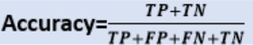

- Precision: It can be defined as the number of correct outputs provided by the model or out of all positive classes that have predicted correctly by the model, how many of them were actually true.
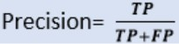

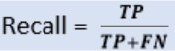
- Recall (or) Sensitivity: It is defined as the out of total positive classes, how our model predicted correctly. The recall must be as high as possible.
- F-Score: If two models have low precision and high recall or vice versa, it is difficult to compare these models. So, for this purpose, we can use F-score. This score helps us to evaluate the recall and precision at the same time. The F-score is maximum if the recall is equal to the precision.
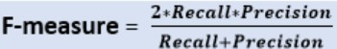

- AUC (Area Under the Curve)-ROC: Sometimes we need to visualize the performance of the classification model on charts; then, we can use the AUC-ROC curve. Firstly, ROC means Receiver Operating Characteristic curve. ROC represents a graph to show the performance of a classification model at different threshold levels. The curve is plotted between two parameters, which are:
  - True Positive Rate: TPR or true Positive rate is a synonym for Recall, hence can be calculated as:
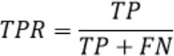
  - False Positive Rate: FPR or False Positive Rate can be calculated as:
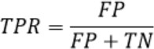
AUC is known for Area Under the ROC curve. As its name suggests, AUC calculates the two-dimensional area under the entire ROC curve, as shown below image:
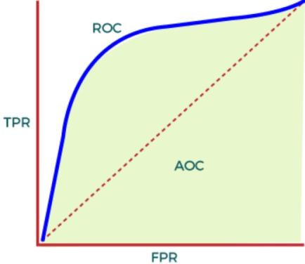
AUC calculates the performance across all the thresholds and provides an aggregate measure. The value of AUC ranges from 0 to 1. It means a model with 100% wrong prediction will have an AUC of 0.0, whereas models with 100% correct predictions will have an AUC of 1.0.

Performance Metrics for Regression:
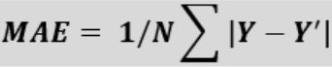
- Mean Absolute Error: Mean Absolute Error or MAE is one of the simplest metrics, which measures the absolute difference between actual and predicted values, where absolute means taking a number as Positive.
Here, Y is the Actual outcome, Y' is the predicted outcome, and N is the total number of data points.
- Mean Squared Error: Mean Squared error or MSE is one of the most suitable metrics for Regression evaluation. It measures the average of the Squared difference between predicted values and the actual value given by the model.
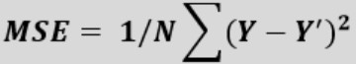

- R2 Score: R squared error is also known as Coefficient of Determination, which is another popular metric used for Regression model evaluation. The R-squared metric enables us to compare model with a constant baseline to determine the performance of the model. To select the constant baseline, we need to take the mean of the data and draw the line at the mean. The R squared score will always be less than or equal to 1 without concerning if the values are too large or small.
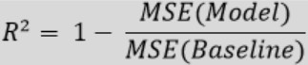

- Adjusted R2: Adjusted R squared, as the name suggests, is the improved version of R squared error. R square has a limitation of improvement of a score on increasing the terms, even though the model is not improving, and it may mislead the data scientists.
To overcome the issue of R square, adjusted R squared is used, which will always show a lower value than R². It is because it adjusts the values of increasing predictors and only shows improvement if there is a real improvement.
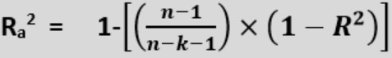

Here, n is the number of observations, k denotes the number of independent variables and Ra2 denotes the adjusted R²

OVERFITTING AND UNDERFITTING
Overfitting and Underfitting are the two main problems that occur in machine learning and degrade the performance of the machine learning models.

Basic terms:
- Signal: It refers to the true underlying pattern of the data that helps the machine learning model to learn from the data.
- Noise: Noise is unnecessary and irrelevant data that reduces the performance of the model.
- Bias: Bias is a prediction error that is introduced in the model due to oversimplifying the machine learning algorithms. Or it is the difference between the predicted values and the actual values.
- Variance: If the machine learning model performs well with the training dataset, but does not perform well with the test dataset, then variance occurs.

Overfitting:
Overfitting occurs when our machine learning model tries to cover all the data points or more than the required data points present in the given dataset. Because of this, the model starts caching noise and inaccurate values present in the dataset, and all these factors reduce the efficiency and accuracy of the model. The overfitted model has low bias and high variance.
The chances of occurrence of overfitting increase as much we provide training to our model. It means the more we train our model, the more chances of occurring the overfitted model. Overfitting is the main problem that occurs in supervised learning.
Example:

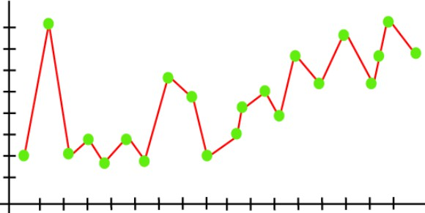
From the above graph, the model tries to cover all the data points present in the scatter plot. It may look efficient, but in reality, it is not so. Because the goal of the regression model to find the best fit line, but here we have not got any best fit, so, it will generate the prediction errors.
How to avoid the Overfitting in Model:
Both overfitting and underfitting cause the degraded performance of the machine learning model. But the main cause is overfitting, so there are some ways by which we can reduce the occurrence of overfitting in our model.
- Cross-Validation
- Training with more data
- Removing features
- Early stopping the training
- Regularization
- Ensembling
Underfitting:
Underfitting occurs when our machine learning model is not able to capture the underlying trend of the data. To avoid the overfitting in the model, the fed of training data can be stopped at an early stage, due to which the model may not learn enough from the training data. As a result, it may fail to find the best fit of the dominant trend in the data.

In the case of underfitting, the model is not able to learn enough from the training data, and hence it reduces the accuracy and produces unreliable predictions. An underfitted model has high bias and low variance.
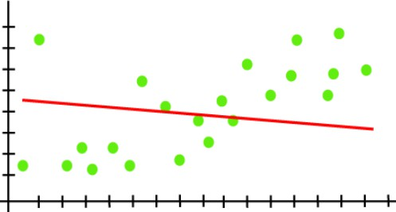
Example:

From the above graph, the model is unable to capture the data points present in the
plot.

How to avoid Underfitting:
- By increasing the training time of the model
- By increasing the number of features

