Syllabus:
Neural Networks: Anatomy of Neural Network
Introduction to Keras: Keras, TensorFlow, Theano and CNTK, Setting up Deep Learning Workstation
Classifying Movie Reviews: Binary Classification, Classifying newswires: Multiclass Classification

Anatomy of a neural network
Training a neural network revolves around the following objects:
- Layers, which are combined into a network (or model)
- The input data and corresponding targets
- The loss function, which defines the feedback signal used for learning
- The optimizer, which determines how learning proceeds
You can visualize their interaction as illustrated in figure 3.1: the network, composed of layers that are chained together, maps the input data to predictions.
The loss function then compares these predictions to the targets, producing a loss value: a measure of how well the network’s predictions match what was expected.
The optimizer uses this loss value to update the network’s weights.
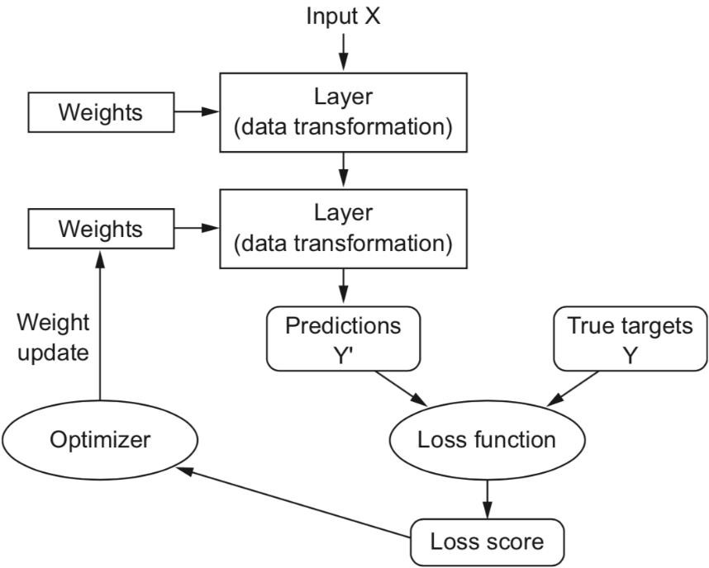

Relationship between the network, layers, loss function and optimizer

Layers: the building blocks of deep learning
The fundamental data structure in neural networks is the layer.
A layer is a data-processing module that takes as input one or more tensors and that outputs one or more tensors. Some layers are stateless, but more frequently layers have a state.
Different layers are appropriate for different tensor formats and different types of data processing.
For instance, simple vector data, stored in 2D tensors of shape (samples, features), is often processed by densely connected layers, also called fully connected or dense layers (the Dense class in Keras). Sequence data, stored in 3D tensors of shape (samples, timesteps, features), is typically processed by recurrent layers such as an LSTM layer. Image data, stored in 4D tensors, is usually processed by 2D convolution layers (Conv2D).
Building deep-learning models in Keras is done by clipping together compatible layers to form useful data-transformation pipelines.
Consider the following example
We’re creating a layer that will only accept as input 2D tensors where the first dimension is 784 (axis 0, the batch dimension, is unspecified, and thus any value would be accepted). This layer will return a tensor where the first dimension has been transformed to be 32.
When using Keras, you don’t have to worry about compatibility, because the layers you add to your models are dynamically built to match the shape of the incoming layer. For instance, suppose you write the following
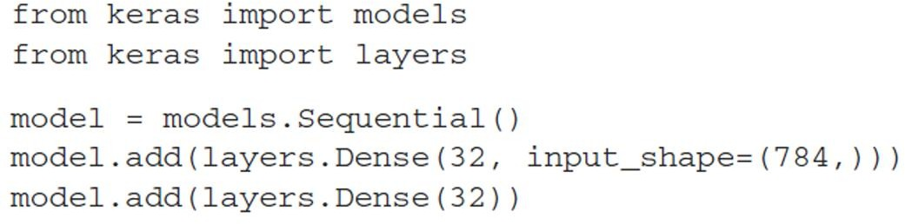
The second layer didn’t receive an input shape argument—instead, it automatically inferred its input shape as being the output shape of the layer that came before.

Models: networks of layers
A deep-learning model is a directed, acyclic graph of layers. The most common instance is a linear stack of layers, mapping a single input to a single output.
But as you move forward, you’ll be exposed to a much broader variety of network topologies. Some common ones include the following:
- Two-branch networks

- Multihead networks
- Inception blocks
Picking the right network architecture is more an art than a science; and although there are some best practices and principles you can rely on, only practice can help you become a proper neural-network architect.

Loss functions and optimizers: keys to configuring the learning process
Once the network architecture is defined, you still have to choose two more things:
- Loss function (objective function)—The quantity that will be minimized during training. It represents a measure of success for the task at hand.
- Optimizer—Determines how the network will be updated based on the loss function.

KERAS
Keras is a deep-learning framework for Python that provides a convenient way to define and train almost any kind of deep-learning model. Keras was initially developed for researchers, with the aim of enabling fast experimentation.
Keras has the following key features:
  - It allows the same code to run seamlessly on CPU or GPU.
  - It has a user-friendly API that makes it easy to quickly prototype deep-learning models.
  - It has built-in support for convolutional networks (for computer vision), recurrent networks (for sequence processing), and any combination of both.
  - It supports arbitrary network architectures: multi-input or multi-output models, layer sharing, model sharing, and so on. This means Keras is appropriate for building essentially any deep learning model, from a generative adversarial network to a neural Turing machine.
Keras is distributed under the permissive MIT license, which means it can be freely used in commercial projects. It’s compatible with any version of Python from 2.7 to 3.6 (as of mid-2017).
Keras has well over 200,000 users, ranging from academic researchers and engineers at both startups and large companies to graduate students and hobbyists.
Keras is used at Google, Netflix, Uber, CERN, Yelp, Square, and hundreds of startups working on a wide range of problems. Keras is also a popular framework on Kaggle, the machine-learning competition website, where almost every recent deep-learning competition has been won using Keras models.

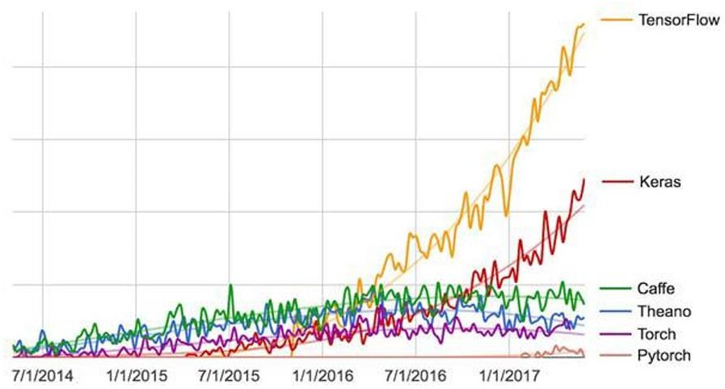
Figure: Google web search interest for different deep-learning frameworks over time

Keras, TensorFlow, Theano, and CNTK
Keras is a model-level library, providing high-level building blocks for developing deep-learning models.
It doesn’t handle low-level operations such as tensor manipulation and differentiation. Instead, it relies on a specialized, well-optimized tensor library to do so, serving as the backend engine of Keras. Rather than choosing a single tensor library and tying the implementation of Keras to that library, Keras handles the problem in a modular way (see figure 3.3); thus several different backend engines can be plugged seamlessly into Keras.
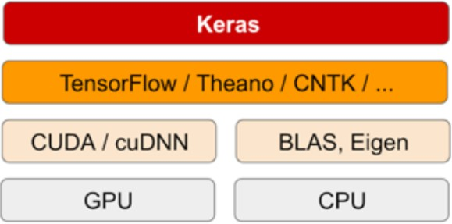

Figure: The deep learning software and hardware stack
Currently, the three existing backend implementations are the TensorFlow backend, the Theano backend, and the Microsoft Cognitive Toolkit (CNTK) backend. In the future, it’s likely that Keras will be extended to work with even more deep-learning execution engines.
    - TensorFlow, CNTK, and Theano are some of the primary platforms for deep learning today.
    - Theano (http://deeplearning.net/software/theano) is developed by the MILA lab at Université de Montréal, TensorFlow (www.tensorflow.org) is developed by Google, and
    - CNTK (https://github.com/Microsoft/CNTK) is developed by Microsoft

Any piece of code that you write with Keras can be run with any of these backends without having to change anything in the code.

Developing with Keras: a quick overview
You’ve already seen one example of a Keras model: the MNIST example. The typical Keras workflow looks just like that example:
- Define your training data: input tensors and target tensors.
- Define a network of layers (or model) that maps your inputs to your targets.
- Configure the learning process by choosing a loss function, an optimizer, and some metrics to monitor.
- Iterate on your training data by calling the fit() method of your model.
There are two ways to define a model: using the Sequential class (only for linear stacks of layers, which is the most common network architecture by far) or the functional API (for directed acyclic graphs of layers, which lets you build completely arbitrary architectures).

Keras Overview of Deep learning
Deep learning is an advanced field of Machine Learning that involves the analysis of input in a layering manner. This way each layer is used to extract deep information about the input provided to the learning model. With the help of Deep Learning, a large amount of data can be processed very smoothly. That is the reason for using deep learning algorithms for the analysis of unstructured data because the analysis of structured data doesn’t require much processing power, but for unstructured data, the deep learning algorithm works best. There are some topics that revolve around deep learning that include:
  - ANN: It is called an Artificial Neural Network. ANN is the main approach of using deep learning. The ANN models are just like the human brain where the main role is of dendrites that receive and transmits the information using axons to other neurons. This way the information is processed among other neurons.
  - CNN: CNN stands for Convolutional Neural Network which is widely used for image and video recognition. The CNN is based on a mathematical concept which is similar to a multi-layer perceptron. CNN has three important layers that include Convolution, Pooling, and Fully Connected layers.
  - RNN: RNN is an abbreviation used for Recurrent Neural Network which is used to address the flaws that are found in other ANN models. The approach is mainly used in image classification.

Keras Deep learning
Keras is based on deep learning that allows you to create any kind of neural network. Keras support neural networks that are very simple as well as complex. To better understand the working of the Keras framework, you can refer to the following Architecture of Keras:
There are three main API layers of Keras architecture that are described as follows:
  - Model API: There are two types of Keras models, i.e. Sequential and Functional. The sequential model is a linear composition of all layers of the Keras model. It is easy to implement and allows you to show all available neural networks. The Functional API model is simply used to create complex deep-learning models.

  - Core Modules API: There is a huge number of built-in neural network functions that contribute to creating the Keras model and its layers. These functions are based on some models, such as the Optimizer module, Regularizers, Activations module, and loss module.
  - Layer API: There are several built-in layers in Keras that are used to create a complex neural network. Some important layers include Core layers, pooling layers, convolution layers, and recurrent layers.

Keras Modules
There are various modules that can be used in Keras. These modules are as follows:
  - Activations: In this module, there is a list of activator functions that are used to create Keras- based models.
  - Initializers: It provides a list of initializer functions that provides initial weight to different functions.
  - Regularizers: Regularizers are used in the optimization phase where it applies some penalties on layer parameters.
  - Optimizers: In this list, you will get a list of optimizers that are used to optimize the input weights.
  - Callback: This module provides a callback function that can be used while training the model.
  - Losses: This function is used to find errors or deviations in the process of learning. The loss function is required at the time of the model compilation process.
  - Image processing: Images can be converted into NumPy arrays with the help of this module. It is used in the data preparation phase.
  - Text Processing: Text can be converted into NumPy arrays by using the Text Processing module. It is also used in the data preparation phase.
  - Sequence Processing: This module provides functions that are used to generate time-based data with a given input.
  - Utilities: Several utilities in deep learning are provided in this module.
  - Backend: It provides functions of backend libraries like Theano and TensorFlow.

Keras Layers
Keras layers need input data to perform some computations and provide the output results. There are some requirements to create a complete layer which are as follows:
  - Input Shape: The input shape refers to the type of data that we provide as input in machine learning. This data can be of any type, such as image, text, or video. This input data is converted into an array of numbers that work as input for the learning algorithm. The dimensions of the input data can be specified with the help of a shape tuple. The following example will give you a clear understanding of how you can get the shape in two dimensions for an input array of numbers:
Initializers: Initializers are used to assign weight to input data. There are some functions that assign these weights to that input data. Some of these functions include:
  - Random Normal: It is used to generate values using the normal distribution of the data we provided as input for the learning model.
  - Random Uniform: This function is used to generate values with the help of uniform distribution of the input data.
  - Zeros: As the name suggests, it generates zeros for all the input data.
  - Ones: It generates ones for all input data.

  - Constants: Here, the function generates constant values specified by the user.
- Regularizers: Regularizers are used to apply penalties on layers at the time of optimization and therefore, these are used in the optimization phase.
- Activations: Activation is a function that allows you to find the status of a specific neuron and whether it is activated or not. The activation function is used to make nonlinear transformations of the input data which then allows the neuron to learn models better. Some activation functions are also described below:
  - linear: This applies a linear function as follows: from keras.models import Sequential
from keras.layers import Activation, Dense

Keras Customized Layer
In Keras, you can also create a customized layer with the help of its baselayer.
Step – 1: Import required modules
  - The necessary modules can be imported with the following code:
  - from keras import backend as ker
  - from keras.layers import Layer Step – 2: Create and initialize a layer class
To create and initialize a layer class, follow the code snippet below: class LayerCustom (Layer):
The class can be initiated with the following code: Step – 3: Define the build method
The build method can be implemented by using the code below: Step – 4: Define the call method
The call method is used to implement the exact working of the layer while training the model. The custom call that we created is as follows:
Step – 5: Define the compute_output_shape method The method can be implemented as follows:
def compute_output_shape (self, inp_shp): return (inp_shp[0], self.dim)
After implementing all these steps, we are going to create a simple model with the help of our customized layer below:
from keras.models import Sequential from keras.layers import Dense

TENSERFLOW

What is TensorFlow?
TensorFlow is an open-source library developed by Google primarily for deep learning applications. It also supports traditional machine learning. TensorFlow was originally developed for large numerical computations without keeping deep learning in mind. However, it proved to be very useful for deep learning development as well, and therefore Google open-sourced it.
TensorFlow accepts data in the form of multi-dimensional arrays of higher dimensions called tensors. Multi-dimensional arrays are very handy in handling large amounts of data.
TensorFlow works on the basis of data flow graphs that have nodes and edges. As the execution mechanism is in the form of graphs, it is much easier to execute TensorFlow code in a distributed manner across a cluster of computers while using GPUs.

History of TensorFlow
TensorFlow was first made public in 2015, while the first stable version appeared on February 11, 2017. It is created and maintained by Google. Ever since then, it has become one of the most popular frameworks for deep learning and machine learning projects. It has a vast library for large-scale machine learning and numerical computation. Here are some moremilestones of TensorFlow:
  - In December 2017, Kubeflow is released for the operation and deployment of TensorFlowon Kubernetes.
  - In March 2018, TensorFlow 1.0 was released for machine learning in JavaScript.
  - In Jan 2019, TensorFlow 2.0 is released which adds a number of components to TensorFlow.
  - In May 2019, TensorFlow Graphic was released for deep learning in computer graphics.

Why TensorFlow?
TensorFlow Offers Both C++ and Python API’s
Before the development of libraries, the coding mechanism for machine learning and deep learning was much more complicated. This library provides a high-level API, and complex coding isn’t needed to prepare a neural network, configure a neuron, or program a neuron. The library completes all of these tasks. TensorFlow also has integration with Java and R.

TensorFlow Supports Both CPUs and GPUs Computing Devices
Deep learning applications are very complicated, with the training process requiring a lot of computation. It takes a long time because of the large data size, and it involves several iterative processes, mathematical calculations, matrix multiplications, and so on. If you perform these activities on a normal Central Processing Unit (CPU), typically it would take much longer.
Graphical Processing Units (GPUs) are popular in the context of games, where you need the screen and image to be of high resolution. GPUs were originally designed for this purpose. However, they are being used for developing deep learning applications as well.
One of the major advantages of TensorFlow is that it supports GPUs, as well as CPUs. It also has a faster compilation time than other deep learning libraries, like Keras and Torch.

How TensorFlow Works
TensorFlow allows you to create dataflow graphs that describe how data moves through a graph. The graph consists of nodes that represent a mathematical operation. A connection or edge between nodes

is a multidimensional data array. It takes inputs as a multi-dimensional array where you can construct a flowchart of operations that can be performed on these inputs.

TensorFlow Architecture
Tensorflow architecture works in three significant steps:
  - Data pre-processing - structure the data and brings it under one limiting value
  - Building the model - build the model for the data
  - Training and estimating the model - use the data to train the model and test it with unknown data.

Components of TensorFlow
Tensor: Tensor forms the core framework of TensorFlow. All the computations in TensorFlow involve tensors. It is a matrix of n-dimensions that represents multiple types of data. A tensor can be the result of a computation or it can originate from the input data.
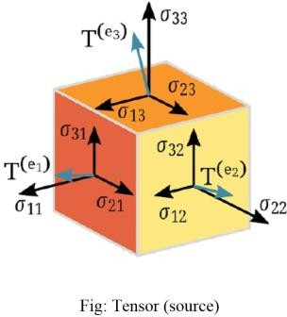

Graphs
Graphs describe all the operations that take place during the training. Each operation is calledan op node and is connected to the other. The graph shows the op nodes and the connections between the nodes, but it does not display values.
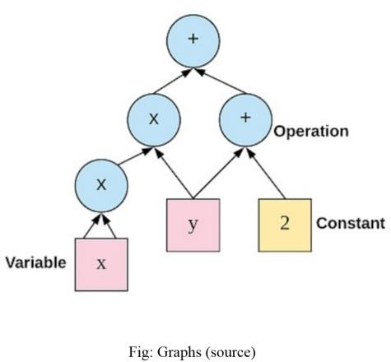

What are Tensors?
Tensor is a generalization of vectors and matrices of potentially higher dimensions. Arrays of data with varying dimensions and ranks that are fed as input to the neural network are called tensors.

For deep learning, especially in the training process, you will have large amounts of data that exist in a very complicated format. It helps when you are able to put, use, or store it in a compact way, which tensors provide, even if they appear in multi-dimensional arrays. When the data is stored in tensors and fed into the neural network, the output we get is as shown below:
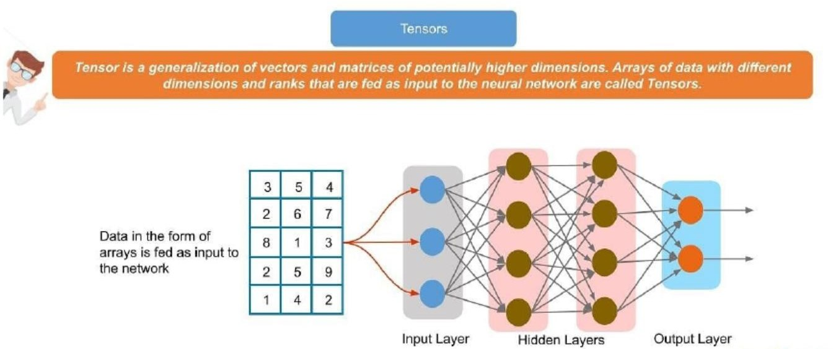

There are some terms associated with tensors that we need to familiarize ourselves with:

Dimension - Dimension is the size of the array elements. Below you can take a look at various types of dimensions:
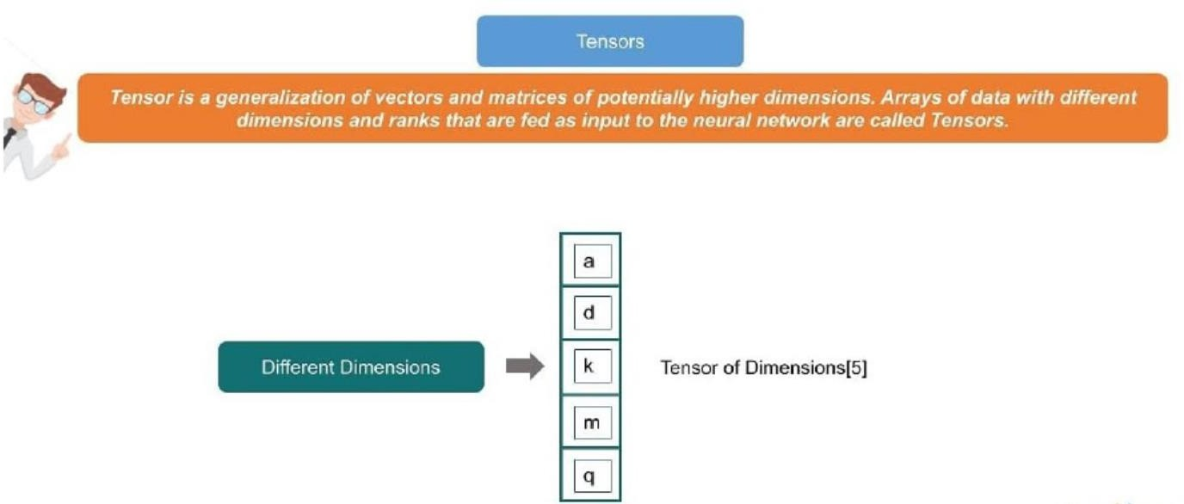

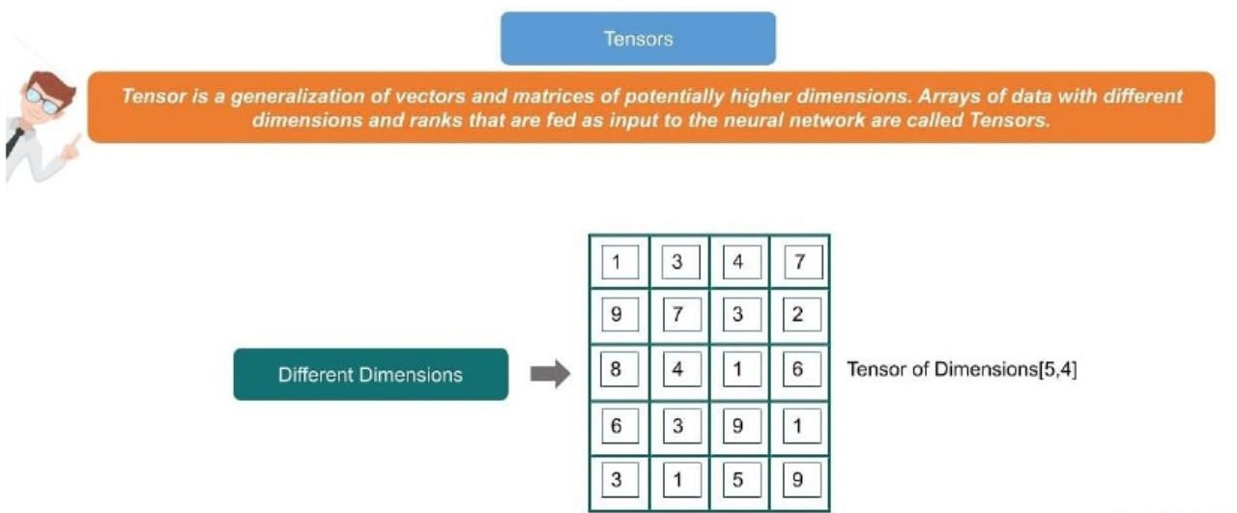

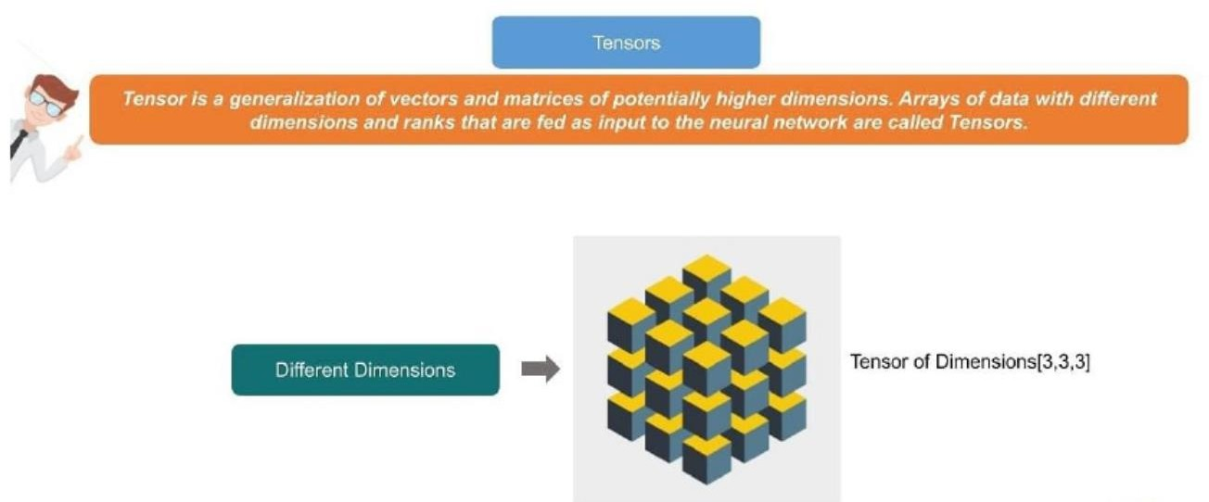
Ranks
Tensor ranks are the number of dimensions used to represent the data. For example:
Rank 0 - When there is only one element. We also call this as a scalar. Example: s = [2000]
Rank 1 - This basically refers to a one-dimensional array called a vector. Example: v = [10, 11, 12]
Rank 2 - This is traditionally known as a two-dimensional array or a matrix. Example: m = [1,2,3],[4,5,6]
Rank 3 - It refers to a multidimensional array, generally referred to as tensor. Example: t = [[[1],[2],[3]],[[4],[5],[6]],[[7],[8],[9]]]
Ranks can then be four or five, and so on.

The data flow graph is another important topic in What is TensorFlow article. It is discussed in the next section.

What is a Data Flow Graph?
When we have the data stored in tensors, there are computations that need to be completed, which happens in the form of graphs.
Unlike traditional programming, where written code gets executed in sequence, here we build data flow graphs that consist of nodes. The graphs are then executed in the form of a session. It is important to remember that we first have to create a graph. When we do so, none of the code is actually getting executed. You execute that graph only by creating a session.
Each computation in TensorFlow is represented as a data flow graph below
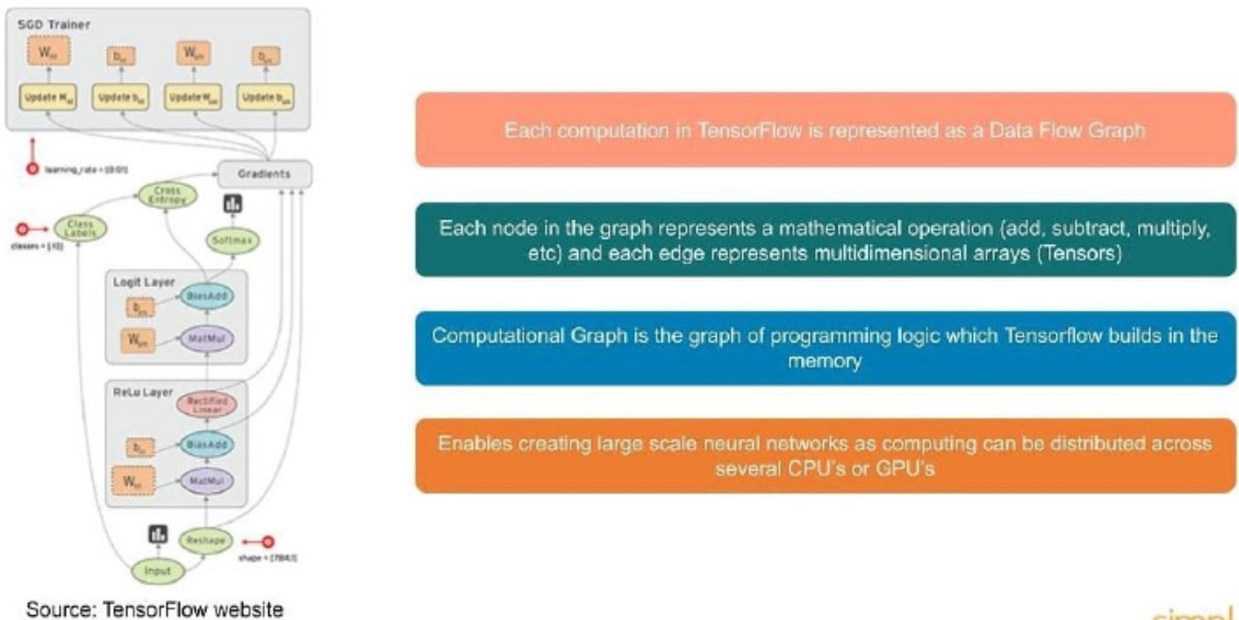
When you start creating a TensorFlow object, there will be a default graph. In more advanced programming, you can actually have multiple graphs instead of a default graph. You can create your own graph as well. The graph is executed and it processes all the data that is fed in. All the external data is fed in the form of placeholders, variables, and constants.
Once you have the graph, the execution can be enabled either on regular CPUs or GPUs, or distributed across several of them so that the processing becomes much faster. As the training of the models in deep learning takes extremely long because of the large amount of data, using TensorFlow makes it much easier to write the code for GPUs or CPUs and then execute it in a distributed manner.

List of Prominent Algorithms Supported by TensorFlow
Here is the list of algorithms currently supported by TensorFlow:
- Classification - tf.estimator.LinearClassifier
- Linear regression - tf.estimator.LinearRegressor
- Boosted tree classification - tf.estimator.BoostedTreesClassifier
- Booster tree regression - tf.estimator.BoostedTreesRegressor
- Deep learning classification - tf.estimator.DNNClassifier
- Deep learning wipe and deep - tf.estimator.DNNLinearCombinedClassifier

Program Elements in TensorFlow
TensorFlow programs work on two basic concepts:
- Building a computational graph
- Executing a computational graph
First, you need to start by writing the code for preparing the graph. Following this, you create a session where you execute this graph.
TensorFlow programming is slightly different from regular programming. Even if you're familiar with Python programming or machine learning programming in sci-kit-learn, this may be a new concept to you.
The way data is handled inside of the program itself is a little different from how it normally is with the regular programming language. For anything that keeps changing in regular programming, a variable needs to be created.
In TensorFlow, however, data can be stored and manipulated using three different programming elements:
- Constants
- Variables
- Placeholders

Constants
Constants are parameters with values that do not change. To define a constant, we use tf.constant() command.
Example:
a = tf.constant(2.0, tf.float32)
b = tf.constant(3.0) Print(a, b)
In the case of constants, you cannot change their values during the computation.

Variables
Variables allow us to add new trainable parameters to the graph. To define a variable, we use tf.Variable() command and initialize it before running the graph in a session.
Example:
W = tf.Variable([.3],dtype=tf.float32) b = tf.Variable([-.3],dtype=tf.float32) x = tf.placeholder(tf.float32) linear_model = W*x+b

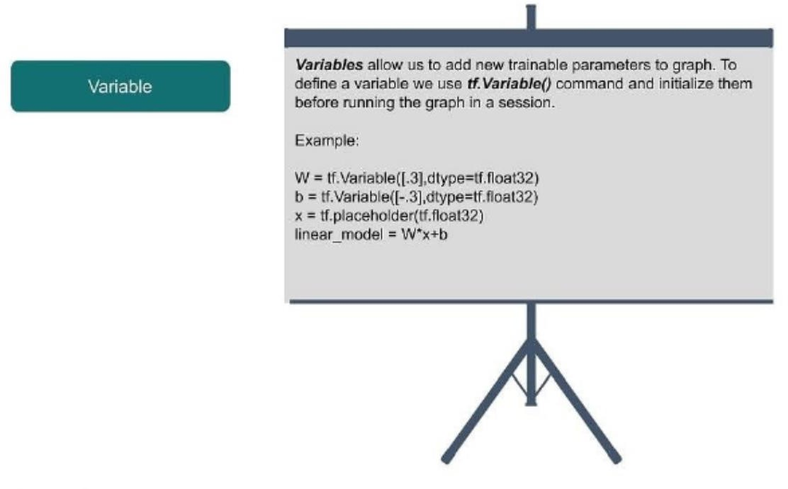
Placeholders
Placeholders allow us to feed data to a TensorFlow model from outside a model. It permits value to be assigned later. To define a placeholder, we use the tf.placeholder() command.
Example:
a = tf.placeholder(tf.float32)
b = a*2
with tf.Session() as sess:
result = sess.run(b,feed_dict={a:3.0}) print result
Placeholders are a special type of the variable and can be a new concept for many of us. Placeholders are like variables, but they are used for feeding data from outside. Typically, when you are performing computations, you need to load data from a local file or from an image file, CSV file, etc. There is a provision with special types of variables, which can be fed on a regular basis. One of the reasons for having this kind of provision is that if you get the entire input in one shot, it may become very difficult to handle the memory.
There is a certain way of populating the placeholder called feed_dict, which specifies tensors that provide values to the placeholder.
In a nutshell, constants, variables, and placeholders handle data within the flow program, after which you have to create a graph and run a session.
Let us know more about Sessions in the following part of the What is TensorFlow article.

Session
A session is run to evaluate the nodes. This is called as the TensorFlow Runtime. Example:
a = tf.constant(5.0)
b = tf.constant(3.0)
c = a*b
# Launch Session sess = tf.Session()
# Evaluate the tensor c print(sess.run(c))
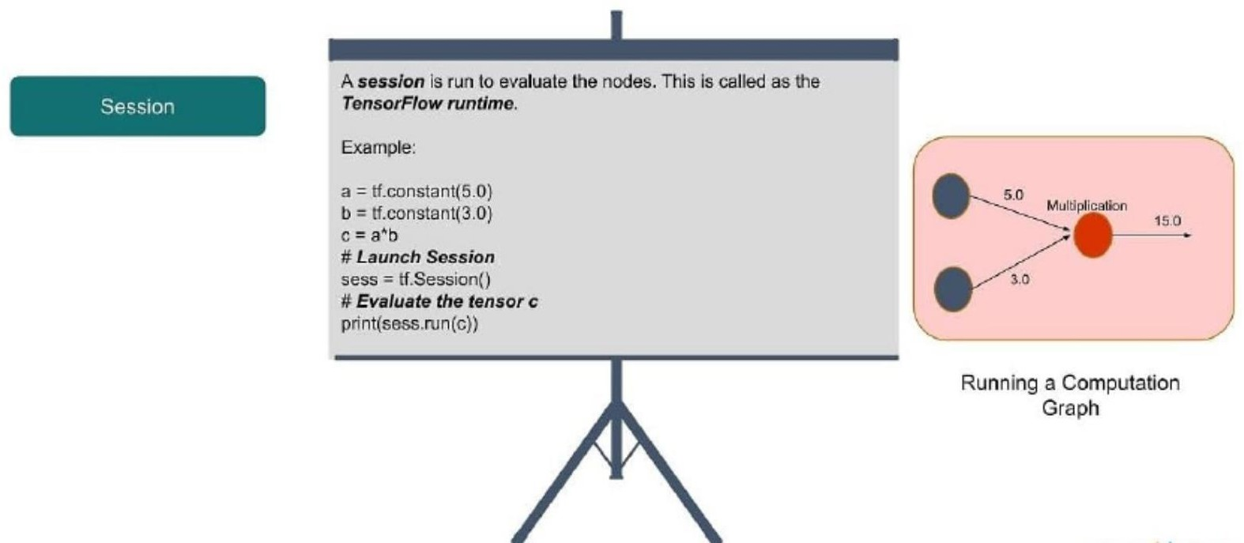
When creating a session, you run a particular computation, node, or an operation. Every variable or computation that you perform is like an operation on a node within a graph. Initially, the graph will be the default one. The moment you create a TensorFlow object, there is a default graph that doesn't contain any operations or nodes. The moment you assign variables, constants, or placeholders, each of them is known as an operation (in TensorFlow terms).
This is in contrast to traditional concepts, where creating a constant or a variable is not an operation. As seen in the example above, only the command ‘c = a*b’ would be an operation. But in TensorFlow, assigning variables or constants are operations as well. During a session, you can actually run all of these operations or nodes.
In our example, for the top three commands, you just create the graph, and execution doesn’t take place until you create a session (with the command sess = tf.session()).

TensorFlow Program Basics
Let us take a look at the various examples of programs in TensorFlow in this section of the ‘What is TensorFlow’ article.

Here is the typical “Hello World” program in TensorFlow:
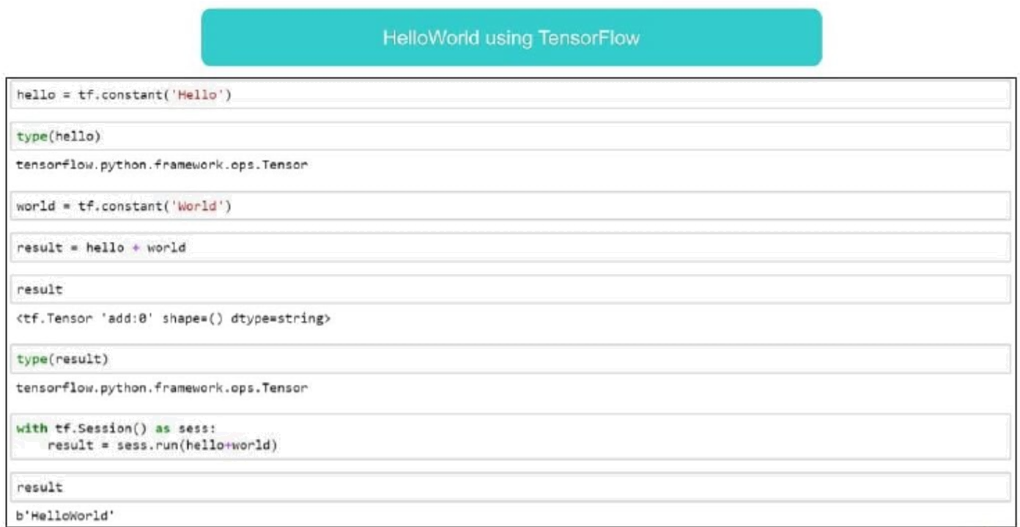
Next, you can see how to create variables, constants, or strings:
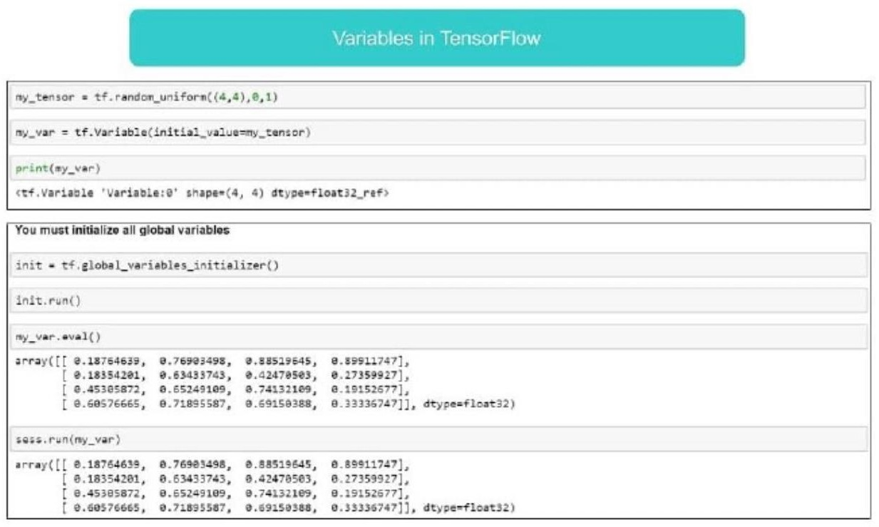
Let’s see how a placeholder is defined, and how to execute and populate the placeholder values:

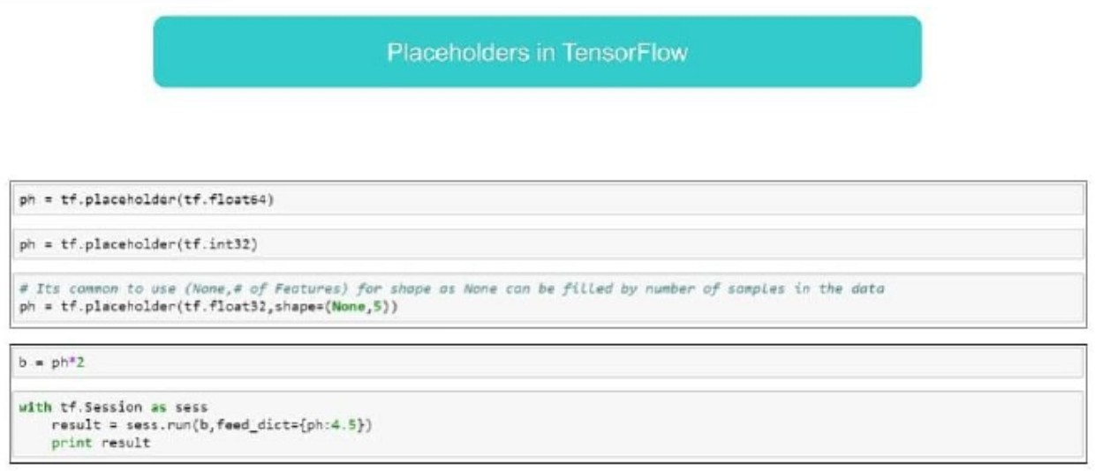

Below is the code to perform computations using TensorFlow:
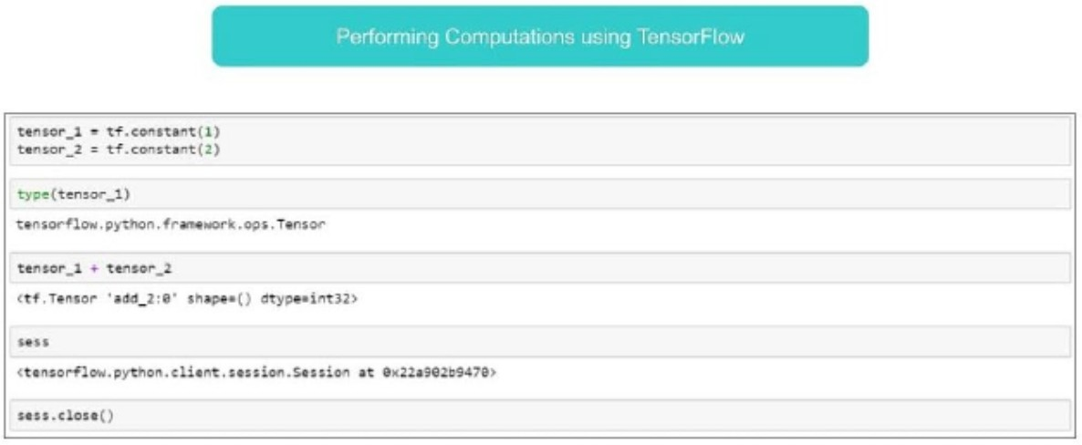
Next, you can see how matrix multiplication is done using TensorFlow:

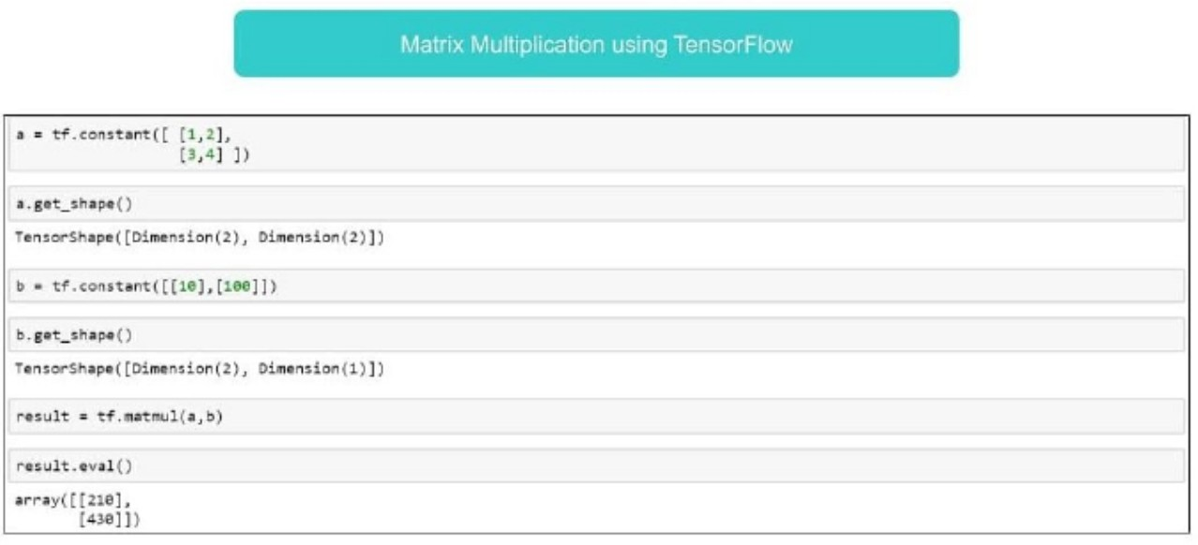

Lastly, you can understand the TensorFlow graphs with the code shown below:
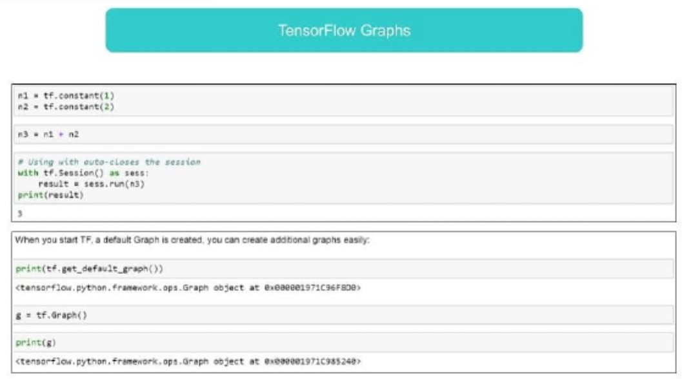

Simple TensorFlow Example
Let us take the example of a basic arithmetic operation like an addition to create a graph. To do so, we need to call tf.add() and add two values, say a=2 and b=3, using TensorFlow. The code will be as follows:

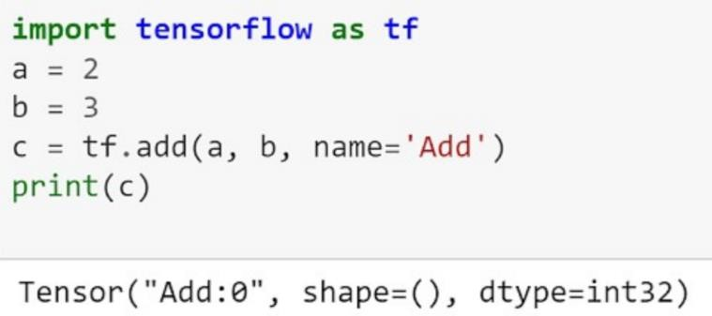
The generated graph and variables are:
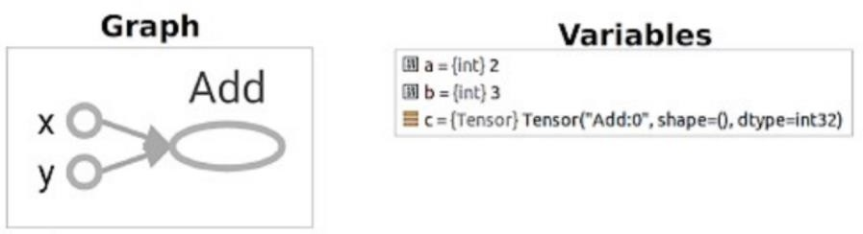
This example creates two input nodes (a=2 and b=3) and one output node for the addition operation. The variable c (the output Tensor of the operation) prints out the Tensor information - its name, shape, and type.

Use Case Implementation Using TensorFlow
Let us finally discuss a use case that will sharpen your understanding of what is TensorFlow.
Problem Statement - To analyze various aspects of an individual and predict what class of income he belongs to (>50k or <=50k) by using census data.
The aspects under consideration are shown below:
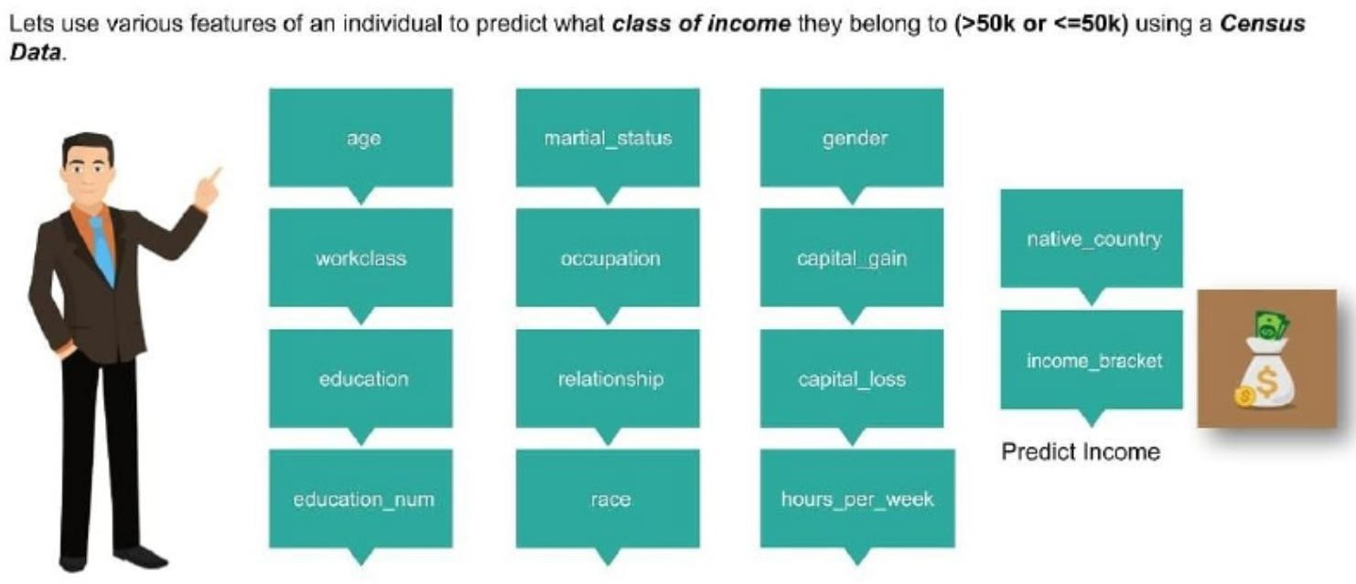
We have to build a model for classifying whether the income of a particular individual is more or less than 50K annually and determine the accuracy. Refer to the aforementioned ‘What is TensorFlow’ video to understand how such a model is created.

THEANO
Theano is a Python library that allows us to evaluate mathematical operations including multi- dimensional arrays so efficiently. It is mostly used in building Deep Learning Projects. It works a way more faster on Graphics Processing Unit (GPU) rather than on CPU. Theano attains high speeds that gives a tough competition to C implementations for problems involving large amounts of data. It can take advantage of GPUs which makes it perform better than C on a CPU by considerable orders of magnitude under some certain circumstances.
It knows how to take structures and convert them into very efficient code that uses numpy and some native libraries. It is mainly designed to handle the types of computation required for large neural network algorithms used in Deep Learning. That is why, it is a very popular library in the field of Deep Learning.

How to install Theano :
pip install Theano
Several of the symbols we will need to use are in the tensor subpackage of Theano. We often import such packages with a handy name, let’s say, T.
from theano import * import theano.tensor as T

Why Theano Python Library:
Theano is a sort of hybrid between numpy and sympy, an attempt is made to combine the two into one powerful library. Some advantages of theano are as follows:
- Stability Optimization: Theano can find out some unstable expressions and can use more stable means to evaluate them
- Execution Speed Optimization: As mentioned earlier, theano can make use of recent GPUs and execute parts of expressions in your CPU or GPU, making it much faster than Python
- Symbolic Differentiation: Theano is smart enough to automatically create symbolic graphs for computing gradients

CNTK

What is Microsoft Cognitive Toolkit (CNTK)?
Microsoft Cognitive Toolkit (CNTK), formerly known as Computational Network Toolkit, is a free, easy-to-use, open-source, commercial-grade toolkit that enables us to train deep learning algorithms to learn like the human brain. It enables us to create some popular deep learning systems like feed-forward neural network time series prediction systems and Convolutional neural network (CNN) image classifiers.
For optimal performance, its framework functions are written in C++. Although wecan call its function using C++, but the most commonly used approach for the same is to use a Python program.

CNTK’s Features
Following is some of the features and capabilities offered in the latest version of Microsoft CNTK:

Built-in components
- CNTK has highly optimised built-in components that can handle multi-dimensional dense or sparse data from Python, C++ or BrainScript.
- We can implement CNN, FNN, RNN, Batch Normalisation and Sequence-to-Sequence with attention.
- It provides us the functionality to add new user-defined core-components onthe GPU from Python.
- It also provides automatic hyperparameter tuning.
- We can implement Reinforcement learning, Generative Adversarial Networks (GANs), Supervised as well as Unsupervised learning.
- For massive datasets, CNTK has built-in optimised readers.

Usage of resources efficiently
- CNTK provides us parallelism with high accuracy on multiple GPUs/machines via 1-bit SGD.
- To fit the largest models in GPU memory, it provides memory sharing and other built-in methods.

Express our own networks easily
- CNTK has full APIs for defining your own network, learners, readers, training and evaluation from Python, C++, and BrainScript.
- Using CNTK, we can easily evaluate models with Python, C++, C# or BrainScript.
- It provides both high-level as well as low-level APIs.
- Based on our data, it can automatically shape the inference.
- It has fully optimised symbolic Recurrent Neural Network (RNN) loops.

Measuring model performance
- CNTK provides various components to measure the performance of neural networks you build.
- Generates log data from your model and the associated optimiser, which we can use to monitor the training process.Version 1.0 vs Version 2.0Following table compares CNTK

Version 1.0 and 2.0
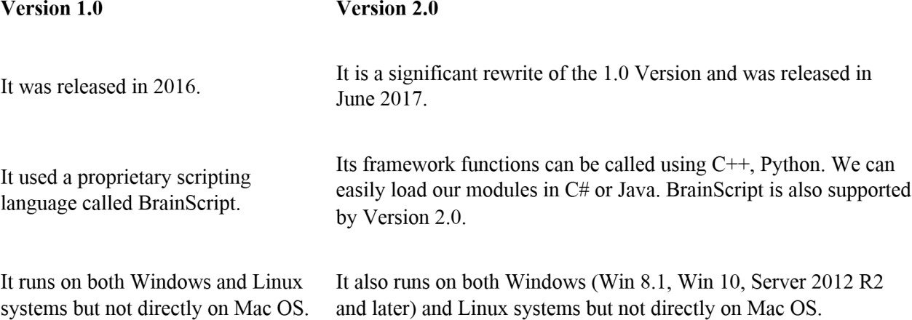

Important Highlights of Version 2.7
Version 2.7 is the last main released version of Microsoft Cognitive Toolkit. It hasfull support for ONNX
1.4.1. Following are some important highlights of this last released version of CNTK.
- Full support for ONNX 1.4.1.
- Support for CUDA 10 for both Windows and Linux systems.
- It supports advance Recurrent Neural Networks (RNN) loop in ONNX export.
- It can export more than 2GB models in ONNX format.
- It supports FP16 in BrainScript scripting language’s training action.

The CNTK library organisation
CNTK, a python package technically, is organised into 13 high-level sub-packages and 8 smaller sub- packages. Following table consist of the 10 most frequently used packages:
- cntk.io - Contains functions for reading data. For example: next_minibatch()
- cntk.layers - Contains high-level functions for creating neural networks. For example: Dense()
- cntk.learners - Contains functions for training. For example: sgd()
- cntk.losses - Contains functions to measure training error. For example: squared_error()
- cntk.metrics - Contains functions to measure model error. For example: classificatoin_error
- cntk.ops - Contains low-level functions for creating neural networks. For example: tanh()
- cntk.random - Contains functions to generate random numbers. For example: normal()
- cntk.train - Contains training functions. For example: train_minibatch()
- cntk.initializer - Contains model parameter initializers. For example: normal() and uniform()
- cntk.variables - Contains low-level constructs. For example: Parameter() and Variable()

Setting up Deep Learning Workstation
Before you can get started developing deep-learning applications, you need to set up your workstation. It’s highly recommended, although not strictly necessary, that you run deep-learning code on a modern NVIDIA GPU
If you don’t want to install a GPU on your machine, you can alternatively consider running your experiments on an AWS EC2 GPU instance or on Google Cloud Platform. But note that cloud GPU instances can become expensive over time.

Jupyter notebooks: the preferred way to run deep-learning experiments
  - Jupyter notebooks are a great way to run deep-learning experiments.
  - They’re widely used in the data-science and machine-learning communities.
  - A notebook is a file generated by the Jupyter Notebook app (https://jupyter.org), which you can edit in your browser.
  - It mixes the ability to execute Python code with rich text-editing capabilities for annotating what you’re doing.
  - A notebook also allows you to break up long experiments into smaller pieces that can be executed independently, which makes development interactive and means you don’t have to rerun all of your previous code if something goes wrong late in an experiment.

Getting Keras running: two options
To get started in practice, we recommend one of the following two options:
- Use the official EC2 Deep Learning AMI (https://aws.amazon.com/amazonai/amis), and run Keras experiments as Jupyter notebooks on EC2. Do this if you don’t already have a GPU on your local machine.
- Install everything from scratch on a local Unix workstation. You can then run either local Jupyter notebooks or a regular Python codebase. Do this if you already have a high-end NVIDIA GPU.

Running deep-learning jobs in the cloud: pros and cons
There are many pros and cons to running deep-learning jobs in the cloud. Here are some of the most important ones:

Pros:
  - Scalability: Cloud computing provides virtually unlimited scalability, so you can easily add or remove resources as needed. This is essential for deep learning, as training models can be very demanding on resources.
  - Cost-effectiveness: Cloud computing can be very cost-effective for deep learning, especially if you only need to use the resources for a short period of time. You can also pay for the resources you use, so you're not wasting money on unused capacity.
  - Ease of use: Cloud computing platforms make it easy to set up and run deep-learning jobs. Many platforms provide pre-configured machine learning environments, so you don't have to worry about setting up the infrastructure yourself.
  - Collaboration: Cloud computing makes it easy to collaborate on deep learning projects. You can share data and models with other team members, and you can also run jobs on multiple machines in parallel.
  - Security: Cloud computing providers offer a high level of security for your data. Your data is encrypted in transit and at rest, and you can control who has access to it.

Cons:
  - Latency: There can be some latency when running deep-learning jobs in the cloud, as the data has to travel to and from the cloud servers. This can be a problem for real-time applications.
  - Vendor lock-in: If you choose to use a particular cloud provider, you may become locked in to their platform. This can make it difficult to switch providers if you're not happy with their services.
  - Complexity: Cloud computing can be complex, especially if you're not familiar with it. There are a lot of different services and features to choose from, and it can be difficult to know which ones are right for you.

What is the best GPU for deep learning?
If you’re going to buy a GPU, which one should you choose? The first thing to note is that it must be an NVIDIA GPU. NVIDIA is the only graphics computing company that has invested heavily in deep learning so far, and modern deep-learning frameworks can only run on NVIDIA cards.

Classifying Movie Reviews: Binary Classification
Two-class classification, or binary classification, may be the most widely applied kind of machine- learning problem. In this example, you’ll learn to classify movie reviews as positive or negative, based on the text content of the reviews.

The IMDB dataset
You’ll work with the IMDB dataset: a set of 50,000 highly polarized reviews from the Internet Movie Database. They’re split into 25,000 reviews for training and 25,000 reviews for testing, each set consisting of 50% negative and 50% positive reviews.
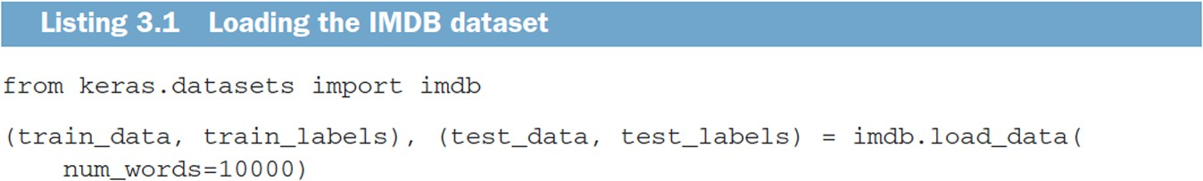

The argument num_words=10000 means you’ll only keep the top 10,000 most frequently occurring words in the training data. Rare words will be discarded. This allows you to work with vector data of manageable size
The variables train_data and test_data are lists of reviews; each review is a list of word indices (encoding a sequence of words). train_labels and test_labels are lists of 0s and 1s, where 0 stands for negative and 1 stands for positive:
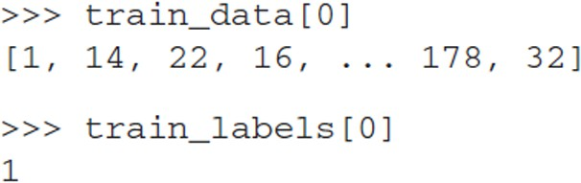

Because you’re restricting yourself to the top 10,000 most frequent words, no word index will exceed 10,000:
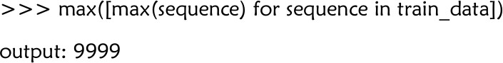

For kicks, here’s how you can quickly decode one of these reviews back to English words:
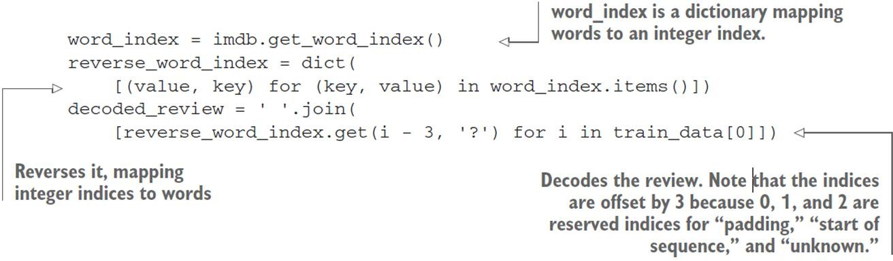

Preparing the data
You can’t feed lists of integers into a neural network. You have to turn your lists into tensors. There are two ways to do that:
- Pad your lists so that they all have the same length, turn them into an integer tensor of shape (samples, word_indices), and then use as the first layer in your network a layer capable of handling such integer tensors (the Embedding layer, which we’ll cover in detail later in the book).
- One-hot encode your lists to turn them into vectors of 0s and 1s. This would mean, for instance, turning the sequence [3, 5] into a 10,000-dimensional vector that would be all 0s except for indices 3 and 5, which would be 1s. Then you could use as the first layer in your network a Dense layer, capable of handling floating point vector data.
Let’s go with the latter solution to vectorize the data, which you’ll do manually for maximum clarity
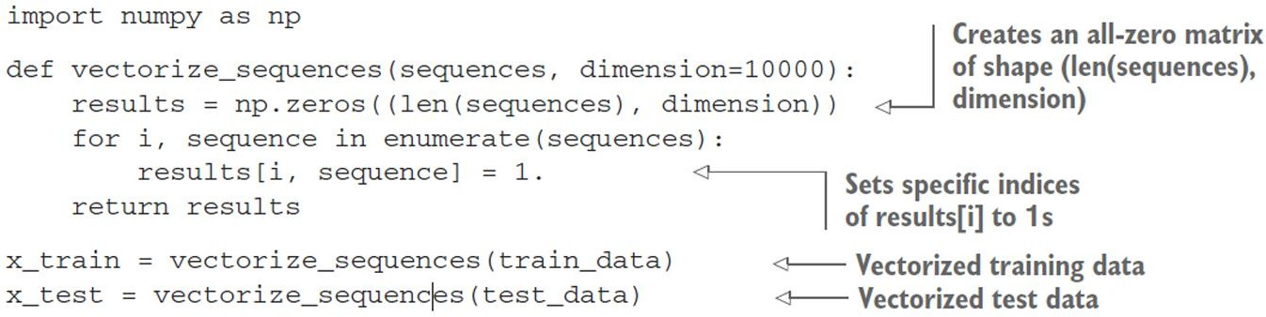
Here’s what the samples look like now:
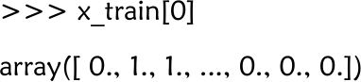
You should also vectorize your labels, which is straightforward:
y_train = np.asarray(train_labels).astype('float32') y_test = np.asarray(test_labels).astype('float32') Building your network
The input data is vectors, and the labels are scalars (1s and 0s): this is the easiest setup you’ll ever encounter. A type of network that performs well on such a problem is a simple stack of fully connected (Dense) layers with relu activations: Dense(16, activation='relu').
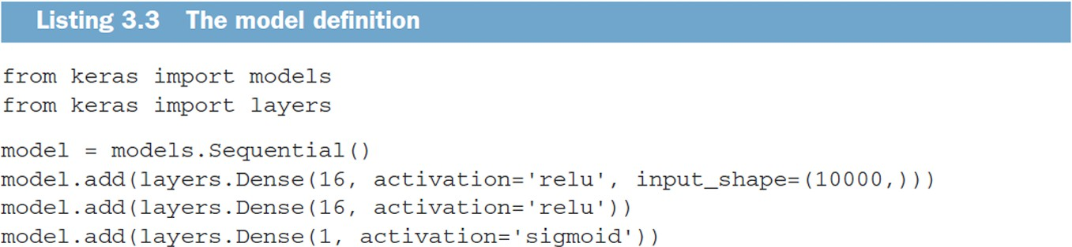

Finally, you need to choose a loss function and an optimizer. Because you’re facing a binary classification problem and the output of your network is a probability (you end your network with a single-unit layer with a sigmoid activation), it’s best to use the binary_crossentropy loss. It isn’t the

only viable choice: you could use, for instance, mean_squared_error. But crossentropy is usually the best choice when you’re dealing with models that output probabilities.
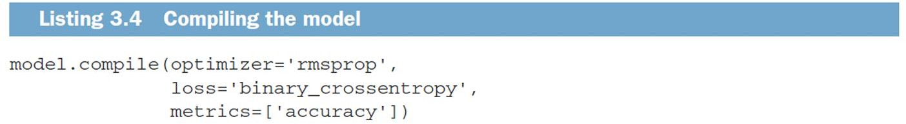

Validating your approach
In order to monitor during training the accuracy of the model on data it has never seen before, you’ll create a validation set by setting apart 10,000 samples from the original training data
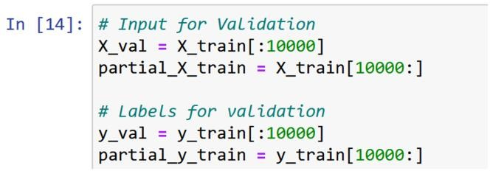
You’ll now train the model for 20 epochs (20 iterations over all samples in the x_train and y_train tensors), in mini-batches of 512 samples. At the same time, you’ll monitor loss and accuracy on the 10,000 samples that you set apart. You do so by passing the validation data as the validation_data argument.
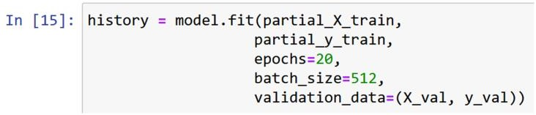
let’s use Matplotlib to plot the training and validation loss side by side, as well as the training and validation accuracy.
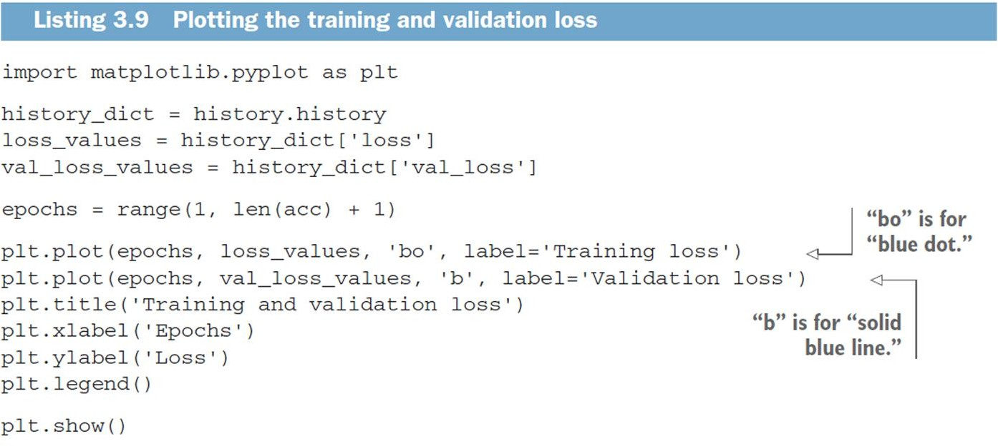

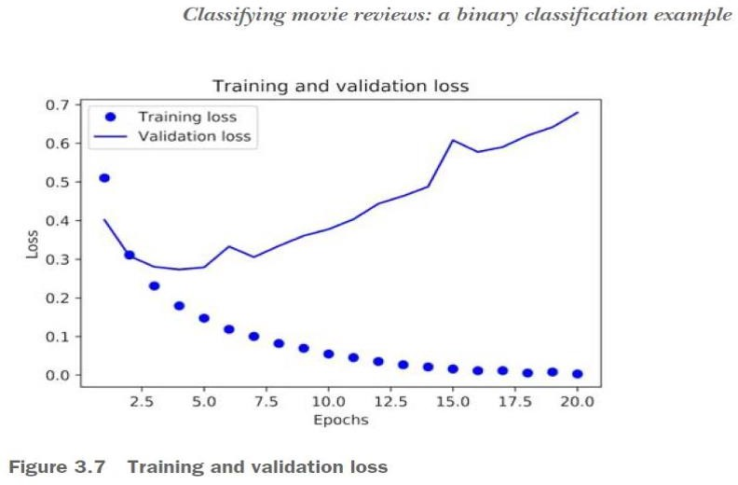
As you can see, the training loss decreases with every epoch, and the training accuracy increases with every epoch. That’s what you would expect when running gradient descent optimization—the quantity you’re trying to minimize should be less with every iteration.

Classifying newswires: Multiclass Classification
In this example, we will build a model to classify Reuters newswires into 46 mutually exclusive topics. Because we have many classes, this problem is an instance of multiclass classification; and because each data point should be classified into only one category, the problem is more specifically an instance of single-label, multiclass classification. If each data point could belong to multiple categories (in this case, topics), you’d be facing a multilabel, multiclass classification problem.

Reuters dataset
We will work with the Reuters dataset, a set of short newswires and their topics, published by Reuters in 1986. It’s a simple, widely used toy dataset for text classification. There are 46 different topics; some topics are more represented than others, but each topic has at least 10 examples in the training set. Like IMDB and MNIST, the Reuters dataset comes packaged as part of Keras.
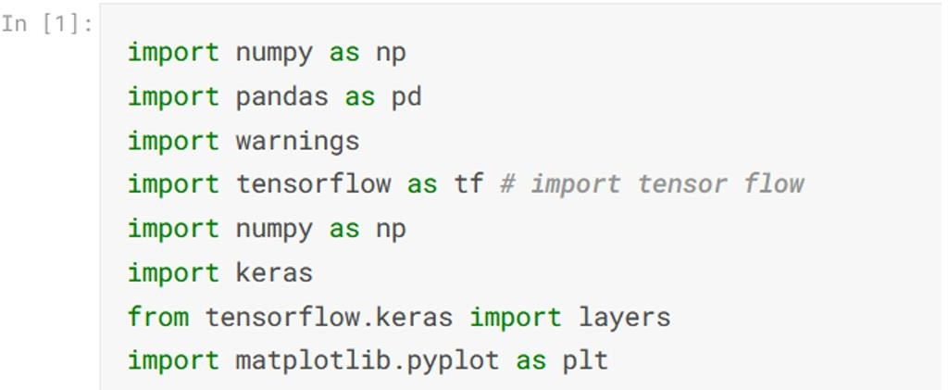
2.
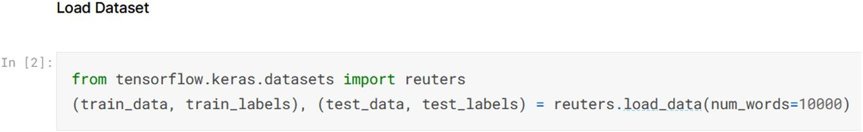

3.
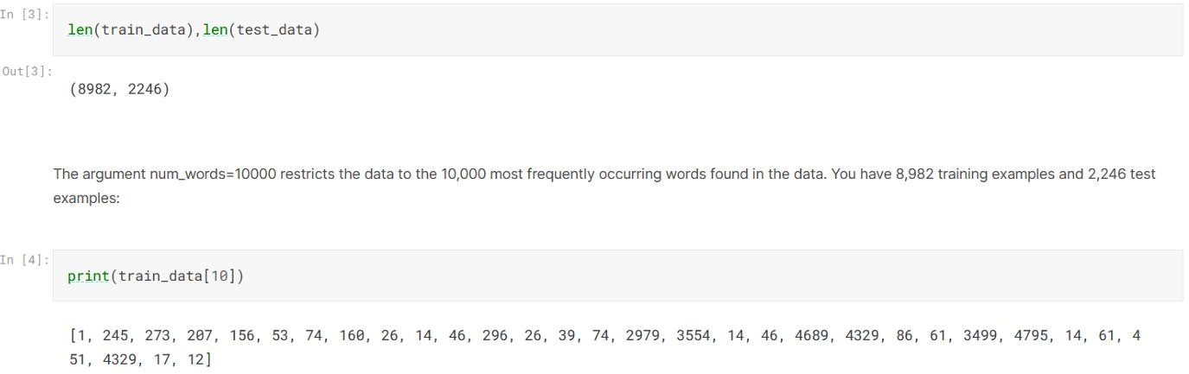

Data Prep
vectorize the input data
def vectorize_sequences(sequences, dimension=10000): results = np.zeros((len(sequences), dimension))
for i, sequence in enumerate(sequences): results[i, sequence] = 1.
return results
x_train = vectorize_sequences(train_data)#1 x_test = vectorize_sequences(test_data)#2
- Verctorize training data
- Vencotrize testing data

vectorize the label with the exact same code as in the previous example.
def to_one_hot(labels, dimension=46): results = np.zeros((len(labels), dimension)) for i, label in enumerate(labels):
results[i, label] = 1. return results
one_hot_train_labels = to_one_hot(train_labels)#1 one_hot_test_labels = to_one_hot(test_labels)#2
- Verctorize training labels
- Vencotrize testing labels
Note that there is a built-in way to do this in Keras: from tensorflow.keras.utils import to_categorical

one_hot_train_labels = to_categorical(train_labels) one_hot_test_labels = to_categorical(test_labels)

Building the model
This topic-classification problem looks similar to the previous movie-review classificationq: in both cases, we are trying to classify short snippets of text. But there is a new constraint here: the number of output classes has gone from 2 to 46. The dimensionality of the output space is much larger.
In a stack of Dense layers like that we have been using, each layer can only access information present in the output of the previous layer. If one layer drops some information relevant to the classification problem, this information can never be recovered by later layers: each layer can potentially become an information bottleneck. In the previous example, we used 16-dimensional intermediate layers, but a 16- dimensional space may be too limited to learn to separate 46 different classes: such small layers may act as information bottlenecks, permanently dropping relevant information. For this reason we will use larger layers. Let’s go with 64 units.

Model Definition
model = keras.Sequential([ layers.Dense(64, activation='relu'), layers.Dense(64, activation='relu'), layers.Dense(46, activation='softmax')
])
Note about this architecture:
- We end the model with a Dense layer of size 46. This means for each input sample, the network will output a 46-dimensional vector. Each entry in this vector (each dimension) will encode a different output class.
- The last layer uses a softmax activation. You saw this pattern in the MNIST example. It means the model will output a probability distribution over the 46 different output classes — for every input sample, the model will produce a 46-dimensional output vector, where output[i] is the probability that the sample belongs to class i. The 46 scores will sum to 1.
- The best loss function to use in this case is categorical_crossentropy. It measures the distance between two probability distributions: here, between the probability distribution output by the model and the true distribution of the labels. By minimizing the distance between these two distributions, you train the model to output something as close as possible to the true labels.

Compile the model
model.compile(optimizer='rmsprop', loss='categorical_crossentropy', metrics=['accuracy'])

Validation of the approach
Let’s set apart 1,000 samples in the training data to use as a validation set.

x_val = x_train[:1000] partial_x_train = x_train[1000:] y_val = one_hot_train_labels[:1000]
partial_y_train = one_hot_train_labels[1000:]

let’s train the model for 20 epochs.
Training the model
history = model.fit(partial_x_train,
partial_y_train, epochs=20, batch_size=512,
validation_data=(x_val, y_val))
Epoch 1/20
16/16 [==============================] - 2s 81ms/step - loss: 3.1029 - accuracy:
0.4079 - val_loss: 1.7132 - val_accuracy: 0.6440 Epoch 2/20
16/16 [==============================] - 1s 38ms/step - loss: 1.4807 - accuracy:
0.6992 - val_loss: 1.2964 - val_accuracy: 0.7230 Epoch 3/20
16/16 [==============================] - 1s 36ms/step - loss: 1.0763 - accuracy:
0.7762 - val_loss: 1.1460 - val_accuracy: 0.7380 Epoch 4/20
16/16 [==============================] - 1s 36ms/step - loss: 0.8441 - accuracy:
0.8245 - val_loss: 1.0389 - val_accuracy: 0.7810 Epoch 5/20
16/16 [==============================] - 1s 37ms/step - loss: 0.6595 - accuracy:
0.8658 - val_loss: 0.9456 - val_accuracy: 0.8050 Epoch 6/20
16/16 [==============================] - 1s 37ms/step - loss: 0.5237 - accuracy:
0.8945 - val_loss: 0.9203 - val_accuracy: 0.8040 Epoch 7/20
16/16 [==============================] - 1s 36ms/step - loss: 0.4181 - accuracy:

0.9160 - val_loss: 0.8765 - val_accuracy: 0.8140 Epoch 8/20
16/16 [==============================] - 1s 35ms/step - loss: 0.3485 - accuracy:
0.9316 - val_loss: 0.8895 - val_accuracy: 0.8060 Epoch 9/20
16/16 [==============================] - 1s 36ms/step - loss: 0.2829 - accuracy:
0.9390 - val_loss: 0.8829 - val_accuracy: 0.8110 Epoch 10/20
16/16 [==============================] - 1s 36ms/step - loss: 0.2246 - accuracy:
0.9479 - val_loss: 0.9112 - val_accuracy: 0.8140 Epoch 11/20
16/16 [==============================] - 1s 36ms/step - loss: 0.1894 - accuracy:
0.9532 - val_loss: 0.9060 - val_accuracy: 0.8120 Epoch 12/20
16/16 [==============================] - 1s 37ms/step - loss: 0.1765 - accuracy:
0.9538 - val_loss: 0.9068 - val_accuracy: 0.8160 Epoch 13/20
16/16 [==============================] - 1s 37ms/step - loss: 0.1610 - accuracy:
0.9529 - val_loss: 0.9394 - val_accuracy: 0.8100 Epoch 14/20
16/16 [==============================] - 1s 37ms/step - loss: 0.1438 - accuracy:
0.9574 - val_loss: 0.9254 - val_accuracy: 0.8190 Epoch 15/20
16/16 [==============================] - 1s 35ms/step - loss: 0.1305 - accuracy:
0.9584 - val_loss: 0.9666 - val_accuracy: 0.8060 Epoch 16/20
16/16 [==============================] - 1s 37ms/step - loss: 0.1291 - accuracy:
0.9562 - val_loss: 0.9537 - val_accuracy: 0.8120 Epoch 17/20
16/16 [==============================] - 1s 36ms/step - loss: 0.1140 - accuracy:
0.9593 - val_loss: 1.0202 - val_accuracy: 0.8020

Epoch 18/20
16/16 [==============================] - 1s 38ms/step - loss: 0.1167 - accuracy:
0.9567 - val_loss: 0.9942 - val_accuracy: 0.8070 Epoch 19/20
16/16 [==============================] - 1s 38ms/step - loss: 0.0972 - accuracy:
0.9669 - val_loss: 1.0709 - val_accuracy: 0.7960 Epoch 20/20
16/16 [==============================] - 1s 34ms/step - loss: 0.1035 - accuracy:
0.9607 - val_loss: 1.0530 - val_accuracy: 0.8020

Plotting the training and validation loss
loss = history.history['loss'] val_loss = history.history['val_loss'] epochs = range(1, len(loss) + 1)
plt.plot(epochs, loss, 'bo', label='Training loss') plt.plot(epochs, val_loss, 'r', label='Validation loss') plt.title('Training and validation loss') plt.xlabel('Epochs')
plt.ylabel('Loss') plt.legend() plt.show()
