UNIT V
- Interactive Applications of Deep Learning
  - Machine Vision
  - Natural Language Processing (NLP)
  - Generative Adversarial Networks (GANs)
  - Deep Reinforcement Learning (DRL)
Deep Learning Research
- Autoencoders
- Deep Generative Models
  - Boltzmann Machines
  - Restricted Boltzmann Machines (RBMs)
  - Deep Belief Networks (DBNs)

Introduction on Interactive Applications of Deep Learning
Deep learning has many uses in various fields, and its potential continues to grow. Let's analyze a few of artificial intelligence's widespread deep learning uses.
Common Applications of Deep Learning in Artificial Intelligence
- Image Recognition and Computer Vision
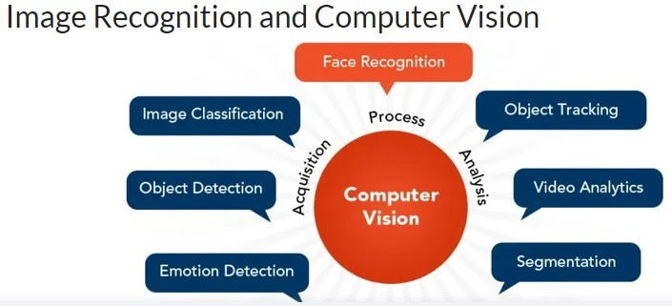

  - The performance of image recognition and computer vision tasks has significantly improved due to deep learning.
  - Computers can now reliably classify and comprehend images by training deep neural networks on enormous datasets, opening up a wide range of applications.

  - Computer Vision processes include Face Recognition, Image Classification, Object Detection, Emotion Detection, Object Tracking, Video Analytics, and Segmentation .
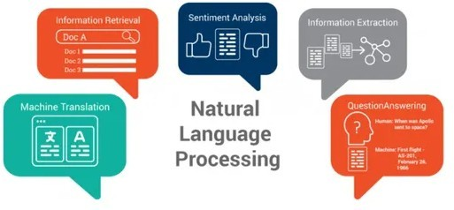
- Natural Language Processing (NLP)

  - NLP aims to enable computers to comprehend, translate, and create human language.
  - Deep learning has substantially advanced NLP, leading to strides in several language-related activities.
  - NLP applications include Information Retrieval, Sentiment Analysis, Information Extraction, Machine Translation, and Question Answering .
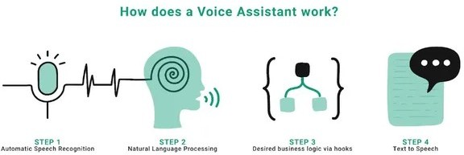
- Speech Recognition and Voice Assistants

  - Deep learning has significantly benefited the advancement of speech recognition systems and the creation of voice assistants that can comprehend and respond to human speech.
  - Virtual voice assistants like Apple’s Siri and Amazon’s Alexa, who can comprehend spoken orders and questions, are a practical illustration.
  - A real-world example is using a smartphone's voice recognition feature to dictate messages instead of typing them, or asking a smart speaker to play music or provide the weather forecast.
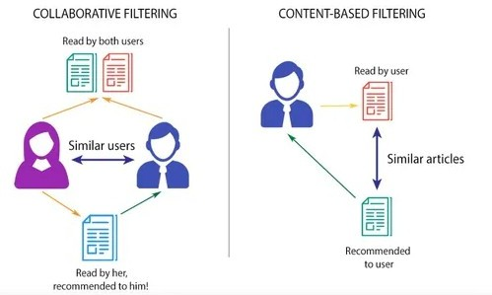
- Recommendation Systems
  - These systems use deep learning algorithms to offer people personalized recommendations based on their tastes and behavior.
  - Recommendation systems often employ methods like Collaborative Filtering and Content-Based Filtering .
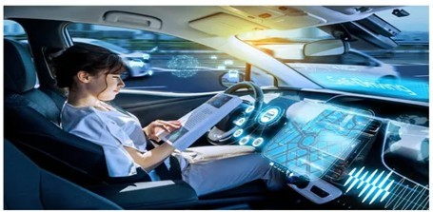
- Autonomous Vehicles

  - Deep learning has significantly impacted how well autonomous vehicles can understand and navigate their surroundings.
  - These vehicles use powerful deep learning algorithms to analyze enormous volumes of sensor data in real-time.
  - This analysis enables them to make wise decisions, navigate challenging routes, and guarantee the safety of passengers and pedestrians.
  - This technology is preparing the path for a time when driverless vehicles will change how we travel .
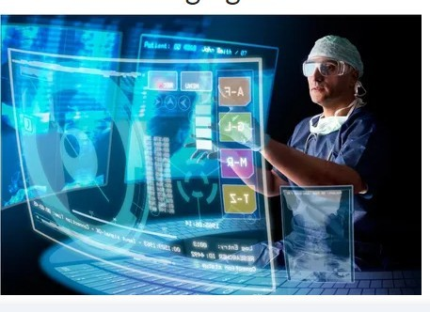
- Healthcare and Medical Imaging
  - Deep learning has shown tremendous potential in revolutionizing healthcare and medical imaging by assisting in diagnosis, disease detection, and patient care.
  - An example is revolutionizing diagnostics using AI-powered algorithms that can precisely identify early-stage tumors from medical imaging, which helps with prompt treatment decisions and improves patient outcomes .
- Fraud Detection and Cybersecurity


- Deep learning has become essential in detecting anomalies, identifying fraud patterns, and strengthening cybersecurity systems .
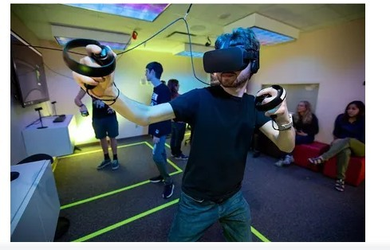
- Gaming and Virtual Reality

  - Deep learning has significantly improved game AI, character animation, and immersive surroundings for the gaming industry and virtual reality experiences.
  - For instance, a virtual reality game can adjust and customize its gameplay based on the player’s real-time motions and reactions by using deep learning algorithms
Machine Vision
Machine vision is the technology that enables robots and other machines like autonomous vehicles to see and recognize objects in their surrounding environment.
- How Machine Vision Works
  - Most systems require a light source and a camera (or cameras) to clearly capture objects, humans, and other features.
  - The captured visual data is sent to a processor or onboard computer.
  - The processor analyzes the images using artificial intelligence and machine learning algorithms, often combined with data from other sensors like LiDAR, radar, and microphones.
  - This information is communicated back to the robot or other machines.
  - Machines then make appropriate decisions, such as stopping at a crosswalk or picking the right item for an order, which improves efficiency and safety.
  - Recent advances in deep learning allow robots to analyze what they’re seeing, enabling them to complete tasks like picking specific items out of a bin.
Types of Machine Vision
There are three main types of machine vision:
- One-dimensional vision (1D vision): Reads an image one line at a time, often using a line-scan camera. It is typically used in inspection processes to spot defects in products on a conveyor.
- Two-dimensional vision (2D vision): Uses a digital camera to collect image data, which is processed by comparing contrast variations. It is often used to track objects, as well as for verification and inspection.
- Three-dimensional vision (3D vision): Uses multiple digital cameras and other sensors in various locations to capture a digital model of an object, providing an accurate assessment of its location, size, and features. It is typically used to help robots navigate their surroundings and perform tasks like picking products from bins for order fulfillment.
Machine Vision Applications
- Used in assembly lines to inspect parts to improve quality control.
- Helps robots working in warehouses locate products and navigate their surroundings.
- Allows self-driving cars to perceive the world around them and identify potential hazards.

Machine Vision vs. Computer Vision
While the terms are often used interchangeably, the main differences are:
- Machine vision systems require cameras to capture and provide image data.
- Computer vision systems can be fed images from other sources (e.g., the internet).
- Computer vision systems are where the AI and machine learning algorithms live that process the visual data.
Natural Language Processing (NLP)
NLP stands for Natural Language Processing. It is a field that is a part of Computer Science, Human language, and Artificial Intelligence . It is the technology machines use to understand, analyze, manipulate, and interpret human languages.
NLP helps developers organize knowledge for performing tasks such as translation, automatic summarization, Named Entity Recognition (NER), speech recognition, relationship extraction, and topic segmentation.
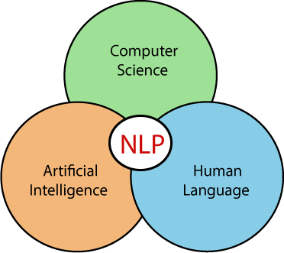

NLP Tasks and Applications
NLP is used for a wide variety of language-related tasks, including answering questions, classifying text, and conversing with users.
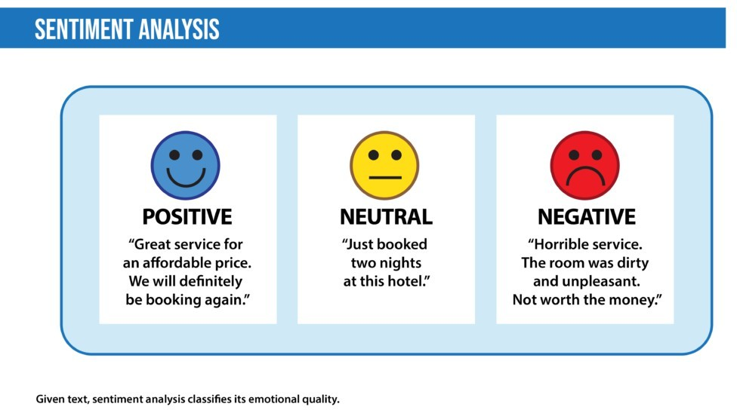
- Sentiment analysis: Classifies the emotional intent of text (positive, negative, or neutral). It is used to classify customer reviews and for niche applications like identifying signs of mental illness in online comments.

- Toxicity classification: A branch of sentiment analysis that aims to classify hostile intent into categories like threats, insults, obscenities, and hatred. It can be used to moderate online conversations, detect hate speech, or scan documents for defamation.
- Machine translation: Automates translation between different languages. It's a famous mainstream application used to improve communication on social-media platforms such as Facebook or Skype. Effective approaches can distinguish between words with similar meanings.
- Spam detection: A binary classification problem in NLP that classifies emails as either spam or not, used by email providers like Gmail.
- Grammatical error correction: Models encode grammatical rules to correct grammar within text. Used by online grammar checkers like Grammarly and word-processing systems like Microsoft Word.
- Topic modeling: An unsupervised text mining task that discovers abstract topics within a corpus of documents.
- Named entity recognition (NER): Extracts entities in a piece of text (e.g., personal names, organizations, locations) into predefined categories. It's useful in applications such as summarizing news documents and combating disinformation .
- Text generation (Natural Language Generation - NLG): Produces text similar to human-written text, which can be fine-tuned for different genres and formats (e.g., tweets, blogs, computer code).
- Autocomplete: Predicts the next word, used in chat applications like WhatsApp and by Google to predict search queries.
- Chatbots: Automate one side of a conversation, divided into Database query and Conversation generation categories.
- Information retrieval: Finds the documents most relevant to a query from a large collection, which is a problem faced by search and recommendation systems.
- Summarization: Shortens text to highlight the most relevant information.
  - Extractive summarization extracts the most important sentences from a long text.
  - Abstractive summarization produces a summary by paraphrasing, including words and sentences not present in the original text.
- Question answering: Deals with answering questions posed by humans in a natural language. Tasks come in two flavors:
  - Multiple choice: The learning task is to pick the correct answer from a set of options.
  - Open domain: The model provides answers in natural language without options, often by querying a large number of texts.
How Does Natural Language Processing (NLP) Work?
NLP models work by finding relationships between the constituent parts of language (letters, words, and sentences). NLP architectures use various methods for:
- Data preprocessing:
  - Stemming and lemmatization: Converting words to their base forms (lemmatization is more formal, using a dictionary to find roots).
  - Sentence segmentation: Breaks a large piece of text into linguistically meaningful sentence units.
  - Stop word removal: Aims to remove the most commonly occurring words that do not add much information (e.g., "the," "a," "an").
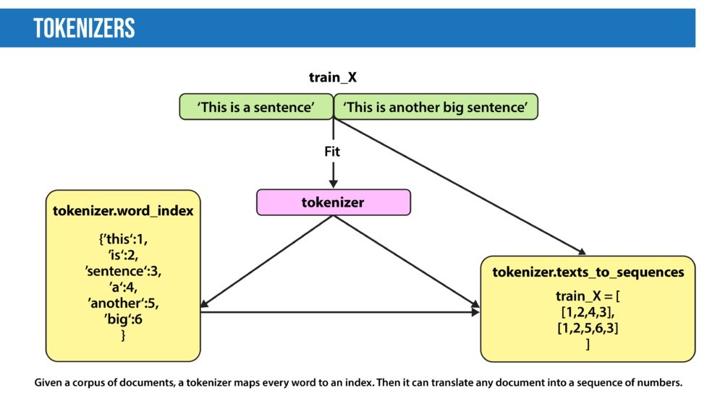
  - Tokenization: Splits text into individual words and word fragments, often represented as numerical tokens for deep learning .

- Feature extraction:
  - Bag-of-Words: Counts the number of times each word or n-gram appears in a document .
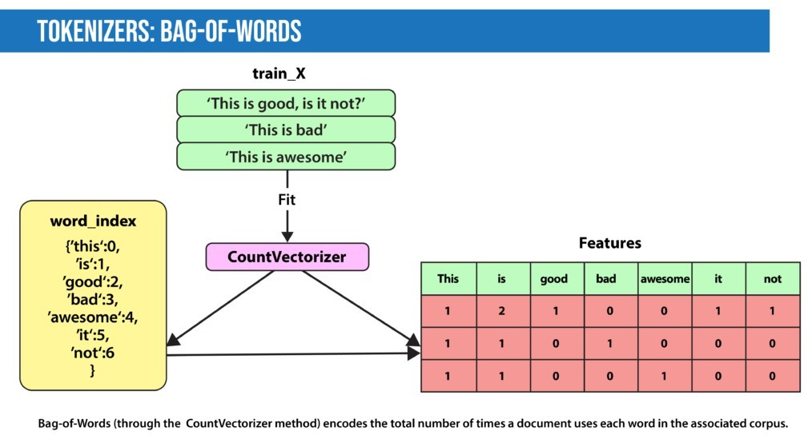
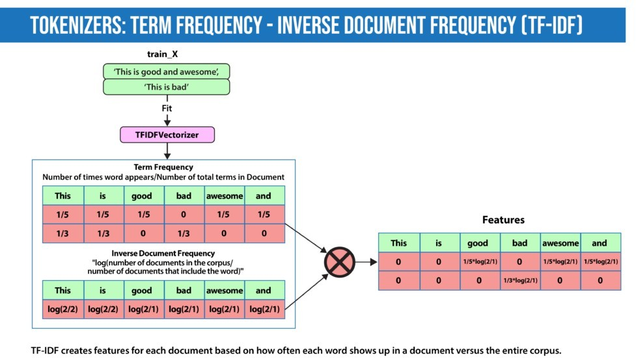
  - TF-IDF (Term Frequency-Inverse Document Frequency): Weights each word by its importance, which is the product of Term Frequency (how important the word is in the document) and Inverse Document Frequency (high if the word is rare across the corpus) .

  - Word2Vec: Uses a vanilla neural network to learn high-dimensional word embeddings from raw text, capturing context. Variations include Skip-Gram and Continuous Bag-of-Words (CBOW).
  - GLoVE: Similar to Word2Vec, it learns word embeddings but uses matrix factorization techniques rather than neural learning.
- Modeling:
  - Numerical features can be fed into various traditional models like logistic regression, naive Bayes, decision trees, or gradient boosted trees for classification tasks.
  - For named entity recognition, hidden Markov models with n-grams can be used.
  - Language Models: Predict the next word given a stream of input words. Deep learning is used to create such models, which take a word embedding as input and return the probability distribution of the next word. Pre-trained language models (like BERT) learn the structure of a language and can be fine-tuned for specific tasks.
Deep Learning NLP Techniques
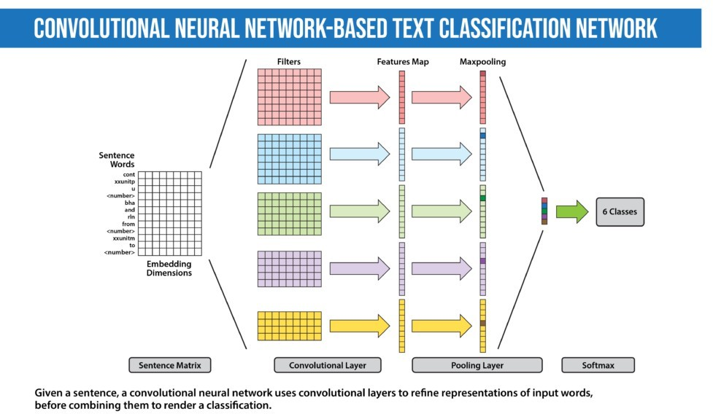
- Convolutional Neural Network (CNN): Views a document as an image where the input is sentences or documents represented as a matrix of words .
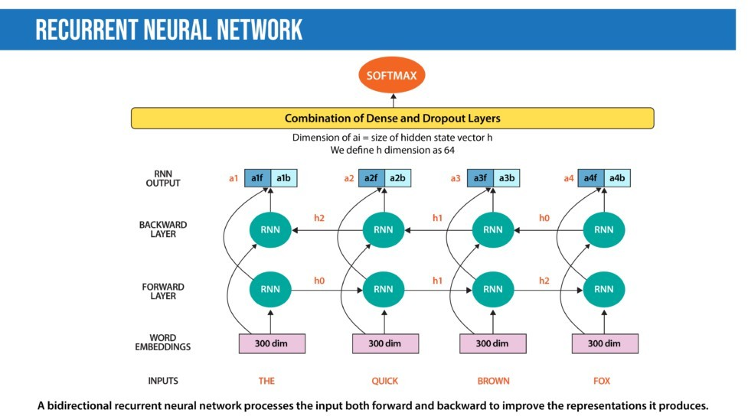
- Recurrent Neural Network (RNN): Used to process sequential data where every word depends on the previous word. They remember previous information using hidden states and connect it to the current task. Architectures like Gated Recurrent Unit (GRU) and Long Short-Term Memory (LSTM) are types of RNNs.

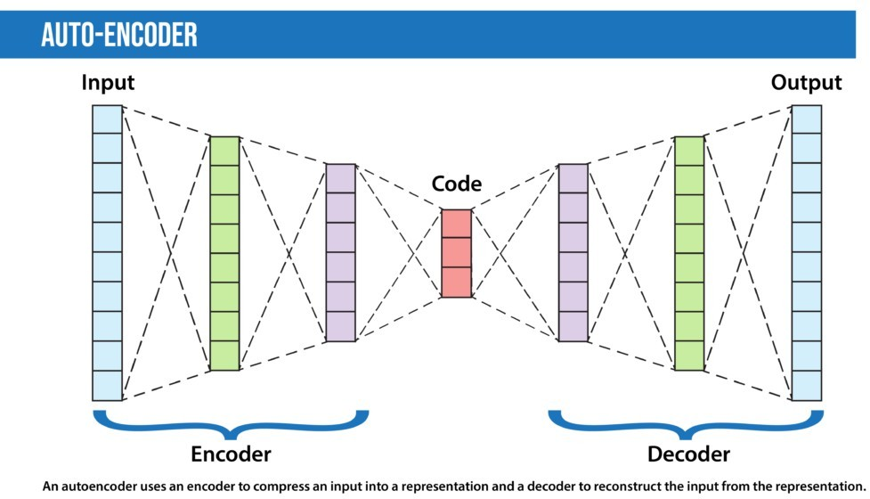
- Autoencoders (AEs): Deep learning encoder-decoders that approximate a mapping from input to output (input=output). They compress input features into a lower-dimensional representation (latent code) and learn to reconstruct the input, useful for dimensionality reduction .
- Encoder-decoder sequence-to-sequence (seq2seq): An adaptation to autoencoders specialized for tasks like translation and summarization. The encoder encapsulates information into an encoded vector, and the decoder generates a different desired output from this vector .
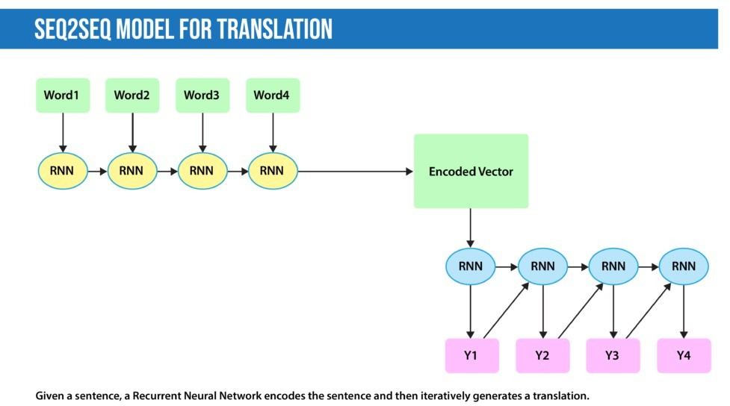

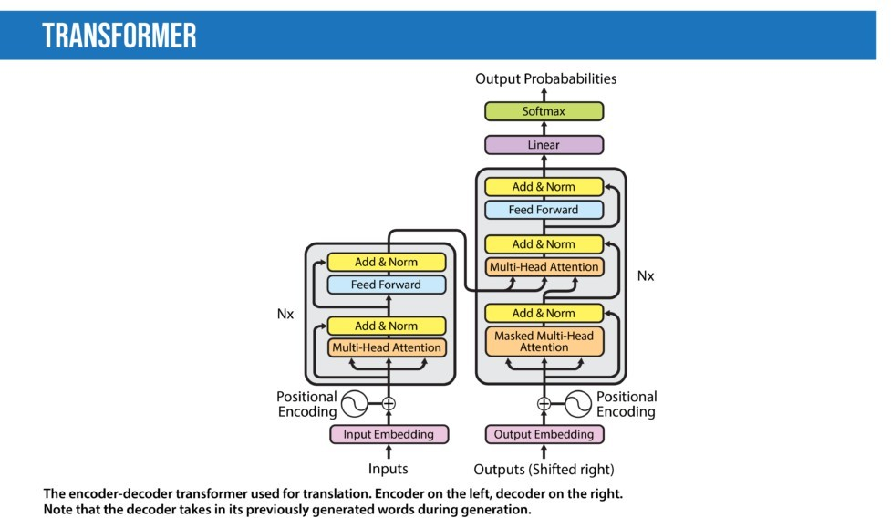
- Transformers: Forgo recurrence and rely entirely on a self-attention mechanism to draw global dependencies between input and output. This processes all words at once, decreasing training speed and inference cost compared to RNNs. The architecture has revolutionized NLP, leading to models like BLOOM and BERT .

Generative Adversarial Networks (GANs)
GANs were introduced in 2014 by Ian J. Goodfellow and co-authors. They perform unsupervised learning tasks in machine learning.
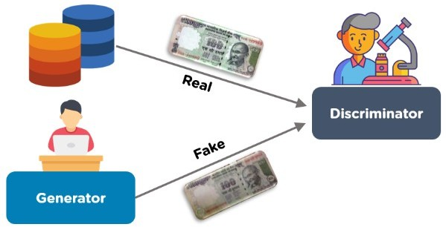

- Structure and Function
  - A GAN consists of two competing models: the Generator () and the Discriminator ().
  - They work simultaneously in an adversarial game to discover, learn, and replicate the variations within a dataset.
  - GANs can be used to generate new examples that plausibly could have been drawn from the original dataset.
The Generator (G)
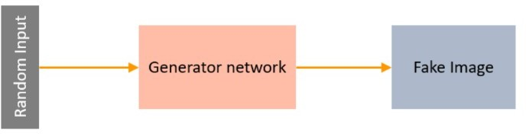

- A neural network that creates fake data.
- Its aim is to fool the discriminator by producing data similar to the training set.
- It takes a fixed-length random vector carrying noise as input and generates a sample (e.g., a fake image) .
- The generated examples become negative training examples for the discriminator.
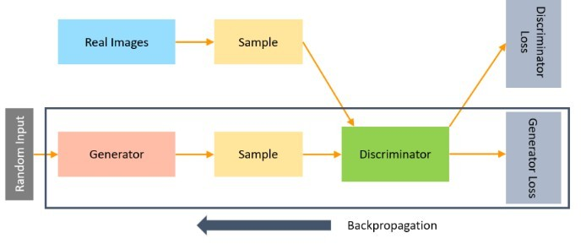
- The Generator is trained to increase the Discriminator network's probability of making mistakes.
The Discriminator (D)
- A neural network that identifies real data from the fake data created by the Generator.
- It tries not to be fooled by identifying fake data from real data.
- Its training data comes from two sources:
  - Real data instances (positive samples) .
  - Fake data instances created by the Generator (negative examples).
- The Discriminator classifies both real and fake data from the generator.
- The discriminator loss penalizes the discriminator for misclassifying a real data instance as fake or a fake instance as real.
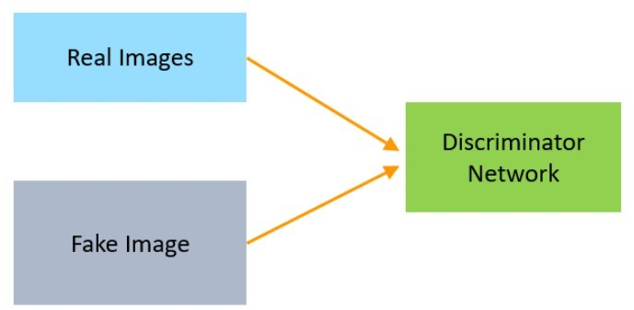

  - While training the discriminator, it connects to two loss functions. During discriminator training, the discriminator ignores the generator loss and just uses the discriminator loss.
  - In the fake data from the generator. The discriminator loss penalizes the discriminator for misclassifying a real data instance as fake or a fake data instance as real.
  - The discriminator updates its weights through backpropagation from the discriminator loss through the discriminator network.
  - While training the process of training the discriminator, the discriminator classifies both real data and
  - discriminator, it connects to two loss functions. During discriminator training, the discriminator ignores the generator loss and just uses the discriminator loss.
  - In the process of training the discriminator, the discriminator classifies both real data and fake data from the generator. The discriminator loss penalizes the discriminator for misclassifying a real data instance as fake or a fake data instance as real.

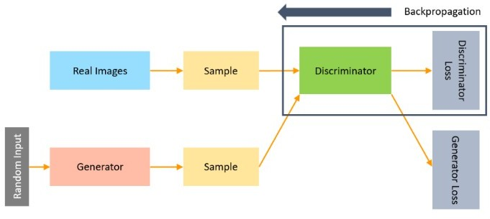

Training a GAN
- The process involves a continuous cycle where the Generator tries to improve its fake data, and the Discriminator tries to improve its ability to distinguish real from fake.
- The loss function is calculated at the end of the Discriminator network, and the loss is backpropagated into both discriminator and generator models .
- The Discriminator updates its weights through backpropagation from the discriminator loss.
- The Generator loss penalizes the Generator for failing to fool the Discriminator, and backpropagation adjusts the Generator weights.
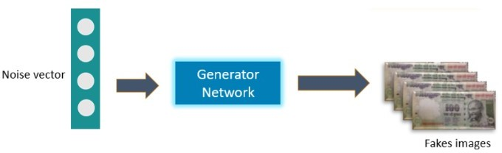
Steps for Training GAN
- Define the problem.
- Choose the architecture of GAN.
- Train discriminator on real data.
- Generate fake inputs for the generator.
- Train discriminator on fake data.
- Train generator with the output of the discriminator.
Types of GANs
- Vanilla GANs: Use a min-max optimization formulation; the Discriminator is a binary classifier using sigmoid cross-entropy loss, and both Generator and Discriminator are multi-layer perceptrons.
- Deep Convolutional GANs (DCGANs): Use Convolutional Neural Networks instead of vanilla neural networks for both the Generator and Discriminator, which are more stable and generate better quality images.
- Conditional GANs (CGAN): Extend Vanilla GANs by using an extra-label information ('y') in the Generator to produce corresponding data, and labels are fed to the Discriminator to aid in distinguishing real from fake data.
- Super Resolution GANs (SRGANs): Use deep neural networks and an adversarial network to produce photorealistic higher resolution images from low-resolution input.
Application of GANs
- Generating faces of anime characters and Pokemon characters using DCGANs.
- Generating realistic human faces that do not exist in reality.
- Building realistic images from textual descriptions of objects like birds, humans, and animals.
Deep Reinforcement Learning (DRL)
Deep reinforcement learning is a category of machine learning and artificial intelligence where intelligent machines learn from their actions, similar to how humans learn from experience.
- Mechanism
  - An agent is rewarded or penalized based on its actions. Actions that lead to the target outcome are rewarded (reinforced).
  - Through a series of trial and error, the machine keeps learning, making it ideal for dynamic environments.
  - The "deep" portion refers to the multiple (deep) layers of artificial neural networks that replicate the structure of a human brain.
  - The combination of reinforcement learning (around for decades) and deep learning has yielded phenomenal results.
- Emergence and Milestones
  - The volumes of data have exploded while computing power costs have dramatically reduced, enabling the explosion of deep learning applications.
  - DRL gained attention with DeepMind’s AlphaGo defeat of a Go grandmaster.
  - DRL has achieved human-level prowess in games like chess, poker, Atari games, and several other competitive video games.
  - Moving to business requires products and services like simulation technology to provide a scalable trial-and-error environment where mistakes won't cause real-world damage.
Practical Applications of Deep Reinforcement Learning
- AI toolkits for training: Open-source toolkits like OpenAI Gym, DeepMind Lab, and Psychlab provide the necessary training environment for DRL agents and are driving large-scale innovation.
- Manufacturing: Intelligent robots in warehouses use DRL to gain knowledge based on success or failure when sorting and picking products, leading to more efficient performance.
- Automotive: Already used in autonomous vehicles, DRL will help transform factories, vehicle maintenance, and overall automation in the industry, potentially improving quality, saving money, and increasing safety.
- Finance: Used by companies like Pit.AI to be better investment managers than humans and to evaluate trading strategies.
- Healthcare: Great potential for improving healthcare through determining optimal treatment plans and diagnosis, as well as in clinical trials, new drug development, and automatic treatment.
- Bots: The conversational UI paradigm for AI bots leverages DRL to rapidly learn the nuances and semantics of language for automated speech and natural language understanding.
Autoencoders
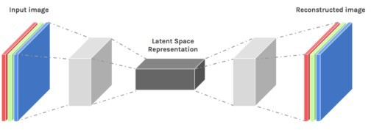
An autoencoder neural network is an Unsupervised Machine learning algorithm that applies backpropagation, setting the target values to be equal to the inputs.

- Purpose: Used to reduce the size of inputs into a smaller representation. The original data can be reconstructed from this compressed data.
- Advantage over PCA: Autoencoders are preferred over PCA because they can learn non-linear transformations with a non-linear activation function and multiple layers. They can also use convolutional layers for data like video, images, and series data.
Architecture of Autoencoders
An autoencoder consists of three layers : Encoder, Code, and Decoder .
- Encoder: Compresses the input into a latent space representation (the compressed image is a distorted version of the original image).
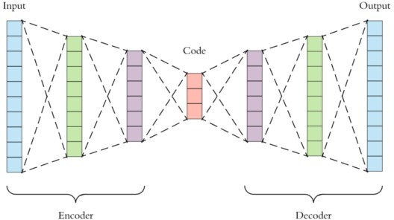
- Code (Bottleneck): Represents the compressed input that is fed to the decoder. It is a well-designed approach to decide which aspects of data are relevant and what can be discarded by balancing compactness (compressibility) and retaining relevant variables.
- Decoder: Decodes the encoded image back to the original dimension. The decoded image is a lossy reconstruction of the original image from the latent space representation.
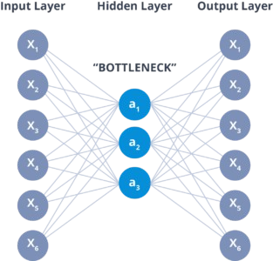
Properties and Hyperparameters

Category | Item | Description
Properties | Data-specific | Only able to compress data similar to what they have been trained on.
 | Lossy | The decompressed outputs will be degraded compared to the original inputs.
 | Learned automatically from examples | Easy to train specialized instances of the algorithm.
Hyperparameters | Code size | Number of nodes in the middle layer; smaller size results in more compression.
 | Number of layers | The autoencoder can consist of as many layers as needed.
 | Number of nodes per layer | Decreases with each subsequent layer of the encoder and increases back in the decoder (which is symmetric to the encoder).
 | Loss function | Typically mean squared error (if input values are not in ) or binary cross-entropy (if input values are in the range ).

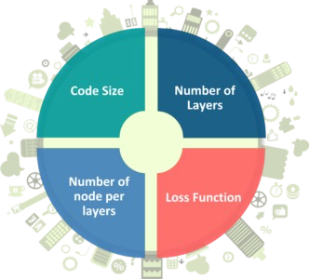

Applications of Autoencoders
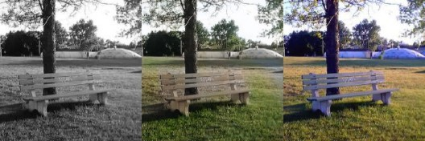
- Image Coloring: Converting any black and white picture into a colored image by predicting the color based on the picture's content.

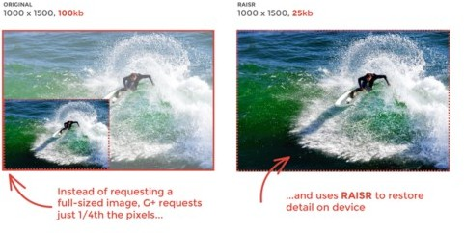
- Feature variation: Extracts only the required features of an image and generates the output by removing any noise or unnecessary interruption.

- Dimensionality Reduction: The reconstructed image is the same as the input but with reduced dimensions.
- Denoising Image: Trained to reconstruct the original input from a stochastically corrupted (noisy) version.
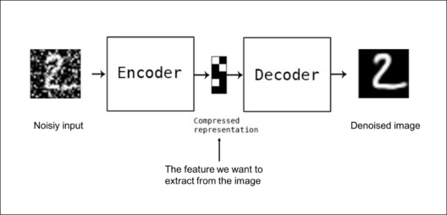
- Watermark Removal: Used for removing watermarks from images or any object while filming a video or movie.
Types of Autoencoders

- Convolution Autoencoders (CAE): Use the convolution operator to encode the input in a set of simple signals and then try to reconstruct the input, useful for image data .

  - Use cases: Image Reconstruction, Image Colorization, latent space clustering, generating higher resolution images.
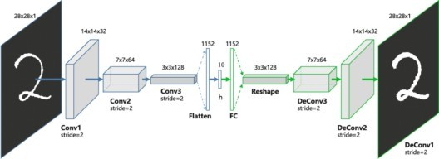
- Sparse Autoencoders: Introduce an information bottleneck without requiring a reduction in the number of nodes at hidden layers. They penalize activations within a layer by constructing the loss function .
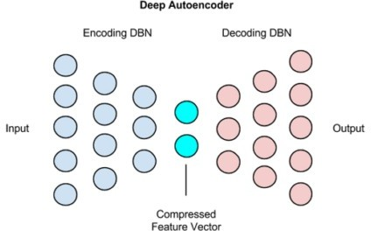
- Deep Autoencoders: An extension of the simple autoencoder with deeper layers. Deeper layers learn higher-order features. A deep autoencoder is composed of two symmetrical Deep Belief Networks (DBNs)—the encoding half and the decoding half .

  - Use cases: Image Search, Data Compression, Topic Modeling & Information Retrieval (IR).
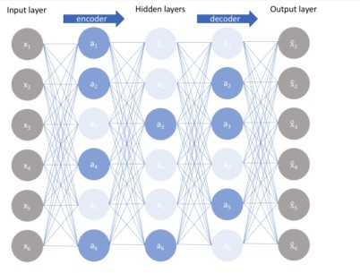
- Contractive Autoencoders: Unsupervised technique that penalizes large derivatives of hidden layer activations with respect to the input training examples. This essentially penalizes instances where a small change in the input leads to a large change in the encoding space .

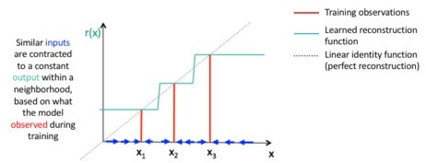
Deep Generative Models: Boltzmann Machines
A Boltzmann machine is an association of uniformly associated neuron-like structures that make hypothetical decisions about whether to be on or off.Boltzmann Machine was invented by renowned scientist Geoffrey Hinton and Terry Sejnowski in 1985.
- Boltzmann Machines have a fundamental learning algorithm that permits them to find exciting features that represent complex regularities in the training data. The learning algorithm is usually slow in networks with various layers of feature detectors, but it is quick in "Restricted Boltzmann Machines" that has a single layer of feature detectors. Many hidden layers can be adapted efficiently by comprising Boltzmann Machines, utilizing the feature activations of one as the training data for the next.
- Features and Learning: Invented by Geoffrey Hinton and Terry Sejnowski in 1985. They have a fundamental learning algorithm that allows them to find exciting features representing complex regularities in the training data.
- Issues: Learning is usually slow in networks with various hidden layers, but it is quick in Restricted Boltzmann Machines (RBMs) that have a single layer of feature detectors.
- Computational Issues: Boltzmann Machines are used to resolve two computational issues:
  - Search problem: Weights are fixed and represent a cost function. The stochastic dynamics permit sampling binary state vectors with minimum cost function values.
  - Learning issue: Given a set of binary data vectors, the machine must figure out how to generate these vectors with high probability.
Stochastic Dynamics of a Boltzmann Machine
When unit updates its binary state, it computes its absolute input , which is the sum of its own bias and the weighted sum of associations from other active units:
- = weight on the association between and .
- = when unit is on.
Unit turns on with a probability given by the logistic function:
The network will eventually reach a Boltzmann distribution (equilibrium or stationary distribution) where the probability of a state vector is determined by its "energy" compared to the energies of all possible binary state vectors:
The energy of state vector is defined as:
Restricted Boltzmann Machine (RBM)
The RBM, invented by Smolensky in 1986.
- Architecture: Comprises a layer of visible units and a layer of hidden units with no visible-visible or hidden-hidden associations.
- Learning Efficiency: With these restrictions, the hidden units are conditionally autonomous given a visible vector, simplifying the sampling process and making learning faster compared to general Boltzmann Machines.

Deep Belief Networks (DBNs)
DBNs are created to address issues with classic neural networks in deep layered networks, such as slow learning, getting stuck in local minima, and requiring a large number of training datasets.
- Features and Structure
  - DBN is a hybrid generative graphical model.
  - It is an algorithm for unsupervised probabilistic deep learning.
  - A DBN consists of several layers of stochastic latent variables (binary latent variables often known as feature detectors or hidden units).
  - DBNs are made up of simple, unsupervised networks like Restricted Boltzmann Machines (RBMs) or autoencoders.
  - The hidden layer of each sub-network serves as the visible layer for the next layer.
  - The top two layers have no direction and form associative memory through undirected and symmetric connections.
  - The layers below the top two have directed links to lower layers.
  - A DBN is a series of constrained Boltzmann machines connected consecutively .

How DBN Works
- Greedy Pre-training: The Greedy learning algorithm is used to pre-train the DBN layer-by-layer to learn the top-down generative weights. The values of the hidden layer of one RBM are treated as the visible layer for the next RBM.
- Fine-tuning: The parameters are fine-tuned after pre-training using a single bottom-up pass to infer the values of the latent variables in each layer .
Applications of DBN
DBNs are used in place of deep feedforward networks or convolutional neural networks in more sophisticated setups. They have the benefit of being less computationally costly (computational complexity grows linearly with the number of layers) and are less susceptible to the vanishing gradients problem.
- Recognition of images.
- Sequences of video.
- Data on mocap.
- Speech recognition.

