**Weather App**

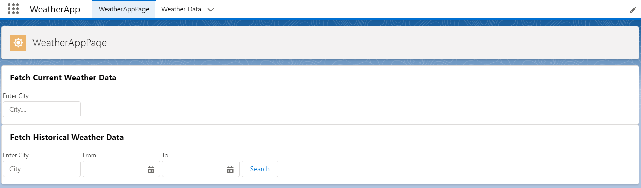

Fetch Current Weather Data from Open Weather API and display on UI

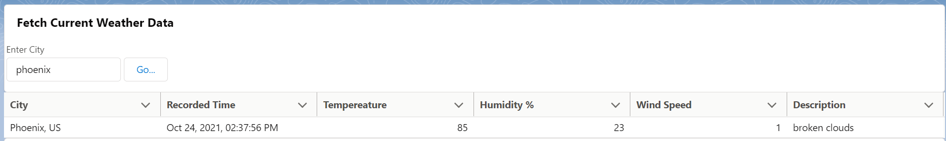

Fetch Historical Data from Salesforce and display on UI and Generate PDF feature

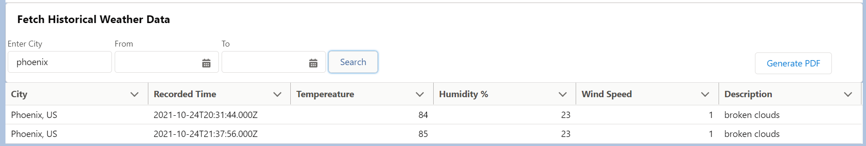

Downloaded PDF file

