MultiThreading
java.lang.Runnable
• void run() - must be overridden and supplied with instructions for the task that you want to have executed.

java.lang.Thread
• Thread(Runnable target) - constructs a new thread that calls the run() method of the specified target.
• void start() - starts this thread, causing the run() method to be called. This method will return immediately. The new thread runs concurrently.
• void run() - calls the run method of the associated Runnable.
• static void sleep(long millis) - sleeps for the given number of milliseconds.
• static void yield() - causes the currently executing thread to yield to another thread. Note that this is a static method.

Thread States
Threads can be in one of six states:
• New
• Runnable
• Blocked
• Waiting
• Timed waiting
• Terminated

To determine the current state of a thread, simply call the getState method.
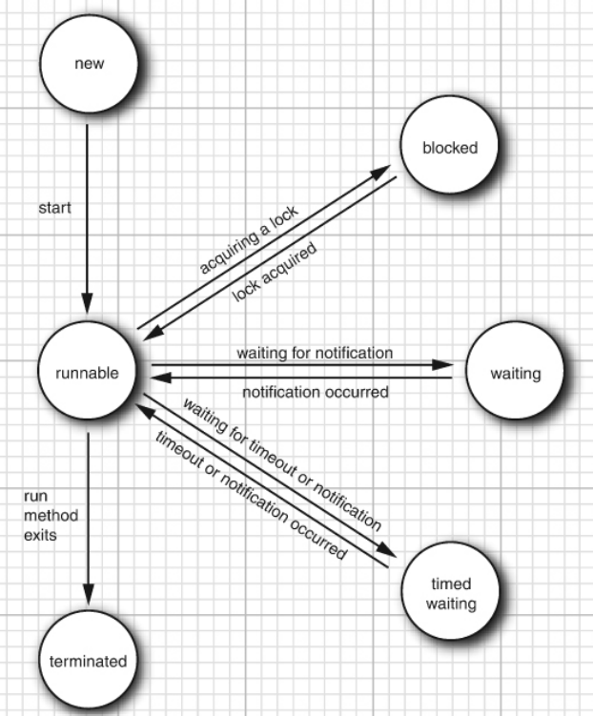

Preemptive Vs Non Preemptive

java.lang.Thread
• void join() waits for the specified thread to terminate.
• void join(long millis) waits for the specified thread to die or for the specified number of milliseconds to pass.
• Thread.State getState() 5 gets the state of this thread: one of NEW, RUNNABLE, BLOCKED, WAITING, TIMED_WAITING, or TERMINATED.
• void stop() stops the thread. This method is deprecated.
• void suspend() suspends this thread’s execution. This method is deprecated for removal.
• void resume() resumes this thread. This method is only valid after suspend() has been invoked. This method is deprecated for removal.

Thread Properties
Interrupting Threads
interrupt method can be used to request termination of a thread.

When the interrupt method is called on a thread, the interrupted status of the thread is set. This is a boolean flag that is present in every thread. Each thread should occasionally check whether it has been interrupted.

while (!Thread.currentThread().isInterrupted() && more work to do)
{
do more work
}

java.lang.Thread
• void interrupt() sends an interrupt request to a thread. The interrupted status of the thread is set to true. If the thread is currently blocked by a call to sleep, then an InterruptedException is thrown.
• static boolean interrupted() tests whether the current thread (that is, the thread that is executing this instruction) has been interrupted. Note that this is a static method. The call has a side effect—it resets the interrupted status of the current thread to false.
• boolean isInterrupted() tests whether a thread has been interrupted. Unlike the static interrupted method, this call does not change the interrupted status of the thread.
• static Thread currentThread() returns the Thread object representing the currently executing thread.

Daemon Threads
You can turn a thread into a daemon thread by calling
t.setDaemon(true);

There is nothing demonic about such a thread. A daemon is simply a thread that has no other role in life than to serve others. Examples are timer threads that send regular “timer ticks” to other threads or threads that clean up stale cache entries. When only daemon threads remain, the virtual machine exits. There is no point in keeping the program running if all remaining threads are daemons.

java.lang.Thread
• void setDaemon(boolean isDaemon) marks this thread as a daemon thread or a user thread. This method must be called before the thread is started.

Thread Names
By default, threads have catchy names such as Thread-2. You can set any name with the setName method:
var t = new Thread(runnable);
t.setName("Web crawler");
That can be useful in thread dumps.

Thread Priorities
In the Java programming language, every thread has a priority. By default, a thread inherits the priority of the thread that constructed it. You can increase or decrease the priority of any thread with the setPriority method. You can set the priority to any value between MIN_PRIORITY (defined as 1 in the Thread class) and MAX_PRIORITY (defined as 10). NORM_PRIORITY is defined as 5.

java.lang.Thread
• void setPriority(int newPriority) sets the priority of this thread. The priority must be between Thread.MIN_PRIORITY and Thread.MAX_PRIORITY. Use Thread.NORM_PRIORITY for normal priority.
• static int MIN_PRIORITY is the minimum priority that a Thread can have. The minimum priority value is 1.
• static int NORM_PRIORITY is the default priority of a Thread. The default priority is 5.
• static int MAX_PRIORITY is the maximum priority that a Thread can have. The maximum priority value is 10.

Synchronization
Lock Objects
The Java language provides a synchronized keyword for this purpose, and Java 5 introduced the ReentrantLock class
The basic outline for protecting a code block with a ReentrantLock is:
private Lock bankLock = new ReentrantLock();
myLock.lock(); // a ReentrantLock object
try {
critical section
} finally {
myLock.unlock(); // make sure the lock is unlocked even if an exception is thrown
}

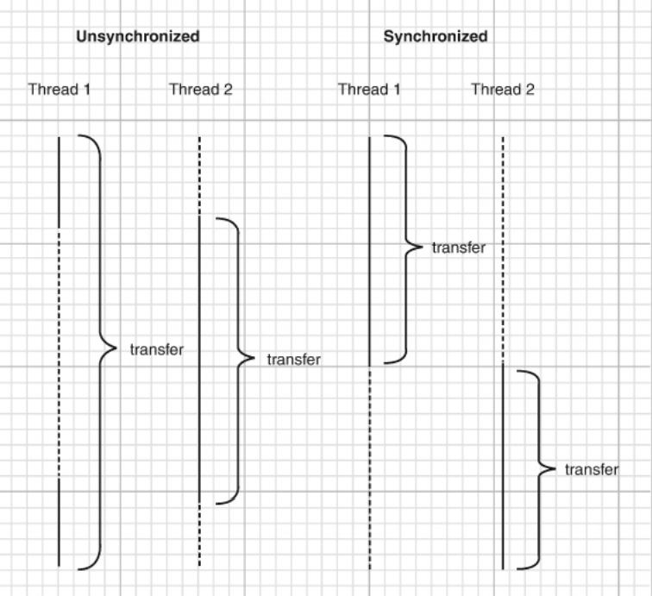

java.util.concurrent.locks.Lock
• void lock() acquires this lock; blocks if the lock is currently owned by another thread.
• void unlock() releases this lock.

java.util.concurrent.locks.ReentrantLock
• ReentrantLock() constructs a reentrant lock that can be used to protect a critical section.
• ReentrantLock(boolean fair) constructs a lock with the given fairness policy. A fair lock favors the thread that has been waiting for the longest time. However, this fairness guarantee can be a significant drag on performance. Therefore, by default, locks are not required to be fair.

