Map
The Map interface is the one of the major Collections Framework interfaces, and the only one that does not inherit from Collection.
It defines the operations that are supported by a set of key-to-value associations in which the keys are unique.

These operations are fall into the following four groups
Adding elements
V put(K key, V value) - add or replace a key-value association return the old value (may be null) if the key was present; otherwise returns null
void putAll(Map m) - add each of the key-value associations in the supplied map into the receiver

Removing Elements:
void clear() - remove all associations from this map
V remove(Object key) remove the association, if any, with the given key; returns the value with which it was associated, or null

Querying the Contents of a Map
V get(Object k) - return the value corresponding to k, or null if k is not present as a key boolean containsKey(Object k) return true if k is present as a key
boolean containsValue(Object v) return true if v is present as a value
int size() return the number of associations
boolean isEmpty() return true if there are no associations

Providing Collection Views of the Keys, Values, or Associations:
Set<Map.Entry<K,V>> entrySet() - return a Set view of the associations
Set keySet() - return a Set view of the keys
Collection values() - return a Collection view of the values

Implementing Map
The implementations, eight in all, that the Collections Framework provides for Map are
HashMap, LinkedHashMap, WeakHashMap, Identity HashMap, EnumMap, NavigableMap, ConcurrentMap, and Concurrent NavigableMap

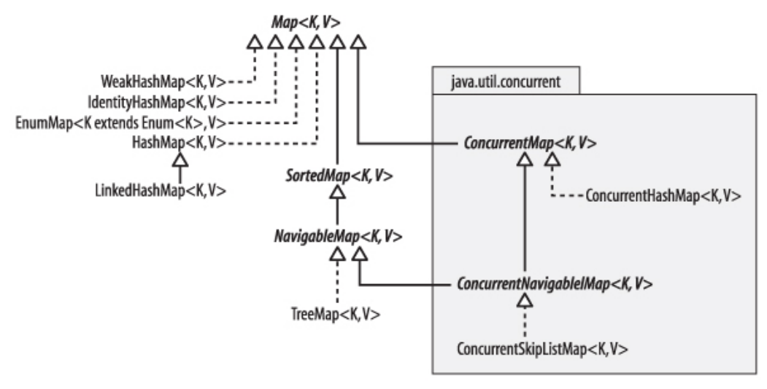

Every implementation excluding EnumMap has at least two constructors; taking HashMap as an example, they are:
public HashMap()
public HashMap(Map m)
The iterators are fail-fast.
HashMap
Two constructors allow the programmer to configure a new instance of HashMap
public HashMap(int initialCapacity)
public HashMap(int initialCapacity, float loadFactor)
how HashMap works internally in Java:
HashMap stores data as key–value pairs. It uses a hashing mechanism to store and retrieve elements efficiently (average time complexity O(1)).
- When you put a key–value pair, HashMap calls the key’s hashCode() method.
- This hash code is processed to determine an index (bucket) in an internal array.
- Each index in the array is called a bucket.
- A bucket can store:
- A linked list (before Java 8)
- A balanced red-black tree (Java 8+) when many collisions occur
If two keys map to the same bucket:
- They are stored in the same bucket.
- Java uses:
  - Linked List initially
  - Red-Black Tree if bucket size exceeds a threshold (≥ 8 entries)
This improves performance from O(n) to O(log n).
Retrieval (get() operation)
- Compute hash of the key
- Find the bucket index
- Compare keys using equals()
- Return the matching value

Resizing (Rehashing)
- Default capacity: 16
- Default load factor: 0.75
- When size exceeds capacity × load factor, the HashMap:
- Doubles its capacity
- Rehashes all entries
Important Points
- Allows one null key and multiple null values
- Not thread-safe
- Performance depends on good hashCode() and equals() implementation

LinkedHashMap:
Almost same as HashMap but this will also maintain two additional pointers before and after to maintain the insertion order.

