OMS inside the Fonepoints Business portal
How it works: the complete flow
Version 2.0 · 12 October 2026 · Prepared by the OMS team

This document explains how OMS works inside the Fonepoints Business portal: every step from the click to the orders, every message between the two apps, every place it can stop, and every security check.
What to build is in the companion document, OMS-Fonepoints-Integration-Guide.docx. Its step numbers refer to the flow in this one.

Contents
- The rule that matters most
- The big picture
- The complete flow: diagram and every step
- Messages between the portal and OMS
- Security checks
- A token that never expires

1. The rule that matters most
The token does not expire, and OMS keeps it. OMS stores the merchant's token in a cookie that lasts up to 400 days and survives closing the browser. Every time the merchant opens OMS, OMS only checks that the cookie is there. No other call, no handshake.
A handshake runs only when OMS has no cookie (the first visit, after sign-out, or after the merchant cleared the browser's site data) or when Sales refuses the token (revoked or replaced). Then OMS asks the portal with oms.auth.renew, and the portal asks your backend for a token and passes it on. The portal keeps no token of its own.
OMS stores the token as it is given, with no extra check. The token came from Providhy IAM through your backend, which already knows the merchant; Sales checks it on the first order request. If Sales refuses it, OMS deletes the cookie and asks the portal again.
The portal can't see OMS's cookie: it is HttpOnly and belongs to OMS's website. So the portal never guesses. It answers oms.ready with the theme only, and answers oms.auth.renew with a token.
The session ends only when the merchant signs out of the portal. The portal then tells OMS to delete its cookie, and drops its own copy of the token.

2. The big picture
Five parts take part, two of them inside the merchant's browser. The numbers follow one journey.
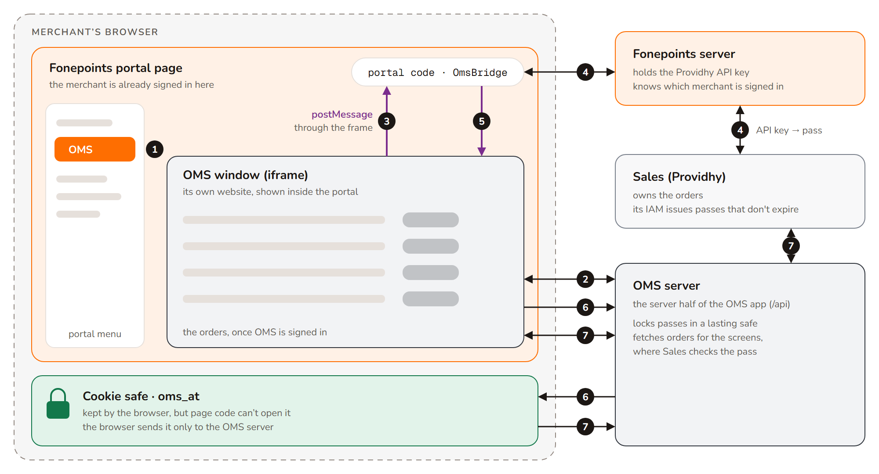
Figure 1 · The five parts. Orange is Fonepoints, dark grey is OMS, light grey is Providhy. Purple arrows are messages through the frame.

The journey in seven steps
- The merchant clicks OMS in the portal menu. The portal shows the OMS window.
- OMS asks its own server: “is there a token in my cookie?” Almost always there is, and OMS opens straight away.
- If there is no cookie, OMS asks the portal for a token through the frame.
- The portal asks your backend, which gets a token from Providhy IAM with the Providhy API key, and passes it on. The portal keeps nothing.
- The portal hands the token through the frame, addressed only to OMS.
- OMS gives it to its own server, which checks the request came from OMS and locks the token in a lasting cookie.
- From now on every OMS screen asks the OMS server, which shows the token to Sales. Sales checks it and returns only this merchant's orders.

The five parts
Part | Owner | What it does
Portal page (Angular) | Fonepoints | Shows OMS in a frame, answers OMS's messages, passes the token from your backend to OMS (keeping none), and tells OMS to sign out when the merchant signs out.
Fonepoints server (your backend) | Fonepoints | Knows which merchant is signed in. Holds the Providhy API key and gets the merchant token from Providhy IAM. Whether it keeps tokens between visits is your call.
OMS window (iframe) | OMS | The OMS screens. Talks to the portal only through messages.
OMS server | OMS | The server half of OMS. Keeps the token in a lasting cookie and fetches orders with it.
Sales and Providhy IAM | Providhy | Sales owns the orders. IAM issues merchant tokens; they don't expire.

Words used here
Word | Meaning
Token | The access token (a JWT) issued by Providhy IAM for one merchant. It does not expire; it stops working only if it is revoked or replaced.
Frame / iframe | OMS is its own website shown inside one portal page.
Message / postMessage | A note one page posts to the other through the frame, addressed to an exact web address.
Cookie (oms_at) | Where OMS keeps the token, for up to 400 days. HttpOnly: page code can't read it; the browser sends it only to the OMS server.
Handshake | Phases 3 to 5 of the flow: getting a token to OMS. Runs only when OMS has no cookie, or Sales refused the token.

3. The complete flow
The diagram is split into five parts to fit the page. The numbered steps after it explain each box in the same order.

How to read the diagram
- Each box names who does the step: Portal page, Fonepoints server, Providhy IAM, OMS window, OMS server, Sales, Browser.
- Arrow labels say how the next step is reached: HTTPS, server to server, or postMessage (purple).
- A green circle with a letter is a security check (section 5).
- A red box is where the flow stops, with what the merchant sees.
- The tinted area (phases 3 to 5) runs only when OMS asks for a token.
- The green line is the shortcut: from step 7 to step 23 when OMS has its cookie (the usual case). The dashed line on the left goes from step 28 back to step 8.
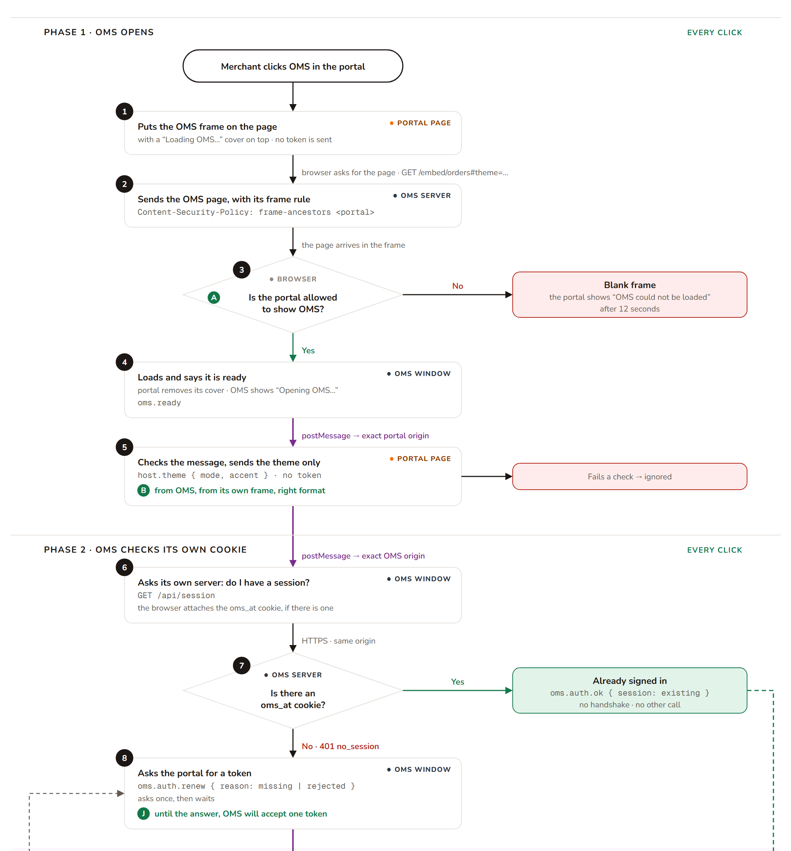
Figure 2a · Phases 1 and 2: OMS opens and checks its own cookie (every click)
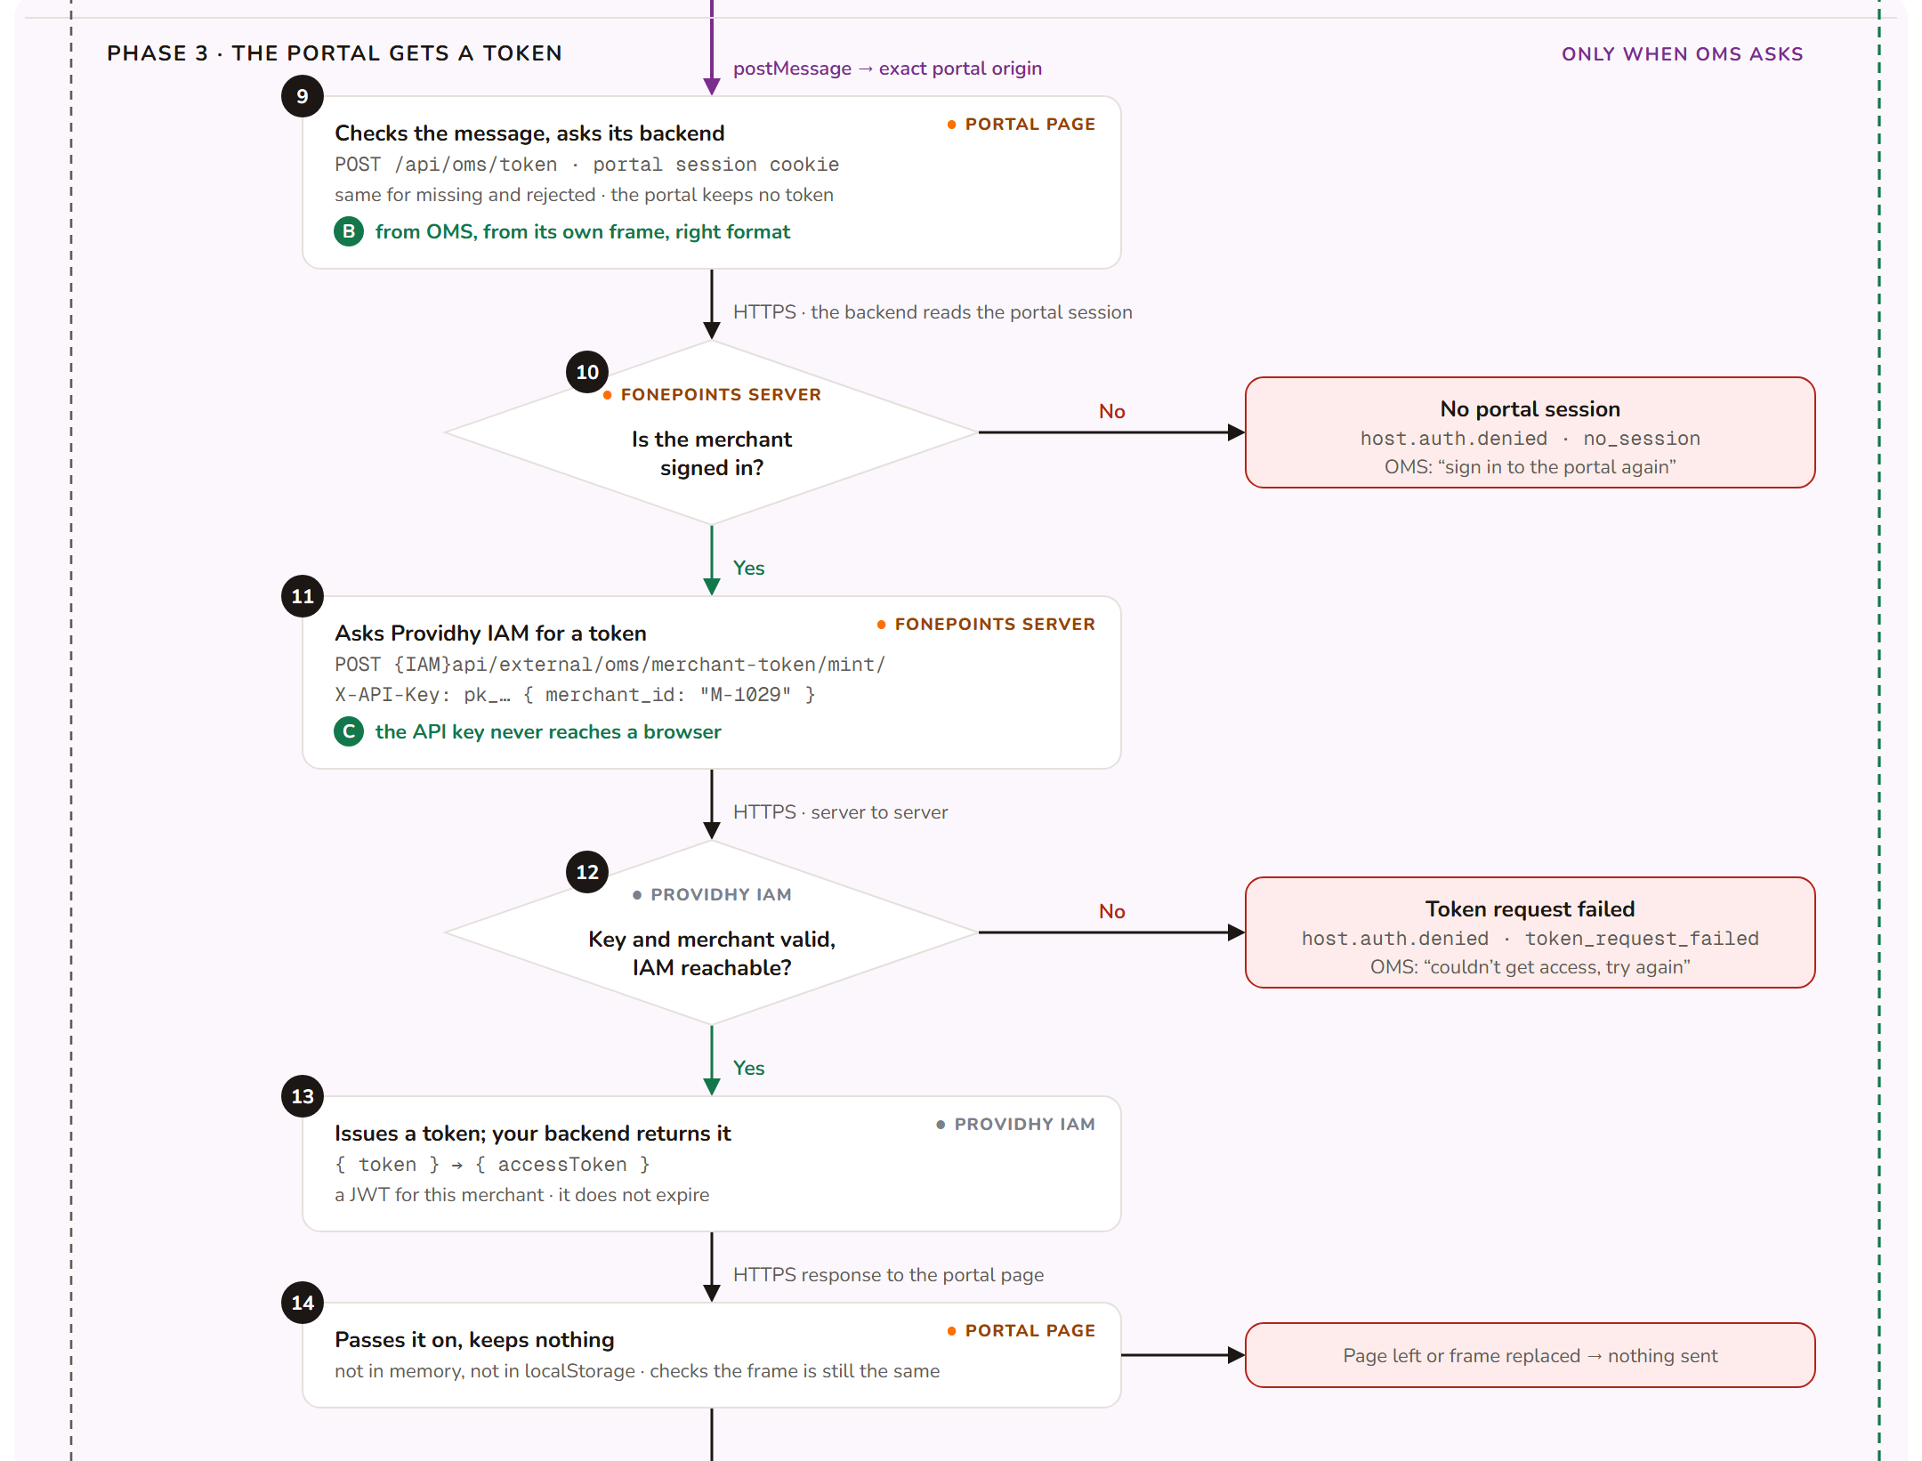
Figure 2b · Phase 3: the portal gets a token (only when OMS asks)
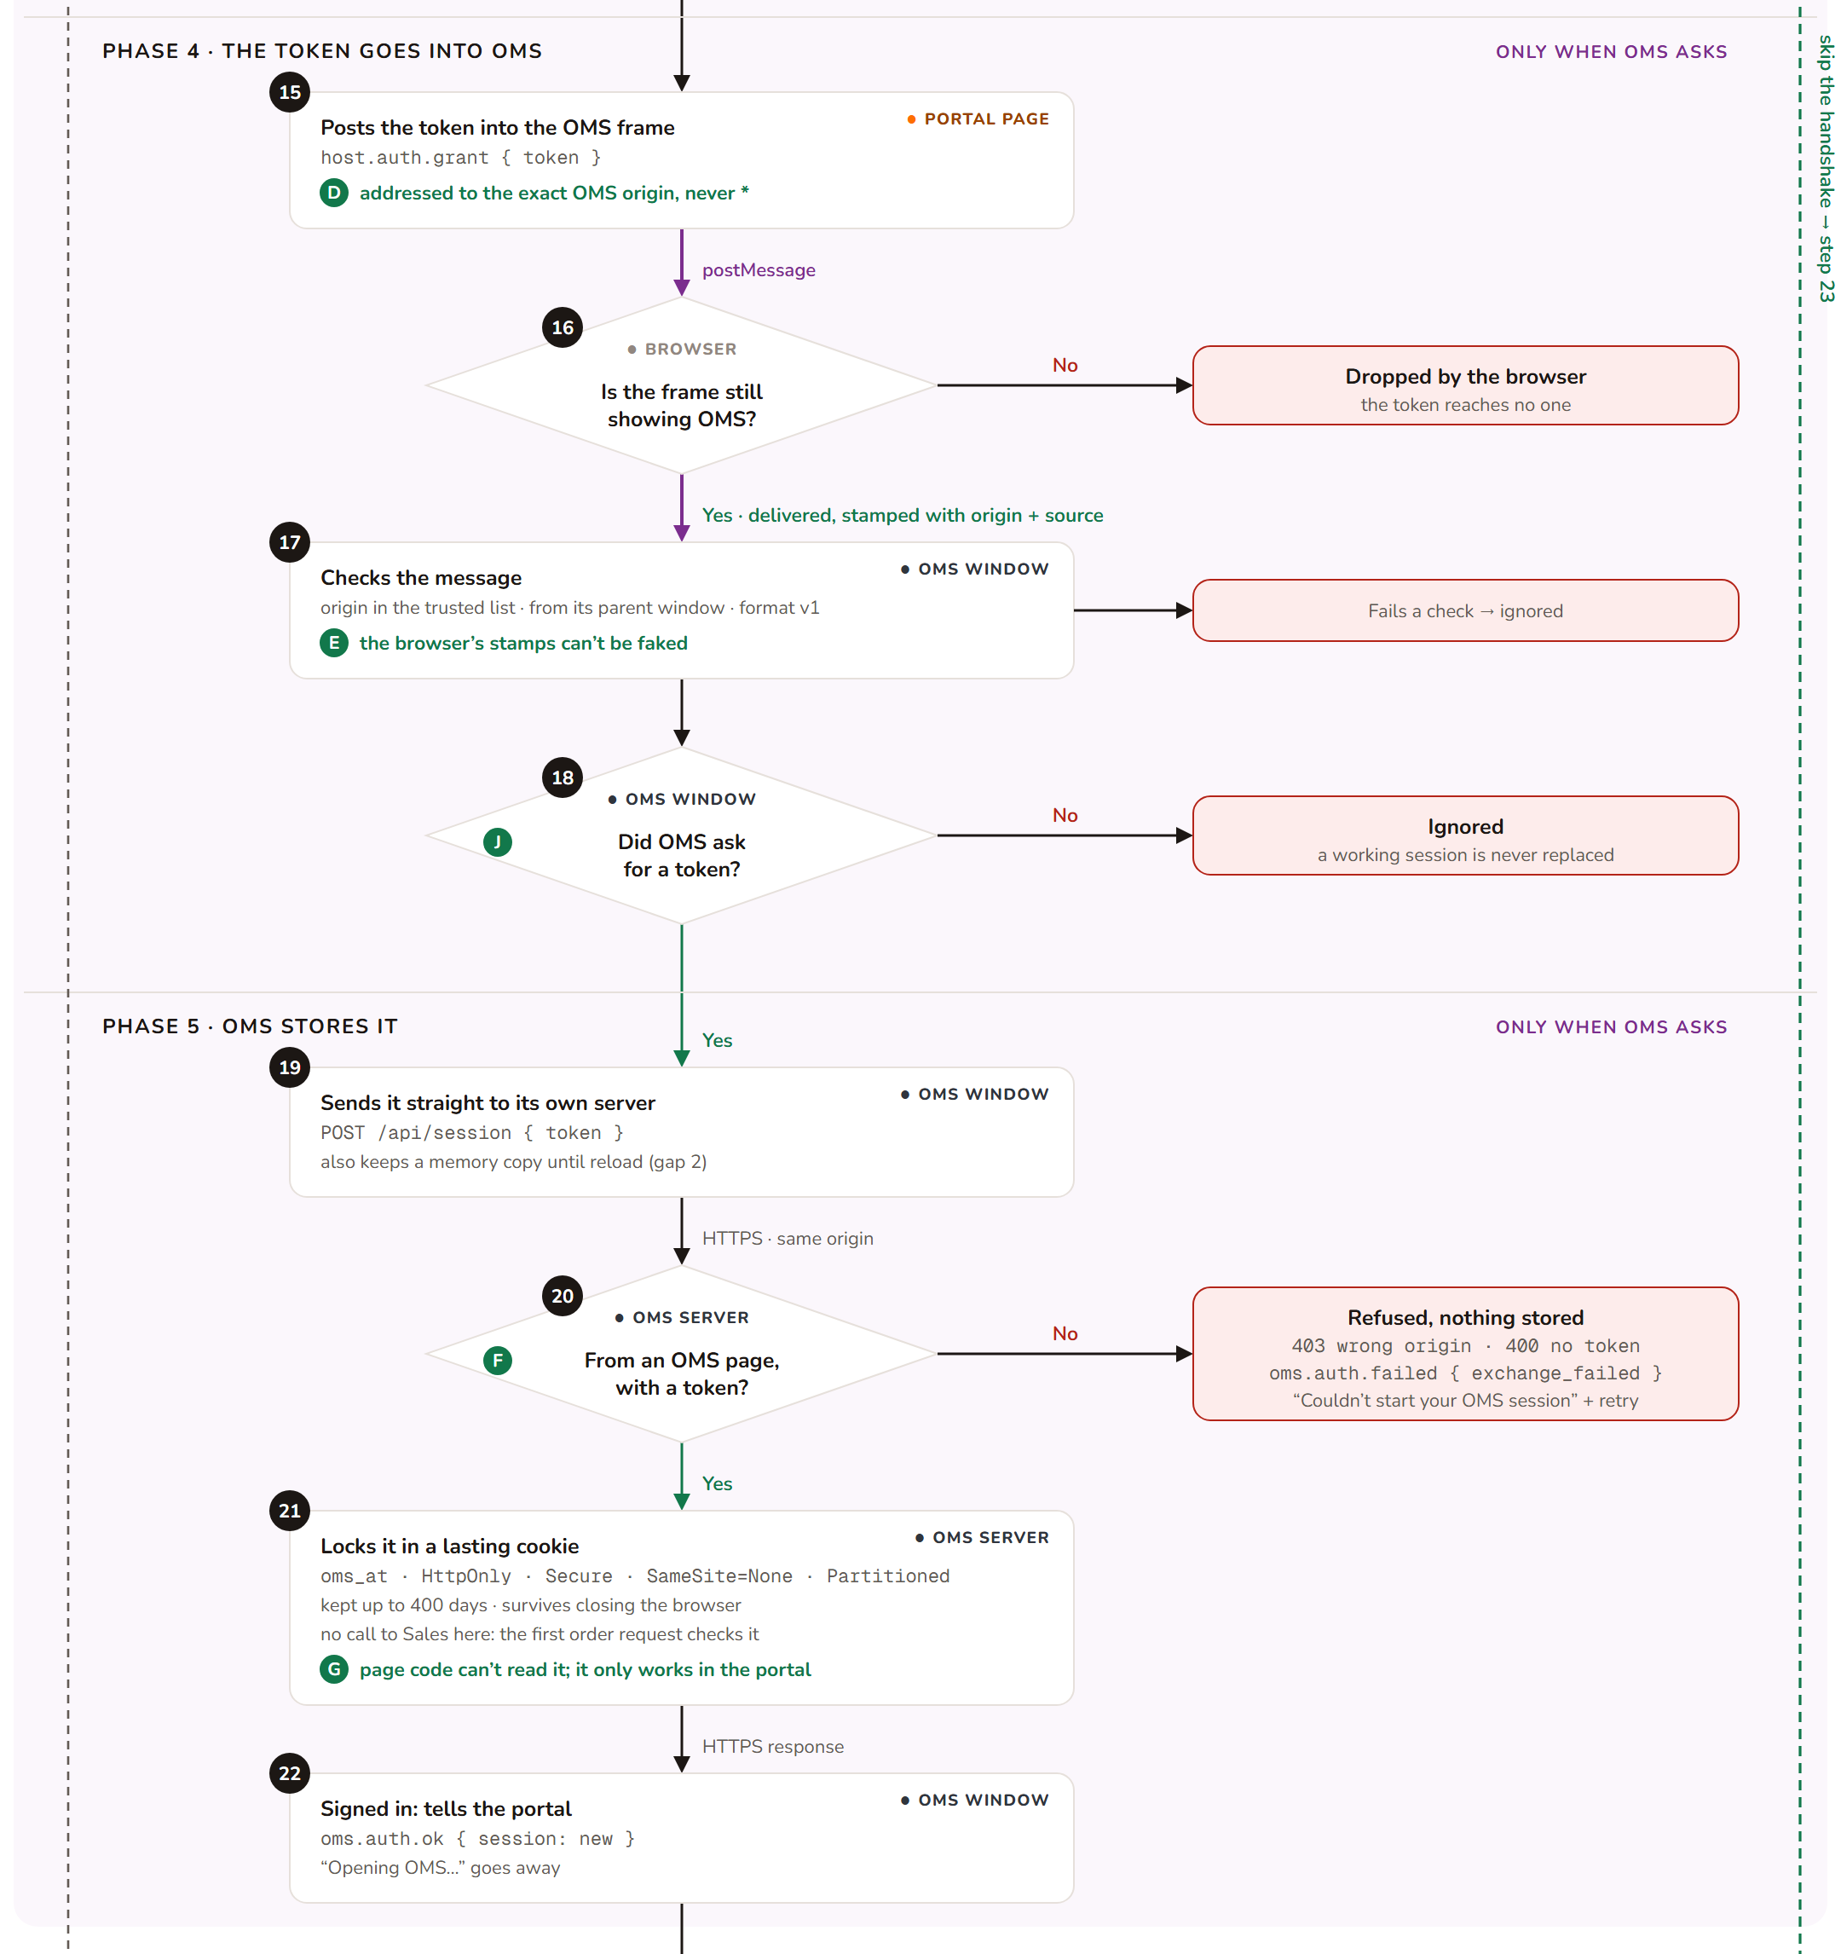
Figure 2c · Phases 4 and 5: the token goes into OMS, which stores it
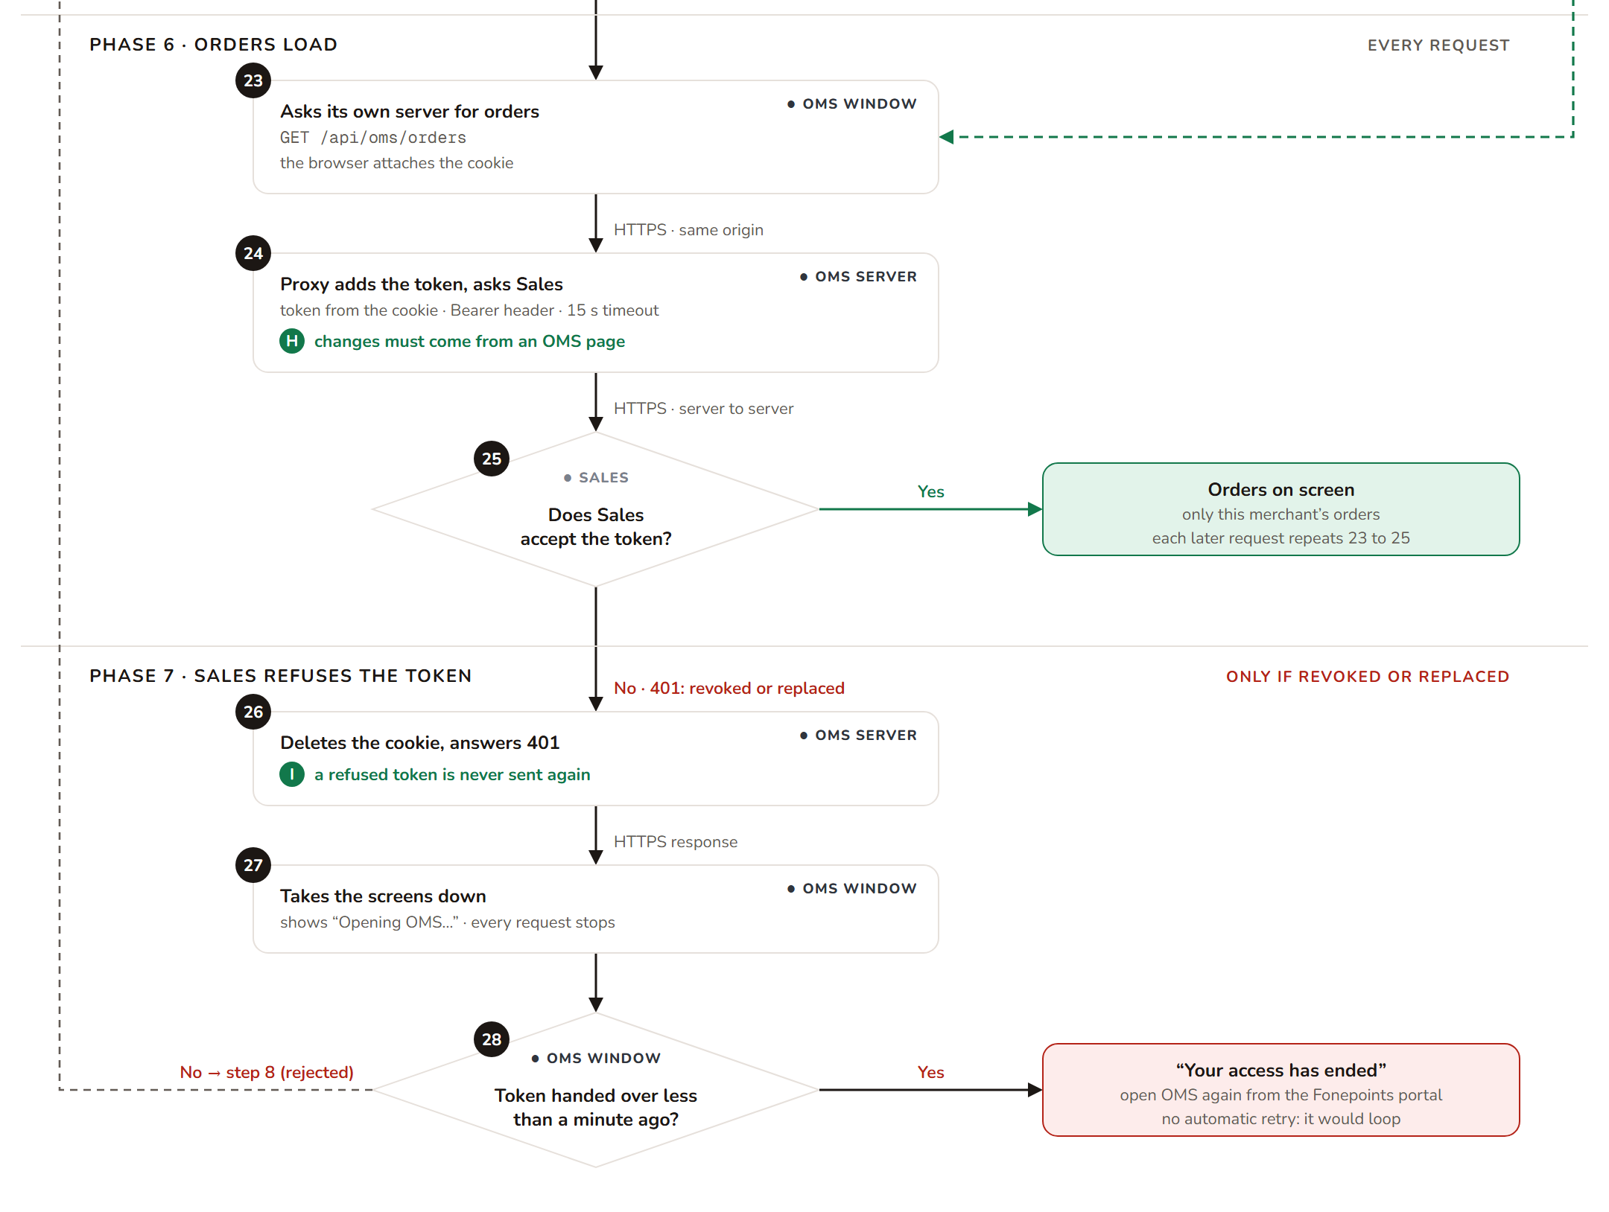
Figure 2d · Phases 6 and 7: orders load, and what happens if Sales refuses the token
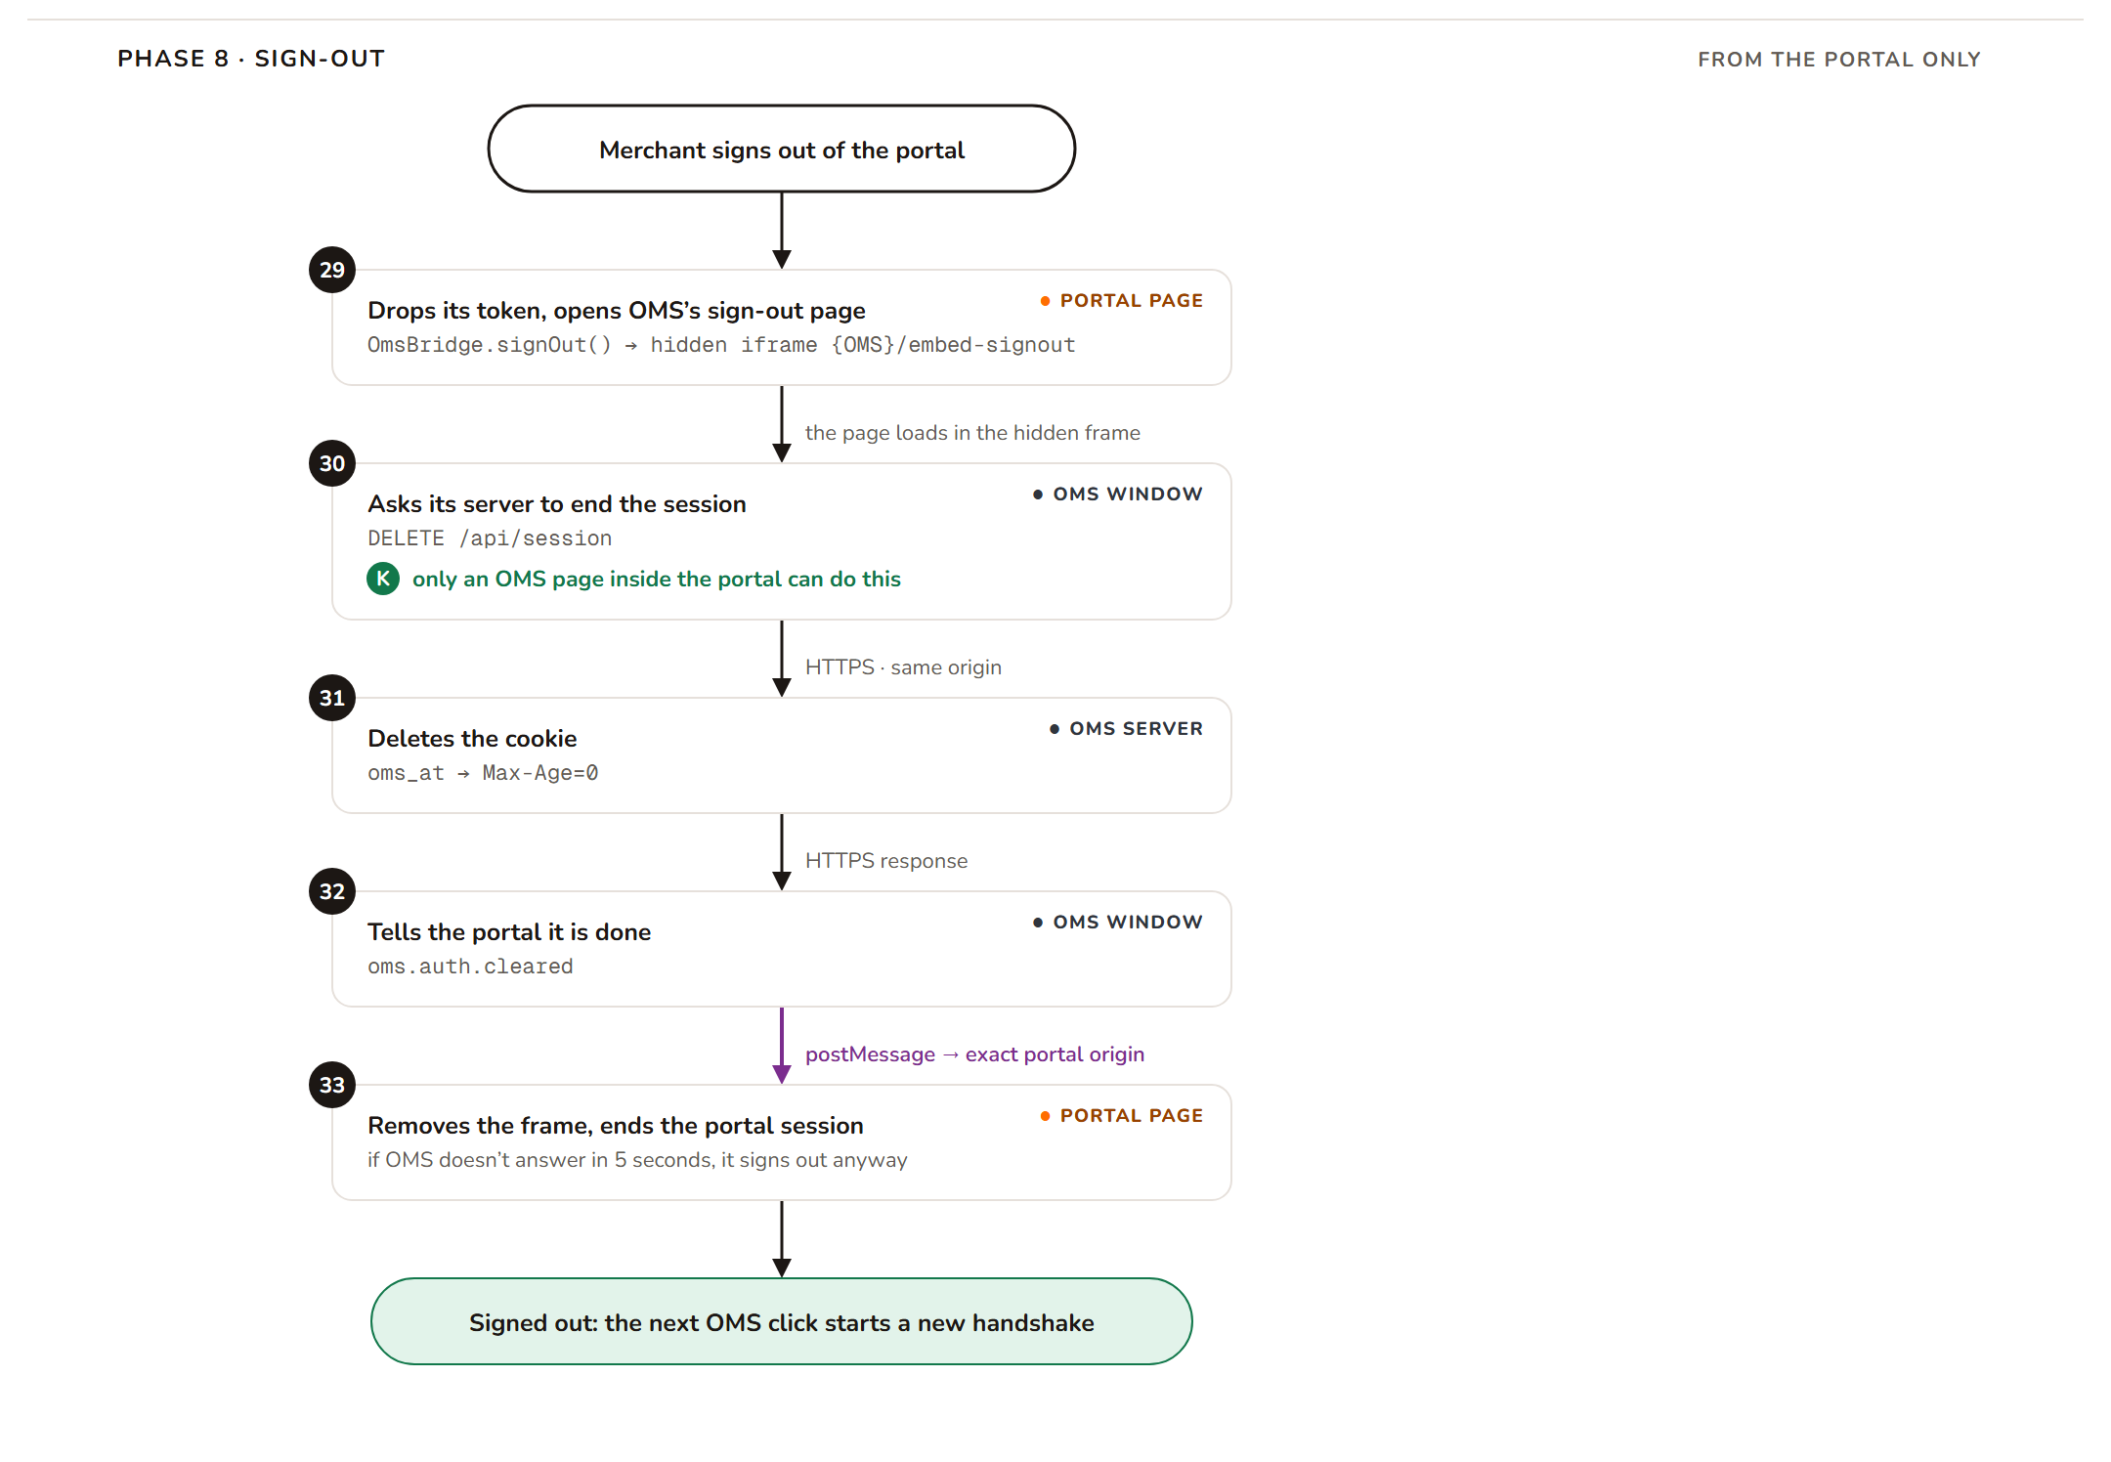
Figure 2e · Phase 8: sign-out from the portal

What the merchant sees
Screen | Shown by | When
“Loading OMS…” | Portal (a cover over the frame) | Steps 1 to 4, while the OMS page downloads.
“Opening OMS…” | OMS | From step 4 until OMS is signed in: step 7 when it has its cookie (almost always), step 22 after a handshake.
The orders | OMS | From step 23.
A short explanation, usually with a retry | OMS or portal | When the flow stops at a red box.

“Ready” is not “signed in”. oms.ready (step 4) only means the OMS page has loaded and is listening. oms.auth.ok (step 7 or step 22) means OMS is signed in.

Every step

Phase 1 · OMS opens (every click)
Step | Who | What happens
1 | Portal page | The merchant clicks OMS in the portal menu. The portal's OMS page puts an iframe on the screen pointing at {OMS address}/embed/orders#theme=…&accent=…, with a “Loading OMS…” cover on top. No token is sent here.
2 | OMS server | The browser asks for the OMS page. OMS sends it with a Content-Security-Policy: frame-ancestors header that lists the websites allowed to show OMS in a frame.
3 | Browser | The browser checks the portal's address against that list (check A). Not on the list: the frame stays blank, and after 12 seconds the portal shows “OMS could not be loaded”.
4 | OMS window | The page loads. The portal removes its cover and OMS shows “Opening OMS…”. OMS sends oms.ready to the portal. This only means “loaded and listening”, not “signed in”.
5 | Portal page | The portal checks the message (check B): from the OMS address, from its own iframe, in the agreed format. It answers with host.theme and nothing else. A message that fails a check is ignored.

Phase 2 · OMS checks its own cookie (every click)
Step | Who | What happens
6 | OMS window | OMS asks its own server whether it already has a session: GET /api/session. The browser sends OMS's cookie along automatically, if there is one.
7 | OMS server | The server only looks for the oms_at cookie. It calls nothing else: the token does not expire, so the cookie is the proof. Cookie found: OMS is signed in, sends oms.auth.ok { session: "existing" } and goes straight to step 23, with no handshake. This is what happens on almost every click, including after the browser was closed and opened again. No cookie (first visit, after sign-out, or site data cleared): the server answers 401 no_session.
8 | OMS window | OMS asks the portal for a token: oms.auth.renew { reason: "missing" }, or reason: "rejected" when it comes from step 28. It asks once and waits; until the answer it will accept exactly one token (check J).

Phase 3 · The portal gets a token (only when oms asks)
Step | Who | What happens
9 | Portal page | The portal checks the message (check B). Whatever the reason (missing or rejected), it does the same: it calls your backend, POST /api/oms/token, with the portal session cookie and no body. The portal keeps no token of its own, so there is nothing to look up or discard first.
10 | Fonepoints server | Your backend reads the portal session. No session: it answers 401, the portal sends host.auth.denied { reason: "no_session" }, and OMS asks the merchant to sign in to the portal again.
11 | Fonepoints server | Your backend asks Providhy IAM for a token for the signed-in merchant: POST {IAM}api/external/oms/merchant-token/mint/ with the API key in X-API-Key and { "merchant_id": "M-1029" } (check C). Server to server: the key never reaches a browser, and the browser can't choose a different merchant. Whether it also keeps tokens between visits is your team's call.
12 | Providhy IAM | Wrong key, unknown merchant or IAM unreachable: your backend answers with an error, the portal sends host.auth.denied { reason: "token_request_failed" }, and OMS shows “try again”.
13 | Providhy IAM | IAM answers { "token": "eyJ…" }: a JWT for that merchant. It does not expire. Your backend returns it to the portal as { accessToken }.
14 | Portal page | The portal receives { accessToken } and passes it straight on. It keeps nothing: not in memory, not in localStorage or sessionStorage. If the merchant left the page, or the frame was replaced while waiting, it sends nothing.

Phase 4 · The token goes into OMS (only when oms asks)
Step | Who | What happens
15 | Portal page | The portal posts host.auth.grant { token } into the iframe, addressed to the exact OMS address, never "*" (check D).
16 | Browser | The browser delivers it only if the frame is still showing OMS; otherwise it drops it. It stamps the message with the sender's address and window, which no page can fake.
17 | OMS window | OMS checks the message (check E): sender address on its allowed list, sent by its parent window, right format and version.
18 | OMS window | OMS checks it actually asked for a token (check J). If not, the token is ignored, so a working session can never be swapped for someone else's token.

Phase 5 · OMS stores the token (only when oms asks)
Step | Who | What happens
19 | OMS window | OMS sends the token straight to its own server: POST /api/session { token }.
20 | OMS server | The server checks that the request came from an OMS page (the Origin header) and contains a token (check F). Refused (403 or 400): nothing is stored, OMS tells the portal oms.auth.failed and shows “Couldn't start your OMS session” with a retry button.
21 | OMS server | The server stores the token in the oms_at cookie: HttpOnly, Secure, SameSite=None and Partitioned, kept for up to 400 days, so it survives closing the browser (check G). The token is not sent back to the page. There is no extra call to Sales here: the token came from IAM through your backend, and the first order request (step 25) is where Sales checks it.
22 | OMS window | OMS is signed in. “Opening OMS…” disappears, and OMS tells the portal oms.auth.ok { session: "new" }.

Phase 6 · Orders load (every request)
Step | Who | What happens
23 | OMS window | Each screen asks OMS's own server for data, for example GET /api/oms/orders. The browser sends the cookie along.
24 | OMS server | The OMS server reads the token from the cookie, adds it as Authorization: Bearer, and forwards the call to Sales (check H).
25 | Sales | Sales checks the token and returns only that merchant's orders.

Phase 7 · Sales refuses the token (only if the token is revoked or replaced)
Step | Who | What happens
26 | OMS server | Sales answers 401: the token was revoked or replaced (tokens don't expire on their own). The OMS server deletes the cookie (check I), so the refused token is never sent again.
27 | OMS window | OMS replaces the screens with “Opening OMS…”, so nothing else is requested.
28 | OMS window | OMS goes back to step 8 with reason rejected, and the portal gets a new token from your backend. The one exception: a token the portal handed over less than a minute ago that is refused straight away. Asking again would likely bring back the same token, so OMS stops and shows “Your access has ended. Open OMS again from the Fonepoints portal.” instead of looping.

Phase 8 · Sign-out (from the portal only)
Step | Who | What happens
29 | Portal page | When the merchant signs out, the portal calls OmsBridge.signOut() before ending its own session. It loads {OMS address}/embed-signout in a hidden iframe.
30 | OMS window | The sign-out page asks its own server to end the session: DELETE /api/session. Only an OMS page inside the portal can do this: only the portal may frame that page, and the server checks the Origin header (checks F and K).
31 | OMS server | The server deletes the oms_at cookie.
32 | OMS window | The sign-out page tells the portal oms.auth.cleared.
33 | Portal page | The portal removes the hidden frame and ends its own session. The next click on OMS starts at step 8 with reason missing and gets a new token. If OMS doesn't answer within 5 seconds, the portal signs out anyway.

4. Messages between the portal and OMS
The portal page and the OMS window are different websites, so they can't call each other's code. They talk only with postMessage: one page posts a message to the other, addressed to its exact web address. The browser delivers it only to that address and stamps who sent it.
Message | From → to | When | Fields | What the receiver does
oms.ready | OMS → portal | Every time OMS loads, including a reload inside the frame | none | Send the theme (host.theme). Nothing about tokens.
host.theme | Portal → OMS | In answer to oms.ready, and whenever the merchant changes the portal theme | mode: light or dark  accent: an accent id | OMS applies it for this visit only. The frame is not reloaded.
oms.auth.ok | OMS → portal | OMS has a session: its cookie (existing, almost every click) or a token it just stored (new) | session: existing or new | Mark OMS as connected. Nothing else to do.
oms.auth.renew | OMS → portal | OMS has no cookie, or Sales refused its token | reason: missing or rejected | Ask your backend for a token and hand it over, the same for both reasons. The only trigger for a token request.
host.auth.grant | Portal → OMS | Only in answer to oms.auth.renew | token  expiresAt: send "" | OMS stores it in its cookie, but only if it asked for one.
host.auth.denied | Portal → OMS | Your backend couldn't give a token | reason: no_session or token_request_failed | OMS shows the matching message to the merchant.
oms.auth.failed | OMS → portal | OMS couldn't store the token it was given | reason: exchange_failed | Mark it as failed. Don't retry on your own; OMS offers the merchant a retry.
oms.auth.cleared | OMS sign-out page → portal | After /embed-signout deleted OMS's cookie | none | Sign-out confirmed: remove the hidden frame.

What every message looks like
The portal sends source: "fonepoints-host"; OMS sends source: "fonepoints-oms". v is the protocol version and is 1.
{
source: "fonepoints-host", // who is talking (OMS uses "fonepoints-oms")
v: 1, // protocol version
type: "host.auth.grant", // which message
token: "eyJhbGciOi…", // fields for this message type
expiresAt: ""
}

Three rules for every message
- Address it exactly. Post to the other window with its exact address as the target. Never "*".
- Check before acting. The sender's address, the sender window and the source and v fields must all match. Otherwise ignore it.
- Ignore what you don't know. An unknown type is skipped, not treated as an error, so either side can add a message later.

5. Security checks
Eleven checks, in the order the flow meets them. The letters match the green circles in the diagram.
Check | Owner and where | What it does | What it stops
A · Framing lock | OMS  next.config.ts  You send us your portal address. | OMS tells the browser which websites may show it in a frame (Content-Security-Policy: frame-ancestors). Only /embed/* and /embed-signout can be framed, and only by the listed portal. | Clickjacking, and any other website loading OMS in a frame to talk to it.
B · The portal checks messages | Portal  oms-bridge.ts → onMessage | Acts on a message only if it comes from the OMS address, from its own iframe window, with source: "fonepoints-oms" and v: 1. | Messages from other websites, popups or extensions. A fake oms.auth.renew can't make the portal hand its token to anyone else.
C · Token from your server | Your backend  Portal oms-auth.ts | Your backend decides the merchant from its own session and asks IAM server to server, with the Providhy API key in X-API-Key. The portal keeps no token: it passes the one from your backend to OMS and drops it. | Leaking the API key, the browser picking a different merchant, and a never-expiring token sitting where any page script could read it.
D · Exact address | Portal sendGrant, sendTheme  OMS does the same | Every message is addressed to the exact receiving address, never "*". | The token reaching whatever page the frame shows after a navigation.
E · OMS checks messages | OMS  lib/host/channel.ts | Acts on a message only if the sender address is on OMS's allowed list, it comes from the parent window, and it has source: "fonepoints-host" and v: 1. | Another window planting its own token in OMS, and forged theme messages.
F · Same-origin session changes | OMS server  /api/session | Storing or deleting a session needs an Origin header equal to OMS's own address, and storing needs a token in the body. | Another website seeding a session of its choice in the merchant's browser, or signing them out.
G · The lasting cookie | OMS server  _cookie.ts | The token lives in the oms_at cookie: HttpOnly, Secure, SameSite=None, Partitioned, kept up to 400 days. | Page code reading the token, sending it over plain HTTP, and any website other than the portal using it. Because it outlives the browser, sign-out (K) is what ends it.
H · The proxy | OMS server  /api/oms/* | Adds the token on the server for every call to Sales. Changes must come from an OMS page. 15-second timeout. | The browser ever holding a credential for Sales, a merchant chosen by the browser, and cross-site changes.
I · Refused-token cleanup | OMS | A 401 from Sales deletes the cookie and stops every request. OMS then asks the portal again, except for a token it was handed less than a minute ago, where it stops with a message. | A revoked token being sent again and again, and an endless retry loop.
J · Token only on request | Portal oms-bridge.ts  OMS AuthProvider | The portal sends a token only on oms.auth.renew. OMS uses a grant or denial only while it is waiting for one, and asks one at a time. | A token being pushed through the browser on every click, and a stray token replacing a working session.
K · Sign-out from the portal only | OMS /embed-signout  Portal OmsBridge.signOut() | The sign-out page can be framed only by the portal and does nothing when opened any other way. It deletes OMS's cookie, and the portal drops its copy of the token. | Another website signing the merchant out of OMS, and an old session staying behind after sign-out, so the next merchant on that browser can't see the last one's orders.

One list, two checks. OMS's list of allowed portal addresses (NEXT_PUBLIC_EMBED_HOST_ORIGINS) drives both check A (who may frame OMS) and check E (whose messages OMS reads).

6. A token that never expires
Keeping one long-lived token is what makes every click free. It also means a token that leaks keeps working until someone revokes it. These are the rules that keep that risk small:
- Never in browser storage. Not in localStorage, sessionStorage, a readable cookie, a URL or a log. OMS keeps it in an HttpOnly cookie; the portal keeps nothing, and only passes it on. If your backend keeps a copy, that is on the server, and your call.
- Sign-out must clear the browser's copies. The portal calls OmsBridge.signOut(), which deletes OMS's cookie and drops the portal's copy. Skipping this leaves a working session in the browser for the next person.
- A refused token is replaced, not retried. If Sales refuses the token (step 26), OMS deletes its cookie and asks again with reason: "rejected"; the portal asks your backend again. A token refused within a minute of being handed over is not retried, so it can't loop.
- Revocation needs an endpoint. Sales has no revoke endpoint today, so a leaked token can't be cut off. This is the most important open item for the Providhy team.

