GPU Programming — Course Project
Accelerating K-Means Clustering on the GPU
using a GEMM Formulation of the Distance Step
Project Report
October 2026

Abstract
K-Means spends most of its time in the assignment step, where every point is compared with every centroid. This report presents a GEMM-based approach to K-Means on the GPU: rewriting the distance computation as a general matrix multiplication (GEMM) and implementing it on an NVIDIA Tesla T4 in Python using Numba CUDA and CuPy. Four GPU versions of the assignment step were built and compared: a naive GEMM kernel, a shared-memory tiled GEMM kernel, a fused GEMM + argmin kernel and a cuBLAS version through CuPy. On 10 million points with 15 clusters, the fused kernel completes the assignment step in 15.8 ms, which is 752 times faster than a straightforward NumPy implementation and reaches about 190 GFLOP/s in double precision. Used inside a complete K-Means loop, the GEMM version produces exactly the same clustering as the Atomic V3 baseline on all nine datasets and is up to 1.35 times faster per iteration, with the advantage growing with data size.

1. Introduction
K-Means clustering (Lloyd's algorithm) alternates between two steps: assigning each point to its nearest centroid and recomputing each centroid as the mean of its points. For N points, K clusters and D features, the assignment step costs O(N·K·D) per iteration and dominates the run time for large data sets. This project benchmarks several CPU and GPU implementations of K-Means on the same synthetic data, with a shared convention for initial centroids, stopping rule and timing so that the results are directly comparable.
This report covers the GEMM-based implementation. The idea is to express the distance computation as a matrix product, which is the operation GPUs are best at, and then to check whether this actually pays off for the shapes in this project. The objectives were:
- implement the GEMM formulation on the CPU and on the GPU and verify that it gives the same clusters as the direct computation;
- compare different GPU implementations of the GEMM (naive, tiled, fused and cuBLAS);
- build a full K-Means loop around the best version and compare it with the team's Atomic V3 GPU implementation under the same conditions.

2. Background: the GEMM formulation
The squared Euclidean distance between a point x and a centroid c can be expanded as
||x − c||² = ||x||² − 2 x·c + ||c||² (1)
Only the middle term involves both the point and the centroid. For all N points and K centroids at once, these dot products form the matrix
S = X Cᵀ, X ∈ ℝ^(N×D), C ∈ ℝ^(K×D), S ∈ ℝ^(N×K) (2)
which is a standard GEMM. The term ||x||² is the same for every centroid, so it does not affect which centroid is closest and can be dropped. The assignment step therefore becomes
cluster(i) = argmin_k ( ||c_k||² − 2 S_ik ) (3)
In this project N ranges from 1 to 10 million, D = 9 and K ranges from 3 to 17. The matrices are therefore very tall and very thin, which is quite different from the large square matrices that GEMM libraries are usually optimised for. One of the questions of this work is how much of the usual GEMM advantage survives for such shapes.

3. Implementation
All code is written in Python in a single notebook, kmeans_gemm_fused_V3_ALIGNED.ipynb, following the style used in the course notebooks: NumPy on the CPU and Numba CUDA kernels or CuPy on the GPU.

3.1 Versions of the assignment step
Six versions of the assignment step were implemented, summarised in Table 1. The two CPU versions serve as references and for correctness checks; the four GPU versions explore different ways of computing the GEMM.
Table 1. Implemented versions of the assignment step
Version | Method | Output
CPU normal | Subtract, square and add for each centroid (NumPy) | Clusters
CPU GEMM | np.dot(X, C.T), then score and argmin | Clusters
GPU naive GEMM | One thread per element of S, all reads from global memory | S (N × K)
GPU tiled GEMM | 16 × 16 tiles of X and Cᵀ loaded into shared memory | S (N × K)
GPU fused GEMM + argmin | One thread per point; centroids in shared memory; data stored as D × N for coalesced reads; argmin inside the kernel | Clusters only
GPU CuPy | cp.dot (cuBLAS), then cp.argmin | Clusters

The fused kernel is the main contribution. Each thread handles one point: it reads the point's nine values once, computes the score for every centroid using the centroids cached in shared memory, and keeps only the best one. The N × K matrix S is never written to global memory. Storing the data transposed (D × N) means that neighbouring threads read neighbouring addresses, so global memory reads are coalesced.

3.2 Full K-Means loop
The full algorithm uses the fused kernel for the assignment step. Each iteration consists of:
- Assign: the fused kernel, which also counts how many points changed cluster (one atomic operation per block after a block-level reduction, as in Atomic V3).
- Sum: every point adds its coordinates to its cluster's running sum with global atomic additions, the same method as Atomic V3. An alternative shared-memory version, in which each block first sums its own points and then performs one global atomic per value, was also implemented.
- Update: the new centroid is the sum divided by the count. This is only K × 9 numbers, so it is done on the CPU; an empty cluster keeps its previous centroid.
- Stop: the same rule as Atomic V3. The loop ends when no centroid moves more than 10⁻⁴, or when at most 0.01% of points change cluster for three iterations in a row, with a maximum of 400 iterations.

4. Experimental setup
All experiments were run on Google Colab with a single Tesla T4 GPU in double precision (float64). The settings are listed in Table 2.
Table 2. Experimental setup
Setting | Value
Data | Synthetic Gaussian clusters generated by faker_data_synthesizer.py (seed 42); 9 numeric features, ID and label columns dropped
Datasets | 1M rows (K = 3, 5, 7), 5M rows (K = 7, 9, 11), 10M rows (K = 13, 15, 17)
Hardware | Google Colab, NVIDIA Tesla T4 (compute capability 7.5, 15 GB), float64
Software | Python 3.13, NumPy, pandas, Numba CUDA, CuPy
Initial centroids | Team canonical files written by Atomic V3 (K rows chosen with np.random.default_rng(42)), verified by SHA-256
Assign-step timing | Fastest of 10 runs after a warm-up call; cuda.synchronize() before stopping the timer
K-Means timing | Whole loop until convergence; data loading and the first copy to the GPU excluded, as in Atomic V3
Correctness | Clusters compared point by point with the CPU; S compared on the first 100,000 rows; iterations and WCSS compared with Atomic V3

To make the comparison with Atomic V3 fair, both implementations start from exactly the same centroid files, use the same stopping rule, maximum number of iterations, GPU and timing boundary. The only difference is therefore the assignment step and the data layout. The SHA-256 hash of the starting centroids was recorded for every run; the GEMM hashes match the canonical files on all nine datasets.

5. Results

5.1 Assignment step
Table 3 and Figure 1 show the time of a single assignment step on 10 million points with K = 15. The FLOP count is N·K·(2D + 2) = 3.0 GFLOP. All GPU versions produced exactly the same clusters as the CPU (0 points differing) and a maximum difference of 0 in S.
Table 3. Assignment step, 10M points, K = 15 (fastest of 10 runs)
Version | Time (ms) | Speed-up vs CPU normal | GFLOP/s
CPU normal | 11,879.1 | 1x | 0.3
CPU GEMM (NumPy) | 3,570.1 | 3.3x | 0.8
GPU naive GEMM | 24.4 | 487x | 122.9
GPU tiled GEMM | 57.4 | 207x | 52.2
GPU fused GEMM + argmin | 15.8 | 752x | 190.0
GPU CuPy (cuBLAS) + argmin | 118.8 | 100x | 25.2
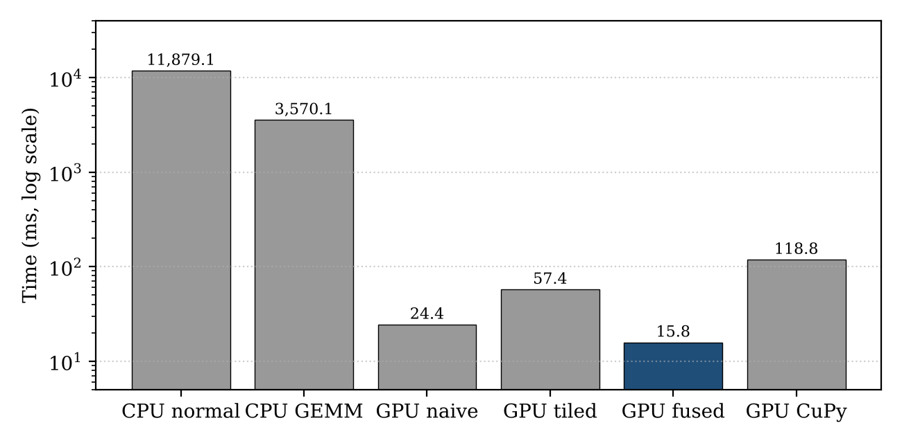
Figure 1. Assignment-step time for each version (10M points, K = 15, log scale)
Even on the CPU, the GEMM formulation is 3.3 times faster than the direct computation, because NumPy hands the matrix product to an optimised BLAS routine. On the GPU, the fused kernel is the fastest version at 15.8 ms, even though the naive and tiled timings cover only the GEMM and not the argmin. At 190 GFLOP/s it reaches roughly 75% of the T4's double-precision peak.

5.2 Full K-Means compared with Atomic V3
Table 4 and Figure 2 compare the time per iteration of the full K-Means loop with the team's Atomic V3 implementation. On all nine datasets the two implementations needed the same number of iterations and reached the same WCSS, so the clustering is identical.
Table 4. Full K-Means, time per iteration, Atomic V3 vs GEMM
Rows | K | Iterations | V3 (ms/iter) | GEMM (ms/iter) | Speed-up
1M | 3 | 78 | 12.85 | 12.98 | 0.99x
1M | 5 | 4 | 16.45 | 17.30 | 0.95x
1M | 7 | 183 | 7.96 | 7.92 | 1.01x
5M | 7 | 219 | 40.85 | 39.22 | 1.04x
5M | 9 | 372 | 40.71 | 37.14 | 1.10x
5M | 11 | 149 | 35.21 | 30.68 | 1.15x
10M | 13 | 185 | 82.16 | 73.96 | 1.11x
10M | 15 | 227 | 92.00 | 67.91 | 1.35x
10M | 17 | 183 | 82.26 | 69.57 | 1.18x
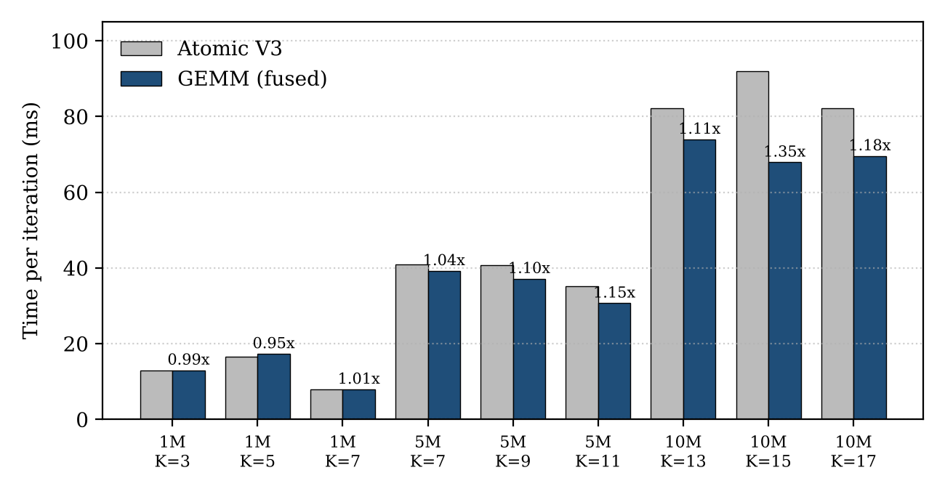
Figure 2. Time per iteration of Atomic V3 and the GEMM version on all nine datasets (labels show the speed-up)
At 1 million rows the two implementations run at about the same speed (0.95–1.01x); here the run time is dominated by fixed costs such as kernel launches and the copy of the centroids back to the CPU. At 5 million rows the GEMM version is 1.04–1.15 times faster, and at 10 million rows 1.11–1.35 times faster. The largest gain was for 10M rows and K = 15, where the total run time dropped from 20.9 s to 15.4 s. Per-iteration times varied by a few percent between Colab sessions (for example, 10M / K = 13 took 64.8 ms per iteration in an earlier run and 74.0 ms in the final run), so small differences at 1M rows are within measurement noise.

5.3 Shared-memory sum step
With the shared-memory sum step (10M rows, K = 15), one iteration takes 59.2 ms instead of 69.1 ms with global atomics, a further 1.17 times speed-up, with the same 227 iterations and no point assigned differently. Compared with Atomic V3 (92.0 ms per iteration) this is about 1.55 times faster. This variant was measured on one dataset only; the full benchmark in Table 4 uses the atomic sum step so that only the assignment step differs from V3.

6. Discussion
Why the fused kernel is fastest. The main cost of the assignment step at these shapes is memory traffic, not arithmetic. The fused kernel reads each point once (about 720 MB at 10M rows) and writes only the cluster numbers (40 MB). The naive, tiled and CuPy versions all first write the full 1.2 GB matrix S and then read it back for the argmin.
Why tiling does not help. Shared-memory tiling pays off when the inner dimension is large, so that each loaded value is reused many times. Here D = 9 is padded to a tile width of 16, so about 44% of the work is padding, and the synchronisation barriers between tile loads add further cost. The tiled kernel is therefore slower than the naive one.
Why cuBLAS is the slowest GPU version. cuBLAS is designed for large, roughly square matrices. For a 10M × 9 by 9 × 15 product it cannot reach high efficiency, and the CuPy version additionally creates a score matrix and reads both matrices again for the argmin, which adds several gigabytes of memory traffic for only 3 GFLOP of work.
Where the gain over Atomic V3 comes from. Most of the improvement comes from the data layout: the fused kernel stores the data as D × N, so neighbouring threads read neighbouring memory, while V3 uses an N × D layout. The GEMM form also needs slightly fewer operations per feature (one multiply-add instead of a subtraction, multiplication and addition).
The sum step is now the bottleneck. At 10M rows an iteration takes about 68 ms, of which the assignment step is only about 16 ms. The rest is mostly 10 million threads performing atomic additions into only K × 9 memory locations. This is why the end-to-end speed-up (up to 1.35x) is much smaller than the assignment-step speed-up, and why the shared-memory sum step gives a clear further gain.
Quality of the clustering. Because all implementations start from the same randomly chosen centroids, they also reach the same local minima. Only the 1M / K = 5 dataset recovered the true clusters; on the other datasets some true clusters were merged or split (for example, cluster sizes of 2.0M and 222K at 10M / K = 15), and at 5M / K = 11 one cluster ended up empty. This affects all implementations equally and does not influence the timing comparison.

7. Limitations and future work
- Run the shared-memory sum step on all nine datasets, since the sum step is now the main cost.
- Time the assignment kernel of Atomic V3 on its own, to measure the assign-only gain directly instead of estimating it from per-iteration times.
- Evaluate single precision. The T4 is about 32 times faster in float32 than in float64, but some near-tie points may change cluster, so the number of changed assignments must be reported alongside the speed-up.
- Use k-means++ initialisation to avoid poor local minima for all implementations.
- Profile a full run with NVIDIA Nsight Systems to obtain the exact split between assignment, sum and data-transfer time.
- Colab timings vary between sessions; repeating the full benchmark several times and reporting the median would make the small differences at 1M rows more reliable.

8. Conclusion
Rewriting the K-Means distance step as a GEMM is effective on the GPU, but only when it is implemented with the actual matrix shapes in mind. For tall, thin matrices (D = 9), general-purpose GEMM approaches such as shared-memory tiling and cuBLAS perform worse than a simple kernel, while a fused GEMM + argmin kernel with a coalesced data layout completes the assignment step for 10 million points in 15.8 ms, 752 times faster than the CPU. In the full algorithm the GEMM version gives exactly the same results as the team's Atomic V3 implementation and is up to 1.35 times faster, with the gain increasing with data size. The remaining bottleneck is the atomic sum step, where a shared-memory reduction already gives a further 1.17 times speed-up.

References
- S. P. Lloyd, "Least squares quantization in PCM," IEEE Transactions on Information Theory, vol. 28, no. 2, pp. 129–137, 1982.
- V. Volkov and J. W. Demmel, "Benchmarking GPUs to tune dense linear algebra," in Proc. ACM/IEEE Conference on Supercomputing (SC08), 2008.
- NVIDIA Corporation, CUDA C++ Programming Guide. Available: https://docs.nvidia.com/cuda/cuda-c-programming-guide/
- NVIDIA Corporation, cuBLAS Library Documentation. Available: https://docs.nvidia.com/cuda/cublas/
- Numba Developers, Numba for CUDA GPUs. Available: https://numba.readthedocs.io/en/stable/cuda/
- CuPy Developers, CuPy: NumPy & SciPy for GPU. Available: https://docs.cupy.dev/

Appendix A. Reproducing the results
The notebook kmeans_gemm_fused_V3_ALIGNED.ipynb is run top to bottom in Google Colab on a T4 runtime, after the Atomic V3 notebook has written the canonical initial-centroid files to MyDrive/kmeans_data/results_gpu_atomic_v3/. Table 5 lists the parts of the notebook.
Table 5. Structure of the notebook
Part | Content | Output
A | Mount Google Drive, load one dataset, load its canonical initial centroids and print their SHA-256 | Data and centroids in memory
B | CPU normal vs CPU GEMM assignment step | Times, cluster check
C | Naive, tiled, fused and CuPy GPU versions and summary table | Table 3
D | Full K-Means with atomic (D1) and shared-memory (D2) sum step | Iterations, ms per iteration
E | Benchmark on all nine datasets | results_gpu_gemm_fused_v3_aligned/summary.csv
F | Comparison with Atomic V3: SHA-256, iterations, WCSS and chart | Table 4, Figure 2

The results are saved in the same format as the other aligned notebooks of the team (summary.csv with identical column names, per-dataset result and history files, and environment.json). A note on the SHA-256 check: the hash stored in the Atomic V3 summary is computed before its centroid file is written, and reading a CSV back with pandas can change the last digit of some float64 values, so that hash differs from the one computed from the file. The GEMM hashes match the canonical files themselves, and the identical iterations and WCSS confirm that both implementations started from the same centroids.

