Readme document

**The current folder has the below folders and files:**

**Important files:**

1. **FInalThesisReport_AnilJain_8_1.pdf**: This is the final thesis report in PDF format.
2. **Turnitin_report_AnilJain_8-3.docx.pdf**: This is the turnitin plagiarism report.

**Important folder:**

1. **data**: this is the data folder and currently is empty.
2. **Note:** Data can be downloaded from the google drive
   1. <https://drive.google.com/drive/folders/1YW3bQfTTITpzi98LnKtJzqKD7emW9-sN?usp=sharing>
3. Data can also be downloaded from the USA Lending club site
   1. <https://www.lendingclub.com/info/statistics.action>

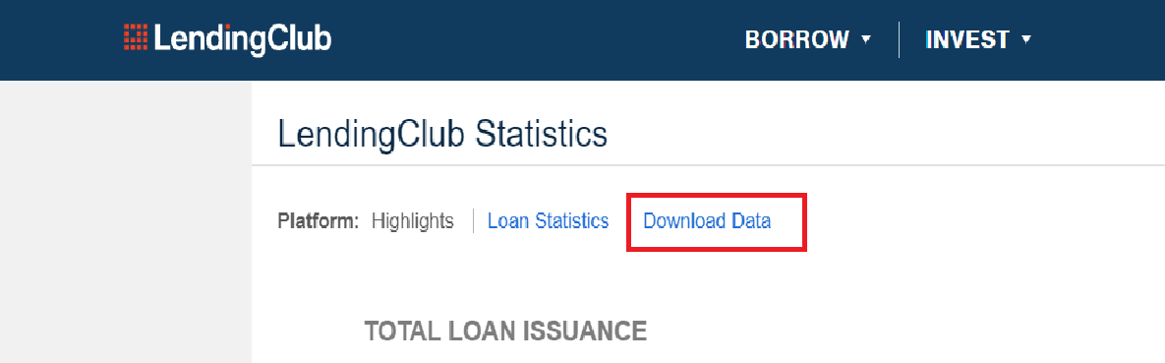

1. **LCDataDictionary.xlsx**: This is the data dictionary file downloaded from the USA Lending club site
2. **code**: This is the code folder and has the below files
   1. “**p2p-cnn-model-pre-processing.ipynb**”: python notebook file for data pre-processing in model development.
   2. “**p2p-lending-cnn-model-with-zero-batch-size.ipynb**”: python notebook file for EDA and cnn model development for batch size 0.
   3. “**p2p-lending-cnn-model-with-batch-size-32_v1.ipynb**”: python notebook file for EDA and cnn model development for batch size 32.
   4. “**p2p-lending-cnn-model-with-batch-size-128_v1.ipynb**”: python notebook file for EDA and CNN model development for batch size 128.
   5. **resnet.py**: resnet model file
   6. **util.py**: python utility file for common code
3. **output:** This is the output folder of the model execution and contains excel sheets that have many tables created for the thesis writing.
4. **plots:** This is the folder that contains important plots during model development and EDA for thesis writing