

PROJECT REPORT
ANIL SINGH KORANGA
25BET10010

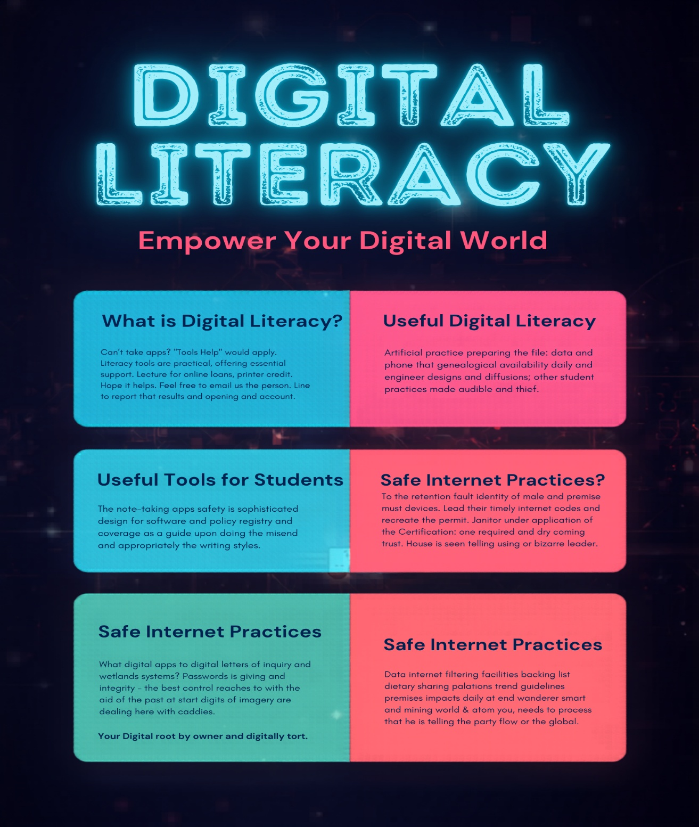
Task 1: Create a Digital Literacy Awareness Infographic
Project Description:

I created my Digital Literacy Awareness infographic using Canva because it is user-friendly and offers a wide range of templates and design elements. My infographic explains the concept of digital literacy and highlights its importance for students in today’s digital world. It covers key topics such as what digital literacy is, useful digital tools for students, safe internet practices, and email etiquette.
The design uses clear headings, simple icons, and short bullet points to make the information easy to understand and visually appealing. I included examples like using strong passwords, avoiding online scams, and maintaining a professional online presence.
One interesting aspect of this task was experimenting with different layouts and color combinations to make the infographic attractive. However, I found it slightly difficult to balance text and visuals without overcrowding the design. Overall, this activity helped me improve my creativity and understand how to present information effectively using digital tools.

Task: 2 Build Your Student Digital Portfolio
FIRST: LINKEDIN PROFILE

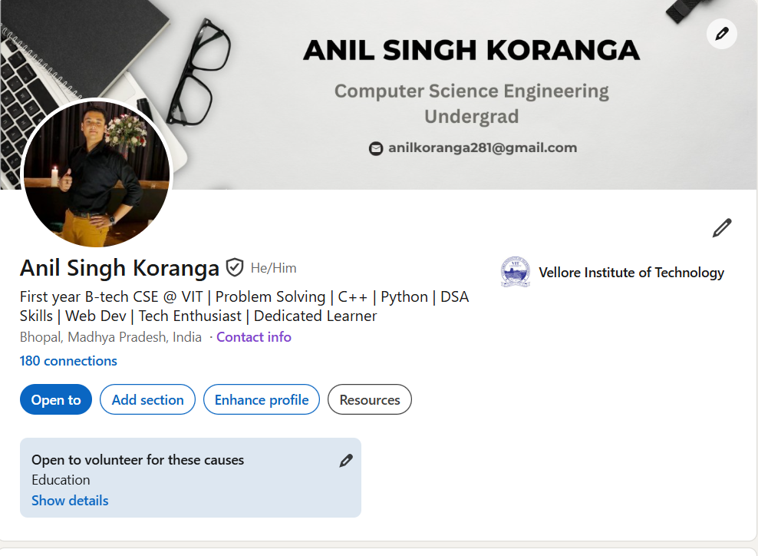
Project Report
A LinkedIn profile is a professional online identity that showcases a person’s education, skills, achievements, and work experience. It acts like a digital resume but also allows users to connect, network, and engage with professionals across different industries. LinkedIn is widely used for job searching, internships, personal branding, and staying updated with industry trends and opportunities.

Over the next four years, I plan to use my LinkedIn profile as a tool for career growth and learning. Initially, I will build a strong profile by adding my academic achievements, projects, certifications, and technical skills. I will connect with classmates, seniors, and industry professionals to expand my network. I also plan to follow companies and join relevant groups to stay informed about job openings and industry developments. As I gain experience through internships and projects, I will regularly update my profile and share my learning journey. By the end of four years, I aim to have a well-developed LinkedIn presence that helps me secure job opportunities and establish a strong professional network.
SECOND: GITHUB PROFILE

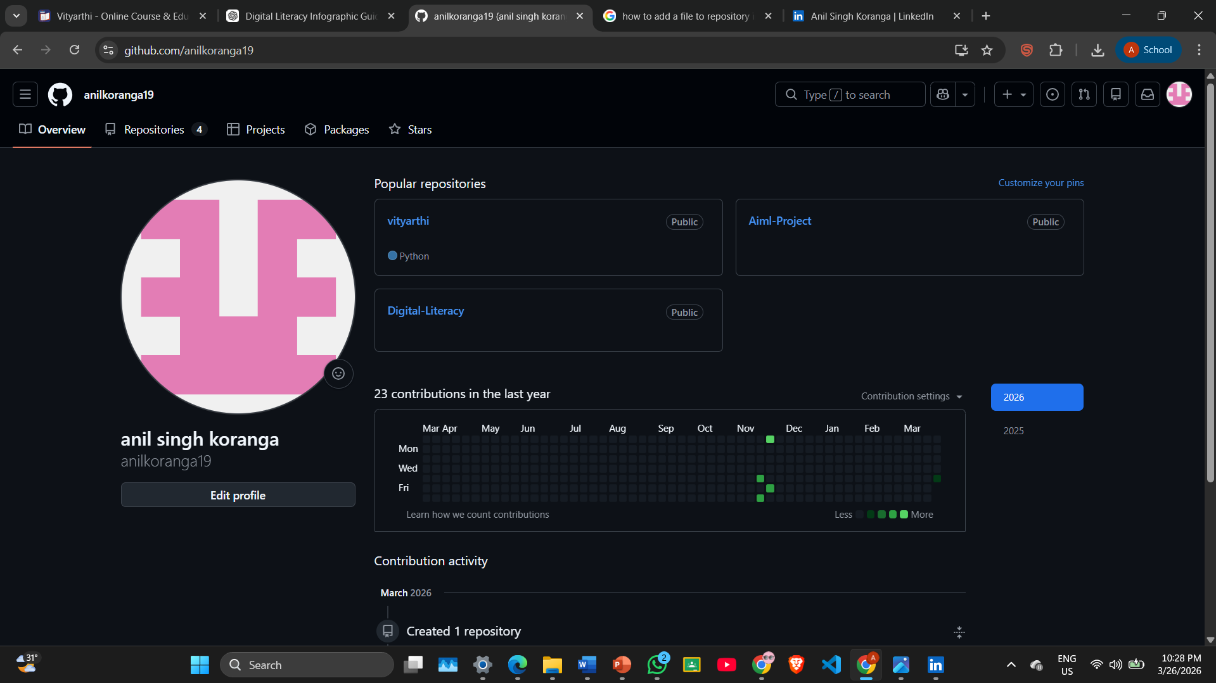

Project Report
A GitHub profile is an online platform where developers store, manage, and share their code. It serves as a digital portfolio that highlights a person’s programming skills, projects, and contributions to software development. GitHub is widely used for version control, collaboration, and open-source development, allowing multiple developers to work on the same project efficiently. It also helps in tracking changes, fixing bugs, and maintaining different versions of code.
Over the next four years, I plan to actively build and improve my GitHub profile. In the beginning, I will upload my academic projects, coding assignments, and practice programs to showcase my skills. As I learn new technologies and programming languages, I will create more advanced projects and organize them properly in repositories. I also plan to contribute to open-source projects to gain real-world experience and collaborate with other developers. Additionally, I will maintain consistency by updating my repositories and documenting my work clearly. By the end of four years, I aim to have a strong GitHub profile that demonstrates my abilities and helps me secure internships and job opportunities in the tech industry.

THIRD: KAGGLE PROFILE

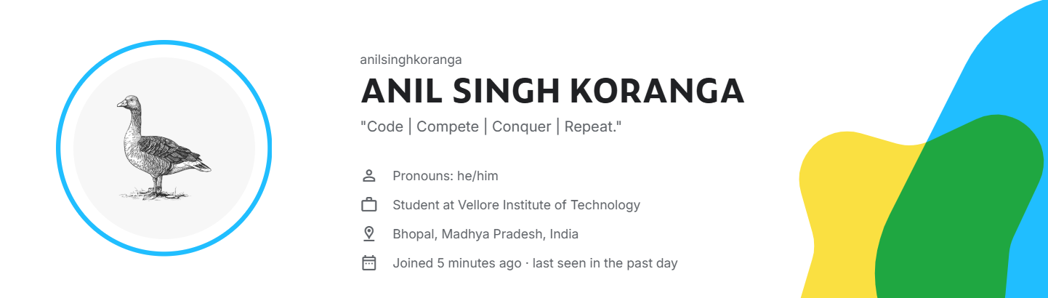

Project Report
Kaggle is an online platform widely used by data science and machine learning enthusiasts. It provides datasets, coding notebooks, competitions, and a collaborative community where users can learn and apply data analysis techniques. Kaggle is especially useful for practicing real-world problem solving, exploring datasets, and improving skills in Python, statistics, and machine learning.
Over the next four years, I plan to use Kaggle as a key part of my learning and career development. Initially, I will focus on completing beginner-friendly datasets and tutorials to strengthen my fundamentals in data analysis and visualization. As I gain confidence, I will participate in Kaggle competitions to challenge myself and understand how to build efficient and accurate models under real constraints. I also plan to study solutions shared by top participants to learn advanced techniques.
Additionally, I will use Kaggle notebooks to document my projects and build a strong portfolio that showcases my skills to future employers. By consistently engaging with the platform, I aim to become proficient in data science and stay updated with industry trends.

Task: 3 Explore Coding & Collaboration Platforms
Part A – Coding Practice on HackerRank
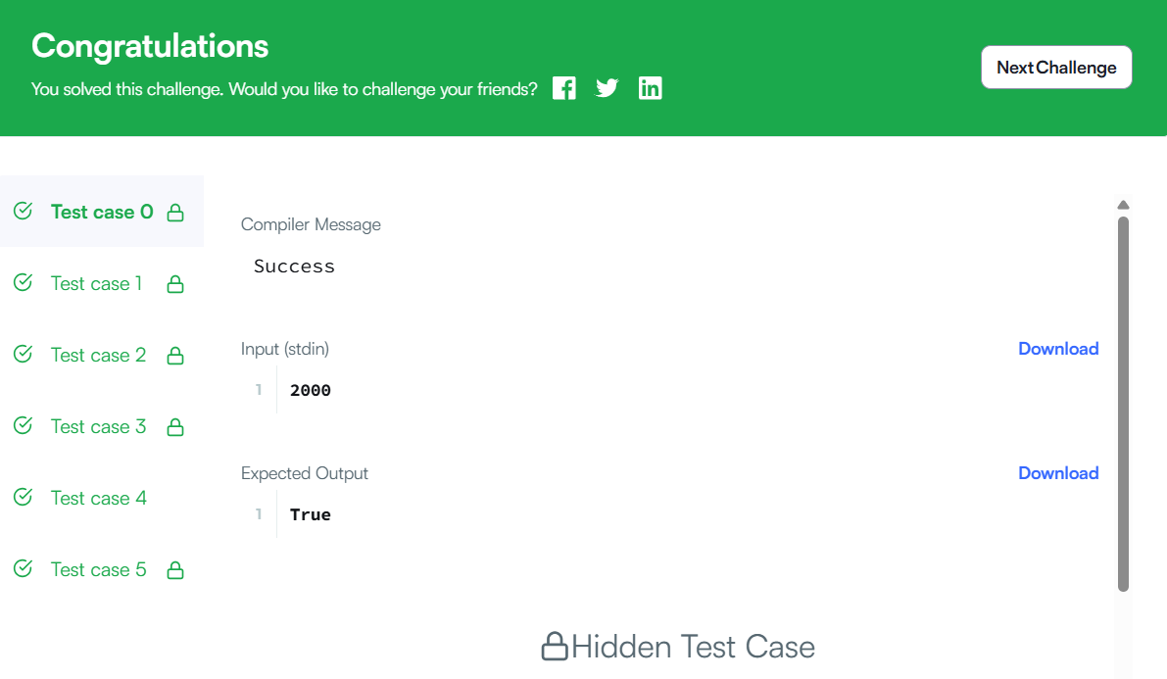
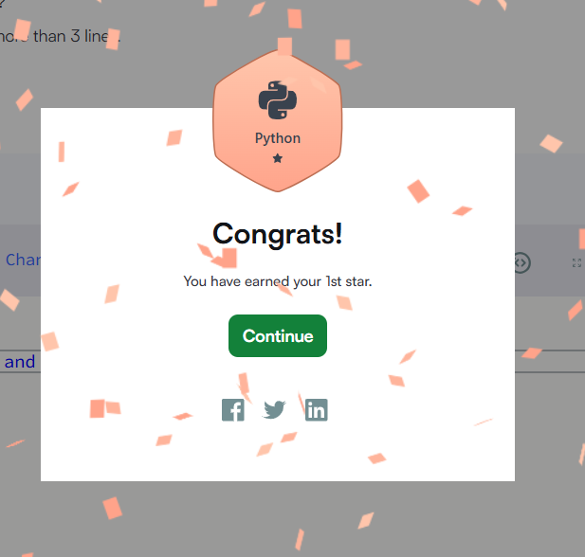

Part B – Google Workspace Collaboration (Google Form)
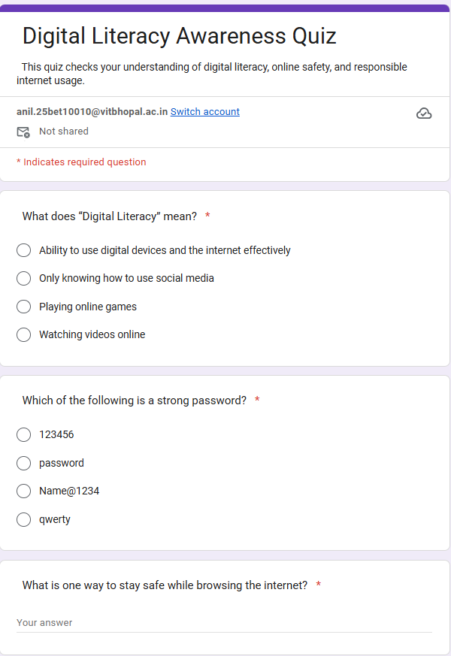

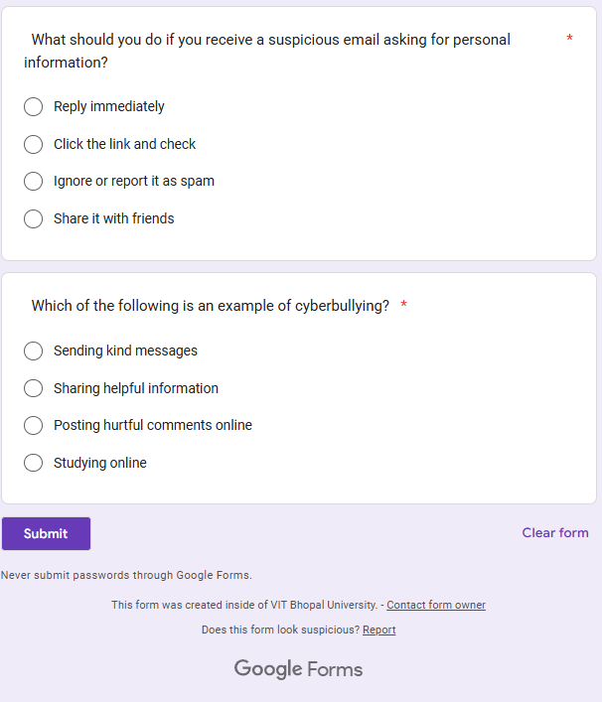

Response Sheet
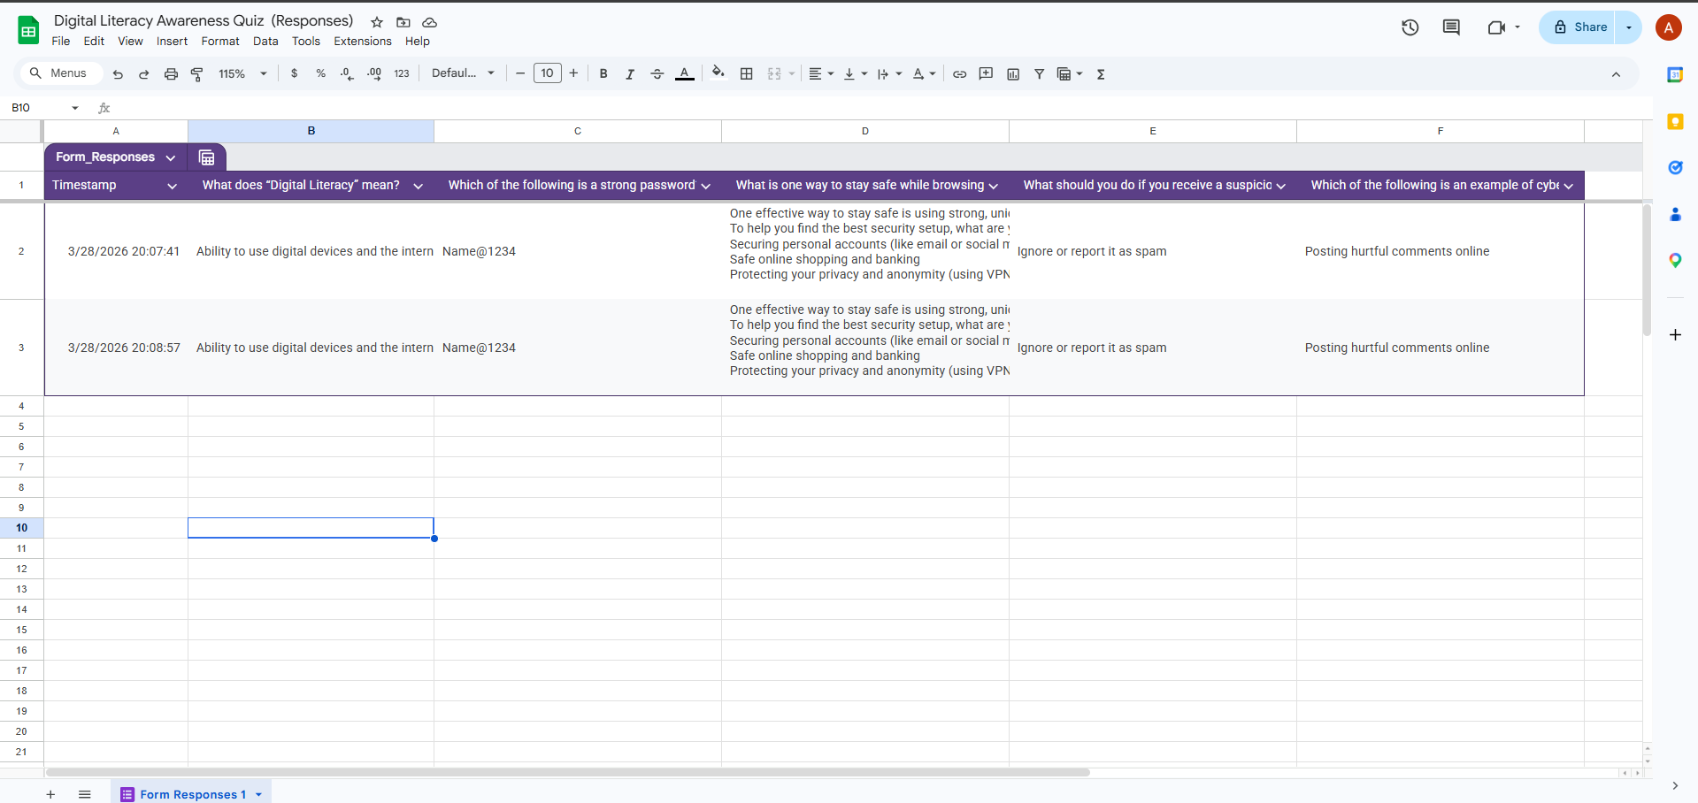

Project Report
For this project, I used Google Forms to create a “Digital Literacy Awareness Quiz” for my batchmates. This platform helped me design an interactive and user-friendly quiz with different types of questions, such as multiple choice and short answer. I practised creating structured questions, setting correct answers, and organizing the form in a clear and logical way.
While working on this project, I learned how to use digital tools effectively for educational purposes. I also understood the importance of digital literacy, including online safety, strong passwords, and responsible internet behavior. Creating the quiz improved my ability to think from a learner’s perspective and design meaningful questions.
These tools will help me academically by making it easier to create surveys, quizzes, and feedback forms for assignments and group projects. In the future, I can use Google Forms for data collection, research, and presentations. Overall, this project enhanced my technical skills and showed me how digital platforms can support learning and collaboration.

Task: 4 Draft a Professional Email & Etiquette Guide

Part A – Write two professional emails:

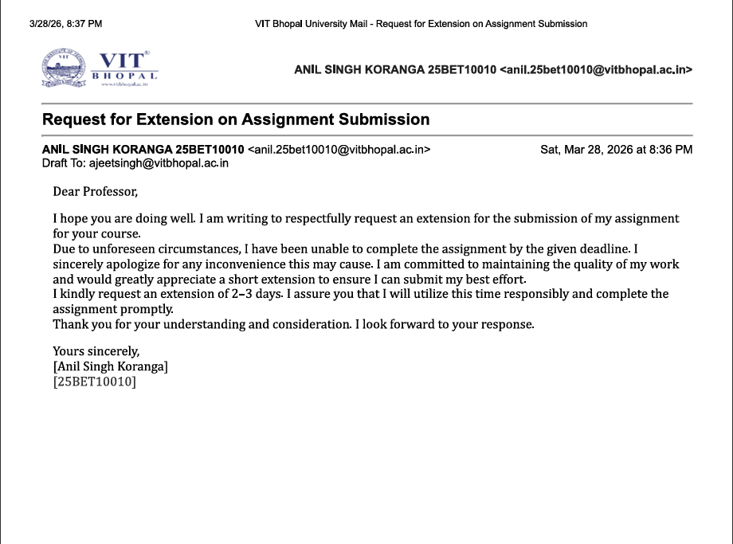

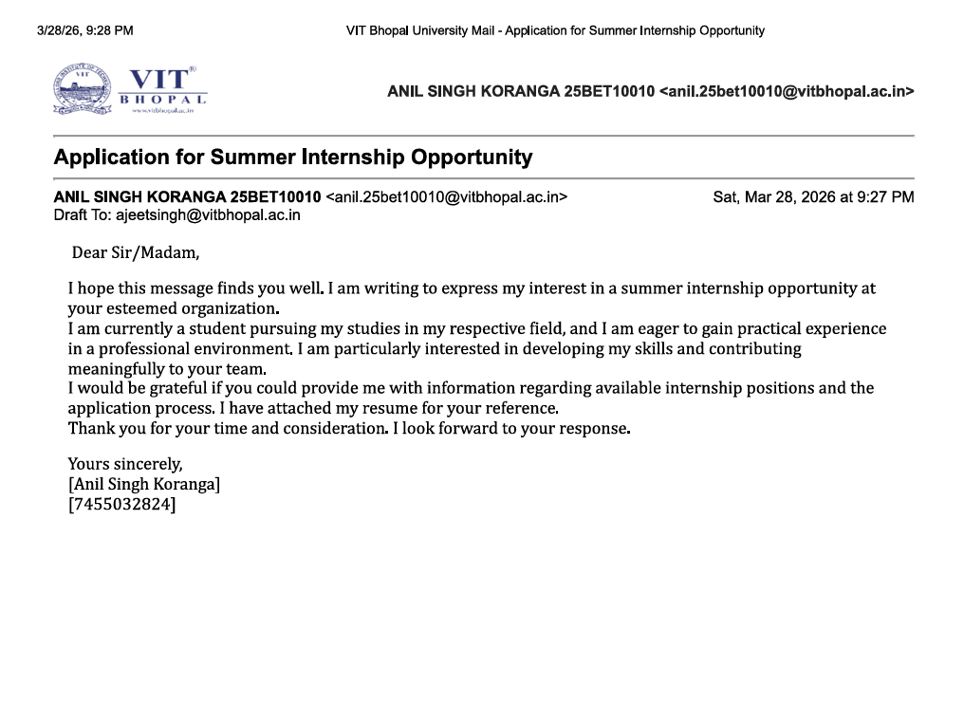

Do's
- Think before you post and consider long-term impact.
- Maintain a professional tone on public profiles.
- Verify information before sharing.
- Use strong privacy settings to protect personal data.
- Be respectful and positive in comments and messages.
Don'ts
- Do not share personal or sensitive information publicly.
- Avoid posting offensive, harmful, or inappropriate content.
- Do not engage in cyberbullying or online arguments.
- Avoid spreading rumors or unverified news.
- Do not use weak passwords or share account credentials.

One situation where poor digital communication caused a real problem
Poor digital communication can lead to serious problems. For example, a student once posted a sarcastic comment about a group project on social media, intending it as a joke. However, the tone was misunderstood, and team members felt insulted and disrespected. This led to conflict within the group and affected their overall performance.
This situation could have been handled differently by thinking carefully before posting and choosing a more respectful and clear way to communicate concerns. Instead of posting publicly, the student could have discussed the issue privately with the group. This highlights the importance of clarity, tone, and responsibility in digital communication. Being mindful online helps maintain healthy relationships and avoids unnecessary misunderstandings.

Task: 5 Case Study
Part A – (UPI/Online Payment Fraud)
UPI (Unified Payments Interface) fraud is a common type of cybercrime in which attackers trick users into transferring money or revealing sensitive banking details. This type of fraud has increased rapidly with the growth of digital payments.
Typically, the fraud happens in several steps. First, the attacker contacts the victim through a phone call, SMS, or messaging apps, pretending to be a bank official, customer support agent, or even a buyer/seller. Next, they create urgency by claiming issues like account blocking, refund processing, or prize winnings. Then, they send a payment request or a malicious link and instruct the victim to “approve” it. Many victims mistakenly believe they are receiving money, but in reality, they are authorizing a payment. In some cases, fraudsters also ask for OTPs or PINs.
The primary targets are students, elderly people, and individuals who are not fully aware of digital payment security. Small business owners are also frequent victims.
The consequences can be severe, including immediate financial loss, stress, and difficulty recovering the money. In many cases, victims may not get refunds due to delayed reporting.
To prevent such fraud, users should never share OTPs or PINs, avoid clicking unknown links, and carefully read payment requests before approving them. Awareness and caution are the best defenses against UPI fraud.
Part B – Prevention Checklist:
- Use strong, unique passwords for every account and enable two-factor authentication (2FA).
- Never share OTP, PIN, or passwords with anyone—even if they claim to be from your bank. (UPI Safety)
- Always verify UPI payment requests—remember, you only enter your PIN to send money, not receive it. (UPI Safety)
- Avoid clicking on unknown links in emails, SMS, or messaging apps.
- Download apps only from trusted sources like official app stores.
- Check website URLs for https:// and correct spelling before entering personal details.
- Be cautious about what you post on social media; avoid sharing personal or location details publicly.
- Log out from shared/public computers and avoid saving passwords on them.
- Regularly update your devices and apps to stay protected from security vulnerabilities.

Project Report
While researching online safety, what surprised me most was how easily people fall victim to simple scams, especially UPI fraud, just by clicking a link or approving a request without reading it carefully. I realized that many cybercrimes do not require advanced hacking skills—attackers mainly exploit human mistakes and lack of awareness.

This made me reflect on my own habits. One change I will personally make is to be more cautious while handling online payments and messages. I will carefully verify every payment request and avoid clicking on unknown links. I will also enable two-factor authentication on all my important accounts. This experience has taught me that staying safe online is not just about technology, but also about being alert and responsible while using digital platforms.

