PROJECT OUTLINE
Generative AI-Assisted Framework for Modernizing Legacy ETL and Data Warehouse Systems to Cloud-Native Data Platforms: A Snowflake-Based Approach
Project Area: AI-Assisted Cloud Data Engineering (Enterprise Data Warehouse & ETL Modernization)
EXL PVT. Ltd., Gurgaon, Haryana, India

TABLE OF CONTENTS
Section No. | Section Name
1 | Background
2 | Requirement Statement / Problem Statement
3 | Motivation for this Project
4 | Project Objectives
5 | Project Scope
6 | Proposed Methodology
7 | Plan of Work
8 | Resource Requirements and Plan for Availability
9 | Risks and Mitigation Plan
10 | Expected Benefits
 | References
 | Glossary

Project Type
☑ Work-related Project
☐ Industry-related Project
☐ Academic Project
If Others, please specify the other project type: Artificial Intelligence and Cloud Data Engineering
Project Area
- Artificial Intelligence
- Cloud Data Engineering
- Enterprise Data Warehousing
- Data Modernization
- Snowflake Data Cloud
- Generative AI

1. Background
Organizations across industries are experiencing unprecedented growth in data volume, variety, and velocity due to rapid digital transformation initiatives. As enterprises increasingly adopt cloud-native technologies, traditional data warehousing environments and legacy ETL (Extract, Transform, Load) systems have become significant barriers to agility, scalability, and innovation. These legacy systems often consist of complex ETL workflows developed over many years using proprietary tools, platform-specific scripting languages, and tightly coupled architectures. While these systems continue to support critical business operations, they introduce substantial technical debt, making modernization projects time-consuming, expensive, and resource-intensive.
The evolution of cloud computing has fundamentally transformed the way organizations manage enterprise data. Cloud-native platforms such as Snowflake provide scalable storage, elastic compute resources, improved security, simplified infrastructure management, and consumption-based pricing models. These capabilities enable organizations to build modern analytical ecosystems capable of supporting advanced analytics, artificial intelligence, and real-time decision-making. Consequently, enterprises are increasingly investing in large-scale migration programs to modernize legacy data warehouses and ETL pipelines.
Despite the availability of advanced cloud platforms, the modernization journey remains a significant challenge. Legacy ETL environments typically contain thousands of transformation rules, stored procedures, workflow dependencies, scheduling configurations, and business logic accumulated over many years of development. Much of this knowledge exists only within legacy codebases or in the experience of senior developers. Documentation is often incomplete, outdated, or unavailable, making migration efforts heavily dependent on manual analysis by subject matter experts. This increases project duration, introduces operational risks, and significantly raises migration costs.
Generative Artificial Intelligence (GenAI) has emerged as a transformative technology capable of understanding, generating, summarizing, and transforming software artifacts. Large Language Models (LLMs) can analyze complex source code, generate documentation, recommend optimized implementations, and assist software engineers during modernization initiatives. While significant research has explored the application of Generative AI in software development, its structured application to enterprise ETL modernization remains an emerging field with considerable research potential.
This project proposes a Generative AI-Assisted Framework for Modernizing Legacy ETL and Data Warehouse Systems to Cloud-Native Data Platforms using Snowflake. Rather than focusing solely on automated code conversion, the proposed framework aims to support the entire modernization lifecycle. The framework will incorporate AI-assisted legacy system analysis, metadata interpretation, dependency identification, transformation rule extraction, migration recommendations, documentation generation, validation support, and governance considerations.
Snowflake has been selected as the target cloud-native platform because of its architecture, scalability, separation of storage and compute, integrated data-sharing capabilities, and growing adoption across global enterprises. The framework will investigate how Generative AI can complement Snowflake-based modernization initiatives by improving productivity, reducing manual effort, enhancing documentation quality, and supporting consistent migration practices.
From a business perspective, successful modernization initiatives directly influence operational efficiency, time-to-market, infrastructure costs, data governance, and organizational competitiveness. Therefore, this project combines technical innovation with strategic management concepts learned during the HACKATHON program, including digital transformation, technology management, project management, innovation management, operations strategy, and business value realization.
The proposed research intends to develop a structured modernization framework that can serve as a practical reference for organizations undertaking legacy ETL migration projects. By integrating Generative AI capabilities with established cloud migration methodologies, the project aims to contribute both to industry practice and academic knowledge.

2. Requirement Statement / Problem Statement
Many organizations continue to rely on legacy ETL and enterprise data warehouse systems that have evolved over decades. Although these systems are functionally stable, they suffer from limited scalability, high maintenance costs, increasing technical debt, and dependence on specialized development skills. As organizations accelerate cloud adoption strategies, migration to cloud-native platforms has become a strategic priority. However, existing modernization approaches remain largely manual and require significant effort to analyze legacy code, identify business rules, document workflows, redesign architectures, and validate migrated solutions.
Several practical challenges are commonly encountered during enterprise modernization projects:
- Inadequate or outdated technical documentation.
- Complex dependencies between ETL jobs and workflows.
- Limited understanding of embedded business rules.
- High manual effort during code analysis and transformation.
- Difficulty validating migrated implementations.
- Increased project cost and extended delivery timelines.
- Knowledge dependency on experienced developers.
- Inconsistent migration practices across teams.
Although Generative AI has demonstrated promising capabilities in code generation and software assistance, its application in enterprise ETL modernization is still evolving. There is a need for a structured framework that integrates AI capabilities into different stages of the modernization lifecycle while maintaining governance, validation, transparency, and business alignment.

Accordingly, the central problem addressed by this project is:
How can a Generative AI-assisted framework improve the efficiency, consistency, documentation quality, and governance of legacy ETL modernization projects targeting Snowflake-based cloud-native data platforms?
The project seeks to answer this question through a systematic framework that combines AI-assisted analysis, migration guidance, documentation generation, and validation mechanisms.

3. Motivation for this Project

Why this project has been chosen by the team?
The motivation for selecting this project originates from both professional experience and current industry trends. Having worked extensively in enterprise data engineering and modern data platform implementations, I have observed that organizations continue to invest substantial effort in migrating legacy ETL systems to modern cloud-based platforms. These initiatives often involve complex technical challenges, prolonged project timelines, and significant dependence on experienced resources with specialized knowledge of legacy systems.
Although several commercial migration tools exist, many organizations continue to perform substantial portions of modernization manually due to project-specific business rules, customized transformations, and legacy application dependencies. Manual analysis and documentation activities frequently consume a considerable share of project resources before actual migration work begins.
Recent advancements in Generative Artificial Intelligence present an opportunity to transform this process. Large Language Models have demonstrated the capability to understand source code, summarize technical documentation, generate structured explanations, and recommend implementation approaches. Integrating these capabilities into enterprise modernization projects has the potential to significantly reduce manual effort while improving documentation quality, consistency, and developer productivity.

How is this project different from your routine work?
This project is distinct from my routine professional responsibilities. While my day-to-day work focuses on delivering enterprise data engineering solutions, the proposed project aims to design, evaluate, and document a reusable AI-assisted modernization framework from both technical and managerial perspectives. It requires systematic literature review, structured research methodology, business analysis, framework design, and academic evaluation, extending beyond operational project execution.

Relevance of this project in the current context
The project is also highly relevant to current industry developments. Organizations across banking, healthcare, insurance, retail, telecommunications, and financial services continue to accelerate cloud transformation programs. Simultaneously, Generative AI has become one of the most significant technological innovations influencing software engineering, enterprise architecture, and digital transformation strategies. Combining these two domains addresses an emerging research area with strong practical significance.

Relevance of this project to the programme of study
From an HACKATHON perspective, the project provides an opportunity to integrate concepts acquired throughout the program, including strategic management, operations management, project management, business analytics, innovation management, technology management, and organizational transformation. Rather than addressing only a technical problem, the proposed framework seeks to deliver measurable business value by improving modernization efficiency, reducing migration risks, supporting governance, and enabling more informed decision-making during enterprise cloud transformation initiatives.
Ultimately, the motivation behind this research is to develop a structured, practical, and scalable framework that can assist organizations in modernizing legacy ETL environments more effectively while leveraging the capabilities of Generative AI and Snowflake. This project also aligns with the growing demand for AI-enabled data engineering practices and contributes to the broader objective of enabling intelligent enterprise modernization.

4. Project Objectives
The primary objective of this project is to design and propose a Generative AI-assisted framework that facilitates the modernization of legacy ETL and enterprise data warehouse systems into cloud-native data platforms using Snowflake as the target environment. The framework seeks to reduce the complexity associated with traditional migration approaches while improving migration quality, documentation, governance, and overall project efficiency.
The project aims to bridge the gap between conventional migration methodologies and the emerging capabilities of Generative Artificial Intelligence by integrating AI-assisted techniques into multiple phases of the modernization lifecycle.

Objective 1: Analyze Legacy ETL Challenges
To study the technical and business challenges associated with legacy ETL systems, including:
- Complex workflow dependencies
- Proprietary ETL technologies
- Legacy SQL scripts
- Incomplete documentation
- High maintenance effort
- Technical debt
- Knowledge dependency on senior developers
This objective establishes the foundation for identifying modernization opportunities.

Objective 2: Study Cloud-Native Data Platform Capabilities
To analyze the architectural capabilities of Snowflake as a cloud-native data platform, including:
- Separation of compute and storage
- Elastic scalability
- Secure data sharing
- Zero-copy cloning
- Time Travel
- Data Governance
- Native support for ELT workloads
The study will evaluate how these capabilities support enterprise modernization initiatives.

Objective 3: Develop a Generative AI-Assisted Modernization Framework
Design a structured framework capable of supporting:
- Legacy code analysis
- Metadata interpretation
- Dependency discovery
- Business rule identification
- Documentation generation
- AI-assisted migration recommendations
- Validation guidance
The framework will integrate AI support throughout the modernization lifecycle rather than only focusing on code conversion.

Objective 4: Develop a Proof of Concept
Develop a conceptual proof-of-concept demonstrating how Generative AI can assist selected modernization activities, including:
- Legacy SQL interpretation
- ETL workflow explanation
- Documentation generation
- Transformation recommendation
- dbt model generation (conceptual)
- Migration planning
The proof-of-concept will validate the feasibility of the proposed framework.

Objective 5: Evaluate Business Benefits
Assess the expected organizational benefits of the proposed framework by evaluating potential improvements in:
- Migration productivity
- Development effort
- Documentation quality
- Standardization
- Knowledge management
- Governance
- Project risk reduction
- Time-to-market

SMART Objectives
Specific: Develop a structured AI-assisted modernization framework for legacy ETL migration to Snowflake.
Measurable: Evaluate improvements using qualitative parameters such as documentation completeness, migration consistency, developer productivity, and governance support.
Achievable: The framework will be developed using publicly available research, industry best practices, Snowflake concepts, and Generative AI techniques.
Relevant: The research addresses a significant challenge faced by organizations adopting cloud-native data platforms.
Time-bound: The framework will be designed, evaluated, documented, and presented during the HACKATHON project timeline.

5. Project Scope
The scope of this project defines the activities, deliverables, assumptions, and boundaries associated with the proposed AI-assisted modernization framework. Rather than developing a complete enterprise migration solution, the project focuses on designing and evaluating a structured framework that organizations can adapt for future modernization initiatives.

In-Scope Activities
Legacy System Assessment
- Study existing ETL architectures
- Analyze workflow structures
- Review legacy SQL scripts
- Understand business logic dependencies
- Identify migration challenges
AI-Assisted Analysis
- Source code understanding
- Metadata interpretation
- Workflow summarization
- Dependency analysis
- Business rule extraction
Documentation Generation
- Technical documentation
- Workflow summaries
- Mapping documents
- Migration reports
- Transformation descriptions
- Data lineage explanations
Snowflake Target Architecture
- Landing Layer
- Staging Layer
- Curated Layer
- Data Mart Layer
- Metadata Repository
- Monitoring Components
- Security Layer
Modernization Workflow
- Discovery
- Assessment
- AI Analysis
- Migration Planning
- Code Transformation
- Validation
- Documentation
- Deployment
Framework Evaluation
- Practical applicability
- Scalability
- Governance support
- Documentation quality
- Developer productivity
- Business value

Out-of-Scope Activities
- Full enterprise migration implementation
- Production deployment
- Performance benchmarking using enterprise workloads
- Organization-specific confidential datasets
- Commercial AI model training
- Development of proprietary migration software
- Enterprise security implementation
- Production DevOps pipeline implementation

Deliverables
- AI-assisted modernization framework
- Snowflake reference architecture
- Migration workflow
- Conceptual proof-of-concept
- Project report
- Presentation
- Recommendations for future work

Project Assumptions
- Legacy ETL systems are available for conceptual analysis.
- Snowflake architectural concepts are representative of modern cloud data platforms.
- Generative AI technologies continue to evolve during the study period.
- Relevant literature and documentation remain accessible.

6. Proposed Methodology
This project adopts a structured research methodology consisting of multiple sequential phases. The methodology combines academic research with practical industry practices to develop an AI-assisted modernization framework.

Phase 1: Literature Review
A comprehensive literature review will be conducted to study:
- Legacy ETL modernization
- Cloud migration strategies
- Enterprise Data Warehousing
- Snowflake Architecture
- Metadata-driven engineering
- Generative AI
- Large Language Models
- Software modernization research
The review will establish the theoretical foundation of the proposed framework.

Phase 2: Requirement Analysis
This phase identifies common enterprise modernization challenges by reviewing:
- Legacy ETL environments
- Existing migration methodologies
- Business requirements
- Technical constraints
- Governance requirements

Phase 3: Framework Design
Based on the identified challenges, an AI-assisted modernization framework will be designed. The framework consists of the following logical components:
Input Layer: Legacy ETL Jobs, SQL Scripts, Metadata, Mapping Documents, Workflow Definitions
AI Analysis Layer: Code Understanding, Dependency Discovery, Business Rule Extraction, Documentation Generation, Migration Recommendation
Transformation Layer: ELT Conversion, SQL Optimization, dbt Model Suggestions, Snowflake Object Mapping
Validation Layer: Business Rule Verification, Metadata Validation, Quality Checks, Documentation Review
Output Layer: Modernized Design, Migration Documentation, AI Recommendations, Governance Reports
Each layer feeds sequentially into the next, forming an end-to-end AI-assisted modernization pipeline from legacy input through to governed, documented output.

Phase 4: Proof-of-Concept Development
A conceptual prototype will demonstrate selected capabilities of the framework, such as:
- AI-assisted SQL explanation
- ETL workflow documentation
- Transformation recommendation
- Metadata interpretation
- Migration planning
The proof-of-concept is intended to illustrate feasibility rather than deliver a production-ready solution.

Phase 5: Framework Evaluation
The framework will be evaluated against qualitative criteria including:
- Ease of adoption
- Documentation completeness
- Governance support
- Maintainability
- Migration consistency
- Expected productivity improvements
Feedback from industry practices and published research will be considered during the evaluation.

Research Methodology Flow
Literature Review → Requirement Analysis → Legacy ETL Assessment → Generative AI Analysis → Framework Design → Snowflake Architecture Mapping → Proof of Concept → Validation → Business Benefit Evaluation → Project Documentation

Expected Research Contribution
- Providing a structured AI-assisted modernization framework.
- Demonstrating how Generative AI can support enterprise data engineering activities.
- Combining cloud architecture, AI, and business management principles within a single research framework.
- Offering a reusable reference model for organizations planning legacy ETL modernization initiatives.

7. Plan of Work
The successful execution of this project requires a structured and phased approach to ensure that all research objectives are achieved within the stipulated project timeline. The work plan has been designed to balance academic research, technical exploration, framework development, validation, and documentation activities. Since this project combines concepts from Data Engineering, Artificial Intelligence, Cloud Computing, and Business Management, each phase contributes incrementally toward the final deliverables.
The project will commence with an extensive review of literature related to legacy ETL modernization, cloud-native data platforms, enterprise data warehousing, and Generative Artificial Intelligence. This phase will establish the theoretical foundation of the research and help identify existing methodologies, research gaps, and opportunities for innovation.
The second phase will focus on understanding enterprise modernization challenges through analysis of legacy ETL systems, migration practices, Snowflake architecture, and AI-assisted software engineering techniques. During this phase, functional and non-functional requirements for the proposed framework will be identified.
The third phase involves the design of the proposed Generative AI-Assisted Modernization Framework. The framework will define the interaction between legacy ETL assets, metadata repositories, AI-assisted analysis modules, migration planning, Snowflake architecture, validation mechanisms, and governance components.
The fourth phase will develop a conceptual proof-of-concept demonstrating selected capabilities of the proposed framework. The proof-of-concept will illustrate how Generative AI can assist in legacy code understanding, workflow summarization, documentation generation, migration planning, and transformation recommendations.
The fifth phase will evaluate the proposed framework using qualitative performance indicators including usability, scalability, governance support, documentation quality, migration consistency, and expected productivity improvements. Feedback from published research and industry practices will be incorporated to strengthen the framework.
The final phase will focus on report preparation, refinement of the proposed framework, incorporation of supervisor feedback, preparation of presentation material, and completion of all academic deliverables required by Hackathon.

8. Resource Requirements and Plan for Their Availability
The successful completion of this project requires a combination of technical resources, software tools, academic literature, organizational support, and computing infrastructure.

Human Resources
The primary human resource for the project is the researcher, who will be responsible for planning, literature review, framework design, implementation, evaluation, documentation, and report preparation. Guidance from the industry supervisor will provide valuable insights into enterprise data engineering practices and project feasibility.
Additional support may include discussions with experienced data engineers, architects, and domain experts to validate assumptions and improve the practical relevance of the proposed framework.

Hardware Resources
The project requires a standard personal computer or workstation with sufficient processing capability to execute development tools, AI-assisted applications, and documentation software. Stable internet connectivity is required for accessing cloud platforms, research databases, and technical documentation.

Software Resources
The proposed project will utilize a combination of industry-standard and academic software resources, including:
- Snowflake (Trial or Enterprise Learning Environment)
- Python Programming Language
- Visual Studio Code
- dbt (Data Build Tool)
- GitHub
- Microsoft Office
- Draw.io or Microsoft Visio for architecture diagrams
- ChatGPT / Generative AI platforms (for conceptual exploration)
- Microsoft Project or equivalent Gantt chart software (optional)

Information Resources
The research will make use of:
- Snowflake Documentation
- dbt Documentation
- IEEE Xplore
- SpringerLink
- ACM Digital Library
- Gartner publications (where accessible)
- Google Scholar
- Research journals
- Industry white papers
- Technical blogs published by recognized organizations

Resource Availability
Most of the required resources are readily available through publicly accessible documentation, open-source software, academic databases, and enterprise development environments. Where proprietary enterprise data is unavailable due to confidentiality, representative datasets and conceptual examples will be used to demonstrate the proposed framework without compromising organizational security.

9. Risks and Mitigation Plan
Like any technology-focused research project, this study involves certain technical, operational, and research-related risks. Appropriate mitigation strategies have been identified to minimize their impact.
Risk | Possible Impact | Mitigation Strategy
Limited access to enterprise datasets | Restricted validation | Use representative sample datasets and published case studies
Confidentiality restrictions | Limited documentation | Exclude proprietary information and use conceptual examples
Rapid evolution of Generative AI technologies | Changing best practices | Base the framework on established AI concepts rather than specific tool versions
AI-generated inaccuracies (hallucinations) | Incorrect recommendations | Perform manual verification and cross-reference outputs with authoritative documentation
Time constraints | Delayed completion | Follow a phased work plan with regular milestone reviews
Limited availability of research papers | Reduced literature coverage | Utilize multiple academic databases and industry publications
Technology compatibility issues | Implementation delays | Focus on conceptual framework rather than platform-specific implementation
Scope expansion | Project complexity | Clearly define project boundaries and adhere to approved objectives

Risk Management Strategy
Risk management will be integrated throughout the project lifecycle. Periodic reviews with the supervisor will ensure that potential issues are identified early and corrective actions are implemented promptly. The project will also maintain flexibility to incorporate emerging best practices in Generative AI and cloud modernization without compromising the original research objectives.

10. Expected Benefits
The proposed framework is expected to generate benefits for both industry practitioners and the academic community.

Organizational Benefits
- Reduced manual effort during ETL modernization.
- Improved migration planning and documentation.
- Better understanding of legacy business logic.
- Enhanced knowledge management.
- Improved migration consistency.
- Reduced dependency on individual experts.
- Better governance and compliance support.
- Standardized modernization practices.
- Improved project productivity.
- Faster cloud adoption.

Technical Benefits
- AI-assisted workflow analysis.
- Automated documentation support.
- Metadata interpretation.
- Migration recommendation generation.
- Improved understanding of ETL dependencies.
- Structured modernization lifecycle.

Academic Benefits
The project contributes to emerging research in AI-assisted software modernization by proposing a structured enterprise modernization framework. It combines concepts from Artificial Intelligence, Cloud Computing, Enterprise Architecture, Data Engineering, and HACKATHON management principles, making it interdisciplinary in nature.

Personal Benefits
The project will strengthen professional competencies in:
- Artificial Intelligence
- Enterprise Architecture
- Snowflake
- Cloud Data Platforms
- Research Methodology
- Technology Strategy
- Project Management
- Innovation Management
- Business Analysis
- Technical Leadership

References
The final report should include full APA-formatted references. An indicative list is provided below.
- KiHackathonll, R., & Ross, M. (2013). The Data Warehouse Toolkit (3rd ed.). Wiley.
- Inmon, W. H. (2005). Building the Data Warehouse (4th ed.). Wiley.
- Snowflake Inc. (Latest). Snowflake Documentation.
- dbt Labs. (Latest). dbt Documentation.
- Russell, S., & Norvig, P. (2021). Artificial Intelligence: A Modern Approach.
- Goodfellow, I., Bengio, Y., & Courville, A. (2016). Deep Learning. MIT Press.
- Gartner. Cloud Data Platform reports.
- IEEE papers on Legacy System Modernization.
- ACM Digital Library papers on Software Engineering and AI.
- Relevant Springer publications on Cloud Migration and Digital Transformation.

Glossary
Term | Definition
ETL | Extract, Transform, Load
ELT | Extract, Load, Transform
Data Warehouse | Central repository for integrated enterprise data
Metadata | Data describing the characteristics of other data
Snowflake | Cloud-native data platform used for analytics and data warehousing
dbt | Data Build Tool used for SQL-based data transformation
LLM | Large Language Model
Generative AI | AI capable of generating text, code, and other content
Cloud-Native | Applications and architectures designed specifically for cloud environments
Technical Debt | Long-term maintenance burden caused by earlier design or implementation decisions
Data Governance | Policies and processes ensuring data quality, security, and compliance
Proof of Concept (PoC) | A limited implementation demonstrating the feasibility of an idea

Appendix A — Gap Analysis: Requirement vs. What Has Actually Been Built
Date of assessment: 24 September 2026
Assessed against: this document (Sections 1–10, Objectives 1–5, Scope, Deliverables, Methodology Phases 1–5)
Evidence base: repository exl-renaissance-hackathon, branch feature/genai-poc-framework
Method: every statement below was checked by running the code and opening the files — not by reading claims made elsewhere in the repository.

A.1 What This Gap Analysis Is Trying To Do (Method & Template)
Before presenting any findings, this section sets out exactly what the exercise is, how a verdict is reached, and what would and would not count as proof. The point of writing this down first is that a gap analysis is only useful if the reader can tell the difference between “we built it” and “we wrote a document saying we built it”. Everything in Sections A.3 to A.5 is produced by applying the template below, item by item.

A.1.1 Purpose
To answer one question honestly: of everything this requirement document promised, what now exists, what exists only in part, and what has not been done at all. The output is intended to be usable in two ways — as a status report for a reviewer or judge, and as a work list for whoever picks the project up next.

A.1.2 The two sides being compared
Left side — the promise | Right side — the evidence
The five Project Objectives (Section 4) | Documents under docs/ and running code under prototype/
The In-Scope Activities and Deliverables (Section 5) | Files that actually exist in the repository
The five Methodology Phases (Section 6) | Output of executing the pipeline and the test suite
The Expected Benefits (Section 10) | What the proof-of-concept can and cannot yet demonstrate

A.1.3 The three verdicts (the template)
Each requirement item is given exactly one of three verdicts. The bar each verdict has to clear is fixed in advance so that the assessment cannot drift towards optimism:
Verdict | What it means | The bar it must clear
Completed | The requirement is done and needs no further work for this project to be judged against it. | A named, finished artefact exists AND it covers every sub-item the requirement lists AND, where the item is code, the code runs and produces the claimed result.
Partially Completed | Real work exists and is genuine, but it does not yet cover the whole requirement. | An artefact exists, but it either covers only some of the named sub-items, or it only works under a restricted condition — one sample, one mode, simulated data, or a single happy path.
Not Completed | Nothing usable exists for this item yet. | No artefact exists, OR what exists is a placeholder, OR a document claims it but the underlying evidence does not support the claim.

A.1.4 Rules of evidence
These four rules were applied consistently and are the reason some items are marked lower than a casual reading of the repository would suggest:
1. A document existing is not the same as a requirement being met. Every document was opened and checked line by line against the sub-items the requirement actually names.
2. Code is judged by executing it, not by reading it. The pipeline and the test suite were both run on the assessment date and their real output is quoted.
3. Where a document claims a capability the code does not have, that is recorded as a defect against the document — it is never counted as coverage.
4. Anything this requirement document itself lists as Out-of-Scope (Section 5) is not treated as a gap. Absence of a production deployment, for example, is compliance with the scope, not a failure.

A.1.5 What was actually run on the assessment date
So the reader can reproduce it, these are the exact commands executed and the results they returned. Everything in Sections A.3 to A.5 traces back to this table.
Command | What came back
python main.py --auto-approve (single-script mode) | PASS. 7 tables and 8 business rules extracted; the 2 deliberately undocumented rules correctly flagged for human review; entity grounding 100%, rule coverage 100%, ambiguity recall 100%.
python main.py --auto-approve --target sample_legacy/workflow_inventory_sync (multi-job workflow mode) | REVIEW_REQUIRED. 5 tables and only 1 business rule extracted; grounding 100% but rule coverage 16.7% and ambiguity recall 0%.
python -m pytest prototype/tests | 6 passed, 1 failed — test_entity_grounding_accuracy_some_ungrounded.
Inspection of prototype/output/ | 18 generated artefacts present, including 7 dbt model/schema files, the migration report, migration plan, lineage graph, metadata interpretation and validation report.
Provider check | mock-heuristic-v1. No ANTHROPIC_API_KEY or OPENAI_API_KEY present — the framework has never been executed against a real large language model.

That last line matters more than any other single fact in this appendix, and it is carried through every verdict that follows.

A.2 Summary of Findings
Twenty-six requirement items were assessed. Fifteen are complete, eight are partial, and three are not started.
Requirement group | Completed | Partially completed | Not completed
Project Objectives (Section 4) | 3 of 5 | 2 of 5 | 0 of 5
Deliverables (Section 5) | 5 of 7 | 2 of 7 | 0 of 7
Methodology Phases (Section 6) | 3 of 5 | 2 of 5 | 0 of 5
Supporting commitments (references, validation depth, CI) | 4 of 9 | 2 of 9 | 3 of 9
Overall | 15 of 26 | 8 of 26 | 3 of 26

The honest one-paragraph version: the thinking and the writing are essentially finished, and the proof-of-concept genuinely works end to end on the sample it was designed around. What is not finished is the proof. The pipeline has only ever been run against a simulated model rather than a real one, it holds up on one script but visibly degrades on the multi-job workflow, one unit test is failing because of a real defect, and the academic reference list was never converted into the full citations this document asks for. None of these are design problems — they are all finishing work.

A.3 COMPLETED
These items clear the full bar in A.1.3: a finished artefact exists, it covers every sub-item the requirement names, and where code is involved, the code runs.

A.3.1 Objective 1 — Analyse Legacy ETL Challenges
Objective 1 asked for a study of seven specific legacy ETL problems: complex workflow dependencies, proprietary technologies, legacy SQL scripts, incomplete documentation, high maintenance effort, technical debt, and knowledge dependency on senior developers.
Evidence: docs/legacy-etl-challenges-analysis.md.
The document works through each named challenge in its own section and, unusually for this kind of write-up, grounds every one of them in a concrete artefact rather than describing the problem in the abstract. The sample legacy script written for the project contains two business rules — a 90-day order discount and a 24-month order cutoff — with no recorded rationale anywhere in the code, which is precisely the tribal-knowledge problem the objective describes. The document closes with a table mapping each challenge to its business impact and to the part of the framework that addresses it. All seven named sub-items are covered.

A.3.2 Objective 2 — Study Cloud-Native Data Platform Capabilities
Objective 2 named seven Snowflake capabilities to be analysed: separation of compute and storage, elastic scalability, secure data sharing, zero-copy cloning, Time Travel, data governance, and native ELT support.
Evidence: docs/snowflake-capabilities-study.md.
Each of the seven has a dedicated section, and each section ends by tying the capability back to a specific layer of the framework — Time Travel to the Validation Layer's rollback strategy, zero-copy cloning to non-destructive migration testing, and so on. There is a quick-reference mapping table and, creditably, a caveats section that marks edition-specific behaviours as needing verification against current Snowflake documentation rather than stating them as fact.
One qualification worth stating plainly: this is a desk study. No Snowflake account was used, and no capability was exercised hands-on. That is consistent with Section 5, which places production deployment out of scope, so it does not reduce the verdict — but it does mean the study is a well-researched reading of the documentation rather than tested experience.

A.3.3 Objective 3 — Develop a Generative AI-Assisted Modernization Framework
This is the strongest area of the project. Objective 3 asked for a framework supporting legacy code analysis, metadata interpretation, dependency discovery, business rule identification, documentation generation, AI-assisted migration recommendations, and validation guidance — seven capabilities.
Evidence: docs/architecture.md, implemented by prototype/main.py.
All seven exist, and each one is not merely described but mapped to a named module that runs:
Required capability | Where it lives | Status
Legacy code analysis | src/ai_analysis.py | Implemented and running
Metadata interpretation | src/metadata_interpreter.py | Implemented and running
Dependency discovery | src/ai_analysis.py, src/lineage.py | Implemented and running
Business rule identification | src/ai_analysis.py | Implemented and running
Documentation generation | src/generate_docs.py | Implemented and running
AI-assisted migration recommendations | src/transform.py, src/migration_planner.py | Implemented and running
Validation guidance | src/validate.py | Implemented and running

Two design decisions go beyond what the requirement asked for and are worth drawing attention to. First, only the first phase depends on the language model at all — phases two through six are deterministic Python, so a model error is caught by code rather than propagating silently into the delivered design. Second, a mandatory human review gate sits between transformation and validation: every rule the AI could not justify from the source must be approved, edited or rejected by a person before the pipeline continues, and a rejection exits the run. That directly answers the governance and hallucination risks this document raises in Section 9.

A.3.4 Deliverable — Project Report
Evidence: docs/PROJECT_REPORT.md.
A consolidated report exists and follows this document's own table of contents — background, problem statement, motivation, objectives, scope, methodology, plan of work, resources, risks, conclusions, references and glossary. Importantly it reports results rather than restating intentions, and it cites the specific output file behind each claim, so a reviewer can check any statement in it against a real artefact.

A.3.5 Deliverable — Presentation
Three decks exist in docs/: an 8-slide Dragon's Den presentation (the current primary deck, including a rebuilt solution-architecture slide, a phase-by-phase slide and a live code demo slide), plus a 6-slide GenAI ETL modernization deck and a 5-slide EXL hackathon deck. Supporting material for the presentation is also complete: docs/Live_Demo_Script.md gives a step-by-step demo runbook, and docs/Judge_Questions_and_Answers.md anticipates the questions a panel is likely to ask.

A.3.6 Deliverable — Migration Workflow
Section 5 asked for a modernization workflow covering discovery, assessment, AI analysis, migration planning, code transformation, validation, documentation and deployment. docs/architecture.md defines the full sequence and prototype/main.py implements the executable core of it. Deployment is deliberately excluded, which Section 5 explicitly places out of scope — the framework stops at a reviewed, validated design plus the plan to deploy it.

A.3.7 Deliverable — Recommendations for Future Work
Present in the conclusions of docs/PROJECT_REPORT.md: run the pipeline across a broader set of real legacy scripts to measure genuine productivity gains, tune prompts and parsing resilience for real providers, connect a Snowflake sandbox to test clone- and Time-Travel-based validation, and extend the analysis layer to emit explicit rule-to-table bindings so the planner can be more precise. These are specific and actionable rather than generic. They sit inside the report rather than as a standalone document, which is a presentational point, not a gap.

A.3.8 Methodology Phases 2 and 3 — Requirement Analysis and Framework Design
Phase 2 is evidenced by Section 2 of this document together with docs/legacy-etl-challenges-analysis.md and docs/competitive-landscape.md, which together establish the problem, the constraints and what the market already offers. Phase 3 is evidenced by docs/architecture.md. Both are complete.

A.3.9 Additional work delivered beyond the requirement
Three pieces of work were produced that this requirement document never asked for, and they are among the more commercially useful outputs of the project:
docs/competitive-landscape.md — positions the framework against SnowConvert, AWS Schema Conversion Tool, BladeBridge/Datometry and generic AI copilots, and states plainly where it does not compete.
docs/prompt-engineering.md — documents the prompting strategy behind the analysis layer, including the strict grounding rules that produce the ambiguity flags.
docs/Judge_Questions_and_Answers.md and docs/Live_Demo_Script.md — presentation-readiness material.

A.4 PARTIALLY COMPLETED
These items contain real, working effort — none of them is a stub — but each is limited in a way that a reviewer would notice, so none can honestly be called done.

A.4.1 Objective 4 — Develop a Proof of Concept
Objective 4 named six proof-of-concept capabilities. Five of the six work. The sixth is the problem.
Required capability | Status | Detail
Legacy SQL interpretation | Working | 7 tables and 8 business rules extracted from the sample script, with 100% entity grounding — no invented tables or columns.
Documentation generation | Working | migration_report.md is generated on every run and includes the mapping table, rule inventory, lineage and risks.
Transformation recommendation | Working | Staging, intermediate and marts models produced with sources and tests declared.
dbt model generation (conceptual) | Working | 7 dbt artefacts generated: 2 staging, 1 intermediate, 2 marts, plus sources.yml and schema.yml.
Migration planning | Working | migration_plan.json sequences the migration by dependency, assigns Low/Medium/High effort and flags blocking items.
ETL workflow explanation | Degrades | Multi-job workflow mode runs to completion but returns REVIEW_REQUIRED — only 16.7% rule coverage and 0% ambiguity recall.

Why this is partial rather than complete. On the single script the proof-of-concept is genuinely impressive: it finds every business rule, invents nothing, and correctly refuses to guess at the two rules whose business justification is undocumented — flagging them for a human instead. That is exactly the behaviour the framework claims. But the second sample, a three-job orchestrated workflow, is where it thins out. The pipeline runs, produces all its artefacts and reports its own weakness honestly, but it finds only one business rule out of six and flags none of the ambiguous ones. Any claim that the framework “holds up on a multi-job workflow” is currently overstated.
The larger qualification. Every number quoted above was produced by the built-in mock heuristic provider, not by a real language model. The framework is written to be provider-agnostic and will select Anthropic or OpenAI automatically when an API key is present, and the code path exists — but it has never been executed. Strictly, the proof-of-concept currently proves that the pipeline, the guardrails and the human review gate all work; it does not yet prove that generative AI performs the extraction well, because no generative AI has been run through it. This is the single most valuable gap to close and it is probably an hour's work.

A.4.2 Objective 5 — Evaluate Business Benefits
Objective 5 named eight benefit categories: migration productivity, development effort, documentation quality, standardization, knowledge management, governance, project risk reduction and time-to-market.
Evidence: docs/business-benefits-evaluation.md.
All eight are addressed, each with an expected benefit, the supporting evidence from the proof-of-concept, and — creditably — an explicit statement of what is not yet proven. The document states its own limitations clearly: a sample size of one, illustrative rather than statistically generalizable, and not a substitute for a controlled comparison against real team productivity data. A quantitative effort and cost estimator also exists in prototype/src/estimator.py and produces per-layer hour and cost figures on every run.
Why this is partial. Two reasons. First, because the benefit narrative rests on proof-of-concept results that were produced in mock mode, the evidence behind it is weaker than the document implies. Second, the document cites two metrics that do not exist in the code — see Section A.6. The structure and the honesty are right; the evidentiary base underneath it needs one real run to become solid.

A.4.3 Deliverable — Snowflake Reference Architecture
Section 5 named seven target-architecture layers: Landing, Staging, Curated, Data Mart, Metadata Repository, Monitoring Components and Security Layer. docs/architecture.md Section 3 lists all seven in a table with a one-line purpose for each, and the first four are genuinely realised — the generated dbt project physically implements the staging, intermediate and marts split.
The gap: the last three layers — Metadata Repository, Monitoring Components and Security Layer — are named and given a one-line purpose, but never designed. There is no description of what the metadata repository would hold or how it would be populated, no monitoring design beyond a reference to dbt tests, and no concrete role, masking-policy or tagging model for the security layer. There is also no Snowflake-specific architecture diagram; the existing diagram depicts the processing pipeline, not the target data platform.

A.4.4 Methodology Phase 1 — Literature Review
docs/literature-review.md exists and is organised around exactly the themes Section 6 names — legacy ETL modernization, cloud migration strategies, enterprise data warehousing, Snowflake architecture, metadata-driven engineering, generative AI and LLMs in software engineering, and software modernization research. Each theme is summarised and, usefully, tied back to how this project fits it.
The gap: the document describes itself, accurately, as “a structured summary for the PoC, not a systematic literature review.” It synthesises themes at the level of what the field generally holds, without citing individual papers, authors or findings inline. Section 6 asked for a comprehensive review establishing the theoretical foundation, and this is a competent thematic summary of one. It is a real contribution that stops short of the stated bar.

A.4.5 Methodology Phase 5 — Framework Evaluation
Evaluation material exists on two fronts: docs/evaluation-rubric.md defines how the proof-of-concept's output quality should be measured, and docs/business-benefits-evaluation.md assesses the framework against the business benefit categories. Section 6 asked for evaluation against six qualitative criteria — ease of adoption, documentation completeness, governance support, maintainability, migration consistency and expected productivity improvements.
The gap: three of those six — ease of adoption, maintainability and migration consistency — are listed in the rubric but never actually assessed anywhere. Nothing in the repository evaluates how easy the framework would be for a new team to pick up, how maintainable the generated dbt project is, or whether two runs over similar inputs produce consistent output. The criteria are named; the evaluation against them was not written.

A.5 NOT COMPLETED
Three items have no usable artefact. All three are small and well-understood — none requires rethinking anything.

A.5.1 Full APA-formatted references
The References section of this document states that the final report should include full APA-formatted references, and provides an indicative list. That indicative list was copied into docs/references.md essentially unchanged and never developed further.
Of the ten entries, six are real citations missing APA formatting, and four are not citations at all — “IEEE papers on Legacy System Modernization”, “ACM Digital Library papers on Software Engineering and AI”, “Gartner Cloud Data Platform reports” and “Relevant Springer publications on Cloud Migration and Digital Transformation” are categories of literature, not sources. No specific paper from any of those four categories is cited anywhere in the project. This is the one requirement in this document with an explicit formatting instruction that was not followed, which makes it disproportionately visible to an academic reviewer relative to the effort needed to fix it.

A.5.2 A passing test suite and a working CI pipeline
Both are broken, and neither break is cosmetic.
The failing test. One of seven unit tests fails: test_entity_grounding_accuracy_some_ungrounded. The test is correct and the code is wrong. The grounding check in prototype/src/validate.py asks whether a table name appears anywhere in the source SQL as a case-insensitive substring, so a table named “C” is considered grounded because the letter c appears inside the word “select”. Because entity grounding accuracy is the project's headline hallucination guardrail — the metric quoted at 100% in the report and on the deck — this is worth fixing properly rather than adjusting the test. The good news is that all seven real table names in the sample still pass under a strict word-boundary check, so the reported figures are not actually inflated. The fix is to match on token boundaries instead of substrings.
The broken CI. The GitHub Actions workflow runs pytest from inside the prototype directory, where test collection fails outright with ModuleNotFoundError: No module named ‘prototype’. The tests only collect from the repository root. CI is therefore not green and has not been validating anything.

A.5.3 Any execution against a real language model
Stated separately from Section A.4.1 because of how much rests on it. The entire evidence base of this project — every metric on the deck, every number in the report, the business benefits case and the evaluation rubric results — comes from a deterministic rule-based mock provider standing in for the language model. The real provider integration is written, but no key has ever been supplied and the path has never run.
The consequence is narrow but real: the project has convincingly proven that the framework, the guardrails, the validation layer and the human review gate all work, and has not yet proven the premise in its own title — that generative AI performs this extraction well. That is a materially different claim, and a reviewer is likely to ask about it directly.

A.6 Documentation Accuracy Defects Found During This Assessment
These are places where a project document states something the code does not do. They are listed separately from the gaps above because they are factual errors rather than missing work, and because each one is an easy thing for a reviewer to catch. All five were confirmed by running or opening the artefact in question.
# | Where | What it claims | What is actually true
1 | docs/evaluation-rubric.md | Lists five metrics computed by the PoC, including SQL Construct Mapping Completeness and Documentation Completeness Score. | Only three metrics are implemented in validate.py: entity grounding accuracy, business rule coverage and ambiguity flag recall. The other two do not exist in code.
2 | docs/evaluation-rubric.md and docs/business-benefits-evaluation.md | Each run produces a validation_report.md. | The code writes validation_report.json. There is no markdown validation report.
3 | docs/business-benefits-evaluation.md | “the PoC computes a Documentation Completeness Score”. | It does not. See defect 1.
4 | docs/GAP_ANALYSIS.md | Lists the literature review, Snowflake capabilities study, legacy ETL challenges analysis, business benefits evaluation and presentation as missing. | All five of those now exist. This earlier gap analysis is stale and understates the project — it should be superseded by this appendix.
5 | prototype/main.py docstring and docs/presentation-outline.md | The pipeline runs with python -m prototype.main; the deck has 12 slides. | That invocation raises ModuleNotFoundError — only python main.py from inside prototype/ works. The current primary deck has 8 slides, not 12.

A.7 Recommended Order of Work
Ordered by how much credibility each item buys relative to the effort it takes. The first three together are roughly a day's work and close every gap a reviewer is likely to probe.
Priority | Action | Closes | Rough effort
1 | Supply an ANTHROPIC_API_KEY and run the pipeline end to end against a real model; record the resulting metrics alongside the mock ones. | A.4.1, A.4.2, A.5.3 | About an hour
2 | Fix the grounding check in validate.py to match on word boundaries instead of substrings, and correct the CI working directory so pytest collects. | A.5.2 | Under an hour
3 | Convert docs/references.md to full APA citations and replace the four placeholder categories with four specific, real papers. | A.5.1 | Two to three hours
4 | Correct the five documentation defects in Section A.6 and retire the stale docs/GAP_ANALYSIS.md. | A.6 | About an hour
5 | Improve rule extraction on the multi-job workflow sample, or state its current limitation explicitly wherever the workflow sample is presented. | A.4.1 | Half a day
6 | Design the Metadata Repository, Monitoring and Security layers rather than naming them, and add a Snowflake target-architecture diagram. | A.4.3 | Half a day
7 | Write the missing evaluation against ease of adoption, maintainability and migration consistency. | A.4.5 | Half a day
8 | Deepen the literature review with inline citations of specific papers. | A.4.4 | One day

A.8 Closing Assessment
Measured against its own requirement document, this project has delivered its framework, its architecture, its supporting research and a proof-of-concept that genuinely runs. Three of five objectives are fully met, and the two that are not are limited by depth of evidence rather than by absence of work.
The strongest thing about the work is also the least common in AI-assisted migration projects: it refuses to overstate itself. The pipeline flags what it cannot justify rather than guessing, the validation layer measures its own output and is willing to return REVIEW_REQUIRED, and the project's own documents state their limitations without being asked to. That discipline is what makes this appendix possible to write with specifics rather than generalities.
The weakest thing is that the proof-of-concept has never met a real language model. Everything else in Section A.5 is minor by comparison and fixable in a day. Closing that one gap converts the project from a well-built framework with simulated evidence into a well-built framework with real evidence — and it is the first question any informed reviewer will ask.

— End of Appendix A —

Appendix B — End-to-End Process: How to Run the PoC, Models Produced, and Data Lineage
Captured by re-running the pipeline on 25 September 2026 (single-script mode, mock provider, commit 89e6206 on feature/genai-poc-framework). Every command, console line, file path, table and diagram below is taken directly from that run — nothing here is reconstructed from memory or from reading the source without executing it. Related: Appendix A §A.5.3 (no run against a real LLM yet) and §A.6 item 3 (workflow-mode caveat, repeated in §B.1 below).

B.1 Two ways to run the pipeline
Single-script mode (recommended / demo-safe) — analyzes one legacy SQL file end-to-end. On the bundled sample script this returns validation status PASS with 100% on all three metrics.
Workflow mode — analyzes a multi-job workflow folder (a manifest.json plus several SQL files). Per Appendix A §A.6, this currently scores 16.7% rule coverage and 0% ambiguity recall and returns REVIEW_REQUIRED. Useful to show the mechanism exists; do not present it as “working” without stating this caveat.

B.2 Prerequisites
Python 3.x on PATH (this environment used the system Python 3.14 install).
From the prototype/ folder: pip install -r requirements.txt
Optional: set ANTHROPIC_API_KEY or OPENAI_API_KEY to run the AI Analysis / Transformation layers against a real LLM instead of the built-in mock-heuristic-v1 provider. This has not yet been exercised in this project — see Appendix A §A.5.3.

B.3 Step-by-step: how to run the job
1. Open a terminal and change into the prototype folder:
cd prototype
2. Non-interactive / demo run — auto-approves the ambiguous rules at the human-in-the-loop checkpoint so the pipeline never blocks waiting for input. This is the run captured in §B.4 below:
python main.py --auto-approve
3. Interactive run — stops at the human-in-the-loop checkpoint and prompts you to approve, edit, or reject each ambiguous rule one at a time:
python main.py
4. Workflow-mode run — points the same pipeline at a multi-job folder instead of one file (see the §B.1 caveat before demoing this):
python main.py --target sample_legacy/workflow_inventory_sync
5. Every run overwrites prototype/output/ with a fresh set of artifacts (analysis, dbt models, lineage, validation report, migration report). There is no separate “build” step — this one command is the whole job.

B.4 Console output — live run captured 25 September 2026
Command: python main.py --auto-approve | Working directory: prototype/ | Provider: mock (no ANTHROPIC_API_KEY / OPENAI_API_KEY set)
Running pipeline with provider: mock (model: mock-heuristic-v1)
NOTE: No ANTHROPIC_API_KEY or OPENAI_API_KEY found - running in mock mode. Full pipeline logic still executes end-to-end.
--- Phase 2: AI Analysis Layer ---
Extracted 7 tables, 8 business rules.
--- Phase 3a: Metadata Interpretation ---
Metadata interpretation written to output\metadata_interpretation.json
--- Phase 3: Transformation Layer ---
Generated 7 dbt/Snowflake artifact files.
--- HUMAN-IN-THE-LOOP CHECKPOINT ---
2 rule(s) flagged for mandatory human review before proceeding:
- Auto-approved: AI-04: Order Aging Discount Exception -> Business justification for the 90-day / 2% values is not present in the source script; flagged for human review rather than assumed.
- Auto-approved: AI-07: 2-Year Order Window -> No documented business reason found for the 24-month cutoff; flagged for human review.
[Auto-approve enabled - proceeding to Validation Layer]
--- Phase 4: Validation Layer ---
Validation status: PASS
PASS: Entity Grounding Accuracy: 100.0%
PASS: Business Rule Extraction Coverage: 100.0%
PASS: Ambiguity Flag Recall: 100.0%
--- Phase 5: Migration Planning ---
Migration plan written to output\migration_plan.json
--- Lineage: generating lineage artifacts ---
Lineage artifacts written: output\lineage.json, output\lineage.dot
--- Estimator: computing cost/time/efficiency estimates ---
Estimates written to: output\estimates.json
--- Phase 6: Output Layer (Documentation) ---
Migration report written to output\migration_report.md
Pipeline complete. See prototype/output/ for all artifacts.

B.5 Models produced
Phase 2 (AI Analysis Layer) reads the legacy SQL and extracts 7 source tables and 8 business rules. Phase 3 (Transformation Layer) turns those into 7 dbt/Snowflake artifact files, laid out as a standard dbt staging → intermediate → marts model:
Layer | File | What it encodes
Staging | dbt_models/staging/stg_customers.sql | Dedup, region/tier mapping, active-customer filter (rules AI-01, AI-02, AI-06)
Staging | dbt_models/staging/stg_orders.sql | Order + line-item join, status normalization (rules AI-03, AI-05)
Intermediate | dbt_models/intermediate/int_order_line_discounts.sql | Discount + order-aging logic (rules AI-03, AI-04)
Marts | dbt_models/marts/dim_customers.sql | Customer dimension, SCD Type 1 / MERGE overwrite (rule AI-08)
Marts | dbt_models/marts/fct_orders.sql | Orders fact table
Config | dbt_models/schema.yml | Column-level dbt tests (not_null, unique, accepted_values) generated per rule
Config | dbt_models/sources.yml | Declares the 3 raw source tables the models read from

Example — generated staging model (dbt_models/staging/stg_customers.sql):
-- Generated from legacy dedupe + region/tier CASE logic (AI-01, AI-02)
with source as (
select * from {{ source('raw', 'raw_customers') }}
where active_flag = 'Y' -- BR: Active Customer Filter (AI-06)
),
deduped as (
select *,
row_number() over (
partition by customer_id order by created_date desc
) as rn
from source
)
select
customer_id,
upper(trim(customer_name)) as customer_name,
email,
case
when region_code = 'NA' then 'North America'
when region_code = 'EU' then 'Europe'
when region_code = 'AP' then 'Asia Pacific'
else 'Unknown'
end as region,
case
when lifetime_value >= 50000 then 'PLATINUM'
when lifetime_value >= 15000 then 'GOLD'
when lifetime_value >= 2000 then 'SILVER'
else 'STANDARD'
end as customer_tier,
created_date
from deduped
where rn = 1

B.6 Data lineage produced
After validation, the pipeline auto-generates lineage in three files: lineage.json (nodes / edges / adjacency list), lineage.dot (Graphviz), and a Mermaid diagram (both as lineage_mermaid.md and embedded in migration_report.md). The table-level view, rendered directly from that run's lineage.json:
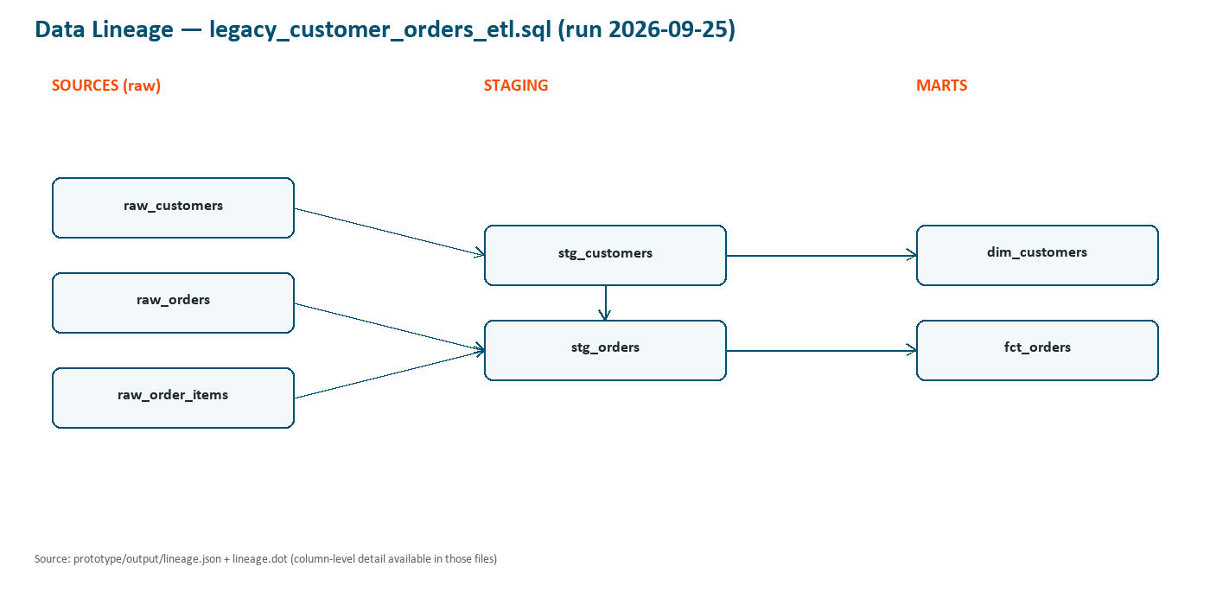
The same lineage.json / lineage.dot also carry column-level edges (e.g. raw_customers.customer_id → stg_customers.customer_id → ... → dim_customers). Not previously catalogued in Appendix A: that run's lineage.json also contained a handful of isolated, edge-less nodes — "0.02", "0.05", "0.10", "0.15", "i.e", "d.customer_id", "order_date.days", and similar — that look like regex-parsing noise picking up literal numbers and SQL aliases as if they were column references. None of them have any lineage edge in or out, so they were left out of the diagram above and do not affect the validation metrics; flagged here as a minor lineage-extraction quality item for the backlog, not a correctness failure.

B.7 Other artifacts produced each run
File | What it contains
output/analysis.json | Raw AI Analysis Layer output: extracted tables + business rules with confidence scores
output/metadata_interpretation.json | Phase 3a output: interpreted column/table metadata
output/migration_plan.json | Phase 5 output: the migration plan (see Appendix A §A.4.3 for what's still short of a full target architecture)
output/estimates.json | Cost / time / effort estimates for the migration
output/validation_report.json | Phase 4 result: PASS / REVIEW_REQUIRED plus the three metrics (grounding, coverage, ambiguity recall). Note: named .json even though evaluation-rubric.md promises .md — Appendix A open item 5
output/migration_report.md | Human-readable summary: business-rule → SQL mapping, lineage, validation summary, generated-artifact list

B.8 Supporting Screenshots
The following screenshots illustrate the pipeline run, the generated artifacts, and the validation output.
Screenshot 1 — Terminal running "python main.py --auto-approve" from start through "Pipeline complete."
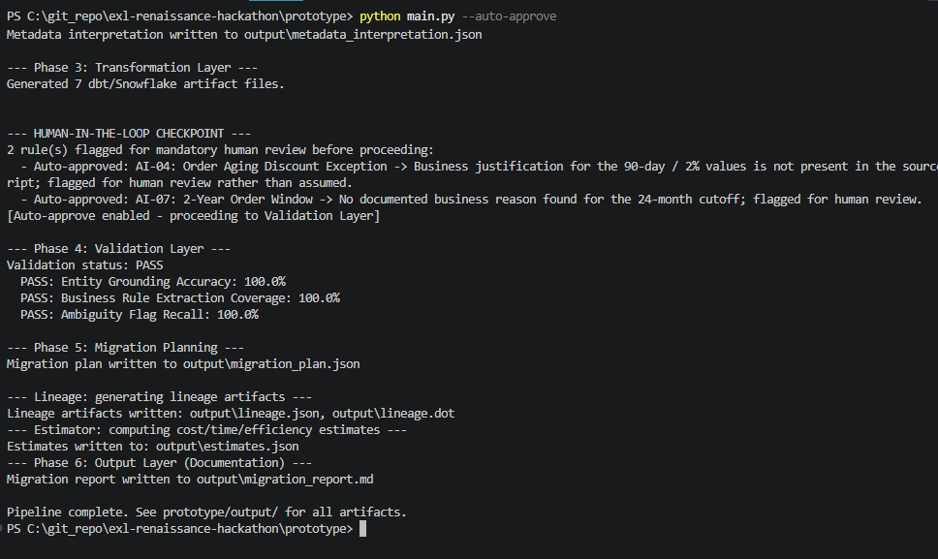
Screenshot 2 — File explorer / VS Code view of prototype/output/ and prototype/output/dbt_models/ showing the generated file tree
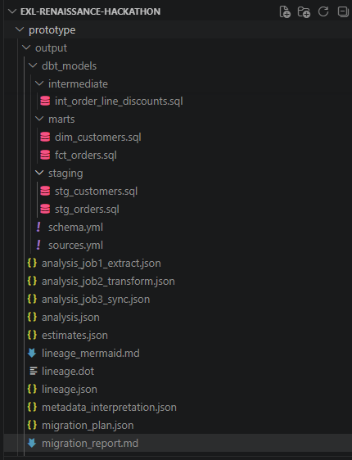
Screenshot 3 — migration_report.md opened in a Markdown preview (e.g. VS Code preview) — shows the formatted rule table and rendered lineage diagram
3a. Business Rule → Snowflake/dbt Mapping table
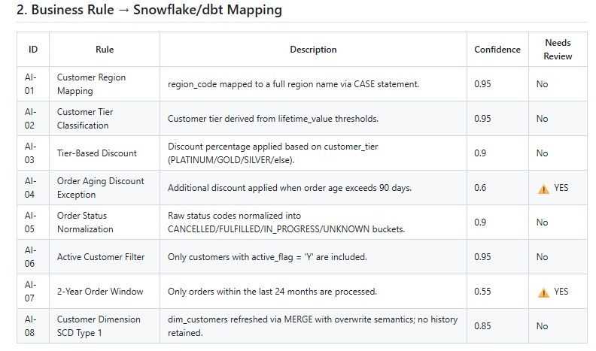
3b. Data Lineage / Dependencies diagram
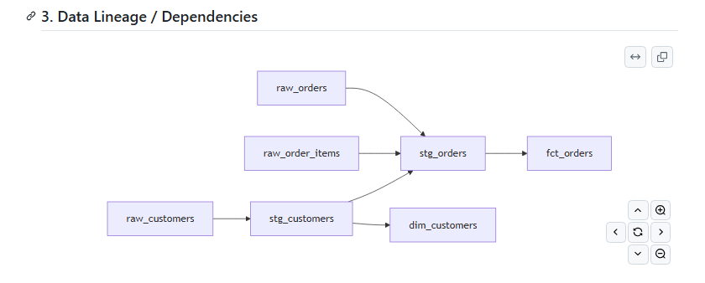
3c. Lineage artifacts and generated dbt/Snowflake artifacts list
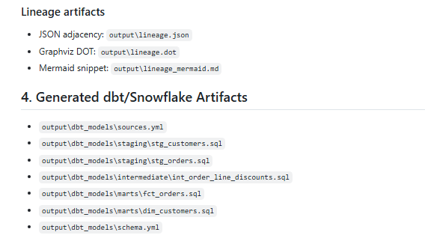
Screenshot 4 — validation_report.json, or the console PASS lines — shows the PASS status and the three metrics
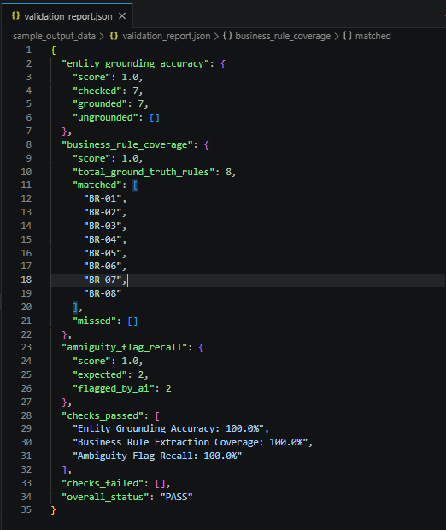
Screenshot 5 — Interactive human-in-the-loop checkpoint (a/e/r prompt)
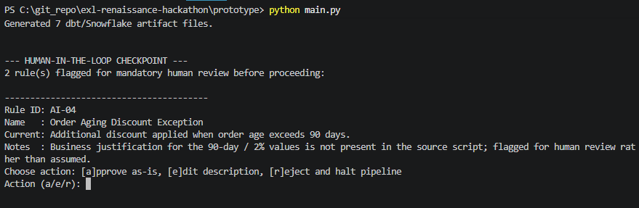

— End of Appendix B —

