## Reports Menu/HIPAA/DesignatedRecordSetReport:

Request:

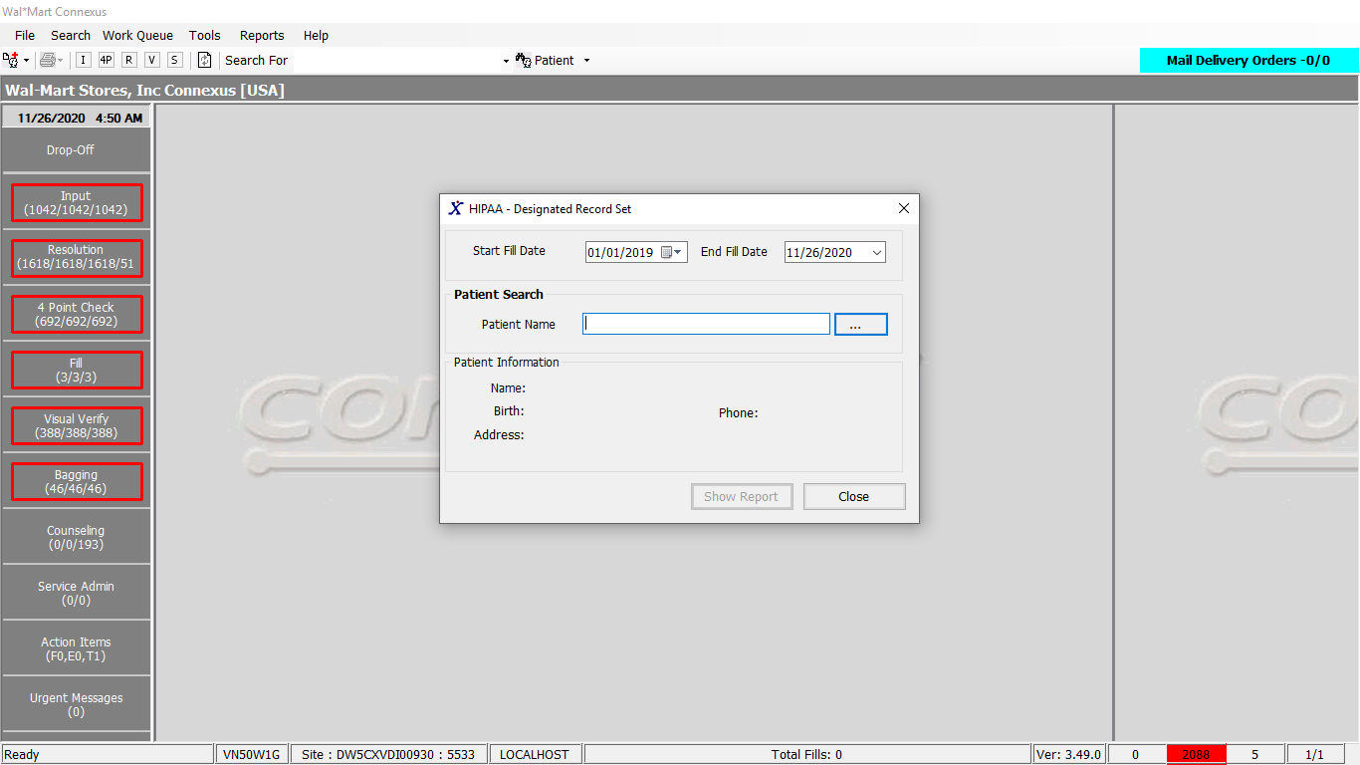

Response:

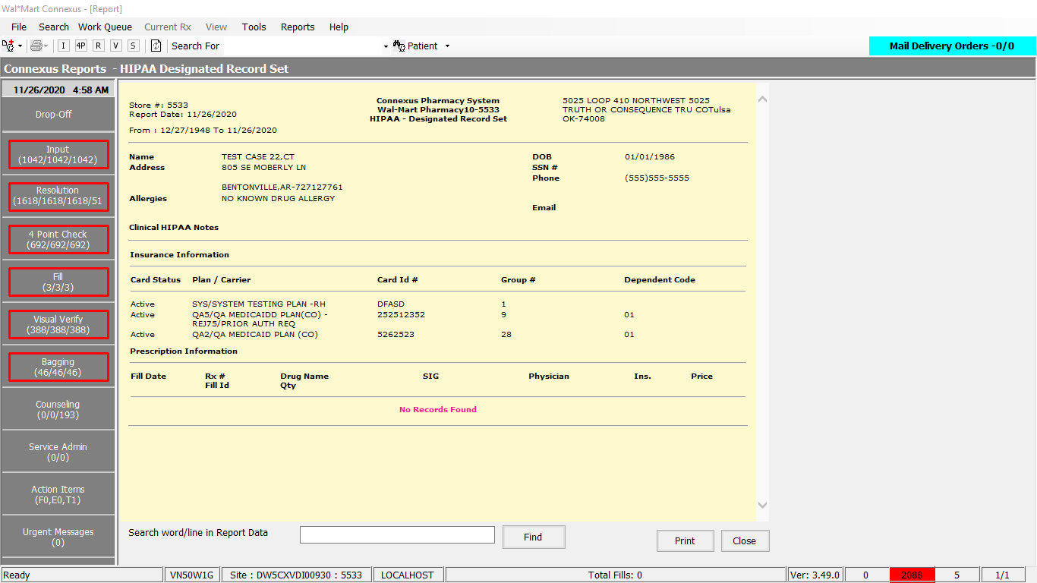

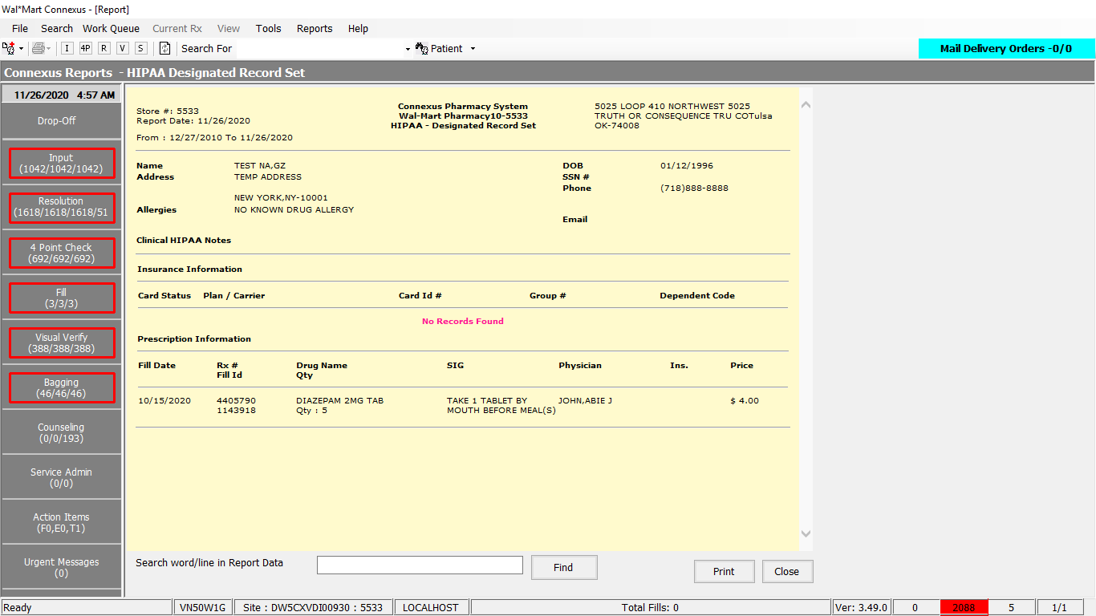

Queries:

Friend Const GetHIPAADesignatedRecordSelect4 As String = "select rx.rx_id , rx.rx_nbr,rx.rx_written_date,rx.compound_ind, case when rx.compound_ind = 'N' then pp.short_name else co.compound_name end DrugName, rf.rx_fill_id ,rf.fill_date, rx.fill_qty prescribedqty, case when rf.fill_type_code=7000 then rf.fill_qty when rf.fill_type_code = 7002 then (select fill_qty from rx_fill where rx_fill_id=(select orig_rx_fill_id from partial_fill where init_partl_fill_id=rx.last_rx_fill_id)) when rf.fill_type_code = 7003 then (select fill_qty from rx_fill where rx_fill_id = (select orig_rx_fill_id from partial_fill where fnl_partl_fill_id=rx.last_rx_fill_id))end fill_qty, rx.expanded_sig_txt,rf.patient_due_amt,rf.pos_due_amt,pi.ndc_nbr, trim(nvl(pres.last_name,'')) || ',' || trim(nvl(pres.first_name,'')) || ' ' || trim(nvl(pres.middle_name,'')) PrescriberName, rx.refill_auth_code, phm.phm_co_name_abbr, phm.phm_co_name, rf.pos_sale_amt,rf.status_code FillStatusCode, rx.status_code RxStatusCode, pgx.gpi_code gpi_code From rx rx,rx_fill rf, rx_fill_item rfi, patient pat,prescriber pres, pharmacy_offering:pharmacy_product pp,pharmacy_offering:pharmacy_item pi, outer (rx_compound rxc , compound co), outer (rx_sale_detail rsd, phm_company phm), outer rx_transfer rxt , outer pharmacy_offering:product_gpi_xref pgx Where rx.patient_id = pat.patient_id and rx.prescriber_id = pres.prescriber_id AND rx.rx_id = rf.rx_id and rf.rx_fill_id = rfi.rx_fill_id AND rx.rx_id = rxt.rx_id AND rx.rx_version_seq_nbr = rxt.rx_version_seq_nbr And rxt.xfer_in_ind = 'Y' AND rfi.item_mds_fam_id = pi.mds_fam_id AND pi.product_mds_fam_id =pp.product_mds_fam_id AND rx.rx_id = rxc.rx_id AND rxc.compound_id = co.compound_id AND rsd.rx_fill_id = rf.rx_fill_id AND rsd.aff_party_id=phm.phm_co_id AND rsd.aff_prty_type_code=1201 and rsd.txn_type_code = 21400 and rf.fill_type_code in (7000, 7002, 7003) AND pat.patient_id = ? and rx.rx_nbr is not null and rx.status_code <> 20600 and rfi.item_seq_nbr=1 and rf.status_code = 20401 and rf.fill_date >= ? and rf.fill_date <= ? and pi.product_mds_fam_id = pgx.product_mds_fam_id "

Public Const GetBuPhmParm As String = _

"SELECT DISTINCT bpp.phm_bu_id, bpp.phm_parm_code, bpp.phm_parm_value " & _

" FROM bu_phm_parm bpp, pharmacy_bu pb " & _

" WHERE bpp.phm_bu_id = pb.phm_bu_id " & _

" AND bpp.phm_parm_code = ? "

Friend Const GetHIPAAAccountDisclosureSelect1 As String = "SELECT patient_id, last_name, first_name, middle_name, gender_code, birth_date, pri_prescriber_id, snap_cap_rqst_date, patient_label_name, pref_language_code, relt_patient_id, relt_last_name, relt_first_name, relt_middle_name, address_line_1, address_line_2, city_name, state_prov_code, postal_code, country_code, ssn, drivers_license, dl_state_code, HomePhone, WorkPhone, Email,comment_text, alt_packaging, ar_account, presc_first_name, presc_middle_name, presc_last_name, pri_clinic_id, charge_freq_code, mail_out_freq_code, patient_DAW, print_HL, dflt_addr_type_cd, hipaa_status_code FROM v_Patient WHERE patient_id = ?"

Public Const GetRestrictionByRxId As String = "SELECT rx_id,expiration_ts,effective_ts FROM rx_restrict WHERE rx_id=? AND restrict_type_code=?"

Friend Const GetHIPAADesignatedRecordSelect2 As String = "SELECT ac.allergen_cls_desc FROM pharmacy_offering:allergen_class_txt ac, patient_allergy pa WHERE pa.allerg_class_code = ac.allerg_class_code AND pa.effective_ts in ( SELECT MAX(pa2.effective_ts) FROM patient_allergy pa2 WHERE pa2.patient_id = pa.patient_id AND pa2.allerg_class_code=pa.allerg_class_code) AND pa.patient_id = ?"

Friend Const QueryTPInfoSelectForBilling As String = "SELECT C.phm_co_name, C.phm_co_name_abbr ," &

" PLAN.ins_plan_ref_code, PLAN.ins_carr_plan_name," &

" ICP.cardholder_id," &

" NVL(ICP.dependent_code, ICP.participant_nbr) dependent_code, ICP.billing_seq_nbr," &

" TXT.relationship_desc code_desc, icp.carrier_co_id, " &

" icp.ins_carr_plan_id, icp.coverage_ind," &

" ic.coverage_exp_date,ICP.bill_grp_seq_nbr, ICP.relationship_code, split_bill_ind, " &

" icp.expiration_date , NVL(ic.ins_plan_type_code,1006) ins_plan_type_code, NVL(pt.ins_plan_type_desc,'COMMERCIAL') ins_plan_type_desc, " &

" comment.comment_text, " &

" PCP.bin_nbr, PCP.processor_ctrl_nbr, ICP.last_change_ts " &

" FROM ins_card_particpnt ICP," &

" insurance_card IC, phm_company C, ins_carrier_plan PLAN," &

" OUTER relationship_text TXT , " &

" OUTER comment_line comment , OUTER ins_plan_type_txt pt ,OUTER phm_carr_processor PCP " &

" WHERE ICP.carrier_co_id = C.phm_co_id" &

" AND ICP.carrier_co_id = PLAN.carrier_co_id" &

" AND ICP.ins_carr_plan_id = PLAN.ins_carr_plan_id" &

" AND ICP.relationship_code = TXT.relationship_code" &

" AND ICP.patient_id = ?" &

" AND ICP.carrier_co_id=IC.carrier_co_id " &

" AND ICP.ins_carr_plan_id=IC.ins_carr_plan_id" &

" AND ICP.cardholder_id = IC.cardholder_id " &

" AND ICP.comment_id = comment.comment_id " &

" AND pt.ins_plan_type_code = ic.ins_plan_type_code " &

" AND pcp.carrier_co_id=ICP.carrier_co_id AND pcp.ins_carr_plan_id=ICP.ins_carr_plan_id " &

" AND (PLAN.carrier_co_id || PLAN.ins_carr_plan_id) not in (select (cvr.carrier_co_id || cvr.ins_carr_plan_id) " &

" FROM covg_opt_restrict cvr " &

" WHERE cvr.restriction_type = " & ConnexusCommonConstants.strCONFlagCode &

" AND cvr.restriction_nbr = '" & ConnexusCommonConstants.CONFlagType & "' " &

" AND cvr.ins_carr_plan_id=PLAN.ins_carr_plan_id " &

" AND cvr.carrier_co_id =PLAN.carrier_co_id)"

Friend Const GetCommentInfo As String = "SELECT pc.comment_id FROM patient_comment pc, comment c WHERE pc.comment_id=c.comment_id " &

"AND pc.patient_id = (?) AND c.comment_subj_code NOT IN (?) "

Friend Const GetNotes2Select As String = "SELECT c.comment_id FROM patient_comment pc, comment c " &

" WHERE pc.patient_id = ? AND c.comment_type_code = ? AND c.comment_subj_code = ? " &

" AND c.comment_id = pc.comment_id ORDER BY c.comment_id DESC "

DAL:

Public Function GetPatientRxAndFillInfo(ByVal siteId As Integer, ByVal patientId As Integer,

ByVal startFillDate As Date, ByVal endFillDate As Date,

Optional ByVal cashPayInd As Boolean = False) _

As List(Of RxBE) Implements IHIPAADAL.GetPatientRxAndFillInfo

Dim querySQL As New StringBuilder

'HIPAA Changes to handle cash pay restriction - Added

Dim cashPayFlag As Boolean = CacheWrapperDal.GetCashPayRestrictionFlag(siteId)

querySQL.Append(HipaaQueries.GetHIPAADesignatedRecordSelect4)

'HIPAA Changes to handle cash pay restriction - Start

If cashPayFlag AndAlso Not cashPayInd Then

querySQL.Append(" AND rx.rx_id NOT IN (SELECT rx_id FROM rx_restrict WHERE expiration_ts IS NULL AND restrict_type_code=400) ")

End If

querySQL.Append(" order by rx.rx_id, rf.rx_fill_id , rf.fill_date ")

'HIPAA Changes to handle cash pay restriction - End

Dim paramList As New List(Of DbParameter)

paramList.AddParameter(DbType.Int32, patientId, "PatientId")

paramList.AddParameter(DbType.Date, startFillDate, "FillDate1")

paramList.AddParameter(DbType.Date, endFillDate, "FillDate2")

Dim rxInfoList As New List(Of RxBE)

Dim rxInfo As RxBE = Nothing

Dim rxFillInfo As RxFillBE = Nothing

Dim pharmacyItemInfo As PharmacyItemBE = Nothing

Dim rxSaleDetail As RxSaleDetailBE

Using dr As IDataReader = ExecuteReader(DatabaseEnum.rx21c, siteId, querySQL.ToString(), paramList)

While dr.Read

rxInfo = New RxBE

rxFillInfo = New RxFillBE

pharmacyItemInfo = New PharmacyItemBE

rxSaleDetail = New RxSaleDetailBE

rxInfo.RxId = dr.GetValueOrDefault(Of Int32)("rx_Id")

rxInfo.RxNbr = dr.GetValueOrDefault(Of Int32?)("rx_nbr")

rxInfo.RxWrittenDate = dr.GetValueOrDefault(Of DateTime?)("rx_written_date")

rxInfo.CompoundIndicator = dr.GetValueOrDefault(Of String)("compound_ind").SafeTrim()

rxInfo.CompoundName = dr.GetValueOrDefault(Of String)("DrugName").SafeTrim()

rxFillInfo.RxFillId = dr.GetValueOrDefault(Of Int32)("rx_fill_Id")

rxFillInfo.RxFillDate = dr.GetValueOrDefault(Of DateTime?)("fill_date")

rxInfo.PrescribedQuantity = dr.GetValueOrDefault(Of Decimal?)("prescribedQty")

rxInfo.FillQuantity = dr.GetValueOrDefault(Of Decimal)("fill_qty")

rxInfo.ExpandedSignatureText = dr.GetValueOrDefault(Of String)("expanded_sig_txt").SafeTrim()

rxFillInfo.PatientDueAmount = dr.GetValueOrDefault(Of Decimal?)("patient_due_amt")

rxFillInfo.PosDueAmount = dr.GetValueOrDefault(Of Decimal?)("pos_due_amt")

pharmacyItemInfo.NdcNbr = dr.GetValueOrDefault(Of String)("ndc_nbr").SafeTrim()

'HIPAA Personal Representatives Phase 2 project changes - Start

'Get the GPI code

pharmacyItemInfo.GPICode = dr.GetValueOrDefault(Of String)("gpi_code").SafeTrim()

'HIPAA Personal Representatives Phase 2 project changes - End

rxInfo.PrescriberName = dr.GetValueOrDefault(Of String)("PrescriberName").SafeTrim()

rxInfo.RefillAuthorizationCode = dr.GetValueOrDefault(Of Int16?)("refill_auth_code")

rxSaleDetail.PhmCompanyNameAbbreviation = dr.GetValueOrDefault(Of String)("phm_co_name_abbr").SafeTrim()

rxSaleDetail.PhmCompanyName = dr.GetValueOrDefault(Of String)("phm_co_name").SafeTrim()

rxFillInfo.PosSaleAmount = dr.GetValueOrDefault(Of Decimal?)("pos_sale_amt")

rxFillInfo.StatusCode = dr.GetValueOrDefault(Of Int16)("FillStatusCode")

rxInfo.StatusCode = dr.GetValueOrDefault(Of Int16)("RxStatusCode")

rxFillInfo.RxSaleDetail = rxSaleDetail

rxInfo.RxFill = rxFillInfo

rxInfo.PharmacyItem = pharmacyItemInfo

rxInfoList.Add(rxInfo)

End While

Return rxInfoList

End Using

End Function

Public Shared Function GetCashPayRestrictionFlag(ByVal siteId As Integer) As Boolean

Dim cprFlag As Boolean = False

If ConnexusCacheManager.Contains(CacheKeys.CashPayRestriction.ToString) Then

cprFlag = Convert.ToBoolean(ConnexusCacheManager(CacheKeys.CashPayRestriction.ToString))

Else

Dim cprFlagValue = LocalSiteDal.GetBUPhmParm(siteId, ConnexusCommonConstants.CashPayRestrictionFlag)

If Not String.IsNullOrEmpty(cprFlagValue) Then _

cprFlag = cprFlagValue.ToUpper.Equals("TRUE")

ConnexusCacheManager.Add(CacheKeys.CashPayRestriction.ToString, cprFlag, CacheHelper.GetExpirationPolicy("CacheKeys.CashPayRestriction.ToString"))

End If

Return cprFlag

End Function

Public Shared ReadOnly Property GetBUPhmParm(ByVal siteId As Integer, ByVal buPhmParmCode As Integer) As String

Get

Using (New Tracer(ConnexusCommonConstants.ConnexusTracer))

Dim buPhmParm As BuPhmParmInfoBE = Nothing

Dim phmParmValue As String = String.Empty

'Check if data already available in CnxCache

Dim buPhmParmsInfo = From buParm In GetBuPhmParms(siteId).RemoveNulls()

Where buParm.PhmParmCode = buPhmParmCode

Select buParm

If (buPhmParmsInfo.HasRecords()) Then

buPhmParm = buPhmParmsInfo.FirstOrDefault()

Else

'Else get Bu Phm Parm data from the DB

Dim parmList As New List(Of DbParameter)

parmList.AddParameter(DbType.Int32, buPhmParmCode)

Using dr As IDataReader = ExecuteReader(DatabaseEnum.rx21c, siteId, BaseQueries.GetBuPhmParm, parmList)

If dr.Read() Then

buPhmParm = New BuPhmParmInfoBE()

buPhmParm.PhmBUId = dr.GetValueOrDefault(Of Integer)("phm_bu_id")

buPhmParm.PhmParmCode = dr.GetValueOrDefault(Of Short)("phm_parm_code")

buPhmParm.PhmParmValue = dr.GetValueOrDefault(Of String)("phm_parm_value").SafeTrim()

End If

If (buPhmParm IsNot Nothing) Then

GetBuPhmParms(siteId).Add(buPhmParm)

End If

End Using

End If

If (buPhmParm IsNot Nothing) Then

phmParmValue = buPhmParm.PhmParmValue

End If

Return phmParmValue.SafeTrim

End Using

End

End Property

Public Function GetBasicPatientInfoForHipaa(ByVal siteId As Integer,

ByVal patientId As Integer) As PatGeneralInfoBE Implements IHIPAADAL.GetBasicPatientInfoForHipaa

Dim paramList As New List(Of DbParameter)

paramList.AddParameter(DbType.Int32, patientId)

Dim patGenInfoBE As PatGeneralInfoBE = Nothing

Using dr As IDataReader = ExecuteReader(DatabaseEnum.rx21c, siteId, HipaaQueries.GetHIPAAAccountDisclosureSelect1, paramList)

If dr.Read Then

patGenInfoBE = New PatGeneralInfoBE

Dim personalInfo As New PersonalInfoBE

Dim contactInfo As New ContactInfoBE

Dim primaryPrescInfo As New PrimaryPrescInfoBE

Dim miscPersonalInfo As New MiscPersonalInfoBE

Dim otherInfo As New OtherInfoBE

Dim hipaaInfo As New Entities.Patient.HipaaInfoBE

Dim relatedPatientInfo As New RelatedPatientBE

personalInfo.LastName = dr.GetValueOrDefault(Of String)("last_name").SafeTrim()

personalInfo.FirstName = dr.GetValueOrDefault(Of String)("first_name").SafeTrim()

personalInfo.MiddleName = dr.GetValueOrDefault(Of String)("mIddle_name").SafeTrim()

personalInfo.Gender = dr.GetValueOrDefault(Of String)("gender_code").SafeTrim()

personalInfo.Dob = dr.GetValueOrDefault(Of DateTime)("birth_date")

primaryPrescInfo.PrescriberId = dr.GetValueOrDefault(Of Int32)("pri_prescriber_Id")

miscPersonalInfo.SnapCapRequestDate = dr.GetValueOrDefault(Of DateTime)("snap_cap_rqst_date")

patGenInfoBE.PatientLabelName = dr.GetValueOrDefault(Of String)("patient_label_name").SafeTrim()

personalInfo.Language = dr.GetValueOrDefault(Of String)("pref_language_code").SafeTrim()

relatedPatientInfo.PatientId = dr.GetValueOrDefault(Of Int32)("relt_patient_Id")

relatedPatientInfo.LastName = dr.GetValueOrDefault(Of String)("relt_last_name").SafeTrim()

relatedPatientInfo.FirstName = dr.GetValueOrDefault(Of String)("relt_first_name").SafeTrim()

relatedPatientInfo.MiddleName = dr.GetValueOrDefault(Of String)("relt_mIddle_name").SafeTrim()

contactInfo.AddressLine1 = dr.GetValueOrDefault(Of String)("address_line_1").SafeTrim()

contactInfo.AddressLine2 = dr.GetValueOrDefault(Of String)("address_line_2").SafeTrim()

contactInfo.City = dr.GetValueOrDefault(Of String)("city_name").SafeTrim()

contactInfo.State = dr.GetValueOrDefault(Of String)("state_prov_code").SafeTrim()

contactInfo.ZipCode = dr.GetValueOrDefault(Of String)("postal_code").SafeTrim()

contactInfo.Country = dr.GetValueOrDefault(Of String)("country_code").SafeTrim()

miscPersonalInfo.Ssn = dr.GetValueOrDefault(Of String)("ssn").SafeTrim()

miscPersonalInfo.DriversLicense = dr.GetValueOrDefault(Of String)("drivers_license").SafeTrim()

miscPersonalInfo.DriversLicenseState = dr.GetValueOrDefault(Of Int32)("dl_state_code")

contactInfo.HomePhone = dr.GetValueOrDefault(Of String)("HomePhone").SafeTrim()

contactInfo.WorkPhone = dr.GetValueOrDefault(Of String)("WorkPhone").SafeTrim()

contactInfo.EmailAddress = dr.GetValueOrDefault(Of String)("Email").SafeTrim()

otherInfo.CommentText = dr.GetValueOrDefault(Of String)("comment_text").SafeTrim()

patGenInfoBE.AltPackaging = dr.GetValueOrDefault(Of String)("alt_packaging").SafeTrim()

patGenInfoBE.ARAccount = dr.GetValueOrDefault(Of String)("ar_account").SafeTrim()

primaryPrescInfo.FirstName = dr.GetValueOrDefault(Of String)("presc_first_name").SafeTrim()

primaryPrescInfo.MiddleName = dr.GetValueOrDefault(Of String)("presc_mIddle_name").SafeTrim()

primaryPrescInfo.LastName = dr.GetValueOrDefault(Of String)("presc_last_name").SafeTrim()

patGenInfoBE.ClinicId = dr.GetValueOrDefault(Of Int32)("pri_clinic_Id")

otherInfo.ChargeCode = dr.GetValueOrDefault(Of Int16)("charge_freq_code")

otherInfo.MailOutCode = dr.GetValueOrDefault(Of Int16)("mail_out_freq_code")

patGenInfoBE.Daw = dr.GetValueOrDefault(Of String)("patient_DAW").SafeTrim()

patGenInfoBE.PrintHL = dr.GetValueOrDefault(Of String)("print_HL").SafeTrim()

patGenInfoBE.DefaultAddressType = dr.GetValueOrDefault(Of Int16)("dflt_addr_type_cd")

hipaaInfo.HipaaStatusCode = dr.GetValueOrDefault(Of Int16)("hipaa_status_code")

personalInfo.ContactInformation = contactInfo

patGenInfoBE.PrimaryPrescriberInformation = primaryPrescInfo

patGenInfoBE.PersonalInfo = personalInfo

patGenInfoBE.RelatedPatient = relatedPatientInfo

patGenInfoBE.OtherInformation = otherInfo

patGenInfoBE.MiscPersonalInformation = miscPersonalInfo

patGenInfoBE.HipaaInformation = hipaaInfo

End If

End Using

Return patGenInfoBE

End Function

Public Function GetCashPayRxStatus(ByVal siteId As Integer, Optional ByVal rxId As Integer = 0,

Optional ByVal patientId As Integer = 0, Optional ByVal productId As String = "", Optional ByVal isCompound As Boolean = False) _

As Dictionary(Of Integer, String) Implements IPrescriptionDAL.GetCashPayRxStatus

Using (New Tracer(ConnexusCommonConstants.ConnexusTracer))

Dim paramList As New List(Of DbParameter)

Dim cashPayInd As New Dictionary(Of Integer, String)

'Check the restriction for the Rx.

If rxId > 0 AndAlso patientId <= 0 Then

paramList.AddParameter(DbType.Int32, rxId)

'Restriction Type Code

paramList.AddParameter(DbType.Int32, RestrictCodes.CashPayRestriction)

Using reader As IDataReader = ExecuteReader(DatabaseEnum.rx21c, siteId,

PrescriptionQueries.GetRestrictionByRxId, paramList)

While reader.Read()

Dim exp_ts As DateTime = reader.GetValueOrDefault(Of DateTime)("expiration_ts")

If exp_ts <> CDate(Nothing) Then

cashPayInd.Add(reader.GetValueOrDefault(Of Int32)("rx_id"), exp_ts.ToString())

Else

cashPayInd.Add(reader.GetValueOrDefault(Of Int32)("rx_id"), Nothing)

End If

End While

End Using

'Check if the patient has any restrictions for the CompoundId.

ElseIf patientId > 0 AndAlso isCompound Then

paramList.AddParameter(DbType.Int32, patientId)

paramList.AddParameter(DbType.String, productId)

Using reader As IDataReader = ExecuteReader(DatabaseEnum.rx21c, siteId,

PrescriptionQueries.GetRestrictionByCompoundId, paramList)

While reader.Read()

Dim exp_ts As DateTime = reader.GetValueOrDefault(Of DateTime)("expiration_ts")

If exp_ts <> CDate(Nothing) Then

cashPayInd.Add(reader.GetValueOrDefault(Of Int32)("rx_id"), exp_ts.ToString())

Else

cashPayInd.Add(reader.GetValueOrDefault(Of Int32)("rx_id"), Nothing)

End If

End While

End Using

'Check if the patient has any restrictions for the product.

ElseIf patientId > 0 AndAlso (Not productId Is Nothing AndAlso productId <> String.Empty) AndAlso rxId <= 0 Then

paramList.AddParameter(DbType.String, productId)

paramList.AddParameter(DbType.Int32, patientId)

Using reader As IDataReader = ExecuteReader(DatabaseEnum.rx21c, siteId,

PrescriptionQueries.GetRestrictionByPatientId, paramList)

While reader.Read()

Dim exp_ts As DateTime = reader.GetValueOrDefault(Of DateTime)("expiration_ts")

If exp_ts <> CDate(Nothing) Then

cashPayInd.Add(reader.GetValueOrDefault(Of Int32)("rx_id"), exp_ts.ToString())

Else

cashPayInd.Add(reader.GetValueOrDefault(Of Int32)("rx_id"), Nothing)

End If

End While

End Using

'Check if the patient has any restrictions at all.

ElseIf patientId > 0 AndAlso (productId Is Nothing OrElse productId = String.Empty) AndAlso rxId <= 0 Then

paramList.AddParameter(DbType.Int32, patientId)

Using reader As IDataReader = ExecuteReader(DatabaseEnum.rx21c, siteId,

PrescriptionQueries.GetRestrictionIndForReports, paramList)

While reader.Read()

Dim exp_ts As DateTime = reader.GetValueOrDefault(Of DateTime)("expiration_ts")

If exp_ts <> CDate(Nothing) Then

cashPayInd.Add(reader.GetValueOrDefault(Of Int32)("rx_id"), exp_ts.ToString())

Else

cashPayInd.Add(reader.GetValueOrDefault(Of Int32)("rx_id"), Nothing)

End If

End While

End Using

'This condition is to get similar prescriptions of the current rx

ElseIf rxId > 0 AndAlso patientId > 0 AndAlso (Not productId Is Nothing AndAlso productId <> String.Empty) Then

paramList.AddParameter(DbType.String, productId)

paramList.AddParameter(DbType.Int32, patientId)

paramList.AddParameter(DbType.Int32, rxId)

Dim rxQuery As New StringBuilder

rxQuery.Append(PrescriptionQueries.GetRestrictionByPatientId)

rxQuery.Append(" AND res.rx_id <> ? ")

Using reader As IDataReader = ExecuteReader(DatabaseEnum.rx21c, siteId,

rxQuery.ToString(), paramList)

While reader.Read()

Dim exp_ts As DateTime = reader.GetValueOrDefault(Of DateTime)("expiration_ts")

If exp_ts <> CDate(Nothing) Then

cashPayInd.Add(reader.GetValueOrDefault(Of Int32)("rx_id"), exp_ts.ToString())

Else

cashPayInd.Add(reader.GetValueOrDefault(Of Int32)("rx_id"), Nothing)

End If

End While

End Using

End If

Return cashPayInd

End Using

End Function

Public Function GetAllergyClassDescription(ByVal siteId As Integer,

ByVal patientId As Integer) As List(Of String) Implements IHIPAADAL.GetAllergyClassDescription

Dim paramList As New List(Of DbParameter)

Dim allergenClassDescription As New List(Of String)

paramList.AddParameter(DbType.Int32, patientId, "PatientId")

Using dr As IDataReader = ExecuteReader(DatabaseEnum.rx21c, siteId, HipaaQueries.GetHIPAADesignatedRecordSelect2, paramList)

While dr.Read

allergenClassDescription.Add(dr.GetValueOrDefault(Of String)("allergen_cls_desc").SafeTrim())

End While

End Using

If Not allergenClassDescription.Count = 0 Then

Return allergenClassDescription

Else

Return Nothing

End If

End Function

--------------------------

Public Function QueryTPInfo(ByVal siteId As Integer, ByVal patientId As Integer,

Optional ByVal hasExpiredPlans As Boolean = False, Optional ByVal billingFlag As Boolean = False, Optional ByVal ShowAllPlans As Boolean = False) _

As List(Of PrimaryThirdPartyInfoBE) Implements IPatientDAL.QueryTPInfo

Using tracer As New Tracer(ConnexusCommonConstants.ConnexusTracer)

Dim paramList As New List(Of DbParameter)

Dim querySQL As String

'Billing Project change : start | a0syed | 08/28/2012

Dim isBillingEnabled As Boolean = CacheWrapperDal.GetBillingFlag(siteId)

querySQL = PatientQueries.QueryTPInfoSelectForBilling

If isBillingEnabled AndAlso (Not ShowAllPlans) Then

querySQL = querySQL & " AND ICP.Coverage_Ind = 'Y'"

End If

If billingFlag Then

UpdatePlanTypeFromGPH(siteId, patientId)

End If

'End Billing Change

If hasExpiredPlans Then

querySQL = querySQL & " AND (PLAN.carr_plan_exp_date IS NULL OR PLAN.carr_plan_exp_date > CURRENT - 180 UNITS DAY)"

End If

querySQL = querySQL & " ORDER BY ICP.billing_seq_nbr"

paramList.AddParameter(DbType.Int32, patientId)

Dim primTPInfoList As New List(Of PrimaryThirdPartyInfoBE)

Using dr As IDataReader = ExecuteReader(DatabaseEnum.rx21c, siteId, querySQL, paramList)

Dim primaryTPInfoBE As PrimaryThirdPartyInfoBE = Nothing

While (dr.Read)

primaryTPInfoBE = New PrimaryThirdPartyInfoBE

Dim IcpInfoBE As New IcpInfoBE

primaryTPInfoBE.PhmCompanyName = dr.GetValueOrDefault(Of String)("phm_co_name").SafeTrim()

primaryTPInfoBE.PhmCompanyNameAbbreviation = dr.GetValueOrDefault(Of String)("phm_co_name_abbr").SafeTrim()

IcpInfoBE.PlanId = dr.GetValueOrDefault(Of Int32)("ins_carr_plan_id")

primaryTPInfoBE.PlanReferenceCode = dr.GetValueOrDefault(Of String)("ins_plan_ref_code").SafeTrim()

primaryTPInfoBE.PlanName = dr.GetValueOrDefault(Of String)("ins_carr_plan_name").SafeTrim()

IcpInfoBE.CardHolderId = dr.GetValueOrDefault(Of String)("cardholder_id").SafeTrim()

primaryTPInfoBE.DependentCode = dr.GetValueOrDefault(Of String)("dependent_code").SafeTrim()

primaryTPInfoBE.RelationshipCode = dr.GetValueOrDefault(Of Int16)("relationship_code")

primaryTPInfoBE.RelationshipDescription = dr.GetValueOrDefault(Of String)("code_desc").SafeTrim()

primaryTPInfoBE.CoverageIndicator = dr.GetValueOrDefault(Of String)("coverage_ind").SafeTrim()

primaryTPInfoBE.SplitBillIndicator = dr.GetValueOrDefault(Of String)("split_bill_ind").SafeTrim()

primaryTPInfoBE.CoverageExpiryDate = dr.GetValueOrDefault(Of Date?)("coverage_exp_date")

primaryTPInfoBE.BillingSequenceNbr = dr.GetValueOrDefault(Of Int16)("billing_seq_nbr")

primaryTPInfoBE.BillGroupSequenceNbr = dr.GetValueOrDefault(Of Int16?)("bill_grp_seq_nbr")

IcpInfoBE.CarrierCompanyId = dr.GetValueOrDefault(Of Int32)("carrier_co_id")

' Billing project changes start 08/09/2012 a0syed

'retriving expiration date , comment text and plan type code from data reader

primaryTPInfoBE.ExpirationDate = dr.GetValueOrDefault(Of Date?)("expiration_date")

primaryTPInfoBE.CommentText = dr.GetValueOrDefault(Of String)("comment_text").SafeTrim()

primaryTPInfoBE.PlanTypeCode = dr.GetValueOrDefault(Of Integer?)("ins_plan_type_code")

primaryTPInfoBE.PlanTypeDesc = dr.GetValueOrDefault(Of String)("ins_plan_type_desc").SafeTrim()

'PIBS changes to get BIN and PCN for a plan-start

primaryTPInfoBE.BIN = dr.GetValueOrDefault(Of Int32?)("bin_nbr")

primaryTPInfoBE.PCN = dr.GetValueOrDefault(Of String)("processor_ctrl_nbr").SafeTrim()

'PIBS changes to get BIN and PCN for a plan-End

'Billing project changes End

IcpInfoBE.LastChangeDate = dr.GetValueOrDefault(Of Date?)("last_change_ts")

primaryTPInfoBE.IcpInfo = IcpInfoBE

primTPInfoList.Add(primaryTPInfoBE)

End While

End Using

Return primTPInfoList

End Using

End Function

Public Function GetNotes2(ByVal siteId As Integer, ByVal patientId As Integer,

ByVal patientNotesType As Short, Optional ByVal excludeHipaaComment As Boolean = False) As List(Of Integer) Implements IPatientDAL.GetNotes2

Using tracer As New Tracer(ConnexusCommonConstants.ConnexusTracer)

Dim commentIdList As New List(Of Integer)

If patientNotesType > 0 Then

Dim querySQL As String

If excludeHipaaComment Then

querySQL = PatientQueries.GetCommentInfo

Else

querySQL = PatientQueries.GetNotes2Select

End If

Dim paramList As New List(Of DbParameter)

paramList.AddParameter(DbType.Int32, patientId)

If Not excludeHipaaComment Then

paramList.AddParameter(DbType.Int16, NoteType)

End If

paramList.AddParameter(DbType.Int16, patientNotesType)

Using dr As IDataReader = ExecuteReader(DatabaseEnum.rx21c, siteId, querySQL, paramList)

While dr.Read

commentIdList.Add(dr.GetValueOrDefault(Of Int32)("comment_id"))

End While

End Using

End If

Return commentIdList

End Using

End Function

''' <summary>