**A VIRTUAL INTERNSHIP REPORT ON**

**ARTIFICIAL INTELLIGENCE-MACHINE LEARNING**

**Submitted in partial fulfillment of requirements for the award of the degree of**

**BACHELOR OF TECHNOLOGY**

**IN**

# COMPUTER SCIENCE AND ENGINEERING

**Submitted by:**

**M. ANIL KUMAR 20091A0512**

**Under the Guidance of Mentor**

**Mr. P Naveen Sundar Kumar M.Tech**

**(Assistant Professor)**

**Designation, Dept. of CSE**



## DEPARTMENT OF COMPUTER SCIENCE AND ENGINEERING

**RAJEEV GANDHI MEMORIAL COLLEGE OF ENGINEERING & TECHNOLOGY**

### (AUTONOMOUS)

AFFILIATED TO J.N.T UNIVERSITY ANANTAPUR, ACCREDITED BY NBA (TIER-1) &

NAAC OF UGC, NEW DELHI, WITH A+ GRADE

RECOGNIZED UGC-DDU KAUSHAL KENDRA

NANDYAL – 518501 (ESTD -1995)

**ACADEMIC YEAR: 2023-2024**

**RAJEEV GANDHI MEMORIAL COLLEGE OF ENGINEERING & TECHNOLOGY**

### (AUTONOMOUS)

AFFILIATED TO J.N.T UNIVERSITY ANANTAPUR, ACCREDITED BY NBA (TIER-1) &

NAAC OF UGC, NEW DELHI, WITH A+ GRADE

RECOGNIZED UGC-DDU KAUSHAL KENDRA

NANDYAL - 518501

**DEPARTMENT OF COMPUTER SCIENCE AND ENGINEERING**

**(ESTD – 1995)**

## CERTIFICATE

This is to certify that the report on “**AI-ML Virtual Internship**” is a bonafide work of following IV B. Tech- I Sem. student in the **Department of Computer Science and Engineering**, **Rajeev Gandhi Memorial College of Engineering and Technology (Autonomous)**, Nandyal, Affiliated to JNTU, Anantapur, during the academic year **2023-2024**, in fulfillment of the requirement for the award of the degree of **Bachelor of Technology** of this university.



**Student Regd. No. Student Name**

**20091A0512 M. ANIL KUMAR**

**Mentor Head of the Department**

### Dr. K. Subba Reddy M.Tech, Ph.D.

**Mr. P Naveen Sundar Kumar M.Tech**

**(Assistant Professor).**

**Assistant Professor, Dept. of CSE Professor, Dept. of CSE**

### Coordinator

### 

**Dr. M. Sravan Kumar Reddy M.Tech, Ph.D.**

**Associate Professor, Dept. of CSE**

**RAJEEV GANDHI MEMORIAL COLLEGE OF ENGINEERING & TECHNOLOGY**

#### (AUTONOMOUS)

AFFILIATED TO J.N.T UNIVERSITY ANANTAPUR, ACCREDITED BY NBA (TIER-1) &

NAAC OF UGC, NEW DELHI, WITH A+ GRADE

RECOGNIZED UGC-DDU KAUSHAL KENDRA

NANDYAL - 518501

**(ESTD – 1995)**



**Internship on AWS Cloud**

Name of the Student : M ANIL KUMAR

Regd. Number : 20091A0512

Department : CSE

Program : B.Tech

Regulation : R20

Year & Semester : IV B. Tech - I Semester

Duration : 19/12/2022 – 25/02/2023

Domain : AI-ML

Supported by : AWS Academy

Type of Internship : Free

**Signature of the Student** **HCSE**

## ACKNOWLEDGEMENT

I take the opportunity to thank one and all who have helped in making the internship possible. We are thankful to **Rajeev Gandhi Memorial College of Engineering & Technology (autonomous)**, for giving us the opportunity to work on an internship as part of the curriculum.

My sincere thanks to my mentor **Dr. M. Sravan Kumar Reddy**, Associate Professor in Department of Computer Science Engineering for his simulating guidance and assistance from the beginning of the internship.

I am very much thankful to the Head of our Computer Science & Engineering Department

**Dr. K. Subba Reddy** for his help and encouragement and for providing the lab facility to

complete the internship work.

My sincere thanks to our beloved principal **Dr. T. Jaya Chandra Prasad,**for providing

the best faculty and lab facility throughout these academic years.

Finally, I am thankful to my entire faculty and lab technicians for their good wishes and

constructive criticism, which led to the successful completion of the internship.

**BY**

**M.ANIL KUMAR (**20091A0512)

**Vision of RGMCET:**

* To develop this rural based engineering college into an institute of technical education with global standards
* To become an institute of excellence which contributes to the needs of society
* To inculcate value based education with noble goal of **“Education for peace and progress”**

**Mission of RGMCET:**

* To build a world class undergraduate program with all required infrastructure that provides strong theoretical knowledge supplemented by the state of art skills
* To establish postgraduate programs in basic and cutting edge technologies
* To create conductive ambiance to induce and nurture research
* To turn young graduates to success oriented entrepreneurs
* To develop linkage with industries to have strong industry institute interaction
* To offer demand driven courses to meet the needs of the industry and society
* To inculcate human values and ethos into the education system for an all-round development of students

**Vision of CSE Department:**

* To empower students with cutting edge technologies in computer science and engineering.
* To train the students as entrepreneurs in computer science and engineering to address the needs of the society.
* To develop smart applications to disseminate information to rural people.

**Mission of CSE Department:**

* To become the best computer science and engineering department in the region offering undergraduate, post graduate and research programs in collaboration with industry.
* To incubate, apply and spread innovative ideas by collaborating with relevant industries and R & D labs through focused research groups.
* To provide exposure to the students in the latest tools and technologies to develop smart applications for the society.

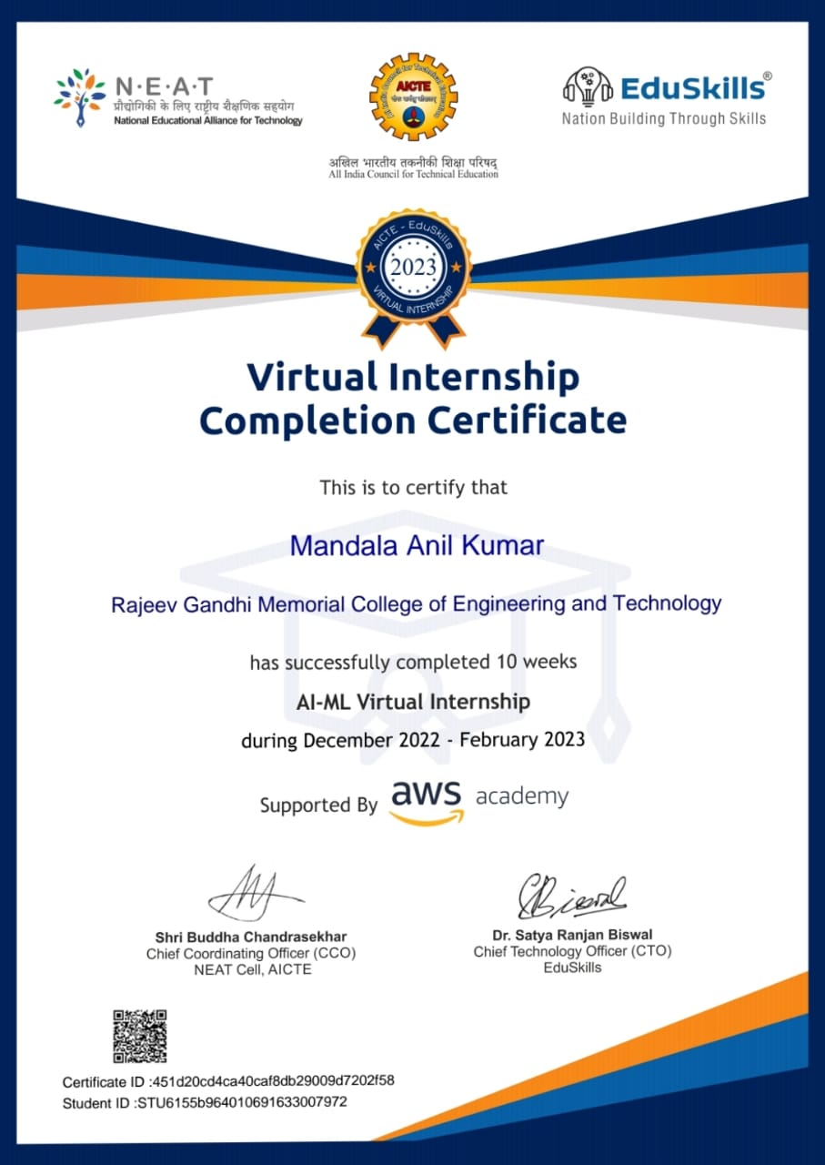INTERNSHIP CERTIFICATE

**CONTENTS**

### S. No. Content Page No

1. **Executive Summary**  1

1.1 AI-ML Virtual Internship

1. **Introduction**  2
   1. Introduction to Cloud Foundations
   2. Advantages of Cloud Foundations
   3. Limitations of Cloud Foundations
   4. Introduction to Amazon Web Services 6
   5. AWS Cloud Adoption Framework
   6. Introduction to Machine Learning
   7. Key concepts in AWS Machine Learning Foundations
2. **Overview of the Organisation** 8
3. **Internship**  8
   1. AI-ML Virtual Internship 9

**Activity log and weekly report**

* + 1. Activity log for first week
    2. Weekly report for first week
    3. Activity log for second week
    4. Weekly report for second week
    5. Activity log for third week
    6. Weekly report for third week
    7. Activity log for fourth week
    8. Weekly report for fourth week
    9. Activity log for fifth week
    10. Weekly report for fifth week
    11. Activity log for sixth week
    12. Weekly report for sixth week
    13. Activity log for seventh week
    14. Weekly report for seventh week
    15. Activity log for eighth week
    16. Weekly report for eighth week

4.9.1 Activity log for nineth week

4.9.2 Weekly report for nineth week

* + 1. Activity log for tenth week
    2. Weekly report for tenth week

1. **Outcomes Description 32** 
   1. Technical skills acquired as AI-ML intern ship 32
   2. References 33

1. **Conclusion** 38

**1. EXECUTIVE SUMMARY**

Cloud computing is built for the world of tomorrow, where we each use many different kinds of computing devices: desktop, laptop, cell phone, or tablet. The intention is to make the functionality and data we need always accessible no matter where we are in the world, and no matter what we’re using to access the Internet.

**Learning Objectives:**

* + - To Learn fundamental concepts of cloud computing and including storage, database, networking, virtualization, containers, and cloud architecture
    - To Create an AWS Free Tier account and launch your first virtual servers on the AWS Cloud
    - To Configure elasticity, high availability and fault tolerance using Amazon EC2 Auto Scaling and Amazon Elastic Load Balancing
    - To Create and configure storage services and upload files and objects using Amazon EBS, Amazon EFS and Amazon S3
    - To Launch a relational database on Amazon RDS and a NoSQL database using Amazon DynamoDB
    - To Implement serverless computing and Dockers containers on AWS using AWS Lambda and Amazon ECS
    - To Create serverless event-driven architectures on Lambda
    - To Create loosely coupled services with Amazon SQS and Amazon SNS

**Outcome Achieved:**

* + 1. Learnt fundamental concepts of cloud computing and including storage, database, networking, virtualization, containers, and cloud architecture.
    2. To configure elasticity, high availability and fault tolerance using Amazon EC2 Auto Scaling and Amazon Elastic Load Balancing Learnt about Simulation View.
    3. To create serverless event-driven architectures on Lambda.
    4. To Create loosely coupled services with Amazon SQS and Amazon SNS

**2. INTRODUCTION**

### 2.1 Introduction to Cloud Foundations:

Cloud computing is a term used to describe the delivery of on-demand computing resources—hardware, storage, databases, networking, and software—to businesses and individuals via a network (usually the internet). Cloud computing enables organizations to access and store information without managing their own physical devices or IT infrastructure.

As the amount of data being generated and shared continues to increase and consumers demand more access to online services, it has become more difficult for companies to continue operating their businesses on in-house computing servers.

Similar to the way you check your email inbox online through a web browser, cloud computing enables companies to access and manage resources and applications anywhere there’s an internet connection. Cloud services are also typically managed and maintained by a third-party service provider, allowing IT teams to rapidly adjust compute and storage without having to pay upfront infrastructure costs or set up and manage yet more systems and applications.

You can choose public, private, or hybrid cloud deployments and the service model based on the level of flexibility, control, and management you need. The three main types of cloud service models include:

* **infrastructure as a service (IaaS):** on-demand access to compute, storage, networking, and virtualization
* **platform as a service (PaaS):** hardware and software resources needed for cloud application development
* **software as a service (SaaS):** full-application stack as a cloud service, including the maintenance and management from underlying infrastructure to application software

Cloud computing is the delivery of different services through the Internet. These resources include tools and applications like data storage, servers, databases, networking, and software.

Rather than keeping files on a proprietary hard drive or local storage device, makes it possible to save them to a remote database. As long as an electronic device has access to the web, it has access to the data and the software programs to run it.

Cloud computing is a popular option for people and businesses for a number of reasons including cost savings, increased productivity, speed and efficiency, performance, and security.

* Cloud computing is the delivery of different services through the Internet, including data storage, servers, databases, networking, and software.
* Cloud storage has grown increasingly popular among individuals who need larger storage space and for businesses seeking an efficient off-site data back-up solution.
* Cloud-based storage makes it possible to save files to a remote database and retrieve them on demand.
* Services can be both public and private—public services are provided online for a fee while private services are hosted on a network to specific clients.
* Cloud security has become an increasingly important field in IT.

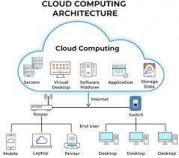

**Fig 1:** Cloud Computing Architecture

### 2.2 Advantages of Cloud Foundations:

* **Faster time to market:** You can spin up new instances or retire them in seconds, allowing developers to accelerate development with quick deployments. Cloud computing supports new innovations by making it easy to test new ideas and design new applications without hardware limitations or slow procurement processes.
* **Scalability and flexibility:** Cloud computing gives your business more flexibility. You can quickly scale resources and storage up to meet business demands without having to invest in physical infrastructure. Companies don’t need to pay for or build the infrastructure needed to support their highest load levels. Likewise, they can quickly scale down if resources aren’t being used.
* **Cost savings:** Whatever cloud service model you choose, you only pay for the resources you actually use. This helps you avoid overbuilding and overprovisioning your data center and gives your IT teams back valuable time to focus on more strategic work.
* **Better collaboration:** Cloud storage enables you to make data available anywhere you are, anytime you need it. Instead of being tied to a location or specific device, people can access data from anywhere in the world from any device—as long as they have an internet connection.
* **Advanced security:** Despite popular perceptions, cloud computing can actually strengthen your security posture because of the depth and breadth of security features, automatic maintenance, and centralized management. Reputable cloud providers also hire top security experts and employ the most advanced solutions, providing more robust protection.
* **Data loss prevention:** Cloud providers offer backup and disaster recovery features. Storing data in the cloud rather than locally can help prevent data loss in the event of an emergency, such as hardware malfunction, malicious threats, or even simple user error.

### 2.3 Limitations of Cloud Foundations:

* **Complexity of Implementation:** Establishing cloud foundations can be complex, particularly for large organizations with diverse IT environments. It may require significant time and resources to implement the necessary governance, security, and compliance measures.
* **Resource and Skill Requirements:**Developing and maintaining cloud foundations requires skilled personnel who are well-versed in cloud technologies, governance, and security practices. Acquiring and retaining these skilled individuals can be challenging and costly.
* **Change Management:** Transitioning to the cloud often involves changes in workflows, processes, and organizational culture. Managing this change can be difficult, and resistance to change from employees can pose challenges.
* **Cost Management:** While cloud computing offers scalability and cost-efficiency, it can also lead to unexpected costs if not managed properly. Organizations must continuously monitor and optimize their cloud spending to avoid budget overruns.
* **Security and Compliance Risks:** Cloud environments can introduce new security and compliance risks if not properly managed. Organizations must ensure that their cloud foundations include robust security measures and adhere to industry regulations.
* **Vendor Lock-In:** Depending on the cloud service provider chosen, organizations may face challenges with vendor lock-in. Migrating away from one cloud provider to another can be complex and costly.

### Introduction to Amazon Web Services:

* Amazon Web Services (AWS), a subsidiary of Amazon.com, has invested billions of dollars in IT resources distributed across the globe.
* These resources are shared among all the AWS account holders across the globe. These account themselves are entirely isolated from each other.
* AWS provides on-demand IT resources to its account holders on a pay-as-you-go pricing model with no upfront cost.
* Amazon Web services offers flexibility because you can only pay for services you use or you need. Enterprises use AWS to reduce capital expenditure of building their own private IT Infra structure (which can be expensive depending upon the enterprise’s size and nature).
* AWS has its own Physical fiber network that connects with Availability zones, regions and Edge locations. All the maintenance cost is also bared by the AWS that saves a fortune for the enterprises.
* Security of cloud is the responsibility of AWS but Security in the cloud is Customer’s Responsibility.
* The Performance efficiency in the cloud has four main areas:- Selection, Review, Monitoring ,Trade-off

### 2.5 AWS Cloud Adoption Framework:

The AWS Cloud Adoption Framework (AWS CAF) leverages AWS experience and best practices to help you digitally transform and accelerate your business outcomes through innovative use of AWS. AWS CAF identifies specific organizational capabilities that underpin successful cloud transformations. These capabilities provide best practice guidance that helps you improve your cloud readiness. AWS CAF groups its capabilities in six perspectives: Business, People, Governance, Platform, Security, and Operations. Each perspective comprises a set of capabilities that functionally related stakeholders own or manages in the cloud transformation journey. Use the AWS CAF to identify and prioritize transformation opportunities, evaluate and improve your cloud readiness, and iteratively evolve your transformation roadmap.

### Introduction to Machine Learning:

Machine Learning is a powerful technology that empowers computers to learn from data and perform tasks that were once thought to be the exclusive domain of humans. As it continues to advance, it holds the potential to revolutionize industries and improve our daily lives in countless ways. Understanding the key concepts and principles of machine learning is essential for anyone looking to leverage its capabilities or contribute tom its development.

### Key Concepts in AWS Machine Learning Foundations:

1. Implementing a Machine Learning Pipeline with Amazon SageMaker
2. Forecasting
3. Computer vision
4. Natural Language Processing

## 3. OVERVIEW OF THE ORGANISATION

Amazon Web Services offers a broad set of global cloud-based products including compute, storage, databases, analytics, networking, mobile, developer tools, management tools, IoT, security, and enterprise applications: on-demand, available in seconds, with pay as-you-go pricing. From data warehousing to deployment tools, directories to content delivery, over 200AWS services are available. New services can be provisioned quickly, without the upfront fixed expense. This allows enterprises, start-ups, small and medium-sized businesses, and customers in the public sector to access the building blocks they need to respond quickly to changing business requirements. This whitepaper provides you with an overview of the benefits of the AWS loud and introduces you to the services that make up the platform. In 2006, Amazon Web Services (AWS) began offering IT infrastructure services to businesses as web services—now commonly known as cloud computing. One of the key benefits of cloud computing is the opportunity to replace upfront capital infrastructure expenses with low variable costs that scale with your business. With the cloud, businesses no longer need to plan for and procure servers and other IT infrastructure weeks or months in advance. Instead, they can instantly spin up hundreds or thousands of servers in minutes and deliver results faster. Today, AWS provides a highly reliable, scalable, low-cost infrastructure platform in the cloud that powers hundreds of thousands of businesses in 190 countries around the world.

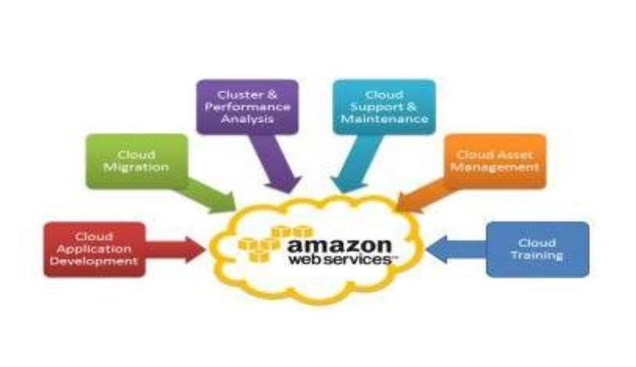

### Fig 3: Different fields in AWS

4. **ACTIVITY LOG AND WEEKLY REPORT**

**WEEK-1**

**Table 4.1: Activity log for the first week**

|  |  |  |
| --- | --- | --- |
| **Day** | **Brief description of the daily activity** | **Learning Outcome** |
| Day–1 | Course on experts | Learnt about experts and difference between them. |
| Day–2 | Course on types of cloud services | Learnt about types of cloud services |
| Day–3 | Course on deployment models | Learnt about deployment models |
| Day–4 | Studied about types of cloud computing | Learnt about types of computing |  |
| Day–5 | Studied about SaaS service | Learnt about SaaS service |
| Day–6 | Studied about IaaS service | Learnt about IaaS service |

**WEEKLY REPORT:**

**WEEK–1 (From** Date: 19-12-2022 **to** Date: 24-12-2022**)**

**Objective of the Activity Done:**

To know the basics of experts and learn about cloud computing course and studied types of cloud computing.

**Detailed Report:**

**Types of Cloud Services:**

Regardless of the kind of service, cloud computing services provide users with a series of functions including:

* Email
* Storage, backup, and data retrieval
* Creating and testing apps
* Analysing data
* Audio and video streaming
* Delivering software on demand

Cloud computing is still a fairly new service but is being used by a number of different organizations from big corporations to small businesses, non-profits to government agencies, and even individual consumers.

**Deployment Models:**

1. There are various types of clouds, each of which is different from the other. Public clouds provide their services on servers and storage on the Internet.
2. Private clouds are reserved for specific clientele, usually one business or organization. The firm's data service centre may host the cloud computing service.
3. Hybrid clouds are, as the name implies, a combination of both public and private services.

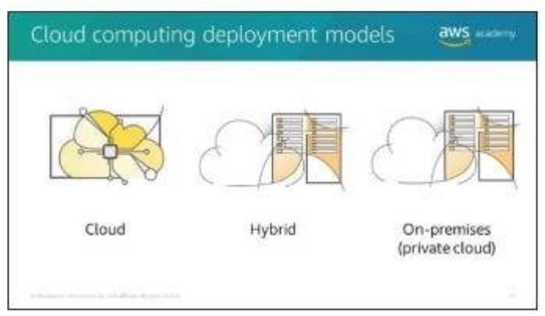

**Figure: Cloud Computing**

**Deployment**  **Models Services provided by AWS:**

The services provided by AWS are mentioned below

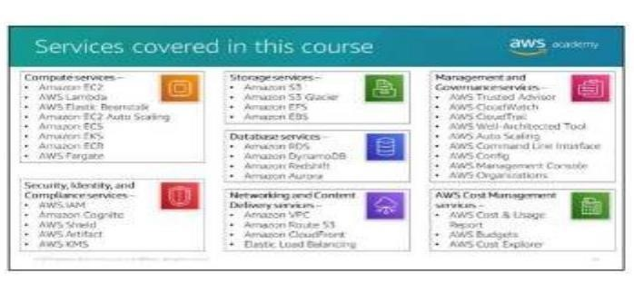

**Figure: Services provided in the course**

**Types of Cloud Computing:**

Cloud computing is not a single piece of technology like a microchip or a cell phone. Rather, it’s a system primarily comprised of three services: software as a service (SaaS), infrastructure-as-a-service (IaaS), and platform-as-a-service (PaaS).

1. Software-as-a-service (SaaS) involves the licensure of a software application to customers. Licenses are typically provided through a pay-as-you-go model or on-demand. This type of system can be found in Microsoft Office's 365.
2. Infrastructure-as-a-service (IaaS) involves a method for delivering everything from operating systems to servers and storage through IP-based connectivity as part of an ondemand service. Clients can avoid the need to purchase software or servers, and instead procure these resources in an out sourced, on-demand service. Popular examples of the IaaS system include IBM Cloud and Microsoft Azure.

**WEEK-2**

**Table 4.2: Activity log for the second week**

|  |  |  |  |
| --- | --- | --- | --- |
| **Day** | **Brief description of the daily activity** | **Learning Outcome** |  |
| Day–1 | Studied about PaaS service | Learnt about PaaS service |  |
| Day–2 | Studied about disadvantages of cloud computing | Learnt about disadvantages of cloud computing |  |
| Day–3 | Studied about the world of business | Learnt about the world of business |  |
| Day–4 | Examples of cloud computing | Learnt about examples of cloud computing |  |
| Day–5 | Main types of cloud computing | Learnt about main types of cloud computing |  |
| Day–6 | Whether cloud computing is good or not? | Learnt whether cloud computing is good or not? |  |

**WEEKLY REPORT**

**WEEK–2 (From** Date 26-12-2022 **to** Date 31-12-2022)

**Objective of the Activity Done:**

To know about PaaS service, to study about disadvantages of cloud computing and world of business, examples of cloud computing and main types of cloud computing.

**Detailed Report:**

1. Platform-as-a-service (PaaS) is considered the most complex of the three layers of cloud based computing. PaaS shares some similarities with SaaS, the primary difference being that instead of delivering software online, it is actually a platform for creating software that is delivered via the Internet.

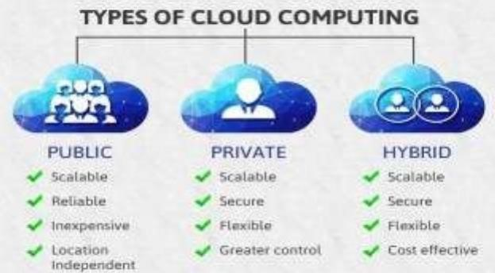

**Figure:** **Types of cloud computing**

**Disadvantages of the Cloud:**

1.With all of the speed, efficiencies, and innovations that come with cloud computing, there are, naturally, risks.

2.Security has always been a big concern with the cloud especially when it comes to sensitive medical records and financial information. While regulations force cloud computing services to shore up their security and compliance measures, it remains an ongoing issue.

3.Servers maintained by cloud computing companies may fall victim to natural disasters, internal bugs, and power outages, too. The geographical reach of cloud computing cuts both ways: A blackout in California could paralyze users in New York, and a firm in Texas could lose its data if something causes its Maine-based provider to crash.

**The World of Business**

Businesses can employ cloud computing in different ways. Some users maintain all apps and data on the cloud, while others use a hybrid model, keeping certain apps and data on private servers and others on the cloud.

When it comes to providing services, the big players in the corporate computing sphere include:

• Google Cloud • AWS • Microsoft Azure • IBM Cloud

**Examples of Cloud Computing:**

Today, there are several examples of cloud computing applications used by both businesses and individuals. One type of cloud service would be streaming platforms for audio, where the actual media files are stored remotely. Another would be data storage platforms like Google Drive, Dropbox, OneDrive, or Box.

**The Main Types of Cloud Computing:**

The main types of cloud computing services include Infrastructure-as-a-Service (IaaS), Platforms-as-a-Service (PaaS), and Software-as-a-Service (SaaS).

* IaaS provides IT infrastructure to end-users via the internet and is commonly associated with server less computing.
* PaaS serves both software and hardware to end-users, who are generally software developers. PaaS allows the user to develop, run, and manage their own apps without having to build and maintain the infrastructure.
* SaaS is a software licensing model, which allows access to software on a subscription basis using external servers without having to download and install them locally.

**Is Cloud Computing Safe?**

Because software and data are stored remotely in cloud computing, data security and platform security are a big concern. Cloud security refers to the measures undertaken to protect digital assets and data stored on cloud-based services. Measures to protect this data include twofactor authorization (2FA), the use of VPNs, security tokens, data encryption, and firewall services, among-others.

**WEEK-3**

**Table 4.3: Activity log for the third week**

|  |  |  |
| --- | --- | --- |
| **Day** | **Brief description of the daily activity** | **Learning Outcome** |
| Day–1 | Course on AWS Services | Learnt about AWS Services |
| Day–2 | Read a case study on cloud computing | Learnt a case study on cloud computing |
| Day–3 | About categories of AWS services | Learnt about categories of AWS services |
| Day–4 | ways to interact with AWS service | Learnt ways to interact with  AWS services |
| Day–5 | ways to interact with AWS service | Learnt ways to interact with  AWS services |

**WEEKLY REPORT**

**WEEK–5 (From** Dt 02-01-2023 **to** Dt 07-01-2023)

**Objective of the Activity Done:**

To know about AWS services, a case study on cloud computing, categories of aws services and ways to interact with AWS service.

**Web Services (AWS):**

In general, a web service is any piece of software that makes itself available over the internet or on private (intranet) networks. A web service uses a standardized format - such as Extensible Mark-up Language (XML) or JavaScript Object Notation (JSON) - for the request and the response of an application programming interface (API) interaction.

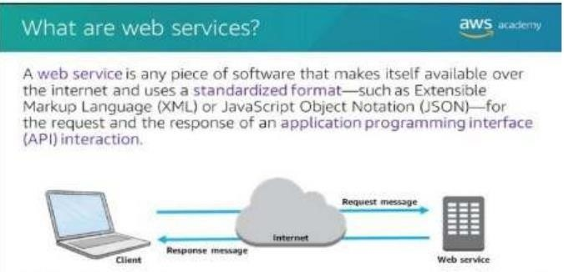

**Categories**

Amazon Web Services (AWS) is a secure cloud platform that offers a broad set of global cloud-based products. Because these products are delivered over the internet, you have ondemand access to the compute, storage, network, database, and other IT resources that youmight need for your projects—and the tools to manage them. You can immediately provisionand launch AWS resources. The resources are ready for you to use in minutes. AWS offersflexibility. Your AWS environment can be reconfigured and updated on demand, scaled up ordown automatically to meet usage patterns and optimize spending, or shut down temporarilyor permanently. The billing for AWS services becomes an operational expense instead of acapital expense.AWS services are designed to work together to support virtually any type ofapplication or workload. Think of these services like building blocks, which you can assemblequickly to build sophisticated, scalable solutions, and then adjust them as your needs change.

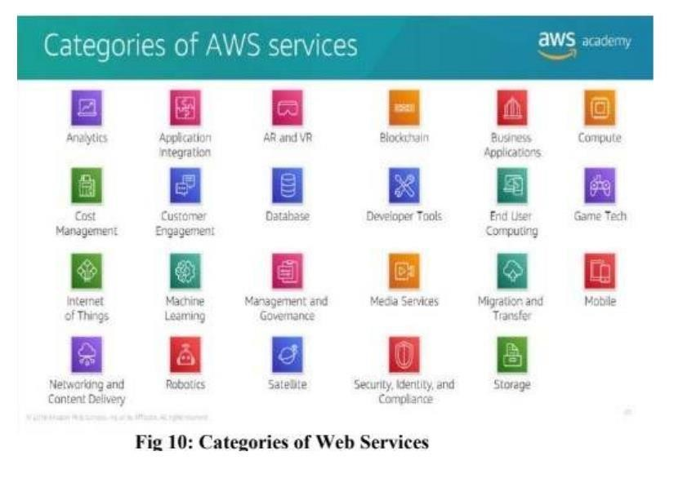

**Ways to interact with AWS:**

You might wonder how to access the broad array of services that are offered by AWS. There are three ways to create and manage resources on the AWS Cloud:

* AWS Management Console: The console provides a rich graphical interface to a majority of the features offered by AWS. (Note: From time to time, new features might not have all of their capabilities included in the console when the feature initially launches.)
* AWS Command Line Interface (AWS CLI): The AWS CLI provides a suite of utilities that can be launched from a command script in Linux, macOS, or Microsoft Windows. • Software development kits (SDKs): AWS provides packages that enable accessing AWS in avariety of popular programming languages. This makes it easy to use AWS in your existing applications and it also enables you to create applications that deploy and monitor complex systems entirely through code.

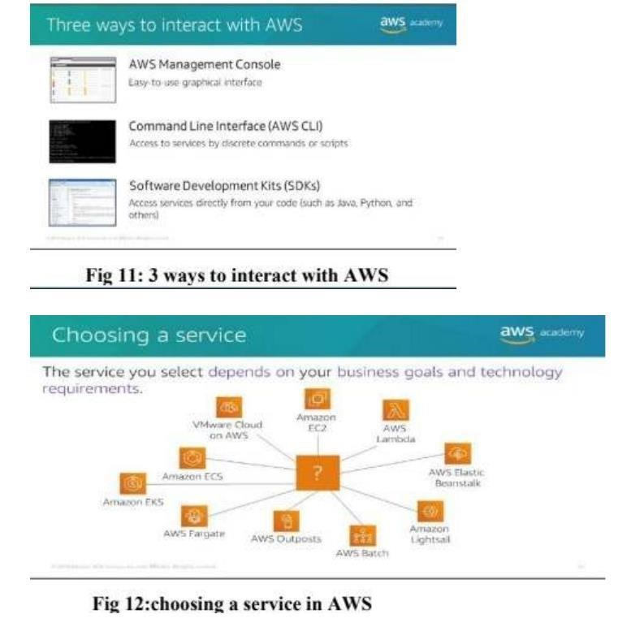

**WEEK-4**

**Table 4.4: Activity log for the fourth week**

|  |  |  |
| --- | --- | --- |
| **Day** | **Brief description of the daily activity** | **Learning Outcome** |
| Day–1 | Read about AWS cloud adoption framework. | Learnt about AWS cloud adoption framework. |
| Day–2 | Read about AWS cloud adoption framework. | Learnt about AWS cloud adoption framework. |
| Day–3 | Read about AWS cloud adoption framework. | Learnt about AWS cloud adoption framework. |
| Day–4 | About six core prespectives | Learnt about six core perspectives |
| Day–5 | About six core prespectives | Learnt about six core perspectives |
| Day–6 | About six core prespectives | Learnt about six core perspectives |

**WEEKLY REPORT**

**WEEK –4** (From Date :09-01-2023 to Date :14-01-2023)

**Objective of the Activity Done:**

To know about AWS cloud adoption services and also about six perspectives of cloud computing. Detailed Report:

AWS Cloud Adoption Framework: The array of AWS services can be intimidating as you start your journey into the cloud. This course focuses on some of the more common services in the following service categories: compute, storage, database, networking and content delivery, security, identity, and compliance, management and governance, and AWS cost management.

Legend:

* Amazon Elastic Block Store (Amazon EBS)
* Amazon Elastic Compute Cloud (Amazon EC2)
* Amazon Elastic Container Registry (Amazon ECR)
* Amazon Elastic Container Service (Amazon ECS)
* Amazon Elastic File System (Amazon EFS)
* Amazon Elastic Kubernetes Service (Amazon EKS)
* Amazon Relational Database Service (Amazon RDS)
* Amazon Simple Storage Service (Amazon S3)
* Amazon Virtual Private Cloud (Amazon VPC)
* AWS Identity and Access Management (IAM)
* AWS Key Management Service (AWS KMS) **Six Core perspectives:**

1. Each organization’s cloud adoption journey is unique. However, in order for any organization to successfully migrate its IT portfolio to the cloud, three elements (that is, people, process, and technology) must be in alignment.
2. Business and technology leaders in an organization must understand the

organization’scurrent state, target state, and the transition that is needed to achieve the target state so theycan set goals and create processes for staff.

1. The AWS Cloud Adoption Framework (AWS CAF) provides guidance and best practices to help organizations identify gaps in skills and processes.
2. It also helps organizations build a comprehensive approach to cloud computing—both across the organization and throughout the IT lifecycle—to accelerate successful cloud adoption. At the highest level, the AWS CAF organizes guidance into six areas of focus, called perspectives.
3. Perspectives span people, processes, and technology. Each perspective consists of a set ofcapabilities, which covers distinct responsibilities that are owned or managed by functionallyrelated stakeholders.
4. Capabilities within each perspective are used to identify which areas of an organization require attention. By identifying gaps, prescriptive work streams can be created that support that supports a successful cloud journey.

In general, the Business, People, and Governance perspectives focus on business capabilities, While Platform, Security, and Operations perspectives focus on technical capabilities

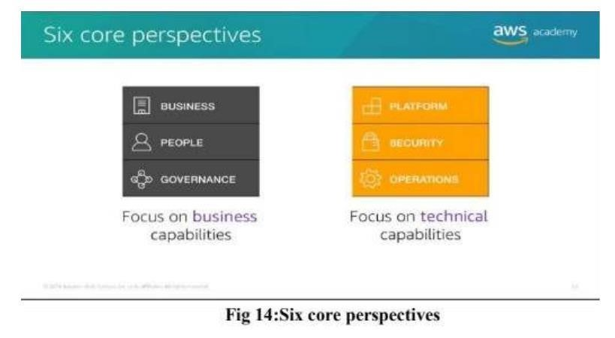

**WEEK-5**

**Table 4.5: Activity log for the fifth week**

|  |  |  |
| --- | --- | --- |
| **Day** | **Brief description of the daily activity** | **Learning Outcome** |
| Day–1 | Read about peoples perspective | Learn about peoples perspective |
| Day–2 | Read about peoples perspective | Learn about peoples perspective |
| Day–3 | Read about peoples perspective | Learn about peoples perspective |
| Day–4 | Read about peoples perspective | Learn about peoples perspective |  |
| Day–5 | Read about governance perspective | Learn about governance  perspective |  |
| Day–6 | Read about governance perspective | Learn about governance  perspective |  |

**WEEKLY REPORT**

**WEEK –5**  (From Date 16-01-2023 to Date 21-01-2023)

**Objective of the Activity Done:**

To know about peoples perspective ,business perspective and governance perspective.

**Detailed Report:**

**People Perspective:**

Stakeholders from the People perspective (for example, human resources, staffing, and peoplemanagers) can use the AWS CAF to evaluate organizational structures and roles, new skill andprocess requirements, and identify gaps. Performing an analysis of needs and gaps can helpprioritize training, staffing, and organizational changes to build an agile organization.

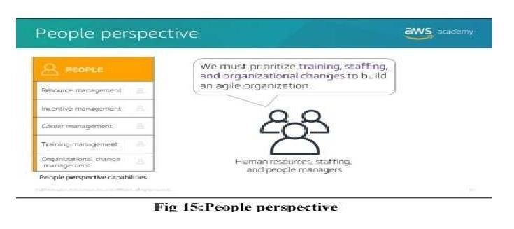

**Bussines Perspectives**:

Stakeholders from the Business perspective (for example, business managers, finance managers, budget owners, and strategy stakeholders) can use the AWS CAF to create a strongbusiness case for cloud adoption and prioritize cloud adoption initiatives.

Stakeholders shouldensure that an organization’s business strategies and goals align with its IT strategies andgoals.

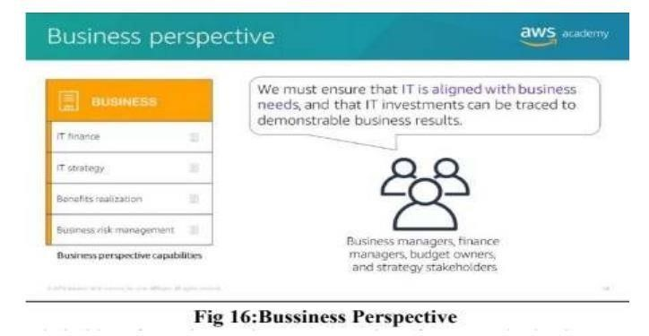

**Governance Perspectives:**

Stakeholders from the Governance perspective (for example, the Chief Information Officeror CIO, program managers, enterprise architects, business analysts, and portfolio managers) canuse the AWS CAF to focus on the skills and processes that are needed to align IT strategy.

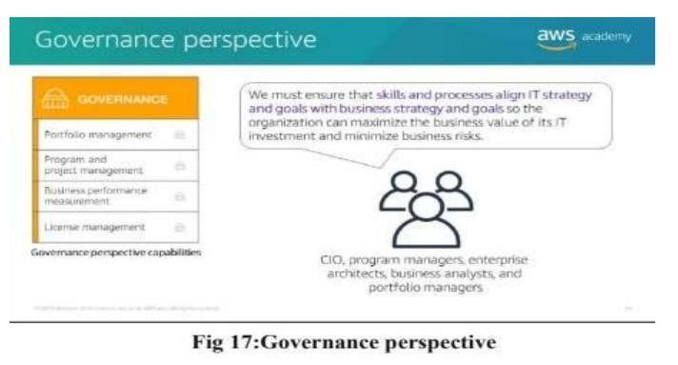

**WEEK-6**

**Table 4.6: Activity log for the sixth week**

|  |  |  |
| --- | --- | --- |
| **Day** | **Brief description of the daily activity** | **Learning Outcome** |
| Day–1 | Read about platform perspective | Learnt about platform perspective |
| Day–2 | Read about platform perspective | Learnt about platform perspective |
| Day–3 | Read about platform perspective | Learnt about platform perspective |
| Day–4 | Read about platform perspective | Learnt about platform perspective |
| Day–5 | Brief summary cloud computing | Learnt brief summary cloud  computing |
| Day–6 | Brief summary cloud computing | Learnt brief summary cloud  computing |

**WEEKLY REPORT**

**WEEK 6** (From Date 23-01-2023 to Date 28-01-2023)

**Objective of the Activity Done:**

To know about platform perspectives, security perspectives and brief summary about cloud computing.

**Detailed Report:**

**Platform Perspective:** Stakeholders from the Platform perspective (for example, Chief Technology Officer or CTO, IT managers, and solutions architects) use a variety of architectural dimensions andmodels to understand and communicate the nature of IT systems and their relationships.They must be able to describe the architecture of the target state environment in detail.

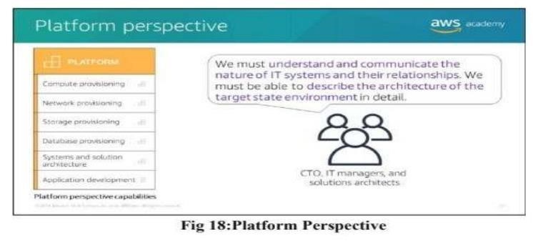

**Security Perspective:**

Security perspective stakeholders can use the AWS CAF to structure the selection and implementation of security controls that meet the organization’s needs.

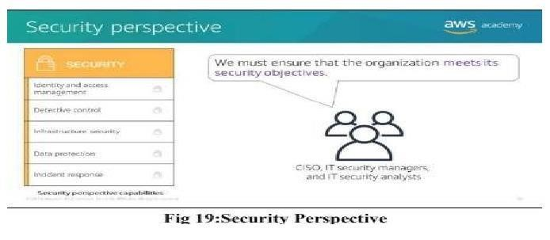

**Summary:**

1. **Back-up and restore data**

Once the data is stored in the cloud, it is easier to get back-up and restore that data using the cloud.

1. **Improved collaboration**

Cloud applications improve collaboration by allowing groups of people to quickly and easily share information in the cloud via shared storage

1. **Excellent accessibility**

Cloud allows us to quickly and easily access store information anywhere, anytime in the whole world, using an internet connection. An internet cloud infrastructure increases. organization productivity and efficiency by ensuring that our data is always accessible

1. **Low maintenance cost**

Cloud computing reduces both hardware and software maintenance costs for organizations.

1. **Mobility**

Cloud computing allows us to easily access all cloud data via mobile.

1. **Services in the pay-per-use model**

Cloud computing offers Application Programming Interfaces (APIs) to the users for access services on the cloud and pays the charges as per the usage of service.

1. **Unlimited storage capacity**

Cloud offers us a huge amount of storing capacity for storing our important data such as documents, images, audio, video, etc. in one place

**WEEK-7**

**Table 4.7: Activity log for the seventh week**

|  |  |  |
| --- | --- | --- |
| **Day** | **Brief description of the daily activity** | **Learning Outcome** |
| Day–1 | Introduction to Machine Learning | Learn about Introduction to Machine Learning |
| Day–2 | Business problems that are solved using Machine Learning | Learn solving of business problems using Machine Learning |
| Day–3 | Machine learning tools | Learn tools of Machine Learning |
| Day–4 | Implementing ML Pipeline with Amazon Sage Maker | Learn implementing of ML Pipeline with Amazon Sage Maker |
| Day–5 | Implementing ML Pipeline with Amazon Sage Maker | Learn implementing of ML Pipeline with Amazon Sage Maker |
| Day–6 | Implementing ML Pipeline with Amazon Sage Maker | Learn implementing of ML Pipeline with Amazon Sage Maker |

**WEEKLY REPORT**

**WEEK –7 (From Date 30-01-2023 to Date 04-02-2023)**

**Objective of the Activity Done:**

To know introduction to machine learning, business problem that are solved

using machine learning, machine learning tools, to know about implementation

of ML pipeline with Amazon Saze Maker.

**Detailed Report:**

**Introduction to Machine Learning:**

Machine learning is a subset of AI, which is a broad branch of computer science for building machines that can do human tasks. Deep learning itself a subdomain of machine learning. To understand where these ideas fit together, you will learn about each field.

**Business problems that are solved using Machine Learning:**

•Machine learning applications are already part of your everyday life.

•Machine learning problems can be grouped into supervised learning:

You have training data for which you know the answer.

•Unsupervised learning:

You have data, but you are looking for insights within the data.

•Reinforcement learning:

The model learns in a way that is based on experience

and feedback.

**Machine Learning Tools:**

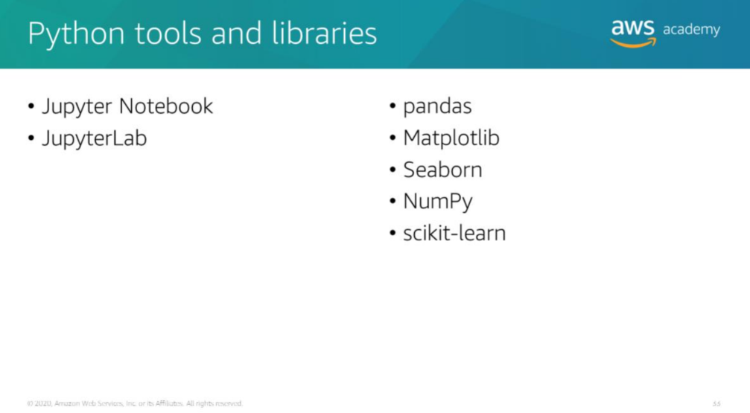

**Implementing ML Pipeline with amazon sagemaker:**

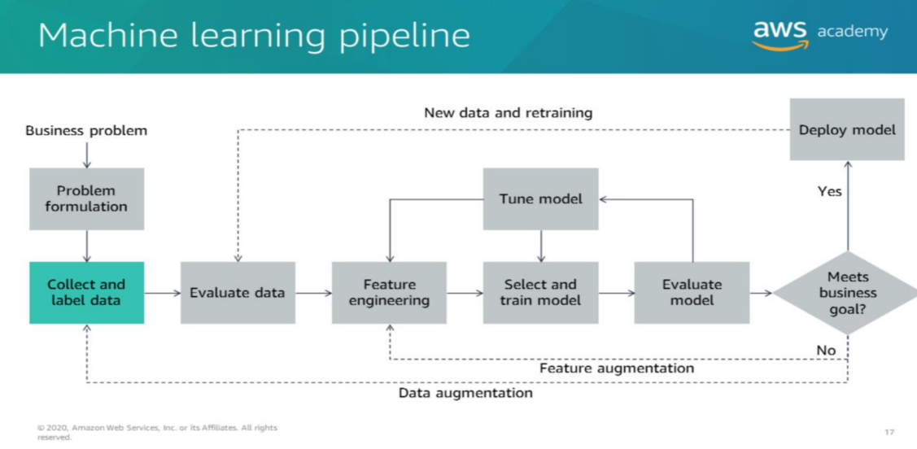

* Formulate a problem from a business request
* Obtain and secure data for machine learning (ML)
* Build a Jupyter Notebook by using Amazon SageMaker
* Outline the process for evaluating data
* Explain why data must be preprocessed
* Use open source tools to examine and preprocess data
* Use Amazon SageMaker to train and host an ML model
* Use cross validation to test the performance of an ML model
* Use a hosted model for inference
* Create an Amazon SageMaker hyperparameter tuning job to optimize a model’s effectiveness

**Week-8:**

**Table 4.8: Activity log for the nineth week**

|  |  |  |  |
| --- | --- | --- | --- |
| **Day** | **Brief description of the daily activity** | | **Learning Outcome** |
| Day–1 | Forecasting use cases | | Learn about forecasting use cases |
| Day–2 | Time series algorithms |  | Learn about Time series algorithms |
| Day–3 | Using Amazon Forecast |  | Learn how to use Amazon Forecast |
| Day–4 | Creating a forecast with amazon forecast |  | Learn how to create a forecast with Amazon Forecast |
| Day–5 | Creating a forecast with amazon forecast |  | Learn how to create a forecast with Amazon Forecast |
| Day–6 | Creating a forecast with amazon forecast |  | Learn how to create a forecast with Amazon Forecast |

**WEEKLY REPORT**

**WEEK –8** (From Date :06-02-2023 to Date :11-02-2023)

**Objective of the Activity Done:**

To know forecasting use cases, time series algorithms and create a forecast with amazon forecast.

**Detailed Report:**

**Forecasting usecases:**

* Marketing applications, such as sales forecasting or demand projections.
* Inventory management systems to anticipate required inventory levels. Often, this type of forecast includes information about delivery times.
* Energy consumption to determine when and where energy is needed.
* Weather forecasting systems for governments, and commercial applications such as agriculture.

**Amazon Forecast supports these five algorithms:**

* Autoregressive Integrated Moving Average (ARIMA)
* DeepAR+ A supervised learning algorithm for forecasting one dimensional time series.
* Exponential Smoothing (ETS): This algorithm is useful for datasets with seasonality.
* NonParametric Time Series (NPTS) - Predictions are based on sampling from past observations.
* Prophet - A Bayesian time series model.

**Creating a Forecast with Amazon Forecast:**

* You can use Amazon Forecast to train and use a model for time series data.
* There are specific schemas defined for domains such as retail and EC2 capacity planning or you can use a custom schema.
* You need to supply at least the time series data, but can also provide metadata and related data to add move information to the model.

**WEEK-9 :**

**Table 4.9: Activity log for the nineth week**

|  |  |  |  |
| --- | --- | --- | --- |
| **Day** | **Brief description of the daily activity** | **Learning Outcome** | |
| Day–1 | Computer vision applications | Learn about applications of computer vision | |
| Day–2 | Computer vision applications | Learn about applications of computer vision | |
| Day–3 | Computer vision applications | Learn about applications of computer vision | |
| Day–4 | Primary use cases for computer vision | Learn about primary use cases for computer vision |  |
| Day–5 | Primary use cases for computer vision | Learn about primary use cases for computer vision |  |
| Day–6 | Primary use cases for computer vision | Learn about primary use cases for computer vision |  |

**WEEKLY REPORT**

**WEEK –9**  (From Date 13-02-2023 to Date 18-02-2023)

**Objective of the Activity Done:**  To learn computer vision applications and primary usecases for computer vision.

**Detailed Report:**

**Computer vision applications:**

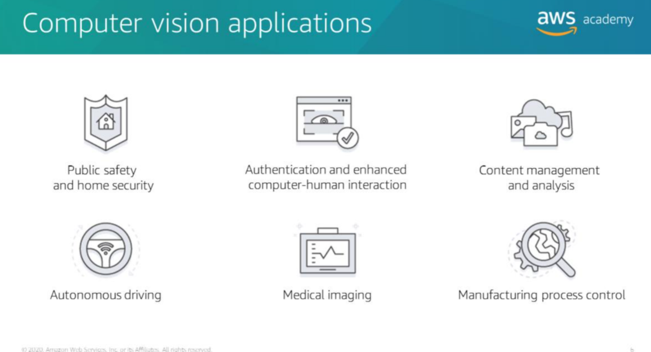

Computer vision is an exciting space in machine learning. The advances in computing power

and algorithms over the last 10 years have led to an increase in capabilities and easier access

to computer vision technologies.

You can think of computer vision as the automated extraction of information

from digital

images.

**Some of the primary use cases for computer vision include theses examples:**

* Public safety and home security
* Authentication and enhanced computer - human interaction
* Content management and analysis
* Autonomous driving
* Medical imaging
* Manufacturing process control

**WEEK-10**

#### Table 4.1: Activity log for the tenth week

|  |  |  |
| --- | --- | --- |
| **Day** | **Brief description of the daily activity** | **Learning Outcome** |
| Day–1 | Introducing Natural Language Processing | Learn about Natural Language Processing |
| Day–2 | Introducing Natural Language Processing | Learn about Natural Language Processing |
| Day–3 | NLP use cases | Learn about Natural Language Processing Use cases |
| Day–4 | NLP use cases | Learn about Natural Language Processing Use cases |
| Day–5 | Text Analysis categories |  |
| Day–6 | Text Analysis categories | Learn about the categories of Text Analysis |

**WEEKLY REPORT**

**WEEK –10** (From Date 20-02-2023 to Date 25-02-2023)

**Objective of the Activity Done:**

**Detailed Report:**

**Introduction to Natural Language Processing:**

NLP is a broad term for a general set of business or computational problems that you can solve with machine learning (ML). NLP systems predate ML. Two examples are speech-to-text on your old cell phone and screen readers. Many NLP systems now use some form of machine learning. NLP considers the hierarchical structure of language. Words are at the lowest layer of the hierarchy. A group of words make a phrase. The next level up consists of

phrases, which make a sentence, and ultimately, sentences convey ideas.

**NLP Usecases:**

* Search applications (such as Google and Bing)
* Human machine interfaces (such as Alexa)
* Sentiment analysis for marketing or political campaigns
* Social research that is based on media analysis
* Chatbots to mimic human speech in applications

**Text Analysis Categories:**

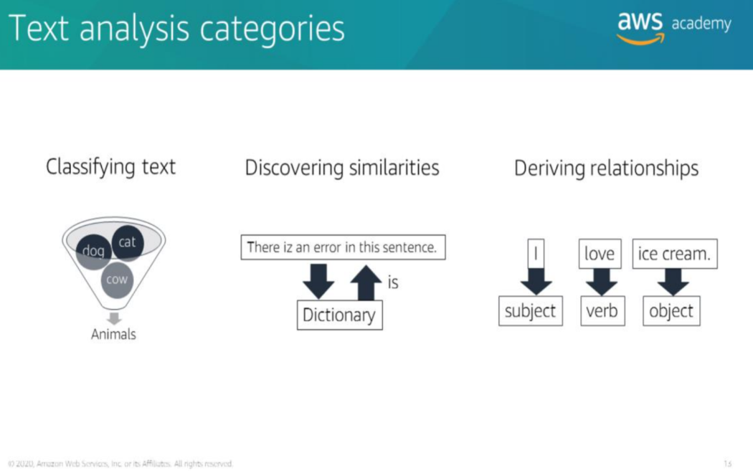

## 6. OUTCOMES DESCRIPTION

### 6.1 Technical Skills as a AI-ML Internship

* **Python:**
  + Python is the primary language for most AI/ML tasks due to its extensive libraries and frameworks. You should be proficient in Python, including data manipulation with libraries like NumPy and Pandas.
* **Machine Learning Frameworks:**

**Scikit-learn:** A versatile library for classical machine learning tasks**.**

**TensorFlow or PyTorch**: Deep learning frameworks used for neural network development

and training.

* **Data Preprocessing:**

Knowledge of techniques for data cleaning, feature engineering, and data transformation.

* **Data Visualization:**

Ability to create meaningful visualizations using libraries like Matplotlib or Seaborn to gain

Insights from data.

* **Statistics and Mathematics:**

Understanding of statistical concepts such as probability, hypothesis testing, and regression analysis.

Linear algebra and calculus knowledge for understanding the underlying mathematics of machine learning algorithms.

* **Machine Learning Algorithms:**

Familiarity with various ML algorithms, including decision trees, support vector machines, k-nearest neighbors, clustering algorithms, and ensemble methods like Random Forest and Gradient Boosting.

* **Deep Learning:**

Understanding of neural networks, including feedforward, convolutional, and recurrent networks.

Experiencewith building and training deep learning models using TensorFlow or PyTorch.

* **Natural Language Processing (NLP):**

Knowledge of NLP techniques and libraries like NLTK or spaCy for text processing, sentiment analysis, and language modeling.

* **Computer Vision:**

Familiarity with computer vision tasks, such as image classification, object detection, and image segmentation.

* **Model Evaluation and Hyperparameter Tuning:**

Ability to assess model performance using metrics like accuracy, precision, recall, F1-score, ROC AUC, etc.

Experience with hyperparameter tuning to optimize model performance.

* **Version Control:**

Proficiency in using Git and platforms like GitHub or GitLab for code versioning and collaboration.

* **Cloud Computing Platforms**

Experience with cloud platforms like AWS, Azure, or Google Cloud for scalable model deployment and cloud-based data processing.

* **Databases and SQL:**

Understanding of relational databases and SQL for data retrieval and manipulation.

* **Big Data Technologies:**

Familiarity with big data tools like Hadoop and Spark for processing large datasets.

* **Containerization:**

Knowledge of containerization technologies like Docker for creating reproducible environments.

* **Linux/Unix:**

Basic proficiency in the Linux/Unix command line for managing environments and servers.

* **AI Ethics and Responsible AI:**

Awareness of ethical considerations in AI/ML, including fairness, bias, transparency, and privacy.

* **Deployment and DevOps:**

Experience with deploying machine learning models into production environments.

Basic understanding of DevOps practices for automating deployments.

* **Collaborative Tools:**

Effective use of collaboration tools like Jupyter Notebooks, Confluence, or Slack for team communication and documentation.

* **Problem-Solving and Critical Thinking:**

Strong problem-solving skills and the ability to think critically to design effective ML solutions.

**6.2 References**

**Sample Questions:**

1. **A machine learning team has several large CSV datasets in Amazon S3. Historically, models built with the Amazon SageMaker Linear Learner algorithm have taken hours to train on similar-sized datasets. The team’s leaders need to accelerate the training process. What can a machine learning specialist do to address this concern?**

**Answer:** Amazon SageMaker Pipe mode streams the data directly to the container, which improves the performance of training jobs. (Refer to this link for supporting information.) In Pipe mode, your training job streams data directly from Amazon S3. Streaming can provide faster start times for training jobs and better throughput. With Pipe mode, you also reduce the size of the Amazon EBS volumes for your training instances. B would not apply in this scenario. C is a streaming ingestion solution, but is not applicable in this scenario. D transforms the data structure.

1. **A company is setting up a system to manage all of the datasets it stores in Amazon S3. The company would like to automate running transformation jobs on the data and maintaining a catalog of the metadata concerning the datasets. The solution should require the least amount of setup and maintenance. Which solution will allow the company to achieve its goals?**

**Answer:** AWS Glue is the correct answer because this option requires the least amount of setup and maintenance since it is serverless, and it does not require management of the infrastructure. Refer to this link for supporting information. A, C, and D are all solutions that can solve the problem, but require more steps for configuration, and require higher operational overhead to run and maintain.

1. **A company uses Amazon EC2 instances to run applications that are dedicated to different departments. The company needs to break out the costs of these applications and allocate them to the relevant department. The EC2 instances run in a single VPC. How can the company achieve these requirements?**

**Answer:** Create tags by department on the instances and then run a cost allocation report.

1. **A company is launching a new website which is expected to have highly variable levels of traffic. The website will run on Amazon EC2 and must be highly available. What is the MOST cost-effective approach?**

**Answer:** Create an Amazon EC2 Auto Scaling group and configure an Elastic Load Balancer.

**Sample Code for AI-ML:**

## The Scenario

In this example, a series of Node.js modules are used to send and receive messages. The Node.js modules use the SDK for JavaScript to send and receive messages by using these methods of the AWS.SQS client class:

* [sendMessage](https://docs.aws.amazon.com/AWSJavaScriptSDK/latest/AWS/SQS.html#sendMessage-property)
* [receiveMessage](https://docs.aws.amazon.com/AWSJavaScriptSDK/latest/AWS/SQS.html#receiveMessage-property)
* [deleteMessage](https://docs.aws.amazon.com/AWSJavaScriptSDK/latest/AWS/SQS.html#deleteMessage-property)

## Prerequisite Tasks

To set up and run this example, you must first complete these tasks:

* Install Node.js. For more information about installing Node.js, see the [Node.js website](https://nodejs.org/).
* Create a shared configurations file with your user credentials. For more information about providing a shared credentials file, see [Loading Credentials in Node.js from the Shared Credentials File](https://docs.aws.amazon.com/sdk-for-javascript/v2/developer-guide/loading-node-credentials-shared.html).
* Create an Amazon SQS queue. For an example of creating a queue, see [Using Queues in Amazon SQS](https://docs.aws.amazon.com/sdk-for-javascript/v2/developer-guide/sqs-examples-using-queues.html).

## Sending a Message to a Queue

Create a Node.js module with the file name sqs_sendmessage.js. Be sure to configure the SDK as previously shown. To access Amazon SQS, create an AWS.SQS service object. Create a JSON object containing the parameters needed for your message, including the URL of the queue to which you want to send this message. In this example, the message provides details about a book on a list of fiction best sellers including the title, author, and number of weeks on the list.

Call the sendMessage method. The callback returns the unique ID of the message.

*// Load the AWS SDK for Node.js*

var AWS = require('aws-sdk');

*// Set the region*

AWS.config.update({region: 'REGION'});

*// Create an SQS service object*

var sqs = new AWS.SQS({apiVersion: '2012-11-05'});

var params = {

*// Remove DelaySeconds parameter and value for FIFO queues*

DelaySeconds: 10,

MessageAttributes: {

"Title": {

DataType: "String",

StringValue: "The Whistler"

},

"Author": {

DataType: "String",

StringValue: "John Grisham"

},

"WeeksOn": {

DataType: "Number",

StringValue: "6"

}

},

MessageBody: "Information about current NY Times fiction bestseller for week of 12/11/2016.",

*// MessageDeduplicationId: "TheWhistler", // Required for FIFO queues*

*// MessageGroupId: "Group1", // Required for FIFO queues*

QueueUrl: "SQS_QUEUE_URL"

};

sqs.sendMessage(params, function(err, data) {

if (err) {

console.log("Error", err);

} else {

console.log("Success", data.MessageId);

}

});

To run the example, type the following at the command line.

node sqs_sendmessage.js

This sample code can be found [here on GitHub](https://github.com/awsdocs/aws-doc-sdk-examples/tree/master/javascript/example_code/sqs/sqs_sendmessage.js).

## Receiving and Deleting Messages from a Queue

Create a Node.js module with the file name sqs_receivemessage.js. Be sure to configure the SDK as previously shown. To access Amazon SQS, create an AWS.SQS service object. Create a JSON object containing the parameters needed for your message, including the URL of the queue from which you want to receive messages. In this example, the parameters specify receipt of all message attributes, as well as receipt of no more than 10 messages.

Call the receiveMessage method. The callback returns an array of Message objects from which you can retrieve ReceiptHandle for each message that you use to later delete that message. Create another JSON object containing the parameters needed to delete the message, which are the URL of the queue and the ReceiptHandle value. Call the deleteMessage method to delete the message you received.

*// Load the AWS SDK for Node.js*

var AWS = require('aws-sdk');

*// Set the region*

AWS.config.update({region: 'REGION'});

*// Create an SQS service object*

var sqs = new AWS.SQS({apiVersion: '2012-11-05'});

var queueURL = "SQS_QUEUE_URL";

var params = {

AttributeNames: [

"SentTimestamp"

],

MaxNumberOfMessages: 10,

MessageAttributeNames: [

"All"

],

QueueUrl: queueURL,

VisibilityTimeout: 20,

WaitTimeSeconds: 0

};

sqs.receiveMessage(params, function(err, data) {

if (err) {

console.log("Receive Error", err);

} else if (data.Messages) {

var deleteParams = {

QueueUrl: queueURL,

ReceiptHandle: data.Messages[0].ReceiptHandle

};

sqs.deleteMessage(deleteParams, function(err, data) {

if (err) {

console.log("Delete Error", err);

} else {

console.log("Message Deleted", data);

}

});

}

});

To run the example, type the following at the command line.

node sqs_receivemessage.js

## 7. CONCLUSION

As an Intern, I did courses on: cloud foundations and also on basics of cloud foundations like

advantages of cloud computing and their limitations, different cloud services provided and also

kinds of perspective present, I also got to know about the AWS services provided. In conclusion,

I had the opportunity to delve into the fascinating world of Artificial Intelligence and Machine Learning, gaining practical knowledge and skills that are in high demand in today's tech-driven world. Throughout this internship, I have worked on various projects, enhancing my problem-solving abilities and understanding of AI/ML concepts.I have witnessed the impact of AI and ML in various domains, including education, healthcare, and industry. The applications are diverse and hold immense potential for innovation and growth. AICTE's AIML initiative plays a crucial role in bridging the skill gap and preparing the workforce for the future.Furthermore, this internship has reinforced the importance of continuous learning in the rapidly evolving field of AI and ML. Staying updated with the latest advancements is essential to remain competitive in this field.I would like to express my gratitude to the AICTE AIML program for providing me with this valuable opportunity. I believe that the knowledge and experience gained during this internship will serve as a strong foundation for my future endeavors in the field of Artificial Intelligence and Machine Learning.