Eks

**What is kubernetes?**

Kubernetes is an open-source container orchestration system for automating software deployment, scaling, and anamgement.

**Why is use kubernetes?**

If traffic to a container is high, Kubernetes is able to load balance and distribute the network traffic so that the deployment is stable

**What is replicatset ?**

ReplicaSet is one of the Kubernetes controllers that makes sure we have a specified number of pod replicas running.

**What is pod**?

A pod is the smallest execution unit in Kubernetes. A pod encapsulates one or more applications.

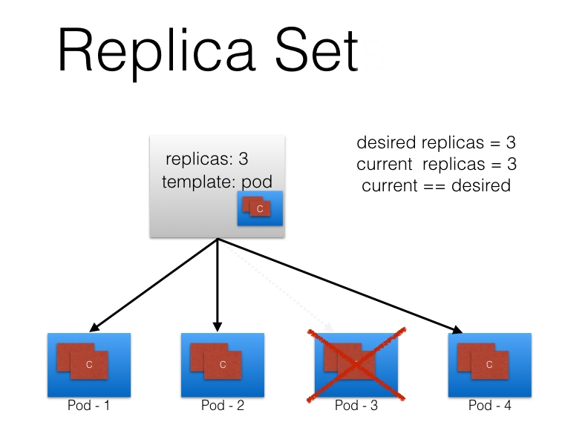



First create one instance (t2.meadim) ( security group =all traffic )

Connect git bash terminal

1. curl "https://awscli.amazonaws.com/awscli-exe-linux-x86_64.zip" -o "awscliv2.zip"

( <https://docs.aws.amazon.com/cli/latest/userguide/getting-started-install.html> )

1. sudo apt install unzip
2. unzip awscliv2.zip
3. sudo ./aws/install
4. curl -o aws-iam-authenticator <https://s3.us-west-2.amazonaws.com/amazon-eks/1.21.2/2021-07-05/bin/linux/amd64/aws-iam-authenticator>

( <https://docs.aws.amazon.com/eks/latest/userguide/install-aws-iam-authenticator.html>)

1. chmod +x ./aws-iam-authenticator

aws

1. aws --version
2. aws configure

( Iam user creation access key ,security key )

1. curl -o kubectl <https://s3.us-west-2.amazonaws.com/amazon-eks/1.22.6/2022-03-09/bin/linux/amd64/kubectl>

( <https://docs.aws.amazon.com/eks/latest/userguide/install-kubectl.html>)

1. chmod +x ./kubectl
2. mkdir -p $HOME/bin && cp ./kubectl $HOME/bin/kubectl && export PATH=$PATH:$HOME/bin
3. aws eks --region ap-southeast-1 update-kubeconfig --name eks-cluster

aws account Search [Amazon Elastic Kubernetes Service](https://ap-southeast-1.console.aws.amazon.com/eks/home?region=ap-southeast-1#/home)

1. Click Add Cluster
2. Name of the cluster
3. Roles([AmazonEKSClusterPolicy](https://us-east-1.console.aws.amazon.com/iam/home#/policies/arn:aws:iam::aws:policy/AmazonEKSClusterPolicy))(already create role)

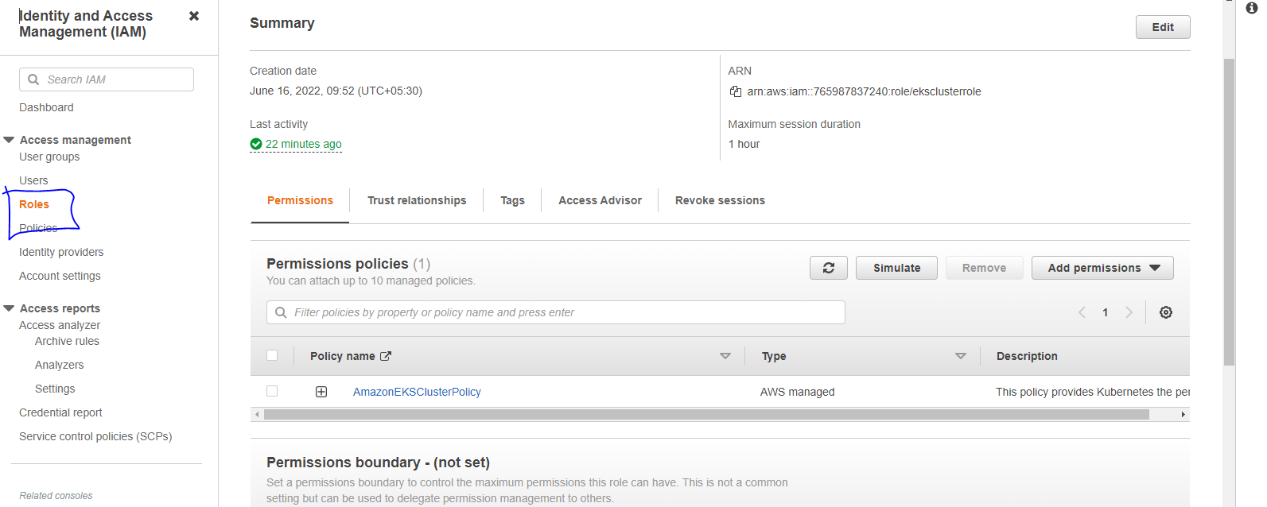

1. Ssh,http,all traffic port no
2. Cereate cluster

GO to compute

Click add node group

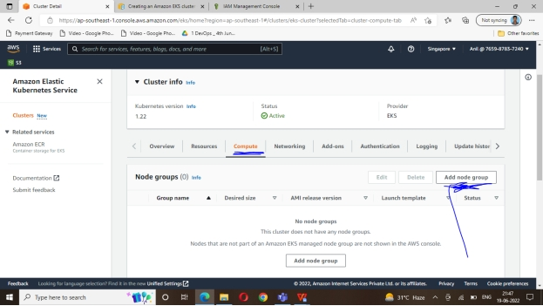

Node name

Eks-node-roles(woker-node)

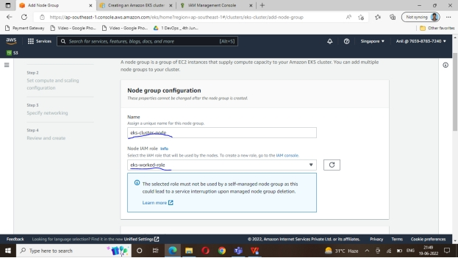

Role (eks-worked-role)( [AmazonEKSClusterPolicy](https://us-east-1.console.aws.amazon.com/iam/home#/policies/arn:aws:iam::aws:policy/AmazonEKSClusterPolicy),

[AmazonEKSWorkerNodePolicy](https://us-east-1.console.aws.amazon.com/iam/home#/policies/arn:aws:iam::aws:policy/AmazonEKSWorkerNodePolicy),

[AmazonEC2ContainerRegistryReadOnly](https://us-east-1.console.aws.amazon.com/iam/home#/policies/arn:aws:iam::aws:policy/AmazonEC2ContainerRegistryReadOnly),

[AmazonEKS_CNI_Policy](https://us-east-1.console.aws.amazon.com/iam/home#/policies/arn:aws:iam::aws:policy/AmazonEKS_CNI_Policy) ) add all these permission (already create role)

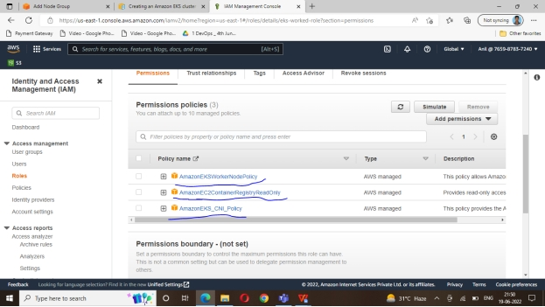

Eks After Ami, t2.medum

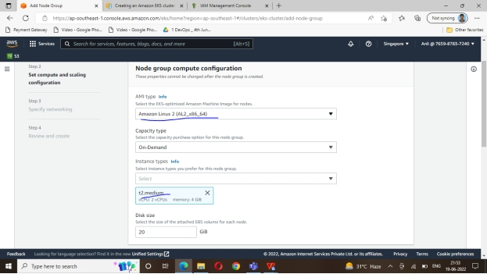

Chooses you nodes( 1 or more)

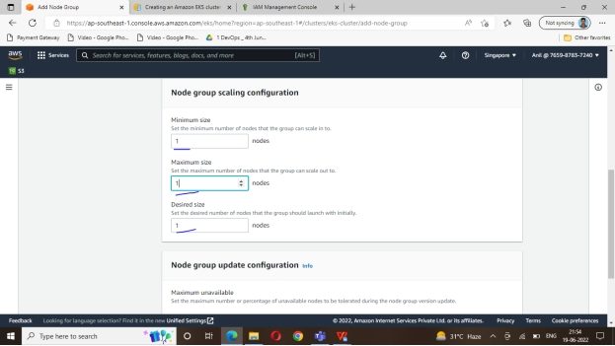

Subnet add

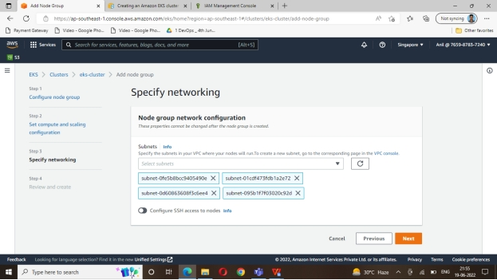

Next click

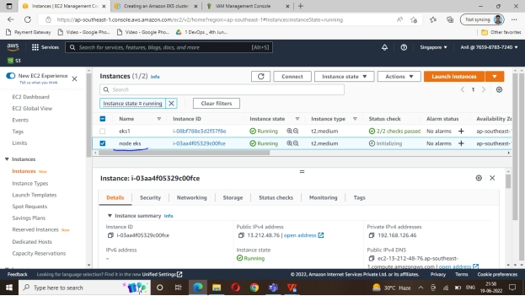

Open master terminal

Follow Below oomands

$ kubectl get all

$ kubect get nodes

Nginx installation

|  |
| --- |
| vi nginx.yaml |
|  |  |
|  | apiVersion: apps/v1 |
|  | kind: Deployment |
|  | metadata: |
|  | name: nginx |
|  | spec: |
|  | selector: |
|  | matchLabels: |
|  | run: nginx |
|  | replicas: 2 |
|  | template: |
|  | metadata: |
|  | labels: |
|  | run: nginx |
|  | spec: |
|  | containers: |
|  | - name: nginx |
|  | image: nginx:1.7.9 |
|  | ports: |
|  | - containerPort: 80 |
|  | ==== |
|  | $ kubectl apply -f nginx.yaml |
|  | ==== |
|  |  |
|  | vi nginx.svs.yaml |
|  | ----- |
|  | apiVersion: v1 |
|  | kind: Service |
|  | metadata: |
|  | name: nginx |
|  | labels: |
|  | run: nginx |
|  | spec: |
|  | ports: |
|  | - port: 80 |
|  | protocol: TCP |
|  | selector: |
|  | run: nginx |
|  | type: LoadBalancer |
|  | === |
|  | kubectl apply -f nginx.svc.yaml |
|  | ===== |

$ kubectl get svc

|  |
| --- |
| https://github.com/anilkumar9494/eks-.git |
|  |  |
|  |  |
|  |  |
|  |  |
|  |  |
|  |  |
|  |  |
|  |  |
|  |  |
|  |  |
|  |  |
|  |  |
|  |  |
|  |  |
|  |  |
|  |  |
|  |  |
|  |  |
|  |  |
|  |  |
|  |  |
|  |  |
|  |  |
|  |  |
|  |  |
|  |  |
|  |  |
|  |  |
|  |  |
|  |  |
|  |  |
|  |  |
|  |  |
|  |  |
|  |  |
|  |  |
|  |  |
|  |  |
|  |  |
|  |  |
|  |  |
|  |  |
|  |  |
|  |  |
|  |  |
|  |  |
|  |  |
|  |  |
|  |  |
|  |  |
|  |  |
|  |  |
|  |  |
|  |  |
|  |  |
|  |  |  |
|  |  |
|  |  |
|  |  |
|  |  |
|  |  |
|  |  |
|  |  |
|  |  |
|  |  |
|  |  |
|  |  |
|  |  |
|  |  |
|  |  |
|  |  |
|  |  |
|  |  |
|  |  |
|  |  |
|  |  |
|  |  |
|  |  |
|  |  |
|  |  |
|  |  |
|  |  |
|  |  |
|  |  |
|  |  |
|  |  |
|  |  |
|  |  |
|  |  |
|  |  |
|  |  |
|  |  |
|  |  |
|  |  |
|  |  |
|  |  |
|  |  |
|  |  |