**Subject: Analysis of Search Functionality Issues and Recommendations**

Dear sir,

I hope this email finds you well. I wanted to provide you with an update on the recent analysis we conducted regarding the search functionality on BingHive. Our goal was to identify any issues users might be facing and suggest recommendations for improvement.

**Key Issues Identified**:

1. **Unresponsive Search Button**: Many users have reported that the search button becomes unresponsive at times, preventing them from executing their search queries effectively.

2. **Ineffective Search Results**: A significant number of users are struggling to find the content they are looking for. The ordering algorithm for search results needs refinement to ensure that relevant content appears at the top of the list.

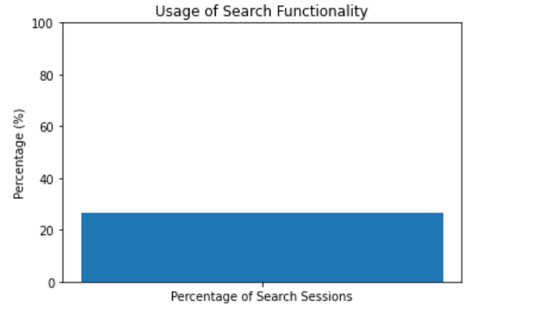

3**. Search Errors**: Users have reported encountering errors after running search queries. These errors are hindering their ability to find content and negatively impacting their experience.

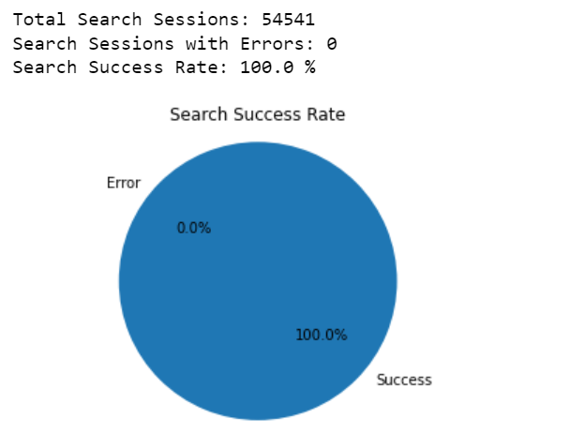

4. **Autocomplete Suggestions**: Users find the autocomplete suggestions less helpful in predicting their search intent. Improving the accuracy of these suggestions can enhance the user experience.

**Identified User Categories**:

1. **OS-specific Issues:** The analysis revealed that certain operating systems and their versions are more prone to experiencing search-related problems.

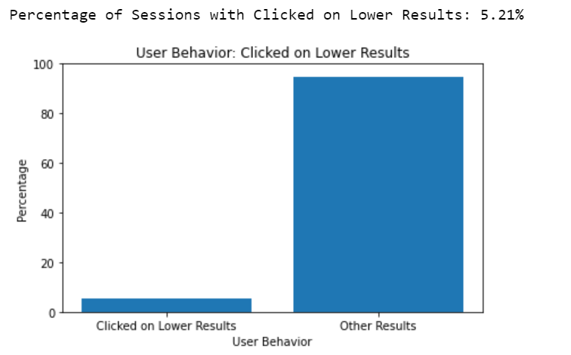

1. **Device-specific Challenges**: Specific devices are also encountering issues with the search functionality, highlighting the need for tailored improvements.

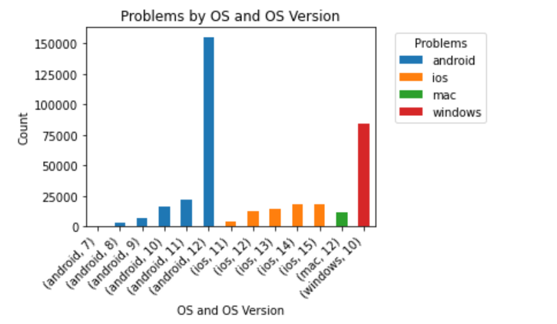

**Recommendations:**

1. **Optimize Search Algorithm**: Collaborate with the tech team to review and optimize the search algorithm to ensure that relevant results appear at the top of the list.

2. **Enhance Autocomplete Suggestions**: Utilize machine learning techniques to offer more accurate autocomplete suggestions that align with users' search intent.

3. **Responsive Design Testing**: Conduct comprehensive testing of the search feature across various devices and operating systems to ensure consistent responsiveness.

4. **User-Centric Design**: Incorporate user feedback and conduct user testing sessions to identify pain points and tailor the search experience accordingly.

5. **Error Handling and Reporting**: Implement a robust error-handling mechanism to provide users with clear error messages and an option to report issues.

6. **A/B Testing**: Consider A/B testing to evaluate the effectiveness of any changes made to the search functionality.

I believe addressing these issues will significantly enhance user satisfaction and engagement with the platform. I'd be happy to discuss these findings further and provide more detailed insights if needed.

Best regards,

Bapathi Anil Kumar

Product Analyst

anilkumarbapathi5100@gmail.com

9392472312