Internship Report
On
Breast Cancer Detection Using Machine Learning
Submitted
To
School of Computer Science and Engineering
IILM University, Greater Noida, U.P.
In partial fulfilment of the requirement of degree of
B.Tech CSE

By
Roll Number of Student: CS-23411451
Name of Student: ANIL KUMAR SAH
Batch: 2023-27
2026-27

CANDIDATE'S DECLARATION
I, Anil Kumar Sah, do hereby declare that the internship report titled "Breast Cancer Detection Using Machine Learning" has been completed by me to fulfil the requirement for the award of the degree of Bachelor of Technology in CSE. All the references have been quoted and I have not taken as such any material from any other source. I affirm that this report is my own and has not been submitted to any other institute for any degree/diploma requirement and further I shall be solely responsible for any kind of copyright violation in this regard.
Signature
Student Name: Anil Kumar Sah
Roll No.: CS-23411451

ACKNOWLEDGEMENT
I am using this opportunity to express my gratitude to everyone who supported me throughout the internship program. I am thankful to Cognify for providing me the opportunity to work as an AIML Engineer and gain practical, hands-on exposure to real-world machine learning problems.
I am sincerely grateful to my mentors and colleagues at Cognify for their aspiring guidance, invaluable constructive criticism and friendly advice during the course of this internship. Their support was instrumental in helping me understand the practical aspects of building and evaluating a machine learning model.
I would also like to thank the faculty of the School of Computer Science and Engineering, IILM University, for their continuous academic support and encouragement throughout this internship.
I express my gratitude to my parents for their blessings.
Signature
Student Name: Anil Kumar Sah
Roll No.: CS-23411451

TABLE OF CONTENTS
Chapter No. | Chapter Name | Page Nos.
 | Cover Page | ---
1. | Candidate's Declaration | i
2. | Acknowledgement | ii
3. | Internship Completion Certificate | iv
4. | Project Description
 | 4.1 Introduction | 1
 | 4.2 Organization Profile | 1
 | 4.3 Problem Statement | 1
 | 4.4 Project Objectives | 1
 | 4.5 Scope of the Project | 2
 | 4.6 Technologies and Tools Used | 2
 | 4.7 System Architecture | 2
 | 4.8 Methodology | 3
 | 4.9 Expected Outcomes | 4
 | 4.10 Certificates and Communication Proof | 6
5. | Bibliography/References | 7

INTERNSHIP COMPLETION CERTIFICATE



4. Project Description

4.1 Introduction
Breast cancer is one of the most common forms of cancer diagnosed worldwide, and early detection plays a critical role in improving treatment outcomes and survival rates. Machine learning offers a powerful, data-driven approach to assist in the classification of tumors as benign or malignant based on measurable characteristics of cell nuclei obtained from diagnostic imaging.
This report documents the work carried out during a one-month internship as an AIML Engineer, in which a supervised machine learning model was developed to classify breast cancer tumors using the Breast Cancer Wisconsin (Diagnostic) dataset. The project covers the complete pipeline of a typical machine learning task: data loading, cleaning, preprocessing, feature scaling, model building using the K-Nearest Neighbors (KNN) algorithm, hyperparameter tuning and performance evaluation.

4.2 Organization Profile
The internship was undertaken at Cognify, a technology company working on applied artificial intelligence and machine learning solutions. As an AIML Engineer, the intern was involved in an individual, project-based assignment focused on applying machine learning techniques to a real-world medical diagnostic classification problem, over a duration of one month.

4.3 Problem Statement
Early and accurate diagnosis of breast cancer is critical for effective treatment. Manual interpretation of diagnostic measurements can be time-consuming and is susceptible to human error. There is, therefore, a need for a reliable, data-driven approach that can classify tumors as benign or malignant using measurable cell-nuclei features, thereby supporting faster and more consistent diagnostic decisions.

4.4 Project Objectives
- To load and explore the Breast Cancer Wisconsin dataset.
- To clean and preprocess the data, removing irrelevant columns such as ID and unnamed fields.
- To split the data into training and testing sets.
- To apply feature scaling using StandardScaler for uniform feature contribution.
- To build a K-Nearest Neighbors (KNN) classification model.
- To tune the value of k for optimal model performance.
- To evaluate the model using the accuracy score metric.
- To visualize accuracy trends across different values of k.

4.5 Scope of the Project
The scope of this project covers an end-to-end machine learning pipeline: data loading, cleaning, preprocessing, feature scaling, model building, hyperparameter tuning and performance evaluation. The project is implemented in Python using the Google Colab environment, and the trained model classifies tumors into two categories - Malignant (M) and Benign (B) - based on thirty numeric features describing the characteristics of cell nuclei present in digitized images of breast mass.

4.6 Technologies and Tools Used
Technology / Tool | Purpose
Python | Core programming language
Pandas / NumPy | Data loading and manipulation
Scikit-learn | Machine learning library (KNN, scaling, metrics)
Matplotlib | Visualization of results
Google Colab | Development and execution environment
StandardScaler | Feature scaling / normalization
K-Nearest Neighbors (KNN) | Classification algorithm
Git / GitHub | Source control

4.7 System Architecture
The system follows a linear machine learning pipeline in which data flows through a series of well-defined stages, from raw input to final evaluated output, as summarized below:
- Dataset - Breast cancer CSV data loaded using Pandas.
- Preprocessing - Removal of irrelevant columns, train-test split, and feature scaling.
- Model Training - Fitting a K-Nearest Neighbors classifier on the training data.
- Hyperparameter Tuning - Testing values of k from 1 to 15 to identify the optimal setting.
- Model Evaluation - Measuring performance using the accuracy score metric.
- Visualization - Plotting accuracy against k to identify the best-performing model.

4.8 Methodology
The project followed an iterative methodology consisting of six stages: data collection, preprocessing, model building, training, evaluation and iteration. Each stage is described below along with representative code snippets.
1. Data Collection: The dataset was loaded into a Pandas DataFrame directly from a CSV file.

import numpy as np
import pandas as pd

df = pd.read_csv('Breast cancer data.csv')
df.head()

2. Preprocessing: Irrelevant columns were removed, and the data was split into training and testing sets before applying feature scaling.

df.drop(columns=['id', 'Unnamed: 32'], inplace=True)

from sklearn.model_selection import train_test_split
X_train, X_test, y_train, y_test = train_test_split(
df.iloc[:, 1:], df.iloc[:, 0], test_size=0.2, random_state=2)

from sklearn.preprocessing import StandardScaler
sc = StandardScaler()
X_train = sc.fit_transform(X_train)
X_test = sc.transform(X_test)

3. Model Building and Training: A K-Nearest Neighbors classifier was initialized and trained on the scaled training data.

from sklearn.neighbors import KNeighborsClassifier
knn = KNeighborsClassifier(n_neighbors=5)
knn.fit(X_train, y_train)

4. Evaluation: The trained model was used to predict outcomes on the test set, and accuracy was calculated.

from sklearn.metrics import accuracy_score
y_pred = knn.predict(X_test)
accuracy_score(y_test, y_pred)
# Output: 0.9736842105263158

5. Hyperparameter Tuning: The model was retrained for k values ranging from 1 to 15, and the resulting accuracies were recorded and plotted.

scores = []
for i in range(1, 16):
knn = KNeighborsClassifier(n_neighbors=i)
knn.fit(X_train, y_train)
y_pred = knn.predict(X_test)
scores.append(accuracy_score(y_test, y_pred))

import matplotlib.pyplot as plt
plt.plot(range(1, 16), scores)

6. Iteration: Based on the plotted results, k = 3 was identified as the optimal number of neighbors, and the model was retrained accordingly.

knn = KNeighborsClassifier(n_neighbors=3)
knn.fit(X_train, y_train)
y_pred = knn.predict(X_test)
accuracy_score(y_test, y_pred)
# Output: 0.9912280701754386

4.9 Expected Outcomes
The initial model, built with the default setting of k = 5, achieved a test accuracy of approximately 97.37%. To improve upon this, the model was evaluated across k values ranging from 1 to 15, and the accuracy for each value was plotted, as shown in Figure 4.1.
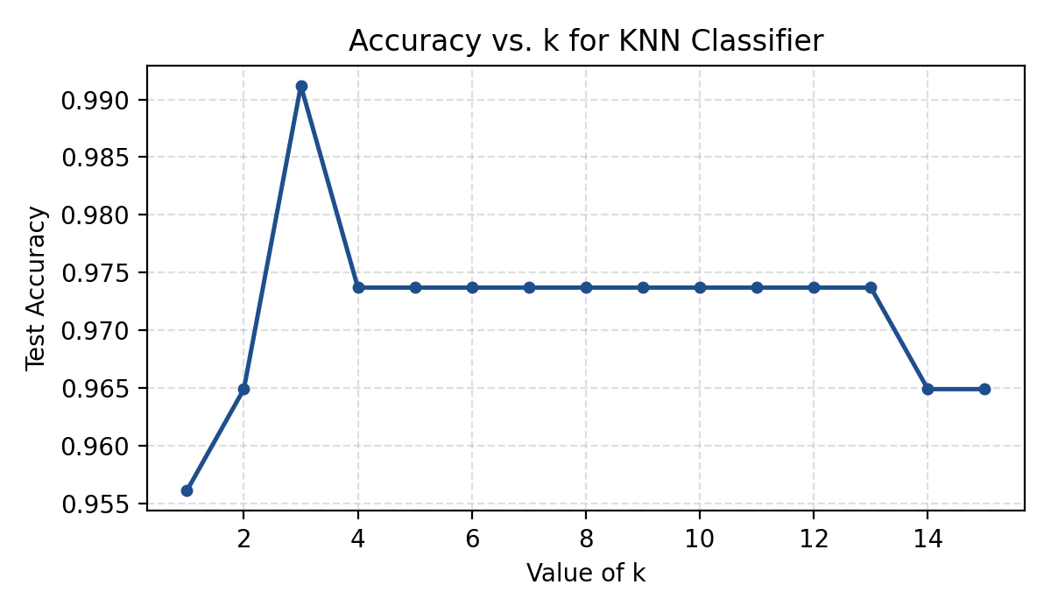
Figure 4.1: Test Accuracy vs. Value of k for the KNN Classifier
The analysis showed that the model achieved its best performance at k = 3, with a test accuracy of approximately 99.12%, a notable improvement over the default configuration. This demonstrates the importance of hyperparameter tuning in improving the performance of a K-Nearest Neighbors classifier.
The key outcomes of this internship project are summarized below:
- Practical understanding of an end-to-end supervised machine learning workflow.
- Achieved approximately 99.1% test accuracy with a KNN classifier at k = 3.
- Hands-on experience with Python, Pandas, NumPy, Scikit-learn and Matplotlib.
- Understood the impact of feature scaling and k-value tuning on model performance.
- Gained experience in exploratory data analysis and result visualization.
- Improved ability to independently research, implement and evaluate machine learning models.

4.10 Certificates of Completion

5. Bibliography/References
1. Pedregosa, F., et al. (2011). Scikit-learn: Machine Learning in Python. Journal of Machine Learning Research, 12, 2825-2830. Available at: https://scikit-learn.org/stable/documentation.html
2. UCI Machine Learning Repository. Breast Cancer Wisconsin (Diagnostic) Data Set. Available at: https://archive.ics.uci.edu/dataset/17/breast+cancer+wisconsin+diagnostic
3. McKinney, W. (2010). Data Structures for Statistical Computing in Python. Proceedings of the 9th Python in Science Conference. Pandas documentation available at: https://pandas.pydata.org/docs/
4. Harris, C.R., et al. (2020). Array Programming with NumPy. Nature, 585, 357-362. Available at: https://numpy.org/doc/
5. Hunter, J.D. (2007). Matplotlib: A 2D Graphics Environment. Computing in Science & Engineering, 9(3), 90-95. Available at: https://matplotlib.org/stable/contents.html
6. Python Software Foundation. Python Language Reference. Available at: https://docs.python.org/3/
7. Google Colaboratory Documentation. Available at: https://research.google.com/colaboratory/faq.html

