EdTech Data Analysis using Azure SQL & Azure Data Factory
Problem Statement
SkillBridge Learning aims to analyze client, course, service, and workforce data to align training programs with industry requirements. The challenge is to identify suitable candidates, optimize services, and improve deployment strategies using structured data.
Objective
The objective of this project is to utilize Azure SQL Database and Azure Data Factory to store, transform, and analyze client data. The goal is to derive insights for client classification, course demand, regional strategy, cost optimization, and workforce deployment.
Data Ingestion and Transformation
In this step, the dataset is ingested and transformed using Azure Data Factory. The source data is read from a delimited file containing multiple columns, where all values are initially in string format. A Mapping Data Flow is implemented to perform data transformation, where a Derived Column transformation is used to convert string values into appropriate integer data types using functions like toInteger() and to handle null values using conditional expressions. After transformation, the cleaned and structured data is loaded into Azure SQL Database. This step ensures that the data is consistent, error-free, and ready for further analysis and use case implementation.
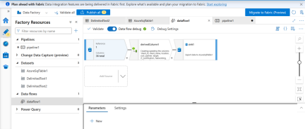
Use Case 1: Client Classification
Objective: Classify clients based on partner type, cost, and domain-specific services.
Explanation: This helps identify high-value enterprise clients, flexible SME/startup clients, and domain-specific clients such as retail and telecom.
Code:-
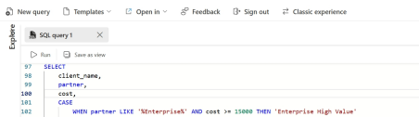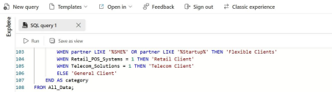Output:-
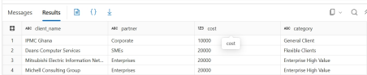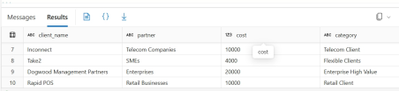
Use Case 2: Course Demand Analysis
Objective: Analyze which courses and skills are most demanded by clients.
Explanation: This helps prioritize training programs such as Networking, Cloud, Data Analytics, and ERP based on industry demand.
Code:-
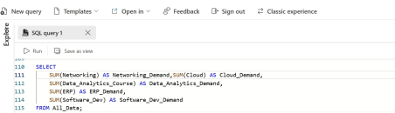Outpiut
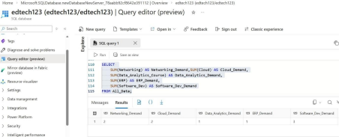
Use Case 3: Regional Strategy Planning
Objective: Analyze client distribution and cost patterns across locations.
Explanation: This helps identify high-value regions, cost-sensitive markets, and enables region-specific strategies.
Code:-
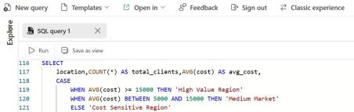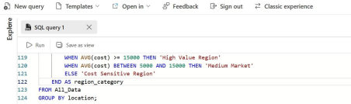Output:-
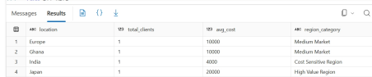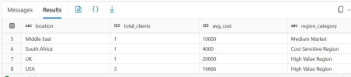
Use Case 4: Cost vs Service Optimization
Objective: Map client cost categories with the type of services utilized.
Explanation: This helps optimize service offerings such as training, IT services, and consulting based on budget levels.
Code:-
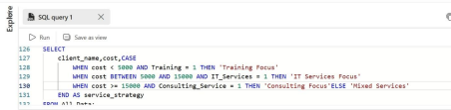Output:-
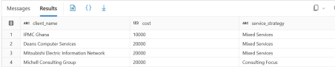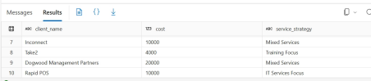
Use Case 5: Workforce Targeting & Deployment
Objective: Align workforce categories with deployment strategies.
Explanation: This ensures proper placement of freshers, engineers, analysts, and retail staff into suitable roles.
Code:-
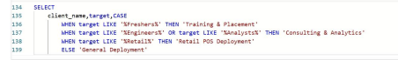
Output:-
Conclusion
This project demonstrates how Azure SQL Database and Azure Data Factory can be used to transform raw data into meaningful business insights. By analyzing client, course, service, and workforce data, organizations can improve decision-making, optimize training programs, and enhance placement success.

