Spark:
Reading the Files:
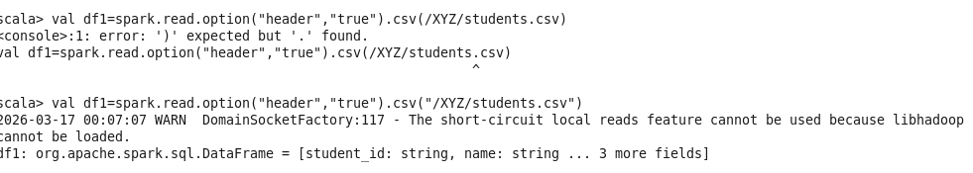

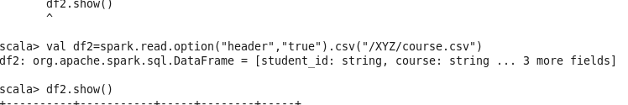

Joining the two files:
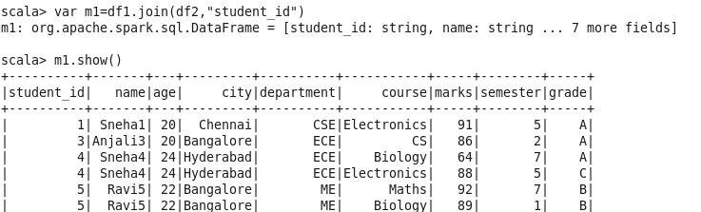

Aggregation:
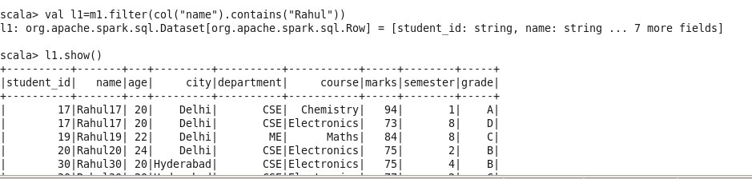

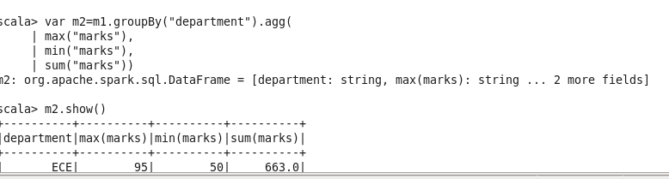

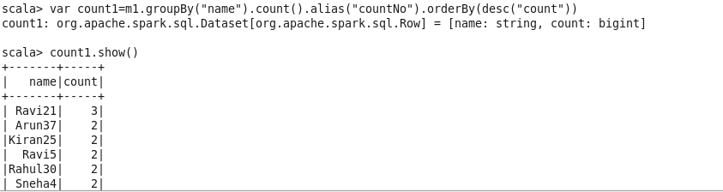

Filtering:
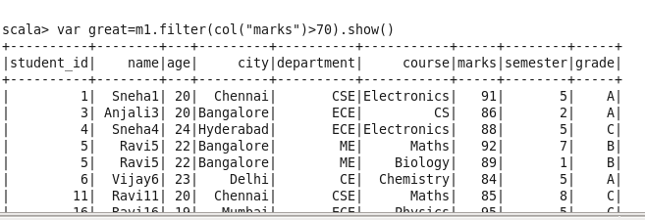

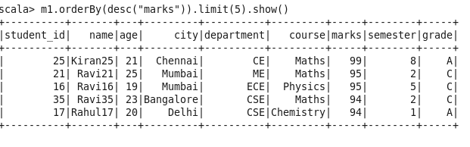

Average Marks per Department:

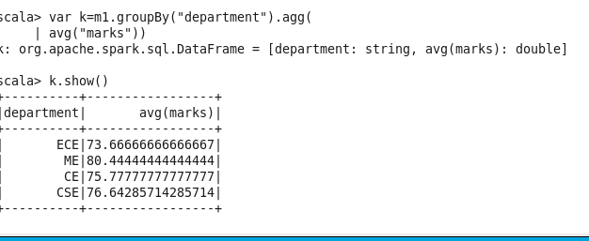

Analyze student performance by combining student and course datasets.
Find the top-performing students in each department based on marks, and display them in descending order.

Maximum marks per each department

Details of top performance in each department:

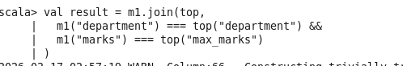

Result:
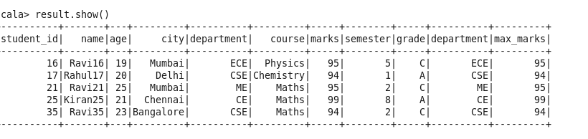

Students Scoring Above Department Average:
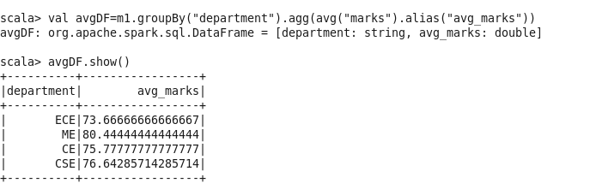

Result:
