SQL:
This database manages employee details, departments, job roles, locations, salaries, and performance reviews. It connects all these areas to give a full picture of the workforce.
For performance analysis, it shows how employees are rated each year. For salary analysis, it tracks pay and compares it with role-based ranges.
For department growth, it counts employees in each department over time. For strategic insights, it combines all data to guide decisions on hiring, promotions, pay, and planning.

Using database:
use company_db;

Creating Tables:

Department:

This table stores all the departments in the organization, with each department having a unique ID and name. It helps categorize employees based on their work area, like HR, Finance, or IT.

create table Departments1(dept_id int primary key,dept_name varchar(40) not null unique);

Location:

This table keeps track of office or branch locations. Each location has a unique ID and name, making it easy to know where employees are based.

create table Locations1(loc_id int primary key,loc_name varchar(50) not null);

Job Roles:

This table defines different job positions in the company, along with their salary ranges. It ensures clarity about roles like Manager, Developer, or Analyst.

create table jobroles(role_id int primary key,role_name varchar(50) not null,min_salary decimal(10,2),max_salary decimal(10,2));

Employees:

This is the main table that holds employee details such as name, gender, department, role, location, joining date, and status. It links employees to their department, role, and location.

create table employees1(emp_id int primary key,emp_name varchar(50) not null,
gender varchar(40),dept_id int,role_id int,loc_id int,join_date date,
status varchar(20) default 'Active',foreign key(dept_id) references Departments1(dept_id),
foreign key(role_id)references jobroles(role_id),
foreign key(loc_id) references Locations1(loc_id));

Salary:

This table records salary information for employees, including the amount and the date it became effective. It helps track salary changes over time.

create table salaries(salary_id int primary key,emp_id int,salary decimal(10,2),effective_date date,foreign key(emp_id) references employees1(emp_id));

Performance:

This table stores yearly performance ratings for employees. It helps measure how well each employee is performing, with ratings between 1 and 5.

create table performance_review(review_id int primary key,emp_id int,review_year int,rating decimal(2,1) check (rating between 1 and 5),foreign key(emp_id) references employees1(emp_id));

Inserting the values through files:

BULK INSERT Locations1
FROM 'C:\Dataset\Locatioin_dataset - Sheet1.csv'
WITH(
FORMAT = 'CSV',
FIRSTROW = 2,
FIELDTERMINATOR = ',',
ROWTERMINATOR = '\n',
TABLOCK);
select * from Locations1;

BULK INSERT Departments1
FROM 'C:\Dataset\Departments Dataset - Sheet1.csv'
WITH(
FORMAT = 'CSV',
FIRSTROW = 2,
FIELDTERMINATOR = ',',
ROWTERMINATOR = '\n',
TABLOCK);
select * from Departments1

BULK INSERT jobroles
FROM 'C:\Dataset\Job_roles_dataset - Sheet1.csv'
WITH ( FIRSTROW = 2, FIELDTERMINATOR = ',', ROWTERMINATOR = '\n', TABLOCK );
select * from jobroles

BULK INSERT employees1
FROM 'C:\Dataset\Employee.csv'
WITH(
FORMAT = 'CSV',
FIRSTROW = 2,
FIELDTERMINATOR = ',',
ROWTERMINATOR = '\n',
TABLOCK);
select * from employees1

BULK INSERT salaries
FROM 'C:\Dataset\Salaries_Data - Salaries_Data.csv'
WITH(
FORMAT = 'CSV',
FIRSTROW = 2,
FIELDTERMINATOR = ',',
ROWTERMINATOR = '\n',
TABLOCK);
select * from salaries

BULK INSERT performance_review
FROM 'C:\Dataset\performance.xlsx - Sheet1.csv'
WITH(
FORMAT = 'CSV',
FIRSTROW = 2,
FIELDTERMINATOR = ',',
ROWTERMINATOR = '\n',
TABLOCK);
select * from performance_review

Task to perform:
Performance Analysis:

1.Top 10 Performances of employees

SELECT TOP 10
e.emp_id,
e.emp_name,
d.dept_name,
jr.role_name,
AVG(pr.rating) AS avg_rating
FROM employees1 e
JOIN Departments1 d ON e.dept_id = d.dept_id
JOIN jobroles jr ON e.role_id = jr.role_id
JOIN performance_review pr ON e.emp_id = pr.emp_id
GROUP BY e.emp_id, e.emp_name, d.dept_name, jr.role_name
ORDER BY avg_rating DESC;

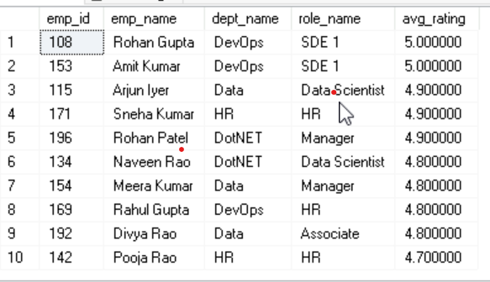

2.Average rating per department

SELECT d.dept_id,
d.dept_name,
AVG(pr.rating) AS avg_rating
FROM Departments1 d
JOIN employees1 e ON d.dept_id = e.dept_id
JOIN performance_review pr ON e.emp_id = pr.emp_id
GROUP BY d.dept_id, d.dept_name
ORDER BY avg_rating DESC;

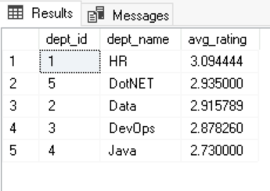

3.Employees eliggible for promotions(rating>4 & 2+Years)

SELECT e.emp_id,
e.emp_name,
d.dept_name,
jr.role_name,
AVG(pr.rating) AS avg_rating,
DATEDIFF(year, e.join_date, GETDATE()) AS years_in_company
FROM employees1 e
JOIN Departments1 d ON e.dept_id = d.dept_id
JOIN jobroles jr ON e.role_id = jr.role_id
JOIN performance_review pr ON e.emp_id = pr.emp_id
WHERE e.status = 'Active'
GROUP BY e.emp_id, e.emp_name, d.dept_name, jr.role_name, e.join_date
HAVING AVG(pr.rating) >= 4.0
AND DATEDIFF(year, e.join_date, GETDATE()) >= 3
ORDER BY avg_rating DESC, years_in_company DESC;

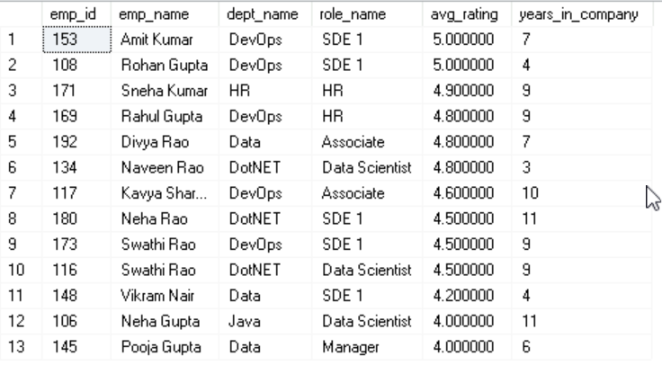

4.performance trend over years
SELECT
review_year,
AVG(rating) AS avg_rating,
MIN(rating) AS min_rating,
MAX(rating) AS max_rating,
COUNT(*) AS total_reviews
FROM performance_review
GROUP BY review_year
ORDER BY review_year;

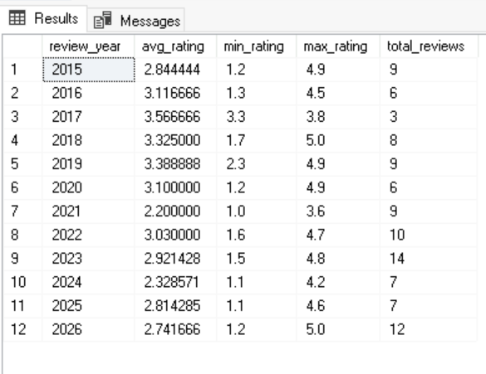

salary analytics

5.Highest and lowest salary per role
select max(s.salary),min(s.salary),j.role_id from salaries s inner join employees1 e on s.emp_id=e.emp_id inner join jobroles j on j.role_id=e.role_id group by j.role_id;

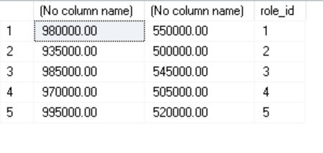

6.Salary distribution per department
SELECT
d.dept_id,
d.dept_name,
MIN(s.salary) AS min_salary,
MAX(s.salary) AS max_salary,
AVG(s.salary) AS avg_salary,
COUNT(s.salary) AS total_employees
FROM Departments1 d
JOIN employees1 e ON d.dept_id = e.dept_id
JOIN salaries s ON e.emp_id = s.emp_id
GROUP BY d.dept_id, d.dept_name
ORDER BY d.dept_name;

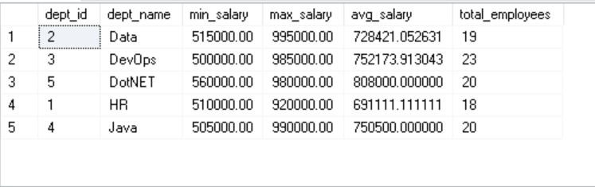

7.salary vs performance correlation
SELECT
SUM((sp.salary - st.avg_salary) * (sp.rating - st.avg_rating)) /
SQRT(SUM(POWER(sp.salary - st.avg_salary, 2)) * SUM(POWER(sp.rating - st.avg_rating, 2)))
AS correlation_coefficient
FROM (
SELECT
s.salary,
p.rating
FROM employees1 e
JOIN salaries s ON e.emp_id = s.emp_id
JOIN performance_review p ON e.emp_id = p.emp_id
) sp
CROSS JOIN (
SELECT
AVG(s.salary) AS avg_salary,
AVG(p.rating) AS avg_rating
FROM employees1 e
JOIN salaries s ON e.emp_id = s.emp_id
JOIN performance_review p ON e.emp_id = p.emp_id
) st;

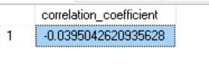

8.Employees below department average salalry
SELECT
e.emp_id,
e.emp_name,
d.dept_name,
s.salary
FROM employees1 e
JOIN Departments1 d ON e.dept_id = d.dept_id
JOIN salaries s ON e.emp_id = s.emp_id
WHERE s.salary < (
SELECT AVG(s2.salary)
FROM employees1 e2
JOIN salaries s2 ON e2.emp_id = s2.emp_id
WHERE e2.dept_id = e.dept_id
);

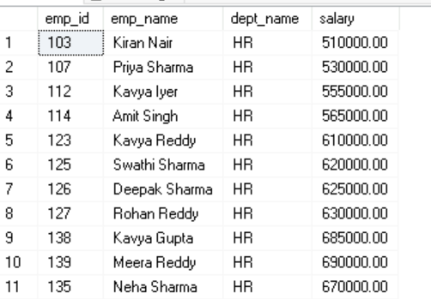

Department Growth
9.hiring trend per year
SELECT
YEAR(join_date) AS hire_year,
COUNT(*) AS total_hired
FROM employees1
GROUP BY YEAR(join_date)
ORDER BY hire_year;
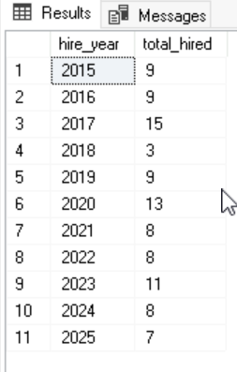

10.headcount growth by department
SELECT
d.dept_name,
YEAR(e.join_date) AS hire_year,
COUNT(e.emp_id) AS headcount
FROM employees1 e
JOIN Departments1 d ON e.dept_id = d.dept_id
GROUP BY d.dept_name, YEAR(e.join_date)
ORDER BY d.dept_name, hire_year;
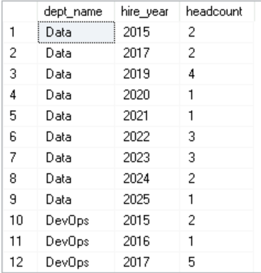

Strategic Insights
12.Employees overdue for promotion
SELECT e.emp_id,
e.emp_name,
e.join_date,
DATEDIFF(year, e.join_date, GETDATE()) AS years_in_company,
AVG(pr.rating) AS avg_rating,
jr.role_name,
d.dept_name,
l.loc_name
FROM employees1 e
JOIN jobroles jr ON e.role_id = jr.role_id
JOIN Departments1 d ON e.dept_id = d.dept_id
JOIN Locations1 l ON e.loc_id = l.loc_id
LEFT JOIN performance_review pr ON e.emp_id = pr.emp_id
GROUP BY e.emp_id, e.emp_name, e.join_date, jr.role_name, d.dept_name, l.loc_name
HAVING DATEDIFF(year, e.join_date, GETDATE()) >= 5
AND AVG(pr.rating) >= 4.0
ORDER BY years_in_company DESC, avg_rating DESC;
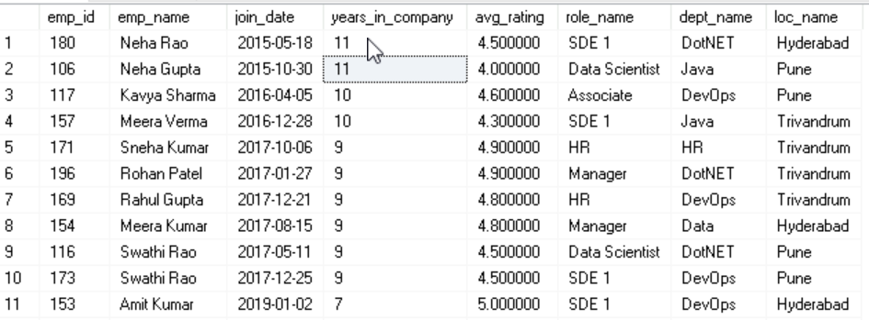

13.High Salary but low performance cases
SELECT e.emp_id,
e.emp_name,
jr.role_name,
d.dept_name,
l.loc_name,
s.salary,
pr.rating
FROM employees1 e
JOIN jobroles jr ON e.role_id = jr.role_id
JOIN Departments1 d ON e.dept_id = d.dept_id
JOIN Locations1 l ON e.loc_id = l.loc_id
JOIN salaries s ON e.emp_id = s.emp_id
JOIN performance_review pr ON e.emp_id = pr.emp_id
WHERE s.salary > (
SELECT AVG(salary)
FROM salaries
)
AND pr.rating < 3.0
ORDER BY s.salary DESC, pr.rating ASC;
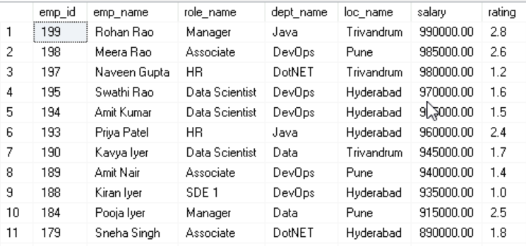

16.Location-wise salary comparison
SELECT l.loc_id,
l.loc_name,
COUNT(e.emp_id) AS total_employees,
ROUND(AVG(s.salary), 2) AS avg_salary,
MIN(s.salary) AS min_salary,
MAX(s.salary) AS max_salary
FROM Locations1 l
JOIN employees1 e ON l.loc_id = e.loc_id
JOIN salaries s ON e.emp_id = s.emp_id
GROUP BY l.loc_id, l.loc_name
ORDER BY avg_salary DESC;

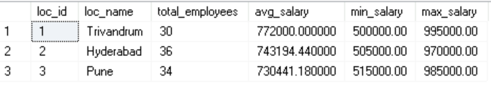

17.Gender diversity ratio(if added)
SELECT d.dept_id,
d.dept_name,
COUNT(e.emp_id) AS total_employees,
SUM(CASE WHEN LOWER(e.gender) = 'male' THEN 1 ELSE 0 END) AS male_count,
SUM(CASE WHEN LOWER(e.gender) = 'female' THEN 1 ELSE 0 END) AS female_count,
ROUND(
(CAST(SUM(CASE WHEN LOWER(e.gender) = 'female' THEN 1 ELSE 0 END) AS FLOAT)
/ COUNT(e.emp_id)) * 100, 2
) AS female_ratio_pct,
ROUND(
(CAST(SUM(CASE WHEN LOWER(e.gender) = 'male' THEN 1 ELSE 0 END) AS FLOAT)
/ COUNT(e.emp_id)) * 100, 2
) AS male_ratio_pct
FROM Departments1 d
JOIN employees1 e ON d.dept_id = e.dept_id
GROUP BY d.dept_id, d.dept_name
ORDER BY female_ratio_pct DESC;

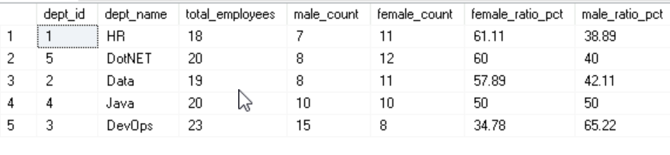

18.Median salary calculation

SELECT
AVG(1.0 * salary) AS median_salary
FROM (
SELECT salary,
ROW_NUMBER() OVER (ORDER BY salary) AS rn,
COUNT(*) OVER () AS cnt
FROM salaries
) AS t
WHERE rn IN ((cnt + 1) / 2, (cnt + 2) / 2);

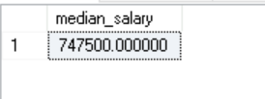

19.Employees with multiple promotions
SELECT e.emp_id,
e.emp_name,
COUNT(DISTINCT e.role_id) AS role_changes
FROM employees1 e
JOIN salaries s ON e.emp_id = s.emp_id
GROUP BY e.emp_id, e.emp_name
HAVING COUNT(DISTINCT e.role_id) > 1
ORDER BY role_changes DESC;
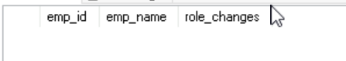
There is no values to print for the case.

20.Identify leadership pipeline candidates
SELECT e.emp_id,
e.emp_name,
d.dept_name,
jr.role_name,
AVG(pr.rating) AS avg_rating,
DATEDIFF(year, e.join_date, GETDATE()) AS years_in_company,
COUNT(DISTINCT e.role_id) AS role_changes
FROM employees1 e
JOIN Departments1 d ON e.dept_id = d.dept_id
JOIN jobroles jr ON e.role_id = jr.role_id
JOIN performance_review pr ON e.emp_id = pr.emp_id
WHERE e.status = 'Active'
GROUP BY e.emp_id, e.emp_name, d.dept_name, jr.role_name, e.join_date
HAVING AVG(pr.rating) >= 4.0
AND DATEDIFF(year, e.join_date, GETDATE()) >= 3
AND COUNT(DISTINCT e.role_id) >= 1
ORDER BY avg_rating DESC, years_in_company DESC;
