Azure Virtual Machine (VM) Creation

1. Introduction
This document describes the steps followed to create a Virtual Machine (VM) in Microsoft Azure. Azure Virtual Machines allow users to run applications and services in the cloud.

2. Prerequisites
- Azure account
- Access to Azure Portal
- Basic knowledge of cloud computing

3. Steps to Create VM in Azure
Login to Azure Portal.

Click on 'Create a resource'.
Select 'Virtual Machine'.
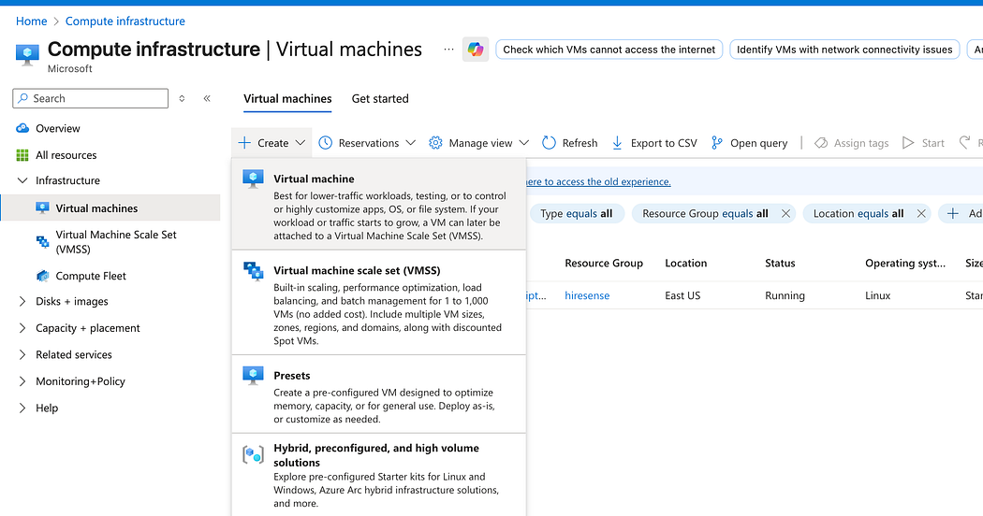
Choose subscription and resource group.
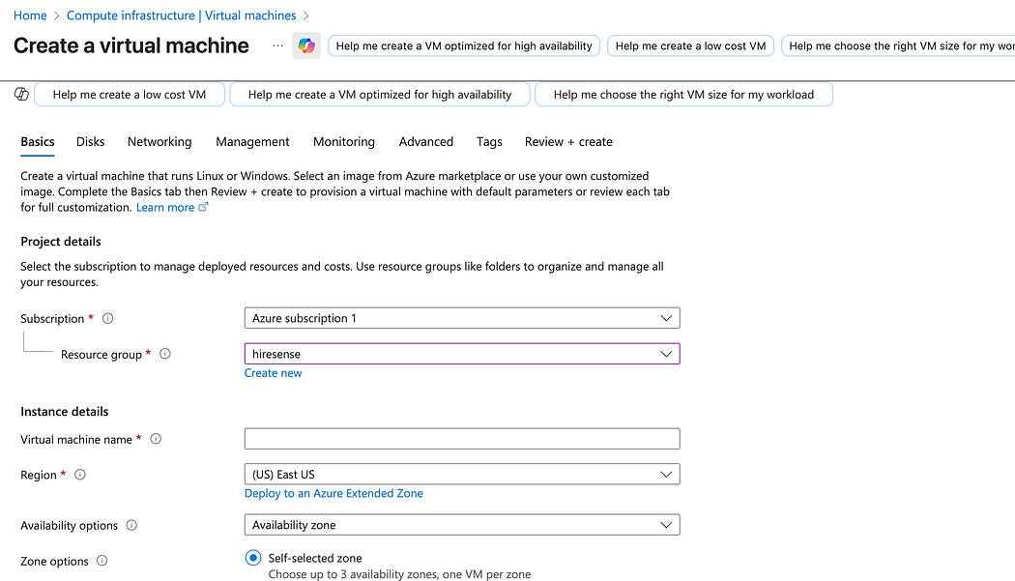
Enter VM name and select region.

Choose image (e.g., Ubuntu/Windows).
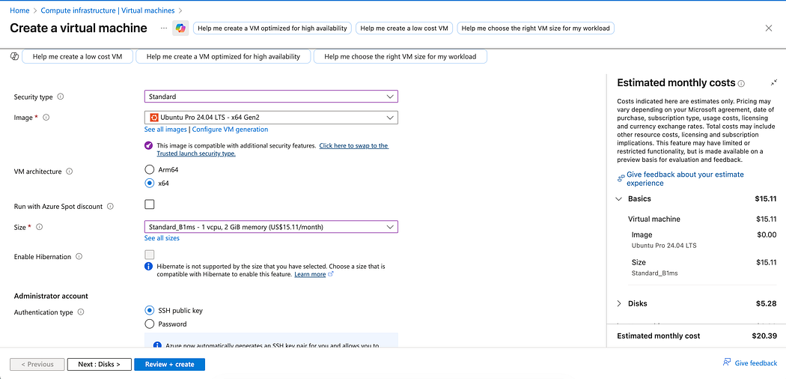
Select VM size based on requirements.

Configure authentication (username/password or SSH key).
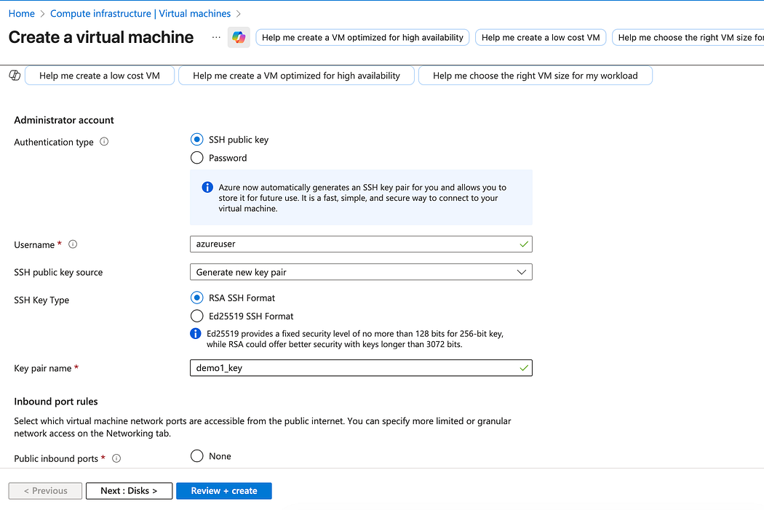
Configure inbound ports (e.g., SSH - 22, HTTP - 80).
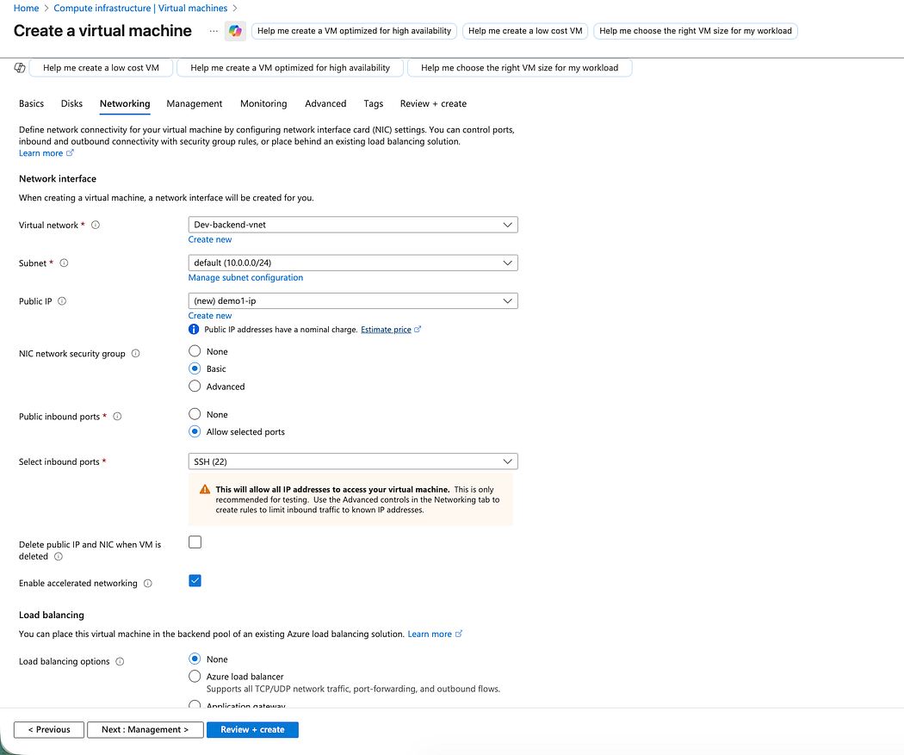
Review and create the VM.

Wait for deployment to complete.
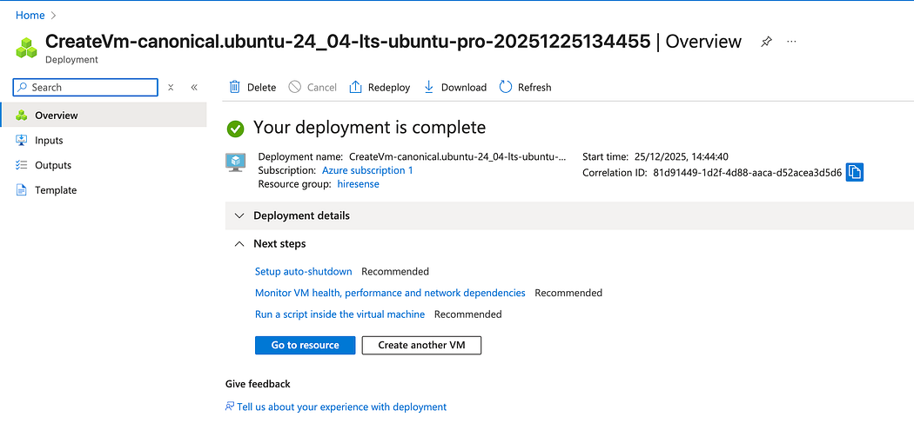

4. Post Deployment Steps
- Connect to VM using SSH or RDP.
- Install required software.
- Configure applications.

5. Conclusion
The Azure VM was successfully created and is ready for use. It can be used for hosting applications, testing environments, or data processing tasks.

