ASSIGNMENT REPORT
Course: CSA0701 - Computer Networks
COMPUTER NETWORKS
ASSIGNMENT 1 (CO1) - SOLUTION REPORT
Make the Data of a Smart Manufacturing Plant Arrive Correctly and On Time
Field | Details
Student name | K. Anil Kumar Reddy
Register number | 192525239
Course code | CSA0701
Course name | Computer Networks
Assignment | Assignment 1 - Individual - Total marks 50 (Bloom's level K5 - Evaluate)
GitHub repository | CSA07-192525239-Assignment1 (paste your link here: https://github.com/<your-username>/CSA07-192525239-Assignment1)
Tools used | Python 3, Cisco Packet Tracer, Wireshark, ethtool, ping, traceroute

Contents of this report
Task | Topic | Marks | Task | Topic | Marks
1 | Traffic sizing | 4 | 7 | Error detection (CRC) | 4
2 | Collision / broadcast domains, standards | 3 | 8 | Error correction (Hamming) | 3
3 | Frame read layer by layer | 4 | 9 | Window size and ARQ | 4
4 | Transmission media, Shannon | 4 | 10 | Delay analysis (traceroute) | 4
5 | Wi-Fi 6 or 5G, hand-over | 4 | 11 | Final recommendation | 4
6 | Ethernet port report | 4 | 12 | Design challenge: private 5G + AGVs | 8

Scenario in one line: robots need commands within 10 ms, hundreds of sensors report data, CCTV streams video, office staff use ERP/e-mail, and the plant talks to a head office 400 km away. The contractor proposes ordinary office Wi-Fi and one broadband line. This report calculates, compares and decides - every answer is supported by working.
Repository note: GitHub folders Task01 to Task12 hold the Python files (task3_layers.py, task4_shannon.py, task7_crc.py, task8_hamming.py, task9_window.py), Packet Tracer files, screenshots and README.md.

TASK 1 - Size the Traffic Before Choosing Anything (4 marks)

Step 1 - Convert every source to Mbps
Rule used: traffic (bps) = bytes x 8 x number of messages per second x number of devices. 1 Mbps = 1,000,000 bps.
Source | Working | Result
Robot controllers (40) | 200 B x 8 = 1,600 bits; one command every 2 ms = 500 per second; 1,600 x 500 = 800,000 bps = 0.8 Mbps each; 0.8 x 40 | 32 Mbps
Vibration sensors (600) | 50 B x 8 = 400 bps each; 400 x 600 = 240,000 bps | 0.24 Mbps
CCTV cameras (24) | 4 Mbps x 24 (continuous) | 96 Mbps
Office users (150) | 10% active = 15 users; 15 x 2 Mbps | 30 Mbps
TOTAL - one line | 32 + 0.24 + 96 + 30 | 158.24 Mbps
TOTAL - plant (8 lines) | 158.24 x 8 | 1,265.92 Mbps (1.266 Gbps)

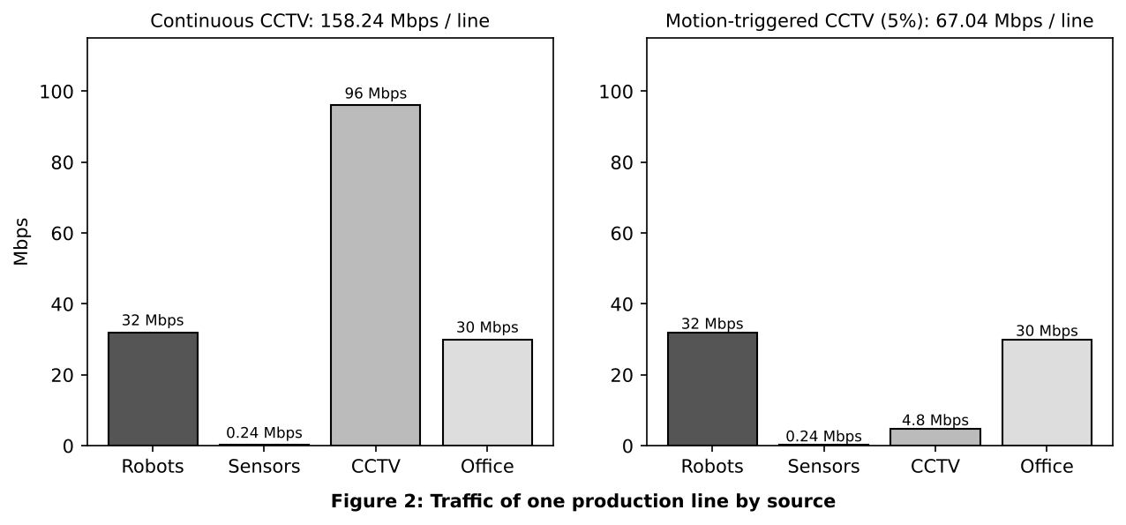

Step 2 - Biggest sender versus strictest delay
- Most data: CCTV, 96 of 158.24 Mbps = 60.7% of the line traffic.
- Strictest delay: the robot controllers (10 ms deadline) although they send only 32 Mbps (20.2%).
- Are they the same? No. The heaviest traffic (CCTV) is delay-tolerant and the most delay-critical traffic (robots) is light. This is why the design must use priority queuing and not only a bigger pipe.

Step 3 - Is a single 1 Gbps uplink enough?
- One line: 158.24 Mbps = 15.8% of 1 Gbps - enough.
- Whole plant: 1,265.92 Mbps = 126.6% of 1 Gbps - NOT enough. Even the usual 70% planning limit (700 Mbps) is passed after about 4.4 lines.
- If CCTV shares one first-in-first-out queue with robots: once the load is above 100%, the queue fills. A 1 MB switch buffer holds 8,000,000 bits and drains at 1 Gbps in 8 ms. A robot command that joins a full queue waits about 8 ms before it is sent, which with the other delays breaks the 10 ms deadline; if the buffer overflows the command is dropped. A 1,500-byte camera frame takes only 12 microseconds to send, but 24 cameras sending together put 288 microseconds in front of a command even at light load.
- Fix: put robots in a separate VLAN and give them strict-priority queuing (DSCP EF), and move CCTV to its own link or queue.

Step 4 - Ranking by harm of a 100 ms delay
Rank | Traffic | Reason
1 (worst) | Robot commands | Deadline is 10 ms; 100 ms is 10 times late, so the robot stops, overshoots or hits a part (safety risk).
2 | CCTV live video | Video buffers hide 100 ms, but alarm response and motion detection are slower and jitter shows as frozen frames.
3 | Vibration sensors | A reading per second is stale by 10%; harmless unless used for emergency shutdown.
4 (least) | Office / ERP / e-mail | Humans do not notice 100 ms in a web page, e-mail or ERP form.

Alternative Concept Analysis - motion-triggered CCTV (5% of the time)
CCTV becomes 24 x 4 Mbps x 0.05 = 4.8 Mbps. Line total = 32 + 0.24 + 4.8 + 30 = 67.04 Mbps; plant = 67.04 x 8 = 536.32 Mbps = 53.6% of 1 Gbps. The uplink is no longer the bottleneck (126.6% to 53.6%). Local recording needs storage and loses live monitoring, but removes 91.2 Mbps per line. The real bottleneck is now delay, so queue priority is still needed.
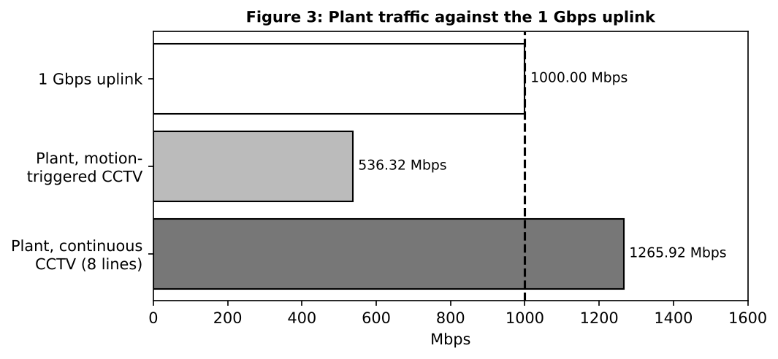

TASK 2 - Count the Domains in the Contractor's Drawing (3 marks)

Step 1 - Rules
- A hub repeats the signal to all ports, so everything connected to a hub (and the port it plugs into) is one collision domain.
- A switch gives every port its own collision domain. A router gives every interface its own broadcast domain.

Step 2 - Count
Part of the drawing | Collision domains | Why
3 hubs with 8 PCs each (hub + the switch port it uses) | 3 | One shared segment per hub
24-port switch to router G0/0 | 1 | Single cable between two devices
Router G0/1 to second switch | 1 | Single cable between two devices
12 IP phones on the second switch | 12 | One switch port (one cable) per phone
TOTAL collision domains | 17 | 3 + 1 + 1 + 12
TOTAL broadcast domains | 2 | One behind G0/0, one behind G0/1

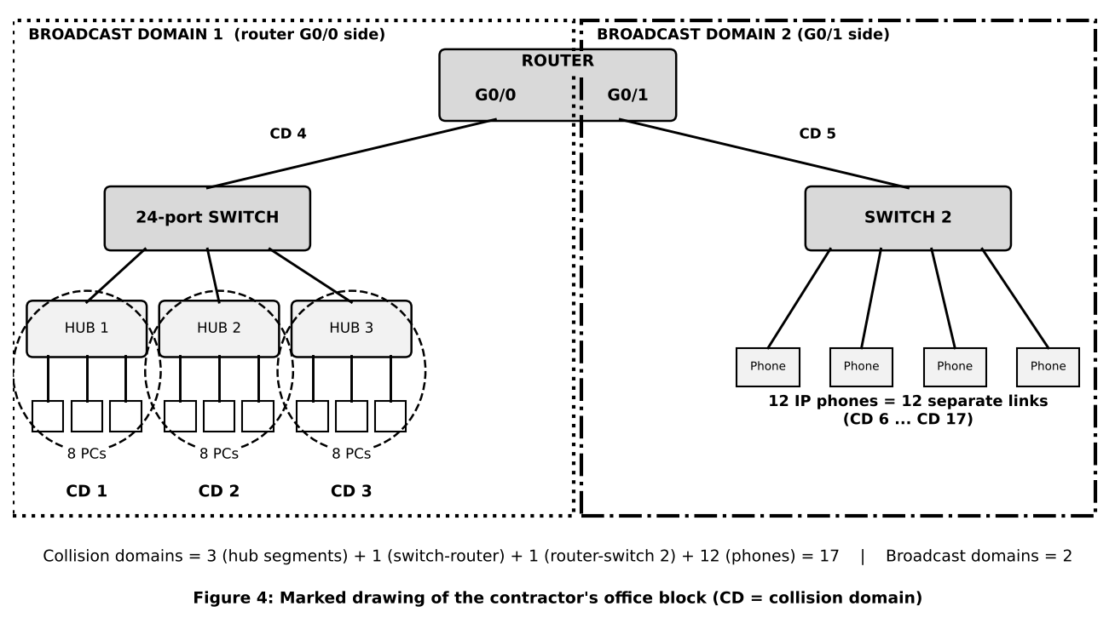

Step 3 - OSI layer of each device and why a hub cannot stop collisions
Device | OSI layer | What it looks at
Hub | Layer 1 - Physical | Electrical signal / bits only
Switch | Layer 2 - Data link | MAC address and frame
Router | Layer 3 - Network | IP address and packet
PC / IP phone | Layers 1-7 | End system: full protocol stack
A hub works only on bits. It has no memory and does not read the MAC address, so it cannot hold a frame back; it copies every bit to every other port at the same time. Two stations that send together therefore collide, and CSMA/CD has to detect and repeat the transmission. A switch stores each frame and forwards it only to the correct port.

Step 4 - Point-to-point and multipoint
Connection | Type
Switch to router G0/0; router G0/1 to switch 2; hub to switch uplink; each phone to switch 2 | Point-to-point (two devices on a cable)
8 PCs sharing one hub | Multipoint (shared medium)
Wi-Fi access point and its stations | Multipoint

Step 5 - Standards table
Technology | Standard | Body | What it defines
Ethernet | IEEE 802.3 | IEEE | Wired frame format, CSMA/CD, speeds, cabling
Wi-Fi | IEEE 802.11 | IEEE (certified by the Wi-Fi Alliance) | Wireless LAN physical and MAC layers
IPv4 | RFC 791 | IETF | 32-bit addressing and packet header
OSI model | ISO 7498 | ISO | Seven-layer reference model
5G | Release 15+ / IMT-2020 | 3GPP / ITU | 5G radio (NR), core, eMBB / URLLC / mMTC
Why buy only standard-compliant equipment: devices from different vendors interoperate, the plant is not locked to one supplier, spares and upgrades are cheaper, security patches and safety / EMC certification exist, and a faulty device can be replaced by any compliant one.

Alternative Concept Analysis - replace the hubs by unmanaged switches
Each of the 24 PCs gets its own port: collision domains = 24 (PCs) + 3 (switch-to-switch uplinks) + 1 + 1 + 12 = 41. Broadcast domains stay 2. Fixed: collisions disappear, every PC gets its own full bandwidth and can use full duplex. Not fixed: broadcasts still reach all 24 PCs, no VLANs, no security or port control, no QoS, no loop protection or monitoring. A managed switch is needed for those.

TASK 3 - Read a Captured Frame Layer by Layer (4 marks)

Step 1 - Layer and PDU of each line
Capture line | OSI layer | Protocol | PDU | Key fields
Ethernet II | 2 - Data link | Ethernet | Frame | Dst 00:1d:9c:c7:b0:41, Src 3c:52:82:4e:11:07, Type 0x0800 (IPv4)
IPv4 | 3 - Network | IP | Packet | 10.10.1.25 to 10.10.9.4, TTL 61, Protocol 6 (TCP)
TCP | 4 - Transport | TCP | Segment | Port 51522 to 502, Seq 1201, Ack 88, Len 12
Data | 5-7 - Application | Modbus | Data / message | 12-byte write-register command

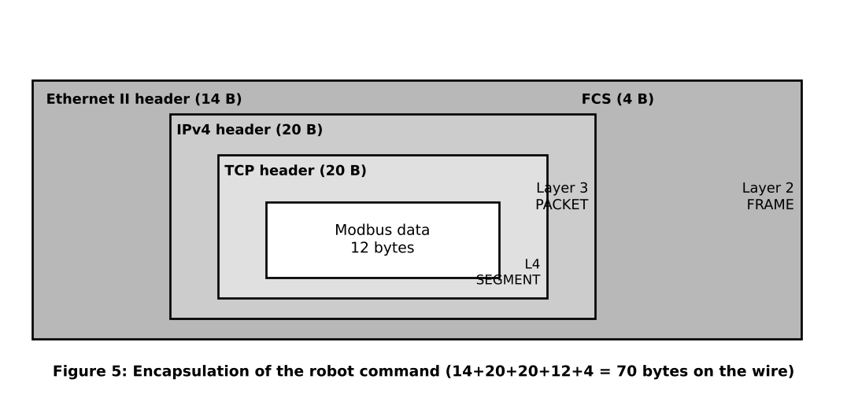

Step 2 - Routers crossed
The sender sets TTL = 64 and each router subtracts 1. Captured TTL = 61, so routers crossed = 64 - 61 = 3 routers.

Step 3 - Bytes on the wire and overhead
Item | 12-byte robot command | 1,400-byte camera packet (data)
Ethernet header | 14 B | 14 B
IPv4 header | 20 B | 20 B
TCP header | 20 B | 20 B
Data | 12 B | 1,400 B
FCS | 4 B | 4 B
Total on the wire | 70 B | 1,458 B
Overhead (58 B) | 58 / 70 = 82.9% | 58 / 1,458 = 4.0%
(I treated the camera figure as 1,400 bytes of data. Preamble and gap are not counted.)
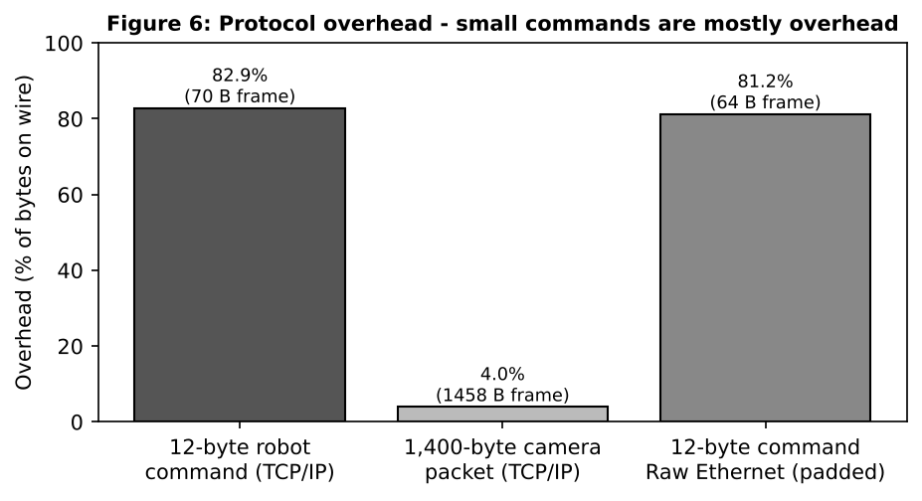
Meaning: a small command is mostly header (82.9%), a large camera packet is mostly data (96%). Small, frequent robot commands waste bandwidth and need priority handling more than big pipes.

Step 4 - Which layer handles the fault
Fault | Layer | What happens
(a) MAC address wrong | Layer 2 - Data link | NIC does not recognise the address and discards the frame
(b) TTL reaches 0 | Layer 3 - Network | Router discards the packet, sends ICMP Time Exceeded
(c) Destination port closed | Layer 4 - Transport | TCP replies with RST (connection refused)

Step 5 - TCP/IP model against the 7 OSI layers
TCP/IP layer | OSI layers | Examples
Application | 7 Application, 6 Presentation, 5 Session | Modbus, HTTP, DNS
Transport | 4 Transport | TCP, UDP
Internet | 3 Network | IP, ICMP
Network access (link) | 2 Data link, 1 Physical | Ethernet, Wi-Fi, 5G

Complete the Code - TODO 1 (wrap the PDU)
Replacement for the TODO line inside the for loop (all other code unchanged):
head = "[" + tag + "│"
tail = "│FCS]" if tag == "ETH" else "]"
pdu = head + pdu + tail
print(f"{layer:<13}adds {tag:<4}-> {len(pdu)} bytes")

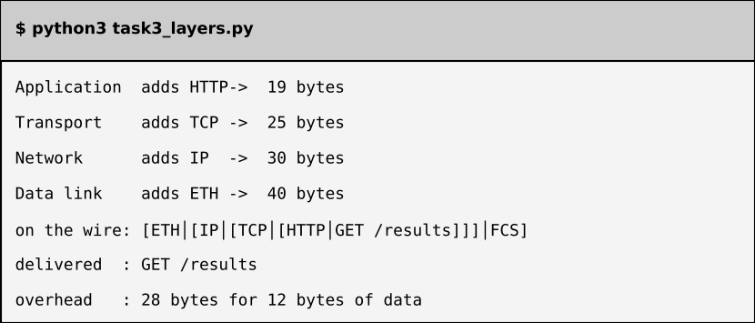
Program output - matches the expected output exactly
Overhead comparison: the program adds 28 bytes. For a 12-byte message that is 28 / 40 = 70% of the bytes on the wire (233% of the data). For a 1,400-byte message it is 28 / 1,428 = 1.96%. The more data in one packet, the smaller the percentage.

Alternative Concept Analysis - raw Ethernet (EtherType 0x8892), no IP/TCP
- Header bytes saved per command: IP 20 + TCP 20 = 40 bytes (frame would be 30 B).
- On the wire: Ethernet needs at least 46 bytes of payload, so the frame is padded to 64 bytes. Real saving = 70 - 64 = 6 bytes per command.
- Commands per second on 100 Mbps: with TCP/IP 100,000,000 / (70 x 8) = 178,571; raw Ethernet 100,000,000 / (64 x 8) = 195,312. Gain = 16,741 commands per second (about 9.4% more).
- What the plant loses by giving up IP: routing between networks (it works only inside one LAN), connection to the head office, TCP reliability (ordering and retransmission), port-based services, and easy firewalling. It is acceptable only for a closed, local, real-time cell.

TASK 4 - Choose a Medium for Each Run (There Is a Trap) (4 marks)

Step 1 - Medium for each run
Copper Ethernet (Cat5e/6/6A) is limited to 100 m per segment.
Run | Distance | Chosen medium | Deciding reason
(a) Robot cell by arc-welders | 85 m | Cat6A S/FTP (shielded) - or multimode fibre | Under 100 m, but welders cause strong electrical noise; shielding (or glass, which is immune) is needed
(b) Office floor to shop-floor switch | 140 m | Multimode fibre (or a switch in between) | Over the 100 m copper limit - this is the trap
(c) Shop floor to data centre | 550 m | Single-mode fibre (multimode OM3/OM4 only for 1G) | Far beyond copper; single-mode leaves room for 10G/40G
(d) Plant to head office | 400 km | Leased line on carrier single-mode fibre (with amplifiers) | Plant cannot own cable for 400 km; carrier provides SLA and repeaters

Step 2 - Which run cannot use copper Ethernet at all?
Runs (b), (c) and (d) all exceed 100 m. Run (d), 400 km, can never use copper because attenuation grows with distance; a 100 m segment would need 4,000 repeaters. The trap is run (b): 140 m looks like an ordinary office link, but copper is 40 m too long.

Step 3 - Shannon capacity, C = B x log2(1 + SNR)
Case | SNR ratio = 10^(dB/10) | Capacity
250 MHz cable, 40 dB | 10^4 = 10,000 | 250e6 x log2(10,001) = 250e6 x 13.288 = 3,321.96 Mbps
Same cable near welders, 15 dB | 10^1.5 = 31.62 | 250e6 x log2(32.62) = 250e6 x 5.028 = 1,256.95 Mbps

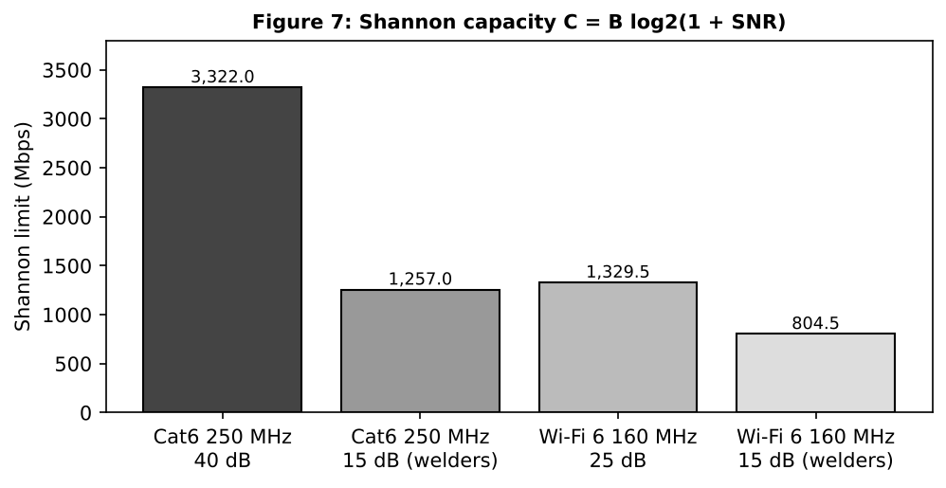
What the difference means: noise cuts the limit by 62.2% (3,321.96 to 1,256.95 Mbps). The robot cell needs only about 0.8 Mbps per robot, so capacity is not the problem; the danger is more bit errors, CRC failures and retransmissions, which add delay. That is why the robot cell uses shielded cable or fibre.
Why a measured speed is always below Shannon: Shannon is an ideal limit that assumes perfect coding. Real links have crosstalk, attenuation, limited modulation levels, fixed rates (1 Gbps), preambles, inter-frame gaps, headers and implementation losses.

Complete the Code - TODO 1 and TODO 2
def nyquist(bandwidth_hz, levels):
return 2 * bandwidth_hz * math.log2(levels)

def shannon(bandwidth_hz, snr_db):
snr = 10 ** (snr_db / 10)
return bandwidth_hz * math.log2(1 + snr)

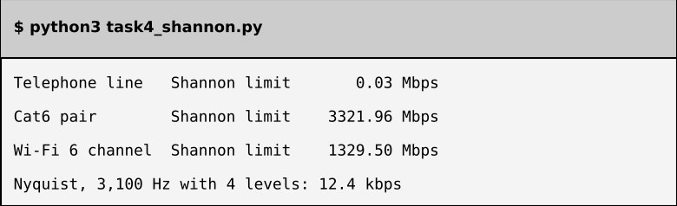
Program output - matches the expected output
SNR for 56 kbps on 3,100 Hz: 56,000 = 3,100 x log2(1 + SNR), so log2(1 + SNR) = 18.06 and SNR = 2^18.06 - 1 = 274,132, i.e. 10 x log10(274,132) = 54.4 dB. This is not realistic for an ordinary telephone line (typically 30-35 dB, which gives about 31-36 kbps). Real 56k modems work only because the ISP side is digital.

Alternative Concept Analysis - Wi-Fi 6 in the robot cell
160 MHz at 15 dB: 160e6 x log2(32.62) = 804.45 Mbps theoretical. Bandwidth is plentiful, but Wi-Fi shares the air with CSMA/CA contention, random back-off and interference from welders, so delay and jitter vary and cannot be guaranteed below 10 ms. Decision: not acceptable for 10 ms robot commands; use shielded cable (or 5G URLLC where the robot must move).

TASK 5 - Wi-Fi 6 or 5G for Moving Equipment? (4 marks)

Step 1 - Hand-overs and unreachable time
Trip time = 1,200 m / 2 m/s = 600 s.
 | Wi-Fi 6 (AP every 30 m) | Private 5G (cell 300 m)
Cells along 1.2 km | 1,200 / 30 = 40 | 1,200 / 300 = 4
Hand-overs | 40 - 1 = 39 | 4 - 1 = 3
Time per hand-over | 150 ms | 20 ms
Unreachable time per trip | 39 x 150 ms = 5.85 s (0.98% of the trip) | 3 x 20 ms = 60 ms (0.01%)
Commands missed (10 ms deadline) | 39 x 15 = 585 | 3 x 2 = 6 (zero with make-before-break)
Hand-over every | 15 s | 150 s

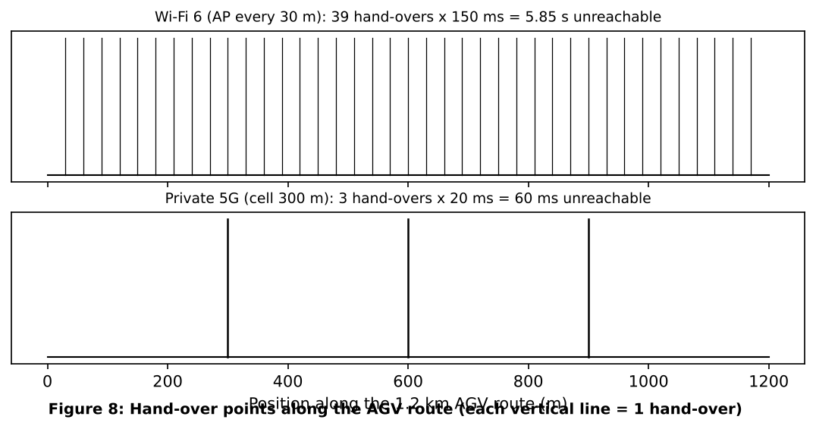

Step 2 - 5G service types
Device | Service | Reason
AGVs (and robots) | URLLC | 10 ms deadline and very high reliability
CCTV cameras | eMBB | High data rate (4 Mbps each); delay not critical
Sensors | mMTC | Huge number of low-rate, low-power devices

Step 3 - Where Bluetooth, Zigbee or LoRa are better
- Bluetooth Low Energy: short range (up to 10-30 m): worker badges, tool tags, handheld scanners, tablets.
- Zigbee: low-power mesh inside a cell for temperature, humidity and switch sensors with tiny batteries.
- LoRa: kilometres of range for rare small messages: yard tanks, remote buildings, asset tracking in the plant compound.

Step 4 - Can Wi-Fi 6 with 802.11r meet the deadline?
802.11r fast transition cuts roaming from about 150 ms to roughly 20-50 ms, but that is still above 10 ms, so it cannot guarantee the deadline. Remaining risks: contention and random back-off, welding interference, AP load, channel changes (DFS) and clients that stay attached to a weak AP. Wi-Fi 6 is fine for office users and cameras, not for AGV control.

Alternative Concept Analysis - sensors on LoRaWAN
600 sensors x 50 B x 8 = 240,000 bps = 240 kbps against 5 kbps gateway capacity: 240 / 5 = 48 times too much. One gateway could carry only 5,000 / 400 = 12 such sensors. Decision: vibration sensors (50 B every second) stay on Wi-Fi, wired or 5G mMTC. LoRa suits slow sensors only: temperature sent once every 60 s is 400 / 60 = 6.7 bps each, so 600 sensors = 4 kbps (80% of the gateway, tight, so use two gateways and respect the duty cycle).

TASK 6 - Interpret an Ethernet Port Report (4 marks)

Step 1 - Meaning of the counters
- Late collision (412): a collision detected after the first 64 bytes (512 bit-times) were sent. In a correct half-duplex network this cannot happen. It means the other end is not listening before sending (it thinks it is full duplex) or the cable is too long.
- CRC error (1,907): the frame arrived damaged; the FCS calculated by the receiver does not match.
- Together: a duplex mismatch. The half-duplex end sees late collisions and runt/CRC frames because the full-duplex end transmits whenever it wants. The two ends do not agree on speed/duplex.

Step 2 - Likely cause and fix
The PC is fixed at 100 Mb/s half duplex with auto-negotiation off, while the gigabit switch port negotiates differently, so duplex is mismatched. Correct both ends to negotiate (or force both to the same value).
# Linux
sudo ethtool -s eth0 autoneg on
sudo ethtool -s eth0 speed 1000 duplex full autoneg on # advertise gigabit full duplex
ethtool eth0 # verify: Speed 1000Mb/s, Duplex Full, Auto-negotiation on

# Windows: Device Manager > Network adapter > Properties > Advanced >
# Speed & Duplex > Auto Negotiation

Gigabit Ethernet (1000BASE-T) requires auto-negotiation, so it must be on. After the change the error counters should stop increasing.

Step 3 - MAC addresses
- 01:00:5e:0a:01:02: first byte 0x01 = 00000001; the last bit of the first byte is 1, so it is a group (multicast) address. The prefix 01:00:5e is IPv4 multicast; the low 23 bits (0a.01.02) map to 224.10.1.2. It belongs to a group, not one device.
- 3c:52:82:4e:11:07: the first three bytes 3c:52:82 are the OUI, which identifies the manufacturer of the network card (look it up in the IEEE OUI list); first byte 0x3c = 00111100, last bit 0, so it is a unicast, globally administered address.

Step 4 - Jumbo frames (9,000 bytes) for the CCTV storage server
With 58 B of headers: a 1,500-byte MTU frame carries 1,460 B of data, efficiency 1,460 / 1,518 = 96.2%; a 9,000-byte MTU frame carries 8,960 B, efficiency 8,960 / 9,018 = 99.4%. The server also handles about 6 times fewer packets and interrupts. Yes, it helps the storage server. To work, every NIC, switch port and VLAN on the path must be set to MTU 9000, otherwise frames are dropped or fragmented. Keep jumbo frames only on the storage VLAN: a 9,000-byte frame needs 72 microseconds at 1 Gbps (12 microseconds for 1,500 B), which would hurt robot traffic on the same link.

Alternative Concept Analysis - ring of industrial switches versus star
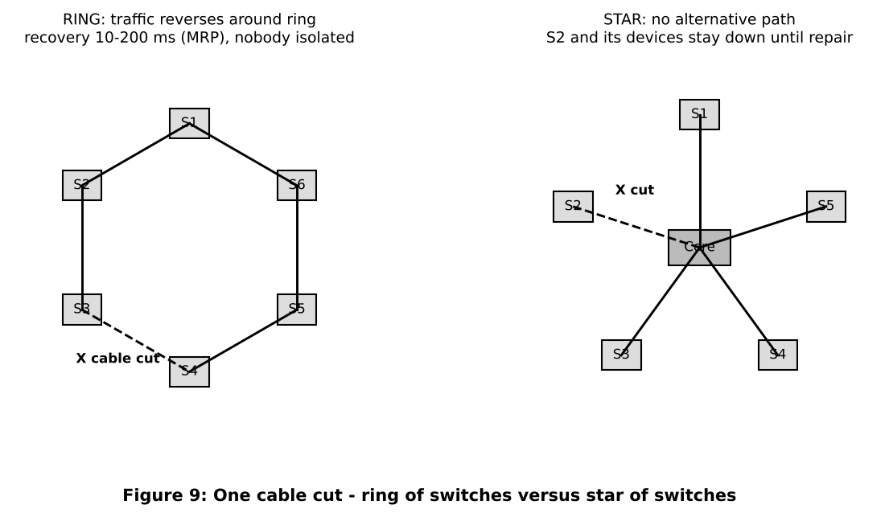
 | Ring with fast recovery | Star
Recovery time for one cut | MRP about 200 ms (configurable 10-30 ms); PRP/HSR 0 ms | No automatic recovery - down until the cable is repaired
Devices that lose connection | None after recovery (brief loss while the ring re-converges) | Every device on that switch / uplink
Cost | More cabling, ring-capable switches | Simple and cheap
Decision: a ring (with PRP/HSR for robots, because 200 ms is longer than 10 ms).

TASK 7 - Will the Receiver Notice the Error? (4 marks)

Step 1 - CRC by hand (data 1101011011, generator 1011)
Generator has 4 bits, so append 3 zeros: 1101011011000. Divide with XOR (modulo-2): whenever the leading bit is 1, XOR 1011 at that position.
Step | Position | Bits before | Bits after XOR with 1011
1 | bit 0 | 1101011011000 | 0110011011000
2 | bit 1 | 0110011011000 | 0011111011000
3 | bit 2 | 0011111011000 | 0001001011000
4 | bit 3 | 0001001011000 | 0000010011000
5 | bit 5 | 0000010011000 | 0000000101000
6 | bit 7 | 0000000101000 | 0000000000100
Remainder (last 3 bits) = 100. Transmitted frame = 1101011011100 = 1101011011100.

Step 2 - Is 1101011011101 accepted?
Divide the received frame by 1011: the remainder is 001, not 000, so the frame is rejected (the last bit was flipped).

Step 3 - Burst and undetectable errors
- The generator has degree 3, so every burst of length 3 bits or less is always detected.
- An error is missed when the error pattern is a multiple of 1011, e.g. 0000000001011 (the generator itself) or 0000000101100. Also two single-bit errors exactly 7 positions apart are missed in frames longer than 7 bits.

Step 4 - Two-dimensional parity of a 4 x 4 block
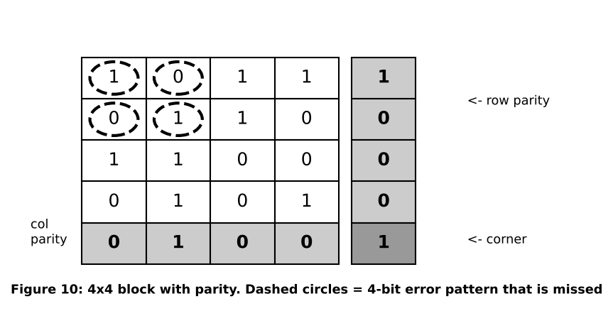
Even parity is used. Rows 1011, 0110, 1100, 0101 give row parities 1, 0, 0, 0; the columns give 0, 1, 0, 0; the corner bit is 1. Flipping the four bits at the corners of a rectangle (two in each of two rows and columns, circled) leaves every row and column parity unchanged, so this 4-bit error is missed.

Step 5 - Internet checksum of 4500, 0073, 0000, 4000
Sum = 0x4500 + 0x0073 + 0x0000 + 0x4000 = 0x8573 (no carry to add back). One's complement = 0xFFFF - 0x8573 = 0x7A8C. The checksum is 7A8C.

Complete the Code - TODO 1 (modulo-2 division)
for i in range(len(dividend) - len(divisor) + 1):
if rem[i] == "1":
for j in range(len(divisor)):
rem[i + j] = "0" if rem[i + j] == divisor[j] else "1"

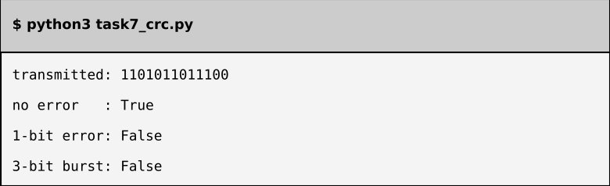
Program output - matches the expected output
Undetected error found with the program: XOR the transmitted frame with 0000000101100 (1011 shifted left 2); the program prints True (accepted). The error pattern equals 1011 x x^2, an exact multiple of the generator, so the remainder stays 000.

Alternative Concept Analysis - even parity bit versus CRC-3 (1011)
Error pattern (13 bits) | Even parity | CRC-3 (1011)
2-bit: 0000000000011 | Missed (even number of flips) | Detected (remainder not 0)
2-bit: 0000010000001 (7 apart) | Missed | Missed (multiple of 1011)
4-bit: 0000000001111 | Missed (even) | Detected
4-bit: 0000000011101 | Missed | Missed (multiple of 1011)
3-bit: 0000000001011 | Detected (odd) | Missed (generator itself)
Parity catches every odd number of flips, even the 3-bit pattern that CRC-3 misses, but misses every even number. CRC-3 catches all bursts up to 3 bits and most random patterns, so it is far stronger overall. Real Ethernet uses CRC-32.

TASK 8 - Correct the Error or Ask Again? (3 marks)

Step 1 - Check bits for 16 data bits
Condition 2^r >= m + r + 1 with m = 16. r = 4: 16 >= 21 false. r = 5: 32 >= 22 true. So r = 5 check bits; overhead = 5 / 16 = 31.25% of the data (5 / 21 = 23.8% of the codeword).

Step 2 - Minimum distance of {00000, 01011, 10101, 11110}
Pair | Distance | Pair | Distance
00000 - 01011 | 3 | 01011 - 10101 | 4
00000 - 10101 | 3 | 01011 - 11110 | 3
00000 - 11110 | 4 | 10101 - 11110 | 3
Minimum distance d = 3. It detects d - 1 = 2 errors and corrects (d - 1) / 2 = 1 error.

Step 3 - Hamming(7,4) word 0110011 received as 0110111
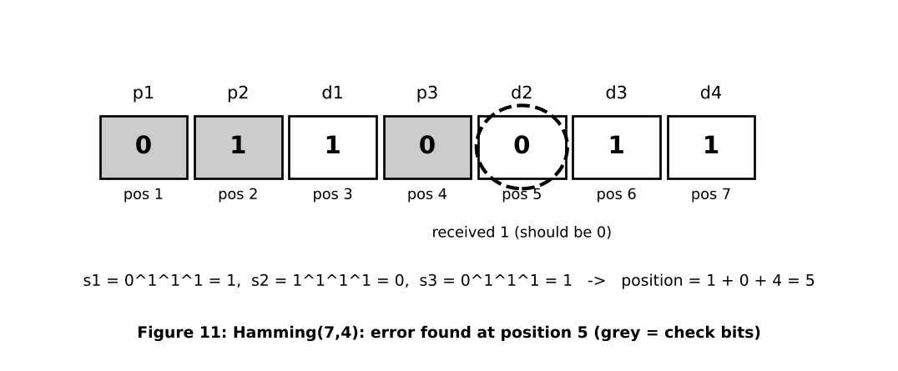
Positions 1..7 received 0,1,1,0,1,1,1. s1 (1,3,5,7) = 0^1^1^1 = 1; s2 (2,3,6,7) = 1^1^1^1 = 0; s3 (4,5,6,7) = 0^1^1^1 = 1. Position = 1 + 0 + 4 = 5. Flip bit 5: 0110011, data bits (positions 3, 5, 6, 7) = 1011.

Step 4 - FEC or ARQ?
Retransmission takes 40 ms but the deadline is about 10 ms, so ARQ always misses it. FEC is the right choice for the noisy radio link. Video streaming and 5G also use FEC because they are real time, the return path is slow, and waiting for a repeat would stall playback or add delay.

Complete the Code - TODO 1 (syndrome decoding)
def decode(c):
s1 = c[0] ^ c[2] ^ c[4] ^ c[6] # positions 1,3,5,7
s2 = c[1] ^ c[2] ^ c[5] ^ c[6] # positions 2,3,6,7
s3 = c[3] ^ c[4] ^ c[5] ^ c[6] # positions 4,5,6,7
pos = s1 + 2 * s2 + 4 * s3
c = c[:]
if pos:
c[pos - 1] ^= 1 # flip the faulty bit
return pos, [c[2], c[4], c[5], c[6]]

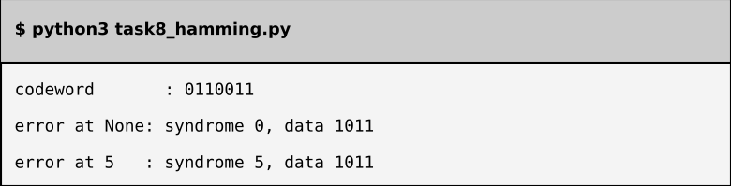
Program output - matches the expected output
Two-bit error: flipping positions 1 and 5 gives syndrome 4; the decoder flips bit 4 (a check bit) and returns data 1111, not 1011. It "corrects" the wrong bit because Hamming(7,4) has distance 3 and can fix only one error.

Alternative Concept Analysis - FEC versus ARQ at BER = 0.001
 | Hamming FEC (16 + 5 bits) | ARQ (16 data + 8-bit CRC)
Bits per reading | 21 | 24 x 1.0243 = 24.58 average
Probability of a bad reading | More than 1 bit wrong in 21: 0.0207% | At least 1 bit wrong in 24: 2.37%
Average extra delay | 0.000207 x 40 ms = 0.008 ms | 0.0243 x 40 ms = 0.97 ms
Worst case | 40 ms (once in about 4,800 readings) | 40 ms (about once in 42 readings)
FEC sends 21 bits instead of 16 but almost never waits; ARQ sends fewer bits on average but 2.4% of readings arrive 40 ms late. For this noisy link FEC is better.

TASK 9 - How Big Must the Window Be? (4 marks)

Step 1 - Timing and utilisation
Quantity | Working | Result
Frame size | 1,500 x 8 | 12,000 bits
Transmission time | 12,000 / 1e9 | 12 microseconds
Propagation time | 400,000 m / 2e8 m/s | 2 ms
a = prop / tx | 2 ms / 12 microseconds | 166.67
Stop-and-wait utilisation | 1 / (1 + 2a) = 1 / 334.33 | 0.299% = 2.99 Mbps

Step 2 - Smallest window and sequence-number bits
- Full use needs W = 1 + 2a = 334.33, so W = 335 frames.
- Go-Back-N: window must be at most 2^k - 1, so 2^k >= 336, giving k = 9 bits (512 numbers).
- Selective Repeat: window must be at most 2^(k-1), so 2^k >= 670, giving k = 10 bits (1,024 numbers).
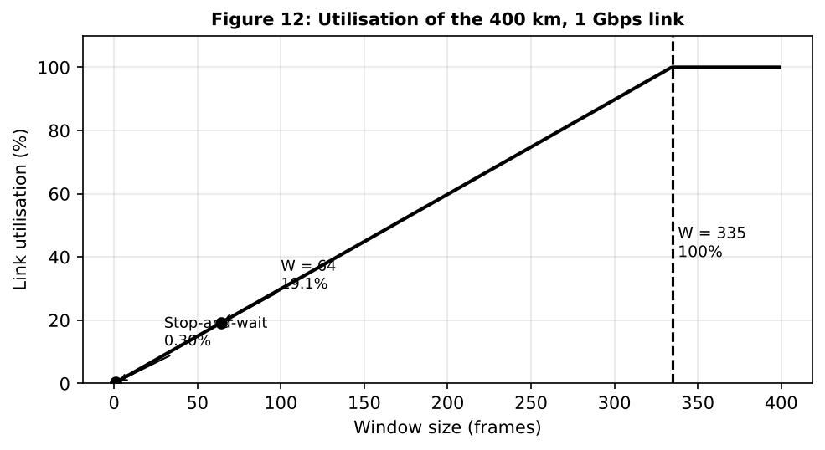

Step 3 - Which resends fewer frames after one loss?
Selective Repeat resends only the lost frame (1 frame). Go-Back-N resends the lost frame and everything after it (up to 335 frames). The cost of Selective Repeat is at the receiver: it must buffer out-of-order frames (335 x 1,500 B = 502,500 B, about 491 KiB), keep a timer and acknowledgment for each frame, and has more complex logic.

Step 4 - How HDLC and PPP mark frame boundaries
- HDLC: flag byte 01111110 at start and end; bit stuffing inserts a 0 after every five consecutive 1s so data never looks like a flag.
- PPP: flag byte 0x7E at start and end; byte stuffing replaces 0x7E or 0x7D inside the data with 0x7D followed by the byte XOR 0x20.

Complete the Code - TODO 1
a = prop / tx
u = min(1, window / (1 + 2 * a))
return u, a

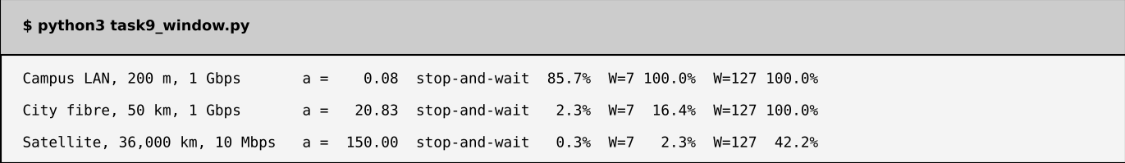
Program output - matches the expected output
Satellite link, 100% utilisation: W = 1 + 2a = 1 + 2 x 150 = 301 frames (the program confirms utilisation = 100% at W = 301).

Alternative Concept Analysis - Selective Repeat with window 64
Utilisation = 64 / 334.33 = 19.1%; throughput = 0.1914 x 1,000 Mbps = 191.4 Mbps (against 2.99 Mbps for stop-and-wait). Receiver buffer = 64 x 1,500 B = 96,000 B (about 94 KiB). Window 64 is easy on memory but uses only one-fifth of the link; window 335 (buffer about 491 KiB) is needed for the full 1 Gbps.

TASK 10 - Find Where the Delay Comes From (4 marks)

Step 1 - Propagation delay for 400 km
One way: 400,000 m / 2 x 10^8 m/s = 2 ms. Traceroute shows round-trip time, so expected = 2 x 2 ms = 4 ms. The last hop measures about 12.6 ms, so propagation explains 4 / 12.6 = about 32%. The other 8.6 ms is queuing, processing, serialisation and a fibre route longer than the straight 400 km.
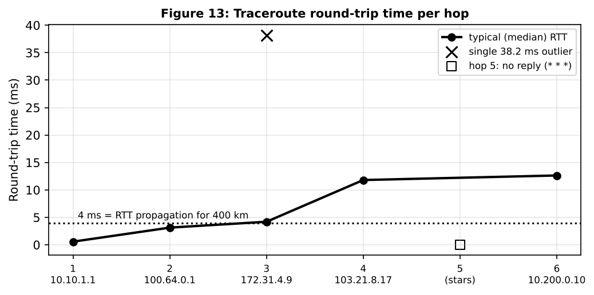

Step 2 - Odd results
- Hop 3, one value of 38.2 ms: the router answers traceroute with ICMP from its slow control CPU, which is sometimes busy, so one reply is late. The other two replies are 4.0 and 4.2 ms and hop 4 is fast, so traffic is not delayed. Not a fault.
- Hop 5, * * *: that router is set not to send ICMP Time Exceeded (or a firewall filters it). Traffic still passes, because hop 6 answers. Not a fault.

Step 3 - Which hop adds the most delay?
Hop | Address | Typical RTT (ms) | Increase over previous hop (ms)
1 | 10.10.1.1 | 0.6 | 0.6
2 | 100.64.0.1 | 3.1 | 2.5
3 | 172.31.4.9 | 4.2 (median) | 1.1
4 | 103.21.8.17 | 11.8 | 7.6 (largest)
6 | 10.200.0.10 | 12.6 | 0.8 (across hidden hop 5)
Hop 4 adds the most (about 7.6 ms), which is the long-distance provider segment that contains the 400 km of fibre (4 ms round trip) plus equipment delay.

Step 4 - My own measurements (to be run on my system)
The commands to run, and where each header is found in Wireshark:
ping -c 10 <head-office-server> (Windows: ping -n 10 ...)
traceroute <head-office-server> (Windows: tracert ...)
Wireshark: capture on the active interface, filter: ip.addr == <server-ip>

Frame ......... Layer 1/2 capture info
Ethernet II ... Layer 2: destination / source MAC, Type 0x0800
Internet Prot.. Layer 3: source / destination IP, TTL, Protocol
TCP / UDP ..... Layer 4: ports, sequence and ack numbers, flags
Application ... Layer 7: HTTP / DNS / ICMP data

[Insert your own ping, traceroute and Wireshark screenshots here and save them in the Task10 folder of the GitHub repository.]

Alternative Concept Analysis - SNMP / NetFlow monitoring against ping / traceroute
Problem | Occasional ping / traceroute | Continuous SNMP + NetFlow
Hop 3 one-off 38.2 ms | Seen only if the test happens at that moment | Interface counters and graphs show spikes over time (within 1-5 minutes)
Hop 5 silent router | Shows only stars | Counters from that device confirm it forwards traffic
Hop 4 extra 7.6 ms | Shows the delay, but only while someone runs the test | Trend of delay and link load; flow records show which traffic fills the link
Speed of detection | Manual - hours or days | Automatic alarms in 1-5 minutes

TASK 11 - Defend the Network Design (4 marks)

Step 1 - Medium, wireless and Ethernet settings per area
Area | Medium / wireless | Ethernet settings | Number that justifies it
Robot cells | Cat6A S/FTP (85 m), fibre where noise is worst | 1 Gbps, full duplex, auto-negotiation on, priority queue (DSCP EF) | Welder SNR 15 dB gives 1,256.95 Mbps; robots need 32 Mbps
Office floor | Multimode fibre (140 m) + Wi-Fi 6 with 802.11r | 1 Gbps, own VLAN | 140 m is over the 100 m copper limit; 30 Mbps traffic
Backbone to data centre | Single-mode fibre, 550 m | 10 Gbps, ring | Plant load 1,265.92 Mbps is over 1 Gbps
CCTV | PoE Cat6A / 5G eMBB | Jumbo MTU 9000 on storage VLAN only | 96 Mbps per line; efficiency 96.2% to 99.4%
Sensors | Wi-Fi 6 / 5G mMTC (LoRa for slow sensors) | VLAN | 240 kbps is 48 times above LoRa 5 kbps
Head office | Leased single-mode fibre, 10 Gbps, two links | Routed, IPsec | 400 km gives 2 ms one way

Step 2 - Error control and flow control per link
Link | Error control | Flow control | Calculation
LAN / robot cell | CRC-32 detect, drop; TCP repeats (UDP/raw for hard real time) | Full duplex, no collisions | Late collisions removed by auto-negotiation (Task 6)
Noisy radio / sensors | FEC (Hamming-type) | Not needed (tiny messages) | FEC delay 0.008 ms against ARQ 0.97 ms; 40 ms retransmit misses 10 ms (Task 8)
Head-office link | CRC + Selective Repeat | Sliding window W = 335, 10-bit sequence numbers | a = 166.67; stop-and-wait 0.299%; W 335 gives 100% (Task 9)

Step 3 - Two biggest remaining risks
- Radio delay and interference (Wi-Fi for office / cameras, and 5G in a metal plant): welding noise and contention can add jitter; mitigated by keeping robot control on shielded cable and using priority queuing.
- Single points of failure and delay under overload: a cut cable or one core switch stops production, and a 200 ms ring recovery is longer than the 10 ms deadline; mitigated by PRP/HSR and a redundant WAN link.

Step 4 - Does it work for five plants?
Five plants with continuous CCTV would produce 5 x 1,265.92 = 6,329.6 Mbps, which would not fit. With motion-triggered recording (Task 1) each plant sends 536.32 Mbps, so five plants = 2,681.6 Mbps = 26.8% of a 10 Gbps WAN. Yes, it scales provided CCTV is recorded locally, the head-office link is 10 Gbps, and sliding window W = 335 is used.

Alternative Concept Analysis - whole plant on private 5G
Assume one private 5G cell group gives about 1 Gbps. Whole plant = 1,265.92 Mbps, which is over capacity. Split:
Traffic | Carry on | Reason
Robots 32 Mbps/line, AGVs | 5G URLLC | Need mobility and 10 ms delay; 8 lines = 256 Mbps
Sensors 0.24 Mbps/line | 5G mMTC | Many tiny low-power devices
CCTV 96 Mbps/line (768 Mbps for 8 lines) | Cable (or motion-triggered 5G) | Would use 77% of the cell on its own
Office 30 Mbps/line | Wi-Fi / cable | Cheap, no delay need

TASK 12 - Re-evaluate and Adapt the Design (8 marks)
Changed requirement: private 5G on the shop floor and 50 AGVs that must never miss a command. Decision: MODIFY (not redesign) - keep the wired core and add a private 5G layer.

A. Impact Analysis (2 marks)
Assumption for each AGV: control 200 B every 10 ms = 160 kbps, telemetry 80 kbps, one 4 Mbps camera, total 4.24 Mbps.
Item | Before | After adding 50 AGVs
AGV traffic | 0 | 50 x 4.24 = 212 Mbps
Plant traffic (8 lines) | 1,265.92 Mbps | 1,477.92 Mbps (147.8% of 1 Gbps)
Uplink needed | 1 Gbps (already short) | 10 Gbps
Media affected | Wi-Fi / copper only | Adds 5G radio and fibre to the 5G core
Error control affected | CRC + TCP | FEC and HARQ on 5G radio; CRC kept on cable

B. Test the Original Design (2 marks)
Test (50 AGVs, Task 5 figures) | Wi-Fi 6 original | Private 5G
Hand-overs per AGV per trip | 39 | 3
Unreachable time per AGV | 5.85 s | 60 ms
Fleet hand-overs per trip | 50 x 39 = 1,950 (one every 0.31 s) | 150
Missed 10 ms commands per fleet trip | 50 x 585 = 29,250 | 300 (0 with make-before-break)
Result: the original design fails the "never miss a command" requirement. 150 ms outages are 15 times the deadline; 802.11r (about 20-50 ms) still exceeds 10 ms; and 1,477.92 Mbps overloads the 1 Gbps uplink.

C. Adaptation (2 marks)
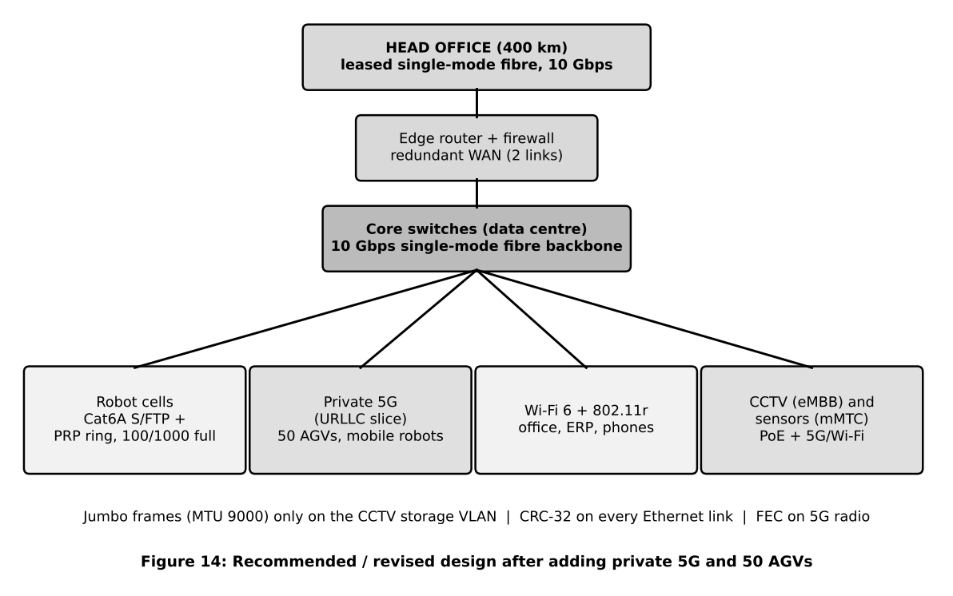
- AGVs and mobile robots: private 5G URLLC slice with dual connectivity.
- Fixed robot cells: Cat6A S/FTP or fibre, CRC-32, PRP redundancy.
- Office, ERP, phones: Wi-Fi 6 with 802.11r. CCTV / sensors: PoE cable or 5G eMBB / mMTC, CCTV recorded locally.
- Backbone and WAN: 10 Gbps single-mode fibre; Selective Repeat window 335.

D. Evidence-Based Defence (2 marks)
Decision | Number | Trade-off
Use 5G for AGVs | 60 ms against 5.85 s outage; 6 against 585 missed commands per AGV trip | Higher cost (cells, core, spectrum, SIM management)
Keep wired robot cells | SNR 15 dB still gives 1,256.95 Mbps; wired delay is deterministic | No mobility; cable work
10 Gbps backbone / WAN | 1,477.92 Mbps load; five plants 2,681.6 Mbps (26.8%) | More expensive optics and carrier circuit
Keep Wi-Fi 6 for office | 30 Mbps per line; no delay need | Contention, but harmless for human traffic
Priority queue for robots | Prevents the 8 ms queue wait of Task 1 | Needs QoS configuration and testing
Final decision: MODIFY - retain the fibre backbone, shielded robot cells, CRC / FEC strategy and window sizing, and add private 5G URLLC for AGVs and a 10 Gbps uplink. The numbers show the original Wi-Fi-only plan cannot serve 50 moving AGVs, while the modified design meets the 10 ms deadline with margin.

