SECURE PASSWORD STORAGE SYSTEM
MICROPROJECT REPORT
Submitted by
Anil Kumar — 2411021061563
<Student Name 2> — <Registration Number>
<Student Name 3> — <Registration Number>
<Student Name 4> — <Registration Number>

Submitted in partial fulfilment of the requirements of the course
CRYPTOGRAPHY AND NETWORK SECURITY
Course Code: E1CSA311
Under the Supervision of
Prof. Swetha C B

ALLIANCE SCHOOL OF ADVANCED COMPUTING
ALLIANCE UNIVERSITY, BENGALURU
OCTOBER - 2026

ALLIANCE SCHOOL OF ADVANCED COMPUTING
ALLIANCE UNIVERSITY, BENGALURU
DEPARTMENT OF CSE

CERTIFICATE
This is to certify that the microproject entitled “SECURE PASSWORD STORAGE SYSTEM” is a bona fide work carried out by Anil Kumar – 2411021061563, <Student Name 2> – <Registration Number>, <Student Name 3> – <Registration Number>, and <Student Name 4> – <Registration Number> as part of the requirements for the course Cryptography and Network Security (E1CSA311) during the academic year 2026–2027, under my guidance.

Faculty in-charge
Prof. Swetha C.B
Assistant Professor
Dept. of CSE

DECLARATION
We hereby declare that the microproject report entitled “SECURE PASSWORD STORAGE SYSTEM” is an original work carried out by us as part of the course Cryptography and Network Security (E1CSA311) during the academic year 2026–2027, under the guidance of Prof. Swetha C B, Assistant Professor, Alliance School of Advanced Computing, Alliance University.
We further declare that this work has not been previously submitted, either in whole or in part, for the fulfilment of the requirements of any other course or academic programme. All sources of information used in this work have been appropriately acknowledged and referenced.
Student Name & Registration Number Signature
- Anil Kumar – 2411021061563 ____________
- <Student Name 2> – <Registration Number> ____________
- <Student Name 3> – <Registration Number> ____________
- <Student Name 4> – <Registration Number> ____________

Date: ______________
Place: Bengaluru
ABSTRACT
Web applications identify their users with passwords, and those passwords have to be kept in a database so that a login can be checked later. If the database stores the passwords as plain text, or protects them with a weak scheme, a single data breach exposes every account at once. This microproject designs and implements a password storage mechanism in which the original password is never written to disk.
For every account the system generates a random 16-byte salt with os.urandom(), appends it to the password and computes the SHA-256 digest of the result with Python's hashlib module. Only the username, the salt and the salted hash are stored in an SQLite database. At login, the entered password is hashed again with the stored salt and the two digests are compared in constant time. The system is delivered as a reusable core module with two front ends: a menu-driven command-line program and a Flask web application.
The implementation was verified with 14 automated unit tests and a set of demonstrations. Two users who chose the same password received different salts and therefore different hashes, a precomputed lookup table that recovered passwords from an unsalted database recovered none from the salted one, and changing one character of a password altered 128 of the 256 output bits. A salted hash takes about 0.56 microseconds to compute, so the protection adds no noticeable delay for the user. The report also discusses the main limitation of a single fast hash against offline guessing and proposes key stretching with PBKDF2, bcrypt or Argon2 as future work.
Keywords: password storage, cryptographic hash function, SHA-256, salt, rainbow table attack, authentication, Python.
LIST OF SYMBOLS & ABBREVIATIONS
Abbreviation / Symbol Full Form / Description
CLI Command-Line Interface
CSPRNG Cryptographically Secure Pseudo-Random Number Generator
CSRF Cross-Site Request Forgery
DB Database
FIPS Federal Information Processing Standards
GPU Graphics Processing Unit
HMAC Hash-based Message Authentication Code
HTTP / HTTPS Hypertext Transfer Protocol / HTTP Secure
NIST National Institute of Standards and Technology
OWASP Open Worldwide Application Security Project
PBKDF2 Password-Based Key Derivation Function 2
SHA-256 Secure Hash Algorithm with a 256-bit digest
SQL Structured Query Language
H(x) Cryptographic hash of the input x
|| Concatenation of two byte strings
µs, ms Microsecond, millisecond
CONTENTS
Page No
Title Page i
Certificate ii
Declaration iii
Abstract iv
List of Symbols & Abbreviations v
Contents
1. Introduction 1
1.1 Background 1
1.2 Problem Statement 1
1.3 Objectives 1
1.4 Scope of the Microproject 2
2. System Design and Methodology 3
2.1 Proposed Approach 3
2.2 System Architecture 3
2.3 Modules/Components 5
2.4 Algorithm or Working Procedure 5
3. Implementation 7
3.1 Software and Hardware Requirements 7
3.2 Tools and Technologies Used 7
3.3 Dataset/Input Data 7
3.4 Implementation Details 8
4. Results and Discussion 11
4.1 Results/Observations 11
4.2 Performance Analysis 12
4.3 Security Analysis 13
4.4 Screenshots/Sample Outputs 15
5. Conclusion and Future Scope 22
References 23
Appendix 24

1. INTRODUCTION

1.1 Background
Passwords remain the most common way of proving identity on the web. When a user creates an account, the application has to remember something about the chosen password so that it can recognise the same user at the next login. The simplest design is to save the password itself in a database table. This design is also the most dangerous one: databases are copied in backups, read by administrators and, from time to time, stolen through attacks such as SQL injection or misconfigured servers. If the table contains plain-text passwords, anyone who obtains a copy can log in as any user, and because people reuse passwords, the damage spreads to their accounts on other services as well.
Cryptography offers a better option. A cryptographic hash function such as SHA-256 maps an input of any length to a fixed 256-bit output. It is a one-way function: computing the hash from the password is fast, but there is no practical method of computing the password from the hash. An application can therefore store only the hash and still check a login by hashing the entered password and comparing the result.
Hashing alone is not sufficient. Because the same password always produces the same hash, an attacker can prepare a table of the hashes of millions of common passwords once and then look up every stolen hash in that table. Rainbow tables are a compact form of such precomputed tables. Identical hashes also reveal which users share a password. Both weaknesses are removed by a salt: a random value, unique to each account, that is combined with the password before hashing. The salt does not need to be secret. Its job is to make every stored hash the output of a different computation, so that precomputed tables become useless and equal passwords no longer look equal.

1.2 Problem Statement
In a real-world web application, user accounts are created and maintained by storing credentials in a database. If passwords are stored in plain text or with weak protection, a data breach can expose sensitive user information. The problem addressed in this microproject is to design and build a password storage and verification system that continues to protect user passwords even when the database itself has been compromised.
Specifically, the system must (a) never store or display the original password, (b) resist rainbow-table attacks, (c) produce different stored values for users who happen to choose the same password, and (d) still verify a login correctly and quickly.

1.3 Objectives
- To implement SHA-256 hashing of passwords using the hashlib module of Python.
- To generate a unique random salt for every password using os.urandom() and append it to the password before hashing.
- To store only the username, the salt and the salted hash in a database, with no plain-text password anywhere in the system.
- To verify a login by re-hashing the entered password with the stored salt and comparing it with the saved hash.
- To demonstrate that two users with the same password receive different hashes, and that a precomputed (rainbow-table) attack fails against the salted database.
- To provide both a command-line interface and a web interface on top of one shared core module.
- To measure the performance of the scheme and analyse its security, including its limitations.

1.4 Scope of the Microproject
The microproject covers user registration, secure storage of credentials, login verification and a set of demonstrations and measurements. It maps to Module III of the syllabus (public-key cryptography and authentication requirements), where hash functions are studied as a building block for authentication, and to course outcome CO3.
The following items are within scope: salt generation, salted SHA-256 hashing, storage in an SQLite database, constant-time verification, input validation, a command-line program, a Flask web application, unit tests, a performance benchmark and a security analysis.
The following items are outside the scope and are discussed only as future work: deliberately slow password-hashing algorithms (PBKDF2, bcrypt, scrypt, Argon2), transport security (HTTPS/TLS), account lockout and rate limiting, multi-factor authentication, password reset by e-mail, and deployment on a production web server.

2. SYSTEM DESIGN AND METHODOLOGY

2.1 Proposed Approach
The system stores, for each user, a record of the form (username, salt, hash), where
hash = SHA-256( password || salt )
and the salt is a fresh 128-bit random value drawn from the operating system's cryptographically secure random number generator. The password is used only in memory, for the duration of one function call, and is never written to the database, to a file or to the screen. Table 2.1 compares this approach with the two weaker alternatives.
Table 2.1: Comparison of password storage approaches
Property | Plain text | Unsalted SHA-256 | Salted SHA-256 (proposed)
What a database thief obtains | Every password, immediately | Hashes that can be looked up in precomputed tables | Salts and hashes; no table applies
Rainbow-table attack | Not needed | Succeeds for common passwords | Defeated
Same password, two users | Visible | Visible (identical hashes) | Hidden (different hashes)
Cost of cracking n users | None | One dictionary pass for all users | One dictionary pass per user
Login verification | String comparison | Hash and compare | Hash with stored salt and compare

Three design decisions follow from this approach. First, the salt is generated with os.urandom() and not with the random module, because the latter is predictable and not intended for security. Second, the salt is stored next to the hash in the same row; it must be available at login and does not need to be secret. Third, the comparison of the two digests uses hmac.compare_digest(), which takes the same time whether the digests differ in the first character or the last, so that response time leaks nothing about the stored hash.

2.2 System Architecture
The system is organised in three layers, shown in Figure 2.1. The interface layer contains two independent front ends. Both call the same core module, which holds all of the cryptographic logic, and the core module is the only component that reads from or writes to the database. Keeping the security logic in one place means that it is written once, tested once and behaves identically in the terminal and in the browser.
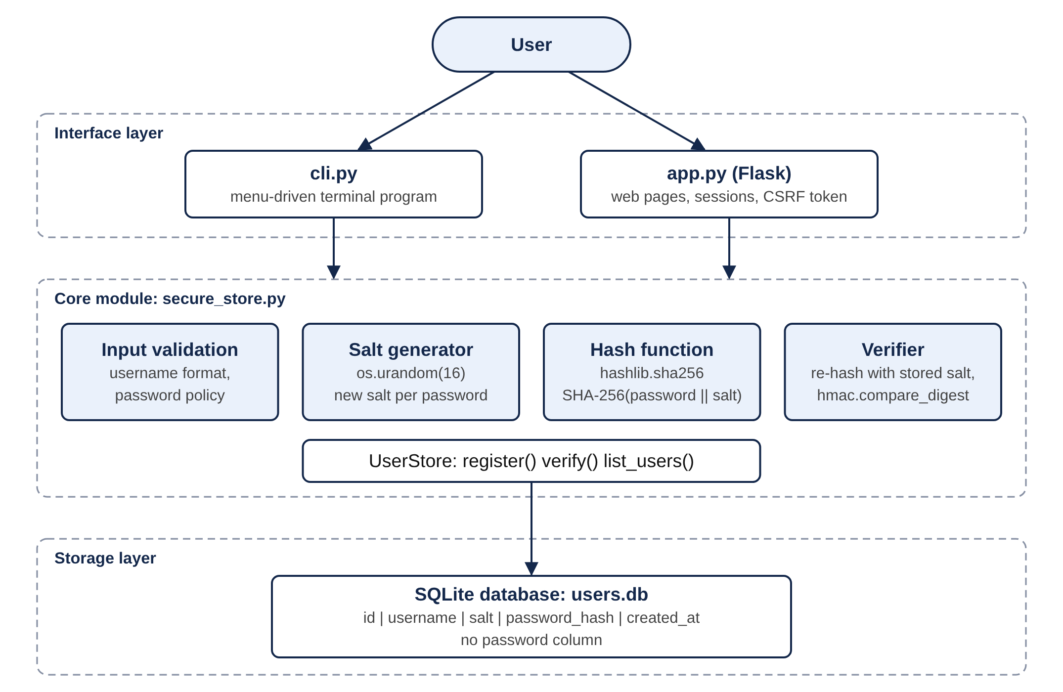
Figure 2.1: Three-layer architecture of the Secure Password Storage System

2.3 Modules/Components
Table 2.2: Modules of the system
Module | File | Responsibility
Salt generator | secure_store.py | generate_salt() returns 16 random bytes from os.urandom().
Hash function | secure_store.py | hash_password() returns the hexadecimal SHA-256 digest of password || salt.
Input validation | secure_store.py | Checks the username format and the password policy (at least 8 characters, one letter, one digit).
User store | secure_store.py | UserStore class: creates the table, registers users, verifies logins and lists records through parameterised SQL.
Command-line interface | cli.py | Menu for register, login and viewing stored records; passwords are read with getpass so they are not echoed.
Web interface | app.py, templates/ | Flask routes for register, login, dashboard, stored records and logout, with a signed session cookie and CSRF token.
Demonstration | demo.py | Shows the same-password case, login checks, the rainbow-table attack and the avalanche effect.
Benchmark | benchmark.py | Measures salt generation, hashing, registration and login times.
Unit tests | tests/ | 14 automated tests of hashing, storage and verification.

2.4 Algorithm or Working Procedure
Registration
- Read the username and the password from the user.
- Validate the username format and the password policy. If either check fails, report the error and stop.
- Generate a salt: salt = os.urandom(16).
- Compute hash = SHA-256(password || salt) and convert the digest to hexadecimal.
- Insert (username, salt, hash, creation time) into the users table. If the username already exists, the database rejects the row and an error is reported.
- Return success. The password variable goes out of scope and is not saved anywhere.
Login verification
- Read the username and the password from the user.
- Fetch the salt and the stored hash for that username from the users table.
- If no such user exists, compute one dummy hash (so that the response time is similar) and deny access.
- Compute candidate = SHA-256(entered password || stored salt).
- Compare candidate with the stored hash using hmac.compare_digest().
- Grant access if they are equal; otherwise deny access with the same message used for an unknown user.
Figure 2.2 shows the two procedures as flowcharts.
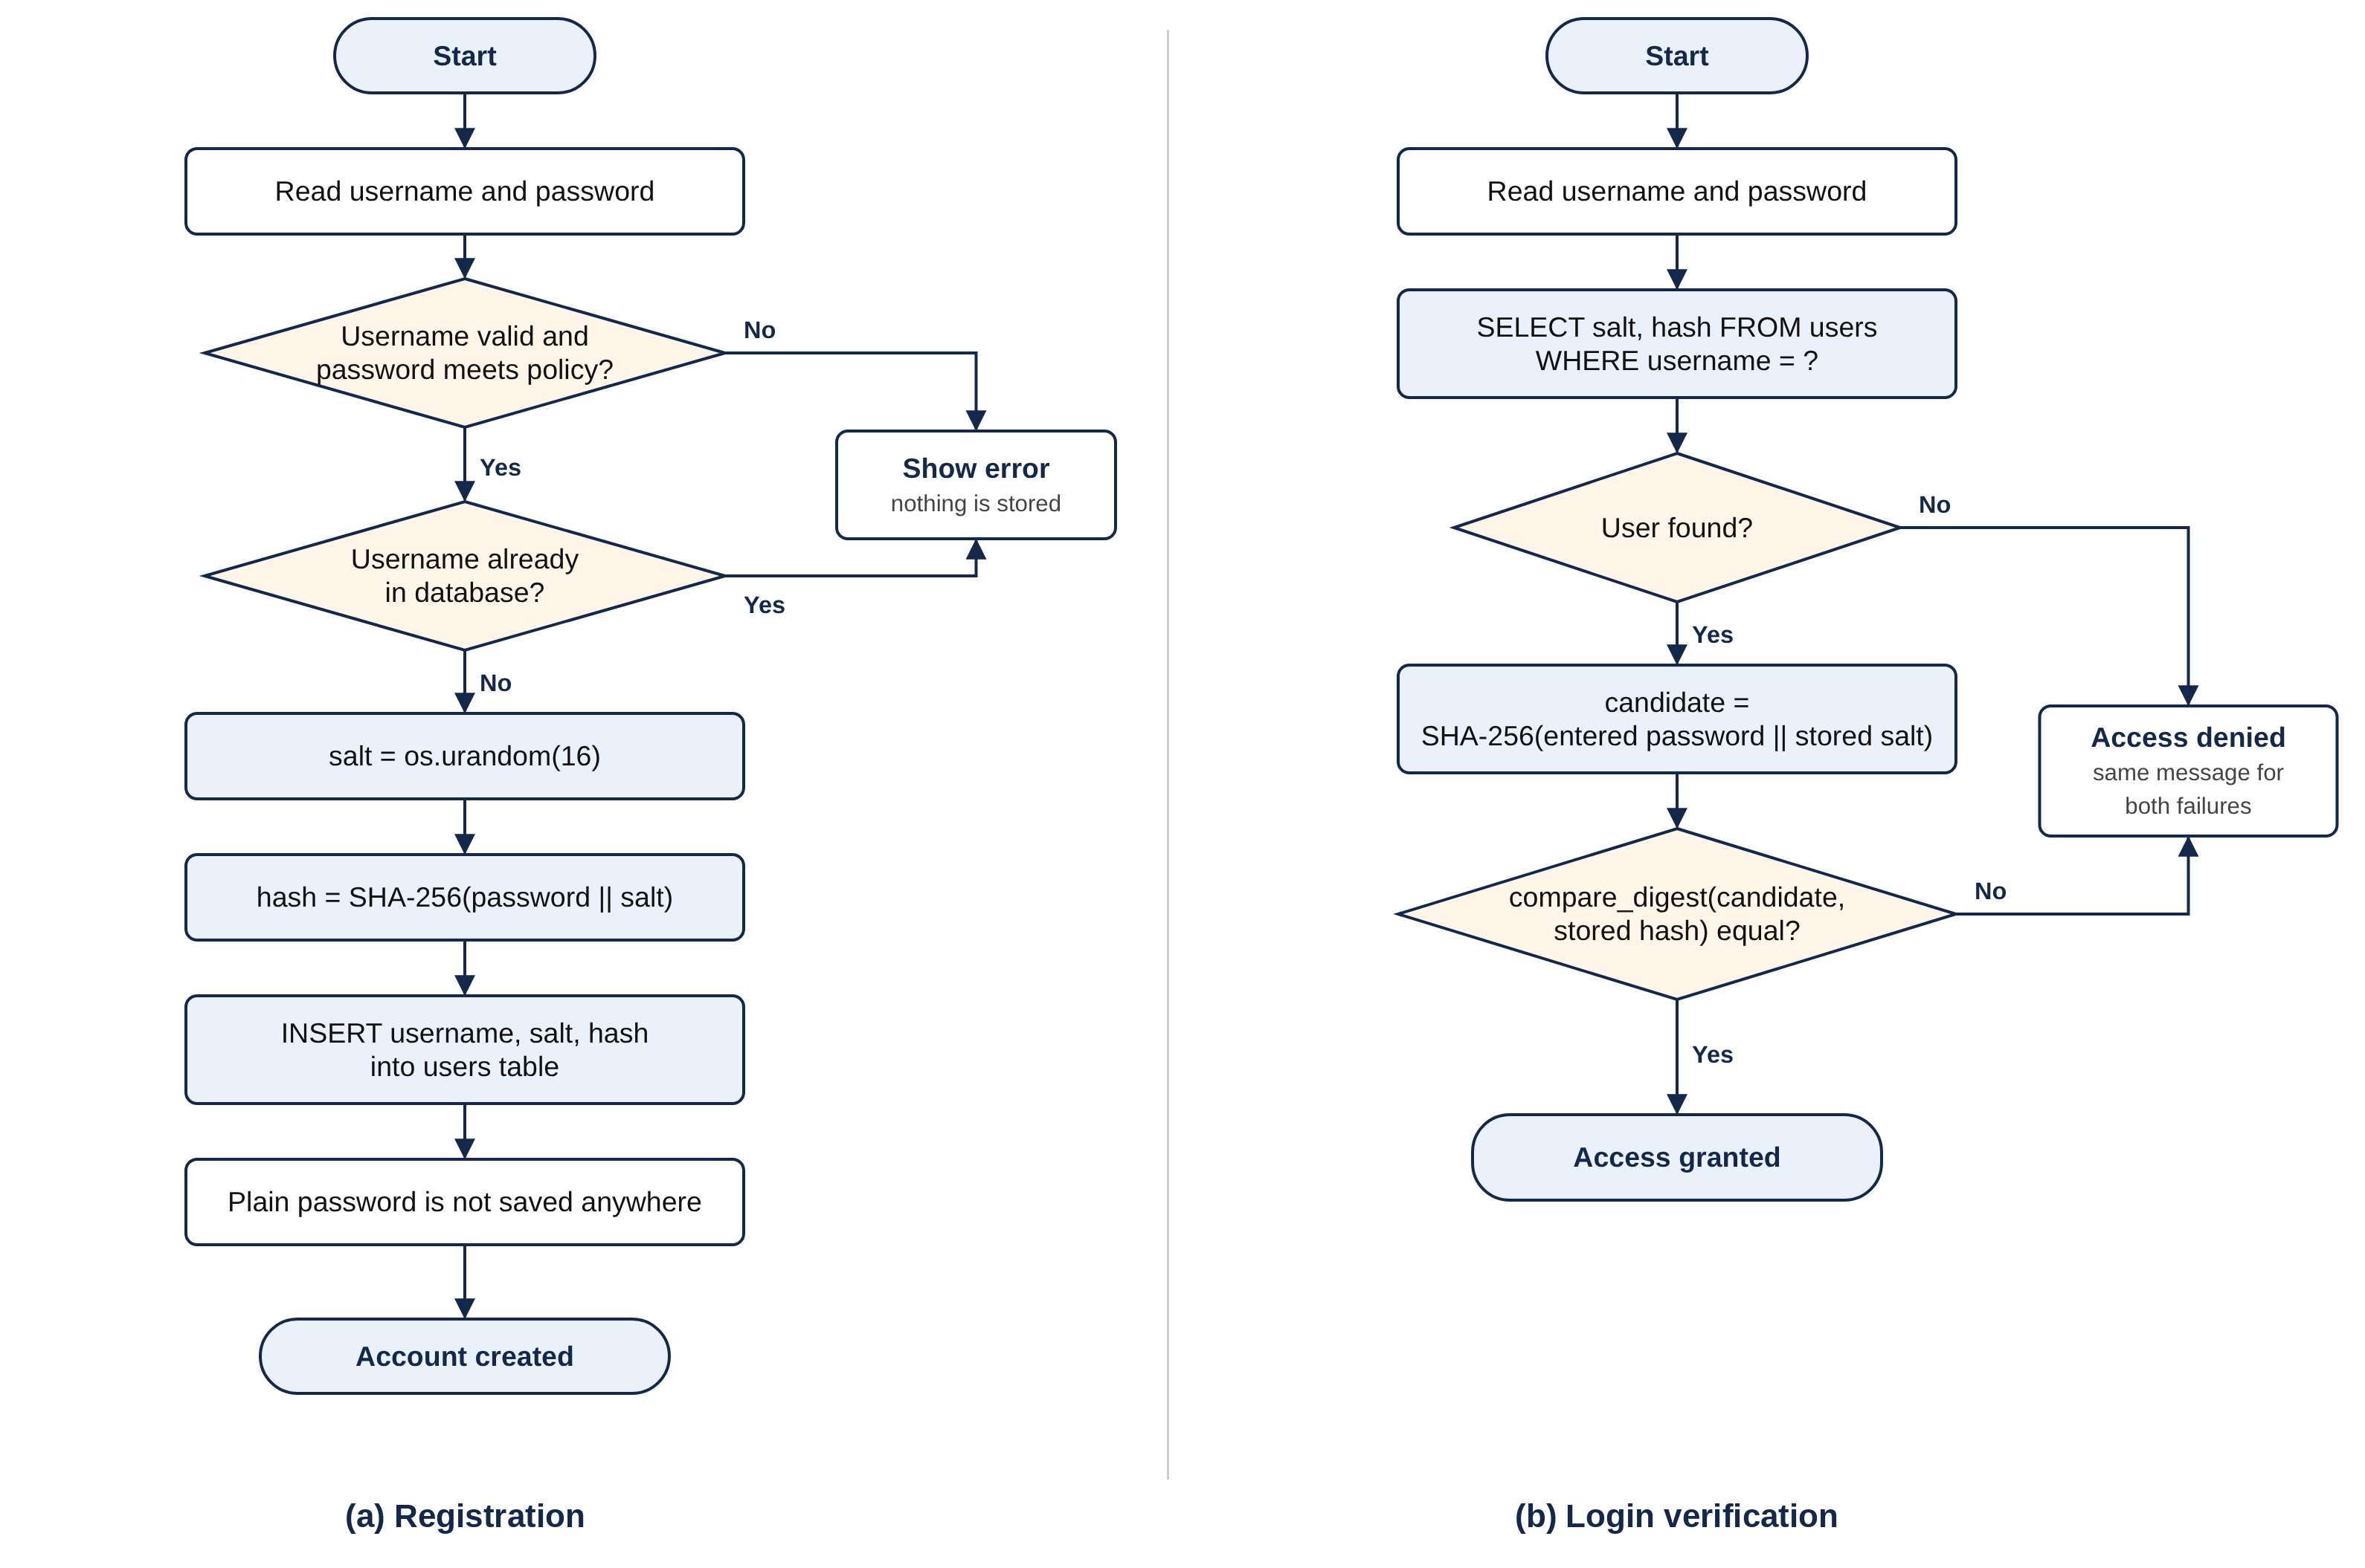
Figure 2.2: Flowcharts of (a) registration and (b) login verification

3. IMPLEMENTATION

3.1 Software and Hardware Requirements
Table 3.1: Software and hardware requirements
Category | Requirement
Operating system | Windows, macOS or Linux
Language | Python 3.8 or later (tested with Python 3.13 on Linux and Python 3.14 on macOS)
Standard-library modules | hashlib, os, hmac, sqlite3, re, getpass, unittest
External package | Flask 3.x (needed only for the web interface)
Editor | Visual Studio Code with the Python extension
Browser | Any modern browser, for the web interface
Processor and memory | Any dual-core processor with 2 GB RAM or more
Disk space | Less than 5 MB for the project and its database

3.2 Tools and Technologies Used
Table 3.2: Tools and technologies
Tool / library | Purpose in this project
hashlib.sha256 | Computes the SHA-256 digest defined in FIPS 180-4.
os.urandom | Provides random bytes from the operating system's CSPRNG for the salt, the session key and the CSRF token.
hmac.compare_digest | Compares two digests in constant time.
sqlite3 | Serverless relational database in a single file (users.db).
getpass | Reads a password in the terminal without displaying it.
Flask | Lightweight web framework used for the browser interface.
unittest | Automated testing of the core module.
Visual Studio Code | Code editing, integrated terminal and debugging.

3.3 Dataset/Input Data
The project does not use an external dataset. Its input is the username and password typed by the user. The database consists of one table whose structure is given in Table 3.3; note that it has no column for the password.
Table 3.3: Structure of the users table
Column | Type | Description
id | INTEGER, primary key | Automatically assigned record number
username | TEXT, unique | Login name, 3 to 30 characters
salt | TEXT | 16 random bytes, stored as 32 hexadecimal characters
password_hash | TEXT | SHA-256(password || salt), 64 hexadecimal characters
created_at | TEXT | Date and time of registration

For the demonstrations and tests, the sample accounts in Table 3.4 were used. Two of them deliberately share a password. The rainbow-table demonstration uses a small list of ten common passwords (for example 123456, password, qwerty123 and Summer2026) to stand in for the very large tables used by real attackers.
Table 3.4: Sample accounts used for testing
Username | Password | Purpose
alice | Summer2026 | Normal registration and login
bob | Summer2026 | Same password as alice, to show that the hashes differ
charlie | Tr1cky#Pass | A password that is not in the attacker's list
mallory | (not registered) | Login attempt for a user that does not exist

3.4 Implementation Details
Salt generation and hashing. These two functions are the heart of the system. The password is encoded as UTF-8 bytes, the salt is appended and the SHA-256 digest of the combined bytes is returned in hexadecimal form.
def generate_salt(length=SALT_BYTES):
"""Return `length` cryptographically secure random bytes."""
return os.urandom(length)

def hash_password(password, salt):
"""Return the hex SHA-256 digest of the password with the salt appended."""
return hashlib.sha256(password.encode("utf-8") + salt).hexdigest()
Registration. The method validates the input, generates the salt, computes the hash and inserts the record. The SQL statement uses ? placeholders, so user input is always passed as data and can never change the meaning of the query. The UNIQUE constraint on the username column makes the database itself reject a duplicate.
def register(self, username, password):
"""Create an account. Returns (ok, message)."""
username = (username or "").strip()
error = check_username(username) or check_password(password)
if error:
return False, error

salt = generate_salt()
digest = hash_password(password, salt)
try:
with self._connect() as con:
# parameterised query -> no SQL injection
con.execute(
"INSERT INTO users (username, salt, password_hash, created_at) "
"VALUES (?, ?, ?, ?)",
(username, salt.hex(), digest,
datetime.now().strftime("%Y-%m-%d %H:%M:%S")),
)
except sqlite3.IntegrityError:
return False, "That username is already taken."
return True, "Account created."
Login verification. The stored salt is read, the entered password is hashed with it and the result is compared with the stored hash.
def verify(self, username, password):
"""Return True only if the username exists and the password matches."""
with self._connect() as con:
row = con.execute(
"SELECT salt, password_hash FROM users WHERE username = ?",
((username or "").strip(),),
).fetchone()

if row is None:
# Do the same amount of work for an unknown user, so response
# time does not reveal which usernames exist.
hash_password(password or "", generate_salt())
return False

salt = bytes.fromhex(row["salt"])
candidate = hash_password(password or "", salt)
# constant-time comparison prevents timing attacks on the digest
return hmac.compare_digest(candidate, row["password_hash"])
Command-line interface. cli.py presents a four-option menu (register, login, view stored records, exit). Passwords are read with getpass(), so they do not appear on the screen, and registration asks for the password twice to catch typing mistakes. The option to view stored records prints the salt and hash of every user, which makes it easy to confirm that no password is kept.
Web interface. app.py is a Flask application that calls the same UserStore class. It offers pages for registration, login, a dashboard that is shown only after a successful login, and a demonstration page that lists the stored records. After a successful login the session is cleared and re-created, the session cookie is signed with a random key and marked HttpOnly, and every form carries a random CSRF token that is checked on submission. A failed login always shows the same message, Invalid username or password, whether the username or the password was wrong.
Testing. tests/test_store.py contains 14 unit tests. They check the hash against the published SHA-256 test vector for the string “abc”, the length and uniqueness of salts, successful and failed logins, rejection of duplicate usernames and weak passwords, the same-password case, an SQL-injection attempt, and that the plain-text password does not occur anywhere in the bytes of the database file.

4. RESULTS AND DISCUSSION

4.1 Results/Observations
The system was exercised through both interfaces and through the automated tests. Table 4.1 summarises the functional test cases. All of them produced the expected result, and all 14 unit tests passed (Figure 4.8).
Table 4.1: Functional test cases and results
No. | Test case | Expected result | Observed
1 | Register a new user with a valid password | Account created; salt and hash stored | As expected
2 | Register with a username that already exists | Rejected: username already taken | As expected
3 | Register with a password shorter than 8 characters or without a digit | Rejected with a policy message | As expected
4 | Login with the correct password | Access granted | As expected
5 | Login with a wrong password (including wrong letter case) | Access denied | As expected
6 | Login with a username that is not registered | Access denied, same message as case 5 | As expected
7 | Two users register with the same password | Different salts and different hashes | As expected
8 | Search the database file for the plain-text password | Not found | As expected
9 | SQL-injection string entered as username or password | Access denied; table unchanged | As expected
10 | Precomputed table of common-password hashes applied to the salted database | No password recovered | As expected

Same password, different hashes. In the demonstration run, alice and bob both registered with the password Summer2026. The values actually stored were:
alice salt = f9abf820752b3fb63a540dcee89d59ca
hash = 4342cbc34610ec18f77247b19c2aafe6eda7f20c1cf5faf13ee78fb932ae466a
bob salt = cbfa2e1d7004efe3ab797f2930f90e24
hash = 816a1b5e187951ed11cc5001276482bcc1a1c84c8930286189264d6fb415c740
The two hashes have nothing in common, so someone reading the database cannot tell that the passwords are equal. Without a salt, both rows would have contained the same value, ed3c9886c697c0ac…07043d1a.
Rainbow-table attack. A lookup table of the unsalted SHA-256 hashes of ten common passwords was built once. Applied to an unsalted copy of the database, it recovered the passwords of alice and bob immediately; charlie's password was not in the list. Applied to the salted database produced by this system, it recovered none of the three (Figure 4.7).
Avalanche effect. Hashing Summer2026 and Summer2027 with the same salt gave digests that differ in 128 out of 256 bits (50.0%). A small change in the password gives a completely different hash, so a stored hash provides no hint about how close a guess is.

4.2 Performance Analysis
Timings were measured with benchmark.py using time.perf_counter() on Python 3.13 (Linux, x86-64, 2.1 GHz Intel Xeon). Each primitive operation was repeated 20,000 times per round and the best of 15 rounds was taken, which filters out interference from other processes. Absolute values will differ from one machine to another; the script can be re-run on any computer to obtain its own figures.
Table 4.2: Measured execution times
Operation | Average time
Salt generation, os.urandom(16) | 0.439 µs
SHA-256 without salt | 0.531 µs
SHA-256 with 16-byte salt | 0.556 µs
Registration (salt + hash + SQLite INSERT) | 1.128 ms
Login (SQLite SELECT + hash + comparison) | 0.082 ms
PBKDF2-HMAC-SHA256, 600,000 iterations (for comparison) | 176.9 ms

Salting adds about 0.02 µs to a hash and 0.44 µs to generate, which is negligible. The time of a complete registration or login is dominated by the database, not by the cryptography: registration takes about 1.1 ms because the row has to be committed to disk, while login needs only a read and takes about 0.08 ms.
Figure 4.1 shows the hashing time for passwords of 8 to 256 characters. The time is almost constant up to 32 characters, because the password and salt together still fit in a single 64-byte SHA-256 block, and rises only slightly for longer inputs (from 0.57 µs to 0.74 µs). Long passwords therefore carry no performance penalty.
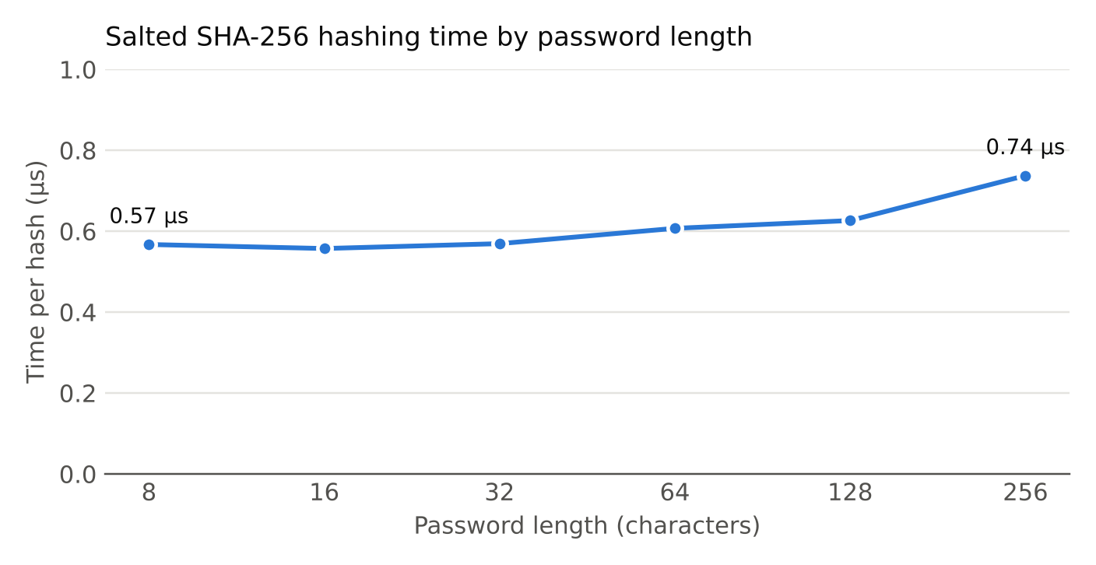
Figure 4.1: Salted SHA-256 hashing time for different password lengths
The benefit of the salt appears on the attacker's side. Table 4.3 and Figure 4.2 show the number of hash computations needed to test a dictionary of one million candidate passwords against a stolen database. Without salts, one pass over the dictionary (or one precomputed table) serves every account. With per-user salts, the whole dictionary has to be hashed again for each account, so the work grows in proportion to the number of users.
Table 4.3: Hash computations needed to test a 1,000,000-word dictionary
Accounts in database | Unsalted SHA-256 | Salted SHA-256 | Increase
1 | 1,000,000 | 1,000,000 | 1×
100 | 1,000,000 | 100,000,000 | 100×
10,000 | 1,000,000 | 10,000,000,000 | 10,000×

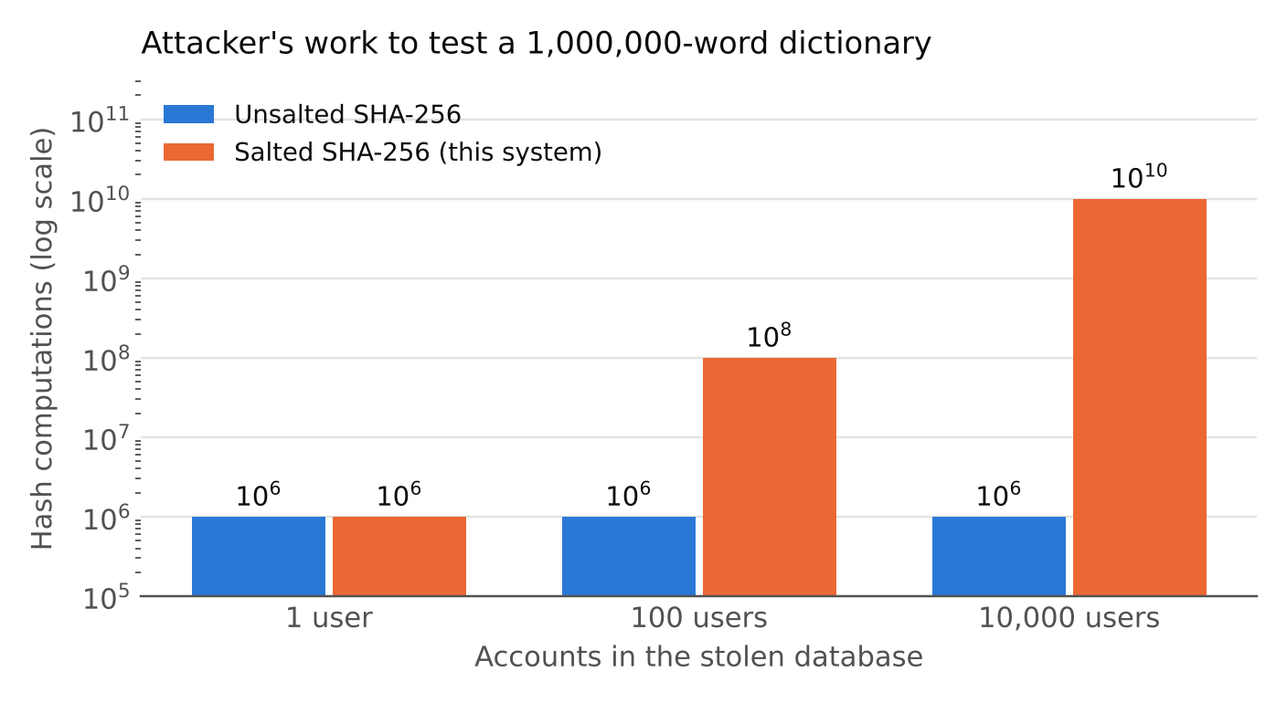
Figure 4.2: Attacker's work with and without salts (logarithmic scale)

4.3 Security Analysis
Table 4.4 lists the threats considered and how the system responds to each.
Table 4.4: Threats and countermeasures
Threat | Countermeasure in this system
Database theft exposes passwords | Only salts and SHA-256 hashes are stored. SHA-256 is preimage resistant, so the password cannot be computed from the hash.
Rainbow-table or other precomputed attack | A 128-bit random salt per password. A table would have to be built separately for each of 2¹²⁸ possible salts, which is infeasible.
Identifying users who share a password | Different salts give different hashes for equal passwords.
Predictable salts | Salts come from os.urandom(), the operating system's CSPRNG, not from the random module.
Timing attack on the comparison | hmac.compare_digest() compares in constant time.
Username enumeration | The same error message, and a dummy hash computation, for unknown users and wrong passwords.
SQL injection | All queries are parameterised; verified by a unit test.
Shoulder surfing and password display | getpass in the terminal and password fields in the browser; passwords are never printed or logged.
Weak passwords | Minimum length of 8 characters with at least one letter and one digit.
Cross-site request forgery and session fixation (web) | Random CSRF token in every form; session re-created at login; signed, HttpOnly cookie.

Limitations. The analysis also has to state what salted SHA-256 does not protect against. SHA-256 is designed to be fast, and a salt does not slow down an attacker who targets one account: knowing the salt, the attacker can simply hash guesses for that user.
The benchmark measured about 1,797,562 salted hashes per second on a single processor core in Python. At that rate, trying every 8-character password made of lowercase letters and digits (36⁸ ≈ 2.82 × 10¹² candidates) would take about 18 days, and password-cracking tools running on graphics processors compute SHA-256 several orders of magnitude faster than that. A weak or short password is therefore still at risk after a breach, even though it is salted.
The accepted remedy is key stretching: replacing the single hash with a deliberately slow function. As a comparison, PBKDF2-HMAC-SHA256 with 600,000 iterations took 176.9 ms per password on the same machine, roughly 318,000 times slower than one SHA-256. That delay is unnoticeable to a user logging in once, but it multiplies the attacker's cost by the same factor. This is listed as the first item of future work.
Two further limitations are that the web interface runs over plain HTTP on the local machine, so a deployed version would need HTTPS to protect the password in transit, and that there is no limit on the number of login attempts, so online guessing is not slowed down.

4.4 Screenshots/Sample Outputs
The figures in this section are the outputs produced by the programs. Figures 4.3 to 4.5 show the command-line interface, Figures 4.6 to 4.9 the demonstration, test and benchmark scripts, Figures 4.10 to 4.14 the web interface and Figure 4.15 the project in Visual Studio Code. Figures 4.10, 4.13 and 4.15 are screenshots taken on macOS with Python 3.14 using the account anilkumar51; the other figures come from the test run with the sample accounts of Table 3.4.
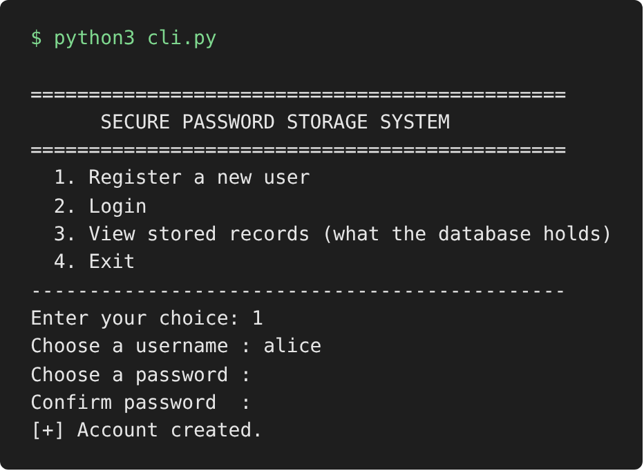
Figure 4.3: Command-line interface: main menu and registration (the password is not echoed)
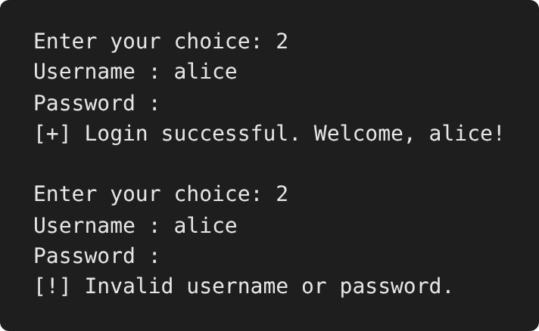
Figure 4.4: Command-line interface: successful and failed login
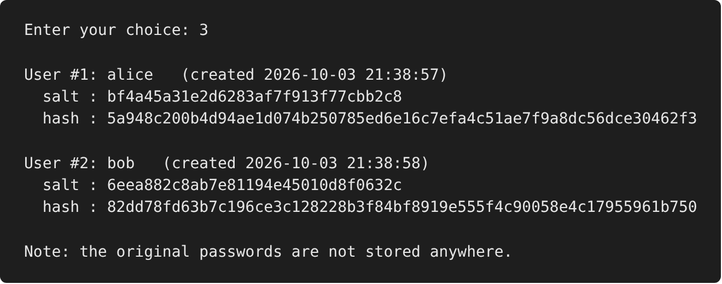
Figure 4.5: Command-line interface: stored records for two users with the same password
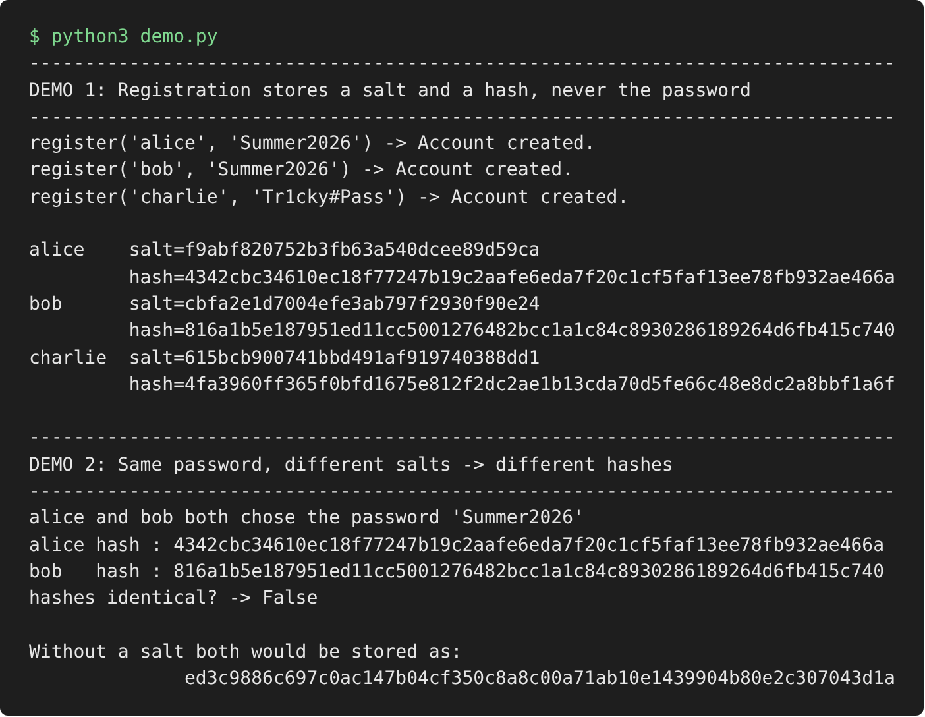
Figure 4.6: demo.py: stored salts and hashes, and the same-password case
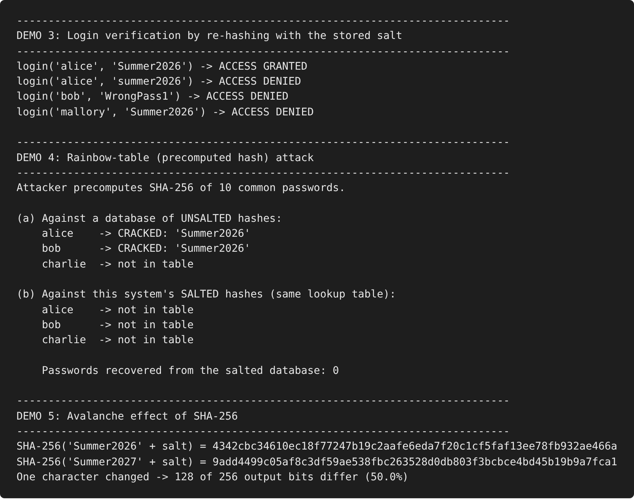
Figure 4.7: demo.py: login verification, rainbow-table attack and avalanche effect
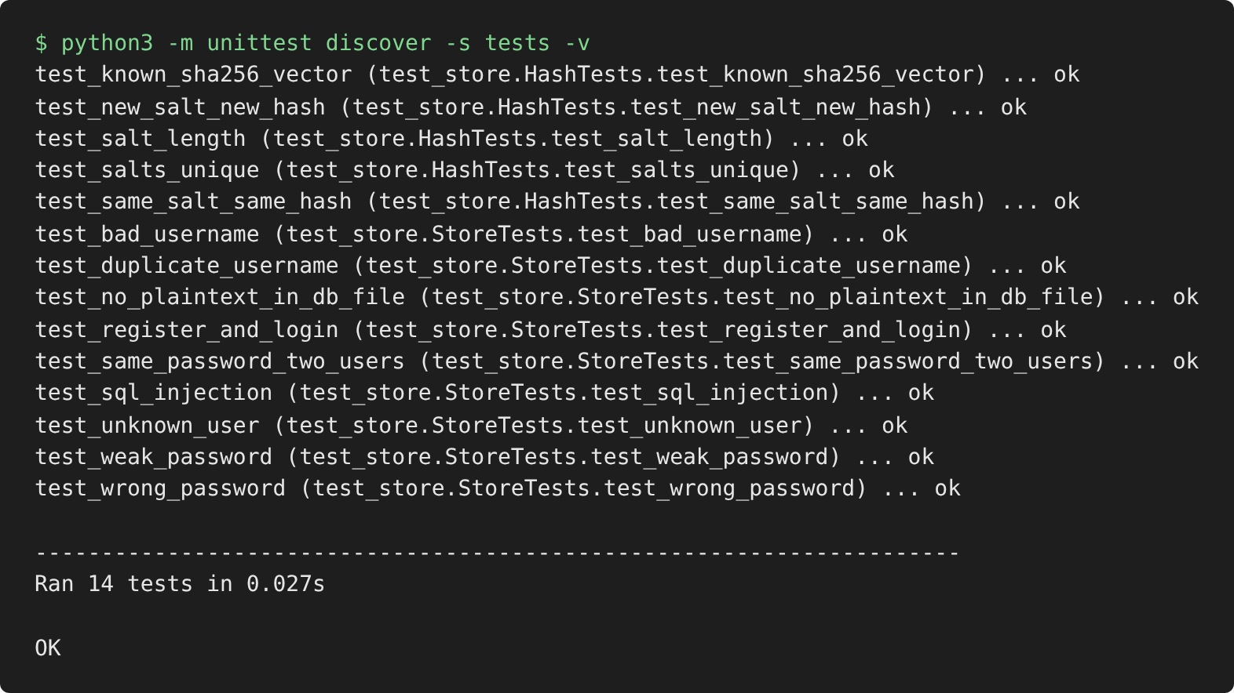
Figure 4.8: All 14 unit tests passing
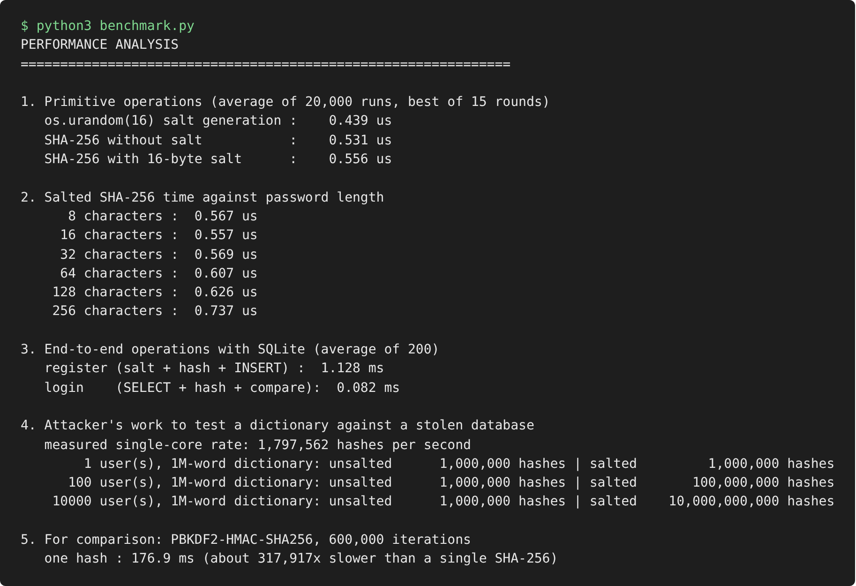
Figure 4.9: Output of benchmark.py
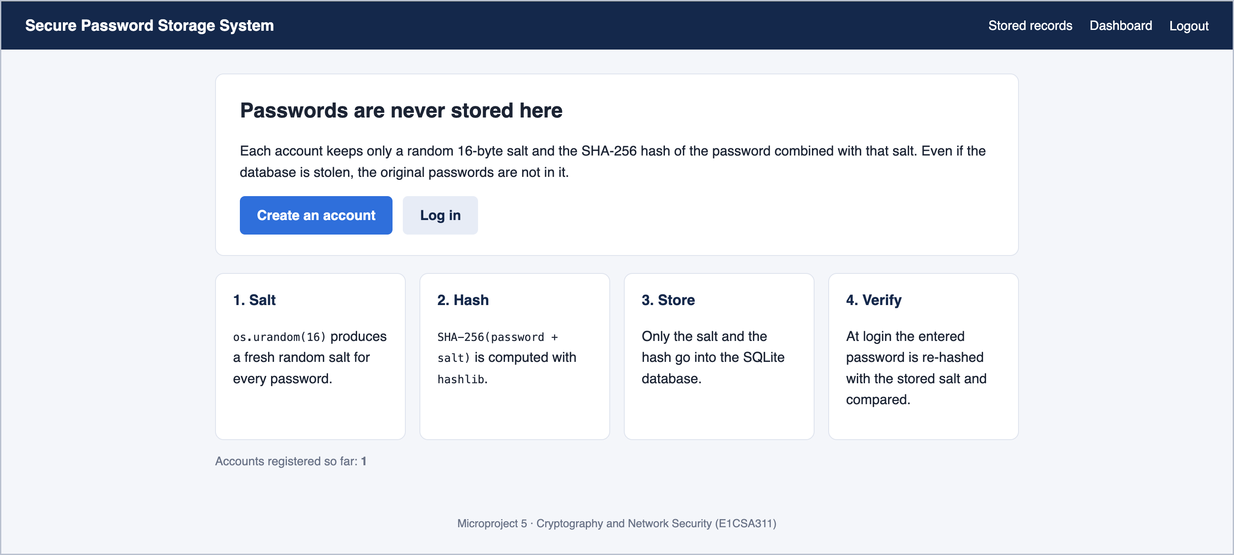
Figure 4.10: Web interface: home page, served at http://127.0.0.1:5000
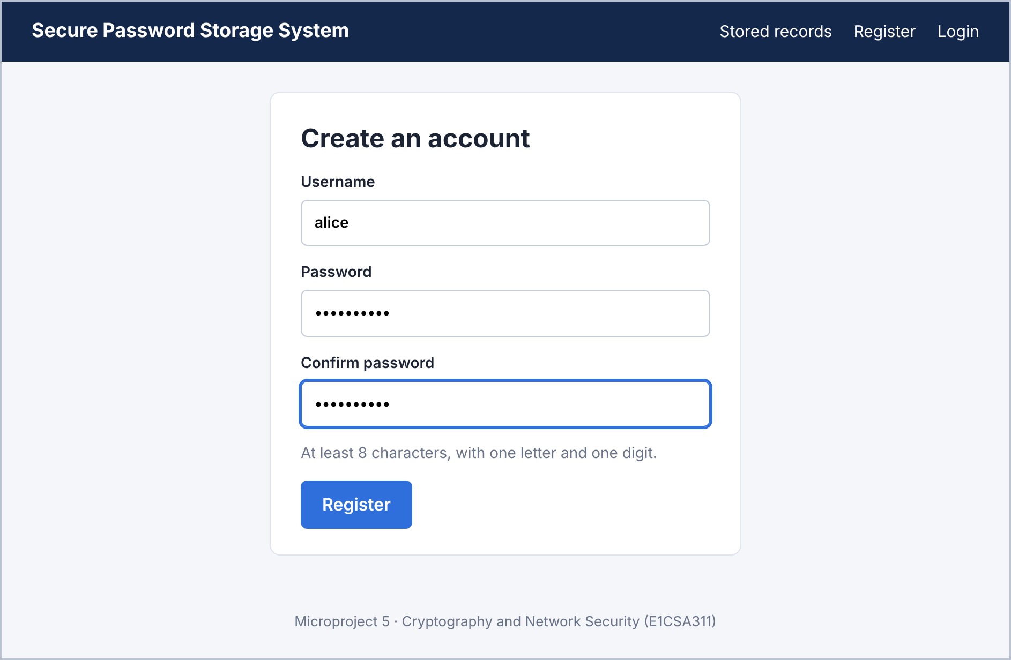
Figure 4.11: Web interface: registration form
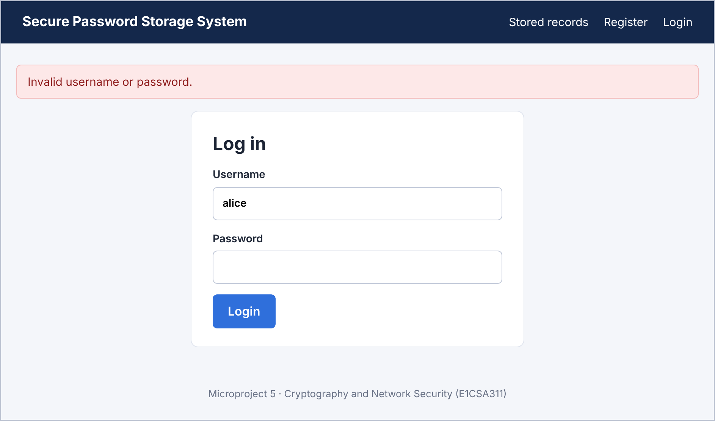
Figure 4.12: Web interface: failed login with a generic error message
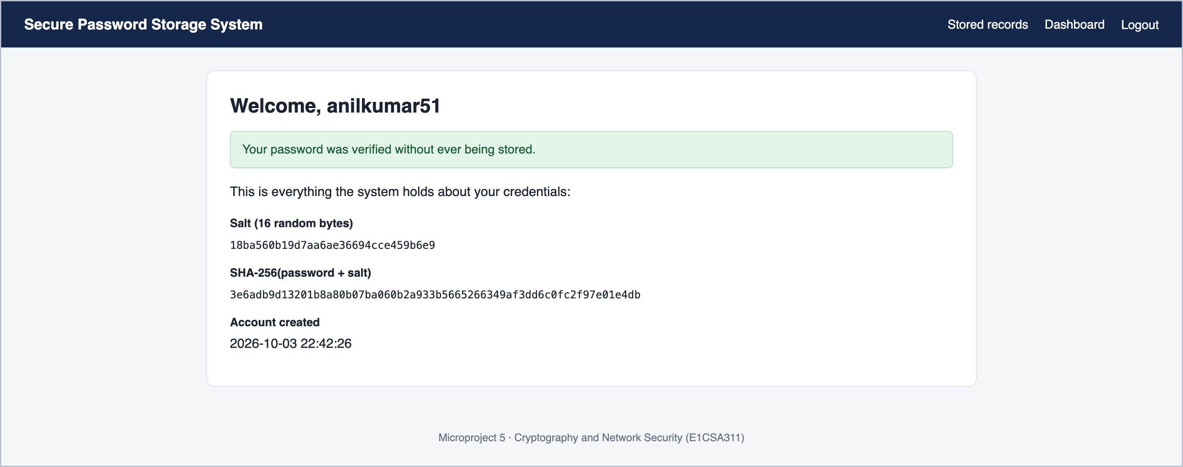
Figure 4.13: Web interface: dashboard after a successful login
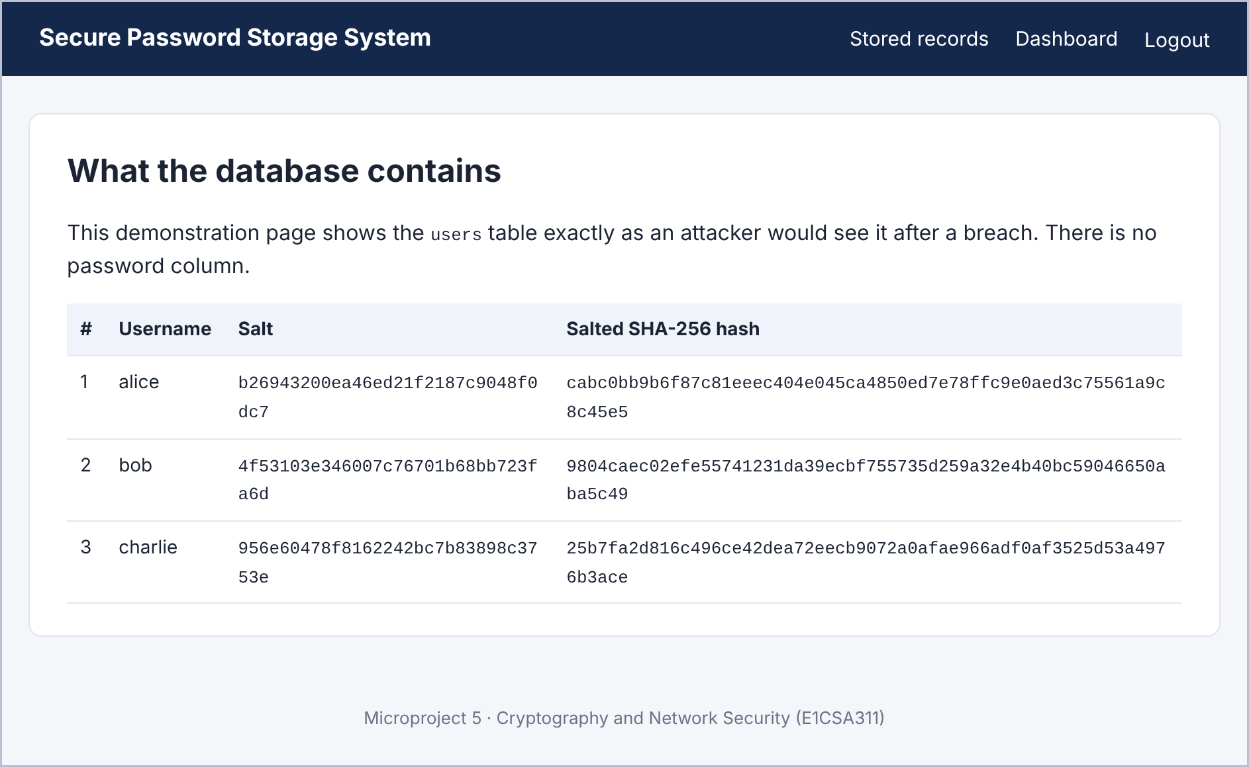
Figure 4.14: Web interface: contents of the users table (alice and bob have the same password)
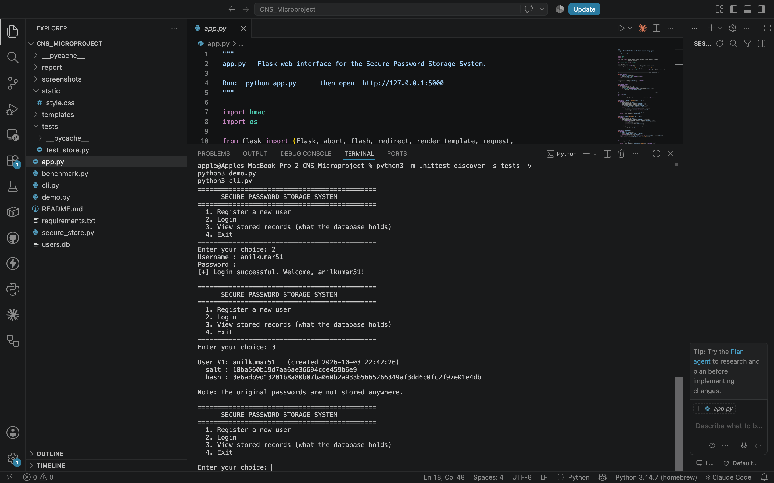
Figure 4.15: The project in Visual Studio Code on macOS, with cli.py running in the integrated terminal (login and stored records)

5. CONCLUSION AND FUTURE SCOPE
Conclusion
This microproject designed and implemented a secure password storage system in Python. The system never stores a password. It generates a unique 128-bit salt for each password with os.urandom(), hashes the password together with the salt using SHA-256 from hashlib, stores only the salt and the hash in an SQLite database, and verifies a login by re-hashing the entered password with the stored salt.
The results confirm that the objectives were met. Users with the same password received different hashes; a precomputed lookup table that broke an unsalted database recovered nothing from the salted one; login verification worked correctly for valid, invalid and unknown credentials; and the plain-text password could not be found in the database file. The cryptographic work costs well under a microsecond per password, so the protection is effectively free for the application, while the cost of a dictionary attack on a stolen database grows in proportion to the number of accounts.
The project also showed where salted hashing stops: it removes precomputation and hides repeated passwords, but it does not make a single guess expensive. Understanding that boundary is as important as the implementation itself.
Future scope
- Key stretching. Replace the single SHA-256 with PBKDF2, bcrypt, scrypt or Argon2id so that each guess costs the attacker a significant amount of time and memory. Python already provides hashlib.pbkdf2_hmac() and hashlib.scrypt().
- Pepper. Add a secret value kept outside the database (for example in an environment variable or a hardware security module), so that a database dump alone is not enough to start guessing.
- Account lockout and rate limiting. Limit repeated failed logins to slow down online guessing.
- Transport security. Serve the web interface over HTTPS so that the password is encrypted between the browser and the server.
- Multi-factor authentication. Add a one-time code as a second factor.
- Stronger password policy. Check new passwords against lists of breached passwords, as recommended by NIST SP 800-63B.
- Algorithm upgrade path. Store an algorithm identifier with each record so that hashes can be upgraded transparently when users next log in.

REFERENCES
- W. Stallings, Cryptography and Network Security: Principles and Practice, 7th ed. Pearson, 2017.
- National Institute of Standards and Technology, “Secure Hash Standard (SHS),” FIPS PUB 180-4, Aug. 2015.
- P. A. Grassi et al., “Digital Identity Guidelines: Authentication and Lifecycle Management,” NIST Special Publication 800-63B, Jun. 2017.
- M. S. Turan, E. Barker, W. Burr and L. Chen, “Recommendation for Password-Based Key Derivation, Part 1: Storage Applications,” NIST Special Publication 800-132, Dec. 2010.
- R. Morris and K. Thompson, “Password security: A case history,” Communications of the ACM, vol. 22, no. 11, pp. 594–597, Nov. 1979.
- P. Oechslin, “Making a faster cryptanalytic time-memory trade-off,” in Advances in Cryptology – CRYPTO 2003, LNCS vol. 2729, Springer, 2003, pp. 617–630.
- OWASP Foundation, “Password Storage Cheat Sheet,” OWASP Cheat Sheet Series. [Online]. Available: https://cheatsheetseries.owasp.org/cheatsheets/Password_Storage_Cheat_Sheet.html
- Python Software Foundation, “hashlib — Secure hashes and message digests,” Python 3 documentation. [Online]. Available: https://docs.python.org/3/library/hashlib.html
- Python Software Foundation, “os — Miscellaneous operating system interfaces (os.urandom),” Python 3 documentation. [Online]. Available: https://docs.python.org/3/library/os.html
- Python Software Foundation, “hmac — Keyed-hashing for message authentication,” Python 3 documentation. [Online]. Available: https://docs.python.org/3/library/hmac.html
- Python Software Foundation, “sqlite3 — DB-API 2.0 interface for SQLite databases,” Python 3 documentation. [Online]. Available: https://docs.python.org/3/library/sqlite3.html
- Pallets Projects, “Flask documentation.” [Online]. Available: https://flask.palletsprojects.com/

APPENDIX
A. How to run the project
Open the project folder in Visual Studio Code, open the integrated terminal and run:
python3 cli.py # command-line interface
python3 demo.py # security demonstrations
python3 benchmark.py # performance figures
python3 -m unittest discover -s tests -v # unit tests

pip3 install -r requirements.txt # Flask, for the web interface only
python3 app.py # then open http://127.0.0.1:5000
The listings of the core module and the command-line interface follow. The remaining files (app.py, the HTML templates, demo.py, benchmark.py and the unit tests) are submitted in the project folder.
B. Source code: secure_store.py (core module)
"""
secure_store.py - core of the Secure Password Storage System.

Microproject 5, Cryptography and Network Security (E1CSA311).

What this module does
---------------------
* never stores a password in plain text
* generates a fresh random salt for every password with os.urandom()
* stores only SHA-256(password || salt) together with the salt
* verifies a login by re-hashing the entered password with the stored salt
and comparing the two digests in constant time

Only the Python standard library is used (hashlib, os, hmac, sqlite3).
"""

import hashlib
import hmac
import os
import re
import sqlite3
from datetime import datetime

SALT_BYTES = 16 # 128-bit salt
MIN_PASSWORD_LENGTH = 8
USERNAME_PATTERN = re.compile(r"^[A-Za-z0-9_.-]{3,30}$")
DEFAULT_DB = os.path.join(os.path.dirname(os.path.abspath(__file__)), "users.db")

# ---------------------------------------------------------------- hashing --

def generate_salt(length=SALT_BYTES):
"""Return `length` cryptographically secure random bytes."""
return os.urandom(length)

def hash_password(password, salt):
"""Return the hex SHA-256 digest of the password with the salt appended."""
return hashlib.sha256(password.encode("utf-8") + salt).hexdigest()

def hash_unsalted(password):
"""Plain SHA-256 with no salt. Used only by the demos to show the weakness."""
return hashlib.sha256(password.encode("utf-8")).hexdigest()

# ------------------------------------------------------------- validation --

def check_username(username):
"""Return an error message, or None if the username is acceptable."""
if not USERNAME_PATTERN.match(username or ""):
return "Username must be 3-30 characters: letters, digits, '_', '.' or '-'."
return None

def check_password(password):
"""Return an error message, or None if the password meets the policy."""
if len(password or "") < MIN_PASSWORD_LENGTH:
return f"Password must be at least {MIN_PASSWORD_LENGTH} characters long."
if not re.search(r"[A-Za-z]", password) or not re.search(r"\d", password):
return "Password must contain at least one letter and one digit."
return None

# ---------------------------------------------------------------- storage --

class UserStore:
"""SQLite-backed table of (username, salt, salted hash)."""

def __init__(self, db_path=DEFAULT_DB):
self.db_path = db_path
with self._connect() as con:
con.execute(
"""CREATE TABLE IF NOT EXISTS users (
id INTEGER PRIMARY KEY AUTOINCREMENT,
username TEXT UNIQUE NOT NULL,
salt TEXT NOT NULL,
password_hash TEXT NOT NULL,
created_at TEXT NOT NULL
)"""
)

def _connect(self):
con = sqlite3.connect(self.db_path)
con.row_factory = sqlite3.Row
return con

def register(self, username, password):
"""Create an account. Returns (ok, message)."""
username = (username or "").strip()
error = check_username(username) or check_password(password)
if error:
return False, error

salt = generate_salt()
digest = hash_password(password, salt)
try:
with self._connect() as con:
# parameterised query -> no SQL injection
con.execute(
"INSERT INTO users (username, salt, password_hash, created_at) "
"VALUES (?, ?, ?, ?)",
(username, salt.hex(), digest,
datetime.now().strftime("%Y-%m-%d %H:%M:%S")),
)
except sqlite3.IntegrityError:
return False, "That username is already taken."
return True, "Account created."

def verify(self, username, password):
"""Return True only if the username exists and the password matches."""
with self._connect() as con:
row = con.execute(
"SELECT salt, password_hash FROM users WHERE username = ?",
((username or "").strip(),),
).fetchone()

if row is None:
# Do the same amount of work for an unknown user, so response
# time does not reveal which usernames exist.
hash_password(password or "", generate_salt())
return False

salt = bytes.fromhex(row["salt"])
candidate = hash_password(password or "", salt)
# constant-time comparison prevents timing attacks on the digest
return hmac.compare_digest(candidate, row["password_hash"])

def list_users(self):
"""Return every stored record. There is no password column to return."""
with self._connect() as con:
rows = con.execute(
"SELECT id, username, salt, password_hash, created_at "
"FROM users ORDER BY id"
).fetchall()
return [dict(r) for r in rows]

def delete_all(self):
with self._connect() as con:
con.execute("DELETE FROM users")
C. Source code: cli.py (command-line interface)
"""
cli.py - menu-driven terminal interface for the Secure Password Storage System.

Run: python cli.py
"""

from getpass import getpass

from secure_store import UserStore

MENU = """
==============================================
SECURE PASSWORD STORAGE SYSTEM
==============================================
1. Register a new user
2. Login
3. View stored records (what the database holds)
4. Exit
----------------------------------------------"""

def register(store):
username = input("Choose a username : ")
password = getpass("Choose a password : ")
if password != getpass("Confirm password : "):
print("[!] Passwords do not match.")
return
ok, message = store.register(username, password)
print(("[+] " if ok else "[!] ") + message)

def login(store):
username = input("Username : ")
password = getpass("Password : ")
if store.verify(username, password):
print(f"[+] Login successful. Welcome, {username}!")
else:
print("[!] Invalid username or password.")

def show_records(store):
users = store.list_users()
if not users:
print("(no users registered yet)")
return
for u in users:
print(f"\nUser #{u['id']}: {u['username']} (created {u['created_at']})")
print(f" salt : {u['salt']}")
print(f" hash : {u['password_hash']}")
print("\nNote: the original passwords are not stored anywhere.")

def main():
store = UserStore()
actions = {"1": register, "2": login, "3": show_records}
while True:
print(MENU)
choice = input("Enter your choice: ").strip()
if choice == "4":
print("Goodbye.")
break
action = actions.get(choice)
if action:
action(store)
else:
print("[!] Please enter a number from 1 to 4.")

if __name__ == "__main__":
main()

