Internet of things : what is it, and should you care ?

From Institute IoT : It is a network of items—each embedded with sensors— which are connected to the Internet. Thus, they can share information with each other in ways that allow for the automation of many tasks

Internet Of Things

Internet + Things i.e Network of things

Internet : The large system of connected computers around the world that allows people to share information and communicate with each other (ref) .
Internet of people :
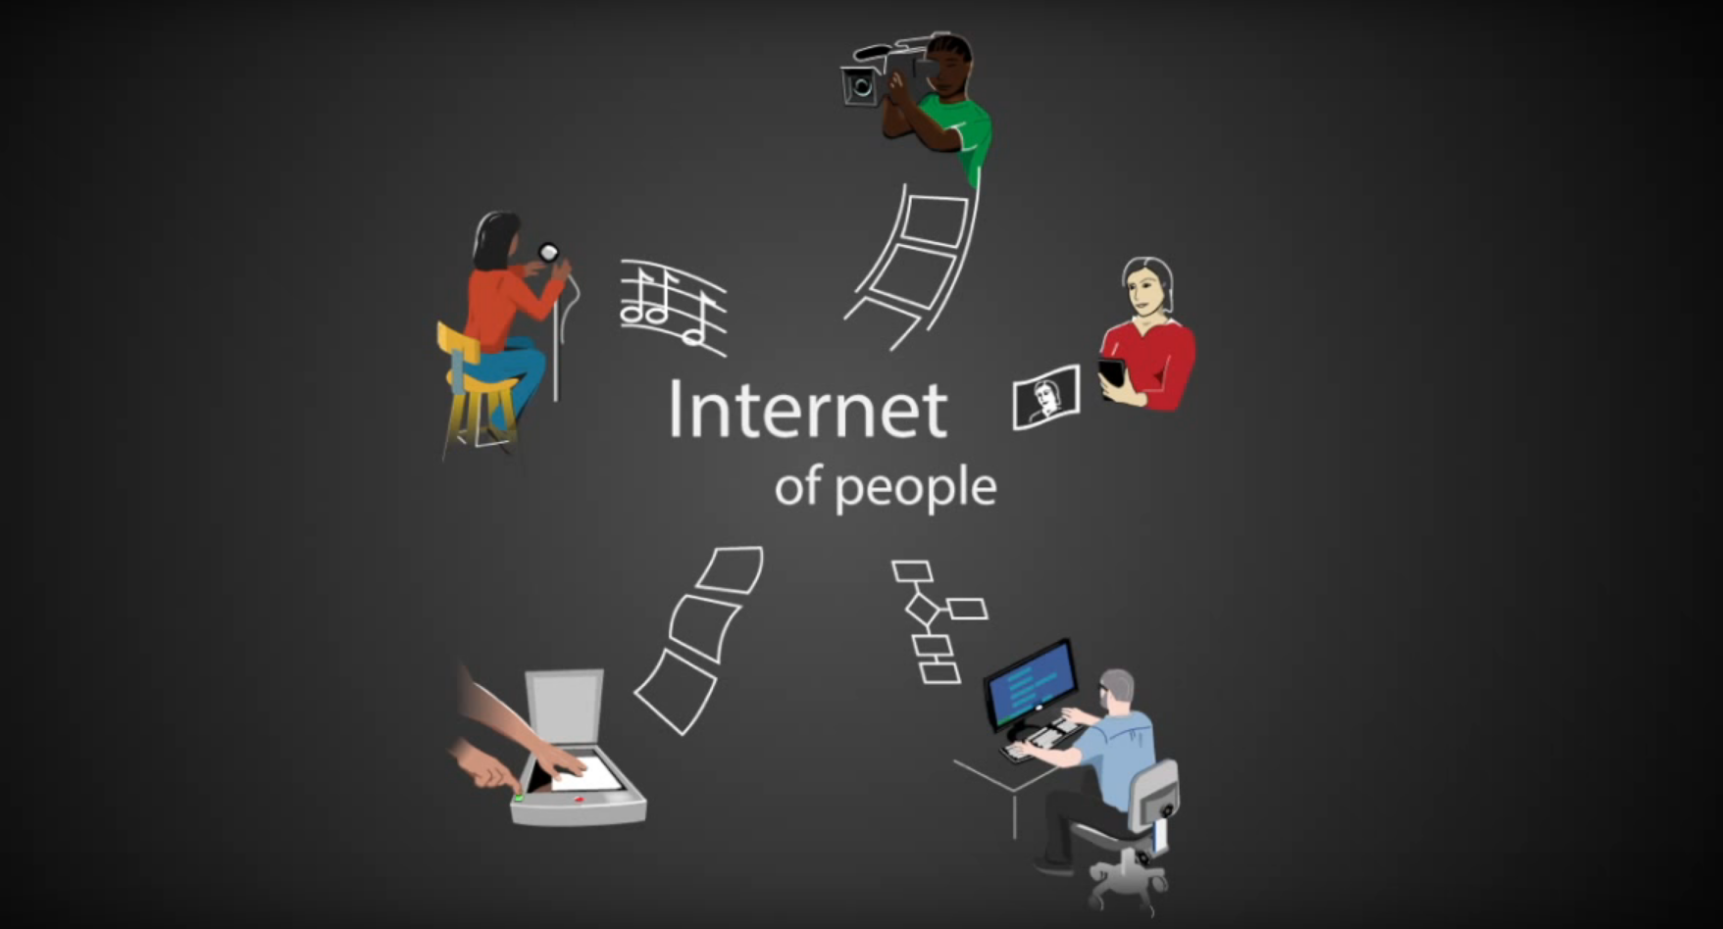

Thing : An object or entity that is not or cannot be named specifically (ref).

IoT is not just about connecting people, it is about connecting things
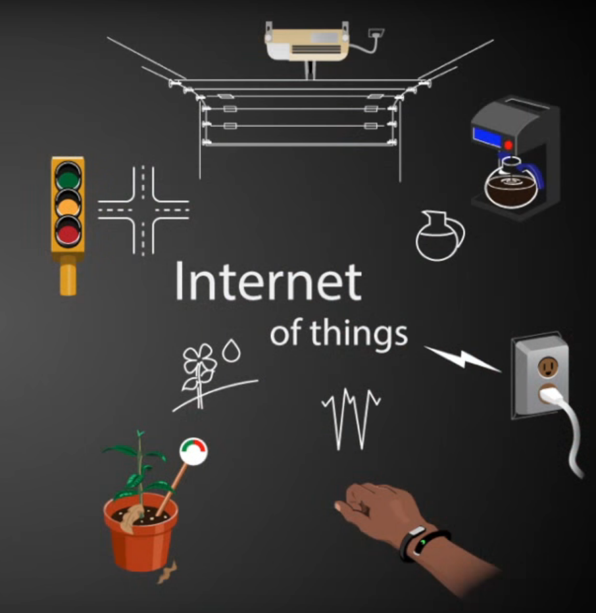

But How can things talk to other things ?
