
Hormel Foods Corporation (Hormel)
Identity Management Deployment Document

Contents
Version Control 4
Revision History 4
Review History 4
Approval History 4
1. Purpose and Scope 5
1.1 Purpose 5
1.2 Scope 5
2. Configuration Pre-requisites 6
2.1 Saviynt Cloud 6
2.1.1 Saviynt Security Manager 6
2.1.2 Saviynt Database User 6
2.2 SFTP Server Details 6
3. Package Structure 8
4. Saviynt Configuration 9
4.1 Configuration Checklist 9
5. Deployment 10
5.1 Import Package on Saviynt Security Manager (SSM) 10
5.2 Configure Password Policy 12
5.3 Configure SAV Role 13
5.4 Configure User Update Rule 14
6. Target Source Configuration 16
6.1 DMZ Active Directory 16
6.1.1 Connection: Active Directory 16
6.1.2 Security Systems 16
6.1.3 Endpoints 18
6.2 SMART 21
6.2.1 SMART : SAV Upload : File Directory 21
6.2.2 Security Systems 22
6.2.3 Endpoints 23
6.3 ASDPT001 24
6.3.1 ASDPT001: SAV Upload : File Directory 24
6.3.2 Security Systems 24
6.3.3 Endpoints 26
6.4 CF Plus 27
6.4.1 Connection: CF Plus 27
6.4.2 Security Systems 30
6.4.3 Endpoints 31
6.5 HFC Active Directory 33
6.5.1 Connection: Account Type Update 33
6.5.2 Connection: Active Directory 36
7. Configure Scheduler 37
8. Certification Campaign 38
9.1 User Manager 38
9.2 Service Account Owner Campaign 42
9. Glossary 47

Version Control

Revision History
Version | Date | Author | Comments

Review History
Version | Reviewed By | Date

Approval History
Version | Approved By | Date
1.0 | KPMG

Purpose and Scope

Purpose
The purpose of this document is to provide the detailed instructions to configure Hormel’ Saviynt infrastructure for initial deployment and IAM processes that are defined in the User Case document.

Scope
The scope of the document is deployment of DMZ Active Directory target application provisioning/reconciliation configuration, Approval workflows for the request able applications. Configure ASDPT001 ,SMART, HFC AD and CF Plus application for certification and reconciliation.

Configuration Pre-requisites
Make sure that you meet all the following pre-requisites before you start the configuration process.

Saviynt Cloud
Following pre-requisites must be fulfilled by Saviynt. Reach out to your customer success representative for these details.
    - Saviynt Security Manager
Saviynt instance on cloud with vanilla version 5.5 SP3.9. Verify that the following patches are applied on the instance

SR No# | Issue Description | Resolution (patch/configuration update)
1 | # Regarding Reconfigure campaign and selecting template for campaign #1210843 | Completed
2 | # Not able to save service account campaign after updating consult query #1249126 | completed
3 | #1139002 Not able to export campaign details from action | completed
4 | #Regarding AD connector "ADVANCE_FILTER_JSON" section is missing in PROD #1249956 | Completed
5 | #Access to files imported via SFTP #1237058 | Completed
6 | #Need to stamp production Saviynt DB password in "Account Type Update" connection #1226891 | Completed
7 | #Regarding updating account owner as primary certifier #1154833 | Completed
8 | #Getting multiple reminders for User manager and Service account campaign | In-Progress

    - Saviynt Database User
Get Database user account with password from Saviynt that has the read and write permission on Saviynt USERS table.

SFTP Server Details
Confirm SFTP server is configured for PROD environment and Shell Script is deployed in Saviynt to copy files from SFTP server to Saviynt. Script is deployed on both production nodes. Cron is schedule on one node.
Following is Shell Script.
File name :- file_transfer.sh
#!/bin/bash
#!/bin/bash
cd /datadrive/sharedappdrive/saviynt/Import/Datafiles
sftp -oIdentityFile=~/.ssh/hormal_sftp.ppk saviynt@ lxcobsav1p.hfc.ad <<EOF
mget /*/Outbound/*.csv
exit
EOF

Note :- To generate a public and private key on Saviynt and then provide public key to Hormel team to import into SFTP server.

Package Structure
The following table provides description of folders and content present in the deployment package. The package is delivered as a zip file and should be unzipped in your local machine at the start of the deployment.

Folder | Description
\Package\Release_1.0 | Top Level folder.
\Package\Release_1.0\ | Folder which contains configuration guide and all the artefact referred in configuration guide like Saviynt zip folder.
Release _1.0\Configuration Guide | This folder contains Configuration guide.
\Package\Release _1.0\Configuration Guide\Configuration Guide.docx | Configuration guide that has detailed steps of Saviynt configuration.
\Package\Release _1.0\zip\file_transfer.sh | This folder contains zip folders that has Shell script used for to copy file from SFTP server operations.
\Package\Release _1.0\Saviynt\Connections.zip | This folder contains all the connection zip for target application.
\Package\Release _1.0\Saviynt\Analytics.zip | This folder contains all the Analytics created for Hormel.
\Package\Release _1.0\Saviynt\Email_Template.zip | This folder contains all the Email templates created for Hormel.
\Package\Release _1.0\Saviynt\Approval_Workflow.zip | This folder contains all the Approval Workflow created for Hormel.
\Package\Release _1.0\Saviynt\User_Group.zip | This folder contains User Group for Access Removal Approval
\Package\Release _1.0\Configuration Sheet | This folder contains excel sheet with configuration of custom attribute, update rule, dynamic attribute.
\Package\Release_1.0\Files | This folder contain all files that will used to upload owners, primary certifier, Account type, Upload user correlation for ASPDT001.

Saviynt Configuration

Configuration Checklist
This section details the list of components that are installed as part of IAM implementation and the order in which the installation and configuration is performed. It is recommended that you mark the status once each step is completed.
Step# | Section | Components | Status
1 | Identity Management Configuration Deployment | Section 2.2 Deploy file_transfer.sh Script on Saviynt server | ☒
2 | Identity Management Configuration Deployment | Section 2.2 Generate Public and Private Key on Saviynt server | ☒
3 | Identity Management Configuration Deployment | Section 5.2 Import Package on Saviynt Security Manager (SSM) | ☐
4 | Identity Management Configuration Deployment | Section 5.2 Configure Password Policy | ☐
5 | Identity Management Configuration Deployment | Section 5.3 Configure SAV Role | ☐
6 | Identity Management Configuration Deployment | Section 5.4 Configure User Update Rule | ☐
7 | Identity Management Configuration Deployment | Section 6.1 DMZ Active Directory | ☐
8 | Identity Management Configuration Deployment | Section 6.2 SMART | ☐
9 | Identity Management Configuration Deployment | Section 6.3 ASDPT001 | ☐
10 | Identity Management Configuration Deployment | Section 6.4 CF Plus | ☐
11 | Identity Management Configuration Deployment | Section 6.5 HFC AD | ☐
12 | Identity Management Configuration Deployment | Section 8 Configure Scheduler | ☐
13 | Identity Management Configuration Deployment | Section 9 Certification Campaign | ☐

Deployment
This section details the component to be created in Saviynt before starting the User and Account data load.

Import Package on Saviynt Security Manager (SSM)
- Login to Saviynt Security Manager (SSM) as administrator.
- Click on “Admin” tab on the top menu bar and click “Transport”. Under “Transport” select “Import Package”.
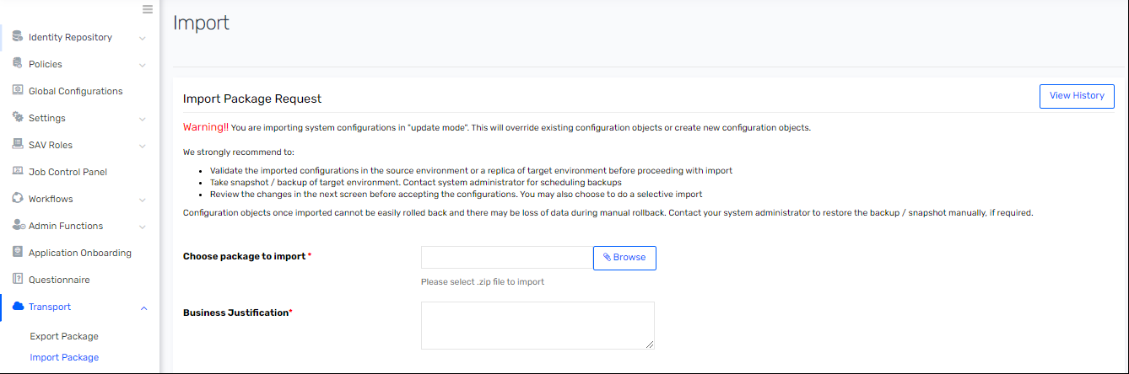
- Click on “Browse” next to “Choose package to import” and navigate to release package folder.
Note: The release package is provided with Configuration guide. Copy the package to local drive and use as showcased in below screenshot.

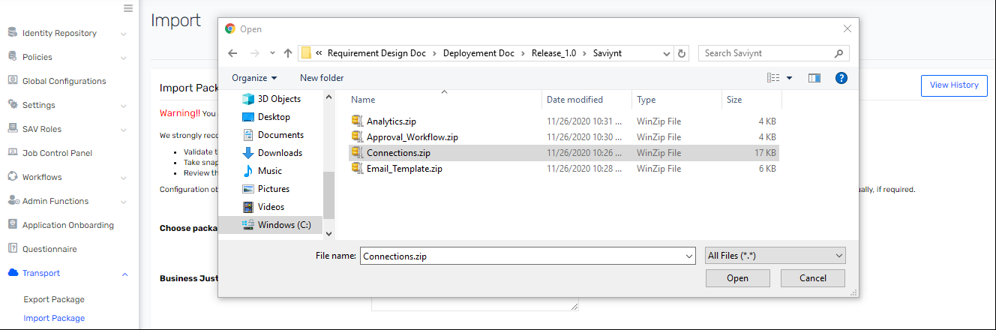
- Select “Connections.zip” from Release _1.0\Saviynt\ folder and click on open. Provide the Business Justification.
- Click on “View Summary”. It will go to next page.
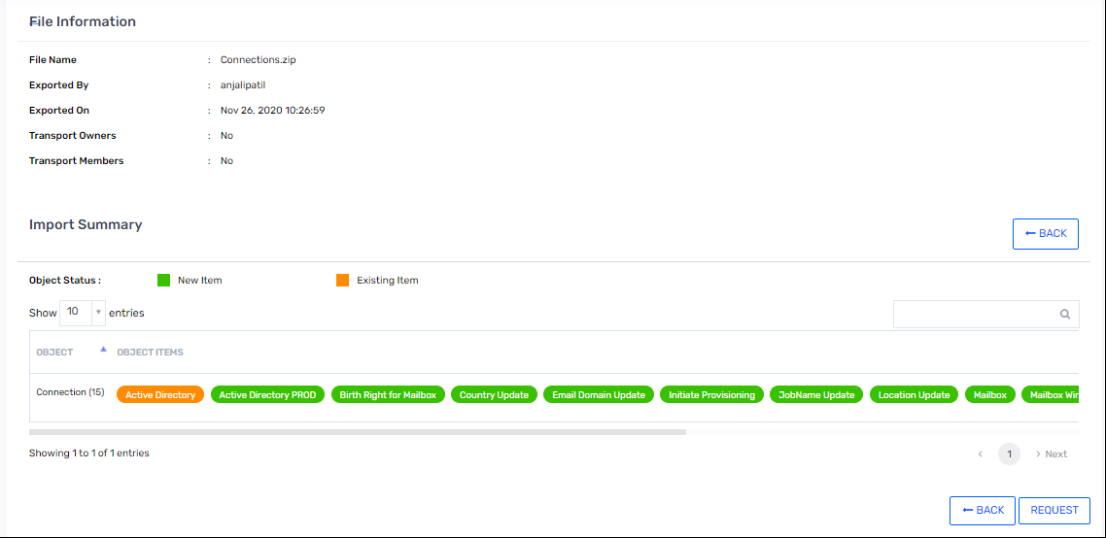
- Click on “Request”.
- Repeat steps 2 till 6 for all zip files.

Zip Name | Details
Release _1.0\Saviynt\Email_Template.zip | This zip contains all the email templates.
Release _1.0\Saviynt\Approval_Workflow.zip | This zip contains the Hormel Approval Workflow.
Release _1.0\Saviynt\Analytics.zip | This zip contains the Analytics created for Hormel.
Release _1.0\Saviynt\User_Group.zip | This folder contains User Group for Access Removal Approval
Release _1.0\Saviynt\Sav_Roles_EndUser.zip | This folder contains Sav role access for end users.

Configure Password Policy
- Login to Saviynt Security Manager (SSM) as administrator.
- Click on “Admin” tab on top menu bar and click “Identity Repository”. Under “Identity Repository” select “Password Policies”.
- Click on “Actions” and select “Create Password Policy”.
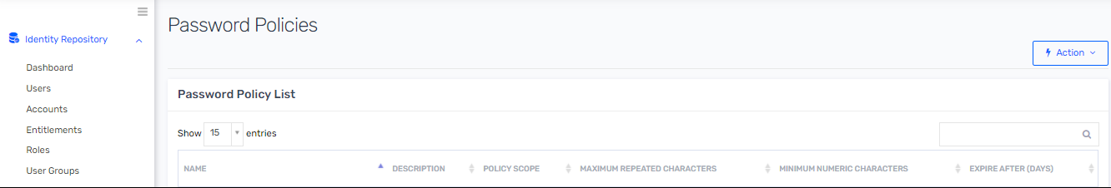

- Provide below details in “Create Password Policy” page.
Attribute Name | Attribute Value
Policy Name | DMZ Hormel Active Directory Password Policy
Policy Description | This is Password policy for Hormel DMZ Active Directory.
Policy Scope | Application
Minimum Numeric Characters | 1
Minimum Special Characters | 1
Disallow Last Password | 24
Use Dictionary | NO
Blacklisted attributes | ${user.username},${user.firstname},${user.lastname}
Minimum Length | 14
Maximum Length | 32
Expire After (Days) | 90

- Click on “Create”.
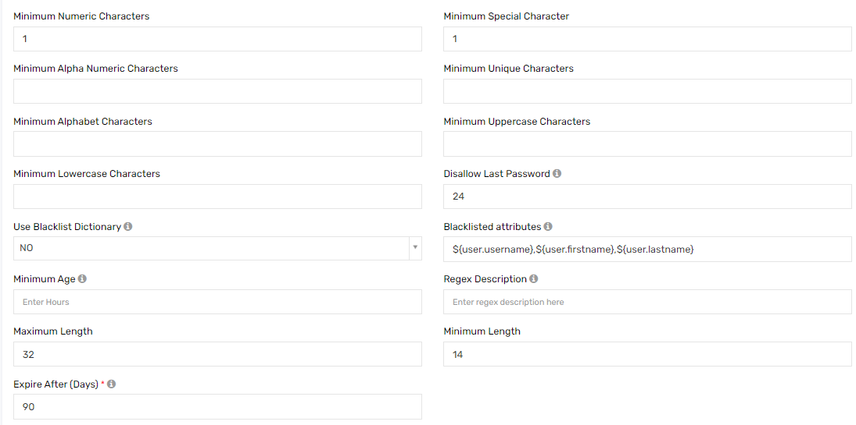

Configure SAV Role
- Login to Saviynt Security Manager (SSM) as administrator.
- Click on “Admin” tab on top menu bar and click on “SAV Role”. Under “SAV Role” select “SAV Roles”.
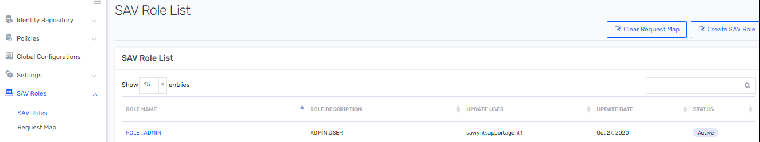

- Update the SAV role as per the Release _1.0\Configuration Sheet\Hormel_IDM_SAV_Roles sheet.
- Repeat the steps for all the SAV role mentioned in Release _1.0\Configuration Sheet \Hormel_IDM_SAV_Roles sheet.
- Assign the Access as mentioned in below table.
Saviynt Role Name | Sub-Menu Entitlement Values
ROLE_HORMEL_ENDUSER | - SUBMENU.ARS.jbpmworkflowmanagement_showmyhistoryrequests  - SUBMENU.ARS.jbpmworkflowmanagement_viewopenrequests  - SUBMENU.ARS.workflowmanagement_requesthomedashboard  - SUBMENU.ARS.workflowmanagement_remaccess  - SUBMENU.ARS.jbpmworkflowmanagement_remaccess  - SUBMENU.ARS.arsDashboard_remaccess  - SUBMENU.ARS.pmgmt_checkpasswordstrength  - SUBMENU.ARS.pmgmt_checkpasswordstrengthuserpolicy  - SUBMENU.ADMIN.pmgmt_resetpassword  - SUBMENU.ATTESTATION.campaign_list  - SUBMENU.CAMPAIGN.certification_list

Configure User Update Rule
- Login to Saviynt Security Manager (SSM) as administrator.
- Click on “Admin” tab on top menu bar and click on “Policies”. Under “Policies” select “User Update Rule List”.
- Click on “Actions” and select “Create User Update Rule”.
- Enter below “Rule Name” and “Rule Description” in “Create User Update Rule” page.

Attribute Name | Attribute Value
Rule Name | Disable Connected Applications on User Inactive from Import
Rule Description | Disable Connected Applications on User Inactive from Import
Type | Trigger when the user is updated from Import

- In “Condition” block select the below details.
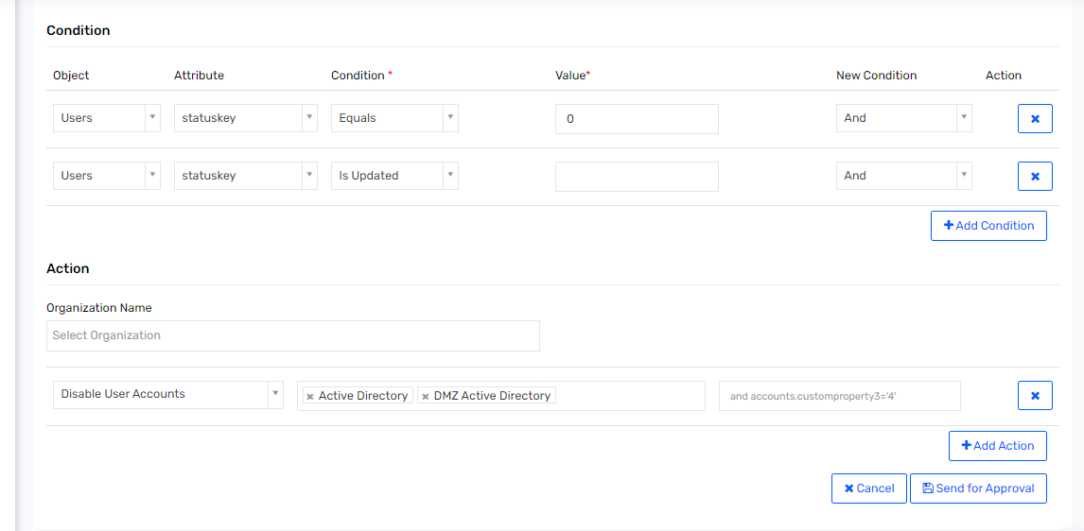
- Click on “Send for Approval”.
- Repeat steps 2 to 6 for rules given in Release _1.0\Configuration Sheet\Hormel_IDM_UpdateRules sheet.

Target Source Configuration

DMZ Active Directory
    - Connection: Active Directory
- Login to Saviynt Security Manager (SSM) as administrator.
- Click on “Admin” tab on top menu bar and click on “Identity Repository”. Under “Identity Repository” select “Connections”.
- Click on “Connection List” and then click on “DMZ Active Directory” connection.
- Update “Active Directory” connection as below.
Attribute Name | Attribute Value
Connection Name | DMZ Active Directory
URL | ldaps://172.16.42.1:636
USERNAME | CN=mrdmzsaviyntprd,OU=ServiceAccounts,OU=HRLDMZ-Users,DC=HRLDMZ,DC=DMZ
PASSWORD | <DMZ Active Directory Production Service Account Password>
SEARCHFILTER | OU=HRLDMZ-Users,DC=HRLDMZ,DC=DMZ
OBJECTFILTER | (&(objectCategory=person)(objectClass=person)(objectClass=user)(objectClass=organizationalPerson)(objectClass=top)(!(objectClass=computer))(!(objectClass=contact)))
CREATEACCOUNTJSON | {  "sAMAccountName": "${task.accountName}",  "employeeNumber": "${(ServiceAccountOwnerMap.get("ServiceAccountType") == 'Service Account' || ServiceAccountOwnerMap.get("ServiceAccountType") == 'Generic Account')?'':(user?.employeeid == null || user?.employeeid == '')?'':user.employeeid}",  "givenName": "${task.accountName}",  "UserPrincipalName": "${task.accountName}@HRLDMZ.DMZ",  "displayname": "${task.accountName}",  "description": "${(ServiceAccountOwnerMap.get("ServiceAccountType") == 'Service Account')?Description:(ServiceAccountOwnerMap.get("ServiceAccountType") == 'Generic Account')?Description:user?.systemUserName+' DMZ Maintenance User'}",  "pwdLastSet":"${(ServiceAccountOwnerMap.get("ServiceAccountType") == 'Service Account' || ServiceAccountOwnerMap.get("ServiceAccountType") == 'Generic Account')?'0':'0'}",  "cn": "${cn}",  "objectClass": [  "top",  "person",  "organizationalPerson",  "user"  ],  "userAccountControl": "${(ServiceAccountOwnerMap.get("ServiceAccountType") == 'Service Account' || ServiceAccountOwnerMap.get("ServiceAccountType") == 'Generic Account')?'66048':'512'}"  }
ENABLEACCOUNTJSON | {  "ATTRIBUTESTOCHECK": {"userAccountControl":"514"},  "REMOVEGROUPS": "NO",  "USEDNFROMACCOUNT": "YES",  "AFTERMOVEACTIONS": {  "userAccountControl": "${(ServiceAccountOwnerMap.get("ServiceAccountType") == 'Service Account' || ServiceAccountOwnerMap.get("ServiceAccountType") == 'Generic Account')?'66048':'512'}",  "accountExpires":"9223372036854775807"  },  "EnableAccountOU": "${(ServiceAccountOwnerMap.get("ServiceAccountType") == 'Service Account')?'OU=ServiceAccounts,OU=HRLDMZ-Users,DC=HRLDMZ,DC=DMZ':(ServiceAccountOwnerMap.get("ServiceAccountType") == 'Generic Account')?'OU=GenericAccounts,OU=HRLDMZ-Users,DC=HRLDMZ,DC=DMZ':'OU=MaintAccounts,OU=HRLDMZ-Users,DC=HRLDMZ,DC=DMZ'}"  }
BASE | OU=HRLDMZ-Users,DC=HRLDMZ,DC=DMZ
ACCOUNTNAMERULE | CN=${task.accountName},${if (ServiceAccountOwnerMap.get("ServiceAccountType") == 'Service Account') {'OU=ServiceAccounts,OU=HRLDMZ-Users,DC=HRLDMZ,DC=DMZ'} else if(ServiceAccountOwnerMap.get("ServiceAccountType") == 'Generic Account') {'OU=GenericAccounts,OU=HRLDMZ-Users,DC=HRLDMZ,DC=DMZ'}  esle {'OU=MaintAccounts,OU=HRLDMZ-Users,DC=HRLDMZ,DC=DMZ'}}
REMOVEACCOUNTACTION | Update the Production OU in JSON
groupSearchBaseDN | Update the Production group Search in JSON
DISABLEACCOUNTJSON | Update the Production OU in JSON
Advance Filter | {  "AdvanceFilter": {  "OU=HRLDMZ-Users,DC=HRLDMZ,DC=DMZ": ["(&(objectCategory=person)(objectClass=person)(objectClass=user)(objectClass=organizationalPerson)(objectClass=top)(!(objectClass=computer))(!(objectClass=contact)))"],  "OU=TBD,DC=HRLDMZ,DC=DMZ": [  "(&(objectCategory=person)(objectClass=person)(objectClass=user)(objectClass=organizationalPerson)(objectClass=top)(!(objectClass=computer))(!(objectClass=contact)))"  ]  }  }
SETRANDOMPASSWORD | TRUE
PASSWORD_MIN_LENGTH | 14
PASSWORD_MAX_LENGTH | 32
PASSWORD_NOOFCAPSALPHA | 1
PASSWORD_NOOFDIGITS | 1
PASSWORD_NOOFSPLCHARS | 1
STATUS_THRESHOLD_CONFIG | {  "statusAndThresholdConfig": {  "statusColumn":"customproperty20",  "activeStatus":["512","active","544","66048","1049088"],  "deleteLinks":false,  "accountThresholdValue": 3000,  "correlateInactiveAccounts": true,  "inactivateAccountsNotInFile": false  }  }
    - Security Systems
- Login to Saviynt Security Manager (SSM) as administrator.
- Click on “Admin” tab on top menu bar and click on “Identity Repository”. Under “Identity Repository” select “Security Systems”.
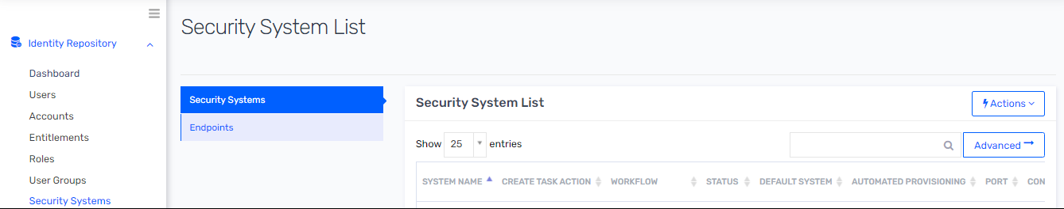

- Click on Action and from dropdown select “Create Security System”.
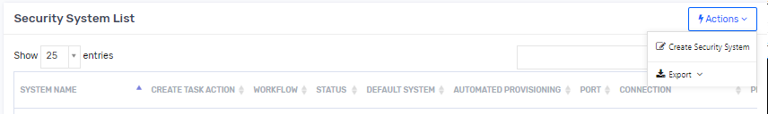

- Enter details as per below table.
Attribute Name | Attribute Value
System Name | DMZ Active Directory
Display Name | DMZ Active Directory
Connections | DMZ Active Directory
Provisioning Connection | DMZ Active Directory
Policy Rule | Hormel DMZ Active Directory Password Policy
Access Add Workflow | Hormel DMZ Active Directory Workflow
Access Remove Workflow | Hormel DMZ Active Directory Workflow
Add Service Account Workflow | Hormel DMZ Active Directory Service Account Workflow
Remove Service Account Workflow | Hormel DMZ Active Directory Service Account Workflow
Policy Rule Service Account | Hormel DMZ Active Directory Password Policy
Number of tries for provisioning | 2880
Default System | No
Automated Provisioning | Enable
Manage Entity | No
Persistent Data | No
Use open connector | No
Recon Application | Yes
Instant Provisioning | Enable
Provisioning Threshold | DISABLEACCOUNT : 50  DELETEACCOUNT : 50

- Click on “Create”.
    - Endpoints
- Login to Saviynt Security Manager (SSM) as administrator.
- Click on “Admin” tab on top menu bar and click on “Identity Repository”. Under “Identity Repository” select “Security Systems”.
- Select “Endpoints”.
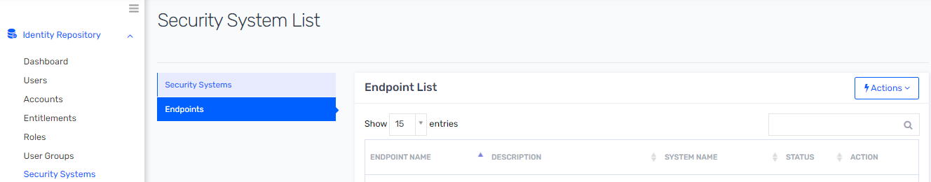

- Click on “Actions” and select “Create Endpoint” from dropdown.
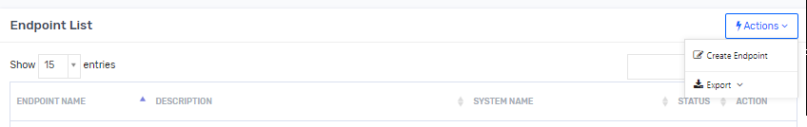

- Enter details as per below table.
Attribute Name | Attribute Value
Endpoint Name | DMZ Active Directory
Display Name | DMZ Active Directory
Security System | DMZ Active Directory
Add Email Template | New Account = DMZ Active Directory User and Service Account Creation  Enable Account = DMZ Active Directory User Account Enable  Disable Account = DMZ Active Directory User Account Disable  Remove Account = DMZ Active Directory User Account Deleted  Change Password = Change Password for DMZ AD
Description
Config For AllowChangePassword | AC.NAME NOT LIKE '%eleted on-%';
User Account Correlation rule | employeeId = CUSTOMPROPERTY8
Account Name Rule | lower(concat('mnt',(case when (users.customproperty14 IS NOT NULL) THEN substring(users.customproperty14,1,1)END),(case when (users.middlename IS NOT NULL) THEN substring(users.middlename,1,1)END),(case when (users.customproperty15 IS NOT NULL) THEN substring(users.customproperty15,1,1)END)))###lower(concat('mnt',(case when (users.customproperty14 IS NOT NULL) THEN substring(users.customproperty14,1,1)END),(case when (users.middlename IS NOT NULL) THEN substring(users.middlename,1,1)END),(case when (users.customproperty15 IS NOT NULL) THEN substring(users.customproperty15,1,1)END),1))###lower(concat((case when (users.middlename IS NULL)THEN concat('mnt',(case when (users.customproperty14 IS NOT NULL) THEN substring(users.customproperty14,1,1)END),(case when (users.customproperty15 IS NOT NULL) THEN substring(users.customproperty15,1,1)END)) END)))###lower(concat((case when (users.middlename IS NULL)THEN concat('mnt',(case when (users.customproperty14 IS NOT NULL) THEN substring(users.customproperty14,1,1)END),(case when (users.customproperty15 IS NOT NULL) THEN substring(users.customproperty15,1,1)END),1) END)))
Account Name Rule | Check Unique Account : All
Access Query | where userkey = ${requestor.id} and departmentname = 'IT'
Disable Modify Account | ON
Disable Modify Service Account | On
Service Account Type | Generic Account, Service Account
Service Account Name Rule | ${if(accountType == 'Service Account') 'mrdmz' +ServiceAccountName.toLowerCase() else if (accountType == 'Generic Account') 'dmz' +ServiceAccountName.toLowerCase() else ''}###INCREMENTINDEX###
Service Account Access Query | where userkey = ${requestor.id} and departmentname = 'IT'
Account Name validator Regex | (^(mnt|mrdmz|dmz)([a-zA-Z0-9-]{1,15})$)
Requestable | True

- Click on Create.
- Open the endpoint “DMZ Active Directory”.
- Update the “Other Attributes” tab with following details
Attribute Name | Attribute Value
Account Custom Property 1 Label | When Changed
Account Custom Property 2 Label | Given Name
Account Custom Property 3 Label | Initial
Account Custom Property 4 Label | SN
Account Custom Property 6 Label | User Principal Name
Account Custom Property 8 Label | Employee Number
Account Custom Property 20 Label | User Account Control
Account Custom Property 21 Label | Object GUID

- Click on “Entitlement Type”. Click on “Action” button.
- Select “Create Entitlement Type” from “Action” dropdown.
- Fill the details in “Create New Entitlement Type” page with following details.
Attribute Name | Attribute Value
Entitlement Type Name | memberOf
Display Name | Group
Endpoint Name | DMZ Active Directory
Entitlement Description | memberOf – DMZ ActiveDirectory
Certifiable | False
Request Option | None
Hierarchy | Not Required
Required | false

- Create Dynamic Attribute as given in Release _1.0\Configuration Sheet\Hormel_IDM_DynamicAttribute sheet.
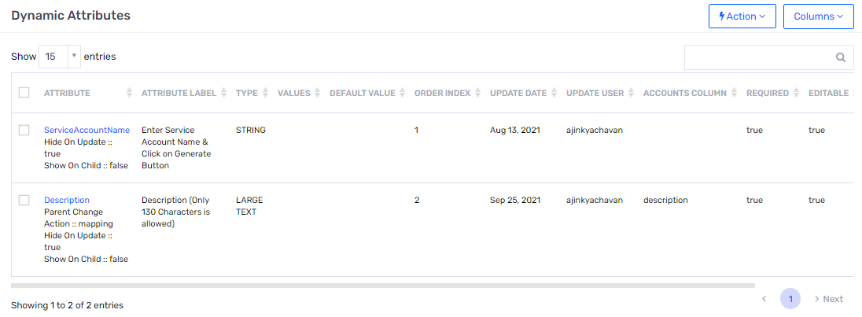
    - Update Account Type
To Update account type perform following Steps
- Login into SSM, Navigate to “Identity Repository”, Select “Accounts” and click on it.
- Click on “Actions” button and select “Upload Account”

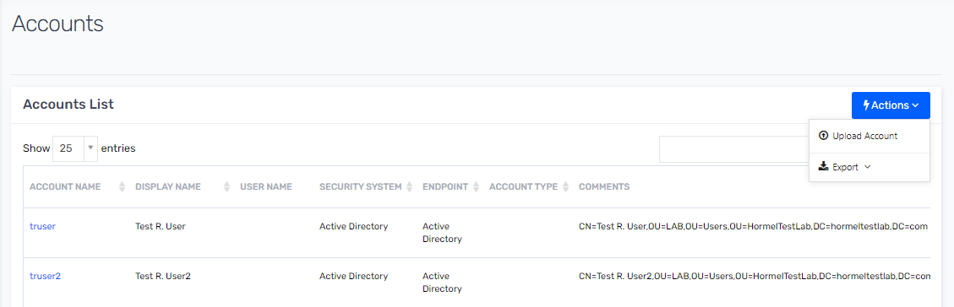

- Select following options as showed in below figure. Then click on Preview button.

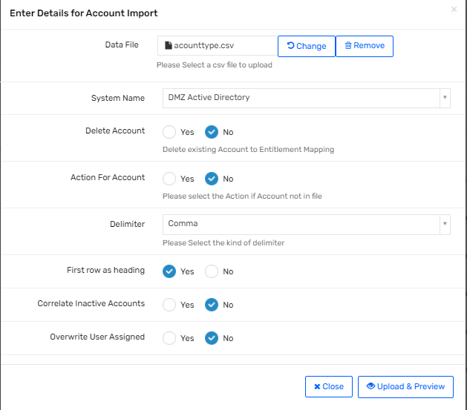
- Validate all header are properly set and then click on “Import Now” button.
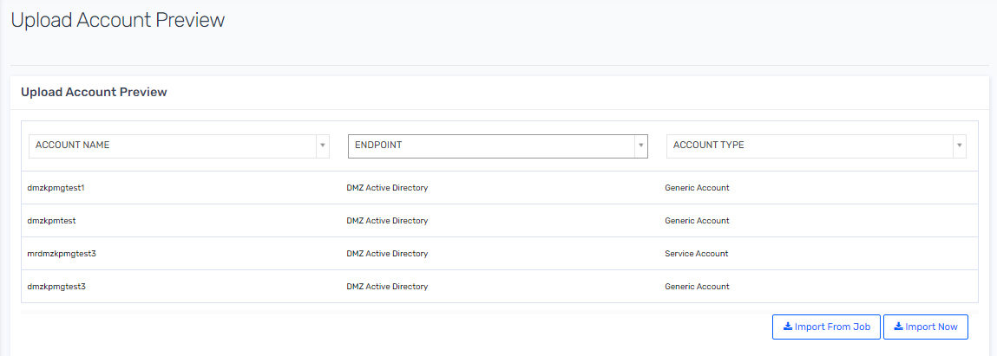
- Verify that account type attribute is updated with proper values.

    - Update Service Account Owner as Rank 1 and Primary certifier.
To Update account type perform following Steps
- Login into SSM, Navigate to “Identity Repository”, Select “Accounts” and click on it.
- Click on “Actions” button and select “Upload Account”

- Select following options as showed in below figure. Then click on Preview button.
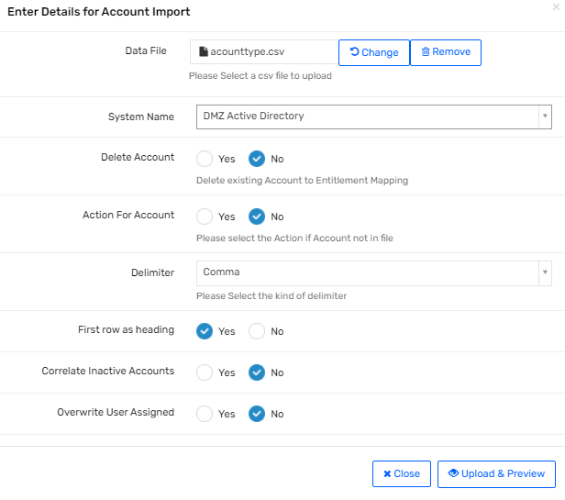
- Validate all header are properly set and then click on “Import Now” button.
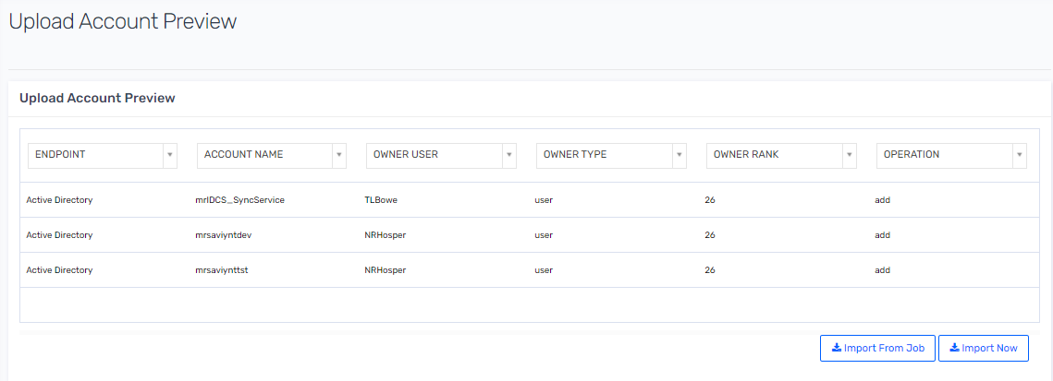
- Verify that Owner are set with proper username.

Note:- To Set Rank 1 Owner Rank must be set as “1” and top set Primary Certifier Owner Rank attribute must be set as “26”.

SMART
    - SMART : SAV Upload : File Directory
- Login to Saviynt Security Manager (SSM) as administrator.
- Click on “Admin” tab on top menu bar and click on “Setting”. Under “Setting” select “File Directory”.
- Click on “SAV” and then click on “New File”.
- Upload “SMART” Application Meta data as below attached Sheet.
SAV Files
SMART_USER_CRED_Accounts.sav
SMART_CREDENTIALS_ENTITLEMENT_VALUES.sav
    - Security Systems
- Login to Saviynt Security Manager (SSM) as administrator.
- Click on “Admin” tab on top menu bar and click on “Identity Repository”. Under “Identity Repository” select “Security Systems”.

- Click on Action and from dropdown select “Create Security System”.

- Enter details as per below table.
Attribute Name | Attribute Value
System Name | SMART
Display Name | SMART
Connections | SMART
Recon Application | Yes
Default System  Manage Entity  Use open connector  Persistent Data | No
Automated Provisioning  Instant Provisioning | Disable

- Click on “Create”.
    - Endpoints
- Login to Saviynt Security Manager (SSM) as administrator.
- Click on “Admin” tab on top menu bar and click on “Identity Repository”. Under the “Identity Repository” select “Security Systems”.
- Select “Endpoints”.

- Click on “Actions” and select “Create Endpoint” from dropdown.

- Enter details as per below table.
Attribute Name | Attribute Value
Endpoint Name | SMART
Display Name | SMART
Security System | SMART
Description | SMART
User Account Correlation rule | Username=name
- Click on Create.
- Click on “Entitlement Type”. Click on “Action” button.
- Select “Create Entitlement Type” from “Action” dropdown.
- Fill the details in “Create New Entitlement Type” page with following details.
Attribute Name | Attribute Value
Entitlement Type Name | CREDENTIALS
Display Name | CREDENTIALS
Endpoint Name | SMART
Entitlement Description
Certifiable | True
Request Option | None
Hierarchy | Not Required
Required | false

ASDPT001
    - ASDPT001: SAV Upload : File Directory
- Login to Saviynt Security Manager (SSM) as administrator.
- Click on “Admin” tab on top menu bar and click on “Setting”. Under “Setting” select “File Directory”.
- Click on “SAV” and then click on “New File”.
- Upload “ASDPT001” Application Meta data as below attached Sheet.
SAV Files
ASDPT001_USER_CRED_Accounts.sav
ASDPT001_CREDENTIALS_ENTITLEMENT_VALUES.sav
    - Security Systems
- Login to Saviynt Security Manager (SSM) as administrator.
- Click on “Admin” tab on top menu bar and click on “Identity Repository”. Under “Identity Repository” select “Security Systems”.

- Click on Action and from dropdown select “Create Security System”.

- Enter details as per below table.
Attribute Name | Attribute Value
System Name | ASDPT001
Display Name | ASDPT001
Connections | ASDPT001
Recon Application | Yes
Default System  Manage Entity  Use open connector  Persistent Data | No
Automated Provisioning  Instant Provisioning | Disable

- Click on “Create”.
    - Endpoints
- Login to Saviynt Security Manager (SSM) as administrator.
- Click on “Admin” tab on top menu bar and click on “Identity Repository”. Under the “Identity Repository” select “Security Systems”.
- Select “Endpoints”.

- Click on “Actions” and select “Create Endpoint” from dropdown.

- Enter details as per below table.
Attribute Name | Attribute Value
Endpoint Name | ASDPT001
Display Name | ASDPT001
Security System | ASDPT001
Description | ASDPT001
User Account Correlation rule | None
- Click on Create.

Note : As ADSPT001 application do not have any unique identifier to correlated account to user. In such case account should be manually correlated or use bulk load.
- Click on “Entitlement Type”. Click on “Action” button.
- Select “Create Entitlement Type” from “Action” dropdown.
- Fill the details in “Create New Entitlement Type” page with following details.
Attribute Name | Attribute Value
Entitlement Type Name | CREDENTIALS
Display Name | CREDENTIALS
Endpoint Name | ASDPT001
Entitlement Description
Certifiable | True
Request Option | None
Hierarchy | Not Required
Required | false

CF Plus
    - Connection: CF Plus
- Login to Saviynt Security Manager (SSM) as administrator.
- Click on “Admin” tab on top menu bar and click on “Identity Repository”. Under “Identity Repository” select “Connections”.
- Click on “Connection List” and then click on “CF Plus” connection.
- Update “CF Plus” connection as below.
Attribute Name | Attribute Value
Connection Name | CF Plus
URL | PROD URL
USERNAME | Saviynt
PASSWORD | <PROD DB>
DRIVERNAME * | oracle.jdbc.driver.OracleDriver
ACCOUNTSIMPORT | <?xml version="1.0" encoding="UTF-8"?>  <dataMapping>  <before-import ></before-import>  <sql-query description="This is the Source DB Query"><![CDATA[  SELECT USERID,SAMACCOUNTNAME,FIRST_NAME as firstName,MI as middleName,LAST_NAME as lastName,FIRST_NAME||','||LAST_NAME as displayName,EMAIL as emailId,EMP_ID as empID,ACTIVE_DATE as activeDate,INACTIVE_DATE as inactiveDate,CASE  WHEN INACTIVE_DATE >= sysdate THEN '1'  WHEN INACTIVE_DATE IS NULL THEN '1'  ELSE '2' END as status, ENTITLEMENT_VALUE as entitlementValue,'CF Plus' as endpoint,'CF Plus' as securitySystem,'CREDENTIALS' as entitlementType FROM HFC.HFC_SAVIYNT_USERS_V FETCH  ]]></sql-query>  <mapper description="This is the mapping field for Saviynt Field name" accountnotinfileaction="suspend" deleteaccountentitlement="true" ifusernotexists="noaction" systems="'CF Plus'">  <mapfield saviyntproperty="securitysystems.systemname" sourceproperty="securitySystem" type="character" ></mapfield>  <mapfield saviyntproperty="endpoints.endpointname" sourceproperty="endpoint" type="character" ></mapfield>  <mapfield saviyntproperty="accounts.name" sourceproperty="SAMACCOUNTNAME" type="character" ></mapfield>  <mapfield saviyntproperty="accounts.accountid" sourceproperty="USERID" type="number" ></mapfield>  <mapfield saviyntproperty="accounts.status" sourceproperty="status" type="number" ></mapfield>  <mapfield saviyntproperty="accounts.displayname" sourceproperty="displayname" type="character" ></mapfield>  <mapfield saviyntproperty="accounts.customproperty1" sourceproperty="firstName" type="character" ></mapfield>  <mapfield saviyntproperty="accounts.customproperty2" sourceproperty="middleName" type="character" ></mapfield>  <mapfield saviyntproperty="accounts.customproperty3" sourceproperty="lastName" type="character" ></mapfield>  <mapfield saviyntproperty="accounts.customproperty4" sourceproperty="emailId" type="character" ></mapfield>  <mapfield saviyntproperty="accounts.customproperty5" sourceproperty="empID" type="character" ></mapfield>  <mapfield saviyntproperty="accounts.customproperty6" sourceproperty="activeDate" type="date" ></mapfield>  <mapfield saviyntproperty="accounts.customproperty7" sourceproperty="inactiveDate" type="date" ></mapfield>  <mapfield saviyntproperty="entitlementtypes.entitlementname" sourceproperty="entitlementType" type="character" ></mapfield>  <mapfield saviyntproperty="entitlementvalues.entitlementvalue" sourceproperty="entitlementValue" type="character" ></mapfield>  </mapper>  <after-import description="EMAIL,BATCH,SQL" ></after-import>  </dataMapping>
ENTITLEMENTVALUEIMPORT | <dataMapping>  <before-import>  </before-import>  <sql-query description="This is the Source DB Query">  <![CDATA[SELECT APPLICATION_ID as applicationID,APP_NAME as appName,ENTITLEMENT_VALUE as entitlementsName,GROUP_ID as groupID,GROUP_DESC as grpDescription,GROUP_INFO as groupInfo,'CF Plus' as securitySystem,'CF Plus' as endpoint,'CREDENTIALS' as entitlementType,'1' as status FROM HFC.HFC_SAVIYNT_CRED_V  ]]>  </sql-query>  <mapper description="Saviynt Field name" deleteentitlementowner="false" systems="'CF Plus'" entnotpresentaction="inactive">  <mapfield saviyntproperty="securitysystems.systemname" sourceproperty="securitySystem" type="character"></mapfield>  <mapfield saviyntproperty="endpoints.endpointname" sourceproperty="endpoint" type="character"></mapfield>  <mapfield saviyntproperty="entitlementtypes.entitlementname" sourceproperty="entitlementType" type="character"></mapfield>  <mapfield saviyntproperty="entitlementvalues.entitlement_value" sourceproperty="entitlementsName" type="character"></mapfield>  <mapfield saviyntproperty="entitlementvalues.description" sourceproperty="grpDescription" type="character"></mapfield>  <mapfield saviyntproperty="entitlementvalues.entitlement_glossary" sourceproperty="groupInfo" type="character"></mapfield>  <mapfield saviyntproperty="entitlementvalues.displayname" sourceproperty="grpDescription" type="character"></mapfield>  <mapfield saviyntproperty="entitlementvalues.customproperty1" sourceproperty="applicationID" type="number"></mapfield>  <mapfield saviyntproperty="entitlementvalues.customproperty2" sourceproperty="appName" type="character"></mapfield>  <mapfield saviyntproperty="entitlementvalues.customproperty3" sourceproperty="groupID" type="number"></mapfield>  <mapfield saviyntproperty="entitlementvalues.status" sourceproperty="status" type="number"></mapfield>  </mapper>  <after-import description="EMAIL,BATCH,SQL">  </after-import>  </dataMapping>
    - Security Systems
- Login to Saviynt Security Manager (SSM) as administrator.
- Click on “Admin” tab on top menu bar and click on “Identity Repository”. Under “Identity Repository” select “Security Systems”.

- Click on “Action” and from dropdown select “Create Security System”.

- Enter details as per below table.
Attribute Name | Attribute Value
System Name | CF Plus
Display Name | CF Plus
Connections | CF Plus
Provisioning Connection | NO
Default System | No
Automated Provisioning | Disable
Manage Entity | No
Persistent Data | No
Use open connector | No
Recon Application | Yes
Instant Provisioning | Disable

- Click on “Create”.
    - Endpoints
- Login to Saviynt Security Manager (SSM) as administrator.
- Click on “Admin” tab on top menu bar and click on “Identity Repository”. Under “Identity Repository” select “Security Systems”.
- Select “Endpoints”.

- Click on “Actions” and select “Create Endpoint” from dropdown.

- Enter details as per below table.
Attribute Name | Attribute Value
Endpoint Name | CF Plus
Display Name | CF Plus
Security System | CF Plus
Description | CF Plus
User Account Correlation rule | Username = name

- Click on Create.
- Navigate to Entitlement Type and click on Create entitlement Type
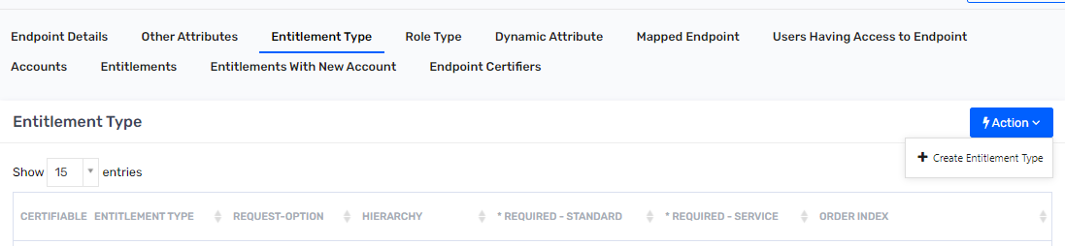
- Click on “Entitlement Type”. Click on “Action” button.
- Select “Create Entitlement Type” from “Action” dropdown.
- Fill the details in “Create New Entitlement Type” page with following details.
Attribute Name | Attribute Value
Entitlement Type Name | CREDENTIALS
Display Name | CREDENTIALS
Endpoint Name | CF Plus
Request Option | None
Hierarchy | Not Required
Required | false
- Open the endpoint “CF Plus”.
- Update the “Other Attributes” tab with following details
Attribute Name | Attribute Value
Account Custom Property 1 Label | First Name
Account Custom Property 2 Label | Middle Name
Account Custom Property 3 Label | Last Name
Account Custom Property 4 Label | Email Id
Account Custom Property 5 Label | Emp ID
Account Custom Property 6 Label | Active Date
Account Custom Property 6 Label | Inactive Date

HFC Active Directory
    - Connection: Account Type Update
- Login to Saviynt Security Manager (SSM) as administrator.
- Click on “Admin” tab on top menu bar and click on “Identity Repository”. Under “Identity Repository” select “Connections”.
- Click on “Connection List” and then click on “Oracle HCM Country” connection.
- Update “Account Type Update” connection as below.
Attribute Name | Attribute Value
Connection Name | Account Type Update
URL | <Saviynt DB PROD URL >
USERNAME | <Prod Username>
PASSWORD | <Prod Username>
DRIVERNAME | com.mysql.jdbc.Driver
ACCOUNTSIMPORT | <?xml version="1.0" encoding="UTF-8"?>  <dataMapping>  <before-import ></before-import>  <sql-query description="This is the Source DB Query"><![CDATA[ select acc.name as accountName,acc.status as accountStatus,CREATED_ON,acc.comments as ou,case  when  acc.comments like '%OU=Generic Accounts%'  or acc.comments like '%OU=ICA Generic Accounts%'  or acc.comments like '%OU=PlantUsers,OU=JOTS%'  or acc.comments like '%OU=Ivanti,OU=Exchange%'  or acc.comments like '%OU=Restricted,OU=Users%'  or acc.comments like '%OU=Departmental Units,OU=Users,OU=JOTS%'  or acc.comments like '%OU=Farms,OU=Users,OU=JOTS%'  or acc.comments like '%OU=GenericUsersMailEnabled,OU=Users,OU=JOTS%'  or acc.comments like '%OU=NVR,OU=Users,OU=JOTS%'  or acc.comments like '%OU=PCAutoLockTesting,OU=Users,OU=JOTS%'  or acc.comments like '%OU=Plant accounts,OU=Users,OU=JOTS%'  or acc.comments like '%OU=Vendors,OU=Users,OU=JOTS%' then 'Generic Account'  when  acc.comments like '%OU=Service Accounts%'  or acc.comments like '%OU=O365_Service-Accounts%' then 'Service Account'  end as accounttype,'Active Directory' as endpoint,'Active Directory' as securitySystem  from  accounts acc,ENDPOINTS EP  where  acc.ENDPOINTKEY=EP.ENDPOINTKEY and  EP.ENDPOINTNAME='Active Directory'  and(acc.comments like '%OU=Generic Accounts%'  or acc.comments like '%OU=ICA Generic Accounts%'  or acc.comments like '%OU=PlantUsers,OU=JOTS%'  or acc.comments like '%OU=Ivanti,OU=Exchange%'  or acc.comments like '%OU=Restricted,OU=Users%'  or acc.comments like '%OU=Departmental Units,OU=Users,OU=JOTS%'  or acc.comments like '%OU=Farms,OU=Users,OU=JOTS%'  or acc.comments like '%OU=GenericUsersMailEnabled,OU=Users,OU=JOTS%'  or acc.comments like '%OU=NVR,OU=Users,OU=JOTS%'  or acc.comments like '%OU=PCAutoLockTesting,OU=Users,OU=JOTS%'  or acc.comments like '%OU=Plant accounts,OU=Users,OU=JOTS%'  or acc.comments like '%OU=Vendors,OU=Users,OU=JOTS%'  or acc.comments like '%OU=Service Accounts%'  or acc.comments like '%OU=O365_Service-Accounts%') and acc.status not in ('SUSPENDED FROM IMPORT SERVICE')  ]]></sql-query>  <mapper description="This is the mapping field for Saviynt Field name" accountnotinfileaction="noaction" deleteaccountentitlement="false" ifusernotexists="noaction" systems="'Active Directory'">  <mapfield saviyntproperty="securitysystems.systemname" sourceproperty="securitySystem" type="character" ></mapfield>  <mapfield saviyntproperty="endpoints.endpointname" sourceproperty="endpoint" type="character" ></mapfield>  <mapfield saviyntproperty="accounts.name" sourceproperty="accountname" type="character" ></mapfield>  <mapfield saviyntproperty="accounts.accounttype" sourceproperty="accounttype" type="character" ></mapfield>  </mapper>  <after-import description="EMAIL,BATCH,SQL" ></after-import>  </dataMapping>
    - Connection: Active Directory
- Login to Saviynt Security Manager (SSM) as administrator.
- Click on “Admin” tab on top menu bar and click on “Identity Repository”. Under “Identity Repository” select “Connections”.
- Click on “Connection List” and then click on “Oracle HCM Country” connection.
- Update “Active Directory” connection as below.
Attribute Name | Attribute Value
REMOVEACCOUNTACTION | {  "removeAction": "${if(task.requestKey == null && task.source == 'ANALYTICS_V2' ){'DELETE'} else {'SUSPEND'}}",  "userAccountControl": "${if(task.requestKey != null || task.source == 'CERTIFICATION'){'514'}}",  "accountExpires": "${if(task.requestKey != null || task.source == 'CERTIFICATION'){10000*(new Date().getTime() + 11644473600000 + 100799999)}}",  "moveUsertoOU":"${if(task.requestKey != null || task.source == 'CERTIFICATION'){'OU=Inactive,OU=Users,OU=Hormel,DC=hormeltestlab,DC=com'}}"  }
    - Entitlement type update
Certifiable | False

    - Update Account Type
To Update account type perform following Steps
- Login into SSM, Navigate to “Identity Repository”, Select “Accounts” and click on it.
- Click on “Actions” button and select “Upload Account”

- Select following options as showed in below figure. Then click on Preview button.

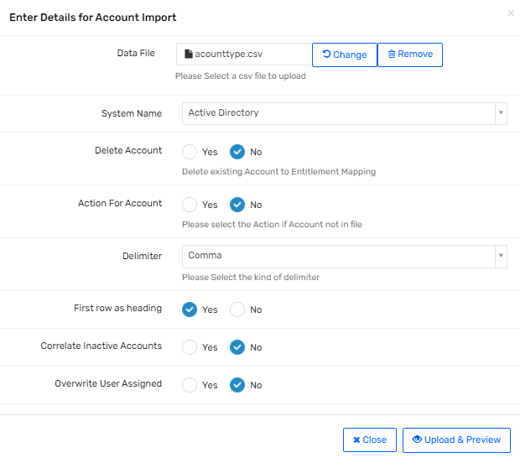
- Validate all header are properly set and then click on “Import Now” button.
- Verify that account type attribute is updated with proper values.

    - Update Service Account Owner as Rank 1 and Primary certifier.
To Update account type perform following Steps
- Login into SSM, Navigate to “Identity Repository”, Select “Accounts” and click on it.
- Click on “Actions” button and select “Upload Account”

- Select following options as showed in below figure. Then click on Preview button.
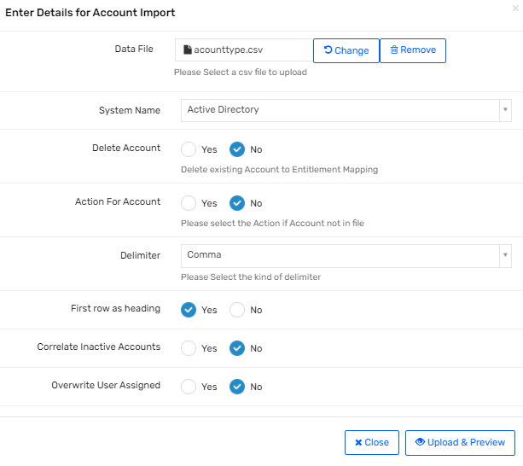

- Validate all header are properly set and then click on “Import Now” button.
- Verify that Owner are set with proper username.

Note:- To Set Rank 1 Owner Rank must be set as “1” and top set Primary Certifier Owner Rank attribute must be set as “26”.

Configure Scheduler
- Login to Saviynt Security Manager (SSM) as administrator.
- Click on “Admin” on the top right corner and click on “Job Control Panel”.
- Select “Utility” and under “Utility” select “Provisioning Job (WSRETRYJOB).
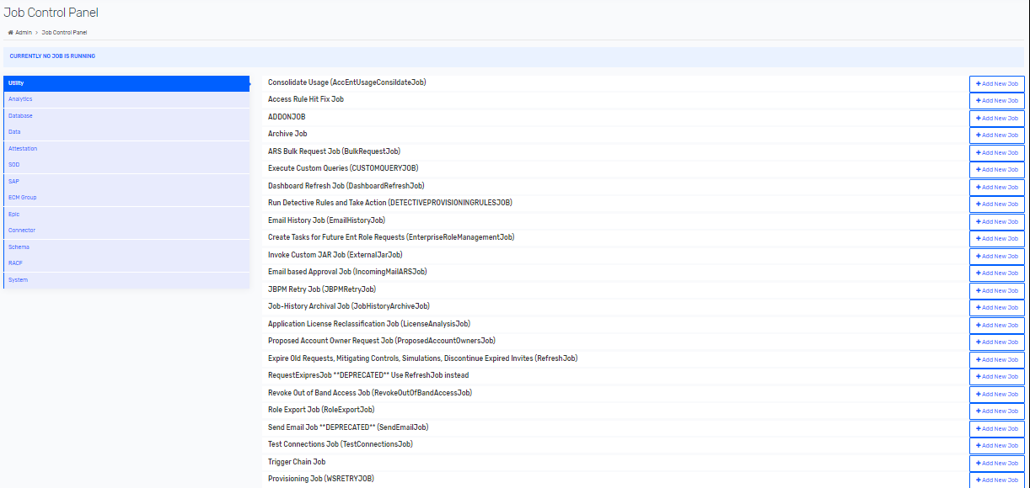
- Click on “Add New Job” and enter the Job Name “Provisioning Trigger” and Click on “Submit”.
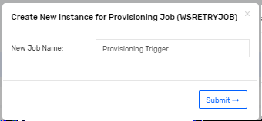
- Repeat the above steps for the schedulers mentioned in Release _1.0\Configuration Sheet\Hormel_IDM_ReconciliationSchedule sheet.

Certification Campaign

9.1 User Manager
- Login to Saviynt Security Manager (SSM) as administrator.
- Click on “Attestations” tab on top menu bar and click on “Campaign”.
- Click on “Create Campaign”.
- Create “USER_MANAGER_CAMPAIGN” template as below and click on ‘Save Template”.
Attribute Name | Attribute Value
Campaign Type | User Manager
Campaign Owner | Chris Soucek
Application | 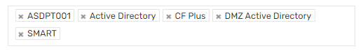
Number of days to expire campaign | 15
Objects to be included in Certification | 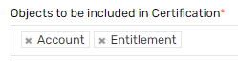
Policy
Attribute To Identify Manager | Manager
Default Certifier | Chris Soucek
Comments on Locking Campaign | Enable
Disable Consult For Certifier | Enable
Disable Consult For Consultee | Enable
Show Consult For Own Access | Disable
Enable E-Signature Using Login credential | Disable
Enable E-Signature Using User Attributes | Disable
Show Consult | NA
Allow Bulk Checkbox | 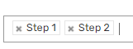
Step 1 - Employment Verification
Enable Employment Verification Only | Disable
Certify All Users By Default | Disable
Include Users Without Accounts | No
Show Employment Status Options | 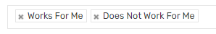
Show Consult Popup on Does Not Work For Me Action | Enable
Update User's Manager on Does Not Work For Me | Disable
Enable Reassignee on Does Not Work For Me | Enable
Default Reassignee | Chris Soucek
Show User Attributes | 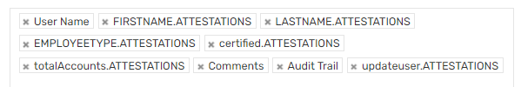
Enable Comment On Individual Action | 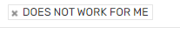
Enable Comment On Bulk Action | N/A
Extend End Date Limit Days | N/A
Step 2 - Access Approval
Enable Access Verification Only | Disable
Ignore Accounts Without Entitlements | No
Disable Condition Certify | Allow
Conditional Certify Limit Days | 180
Show Access Attributes | 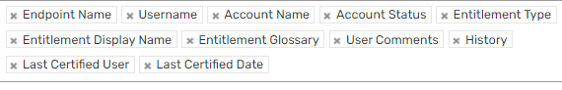
Show Filter Attributes | 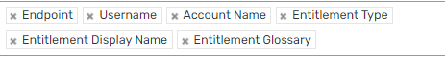
Show Details On Hover | 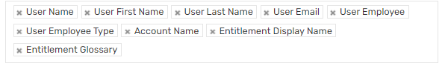
Enable Comment On Individual Action | NO
Enable Comment On Bulk Action | N/A
Select Smart Filter Cards | 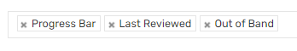
Revoke Tasks

Create Revoke Task for Terminated User & Revoked/Conditional Certified Acc. & Ent. on Locking | Enable
Create Revoke Task for Terminated User & Revoked/Conditional Certified Acc. & Ent. on Expiring | Not Allowed
Create Revoke Task For Unresponded Item on Expiry | Not Allowed
Create Remove Account Task For Base Account | Enable
Create Revoke Task For Certified Item on Expiry | Not Allowed
Basic Campaign Notifications
Create Email Template | User Manager Certification Campaign Launched
Consult Email Template | User Manager Certification Campaign Consult
Consult Complete Email Template | User Manager Certification Campaign Consult Completed
Reassign User Email Template | User Manager Certification – Reassignment
Campaign Reminder Notifications
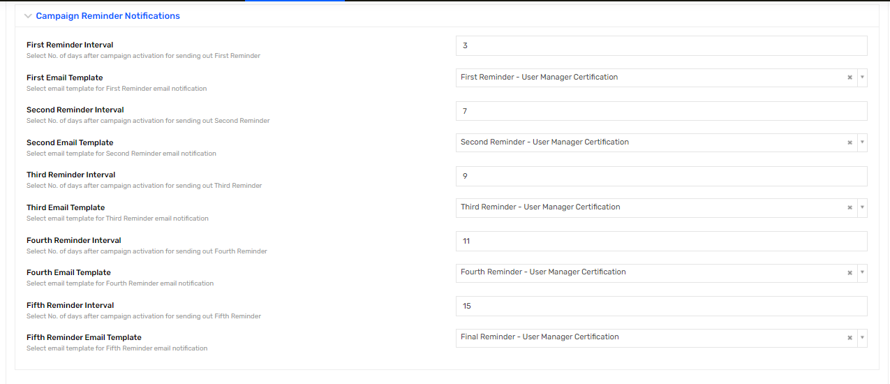
Select Certifier | 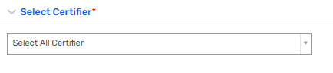
Advanced Campaign Configurations
Users Query | employeetype not in ('Pending worker') and username not in ('admin','saviyntsupportagent1','saviyntsupportagent2','saviyntsupportagent3')
Accounts Query
Entitlements Query
Consult User Query | select u from Users u where 1=1 and u.id in (select b.id from Users a,Users b where a.id=:loggedInUser and a.id='2434')  Note :- '2434' is campaign owner userkey. If campaign owner is changed then userkey must be changed.

9.2 Service Account Owner Campaign
Pre-requisite :
- Service account type must be populates as “Generic/Service account” on account profile.
- Primary Certifier must be set before launching campaign.
Following configuration will be done to setup service account owner campaign.
- Login to Saviynt Security Manager (SSM) as administrator.
- Click on “Attestations” tab on top menu bar and click on “Campaign”.
- Click on “Create Campaign”.
- Create “SERVICE_ACCOUNT_OWNER_CAMPAIGN” template as below and click on ‘Save Template”.
Attribute Name | Attribute Value
Campaign Type | Service Account
Campaign Owner | Chris Soucek
Application | 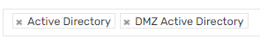
Number of days to expire campaign | 15
Objects to be included in Certification | 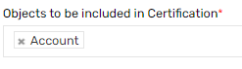
Service Account Type | 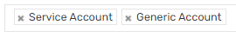
Policy
Default Certifier | Chris Soucek
Comments on Locking Campaign | Enable
Disable Consult For Certifier | Disable
Disable Consult For Consultee | Disable
Enable E-Signature Using Login credential | Disable
Enable E-Signature Using User Attributes | Disable
Show Consult | Step2
Allow Bulk Checkbox
Step 1 - Ownership Verification
Certify All Accounts By Default | Disable
Enable Account Verification Only | Disable
Show Account Attributes | 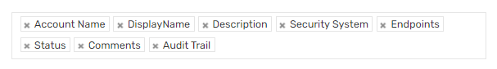
Enable Comment On Individual Action | 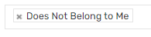
Enable Comment On Bulk Action | Blank
Show Consult Popup on Does Not Belong to Me action | Enable
Update Account Owner on Does Not Belong to me action | Enable
Enable Reassignment for Certifier | Enable
Default Reassignee User | Chris Soucek
Step 2 - Access Approval
Enable Access Verification Only | Disable
Ignore Accounts Without Entitlements | No
Disable Condition Certify | Allow
Conditional Certify Limit Days | 180
Show Access Attributes | 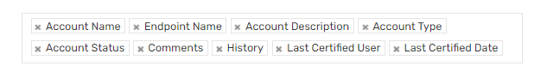
Show Filter Attributes | 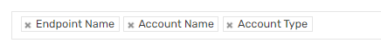
Show Details On Hover
Enable Comment On Individual Action | NO
Enable Comment On Bulk Action | NA
Select Smart Filter Cards
Revoke Tasks

Create Revoke Tasks for Revoked/Conditional Certified Acc. & Ent. on Locking | Enable
Create Revoke Tasks for Revoked/Conditional Certified Acc. & Ent. on Expiring | Not Allowed
Create Revoke Tasks For UnResponded Items on Expiry | Not Allowed
Create Revoke Tasks For Certified Items on Expiry | Not Allowed
Basic Campaign Notifications
Create Email Template | Service Account Owner Certification Campaign Launched
Consult Email Template | Service Account Owner Certification Campaign Consult
Consult Complete Email Template | Service Account Owner Certification Campaign Consult Completed
Reassign User Email Template | Service Account Owner Certification – Reassignment
Campaign Reminder Notifications
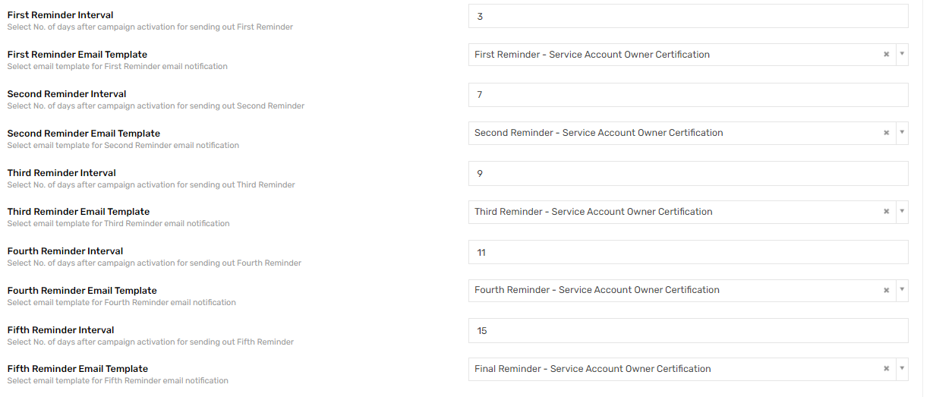
Advanced Campaign Configurations
Accounts Query | accounttype in ('Service Account','Generic Account') and status in (1,'Manually Provisioned','Active')
Entitlements Query | Blank
Consult User Query | select u from Users u where u.statuskey=1 and u.username not in ('admin','saviyntsupportagent1','saviyntsupportagent2','saviyntsupportagent3') and u.departmentname = 'IT'
Include Access Assigned Through | Both

Glossary
Application Name | Description | Attestation | Provisioning Support | Reconciliation Support | Connector(s)
HFC Active Directory | Downstream system | Yes  User Account  Service Account | Yes  (Maintenance and Service Account out of scope) | Yes | AD
DMZ Active Directory | Downstream system | Yes  User Account  Service Account | Yes | Yes | AD
iSeries (ASDPT001) | Target Reconciliation | Yes  User Account and Entitlement | No | Yes | Flat File based Import Job
CF PLUS | Target Reconciliation | Yes  User Account and Entitlement | No | Yes | Flat File based Import Job
SMART | Target Reconciliation | Yes  User Account and Entitlement | No | Yes | Flat File connector

