IBM Advanced Developer Portal Installation & Configuration

Table of Contents

Introduction 3
Configure the Advanced Developer Portal 3
Putty Access & GUI access 4

Introduction
This document provides the step by step instructions for installation & configuration of Advanced Developer Portal.

Configure the Advanced Developer Portal
At this point both gateway and management appliances should be started and configured.
- Ensure that the Advanced Portal VM is started
- Using the VMware console, log into the advanced portal using the default credentials of admin / !n0r1t5@C
- Change the networking for the eth0 interface on the portal by doing the following
  - Type in sudo nano /etc/network/interfaces
  - We will be focusing on the following sections in this file
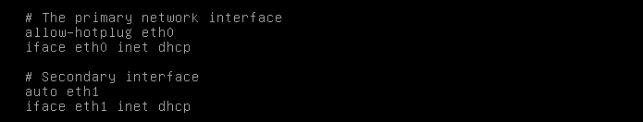
  - Change the Primary network interface information to the following:
allow-hotplug eth0
iface eth0 inet static
address 192.168.225.20
netmask 255.255.255.0
gateway 192.168.225.2
  - Comment out the two lines under secondary interface. The screen should appear like below.
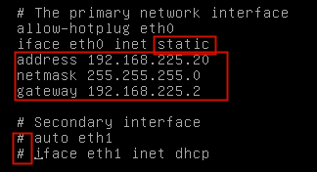
  - Key Ctrl l+ x to exit; y to save the changes; Enter to write.
Expect a response like: [Wrote 21 lines] and focus returns to the command line.

  - You will need to recycle networking by typing the following (or reboot the VM):
sudo ifdown eth0
sudo ifup eth0
sudo /etc/init.d/networking stop
sudo /etc/init.d/networking start
If all went well, expect to see:
[OK] Configuring network interfaces . . . . Done

  - Issue the command ifconfig to verify that eth0 addressing is correct – 192.168.225.20.

Putty Access & GUI access
Now this appliance can be accessible from putty but GUI will not be available until this was integrated with the APIM appliance.

