IBM API MANAGEMENT INSTALLATION & CONFIGURATION

Table of Contents

Introduction 3
Configure the Management appliance 3
Verifying the system status 3
Accepting License 3

Introduction
Once the APIM .ova file was deployed on VMWare workstation follow the below steps to configure the API management appliance.

Configure the Management appliance
Once the appliance is successfully started you will get a login prompt. The following instructions are for API Management V4.0.

- Login with username admin and password !n0r1t5@C
- net set eth0 address 192.168.225.100 mask 255.255.255.0
- net set gateway static 192.168.225.2 eth0
- net set nameserver static 192.168.225.2
- net set ntp static 192.168.225.1
- net set search none
- net restart (this may take minute to complete)
- net show all (if Network is inactive message appears, wait a little longer for the networking to restart fully and repeat this command until the correct details display)

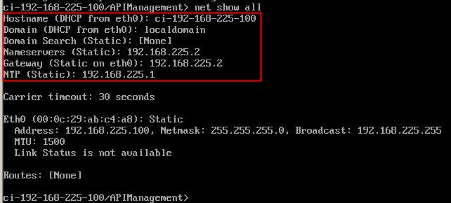

Verifying the system status
Execute the command “ system show status” to verify the current running status of the virtual appliance.
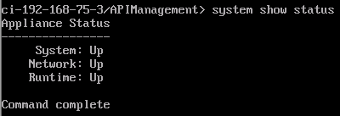

Accepting License
At this point both appliances should be started.
- Log into the Cloud Management Console: https://192.168.225.100/cmc/
- Accept any security trust exceptions that pop up.
- When the login screen pops up, log in with Username admin and Password: !n0r1t5@C
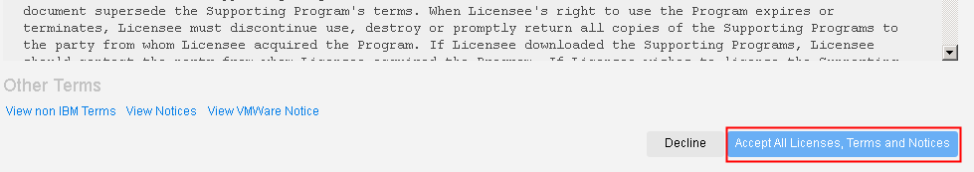
- Click the Accept All Licenses, Terms and Notices button.
You will be required to change the admin password to something else upon logging in for the first time.

