Integration Manual

Table of Contents

Introduction 3
Enabling the XML Management Interface Port 3
Idle timeout 3
Integrating DataPower & API Management 3
Integrating API Management & Advanced Developer Portal 5

Introduction
Once the installation & configuration of all virtual appliances were done individually, all these appliances need to be integrated by following below steps/instructions.

Enabling the XML Management Interface Port
The show XML Management Interface port must be enabled to allow IBM API Management to configure the gateway server.
- Select Network > Management > XML Management Interface
- Set Administrative State to enabled and keep the default port (5550)
- Click the Apply button and the object status should change to [up] at the top of the page.
- Click the Save Configuration link at the top right.

Idle timeout
- Key in web management in the left panel search field.
- Select Web Management Service.
- Change the Idle timeout value from 600 to 6000 seconds.
- Click the Apply button and the object status should change to [up] at the top of the page.
- Click the Save Configuration link at the top right.

Integrating DataPower & API Management
- Log in to APIM CMC & click clusters
- Click settings below the Gateway clusters
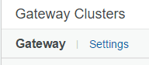
- Provide DataPower IP in the address field as shown below

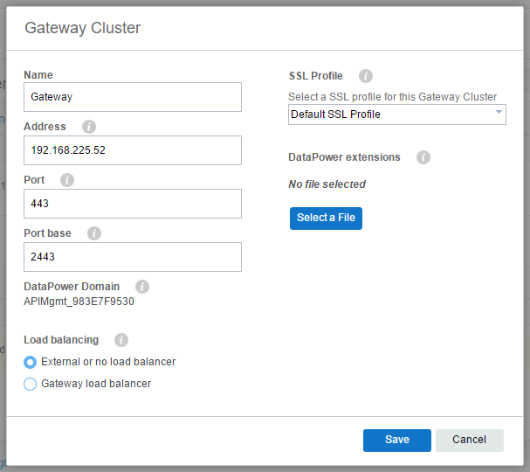

- Click save to see a popup in the right top corner saying “success updated cluster”

- Once the gateway cluster was saved, click +server button to add the DataPower to the Gateway clusters.

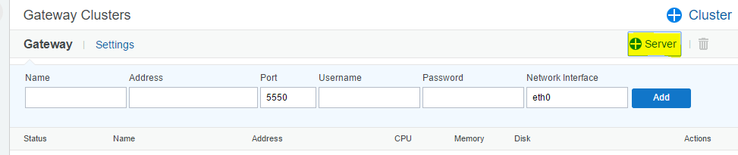
- Provide the DataPower details like unique identifier, IP, username & password
- Click add

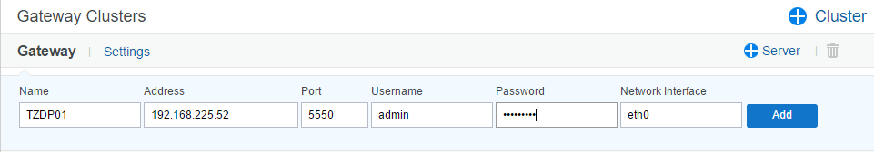
- Adding the DataPower to the gateway cluster takes some time, which will be displayed as a popup/notification.

- During this process the DataPower entry will be visible under the Standalone servers.

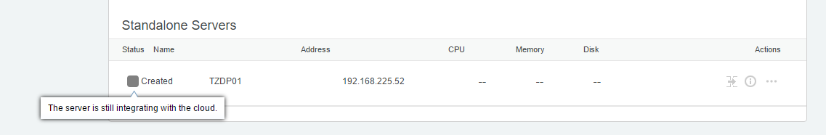
- After the addition process was done DataPower will move up to the gateway clusters & appears as active member of the cluster.

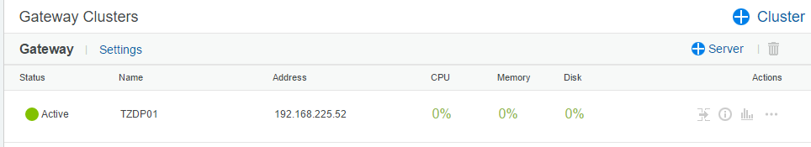
- Now both the API management & DataPower are integrated.

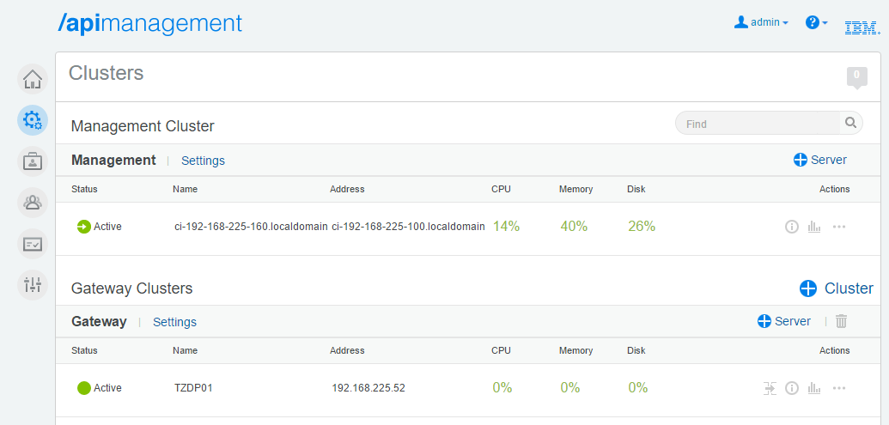
- To verify the successful integration check for the API management domain in the drop down in DataPower.

Integrating API Management & Advanced Developer Portal
- Login to the API management Cloud Management Console & click settings
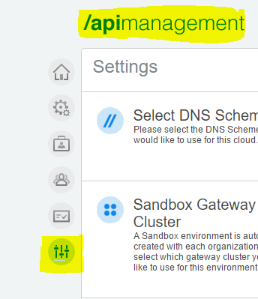

- Add valid SMTP credentials/details, which is mandatory configuration for creating api manager login.
- Add the details as mentioned below

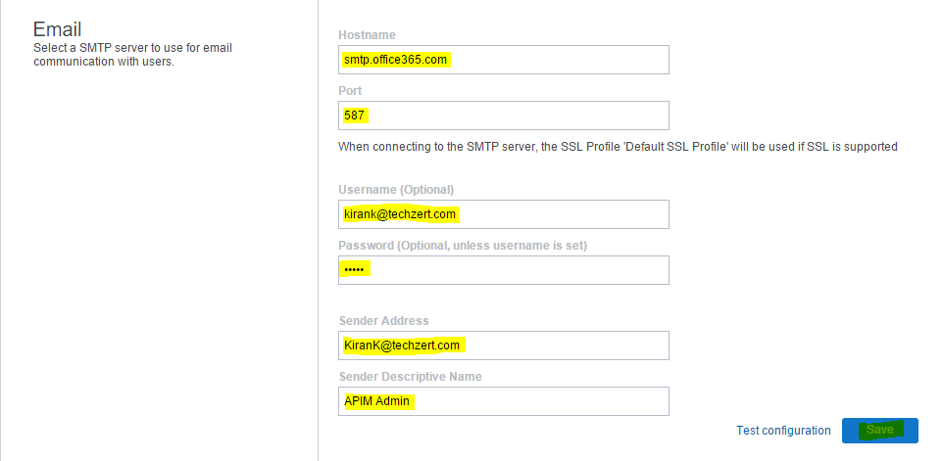
- Click organisations tab in the menu & add a organisation along with a valid/working mail id.

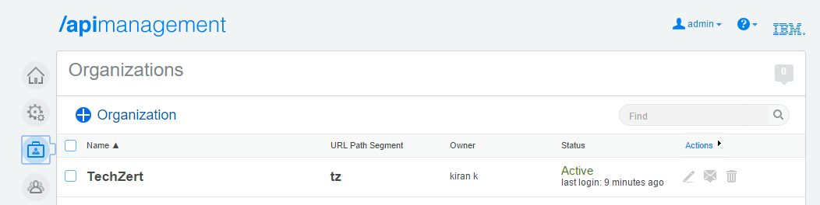
- An activation mail link will be sent to the mail id configured with the organisation.
- Click the link to generate a api manager login & this organisation will be termed as the API provider organisation.
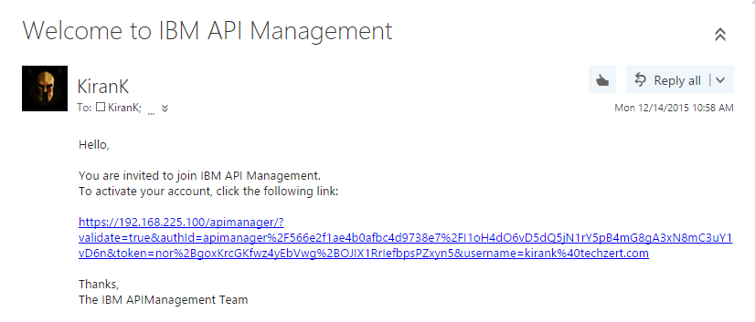

- Once the password is set try login to the api manager using the URL https://192.168.225.100/apimanager

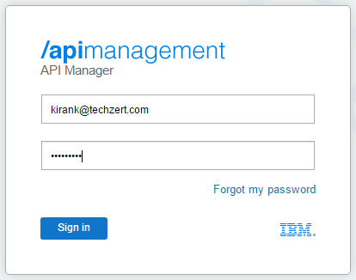
- For a successful login the below screen will appear.



- Now using both the CMC and Api manger we can integrate the ADP with API management.
- Login to SSH into the Advanced Developer Portal VM using Putty.
- Via your browser, connect to the CMC portal (https://192.168.225.100/cmc/) and log in as the admin user / Password.
- Go to Settings on the left menu tray and locate the section for the Advanced Developer Portal.
- Ensure the following is filled in
Enable Optional Advanced Portal Check box is checked
Enter in the Portal Management Address -> 192.168.225.20
- Click the Save button.
- Copy the public key.

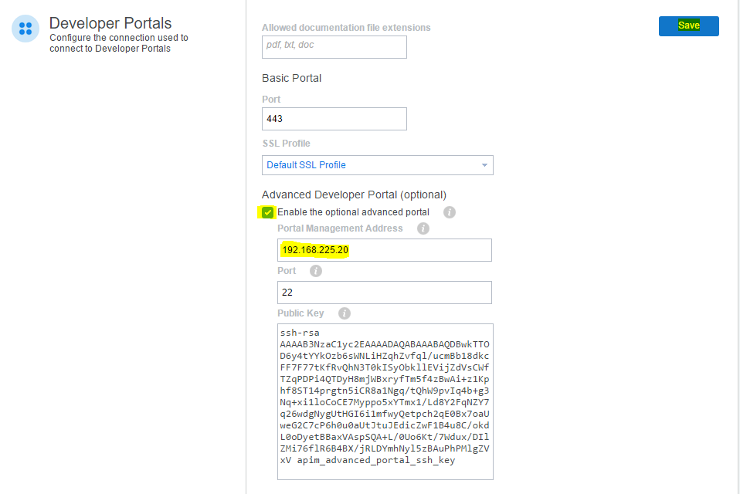
- Login via putty to 192.168.225.20

- Go to your putty screen, type the following and then paste the contents of the public key into the window

echo “contents_pasted_from_the_public_key_field" > keysslfile

- Execute this command to set the APIM host name
cat keysslfile | set_apim_host DeveloperPortal 192.168.225.100

- Configure the SMTP server
set_smtp mail_server_host_name port user password

- Download the cert from the APIM node to this machine. This causes the Advanced Developer Portal to contact the configured Management cluster, download the SSL certificate and add it to the Advanced Developer Portal trust store.

Issue the command: download_apim_cert

- Type in: set_apim_cert –i
This will cause the Advanced Developer Portal to trust any SSL certificate served by the API Management node

- Add the Advanced Developer Portal to your environment.
- Login to API Management
- In the Environment select the Portal tab.
- Click the Advanced Developer Portal button and key in the URL: https://192.168.225.20
Click the Save button.
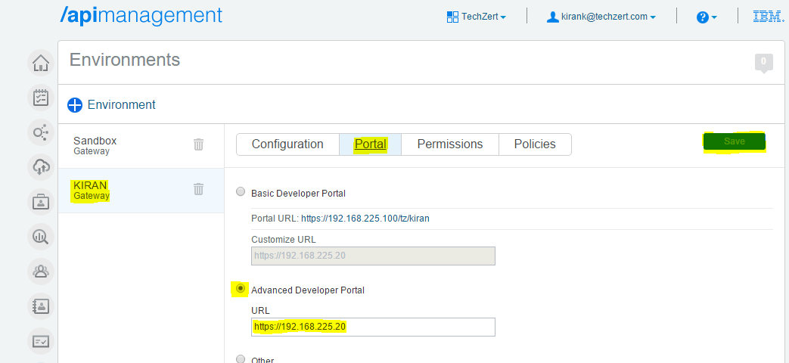

- In Putty SSH window and issue the below command: list_sites
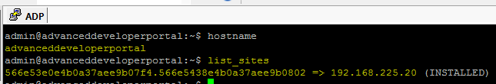

- Above commands give a unique code/id of your portal site. 56710263e4b00d46be100942.567230f8e4b01b48a463965d=> 192.168.225.20 (INSTALLED)
- To get the link, copy and paste the unique code/id as show below:
site_login_link 56710263e4b00d46be100942.567230f8e4b01b48a463965d

- A link will be generated for admin login.

- Copy and Paste that link to your browser and finish setting up your Admin user.
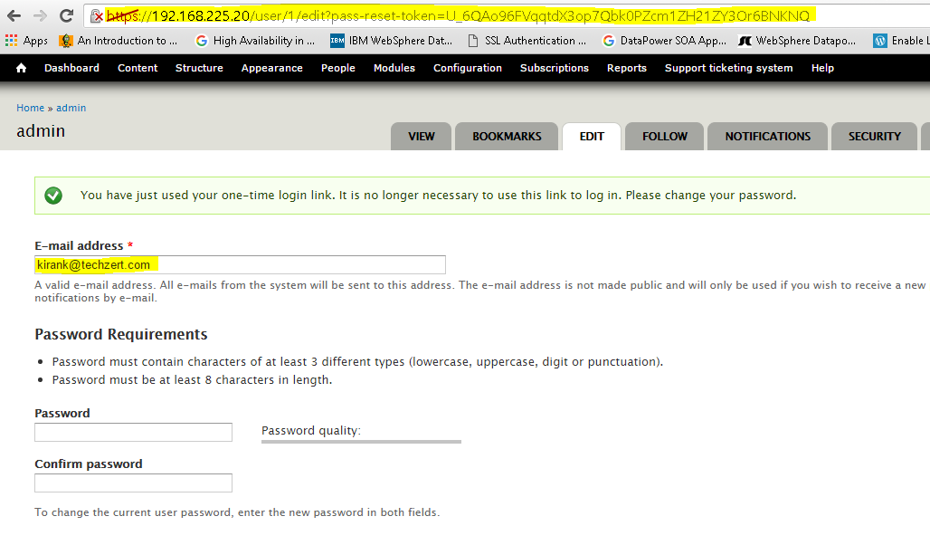
- Point your browser to the IP address of the Advanced Portal (192.168.225.20), the advanced developer portal is now visible with all API’s with in the attached environment.

