IBM DataPower Installation

Table of Contents

Introduction 3
Running DataPower Install wizard 3
Accepting the license 5
Connectivity checks 5
Putty Acess 6

Introduction
This document provides the information/instructions for installing IBM DataPower virtual appliance on the VMWare workstation hypervisor. This configuration can be carried out only after deploying the .ova file.

Running DataPower Install wizard
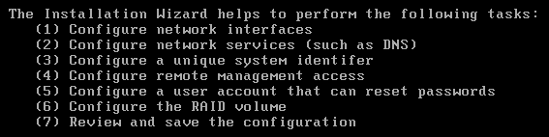
- Log into the DataPower virtual appliance with username admin and password admin.
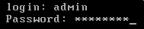
- Enter y to enable Secure Backup mode.
- Enter y to confirm Secure Backup mode.
- Enter n to disable common criteria compatibility mode
- Enter Passw0rd! and confirm your new admin password (we will use the same password for everything in the Workshop for the sake of simplicity.
- Enter y to run the install wizard
- Enter y to configure network interfaces
- Enter y to say you have all the information
- Enter y to configure eth0
- Enter n to disable DHCP
- Enter the eth0 IPv4 address for the interface in CIDR notation, (192.168.225.52/24). 255.255.255.0
- Enter the IP address for the IPv4 default gateway (192.168.225.2).
- Enter n to skip the eth1 configuration.
- Enter n to skip the eth2 configuration.
- Enter n to skip the eth3 configuration.
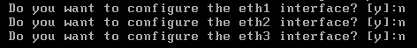
- Enter y to configure network services
- Enter y to configure DNS
- Enter y to say you have all the information
- Enter the IP address of the DNS server (same as the gateway, 192.168.225.2)
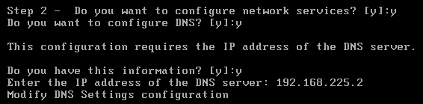
- Enter n to skip defining a unique system identifier for this appliance
- Enter y to configure remote management access
- Enter y to say you have all the information
- Enter y to enable ssh
- Press enter to use all local IP addresses
- Press enter to accept the default port (22)
- Enter y to enable the WebGUI
- Press enter to use all local IP addresses
- Press enter to accept the default port (9090)
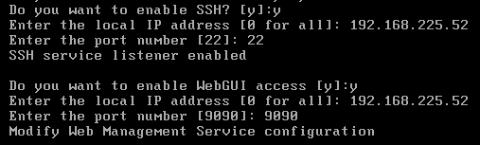
- Enter y to configuring a user account that can reset passwords
- Press enter to accept the default user account (password-reset-user)
- Enter Passw0rd! and confirm with the new password-reset-user password.
- Enter n to skip configuring a hard disk array
- Enter n to skip reviewing the current configuration
- Enter y to save the current configuration
- Enter y to overwrite the previous configuration
- Check the IP addresses you configured above by entering the command show int
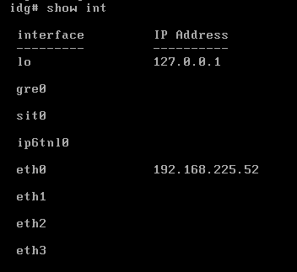

Accepting the license

- Navigate to the following URL in a browser: https://192.168.225.52:9090/ (use the eth0 IP address)
- Proceed through any security warnings about the certificate
- Log in with username “admin”, the new password you specified (Passw0rd!) and the default domain.
- Click “I agree” to accept the license.
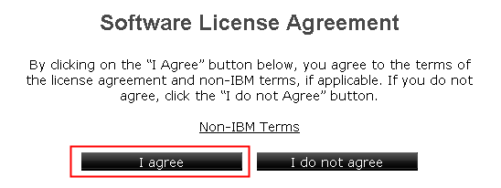
- The appliance reloads. The next time you log into the console, the wizard is not displayed.
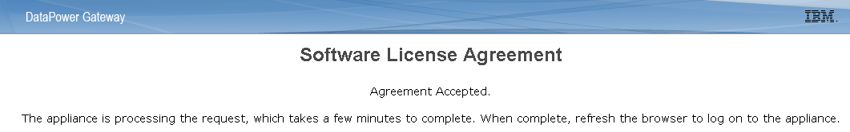

Connectivity checks
Login from the browser using the URL https://192.168.225.52:9090 to access the configured DataPower GUI.

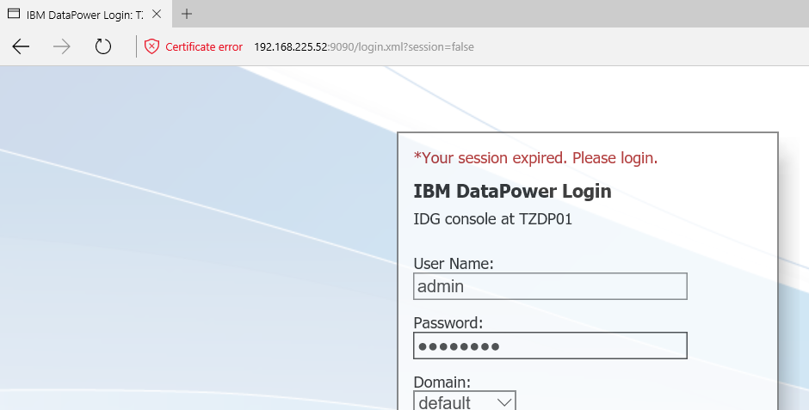

Putty Acess
As the GUI appeared the virtual appliance should be accessible from putty also
