System Requirements & VMWare Settings

Table of Contents

Introduction 3
Hardware Requirements 3
System requirements 3
Connectivity requirements 3
Static IP addresses 3
Setting up the software images on your workstation 3
Enable the Windows host NTP service 3

Introduction
This document provides information & instructions to prepare system for the installations of DataPower, API Management & APIM Advanced Developer Portal on the VMWare hypervisor.

Hardware Requirements
Minimum requirements:
- 1.6 GHz or greater processor
- 25 GB Hard disk
- 8 to 16 GB core host RAM

System requirements
IBM Gateway, APIM & ADP virtual appliances can be hosted on hypervisors like VMWare Workstation & ESXi.
Each of these appliances requires 4GB of RAM, so a machine with at least 12GB/16GB of RAM is recommended to leave capacity for other applications.
Installation can be achieved with 8GB of RAM if you reduce the RAM allocated to each image in VMware. This has been tested with the following settings:
- Gateway server: 4GB RAM
- Management server: 4GB RAM
- 1 CPUs and 2 cores per CPU on each virtual machine

Connectivity requirements
The recommended connectivity approach for this training/KT.
- The virtual network setting is set to NAT for both the API Management and DataPower VMs.
- The hypervisor (VMWare) needs the NAT subnet to be 192.168.225.0.
- The host workstation needs to be configured as an NTP server.
- The host workstation needs to be on the network with access to the Internet.

Static IP addresses
The following static IP addresses will be used for the IBM API Management appliances
Purpose | IP Address
API Gateway | 192.168.225.52(eth0_
APIMGMT | 192.168.225.100
APIM ADP | 192.168.225.

Setting up the software images on your workstation
Basic steps to setup a single workstation image. In summary, you will need to:
- Download the required software images
- Enable the Windows host NTP service
- Configure the VMWare NAT subnet address
- Install and configure DataPower, API Manager & APIM ADP virtual machines

Enable the Windows host NTP service
A Network Time Protocol (NTP) server is used by both the DataPower and API Manager appliances in order to keep their time synchronized. Windows 7 includes an NTP server; however it is not enabled by default. In this section, you will enable the Windows Time Service

To enable the Windows NTP service, two registry keys must be modified. The following steps will guide you through modifying the Windows registry to enable the NTP service.
- Click Start, click Run, type regedit, and then click OK.
- Locate and then click the following registry entry:
HKEY_LOCAL_MACHINE\SYSTEM\CurrentControlSet\Services\W32Time\Config\
- In the right pane, right-click Announce Flags, and then click Modify.
- In the Edit DWORD Value (Hex) dialog box, under Value data, type 5, and then click OK.
- Locate and then click the following registry subkey:
HKEY_LOCAL_MACHINE\SYSTEM\CurrentControlSet\Services\W32Time\TimeProviders\NtpServer\
- In the right pane, right-click Enabled, and then click Modify.
- In the Edit DWORD Value (Hex) dialog box, type 1 under Value data, and then click OK.
- Exit Registry Editor.
- At a command prompt, type the following commands to restart the Windows Time Service:
  - net stop w32time
  - net start w32time
- Go to Windows Services applet and set Windows Time to ‘Automatic (Delayed Start)’
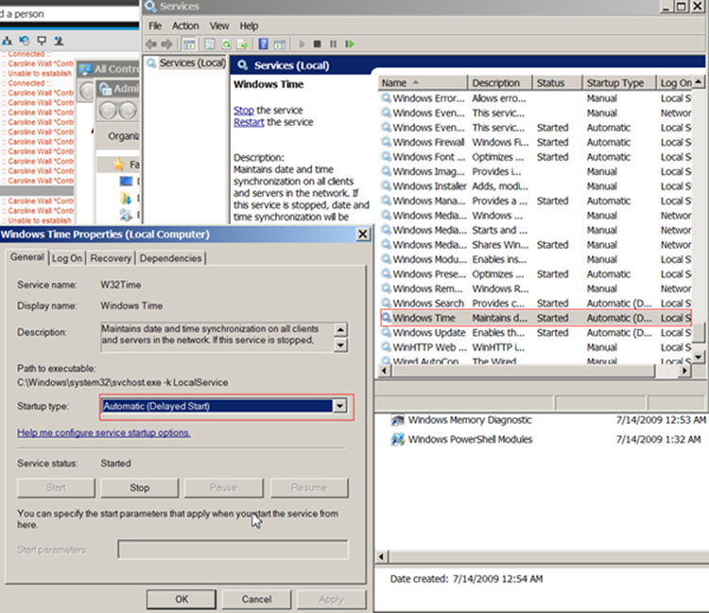

Configure the VMWare NAT subnet address
Note you can check or update your default gateway and DNS server in VMWare Workstation using this procedure with VMware Workstation V10.

The following steps guide you through setting the VMWare NAT subnet IP address.
- In VMWare Workstation, open the virtual network editor: Edit→Virtual Network Editor…
- In the list of networks, select VMnet8 (type = NAT).
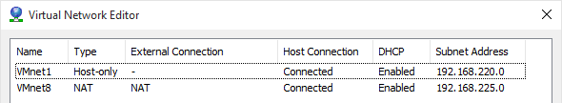
- At the bottom of the dialog window, change the Subnet IP to: 192.168.225.0.
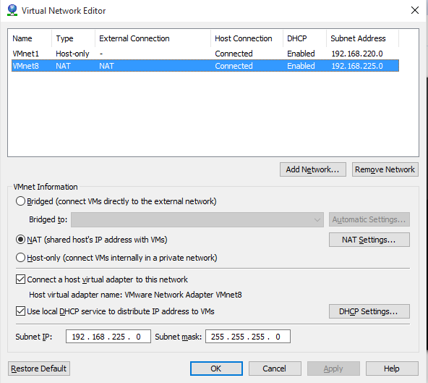
- Click the NAT Settings … button to confirm that the Gateway IP is now set to 192.168.225.2 automatically.
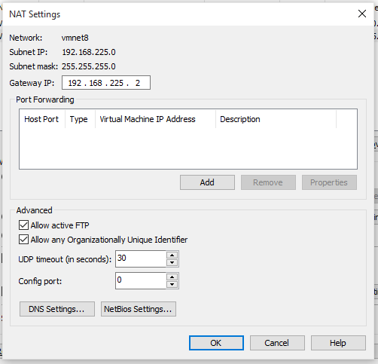
- Click the OK button twice to exit out of the Virtual Network Editor.
- DHCP settings (cross verify)
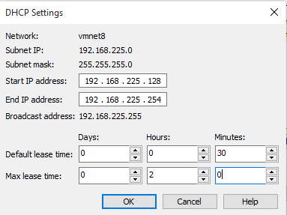

- Change the configuration on each Network Adapter from Bridged to NAT for each virtual machine individually.
