Ministry of Science and Higher Education of the Russian Federation

Federal State Budgetary Educational Institution

of Higher Education

«Ufa University of Science and Technology»

Institute of Informatics, Mathematics and Robotics

Department of Computational Mathematics and Cybernetics

Web-technologies

Laboratory reports №1-6

Performed:

Students of the group PRO - 427 Polina Kasich

Polina Loginova

Ufa – 2024

**CONTENT**

Laboratory work №1 – Layout of a web page using HTML language 3

Task and goal 3

Progress of the work 3

# Laboratory work №1 – Layout of a web page using HTML language

## Task and goal

The goal of the work is to gain practical skills in creating and formatting web pages using markup tools.

The task is to make a layout of the page according to the option 8.

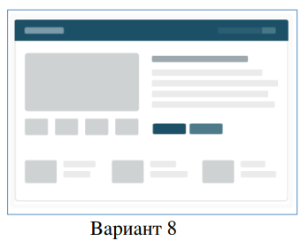

## Progress of the work

1. We created the file “index.html”. This is the basic structure of the page:

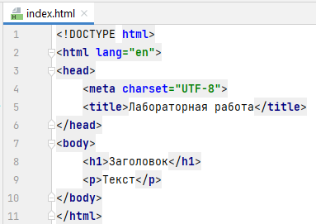

The opened page:

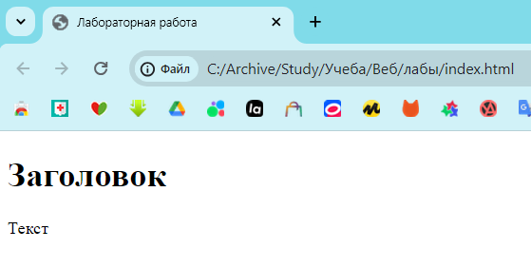

1. Let’s make a layout.

|  |  |  |  |
| --- | --- | --- | --- |
| № | Type of a block | Block ID | HTML-code |
| 1 | Navigation bar | main | <nav id="main">…</nav> |
| 2 | Link to the main page | Site_name | <a id="site_name">Site</a> |
| 3 |  |  |  |
| 4 |  |  |  |
| 5 |  |  |  |
| 6 |  |  |  |
| 7 |  |  |  |

