1. Goto:  <https://ui.appscan.ibmcloud.com/AsoCUI/serviceui/home>
2. Click on Create App and provide appropriate details:

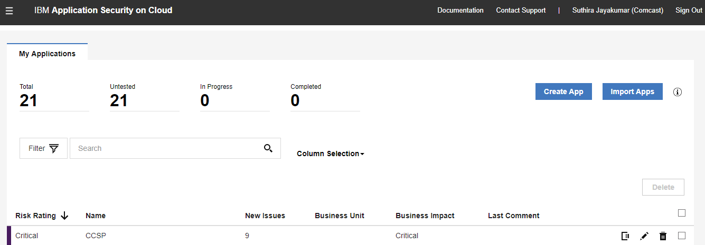

1. Hit Create Scan:

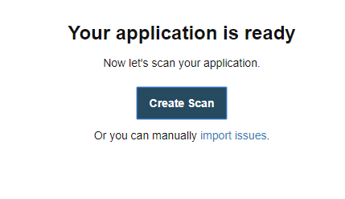

1. Select Web:

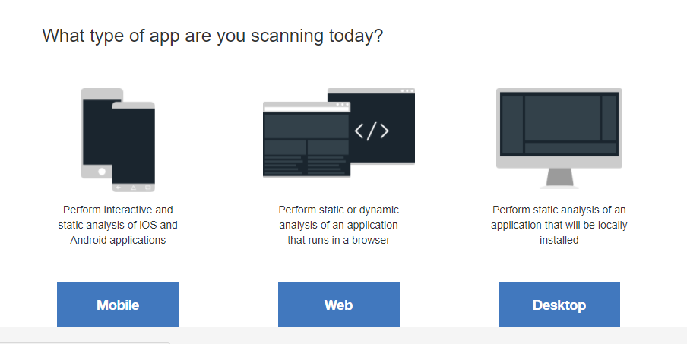

1. Select Static:

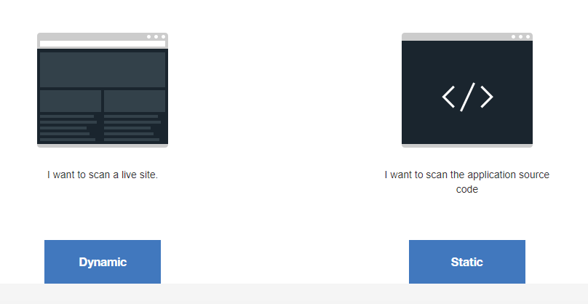

1. Download the Static Analyzer Client utility (IRX generator)

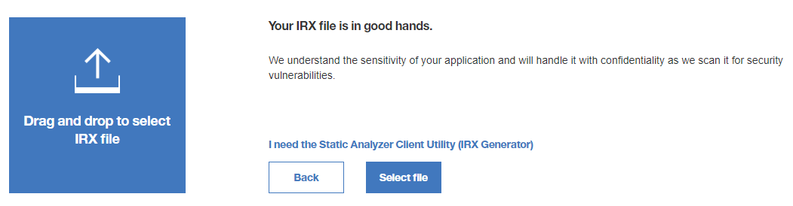

1. Install the IRX generator and follow the configurations
2. Go to the project folder and run the following command in cmd: **appscan prepare**
3. It will generate the IRX file and upload the same in Step 6.
4. Run the Scan.