MagMutual MFQ UI Portal
Requirements and Screen Design
Detailed UX/UI planning document for the Medical Faculty Questionnaire portal
Prepared For | MagMutual MFQ initiative
Prepared By | working draft based on supplied UI requirements and sample screens by Hexaware
Document Type | Requirements + Screen Design
Scope | Dashboard, claim review, MFQ workflow, reporting, RBAC, notifications, and Appian-trigger integration

This document consolidates the provided UI portal requirements, screen expectations, sample screenshots, and recommended workflow logic into a single implementation-ready reference.

1. Purpose of this document
This document defines the proposed web application experience for the MagMutual Medical Faculty Questionnaire (MFQ) portal. It translates business requirements into a screen-by-screen design reference so product, business, engineering, UX, and workflow teams can align before development begins.

2. Design objectives
The portal should support human-in-the-loop claim review, section-based medical faculty collaboration, AI confidence-driven routing, role-based access control, and downstream workflow triggering. The UI must be simple for analysts to operate, safe for faculty review, and extensible for future AI-assisted analysis.
Key design principles
• Automatic MFQ prefill with visible confidence indicators
• Role-based dashboard and claim visibility
• Section-level assignment and editability for medical faculty
• Record validation before approval
• Built-in missing document escalation path
• Reports and notifications connected to business workflow tools

3. User personas and role intent

4. High-level application modules
Persona | Primary responsibilities | Main UI needs
Claims Analyst | Validate claim completeness, review AI prefill, approve claim, assign sections to medical faculty, trigger missing document process. | Dashboard, claim queue, claim detail, section assignment, approval actions, confidence alerts.
Advice Team | Monitor processed claims, coordinate claim routing, review outcomes, receive rejection/return flows. | Processed claims list, claim details in read-only or controlled edit mode, notifications.
Medical Faculty | Review only assigned claim sections, override MFQ answers, approve or reject assignment with a reason. | Assigned claims queue, editable assigned sections, read-only non-assigned sections, reject/reassign actions.
Executives | Track throughput, approval ratios, specialty mix, turnaround time, pending work. | Role-based analytics dashboard and reports.
Admin | Manage users, groups, access, role mappings, assignment rules, and configuration. | User/group management screens, security settings, routing setup, audit controls.

Modules: Dashboard, Claims, Claim Details, MFQ Form, Records Summary, MedCron, Legal Memo, Enquiries, AI Assist, Documents, Reports & Analytics, User Administration, Notifications, and Appian workflow trigger integration.

5. Screen catalog
Screen ID | Screen name | Primary user(s) | Purpose
S1 | Role-based Dashboard | All roles | Entry page with KPIs, claim list, search, and quick navigation.
S2 | Claims List / Work Queue | Claims Analyst, Advice Team, Medical Faculty | Search and access claims based on queue ownership and RBAC.
S3 | Claim Detail Header | Claims Analyst, Advice Team, Medical Faculty | Single claim context banner with owner, priority, reviewer, and reassignment.
S4 | MFQ Form Workspace | Claims Analyst, Medical Faculty | Main review form with section-based responses and AI confidence guidance.
S5 | Records Summary | Claims Analyst, Medical Faculty | Section-wise summary of claim records for quick evidence review.
S6 | MedCron Summary | Claims Analyst, Medical Faculty | Summary of legal/medical chronology data.
S7 | Legal Memo Summary | Claims Analyst, Medical Faculty | Summary of legal memo findings for review.
S8 | Enquiries / AI Assist | Claims Analyst, Medical Faculty | Ask additional questions with RBAC-safe responses.
S9 | Documents | Claims Analyst, Medical Faculty | View/download source records, MedCron, Legal Memo, and summary PDFs.
S10 | Reports & Analytics | Executives, Leads, Claims Analyst | Claim throughput, assignment status, priority distribution, faculty performance, specialty mix.
S11 | Admin & RBAC | Admin | Manage users, groups, permissions, rules, and audit settings.

6. Role-based Dashboard
Objective | Provide a role-aware entry experience showing workload, claim status, and the most recent claims needing attention.
Primary users | All authenticated users, with data visibility filtered by RBAC.
Key navigation/actions | Open dashboard, search claims, filter workload, navigate into a claim, or generate operational reports.
Key UI controls and content:
• Global top search bar to search claims, files, or patients, with role-aware results.
• Left navigation for Dashboard, Claims, and Reports.
• KPI cards for total active claims, MFQ generated, assigned, approved, and rejected counts, refreshed by the active role context.
• Recent Claims grid with claim ID, patient/defendant, status, priority, date requested, AI confidence, regenerate eligibility, and review action.
• Filters and Generate Report actions for quick operational use, including status, priority, and AI confidence filters.
• Header includes user profile, role switcher, and notification center indicator.
Design notes
Dashboard widgets should vary by role. For example, medical faculty should see only assigned workload, executives should see aggregate metrics, and analysts should see pending validation plus assignment alerts.
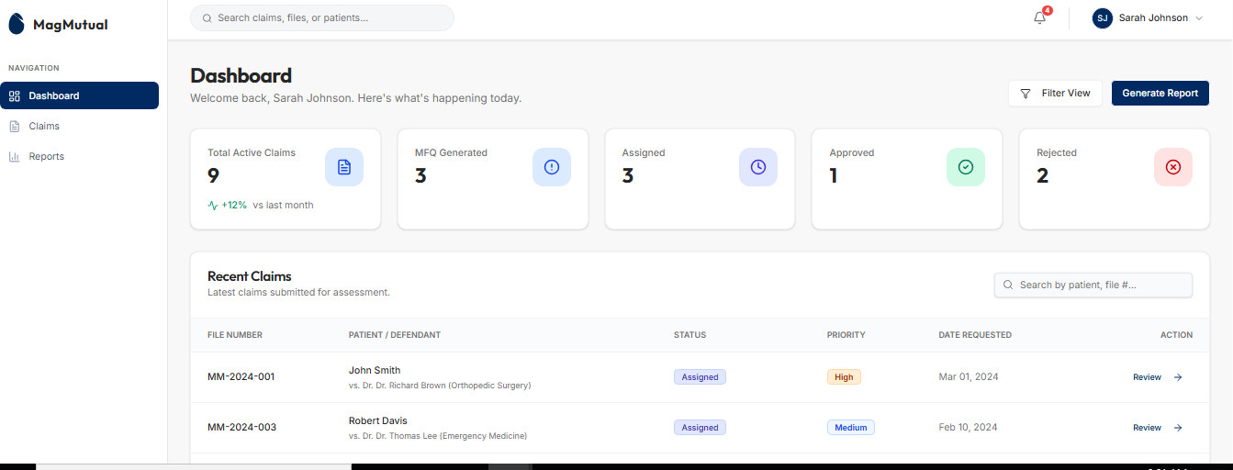
Sample dashboard layout showing KPI cards and the recent claims table.

7. Claims list / work queue
Objective | Allow users to locate, filter, and open claims according to role permissions and queue ownership.
Primary users | Claims Analyst, Advice Team, Medical Faculty.
Key navigation/actions | Search, filter, open claim, or move from queue view into claim details.
Key UI controls and content:
• Work queue presented as a searchable claim table with AI confidence visibility.
• Review action per row to open the claim detail screen; Regenerate action available for eligible claims.
• Status, priority, flag indicators, and confidence chips for fast triage.
• Claim visibility determined by assignment, processed ownership, or permitted team queue under the currently selected role.
Design notes
For medical faculty, this screen should default to Assigned Claims. For analysts and advice team, tabs such as New, In Review, Returned, and Processed are recommended.
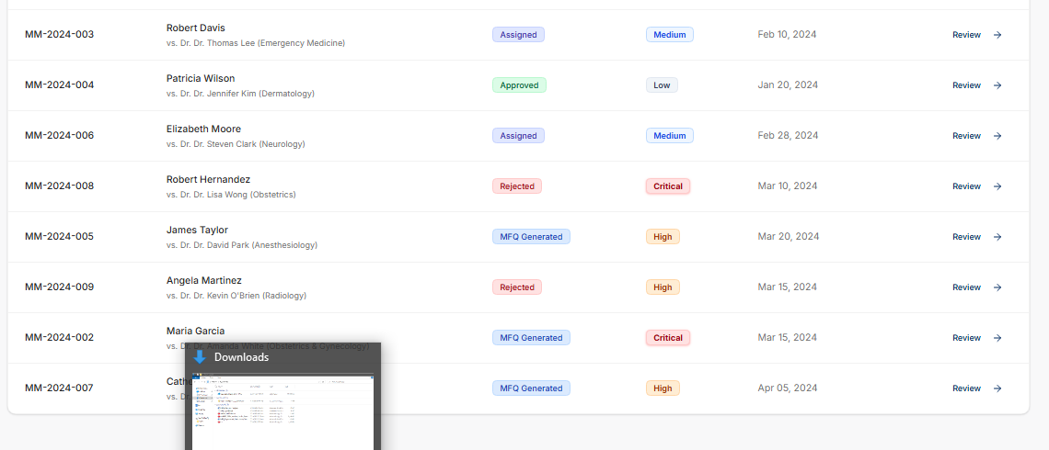
Sample claim queue showing status, priority, request date, and review action.

8. Claim detail header and tabbed workspace
Objective | Establish a single claim context and provide quick access to all review tabs.
Primary users | Claims Analyst, Advice Team, Medical Faculty.
Key navigation/actions | Reassign claim, switch tabs, start review, or access supporting content.
Key UI controls and content:
• Back-to-dashboard breadcrumb.
• Claim banner with patient vs defendant, status, priority, file number, reviewer, specialty, contact owner, and date requested.
• Action bar supports Assign to Faculty, Approve, Edit, and reassignment for claims analyst or privileged users.
• Tabbed content area for MFQ Form, Records Summary, MedCron, Legal Memo, Enquiries, AI Assist, and Documents.
Design notes
This banner should stay consistent across all tabs so the reviewer never loses claim context. Role-based controls should hide unavailable actions while still showing non-editable evidence tabs when allowed.
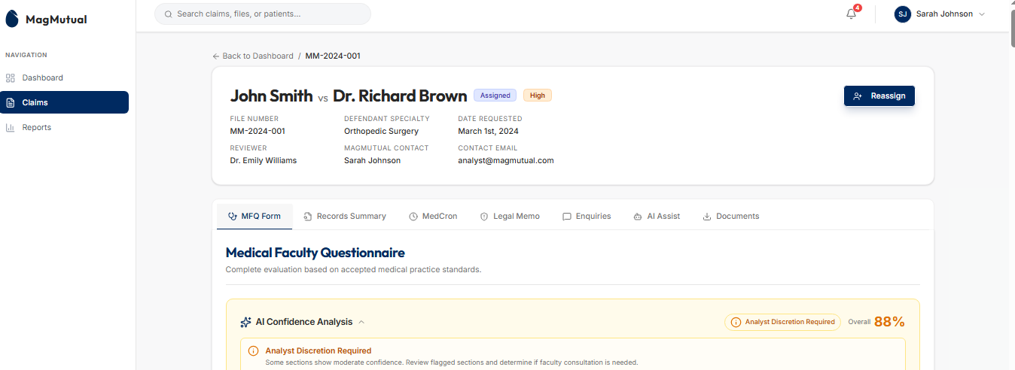
Sample claim detail screen with tabbed navigation and reassignment action.

9. AI confidence analysis panel
Objective | Show section-level confidence so analysts know whether medical faculty review is advisable.
Primary users | Claims Analyst primarily; Medical Faculty can view it for context.
Key navigation/actions | Use the confidence signal to decide self-approval, request faculty review, or limit assignment to specific sections.
Key UI controls and content:
• Overall confidence score.
• Analyst guidance badge such as “Analyst Discretion Required”.
• Section-wise confidence bars for each MFQ section.
• Highlighted low-confidence areas that need review.
• Grouped summary of sections requiring attention versus moderate confidence.
Design notes
Confidence is decision-support only. It must never auto-approve a claim without human review. The UI should explain that the analyst remains accountable for approval and assignment decisions.
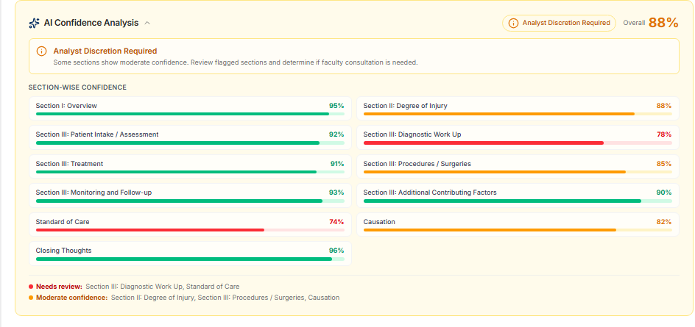
AI confidence panel with overall score and section-wise confidence guidance.

10. MFQ form workspace – synopsis and detailed case evaluation
Objective | Display the pre-filled MFQ in a section-wise review experience with evidence context and editable answers.
Primary users | Claims Analyst and assigned Medical Faculty.
Key navigation/actions | Review AI prefill, edit answers where allowed, evaluate evidence, approve, or return for missing records.
Key UI controls and content:
• Claim synopsis panel with high-level facts, alleged injury, and allegations.
• Section navigator for MFQ sections such as Overview, Degree of Injury, Diagnostic Work Up, Treatment, and Standard of Care.
• Question cards with Yes/No/Unclear/Not Applicable options.
• Evidence-based rationale text areas under each question.
• Expandable or accordion-style organization for better readability.
• Read-only behavior for sections not assigned to the current medical faculty reviewer, while claims analysts retain governed edit capability.
Design notes
This is the most important screen in the application. It should support autosave, section status markers, validation, and clear differentiation between AI-suggested content and human-confirmed final answers.
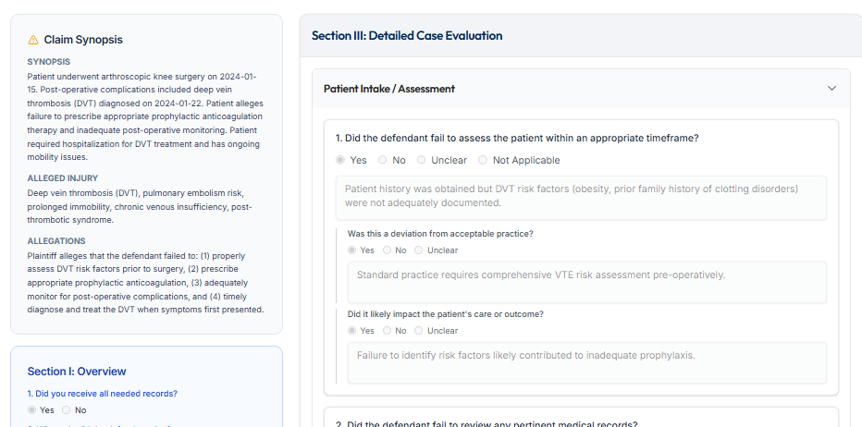
MFQ review workspace with synopsis on the left and detailed evaluation questions on the right.

11. Section editor – Degree of Injury and detailed question cards
Objective | Support deep section review for medical faculty with structured answer capture and explanation.
Primary users | Assigned Medical Faculty and Claims Analyst.
Key navigation/actions | Edit only assigned sections, provide expert rationale, approve section review, or reject assignment with reason.
Key UI controls and content:
• Editable form fields for injury description, degree of injury alleged, degree of injury suffered, impact on patient, and reason for difference.
• Question cards for deviations from accepted practice and care impact.
• Role-based edit restriction by section.
• Section-specific save/submit behavior.
Design notes
To reduce accidental edits, editable sections should be visually highlighted, while non-editable sections remain readable but disabled. The UI should clearly show who assigned the section and when.
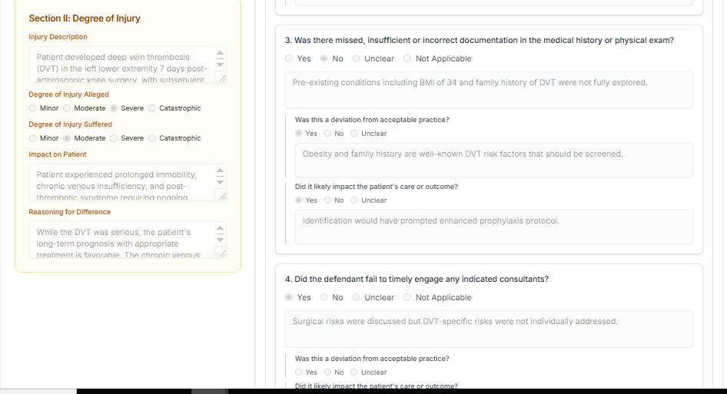
Example of a deeper section review experience with section editor and question cards.

12. Reports and analytics dashboard
Objective | Provide operational and management visibility into claim performance and review progress.
Primary users | Executives, Leads, Claims Analyst, Advice Team.
Key navigation/actions | View operational trends, monitor claim flow, and export insights for leadership.
Key UI controls and content:
• Filter by time range and active role context.
• KPI cards for total claims, approval rate, average resolution time, and pending review.
• Charts for claims by status and claims by priority.
• Support export or generate report actions with data scoped by role and selected filters.
Design notes
Executives should receive aggregate views only, while analysts may see drill-down capability to affected claims. Any personally sensitive claim data should be suppressed unless the role explicitly requires it.
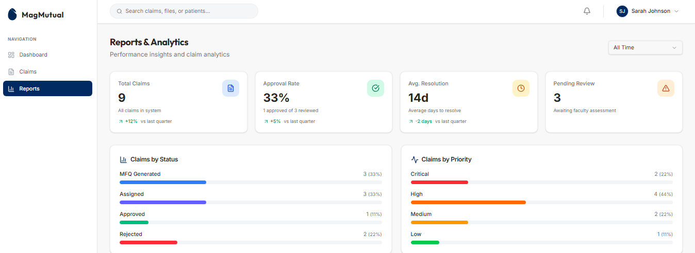
Reports landing page with operational KPIs and claim distribution charts.

13. Reports breakdown – faculty performance and claims by specialty
Objective | Show workload balance and domain distribution to support staffing and assignment decisions.
Primary users | Executives, Leads, Claims Analyst.
Key navigation/actions | Assess reviewer load, identify bottlenecks, and tune assignment logic.
Key UI controls and content:
• Faculty performance tiles with assigned, completed, and pending counts.
• Claims by specialty distribution panel.
• Potential future drill-down into aging, overload risk, and conflict history.
Design notes
This screen directly supports the requirement that assignment logic needs to be defined. Over time, the UI can surface rule-driven recommendations such as specialty match, current load, turnaround history, and conflict restrictions.
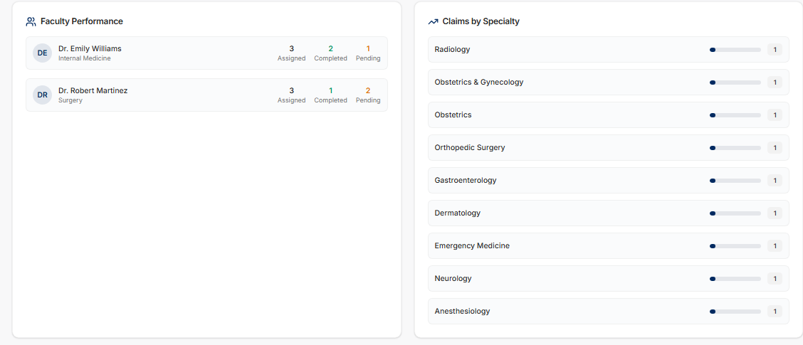
Reports detail view for faculty performance and specialty distribution.

14. Detailed workflow design

14.1 MFQ initiation workflow
• Claim enters the portal after upstream processing completes and source documents are available.
• System generates pre-filled MFQ answers, confidence scores, and an auditable AI output version.
• User receives notification that claim is processed; the event can appear in-app, by email, and through Appian mailbox integration where configured.
• Claim appears in the analyst dashboard/work queue based on RBAC and the selected role context.
• Analyst opens claim details and first verifies relevance and completeness of records.
• If irrelevant or missing documents are identified, analyst triggers missing document process before approval.
• If records are complete, analyst can edit AI-prefilled content, approve directly, regenerate eligible outputs, or assign selected sections to medical faculty based on confidence and case complexity.

14.2 HITL review and override flow
• Claims Analyst reviews AI-prefilled MFQ, evidence summary, and confidence guidance.
• Claims Analyst can approve the claim without faculty review when business rules allow and confidence is acceptable.
• Claims Analyst can assign one or more sections to medical faculty; only those sections become editable for that faculty reviewer.
• Medical Faculty reviews assigned sections, updates answers and rationale, and approves or rejects the assignment.
• If Medical Faculty rejects due to over-allocation, conflict of interest, leave, or another reason, the claim returns to Claims Analyst/Advice Team queue.
• Final approved claim data is pushed to the database and downstream notifications/workflow triggers execute with full audit history for edits, assignments, approvals, and regenerations.

14.3 Missing document process
• Missing document process may be triggered by Claims Analyst or Medical Faculty.
• Trigger should capture reason, missing item type, urgency, and requesting role.
• Claim status should move to a dedicated “Waiting for Documents” or equivalent state.
• System should notify relevant users and also notify the mailbox that starts the related Appian case.
• Once documents are received and indexed, claim returns to the appropriate queue with an audit trail.

15. Functional requirements by screen
Requirement area | What the screen must support | Recommended screen(s) | Notes
Dashboard | Role-based landing page and basic insights. | S1, S10 | Dashboard content varies by role.
Claim Search | Search facility to locate claims for review. | S1, S2, S3 | Global search plus queue filters recommended.
Assigned / Processed Claims | Medical Faculty sees assigned claims; analyst/advice team sees processed claims. | S2 | Queue tabs should be RBAC-driven.
Claim Detail | Route user to full claim detail screen after selection. | S3 | Consistent claim header across tabs.
Prefilled MFQ | Display pre-filled questionnaire with editable controls based on role. | S4, S10, S11 | Highlight AI-generated content and confidence.
Record Relevance / Missing Docs | Check relevance and completeness; trigger missing document process when needed. | S3, S4, S9 | Mandatory before final approval.
Section-wise claim summary | Show summary of claim records by section. | S5 | Tabbed content next to MFQ.
MedCron summary | Show summary of legal MedCron data. | S6 | Also allow PDF download.
Legal Memo summary | Show summary of legal memo data. | S7 | Also allow PDF download.
Ask new questions | Allow additional questions while respecting RBAC. | S8 | Data outside role scope must be blocked.
PDF downloads | Download MedCron, Legal Memo, and Summary files. | S9 | Support document history/version if needed.
Claims Analyst approval | Analyst reviews claim and approves it, pushing approved data to DB. | S4 | Require explicit final approval action.
Section assignment | Analyst assigns claim or sections to medical faculty. | S3, S4 | Only selected sections editable by faculty.
Medical Faculty review | Faculty edits assigned sections and approves. | S4, S11 | Read-only access elsewhere.
Medical Faculty missing docs | Faculty can trigger missing docs process. | S4, S9 | Same process as analyst, different initiator.
Medical Faculty reject | Faculty can reject due to overload/conflict/leave. | S4 | Reason mandatory; route back to analyst/advice team.
AI confidence guidance | Display AI confidence and further review guidance. | S4 | Use score as recommendation, not final decision.
Assignment logic | System-backed logic to help select faculty. | S11, S13 | Load, specialty, availability, conflict, and turnaround should be factors.
Notifications | Notify when claim is processed or assigned. | Cross-cutting | Also send mailbox notification for Appian trigger.
Admin | Add/remove user to group and modify access. | S11 | Backend RBAC must enforce, not only UI.

16. RBAC design guidance
• RBAC must be enforced in the backend API and data layer; the UI should only reflect permitted actions, not define them.
• Recommended permission model: role -> capability -> object scope -> section scope.
• Section scope is critical because medical faculty can edit only the sections assigned by the claims analyst.
• Enquiries / AI Assist responses must respect record-level and role-level access boundaries.
• Admin functions should be isolated from operational review functions for security and audit reasons.

17. Notification and Appian integration design
• System should notify users when a claim is processed, assigned, regenerated, approved, rejected, or returned for action.
• Notifications should appear in-app through a notification center and also support email delivery where required.
• When a workflow-triggering event occurs, the system must also notify the specific mailbox that initiates the corresponding Appian case.
• Recommended notification payload: claim ID, event type, role recipient, timestamp, triggering user/system, reason, and deep link to the claim or work queue.
• Workflow events should be auditable and retryable so mailbox/Appian failures do not silently lose business actions.

18. Assignment logic recommendations
• Match faculty specialty to claim specialty whenever possible.
• Check reviewer workload and pending volume to avoid over-allocation.
• Apply conflict-of-interest rules before assignment.
• Use availability calendars or leave status where available.
• Use AI confidence and case complexity to decide whether full review, section-only review, or direct analyst approval is needed.

21.

21.1 Header role switcher
A role switcher is now shown in the header so the application can expose a role-specific experience such as Claims Analyst or Advice Team. This is useful for controlled multi-role access, demo environments, test environments, and users who are explicitly granted more than one operational role.
- Display the active role clearly in the top bar.
- Allow switching only among roles granted to the signed-in user.
- Refresh dashboard metrics, work queue, actions, notifications, and reports based on the newly selected role context.
- Record role-switch activity in the audit trail because the visible worklist and allowed actions change immediately.
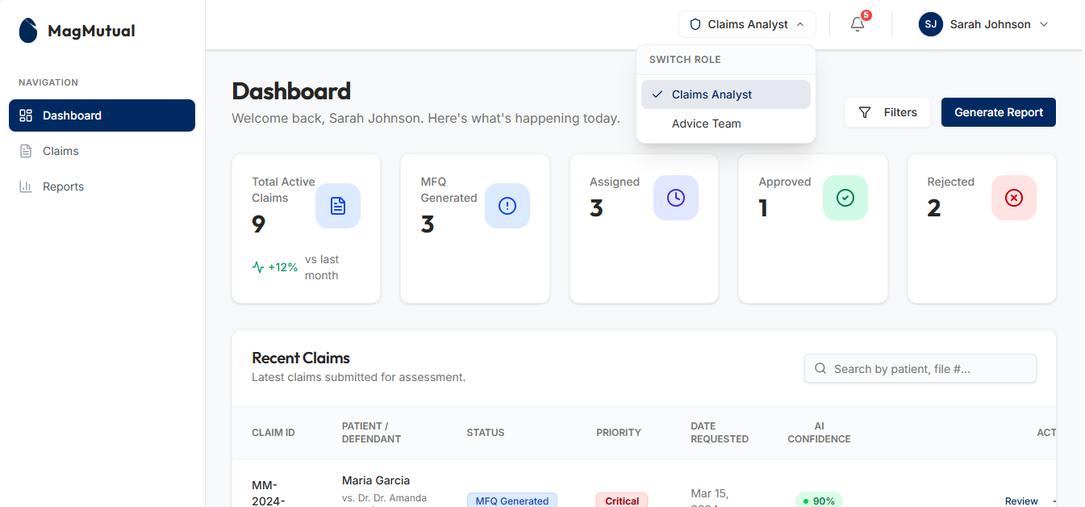
Updated dashboard header with role switcher for Claims Analyst and Advice Team.

21.2 Notification center
The header notification bell now expands into a notification center that lists operational events such as claim rejection, MFQ generation, assignment, and other workflow outcomes. This supports the notification requirements and creates a clear bridge to Appian-trigger events.
- Unread count badge in the header.
- Scrollable notification panel with event icon, claim ID, message text, and relative timestamp.
- Mark all read action and per-item read state.
- Deep link from each notification to the related claim detail or work queue.
- Same business event should optionally fan out to in-app notification, email, and Appian mailbox integration.
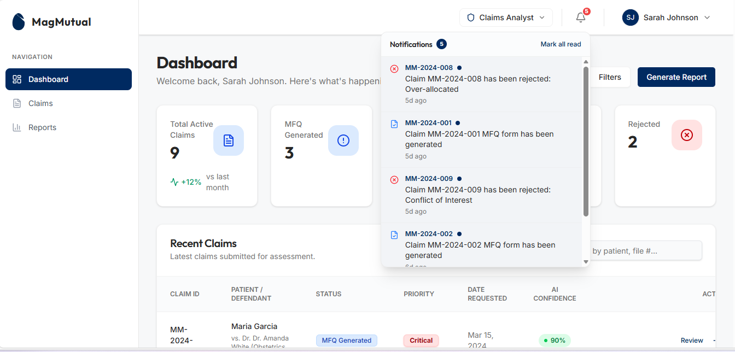
Notification center showing claim events, unread count, and quick read management.

21.3 Claims list enhancements: AI confidence, flagged claims, and regenerate
The work queue mockup now includes AI confidence visibility directly in the table, red-flag indicators on select claims, and a Regenerate action for MFQ-generated items. These controls are important because analysts should be able to identify questionable AI output before opening every claim.
- Add an AI Confidence column to the claim list with threshold-based chips such as High, Medium, or Low confidence.
- Support visual flags for claims that need attention, rework, or special handling.
- Provide Regenerate action only when the claim is eligible and the user has permission.
- Regenerate should create a new AI generation version, preserve previous output for audit comparison, and notify the user when the refreshed MFQ is ready.
- Review link remains available as the primary navigation into the claim workspace.
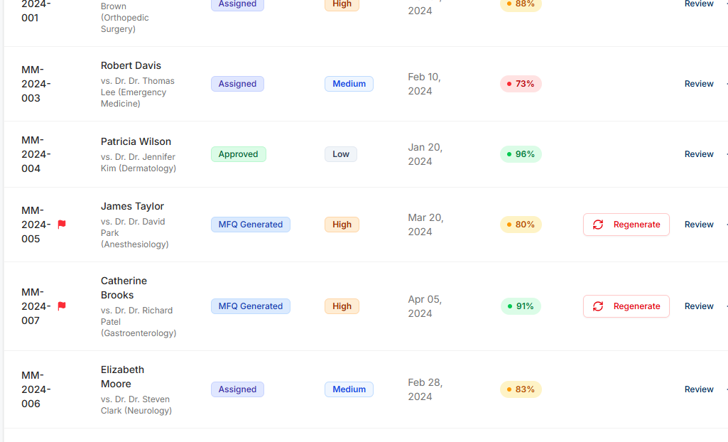
Claims list with AI confidence, attention flags, and Regenerate action.

21.4 Claim detail action bar: Assign to Faculty, Edit, and Approve
The claim detail page now shows stronger action controls for the Claims Analyst role. These actions should be treated as first-class workflow buttons because they directly support HITL review and override design.
- Assign to Faculty button should open an assignment workflow where the analyst selects reviewer, specialty alignment, due date, and editable MFQ sections.
- Approve button should validate mandatory fields, role permissions, and missing-document checks before completing approval.
- Edit button allows the claims analyst to modify AI-prefilled answers before approval or assignment, subject to field-level audit tracking.
- Buttons should be enabled or disabled based on claim status, selected role, and backend RBAC.
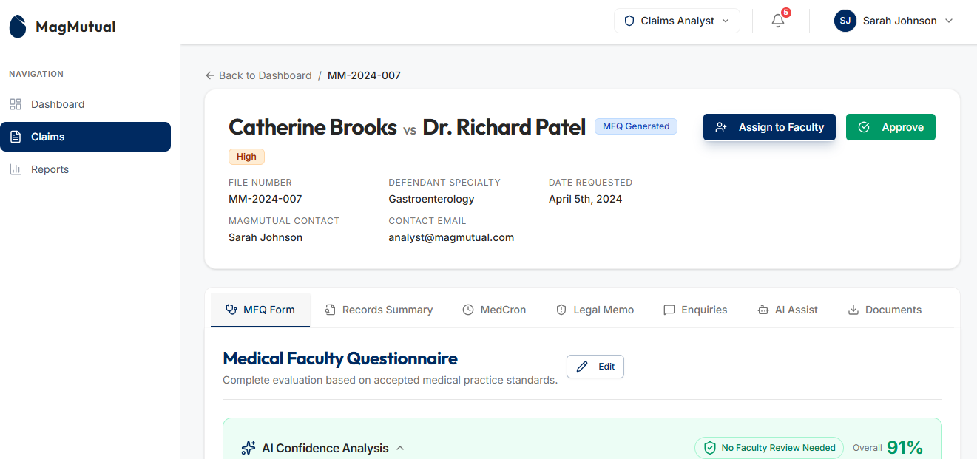
Claim detail header with Assign to Faculty, Approve, and MFQ Edit actions.

21.5 Dashboard and work queue filter panel
The updated dashboard includes a filter drawer or popover for status, priority, and AI confidence score. This makes the dashboard more actionable and reduces the need to open a separate advanced-search page for common operational filtering.
- Filter by claim status such as MFQ Generated, Assigned, Approved, and Rejected.
- Filter by priority such as High, Medium, and Low.
- Filter by AI confidence bands such as High (90%+), Medium (80-89%), and Low (<80%).
- Selected filters should update KPI cards and the visible recent claims list consistently.
- Filters should be retained temporarily in session for analyst convenience.
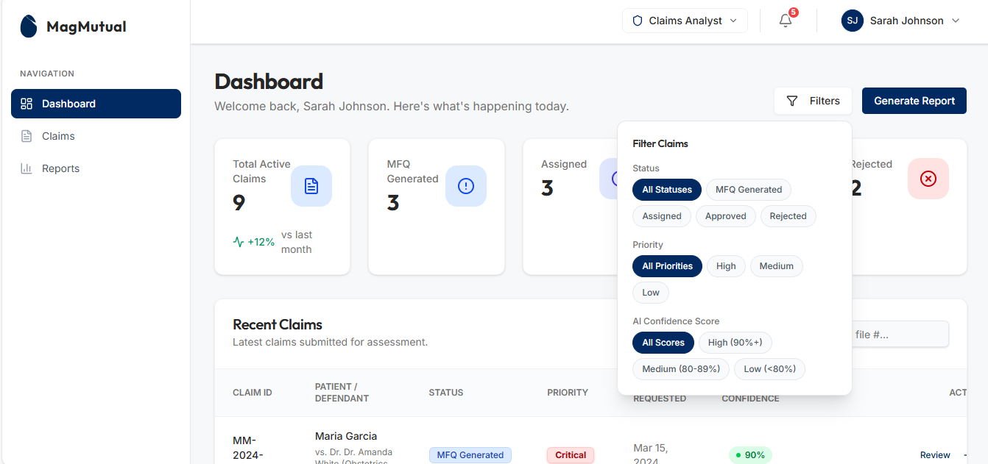
Dashboard filter panel with status, priority, and AI confidence controls.

20. Conclusion
The supplied requirements and reference screens support a strong foundation for an MFQ review portal. The recommended design centers on one unified claim workspace, guided AI confidence indicators, role-based section editing, robust missing-document handling, and workflow integration for downstream Appian case creation. This document can now be used as the working baseline for UX refinement, API design, workflow mapping, and development estimation.

