Design Specification Document
for
LockedMe.com

Project objective:
Company Lockers Pvt. Ltd. is one of the biggest MNC in the world in the field of providing lockers. They aim to digitize their products and chose LockedMe.com as their first project to start with. The objective of this project is to develop a prototype of the application.

Developer: Anil Patil

Flow Chart:

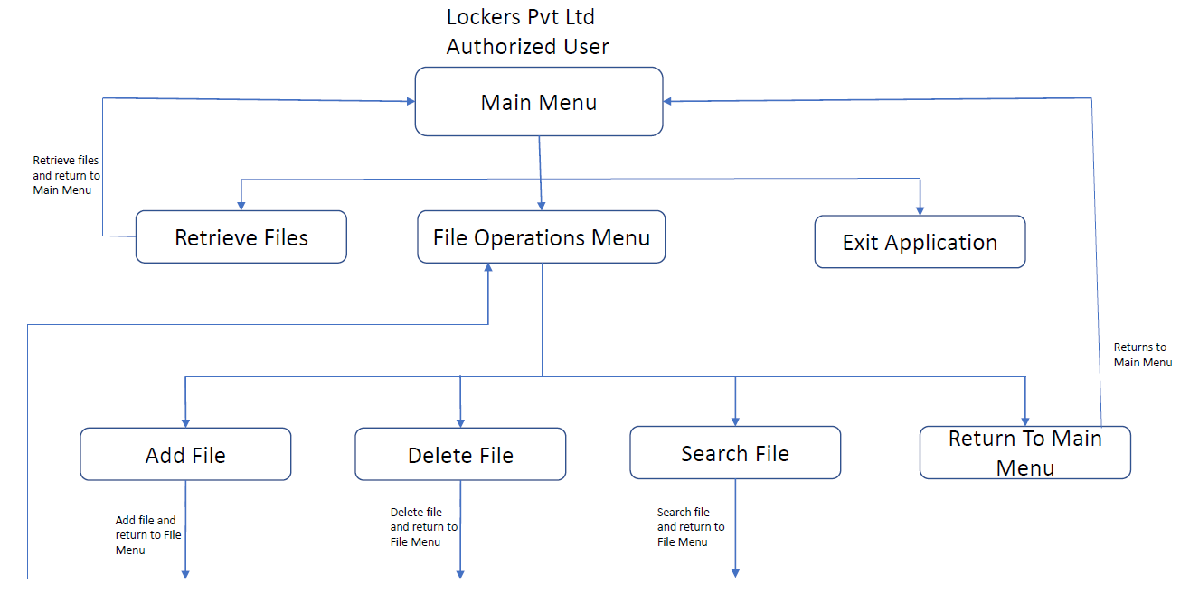

Sprint Planning:
Development and testing of this requirement require 3 sprints. Please see below the Sprint planning in the spread sheet:
Sprint Planning
Sprints/Stories | Tasks | Priority | Person | Actual  Effort  (hrs) | Task  Status | Start  Date | Completion  Date
SPRINT 1:
Storey 1:  Design Specification document | Design Menu Screens | 1 | Anil Patil | 8 | Done | 1/25/2021 | 1/25/2021
Storey 1:  Design Specification document | Prepare Flow Chart | 1 | Anil Patil | 8 | Done | 1/26/2021 | 1/26/2021
Storey 1:  Design Specification document | Sprint Planning | 1 | Anil Patil | 12 | Done | 1/27/2021 | 1/28/2021
Storey 1:  Design Specification document | Write Algorithm | 1 | Anil Patil | 32 | Done | 1/28/2021 | 2/5/2021
Storey 1 |  |  | Anil Patil | 60 | Done | 1/25/2021 | 2/5/2021
SPRINT 1 |  |  | Anil Patil | 60 | Done | 1/25/2021 | 2/5/2021
SPRINT 2:
Storey 2:  Develop Menu Screens | Design Main Menu navigatrion | 2 | Anil Patil | 8 | Done | 2/8/2021 | 2/8/2021
Storey 2:  Develop Menu Screens | Design File Operation Menu navigation | 2 | Anil Patil | 12 | Done | 2/9/2021 | 2/10/2021
Storey 2:  Develop Menu Screens | Test Main Menu navigation | 2 | Anil Patil | 4 | Done | 2/10/2021 | 2/10/2021
Storey 2:  Develop Menu Screens | Test File Operation Menu navigation | 2 | Anil Patil | 8 | Done | 2/11/2021 | 2/11/2021
Storey 2 |  |  | Anil Patil | 32 | Done | 2/8/2021 | 2/11/2021
Storey3: Main Menu functionality | Develop Retrieve files functionality | 2 | Anil Patil | 16 | Done | 2/12/2021 | 2/16/2021
Storey3: Main Menu functionality | Develop Exit from application functionality | 2 | Anil Patil | 4 | Done | 2/17/2021 | 2/17/2021
Storey3: Main Menu functionality | Test Main Menu functionality | 2 | Anil Patil | 8 | Done | 2/18/2021 | 2/19/2021
Storey 3 |  |  | Anil Patil | 28 | Done | 2/11/2021 | 2/11/2021
Sprint 2 |  |  | Anil Patil | 60 | Done | 2/8/2021 | 2/19/2021
SPRINT 3:
Storey 4:  File Operation Menu functionalities | Develop Search file functionality | 2 | Anil Patil | 16 | Done | 2/22/2021 | 2/24/2021
Storey 4:  File Operation Menu functionalities | Develop Add file functionality | 2 | Anil Patil | 12 | Done | 2/24/2021 | 2/26/2021
Storey 4:  File Operation Menu functionalities | Develop Delete file functionality | 2 | Anil Patil | 8 | Done | 3/1/2021 | 3/2/2021
Storey 4:  File Operation Menu functionalities | Test Search file functionality | 2 | Anil Patil | 8 | Done | 3/2/2021 | 3/3/2021
Storey 4:  File Operation Menu functionalities | Test Add file functionality | 2 | Anil Patil | 8 | Done | 3/3/2021 | 3/4/2021
Storey 4:  File Operation Menu functionalities | Test Delete file functionality | 2 | Anil Patil | 8 | Done | 3/4/2021 | 3/5/2021
Storey 4 |  |  | Anil Patil | 60 | Done | 2/22/2021 | 3/5/2021
SPRINT 3: |  |  | Anil Patil | 60 | Done | 2/22/2021 | 3/5/2021
Algorithm:
Main Class:
- Define constants private static final: int numOfMainMenuOptions = 3, int numOfFileMenuOptions = 4, String filePath = "C:\\Users\\patila\\simpleLearn"
- Main method:
  - Define integer variable mainMenuChoice
  - Create new object reference of class MyScanner scanner = new MyScanner()
  - Create new object reference of class Menu menu = new Menu()
  - Create new object reference of class Filehandler filehandler = new Filehandler()
  - iterate until user wants to exit the main menu/application using do and while loop with conditions: mainMenuChoice > 0 && mainMenuChoice < numOfMainMenuOptions
  - Display Main Menu by calling menu method displayMainMenu()
  - Scan the main menu choice by calling scanner method scanInt(numOfMainMenuOptions)
  - Switch to mainMenuChoice
  - Main Menu:
    - Choice/Case 1 defined to retrieve files
    - Retrieve files by calling filehandler method retrieveFiles(filePath)
    - Once retrieved files display, then break the case and return to the main menu
    - Choice/Case 2 defined to navigate to File Operations menu
    - Define integer variable fileMenuChoice
    - Iterate until user wants to exit from the file operation menu using do and while loop with conditions: fileMenuChoice > 0 && fileMenuChoice < numOfFileMenuOptions
    - Display File Operation Menu by calling menu method: menu.displayFileOperationMenu()
    - Scan the file operation menu choice by calling scanner method scanInt(numOfFileMenuOptions)
    - Define String variable fileName
    - Switch to file operation menu choices
    - File Operations menu:
      - Choice/Case 1 defined to add a file
      - Read file name by calling scanner method readFileName()
      - Add a file by calling filehandler method addFile(filePath, fileName) in try block.
      - Catch IOException exception
      - break and return to File Operations Menu
      - Choice/Case 2 defined to delete a file
      - Read file name by calling scanner method readFileName()
      - Delete a file by calling filehandler method deleteFile(filePath, fileName)
      - break and return to File Operations Menu
      - Choice/Case 3 defined to search a file
      - Read file name by calling scanner method readFileName()
      - Search a file by calling filehandler method searchFile(filePath, fileName)
      - break and return to File Operations Menu
      - Choice/Case 4 defined to break and return to Main Menu
    - Choice/Case 3 defined to Close the Application
MyScanner Class:
- Define constant: private static final int numOfScanAttempts = 3
- Method: scanInt(int numOfMenuOptions) returns numOfMenuOptions
  - Create new object reference of class MyScanner scanner = new MyScanner()
  - Define integer variable counter and initialize counter = 0
  - Define integer variable and initialize: numOfAttemptsLeft = numOfScanAttempts
  - Use while loop to limit the number of attempts for a menu choice with condition: counter < numOfScanAttempts
    - Decrement the numOfAttemptsLeft—
    - Define Boolean variable isAnInt and check using scan method scan.hasNextInt()
    - If isAnInt is true then:
      - define integer variable number and read using scan method scan.nextInt
      - If number > 0 and number <= numOfMenuOptions then return number
      - Else Print: Please enter valid option. You have numOfAttemptsLeft more attempts
    - Else Print: Please enter valid option. You have numOfAttemptsLeft more attempts
    - Scan next line using scan method scan.nextLine()
    - Increment the counter++
  - Return numOfMenuOptions

- Method: readFileName() returns fileName
  - Create new object reference of class Scanner scanFileName = new Scanner(System.in)
  - Input file name
  - return scanned file name scanFileName.nextLine()

FileHandler Class:
- Method: getFiles (String filePath): gets files from filePath
  - Use java File class to create a file object File file = new File(filePath)
  - Use file list method to convert file object to String array and return
- Method: retrieveFiles(String filePath) displays retrieved files in ascending order
  - Use getFiles method
  - Use Collections method addAll(filesList, files) to convert array to arrayList. This method will also sort items in ascending order
  - Print file arrayList
- Method: searchFile(String filePath, String fileName) searches a file at filePath
  - Use getFiles method. Returns String array of files.
  - Search a file inside string array using contentEquals method that will make sure case sensitivity
  - Return true if file exits and break, else return false
  - Return to File Operation Menu
- Method: addFile(String filePath, String fileName) adds a file
  - Use searchFile method to return Boolean value
  - If file filename does not exists, then use FileOutputStream class to add a file, Else print a message “file already exists”
  - Return to File Operation Menu
- Method: deleteFile(String filePath, String fileName) deletes a file
  - Use searchFile method to return Boolean value
  - If file filename exists, then use File class delete method to delete the file fileName, Else print a message “file not found”.
  - Return to File Operation Menu

Menu Class:
- Method: displayMainMenu(): displays Main Menu
  - Displays Main Menu with choices
    - 1. Retrieve existing files
    - 2. File operations (Add/Delete/Searching)
    - 3. Close the application
  - Request user to enter option: “Please enter your choice”
- Method: displayFileOperationMenu(): displays Main Menu
  - Displays Main Menu with choices
    - 1. Add a file
    - 2. Delete a file
    - 3. Search a file
    - 4. Return to Main Menu
  - Request user to enter option: “Please enter your choice”

Core Concepts:
Following core concepts has been used:
- jdk version: 1.8.0_192
- OOP composition
- Java File class used for getting file from the source directory
- Java Collections are used to convert array to arrayList
- Java FileOutputStream class used to dd/append a new file in the source directory
- Java Scanner class is used to scan integer and string values

Git hub link:
https://github.com/anilpatil15/anilpatil_phase1_viveksharma.git
https://github.com/anilpatil15/anilpatil_phase1_viveksharma

Conclusion:
The scope of this project is limited to design interactive screen for LockedMe.com without windows concepts. It can be further enhanced by:
- An interacting User Interface can be added using windows frames
- Login functionality can be added for privacy of the user
- Copy file method can be added for reusing existing files
- Edit file method can be used to update content in the file and finally

