Output Screen shots:
Main Menu
Option 1: Retrieve files in ascending order:
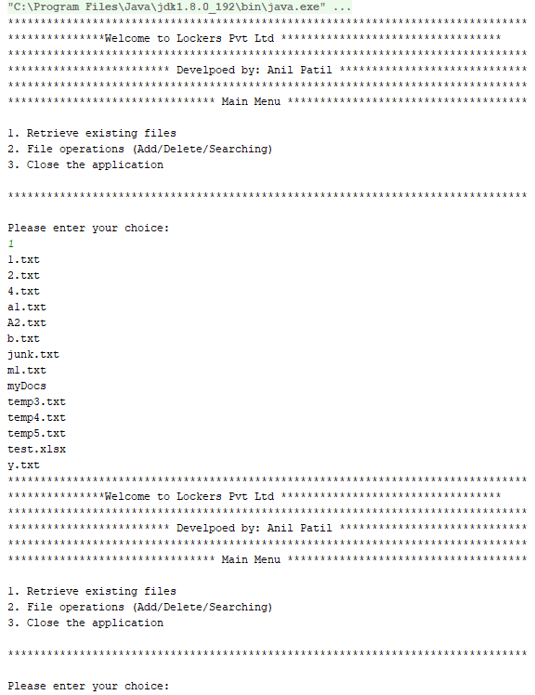
Option 2: Navigates to File Operation Menu:
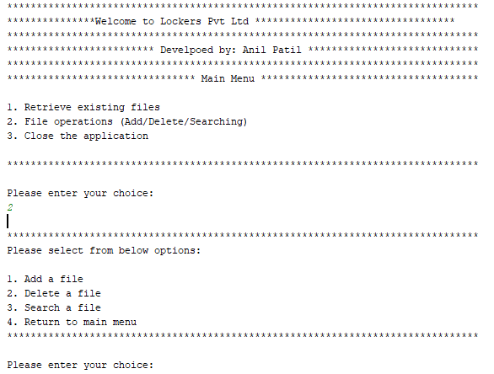
Option 3: Exit Application:
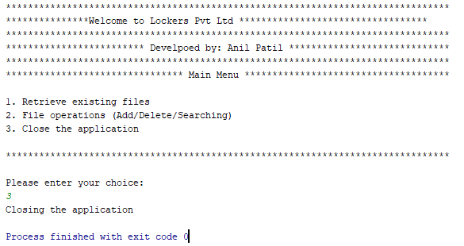

File Operation Menu:
Option 1: Add a File (Anil.txt) that does not exist
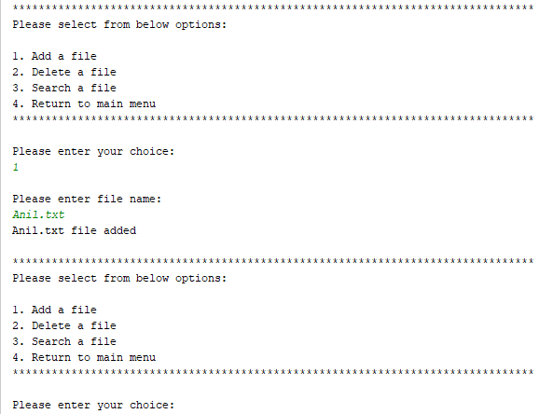

Option 1: Add a File (1.txt) that already exist
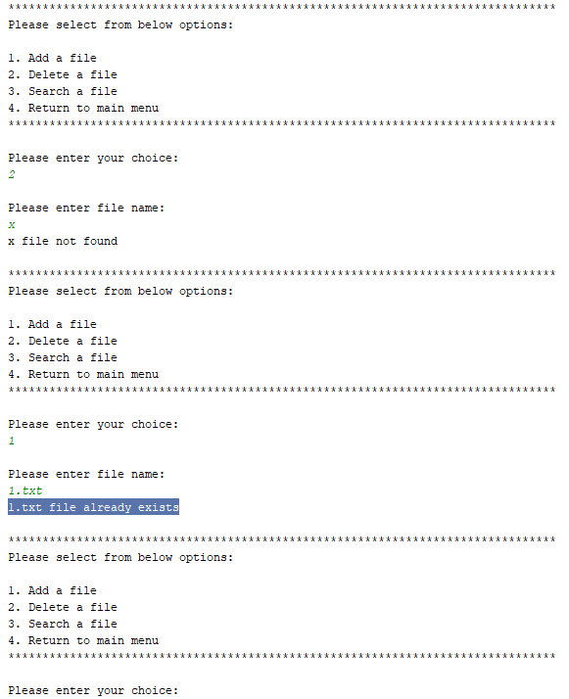

Option 2: Delete a file (2.txt) that exist
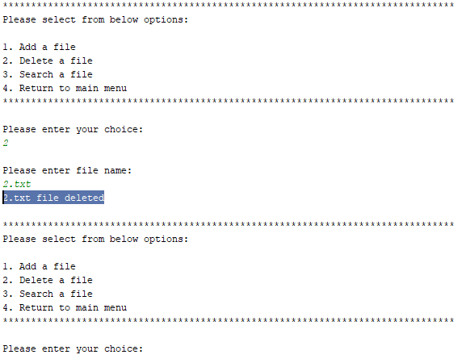

Option 3: Delete a file (temp6.txt) that does not exist
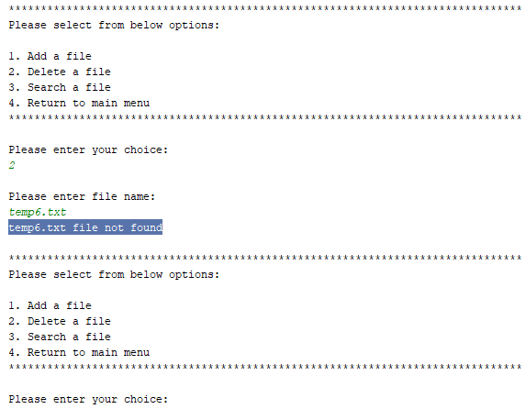

Option 3: Search a file (Anil.txt) that already exist
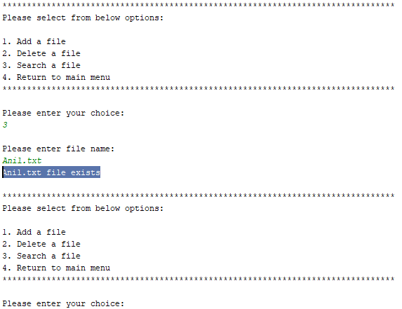

Option 3: Search a file (2.txt) that does not exist
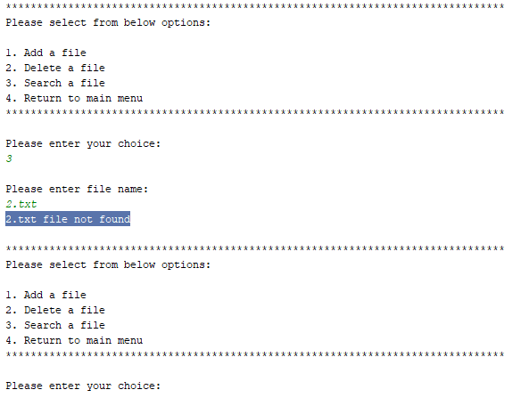

Option 4: Return to Main Menu
