ServiceNow Document Verification
Consolidated solution and feature reference
  - Prepared from the Document Standardization POC workspace | Version 1.0 | 14 October 2026
IMPORTANT: This is a proposed ServiceNow integration design, not an existing ServiceNow implementation. All included form images are explicitly labeled illustrative mockups. No ServiceNow instance was available for authentic page captures.

1. Executive summary
This guide describes a proposed ServiceNow front end for the existing document-standardization proof of concept. Standards Officers configure versioned document rules; Authors submit documents; a verification service evaluates structure, order, content, and formatting; and users receive decisions with actionable remediation. ServiceNow would provide request/workflow, role-aware forms, and audit presentation, while the current Python/Azure POC remains the evaluation engine unless an approved redesign changes that boundary.

Current state and scope
- Existing application: Streamlit user interface, Python document parser/evaluators, standards repository, remediation generator, and optional Microsoft Foundry/Azure service configuration.
- Existing supported document inputs described in the project: DOCX, PDF, Markdown, and TXT. Confirm deployed limits and parsing behavior before production configuration.
- Not present in the repository: ServiceNow tables, catalog items, flows, scripted REST APIs, ACLs, update sets, or genuine ServiceNow screenshots.
- This proposal covers five user-facing feature areas, conceptual forms, integration boundaries, security considerations, and validation scenarios. It is not a certified implementation design for a specific ServiceNow release.

2. Proposed ServiceNow experience
Suggested navigation: Document Verification workspace with Standards, New Request, My Requests, Assigned Reviews, and Operations Dashboard. The actual implementation may use a Service Catalog item, Workspace forms, Flow Designer, IntegrationHub, or a custom scoped application based on licensing and platform standards.

2.1 Proposed high-level flow
- Standards Officer publishes a versioned category/template and its rules.
- Author creates a verification request, selects the standard, attaches a supported document, and acknowledges the privacy notice.
- ServiceNow validates metadata and submits a secured request to the verification API using an approved authentication mechanism.
- The verification service parses and evaluates the document; ServiceNow stores the correlation ID and lifecycle state, then receives or polls for the result.
- ServiceNow displays the decision, score dimensions, findings, and remediation. Borderline or disputed cases can be routed to a human reviewer.
- Audit events preserve template version, automated result, reviewer action, and resubmission linkage.

2.2 Integration boundary
ServiceNow responsibility | Request lifecycle, user/role experience, assignment, notifications, access controls, reviewer workflow, audit presentation, operational reporting.
Verification service responsibility | File parsing, section alignment, synonym/semantic matching, LCS order analysis, rules, scoring, blocker override, remediation generation.
Transport (to decide) | Authenticated HTTPS API; synchronous response for small/fast jobs or asynchronous request + callback/polling for longer evaluation.
Attachment handling (to decide) | Choose either controlled transfer from ServiceNow to protected backend storage or approved ServiceNow attachment access; define encryption, retention, deletion, size limits, and failure recovery.
Authentication (to decide) | Use the organization's supported OAuth/client-credentials or equivalent service identity pattern, credential rotation, and outbound allowlisting. Do not place secrets in scripts or documents.

2.3 Suggested logical records (names are placeholders)
Document Category | Category ID, name, description, active state, owner.
Document Standard | Template ID, category, version, state, sections/rules, weights, thresholds, effective dates.
Verification Request | Request number, submitter, attachment reference, selected standard/version, state, correlation ID.
Evaluation Result | Decision, total score, dimension scores, blocker state, evaluator timestamp, result schema version.
Finding / Remediation | Severity, rule, section, evidence location, description, remediation steps, related result.
Review / Audit Event | Reviewer, disposition, rationale, timestamp, prior result, resubmission relationship.

These are conceptual entities, not existing tables or prescribed ServiceNow table names. Confirm scope, table extension strategy, licensing, retention, and ACL approach during implementation design.

3. Feature documents embedded in this guide
The following feature specifications are included in full as sections in this consolidated document. Standalone Word documents for each feature are also provided in the documents folder.
01. Standards and Template Administration - Standards Officers create and maintain document categories and versioned templates, including canonical sections, aliases, requirements, content rules, scoring weights, pass thresholds, and blocker clauses.
02. Document Submission and Ingestion - Document Authors submit a file or text for verification, select the applicable standard, review privacy/retention notices, and receive a tracked submission record.
03. Compliance Evaluation and Results - The evaluation view presents an overall decision, score dimensions, matched/missing sections, ordering issues, content findings, and the exact template version used.
04. Remediation and Human Review - Authors receive issue-specific steps to fix. Assigned reviewers can inspect the evaluation, record a reasoned override or disposition, and preserve the original automated outcome.
05. Demo Scenarios, Reporting, and Audit - Standards owners and reviewers monitor request states and outcome trends. The POC's four NDA scenarios provide a practical acceptance-test baseline for a ServiceNow experience.

4. Feature specifications

Standards and Template Administration
Standards Officers create and maintain document categories and versioned templates, including canonical sections, aliases, requirements, content rules, scoring weights, pass thresholds, and blocker clauses.

Users and ownership
Standards Officer (owner); Platform Administrator (configuration support); Reviewer (read-only).

Illustrative ServiceNow form screenshot
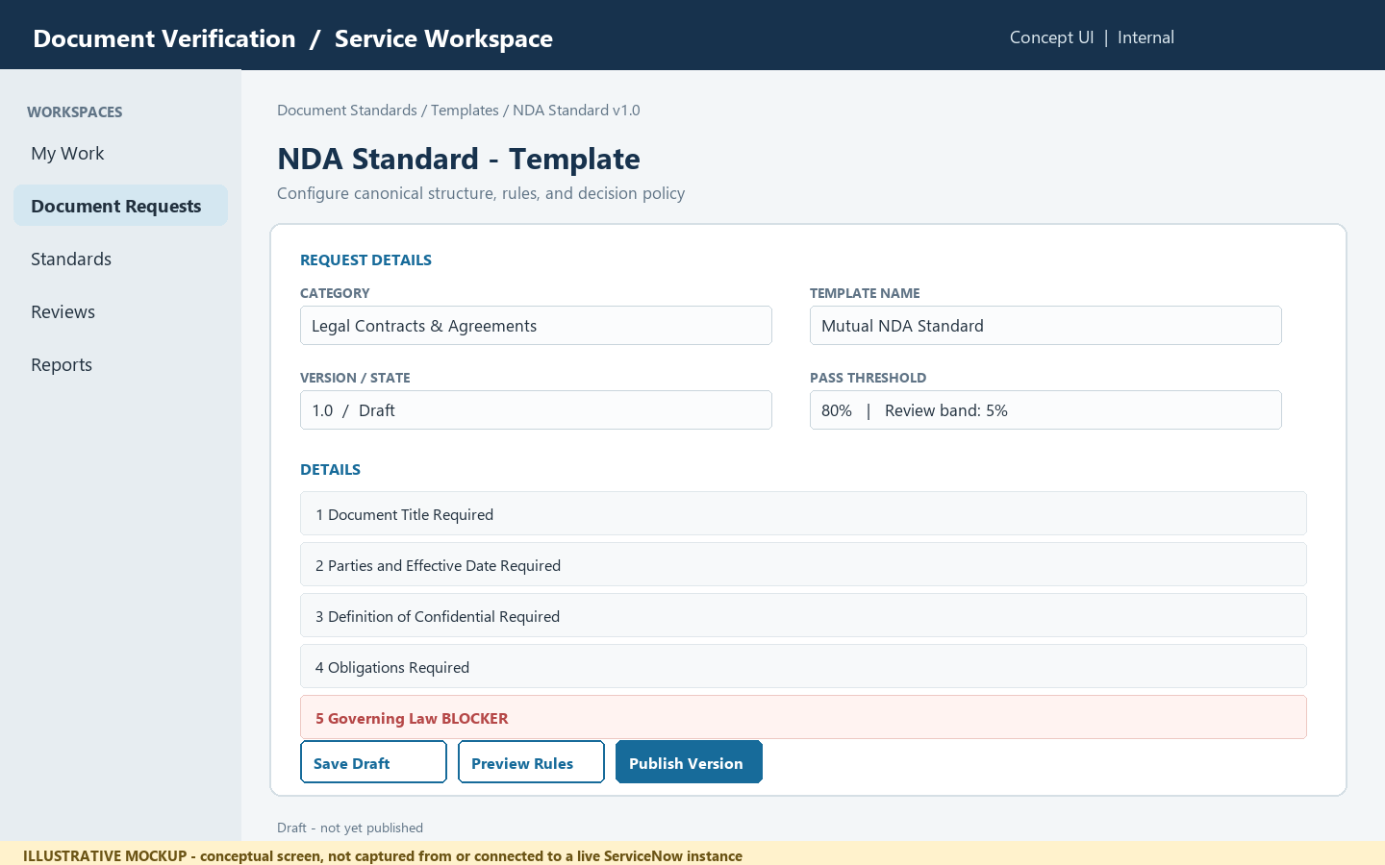
Conceptual mockup only; it is not a screenshot from a live ServiceNow tenant.

User and system flow
- Open the standards workspace and select a category or create one (for example, Legal Contracts & Agreements).
- Create a template version and add ordered sections with canonical title, accepted aliases, requirement level, and ordering strictness.
- Define mandatory keywords, optional regular expressions, semantic intent, and blocker status for each applicable section.
- Set scoring weights and acceptance/review thresholds. Validate that weights total 100% before publishing.
- Preview and publish the version. Preserve prior versions for audit and reproducibility; do not silently change rules for evaluations already completed.

Proposed form fields / record data
Category | Name, description, active/inactive status
Template identity | Name, version, owner, effective date, lifecycle state
Section definition | Canonical title, order, aliases, requirement level, strict/flexible ordering
Content rules | Required phrases, regex, semantic intent, blocker flag
Decision policy | Structure/order/content/format weights, pass score, review band

Business, security, and behavior rules
- Use draft/published/retired lifecycle states and require an explicit publish action.
- Validate non-negative weights with a total of 100%; show the computed decision bands before publishing.
- Require a reason and user identity for policy changes; retain template version on every submission result.
- A blocker is a hard decision override and must be visually distinguished from ordinary score deductions.

Acceptance criteria
- An authorized Standards Officer can create and publish a category template with ordered sections and aliases.
- Invalid weight totals or missing required fields prevent publishing and identify the fields to fix.
- A previously published version remains available for viewing and for interpreting historical submissions.

Repository traceability
POC source: src/models/template_models.py, src/standards/standards_repository.py, app.py (Admin Create / View Standard).

Document Submission and Ingestion
Document Authors submit a file or text for verification, select the applicable standard, review privacy/retention notices, and receive a tracked submission record.

Users and ownership
Document Author (submitter); Service Desk / Platform Support (operational support); Standards Officer (policy owner).

Illustrative ServiceNow form screenshot
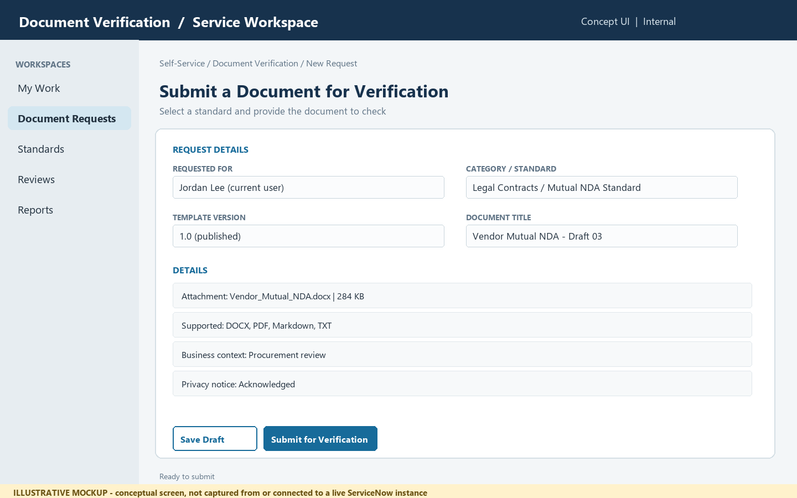
Conceptual mockup only; it is not a screenshot from a live ServiceNow tenant.

User and system flow
- Start a new verification request from a ServiceNow catalog item or workspace form.
- Choose the document category and active template version, or allow the service to select the current published version.
- Attach a supported file (.docx, .pdf, .md, .txt) or enter/paste text where enabled; capture title and business context.
- Confirm permitted use and retention information, then submit. Display a request number and processing state.
- Validate file type, size, and required metadata before sending content to the verification service.

Proposed form fields / record data
Request | Number, submitter, created date, state, business purpose
Standard selection | Category, selected template, pinned version
Document | Attachment or text input, file type, size, checksum/reference
Privacy | Notice acknowledgement, retention class, access group
Processing | Queued / processing / complete / failed, correlation ID

Business, security, and behavior rules
- The current POC parser supports .docx, .pdf, .md, and .txt; confirm actual deployment size limits before configuring upload validation.
- Do not place document text or secrets in general ServiceNow journal fields or broad-access logs.
- Use least-privilege attachment ACLs; determine whether documents are stored in ServiceNow or transferred to a protected backend.
- For asynchronous processing, acknowledge immediately and update the request record when evaluation completes.

Acceptance criteria
- A submitter can select a standard and attach a supported document with a visible request identifier.
- Unsupported file types and missing required fields produce actionable validation messages.
- Only authorized users can open the request and its attachment; submission state progresses visibly.

Repository traceability
POC source: app.py (Upload & Verify tab), src/parsers/doc_parser.py, src/foundry/foundry_client.py. ServiceNow submission is a proposed integration, not present in this repository.

Compliance Evaluation and Results
The evaluation view presents an overall decision, score dimensions, matched/missing sections, ordering issues, content findings, and the exact template version used.

Users and ownership
Document Author (own result); Reviewer (assigned cases); Standards Officer (policy insight); Integration Service (writes evaluation result).

Illustrative ServiceNow form screenshot
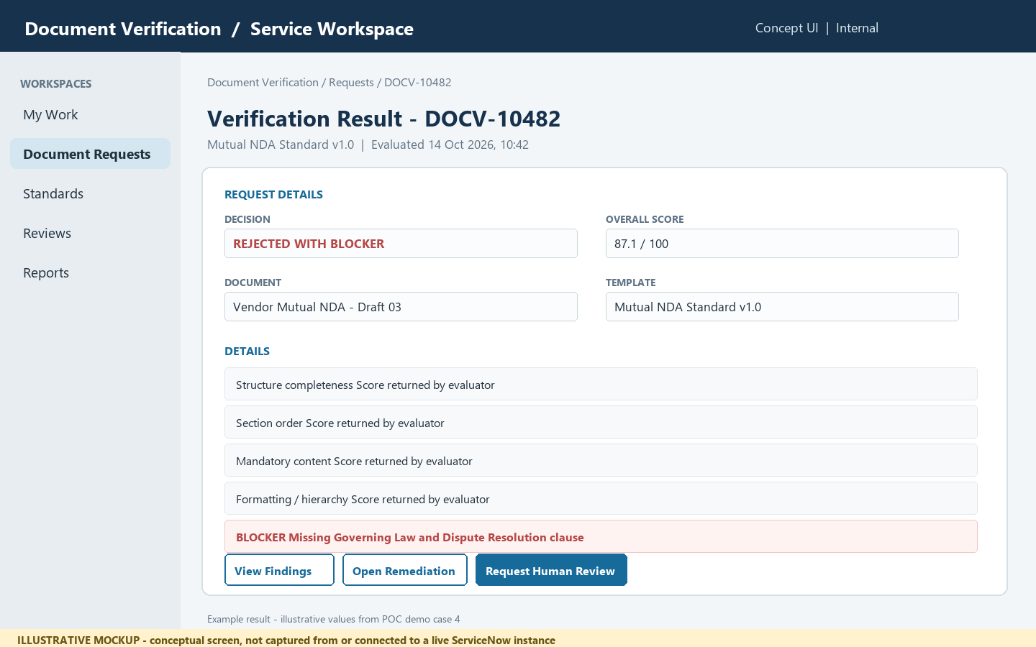
Conceptual mockup only; it is not a screenshot from a live ServiceNow tenant.

User and system flow
- After processing, open the request result from the request record or notification.
- Show accepted, needs human review, rejected, or rejected with blocker as separate, clear outcomes.
- Display the weighted overall score and the structure, sequence, content, and format dimensions.
- List matched, missing, unrecognized, or out-of-order sections and identify blocker rules separately.
- Provide a link to remediation guidance and show the template version and evaluation timestamp.

Proposed form fields / record data
Decision | Outcome, overall score, evaluated timestamp
Score breakdown | Structure, order, content, formatting dimensions and configured weights
Alignment | Expected section, detected heading, detected order, match status
Findings | Severity, rule, description, location, blocker indicator
Provenance | Submission, template/version, evaluator/build reference, correlation ID

Business, security, and behavior rules
- Make a blocker override explicit even where the numeric score is high.
- Treat score dimensions and decision bands as values returned by the evaluation service, not independently recomputed in a ServiceNow client script.
- Differentiate NEEDS_HUMAN_REVIEW from rejection; the repository uses NEEDS_HUMAN_REVIEW in its model, while some requirements call the state NEEDS_REVIEW.
- Expose document excerpts only to users with access to the original submission; minimize copied sensitive text in findings.

Acceptance criteria
- The result shows the decision, score, four score dimensions, and exact evaluated template version.
- A blocker finding is clearly visible and cannot be mistaken for a score-only failure.
- Every actionable finding includes a human-readable reason and an available next step.

Repository traceability
POC source: src/evaluators/scoring_engine.py, src/evaluators/lcs_order.py, src/evaluators/semantic_matcher.py, src/models/template_models.py, app.py.

Remediation and Human Review
Authors receive issue-specific steps to fix. Assigned reviewers can inspect the evaluation, record a reasoned override or disposition, and preserve the original automated outcome.

Users and ownership
Document Author (fix and resubmit); Compliance Reviewer (review / disposition); Audit user (read-only history).

Illustrative ServiceNow form screenshot
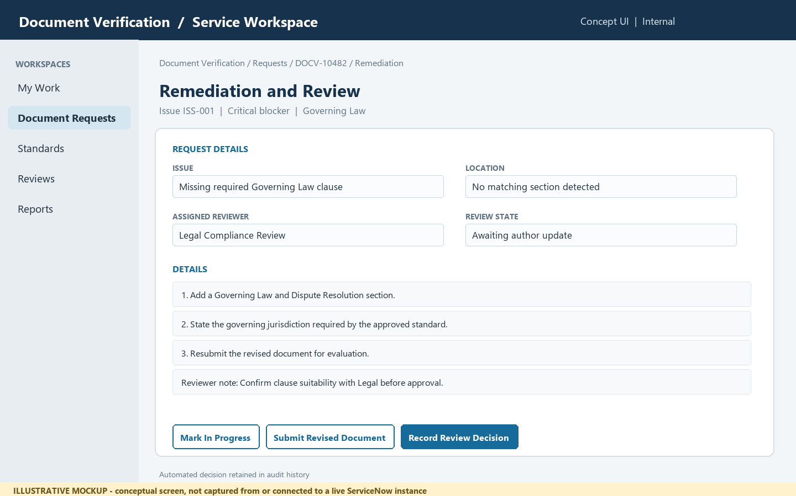
Conceptual mockup only; it is not a screenshot from a live ServiceNow tenant.

User and system flow
- Open the findings list and choose an issue; show severity, affected section, evidence location, and violated rule.
- Provide concise instructions such as moving a section to a canonical position or adding a missing clause.
- Allow the author to revise and submit a new version linked to the original request, if resubmission is enabled.
- Route borderline cases or disputes to an assigned reviewer with reason and supporting context.
- Record reviewer decision, rationale, actor, timestamp, and the unchanged original machine decision as an audit event.

Proposed form fields / record data
Issue | Issue ID, severity, type, affected section, description
Evidence | Page/paragraph/section reference and limited excerpt where permitted
Action | Ordered remediation steps, expected template reference
Review | Assignment group, reviewer, disposition, reason, decision timestamp
History | Original result, resubmissions, reviewer actions, related records

Business, security, and behavior rules
- Do not let a manual override erase or rewrite the automated result; store both as separate facts.
- Require reviewer rationale and role authorization for any disposition that changes downstream status.
- Remediation is guidance, not legal advice; owners must validate clause content for their organization.
- Restrict access to evidence and uploaded documents using the same or stronger ACLs as the parent request.

Acceptance criteria
- Each issue displays severity, location, explanation, and ordered steps to resolve it.
- A reviewer can record a permitted disposition with rationale and traceable identity/time.
- The original result remains available after review and after document resubmission.

Repository traceability
POC source: src/remediation/remediation_generator.py, src/models/template_models.py, docs/SRS.md (FR-REM / human-in-the-loop requirements). Reviewer workflow is a proposed ServiceNow capability.

Demo Scenarios, Reporting, and Audit
Standards owners and reviewers monitor request states and outcome trends. The POC's four NDA scenarios provide a practical acceptance-test baseline for a ServiceNow experience.

Users and ownership
Standards Officer (quality trends); Service Owner (operations); Compliance Auditor (traceability); Test operator (demo scenarios).

Illustrative ServiceNow form screenshot
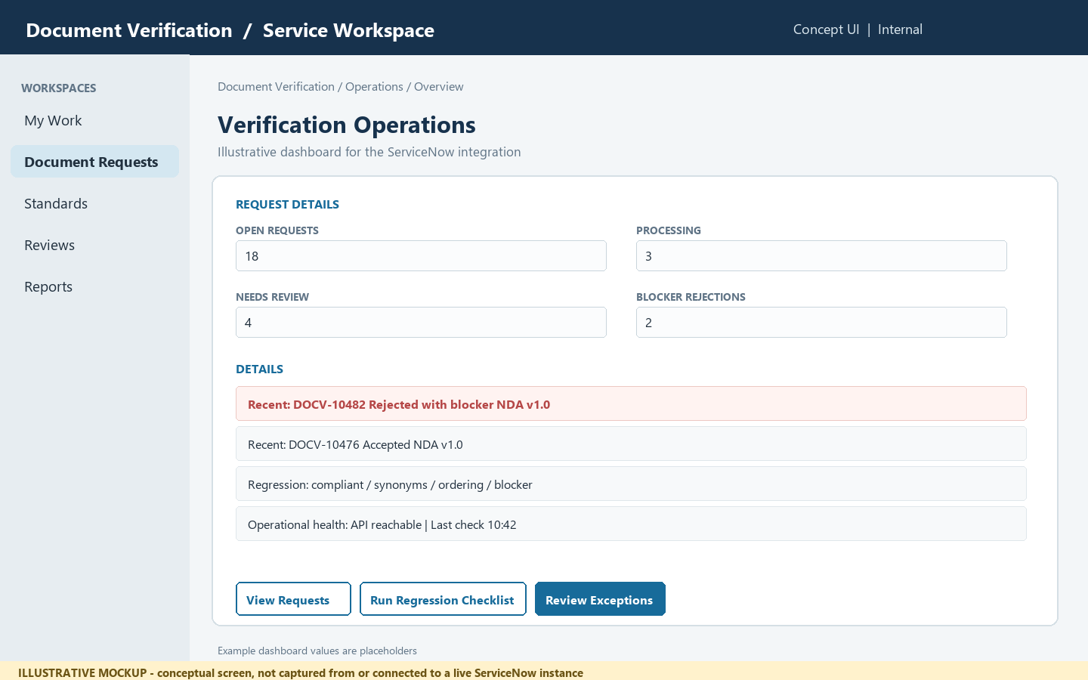
Conceptual mockup only; it is not a screenshot from a live ServiceNow tenant.

User and system flow
- View the operational dashboard for requests by state, outcome, and template version.
- Open an individual request to inspect its evaluation, findings, and review history.
- Use the four repository NDA examples as regression cases when validating an integration.
- Track failures and integration latency using correlation IDs, without putting document content in telemetry.
- Export only authorized, minimized data according to the organization's retention and audit policies.

Proposed form fields / record data
Operations | Submission count, queue state, processing failures, turnaround time
Quality | Decision distribution, score dimensions, blocker frequency
Trace | Request number, template version, timestamps, correlation ID
Regression cases | Compliant, synonyms, out-of-order, missing blocker
Audit | Access, policy changes, review actions, resubmission chain

Business, security, and behavior rules
- The existing POC demonstrates four NDA examples; reported scenario scores and decisions should be treated as sample test outputs, not production service levels.
- Avoid dashboards that reveal contract names, clause text, or document contents to users outside the request ACL.
- Define retention, deletion, audit ownership, and operational alerting before production rollout.

Acceptance criteria
- An authorized owner can filter request counts by state, outcome, and template version.
- The integration regression set exercises acceptance, synonym tolerance, order detection, and blocker override.
- Audit records identify who changed a standard or review disposition and when, without logging document payloads.

Repository traceability
POC source: demo_docs/, tests/test_pipeline.py, run_demo.py, README.md. Reporting/audit screens and ServiceNow analytics are proposed, not implemented in this repository.

5. POC regression and acceptance checklist
Use the existing four NDA examples as a baseline to verify the end-to-end integration. The values below are project-reported sample results, not production guarantees.
Scenario | Expected behavior | Repository-reported reference
Compliant NDA | Accepted | Reported 98.8%; all eight sections aligned in expected order.
Synonyms NDA | Accepted | Reported 98.2%; tests heading/phrasing tolerance.
Out-of-order NDA | Order issue detected | Reported overall 83.5% with order dimension 47.5%; verify exact current test output before release.
Missing blocker NDA | Rejected with blocker | Reported 87.1% with mandatory Governing Law blocker; blocker must override numeric score.

Release checks
- Test supported and unsupported file types, upload failures, API timeouts, duplicate callbacks, retry behavior, and correlation IDs.
- Verify ACLs for requests, attachments, results, findings, template administration, reviewer actions, and dashboards using representative roles.
- Verify the published template version is pinned to each evaluation and historical results remain interpretable after template updates.
- Verify a blocker overrides score, synonym phrases remain acceptable, order findings are actionable, and a reviewer action does not erase the original result.
- Validate retention/deletion, encryption, audit/event logging, and redaction of sensitive document payloads with the security/privacy owners.

6. Assumptions, decisions, and implementation notes
- No target ServiceNow instance, release, licensed plugins, authentication policy, or instance-specific form standards were supplied; all proposed platform elements require validation.
- The provided screenshots are generated conceptual mockups for user-reference and requirements discussion, not genuine ServiceNow screenshots.
- The current POC repository is the source for capabilities; the proposed ServiceNow experience and integration have not been implemented or tested against ServiceNow.
- Before build: agree integration ownership, API contract/schema versioning, attachment flow, request/table design, user roles/ACLs, retention, failure handling, and reviewer governance.

7. Source references
- README.md - POC feature summary and sample outcomes.
- docs/SRS.md - functional requirements for templates, upload/evaluation, scoring, remediation, security, and review.
- docs/MICROSOFT_FOUNDRY_SOLUTION_DESIGN.md - POC architecture and Microsoft Foundry design.
- app.py - current Streamlit interface; src/ - Python models, parser, evaluators, remediation, standards, and Foundry client.
- demo_docs/ and tests/ - example NDA cases and regression coverage.

