ServiceNow Document Verification
Question-order test variant
  - Prepared from the Document Standardization POC workspace | Version 1.1 | 14 October 2026
IMPORTANT: This single guide consolidates the feature descriptions, requirements, and form images. It describes a proposed ServiceNow experience, not an existing implementation. Images are illustrative mockups, not screenshots captured from a live ServiceNow instance.

ORDER-TEST VARIANT: The original Question 2 and its answer appear before the original Question 1 and its answer. This is intentional for sequence-validation testing.

Question 2: Is this already running in ServiceNow?
Answer: No. The workspace contains a Streamlit/Python document-standardization proof of concept with optional Microsoft Foundry/Azure configuration. It does not contain a ServiceNow application, instance-specific forms, tables, flows, REST endpoints, ACL configuration, or genuine ServiceNow screenshots. The ServiceNow experience below is a proposal.

Question 1: What is this document for?
Answer: This is one consolidated, user-facing ServiceNow reference. It presents common user questions followed immediately by the relevant answer, feature requirements, and form images. All five feature areas are embedded as content in this DOCX; no separate document is required to understand the design.

Question: What can users do with the proposed experience?
Answer: Standards Officers configure document rules; Authors submit files; the verification service evaluates structure, order, content, and formatting; and users receive a decision with remediation. Reviewers can handle borderline or disputed cases while preserving the original automated result.

Question: What file types does the POC describe?
Answer: DOCX, PDF, Markdown (.md), and TXT are described as supported input formats. Confirm the behavior and size limits in the target deployment before configuring production upload validation.

Question: What is the proposed end-to-end flow?
Answer: A Standards Officer publishes a versioned standard. An Author submits a document through ServiceNow. ServiceNow securely sends it to the verification service, tracks processing, and displays the completed result. A reviewer can be assigned where needed, and the audit trail links the template version, result, review, and any resubmission.

Question: Which system owns which responsibilities?
Answer:
ServiceNow | Request lifecycle, role-aware forms, assignment, notifications, access controls, reviewer workflow, audit presentation, and operational reporting.
Verification service | Parsing, section alignment, synonym/semantic matching, order analysis, rule evaluation, scoring, blocker override, and remediation generation.
Integration | Authenticated HTTPS API. Decide whether requests are synchronous or asynchronous; define attachment transfer, callback/polling, retries, and correlation IDs.
Security decisions | Confirm service identity, credential rotation, attachment protection, encryption, access groups, retention/deletion, and payload redaction with platform/security owners.

Question: Which third-party services are relevant to this proposed integration?
Answer: The project architecture describes optional Microsoft Azure services: Azure AI Document Intelligence for document-layout extraction, Azure OpenAI for embeddings and optional language-model evaluation, and Microsoft Foundry for a proposed agent-orchestration design. These are external services, not ServiceNow features included automatically. The current POC's evaluation path runs in Python and does not invoke a deployed Foundry workflow. Confirm the selected services, tenant boundaries, regions, licensing, and security approvals before implementation.

Question: How could ServiceNow connect to those third-party services?
Answer: Use an approved, authenticated integration pattern such as an HTTPS REST API; ServiceNow IntegrationHub capabilities or spokes may be options where licensed and supported. A MID Server may be relevant when connectivity to private or on-premises systems is required. The exact connector, authentication method, network route, retry behavior, payload limits, and supported release must be validated with the ServiceNow platform owner. Do not assume a named third-party connector is available out of the box.

Question: What types of ServiceNow records are proposed?
Answer: The following are logical placeholders, not existing or prescribed ServiceNow table names: Document Category, Document Standard, Verification Request, Evaluation Result, Finding/Remediation, and Review/Audit Event. Confirm scope, licensing, table design, and ACL strategy before implementation.

Feature questions and answers

Question: How do I use this feature guide?
Answer: Each feature section states what the feature does, who uses it, and its workflow, fields, rules, and acceptance criteria. The relevant form mockup appears beside the questions for that feature. Feature material from the earlier specifications is consolidated here.

Feature 01: Standards and Template Administration

Question: What does this feature do?
Answer: Standards Officers create and maintain document categories and versioned templates, including canonical sections, aliases, requirements, content rules, scoring weights, pass thresholds, and blocker clauses.

Question: Who uses or owns this feature?
Answer: Standards Officer (owner); Platform Administrator (configuration support); Reviewer (read-only).

Question: What would the ServiceNow form look like?
Answer: The following embedded image is a conceptual user-reference mockup for the proposed form.
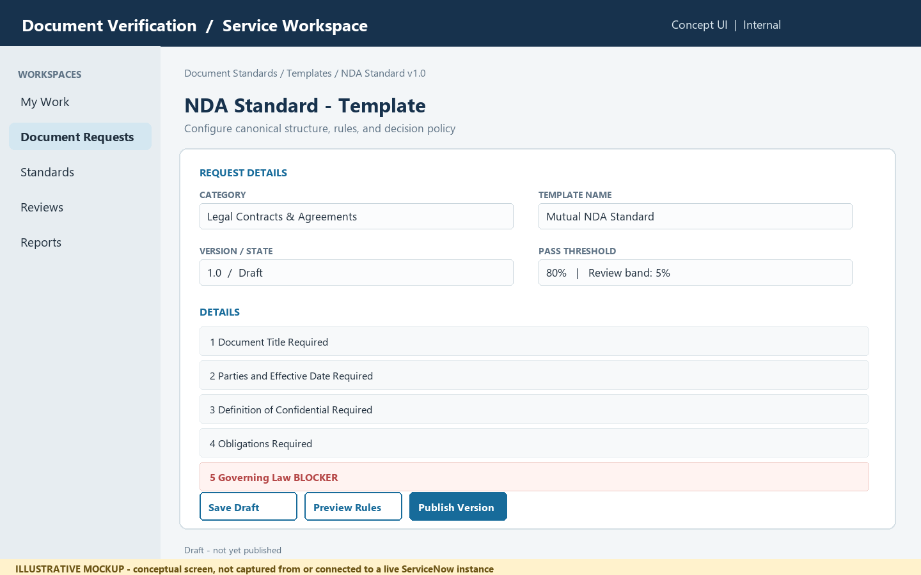
Illustrative mockup only; not a screen capture from a live ServiceNow tenant.

Question: What steps does the user or system follow?
Answer:
- Open the standards workspace and select a category or create one (for example, Legal Contracts & Agreements).
- Create a template version and add ordered sections with canonical title, accepted aliases, requirement level, and ordering strictness.
- Define mandatory keywords, optional regular expressions, semantic intent, and blocker status for each applicable section.
- Set scoring weights and acceptance/review thresholds. Validate that weights total 100% before publishing.
- Preview and publish the version. Preserve prior versions for audit and reproducibility; do not silently change rules for evaluations already completed.

Question: What information should the form or record contain?
Answer:
Category | Name, description, active/inactive status
Template identity | Name, version, owner, effective date, lifecycle state
Section definition | Canonical title, order, aliases, requirement level, strict/flexible ordering
Content rules | Required phrases, regex, semantic intent, blocker flag
Decision policy | Structure/order/content/format weights, pass score, review band

Question: What rules and safeguards apply?
Answer:
- Use draft/published/retired lifecycle states and require an explicit publish action.
- Validate non-negative weights with a total of 100%; show the computed decision bands before publishing.
- Require a reason and user identity for policy changes; retain template version on every submission result.
- A blocker is a hard decision override and must be visually distinguished from ordinary score deductions.

Question: How do we know this feature works?
Answer:
- An authorized Standards Officer can create and publish a category template with ordered sections and aliases.
- Invalid weight totals or missing required fields prevent publishing and identify the fields to fix.
- A previously published version remains available for viewing and for interpreting historical submissions.

Question: Where does this feature come from in the current project?
Answer: POC source: src/models/template_models.py, src/standards/standards_repository.py, app.py (Admin Create / View Standard).

Feature 02: Document Submission and Ingestion

Question: What does this feature do?
Answer: Document Authors submit a file or text for verification, select the applicable standard, review privacy/retention notices, and receive a tracked submission record.

Question: Who uses or owns this feature?
Answer: Document Author (submitter); Service Desk / Platform Support (operational support); Standards Officer (policy owner).

Question: What would the ServiceNow form look like?
Answer: The following embedded image is a conceptual user-reference mockup for the proposed form.
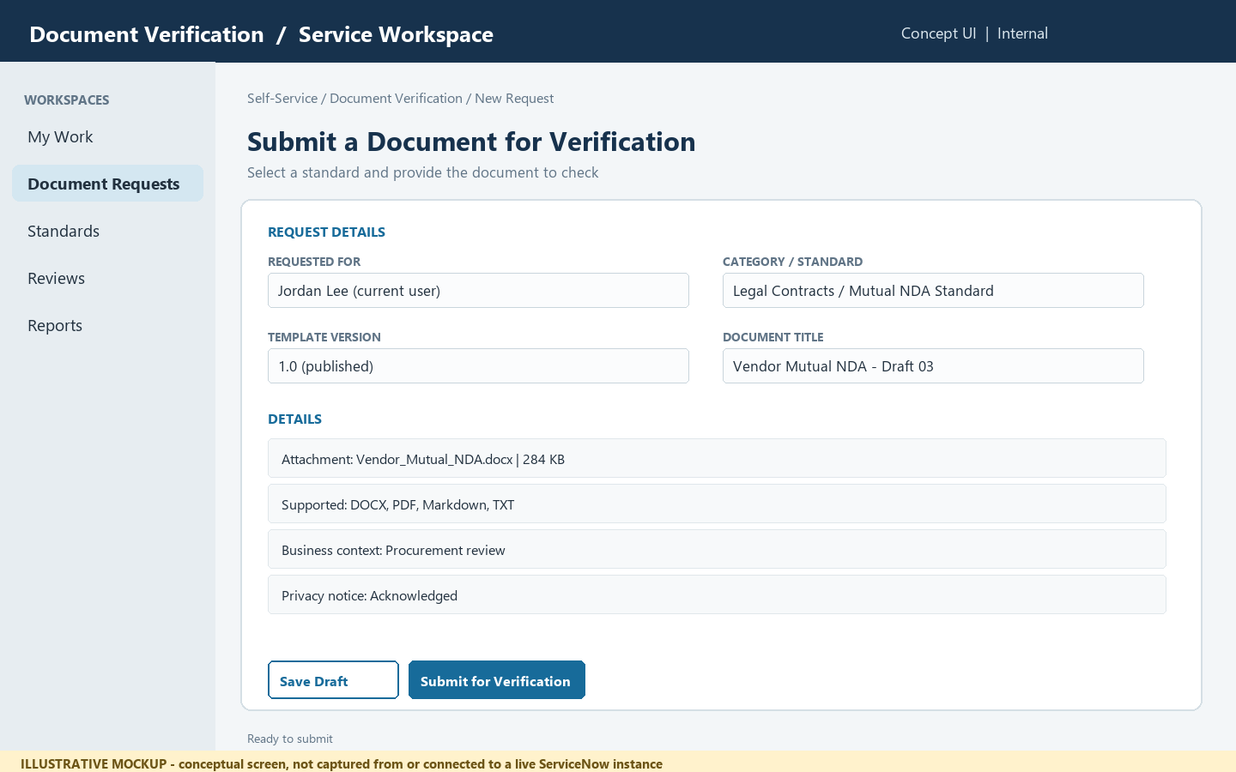
Illustrative mockup only; not a screen capture from a live ServiceNow tenant.

Question: What steps does the user or system follow?
Answer:
- Start a new verification request from a ServiceNow catalog item or workspace form.
- Choose the document category and active template version, or allow the service to select the current published version.
- Attach a supported file (.docx, .pdf, .md, .txt) or enter/paste text where enabled; capture title and business context.
- Confirm permitted use and retention information, then submit. Display a request number and processing state.
- Validate file type, size, and required metadata before sending content to the verification service.

Question: What information should the form or record contain?
Answer:
Request | Number, submitter, created date, state, business purpose
Standard selection | Category, selected template, pinned version
Document | Attachment or text input, file type, size, checksum/reference
Privacy | Notice acknowledgement, retention class, access group
Processing | Queued / processing / complete / failed, correlation ID

Question: What rules and safeguards apply?
Answer:
- The current POC parser supports .docx, .pdf, .md, and .txt; confirm actual deployment size limits before configuring upload validation.
- Do not place document text or secrets in general ServiceNow journal fields or broad-access logs.
- Use least-privilege attachment ACLs; determine whether documents are stored in ServiceNow or transferred to a protected backend.
- For asynchronous processing, acknowledge immediately and update the request record when evaluation completes.

Question: How do we know this feature works?
Answer:
- A submitter can select a standard and attach a supported document with a visible request identifier.
- Unsupported file types and missing required fields produce actionable validation messages.
- Only authorized users can open the request and its attachment; submission state progresses visibly.

Question: Where does this feature come from in the current project?
Answer: POC source: app.py (Upload & Verify tab), src/parsers/doc_parser.py, src/foundry/foundry_client.py. ServiceNow submission is a proposed integration, not present in this repository.

Feature 03: Compliance Evaluation and Results

Question: What does this feature do?
Answer: The evaluation view presents an overall decision, score dimensions, matched/missing sections, ordering issues, content findings, and the exact template version used.

Question: Who uses or owns this feature?
Answer: Document Author (own result); Reviewer (assigned cases); Standards Officer (policy insight); Integration Service (writes evaluation result).

Question: What would the ServiceNow form look like?
Answer: The following embedded image is a conceptual user-reference mockup for the proposed form.
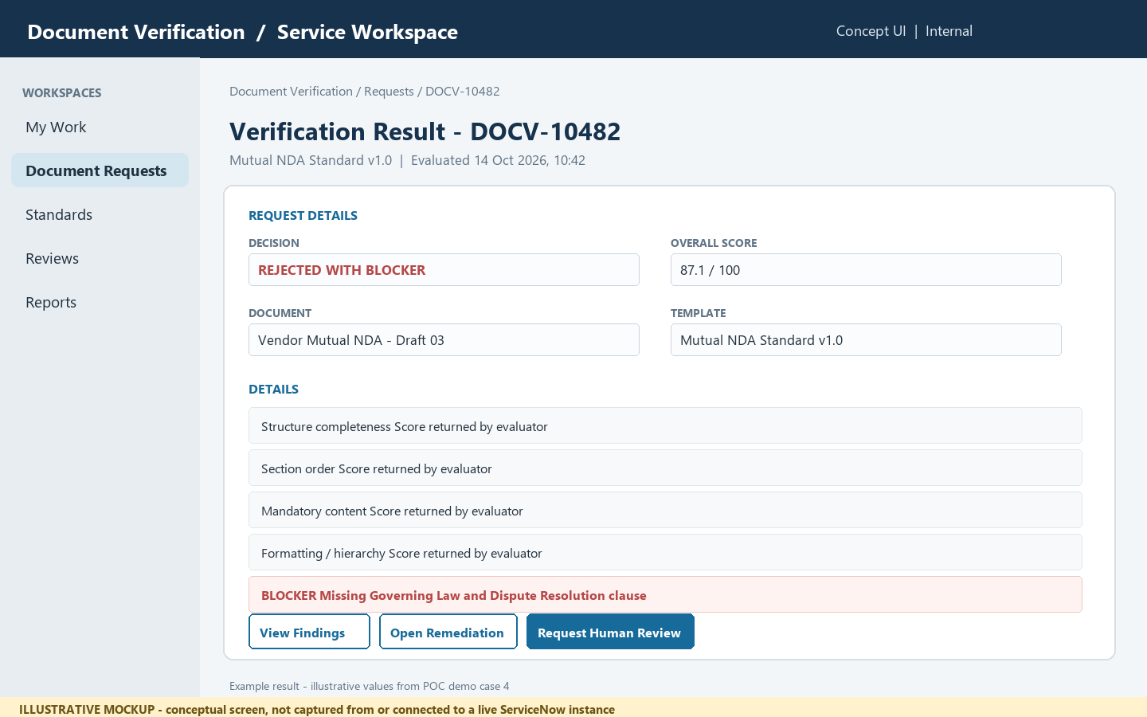
Illustrative mockup only; not a screen capture from a live ServiceNow tenant.

Question: What steps does the user or system follow?
Answer:
- After processing, open the request result from the request record or notification.
- Show accepted, needs human review, rejected, or rejected with blocker as separate, clear outcomes.
- Display the weighted overall score and the structure, sequence, content, and format dimensions.
- List matched, missing, unrecognized, or out-of-order sections and identify blocker rules separately.
- Provide a link to remediation guidance and show the template version and evaluation timestamp.

Question: What information should the form or record contain?
Answer:
Decision | Outcome, overall score, evaluated timestamp
Score breakdown | Structure, order, content, formatting dimensions and configured weights
Alignment | Expected section, detected heading, detected order, match status
Findings | Severity, rule, description, location, blocker indicator
Provenance | Submission, template/version, evaluator/build reference, correlation ID

Question: What rules and safeguards apply?
Answer:
- Make a blocker override explicit even where the numeric score is high.
- Treat score dimensions and decision bands as values returned by the evaluation service, not independently recomputed in a ServiceNow client script.
- Differentiate NEEDS_HUMAN_REVIEW from rejection; the repository uses NEEDS_HUMAN_REVIEW in its model, while some requirements call the state NEEDS_REVIEW.
- Expose document excerpts only to users with access to the original submission; minimize copied sensitive text in findings.

Question: How do we know this feature works?
Answer:
- The result shows the decision, score, four score dimensions, and exact evaluated template version.
- A blocker finding is clearly visible and cannot be mistaken for a score-only failure.
- Every actionable finding includes a human-readable reason and an available next step.

Question: Where does this feature come from in the current project?
Answer: POC source: src/evaluators/scoring_engine.py, src/evaluators/lcs_order.py, src/evaluators/semantic_matcher.py, src/models/template_models.py, app.py.

Feature 04: Remediation and Human Review

Question: What does this feature do?
Answer: Authors receive issue-specific steps to fix. Assigned reviewers can inspect the evaluation, record a reasoned override or disposition, and preserve the original automated outcome.

Question: Who uses or owns this feature?
Answer: Document Author (fix and resubmit); Compliance Reviewer (review / disposition); Audit user (read-only history).

Question: What would the ServiceNow form look like?
Answer: The following embedded image is a conceptual user-reference mockup for the proposed form.
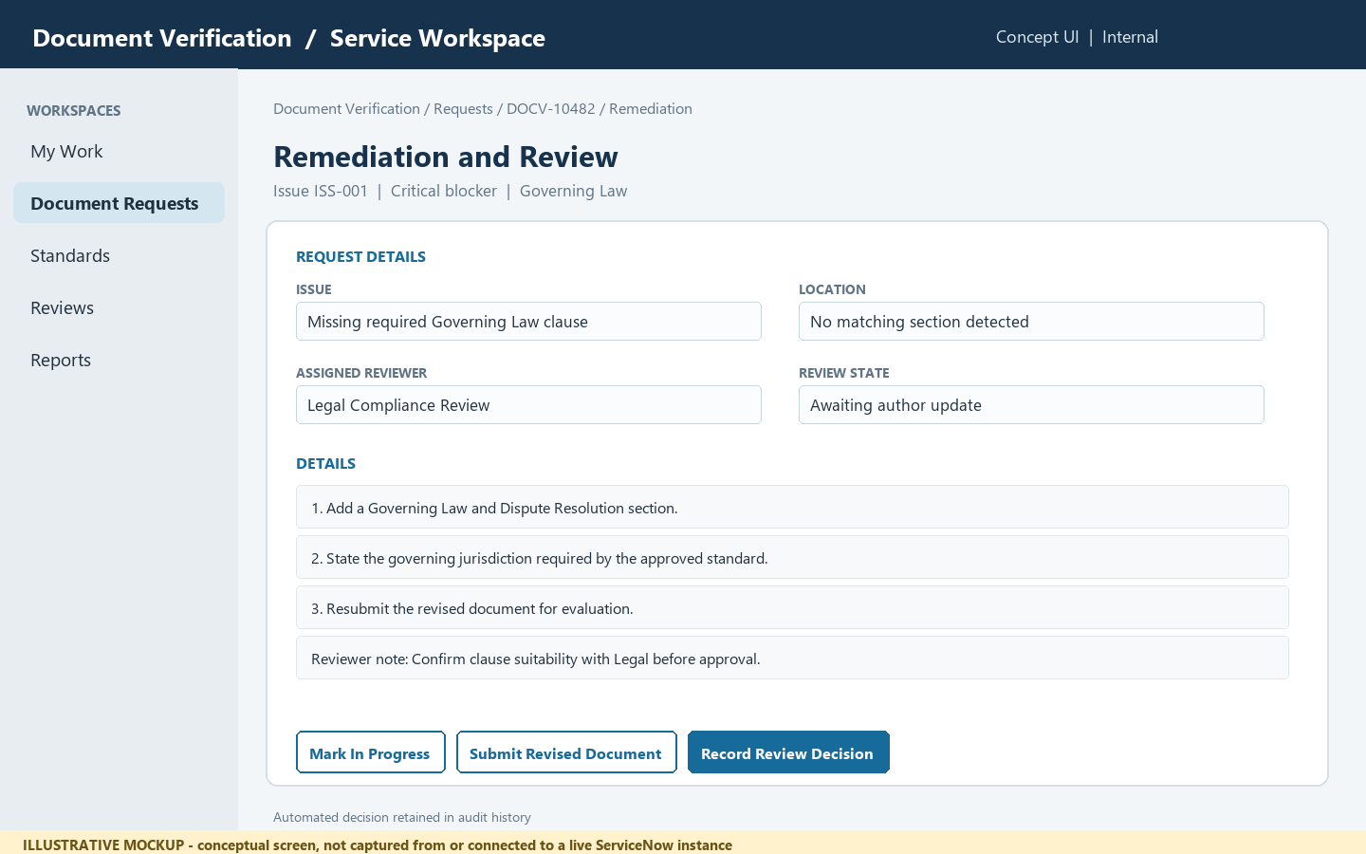
Illustrative mockup only; not a screen capture from a live ServiceNow tenant.

Question: What steps does the user or system follow?
Answer:
- Open the findings list and choose an issue; show severity, affected section, evidence location, and violated rule.
- Provide concise instructions such as moving a section to a canonical position or adding a missing clause.
- Allow the author to revise and submit a new version linked to the original request, if resubmission is enabled.
- Route borderline cases or disputes to an assigned reviewer with reason and supporting context.
- Record reviewer decision, rationale, actor, timestamp, and the unchanged original machine decision as an audit event.

Question: What information should the form or record contain?
Answer:
Issue | Issue ID, severity, type, affected section, description
Evidence | Page/paragraph/section reference and limited excerpt where permitted
Action | Ordered remediation steps, expected template reference
Review | Assignment group, reviewer, disposition, reason, decision timestamp
History | Original result, resubmissions, reviewer actions, related records

Question: What rules and safeguards apply?
Answer:
- Do not let a manual override erase or rewrite the automated result; store both as separate facts.
- Require reviewer rationale and role authorization for any disposition that changes downstream status.
- Remediation is guidance, not legal advice; owners must validate clause content for their organization.
- Restrict access to evidence and uploaded documents using the same or stronger ACLs as the parent request.

Question: How do we know this feature works?
Answer:
- Each issue displays severity, location, explanation, and ordered steps to resolve it.
- A reviewer can record a permitted disposition with rationale and traceable identity/time.
- The original result remains available after review and after document resubmission.

Question: Where does this feature come from in the current project?
Answer: POC source: src/remediation/remediation_generator.py, src/models/template_models.py, docs/SRS.md (FR-REM / human-in-the-loop requirements). Reviewer workflow is a proposed ServiceNow capability.

Feature 05: Demo Scenarios, Reporting, and Audit

Question: What does this feature do?
Answer: Standards owners and reviewers monitor request states and outcome trends. The POC's four NDA scenarios provide a practical acceptance-test baseline for a ServiceNow experience.

Question: Who uses or owns this feature?
Answer: Standards Officer (quality trends); Service Owner (operations); Compliance Auditor (traceability); Test operator (demo scenarios).

Question: What would the ServiceNow form look like?
Answer: The following embedded image is a conceptual user-reference mockup for the proposed form.
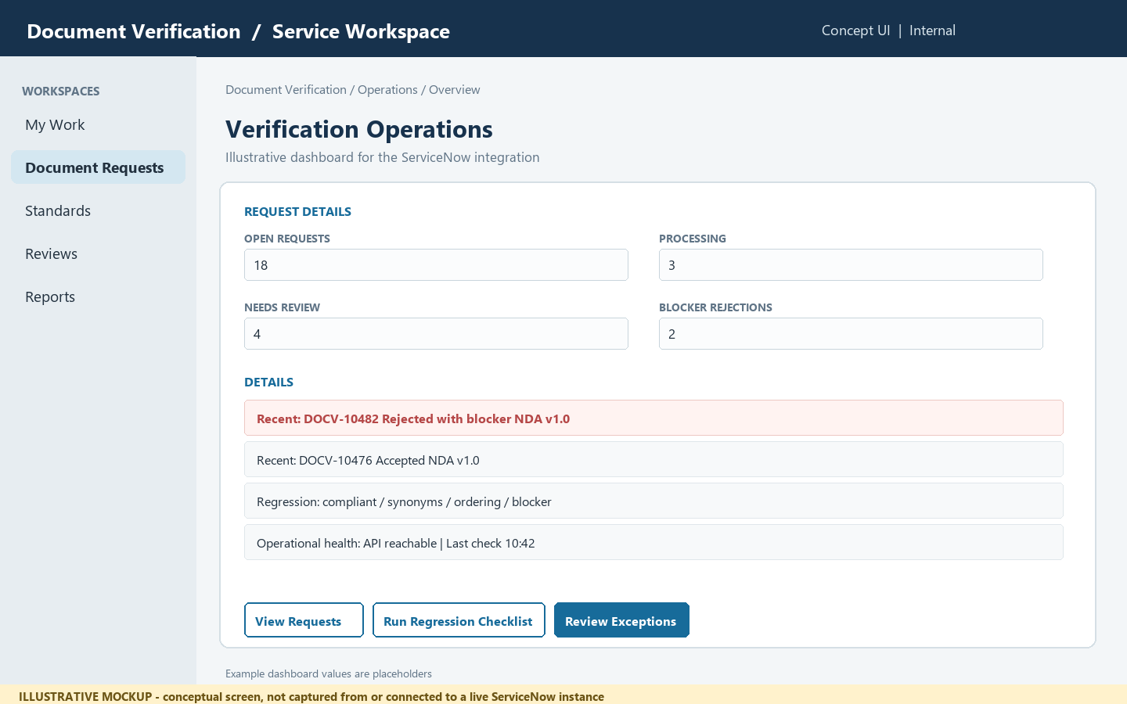
Illustrative mockup only; not a screen capture from a live ServiceNow tenant.

Question: What steps does the user or system follow?
Answer:
- View the operational dashboard for requests by state, outcome, and template version.
- Open an individual request to inspect its evaluation, findings, and review history.
- Use the four repository NDA examples as regression cases when validating an integration.
- Track failures and integration latency using correlation IDs, without putting document content in telemetry.
- Export only authorized, minimized data according to the organization's retention and audit policies.

Question: What information should the form or record contain?
Answer:
Operations | Submission count, queue state, processing failures, turnaround time
Quality | Decision distribution, score dimensions, blocker frequency
Trace | Request number, template version, timestamps, correlation ID
Regression cases | Compliant, synonyms, out-of-order, missing blocker
Audit | Access, policy changes, review actions, resubmission chain

Question: What rules and safeguards apply?
Answer:
- The existing POC demonstrates four NDA examples; reported scenario scores and decisions should be treated as sample test outputs, not production service levels.
- Avoid dashboards that reveal contract names, clause text, or document contents to users outside the request ACL.
- Define retention, deletion, audit ownership, and operational alerting before production rollout.

Question: How do we know this feature works?
Answer:
- An authorized owner can filter request counts by state, outcome, and template version.
- The integration regression set exercises acceptance, synonym tolerance, order detection, and blocker override.
- Audit records identify who changed a standard or review disposition and when, without logging document payloads.

Question: Where does this feature come from in the current project?
Answer: POC source: demo_docs/, tests/test_pipeline.py, run_demo.py, README.md. Reporting/audit screens and ServiceNow analytics are proposed, not implemented in this repository.

Common questions and validation

Question: What outcomes can a user receive?
Answer: The POC distinguishes accepted, human-review, and rejected outcomes, including rejected-with-blocker. The result must show the evaluator's outcome and score dimensions. A critical blocker must remain visible and override a high numeric score. Confirm the final state labels against the implementation model and the desired ServiceNow choice values.

Question: What should happen when a blocker is found?
Answer: Show a distinct critical blocker finding, explain the missing or violated rule, and provide the remediation steps. A blocker is not merely a score deduction. Reviewer handling must not erase the original automated outcome.

Question: Which demo cases should be tested before release?
Answer: Use the repository's four NDA examples as an integration regression baseline. Reported figures below are sample POC outputs, not production guarantees.

Question: What behavior is expected for each demo case?
Answer:
Compliant NDA | Accepted; repository reports 98.8% and all eight sections in expected order.
Synonyms NDA | Accepted; repository reports 98.2%, demonstrating heading/phrasing tolerance.
Out-of-order NDA | Order issue detected; README reports overall 83.5% and order 47.5%. Verify current test output before release.
Missing blocker NDA | Rejected with blocker; README reports 87.1% and missing mandatory Governing Law. Blocker must override the score.

Question: What should the implementation team verify?
Answer:
- Supported/unsupported file types, upload errors, timeouts, duplicate callbacks, retries, and correlation IDs.
- Access to requests, attachments, results, findings, administration, review actions, and dashboards for representative user roles.
- Template version pinning and historical result interpretation after a standard changes.
- Blocker override, synonym tolerance, actionable order findings, and preservation of the machine result after reviewer action.
- Retention/deletion, encryption, audit logging, and removal of sensitive document text from general telemetry.

Question: Are these screenshots genuine ServiceNow pages?
Answer: No. They are generated visual mockups to help users understand the proposed forms. To document genuine pages, capture them from an authorized target ServiceNow instance and replace the mockups after confirming that the screenshots contain no sensitive data.

Question: What must be decided before implementation?
Answer: Confirm the target ServiceNow release and licensed capabilities, request and table design, API contract, authentication, attachment flow, asynchronous processing behavior, user roles/ACLs, retention, failure handling, and reviewer governance. Validate all proposed platform choices with the ServiceNow owner.

Question: Which project sources support this reference?
Answer: README.md and docs/SRS.md describe capabilities and sample scenarios; docs/MICROSOFT_FOUNDRY_SOLUTION_DESIGN.md describes the proposed Azure/Foundry architecture; app.py and src/ contain the current interface and Python implementation; demo_docs/ and tests/ contain sample documents and regression cases.

Embedded reference brief: Third-Party Service Integration
This in-document reference brief is included so the Q&A can be read and shared as one self-contained DOCX. The entries below describe the project's proposed external-service options, not a claim that every service is natively supported or bundled by ServiceNow.
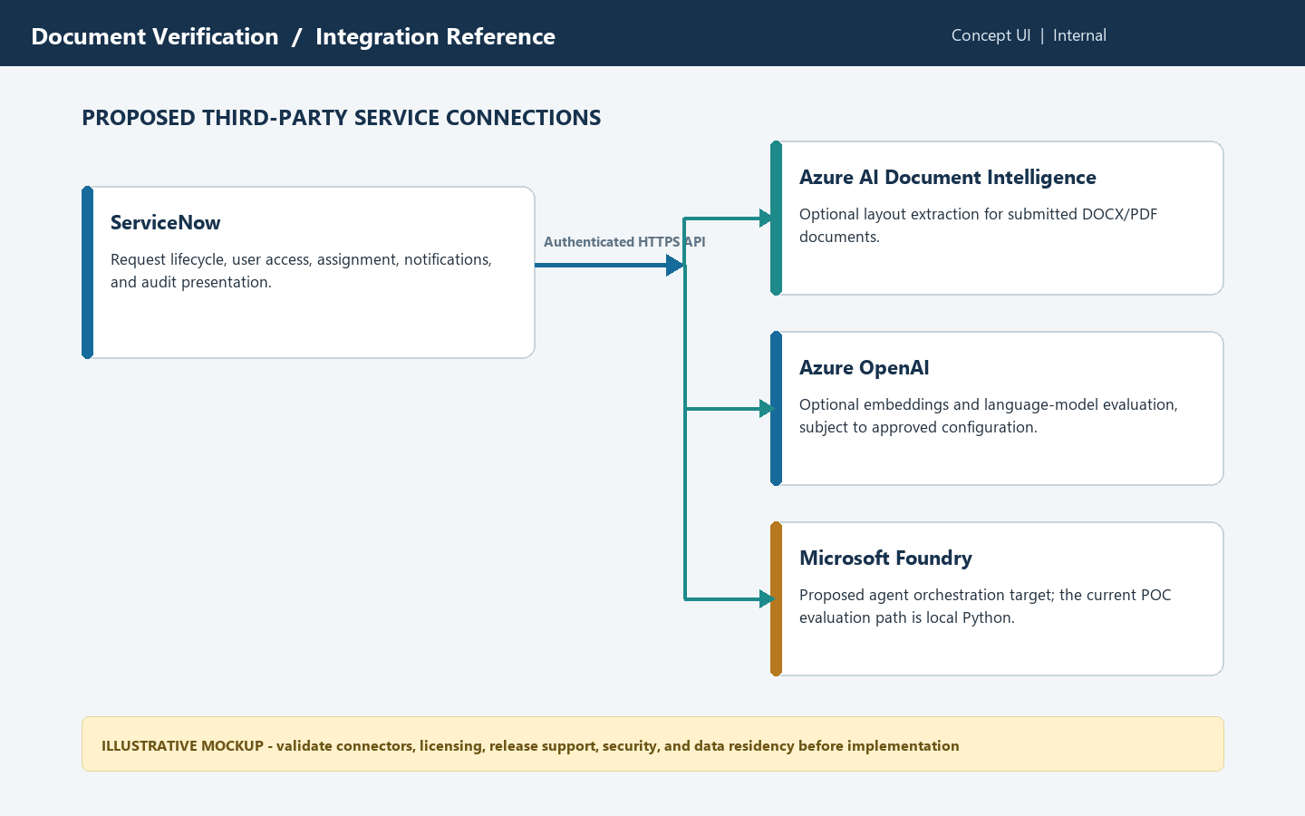
Illustrative integration concept only; not a live ServiceNow or Azure screenshot.
Azure AI Document Intelligence | Optional document-layout extraction service described in the Foundry solution design; validate file formats, region, network access, and data handling.
Azure OpenAI | Optional embedding and language-model service described for semantic comparison/evaluation; validate deployment availability, model choice, data boundary, and responsible-use controls.
Microsoft Foundry | Proposed agent-orchestration target in the solution design; the currently implemented POC validation flow does not call a deployed agent workflow.
ServiceNow connection | A proposed authenticated HTTPS integration. IntegrationHub, spokes, or MID Server may be considered according to requirements, licensing, and the target ServiceNow release.

