ServiceNow questions and answers
Now Platform, ITSM, scripting, CMDB, access control, update sets, and workspaces.
These notes answer the platform questions: how the processes fit together, where logic should live, how access control is decided, and how a change moves between instances. Questions about products outside ServiceNow are in a second document. That document is embedded at the end of this file, and the same file is saved beside this one as ServiceNow-Third-Party-Services-QA.docx.
Sections in this document:
- Platform
- ITSM processes
- Server and client logic
- CMDB
- Security and moving changes
- Automation and the agent UI
- Third-party services (embedded document)

Platform

What is the Now Platform?
The Now Platform is ServiceNow's cloud platform for building and running workflows. Applications such as ITSM, ITOM, HRSD, CSM, and Security Operations sit on one database and one security model. Tables, fields, forms, lists, access rules, notifications, and flows are metadata. Most changes are configuration, stored as data, rather than a separate code deploy. A custom application uses the same tables, forms, and access checks as the applications ServiceNow ships.

What is an instance, and how do releases reach it?
An instance is one ServiceNow environment, reached at its own hostname, such as company.service-now.com. Production and non-production are separate instances. ServiceNow applies patches, and about twice a year it offers a named family upgrade. You do not install the platform on your own servers. The process that does run inside your network is an agent such as the MID Server. Rehearse the upgrade on a non-production instance, including cloned data, before you upgrade production.

ITSM processes

How do Incident, Problem, Change, and Request differ?
An incident is an unplanned interruption, or a drop in the quality of a service. The goal is to restore the service. A problem is the cause of one or more incidents. Problem management finds that cause, records a known error, and proposes a permanent fix. A change is an addition, modification, or removal that could affect a service, and change management controls the risk. A request is a user asking for something from the catalog. The request record holds one or more requested items, and catalog tasks do the fulfillment. A password reset is a request. A password reset that is failing for every user is an incident.

How does ServiceNow set incident priority?
Priority is calculated from impact and urgency. Impact is how much of the business is hurt. Urgency is how soon the business needs a restore. Data lookup rules on the incident table map each pair to a priority, from 1 - Critical through 5 - Planning. While those rules are active, a priority someone types by hand is replaced the next time impact or urgency is saved. Change the lookup table when the business wants a different matrix. Do not hide that behavior with a client script that fights the lookup.
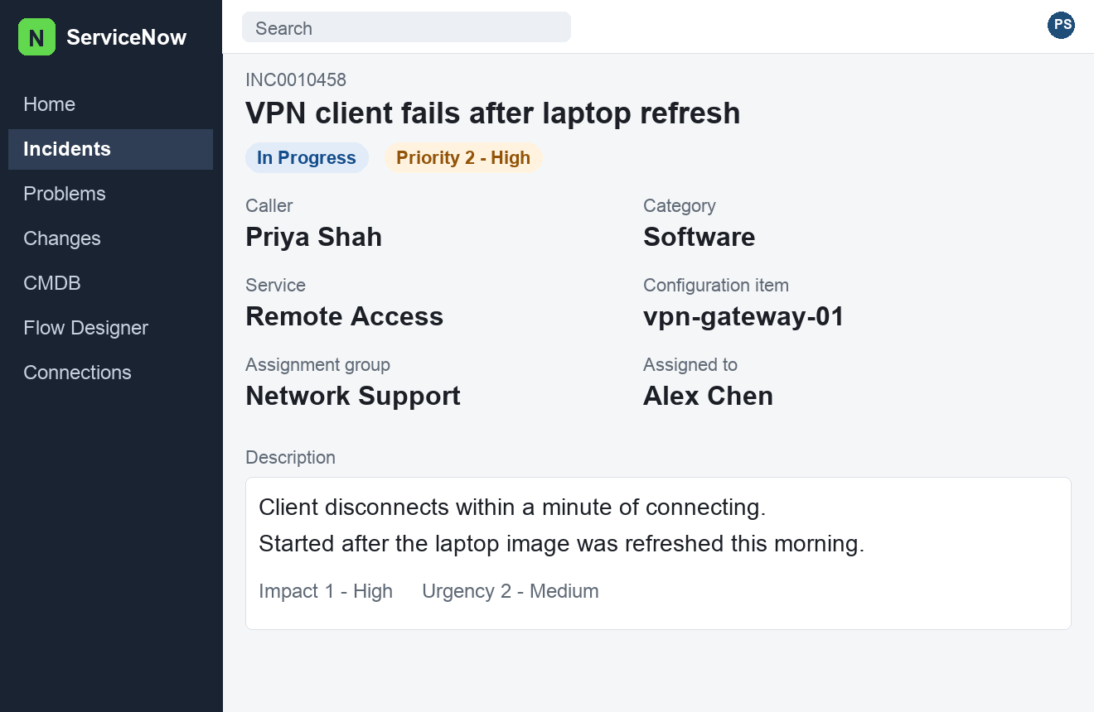
Figure 1. Study layout of an incident in Next Experience. Priority is shown as the result of impact and urgency. Not a capture from a live instance.

What starts, pauses, and stops an SLA?
An SLA definition names the table, the duration, the schedule, and the conditions that start, pause, and stop the clock. When a task matches the start condition, ServiceNow attaches a task SLA record. On the default incident SLAs, the clock pauses while the state is On Hold, because the team is waiting on the caller or a vendor. The clock stops when the incident reaches the stop condition, often Resolved or Canceled. Response and resolution are separate definitions, so a ticket can meet the response target and still breach resolution. A schedule removes hours that fall outside the working calendar.

Server and client logic

What are the business rule types, and when does each run?
A business rule is server-side JavaScript on a table. A before rule runs before the database write. It can change the record, or cancel the save with current.setAbortAction(true). An after rule runs after the write. Use it to create or update related records. Writing to current again inside an after rule does not reliably save a second time. An async rule runs after the user's transaction, so the form is not held open for slow work such as a call to another system. A display rule runs when a form loads and can pass values to the browser on g_scratchpad. The When filter is insert, update, delete, or query. A query rule adds conditions before the read, which limits the rows a list returns.

When do you pick a UI policy, a data policy, or a client script?
Use a UI policy when a form field should be mandatory, read-only, or hidden because of other values on the form. The rule is declarative, and it runs in the browser. Use a data policy when that mandatory or read-only rule must also hold for import sets, web services, and other server writes. A UI policy does not run on those paths. Use a client script when the form needs something a policy cannot express: a server call, a confirmation, or a check on submit. If a client script and a UI policy both control the same field, they overwrite each other. Keep the policy, and delete the script.

What is a Script Include, and how does a form call it?
A Script Include is a reusable server-side class. Other server scripts call it with new and a method. A form cannot call that class directly, because a client script runs in the browser and has no GlideRecord. Mark the Script Include client callable so it extends AbstractAjaxProcessor. The client builds a GlideAjax object, sets sysparm_name to the method, and reads the string that method returns. Keep queries and credentials inside the server method. Return only the fields the form is allowed to see.

CMDB

What does the CMDB store, and how does identification stop duplicates?
The configuration management database stores configuration items and the relationships between them. A server, an application, or a service is a row in cmdb_ci or a child class. A relationship is a row in cmdb_rel_ci. Discovery, Service Graph Connectors, and imports all write those same tables. The Identification and Reconciliation Engine matches an incoming payload to an existing item using the identifier rules for that class, such as a serial number, or a name unique inside a domain. A match updates that item. No match inserts one. Reconciliation rules then decide which source may overwrite each attribute, so two discovery tools do not take turns clearing the same field.

What is CSDM for?
CSDM, the Common Service Data Model, is the map of which CMDB tables to use and how services, applications, and infrastructure should connect. It is a model, not one plugin with an on switch. The domains in that model are Foundation, Design, Build, Manage Technical Services, and Sell / Consume. Teams usually fill them in that order: people, groups, and locations; then business applications; then application services and the infrastructure under them; then business services, offerings, and the catalog. Incident routing, service mapping, and reporting all assume those links exist. Loading every service into one generic class makes that reporting a cleanup project later.

Security and moving changes

How does an ACL decide whether a user can read or write a field?
An access control list rule grants one operation, such as read or write, on a table or on a field. The rule can require a role, a condition, and a script. Every check that is filled in must pass. An empty check passes. The user must pass a field rule and the table rule. Both levels are required. When several rules match at the same level, passing any one of them is enough. A rule on the exact field is considered before a wildcard. The admin role skips a rule only when Admin overrides is checked on that rule, which is the default. Read, write, and create are separate rules. Passing read does not pass write.

What does an update set capture, and how do you move it safely?
An update set records configuration: forms, dictionary changes, business rules, client scripts, flows, notifications, and access rules. It does not record ordinary rows such as incidents or users, unless you deliberately unload one row into the set. Build in a non-production instance, mark the set Complete, and retrieve it on the next instance. Always preview before commit. The preview lists collisions with a local change and records the set depends on that are missing. Fix those, then commit. Back out exists, and it is a poor replacement for reading the preview. For a scoped app, the application repository or source control moves the app with less manual merging than a long chain of update sets.

Why put new work in an application scope?
A scope draws a line around one application's tables, scripts, and modules. Global is the shared scope used by the older platform. A private scope, whose name starts with x_ plus your company prefix, keeps a new table or script from colliding with another application or with an upgrade. A different scope cannot call your script or read your table until you allow that cross-scope privilege. Put a new application in its own scope. Stay in global only when you are changing something that already lives there and a scoped extension cannot reach it.

Automation and the agent UI

When do you use Flow Designer instead of the legacy workflow editor?
Build new automation in Flow Designer. A flow has a trigger, then actions, and it can call a subflow. Integration Hub spokes are actions in that same canvas, which is how a flow reaches another product without a custom protocol. The legacy workflow editor still runs workflows that are already in production. Leave a stable workflow there. Do not add new steps to it. When no spoke covers a step, add one custom action, or one short script step. A flow that is a long script has given up the reason for using the flow.
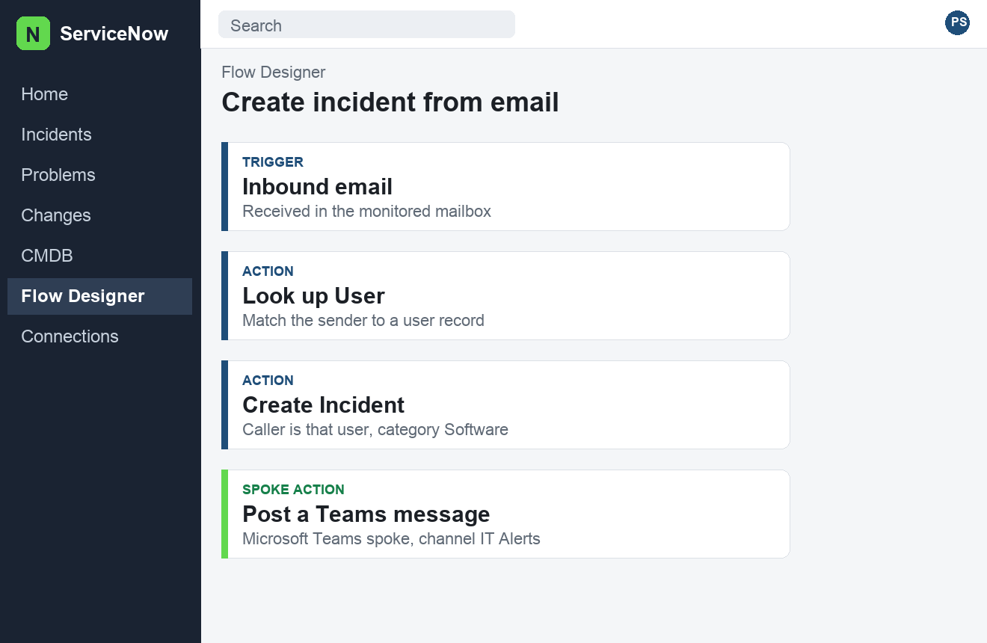
Figure 2. Study layout of a Flow Designer flow. The last step is a Microsoft Teams spoke. The questions about that spoke are in the embedded document. Not a capture from a live instance.

What is a configurable workspace, and where does UI Builder fit?
A configurable workspace is where agents work in Next Experience. Service Operations Workspace and CSM Configurable Workspace are the common ones. The agent handles incidents, cases, and interactions there instead of on the classic form. UI Builder lays out those pages: the list, the record, and the components around them. The dictionary and the form layout still decide which fields exist and how they behave. UI Builder decides where the workspace shows them. People who request things usually stay on Employee Center or Service Portal. Adding a field to the form does not, by itself, place that field on the portal or on the workspace page.

Third-party services
Jira, Teams, Slack, identity providers, LDAP, JDBC, email, and Service Graph Connectors are covered in the embedded Word document. Open ServiceNow-QA.docx in Microsoft Word, then double-click the icon. If this file is open in an editor that does not run embedded objects, open ServiceNow-Third-Party-Services-QA.docx from the same folder.
The embedded document answers:
- What is Integration Hub, and what is a spoke?
- When do you use an outbound REST message, and when a Scripted REST API?
- What is a MID Server, and which integrations need one?
- Where should credentials live, and how does OAuth fit?
- How do import sets and transform maps load data from another system?
- How does single sign-on work with an identity provider?
- How should users and groups be brought in from LDAP, Entra ID, or Okta?
- What is a Service Graph Connector, and when is it a better fit than a custom integration?
- How do inbound email actions differ from notifications?
- A third-party call failed. What do you check first?
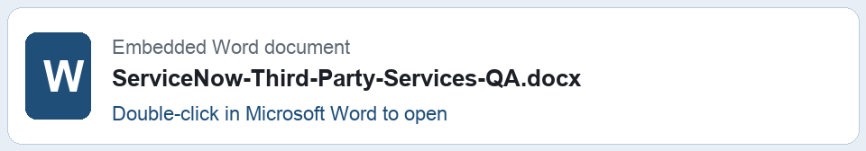
Double-click the icon in Microsoft Word to open ServiceNow-Third-Party-Services-QA.docx.

