ServiceNow third-party services
Questions and answers on systems outside the Now Platform, and on the connections ServiceNow uses to reach them.
This file stands on its own. The same file is embedded in ServiceNow-QA.docx. In Microsoft Word, double-click that icon to open this document.

Connections
Integration Hub stores one connection per outside system. The flow names the connection alias. The alias points at a credential on this instance. The screenshot below is a study layout of that list, covering a cloud spoke, an identity provider, and two targets that can be reached only through a MID Server.
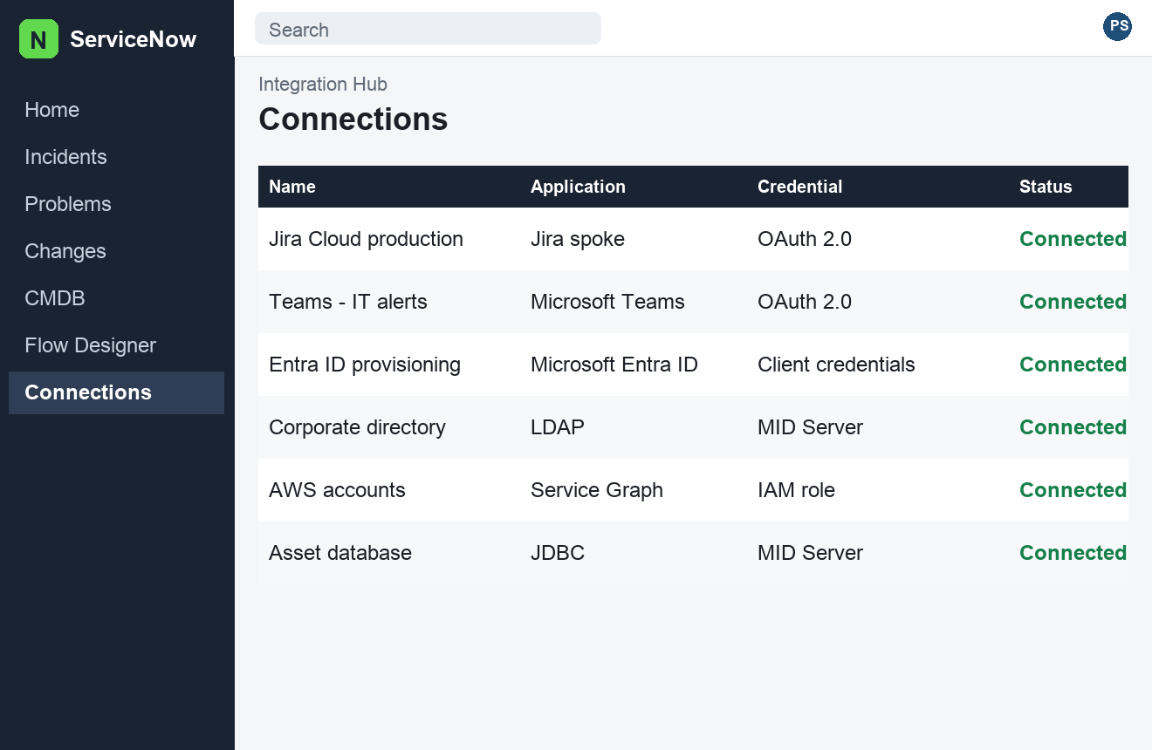
Figure 1. Study layout of Integration Hub connections. Not a capture from a live instance.

Questions

What is Integration Hub, and what is a spoke?
Integration Hub is the integration layer inside Flow Designer. A spoke is a scoped set of actions for one outside product, such as Jira, Microsoft Teams, Slack, or Microsoft Entra ID. You drop a spoke action into a flow the same way you drop a core action. The connection and the credential are records the action looks up at run time, so the password is not written into the flow. When ServiceNow does not ship a spoke for the product, build a small scoped app of your own actions and call those. That app is your spoke. Prefer a maintained spoke over a one-off script when both can do the job, because the spoke already handles paging, retries, and credential refresh.

When do you use an outbound REST message, and when a Scripted REST API?
An outbound REST message is ServiceNow calling another system. You set the endpoint, the HTTP method, and the headers, and you can test it from the record. A flow action or a server script then runs that message. A Scripted REST API is the other direction: another system calls ServiceNow. You publish an API and a resource for GET, POST, PUT, or DELETE, and the script reads the request and writes the response. A webhook from Jira or from a monitoring tool is usually a Scripted REST resource. Use Integration Hub's REST step for new outbound calls unless you are maintaining a REST message that already works. Keep the payload small and return clear HTTP status codes from the scripted API so the caller can retry safely.

What is a MID Server, and which integrations need one?
A MID Server is a Java agent on a host inside your network. It runs Discovery, JDBC, PowerShell, SSH, and LDAP queries that the ServiceNow datacenter cannot reach. The MID Server opens no inbound port for the instance to call into. The agent calls the instance over outbound HTTPS and picks up work from the ECC queue. A public cloud API, such as Jira Cloud or Microsoft Graph, does not need a MID Server. An on-prem database, a Windows server, or an internal LDAP directory does. If the MID is down, those jobs sit in the ECC queue. Cloud spokes keep working, because they never used that agent.

Where should credentials live, and how does OAuth fit?
Store secrets on a credential record, and point the connection at a credential alias. The flow uses the alias, so a move to another instance only requires the local credential, not an edit to the flow. Basic auth, an API key, and OAuth 2.0 are all credential types. OAuth client credentials fit a server-to-server call. Authorization code fits a call that must act as a user. The platform stores the refresh token and renews the access token. Recreate passwords and client secrets on each instance. An update set does not carry those secrets in a form you can rely on. Do not paste a token into a script include or a flow variable.

How do import sets and transform maps load data from another system?
An import set is a staging table. A data source fills it from a file, a JDBC query through a MID Server, or a REST response. A transform map then copies staging columns onto a target table such as cmdb_ci or sys_user. Coalesce fields are the match key. When the key matches an existing row, the transform updates that row. When it does not, the transform inserts. Transform scripts (onBefore, onAfter, onForeign) handle lookups and skips. A coalesce on the wrong column, or on a column that is blank, creates a duplicate on every run. For CMDB data, prefer a Service Graph Connector or an IRE payload over a transform that inserts straight into cmdb_ci, because the identifier rules are what prevent duplicates.

How does single sign-on work with an identity provider?
ServiceNow is the service provider. Azure AD (Entra ID), Okta, or ADFS is the identity provider. With SAML or OpenID Connect, the user authenticates at the identity provider, and ServiceNow receives an assertion. The NameID, or the equivalent claim, must match a field on the user record, usually user_name or email. Multi-provider SSO allows more than one identity provider on the same instance. SSO proves who the person is. It does not create the user record. Provisioning does that. Test SSO with a non-admin account, and keep one local break-glass admin so a bad certificate or a changed claim does not lock everyone out.

How should users and groups be brought in from LDAP, Entra ID, or Okta?
LDAP reaches an internal directory through a MID Server, on a schedule, and can import users and groups. That pattern is still common for an on-prem Active Directory. For Entra ID or Okta, prefer the vendor's provisioning integration or SCIM, plus SSO. The identity system then creates, updates, and disables users when people join, move, or leave. A nightly LDAP pull that never disables anyone will leave departed staff with active accounts. Map groups to ServiceNow groups that already hold the roles, instead of assigning roles one user at a time. Roles live on groups. Users inherit them.

What is a Service Graph Connector, and when is it a better fit than a custom integration?
A Service Graph Connector is a supported import from one product into the CMDB, already wired to the Identification and Reconciliation Engine. Connectors exist for sources such as Microsoft Intune, SCCM, AWS, Azure, Jamf, and similar systems. The connector knows which class to write, which identifier to use, and which relationships to draw. A custom REST script that inserts cmdb_ci rows skips that identification and creates duplicates the next time Discovery sees the same machine. Use the connector when one exists for that source. Build a custom integration when the source has no connector, and still send CMDB writes through the IRE API rather than a direct insert.

How do inbound email actions differ from notifications?
An inbound email action reads mail that arrived in a mailbox ServiceNow monitors. It creates or updates a record. The usual match is a watermark in the subject or body, so a reply lands on the existing incident instead of opening a new one. Conditions on the action decide which script runs. A notification is outbound mail. It fires from an event, uses a template, and goes to the recipients defined on the notification, often the caller, the assignment group, or a watch list. Insert an event from the business rule or the flow, and let the notification react to the event. Sending mail directly from a business rule skips the template, the conditions, and the log that shows why a message was sent.

A third-party call failed. What do you check first?
Open the flow execution, or the Outbound HTTP Requests log, and read the status code and the response body before you change any script. A 401 or 403 is a credential or a permission on the remote side. A timeout or a connection error is the path: wrong URL, firewall, or a MID Server that is down. If the action uses a MID Server, check that the MID is validated and read the ECC queue for the input and output payloads. Confirm the connection on this instance, because credentials are not shared from production by an update set. Then compare the body you sent with what the remote API documents. Only after the log shows a bad payload should you edit the action.

