Challenge -04
Use Case: Setting up Transit Gateway and VPC Endpoints for a Multi-VPC Architecture
Scenario:
A large organization is migrating its on-premises infrastructure to the AWS cloud.
The organization's architecture involves multiple VPCs for different departments and applications, each requiring secure communication with centralized services and external resources.
The IT team needs to design and implement a scalable and efficient network architecture to accommodate the organization's growth and ensure robust connectivity between VPCs and external services.
Objectives:
- Design and deploy a scalable network architecture using AWS Transit Gateway to simplify network connectivity between multiple VPCs.
- Configure VPC endpoints to securely access AWS services without internet gateways or NAT gateways, ensuring data privacy and minimizing exposure to external threats.

Step 1: Confirm 3 VPCs
You already created 3 VPCs.
Use this structure:
VPC-1: 10.0.0.0/16
VPC-2: 10.1.0.0/16
VPC-3: 10.2.0.0/16

Step 2: Confirm Transit Gateway
Go to:
VPC → Transit Gateways
Confirm Transit Gateway is:
State: Available

Step 3: Confirm Transit Gateway attachments
Go to:
VPC → Transit Gateway Attachments
Confirm all 3 attachments are:
Resource type: VPC
State: Available

Step 4: Confirm Transit Gateway route table associations
Go to:
VPC → Transit Gateway Route Tables
→ Select your TGW route table
→ Associations
Confirm all 3 VPC attachments show:
State: Associated

Step 5: Confirm Transit Gateway propagations
Go to:
Transit Gateway Route Table
→ Propagations
Confirm all 3 VPC attachments are enabled.

Step 6: Confirm Transit Gateway routes
Go to:
Transit Gateway Route Table
→ Routes
You should see routes similar to:
10.0.0.0/16 → VPC-1 attachment
10.1.0.0/16 → VPC-2 attachment
10.2.0.0/16 → VPC-3 attachment

Step 7: Update normal VPC route tables
Go to:
VPC → Route Tables

VPC-1 route table should have:
10.0.0.0/16 → local
10.1.0.0/16 → Transit Gateway
10.2.0.0/16 → Transit Gateway

VPC-2 route table should have:
10.1.0.0/16 → local
10.0.0.0/16 → Transit Gateway
10.2.0.0/16 → Transit Gateway

VPC-3 route table should have:
10.2.0.0/16 → local
10.0.0.0/16 → Transit Gateway
10.1.0.0/16 → Transit Gateway

Step 8: Security groups for Transit Gateway testing
For public EC2 security group:
SSH | 22 | My IP
For private EC2 security groups:
SSH | 22 | 10.0.0.0/16
All ICMP - IPv4 | All | 10.0.0.0/16
If you want all VPCs to ping each other, allow ICMP from the other VPC CIDRs also.

Step 9: Test Transit Gateway
From public EC2, ping private EC2s using private IP:
ping PRIVATE-IP-OF-VPC2-EC2
ping PRIVATE-IP-OF-VPC3-EC2
If ping works, Transit Gateway setup is successful.

Part 2: S3 VPC Endpoint for Private EC2

Step 1: Use VPC-1
Use your VPC-1:
VPC ID: vpc-057f5606a3e02a1c4
CIDR: 10.0.0.0/16

Step 2: Keep public subnet for public EC2
Your public EC2 is:
Public EC2: ec2-1
Public IP: 3.91.206.114
Private IP: 10.0.1.89
Subnet: subnet-0690a990af15094bc
This subnet should be associated with a public route table.
Public route table should have:
10.0.0.0/16 → local
0.0.0.0/0 → Internet Gateway

Step 3: Create private subnet
Go to:
VPC → Subnets → Create subnet
Enter:
VPC: vpc-057f5606a3e02a1c4
Subnet name: vpc1-private-subnet-new
Availability Zone: us-east-1a
IPv4 subnet CIDR: 10.0.4.0/24
Click:
Create subnet

Step 4: Create or use private route table
Go to:
VPC → Route Tables
Use your private route table:
vpc1-private-rt
rtb-0efb893f5b940fcc8
It should have:
10.0.0.0/16 → local
pl-63a5400a → vpce-0c8f230452ae09324
Do not add Internet Gateway route in this private route table.

Step 5: Associate new private subnet with private route table
Go to:
VPC → Route Tables
→ Select vpc1-private-rt
→ Subnet associations
→ Edit subnet associations
Select:
vpc1-private-subnet-new
10.0.4.0/24
Click:
Save associations

Step 6: Confirm S3 VPC Endpoint
Go to:
VPC → Endpoints
Confirm your S3 endpoint is:
Service: com.amazonaws.us-east-1.s3
Type: Gateway
State: Available
VPC: vpc-057f5606a3e02a1c4
Endpoint target route should be:
pl-63a5400a → vpce-0c8f230452ae09324

Step 7: Confirm endpoint is attached to private route table
Go to:
VPC → Route Tables
→ vpc1-private-rt
→ Routes
Confirm routes show:
10.0.0.0/16 → local
pl-63a5400a → vpce-0c8f230452ae09324

Step 8: Create IAM role for S3 access
Go to:
IAM → Roles → Create role
Select:
Trusted entity: AWS service
Use case: EC2
Attach policy:
AmazonS3ReadOnlyAccess
or for lab:
AmazonS3FullAccess
Role name:
EC2-S3-Access-Role
Click:
Create role

Step 9: Launch new private EC2
Go to:
EC2 → Instances → Launch instance
Use:
Name: private-s3-test-server-new
AMI: Amazon Linux 2023
Instance type: t3.micro
Key pair: bashscript
VPC: vpc-057f5606a3e02a1c4
Subnet: vpc1-private-subnet-new / 10.0.4.0/24
Auto-assign public IP: Disable
IAM role: EC2-S3-Access-Role
Security group inbound rules:
SSH | 22 | Custom | 10.0.0.0/16
All ICMP - IPv4 | All | Custom | 10.0.0.0/16
Launch the instance.

Step 10: Copy key to public EC2
From your laptop Git Bash:
cd ~/Downloads
chmod 400 bashscript.pem
scp -i bashscript.pem bashscript.pem ec2-user@3.91.206.114:/home/ec2-user/

Step 11: Connect to public EC2
From your laptop Git Bash:
ssh -i bashscript.pem ec2-user@3.91.206.114
After connection, you should see:
[ec2-user@ip-10-0-1-89 ~]$

Step 12: Connect from public EC2 to private EC2
Inside public EC2, run:
ls
chmod 400 bashscript.pem
ssh -i bashscript.pem ec2-user@NEW-PRIVATE-EC2-PRIVATE-IP
Example:
ssh -i bashscript.pem ec2-user@10.0.4.25
After connection, you should see private EC2 prompt:
[ec2-user@ip-10-0-4-25 ~]$

Step 13: Configure AWS region on private EC2
Inside private EC2, run:
aws configure set region us-east-1
Check region:
aws configure get region
Expected output:
us-east-1

Step 14: Confirm IAM role on private EC2
Inside private EC2, run:
TOKEN=$(curl -X PUT "http://169.254.169.254/latest/api/token" -H "X-aws-ec2-metadata-token-ttl-seconds: 21600")
Then run:
curl -H "X-aws-ec2-metadata-token: $TOKEN" http://169.254.169.254/latest/meta-data/iam/security-credentials/
Expected output:
EC2-S3-Access-Role

Step 15: Test S3 access from private EC2
Inside private EC2, run:
aws s3 ls --region us-east-1
If it lists your S3 buckets, your VPC endpoint setup is successful.

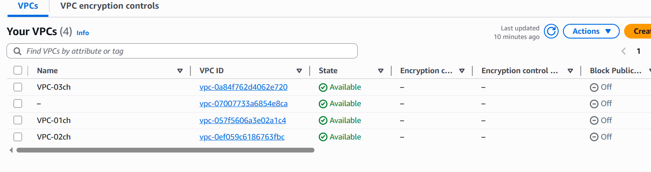

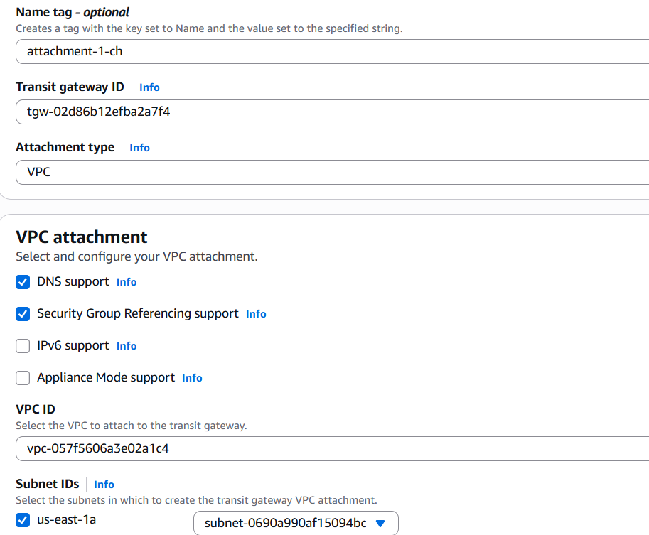

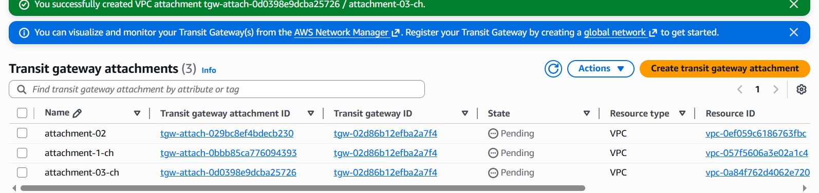

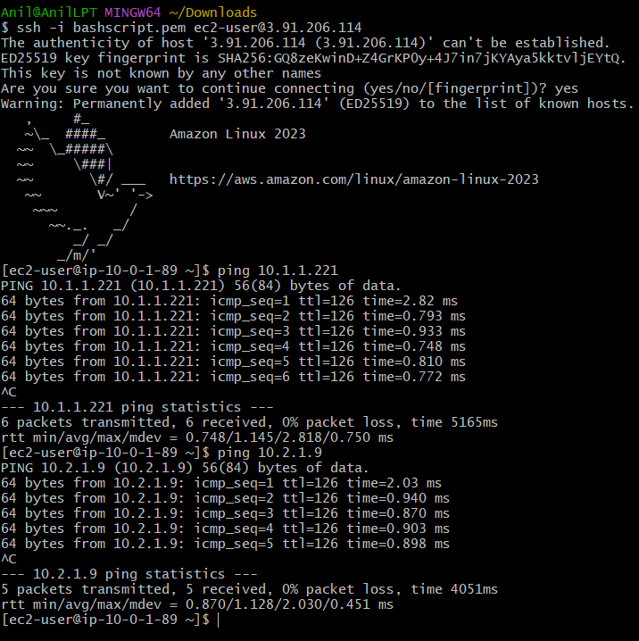

Configure VPC Endpoint for S3
Purpose: The purpose of a VPC Endpoint is to allow private instances to access AWS services without using :Internet Gateway NATGateway Public IP
if that private EC2 needs to access S3, we can create an S3 VPC Endpoint
Private EC2 → VPC Endpoint → Amazon S3
