EC2 Instance creation
Reference link : https://youtu.be/86Tuwtn3zp0?si=pQqYu6itQ9UCvirU
login to Aws cloud from browser
- Then search for Ec2 in search bar
- Then click on instance then create a new instance
or launch new instance
- Select free eligible tiers
- Such as t3.micro and select custom keypair and
download Pem.file for security
- Then click on launch instance.

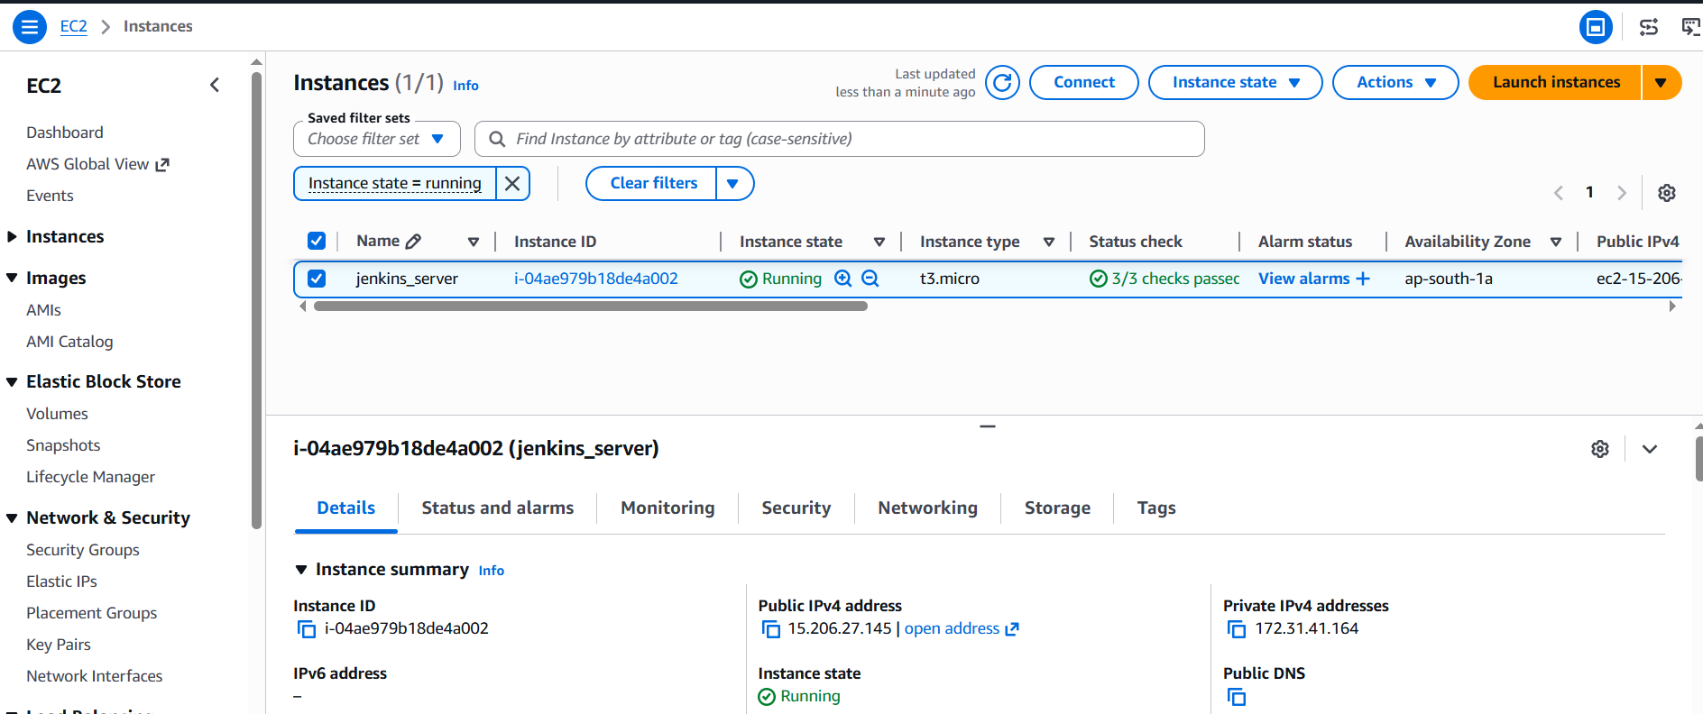

Jenkins
Reference link : https://youtu.be/Zdxko2bPAAw?si=tkETa_KVahyxhlNG

- Download Jenkins windows msi installer package from
Jenkins website.
- Run the Jenkins package after downloading.
-download and install java jdk21 from java website.
- install Jenkins application then in
setup browse java path and select then create a
username and password for the Jenkins admin
- Default Jenkins password is shown in setup page
just copy and open Jenkins make port number
8080
- Then just type hostname:8080 in chrome now you can see Jenkins running

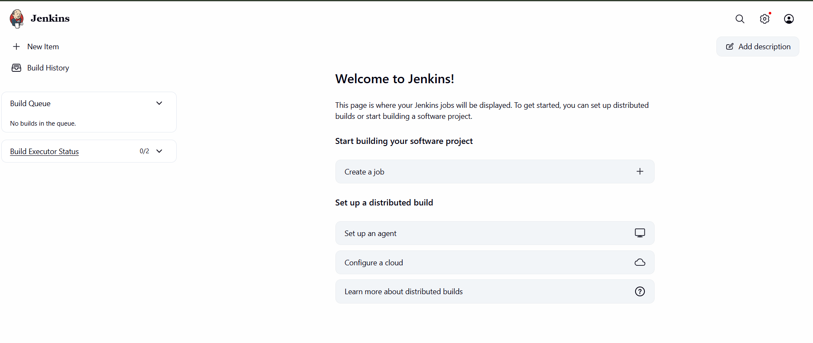
Installing apache tomcat in ubuntu
Reference link : https://youtu.be/7i0wj2QYo4M?si=2w4uLCNdePKcdfZ3
- Open ubuntu terminal and first update
(sudo apt update)
- install java using command sudo apt install default-jdk
- check java version using command
Java --version
- Then search for tomcat in terminal with
command
sudo apt search tomcat
- Then we can install tomcat with command
sudo apt install tomcat11 tomcat11-admin
With this the tomcat has installed Successfully
- To check tomcat is running or not
Use the command ps –ef|grep –i tomcat
- Now we have succesfully installed tomcat to
know we can go to mozilla firefox and search
localhost:8080

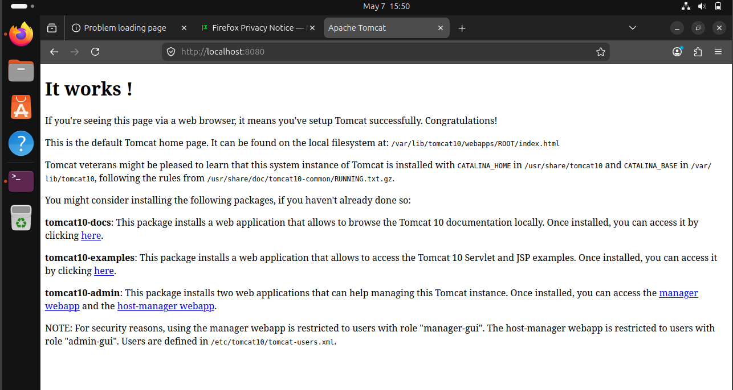

Docker
Reference link : https://youtu.be/JBEUKrjbWqg?si=L2mywYTWxDIjKNiS
Go to docker website and download package
for your pc
- Just install docker app and continue through
setup
- And after completing installation restart your
computer to complete the installation
- After restart open desktop docker and create
an account in docker desktop and website
- And make sure your wsl is updated
- To update open cmd and input command
Wsl – update
- Now open desktop docker.

